=== FINAL RESULTS ===
Best Fitness: 1603.334025
Best Solution: [-15.360195360195362, 15.653235653235669, -99.8046398046398, -42.22222222222223, 4.713064713064725, -8.229548229548229, 52.67399267399267, -62.39316239316239, 23.223443223443226, 62.735042735042725]
Total Time: 16.23s

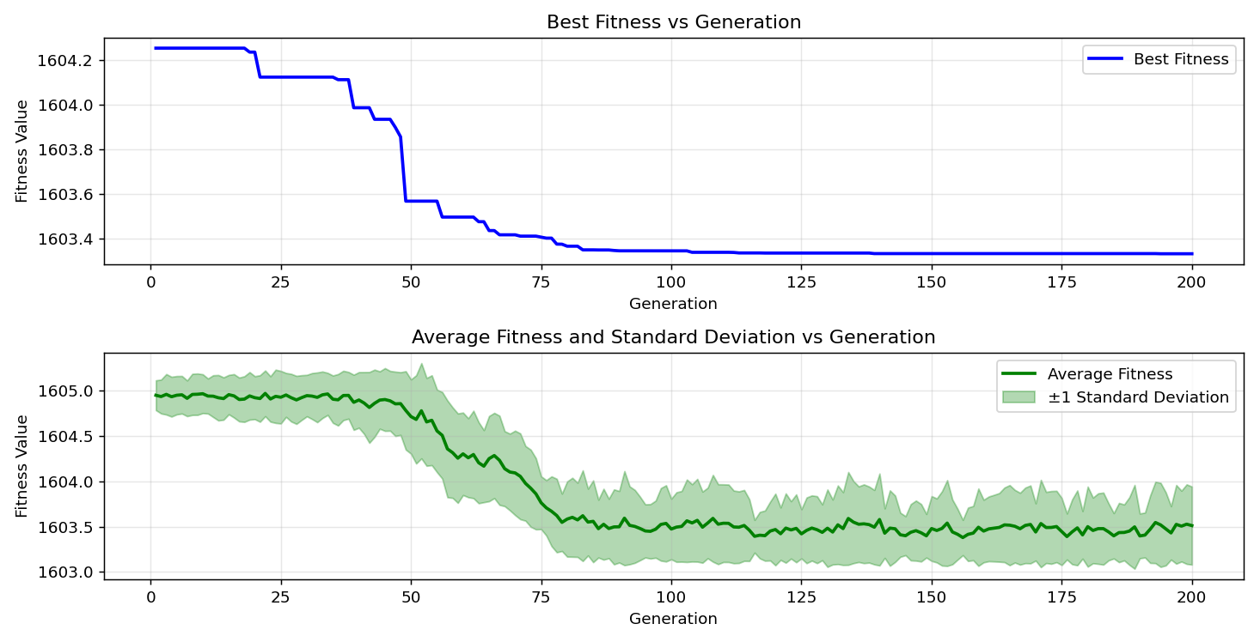
=== FINAL RESULTS ===
Best Fitness: 1602.825172
Best Solution: [-46.91086691086691, -31.623931623931625, -45.44566544566545, 11.25763125763126, -49.79242979242979, 1.684981684981679, -37.533577533577535, -69.91452991452991, 4.029304029304043, 62.49084249084248]
Total Time: 16.13s

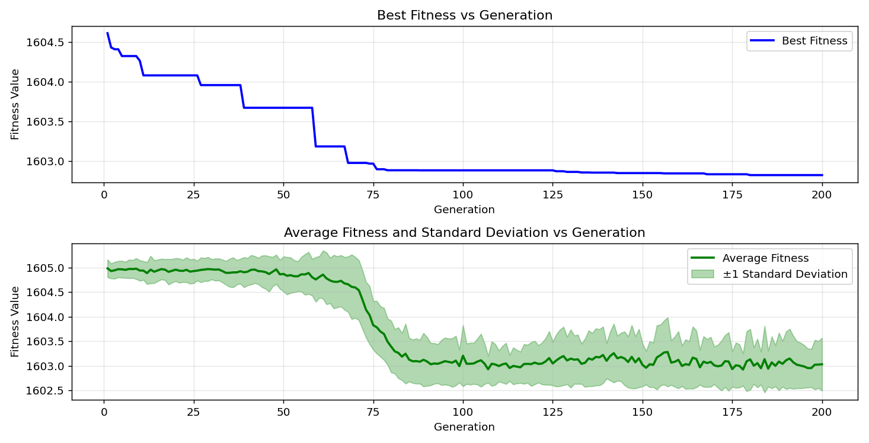

=== FINAL RESULTS ===
Best Fitness: 1602.825972
Best Solution: [-64.83516483516483, 17.167277167277177, -58.38827838827839, -23.125763125763115, -47.25274725274725, -71.62393162393163, 50.23199023199024, 38.94993894993894, 25.079365079365076, 38.705738705738696]
Total Time: 16.63s

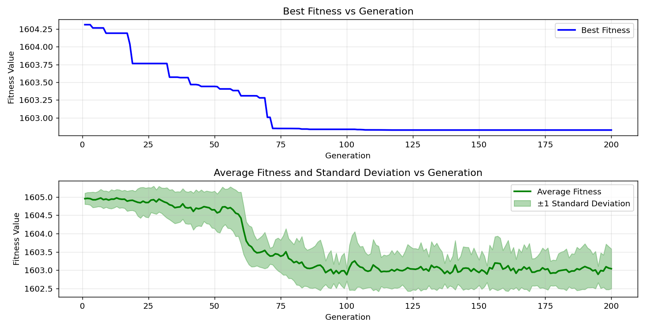

=== FINAL RESULTS ===
Best Fitness: 1602.801281
Best Solution: [69.81684981684981, -40.17094017094017, 70.54945054945054, -15.360195360195362, -54.969474969474966, -32.21001221001221, -30.30525030525031, -66.3980463980464, 17.264957264957275, -61.51404151404151]
Total Time: 16.50s

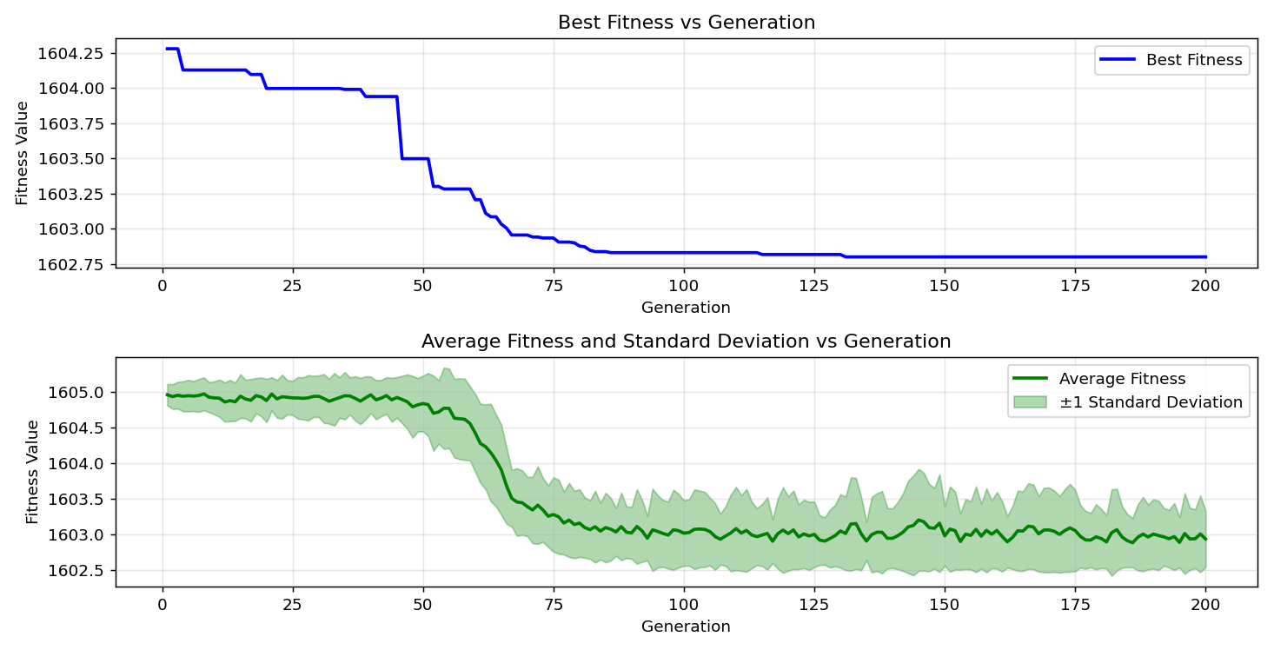
=== FINAL RESULTS ===
Best Fitness: 1602.629223
Best Solution: [-94.96947496947497, 23.80952380952381, -73.23565323565323, -60.04884004884005, -4.859584859584871, -30.6959706959707, -80.02442002442002, 72.55189255189256, 35.28693528693529, 83.3943833943834]
Total Time: 16.44s

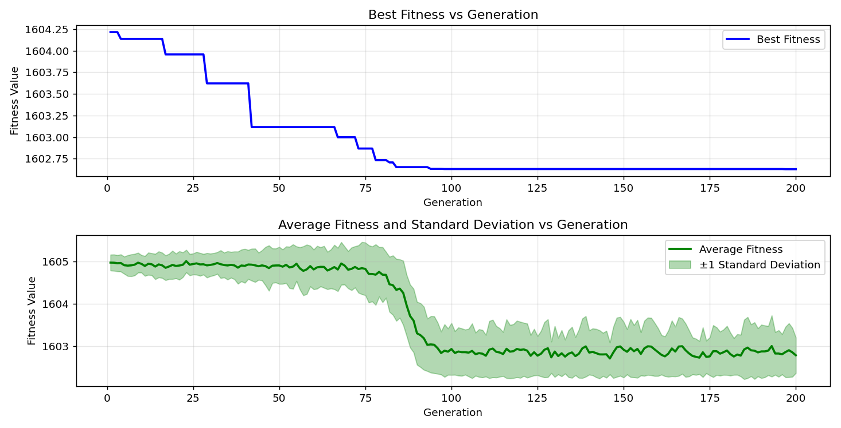
=== FINAL RESULTS ===
Best Fitness: 1603.220776
Best Solution: [-42.173382173382166, -100.0, -86.91086691086691, -16.434676434676433, -100.0, 93.45543345543345, -93.6996336996337, -72.21001221001221, -48.71794871794872, 27.47252747252746]
Total Time: 16.21s

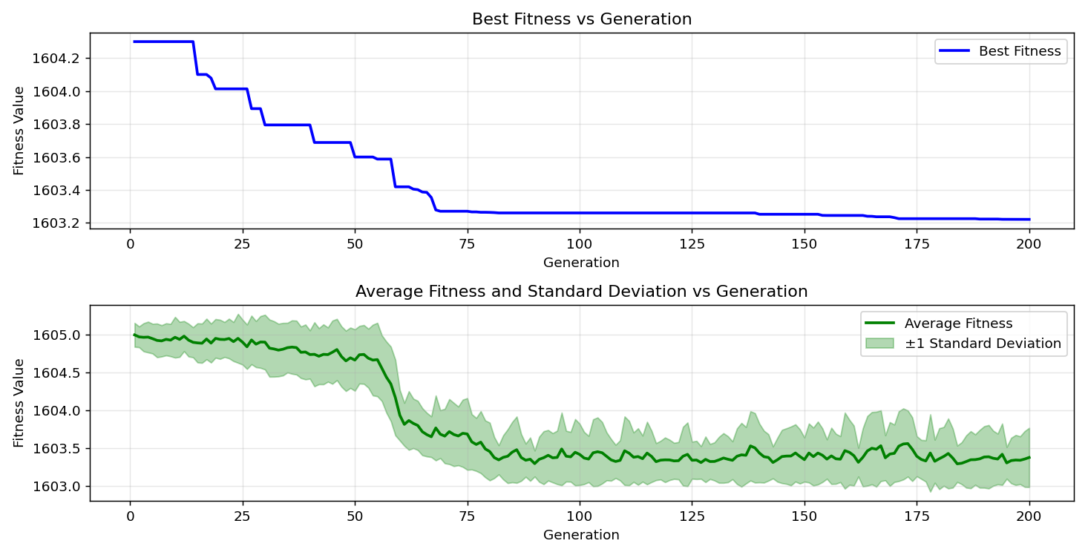

=== FINAL RESULTS ===
Best Fitness: 1603.158781
Best Solution: [-74.31013431013432, -38.21733821733822, -96.67887667887668, -13.211233211233207, -42.710622710622715, -49.98778998778999, 15.604395604395592, -49.98778998778999, -39.43833943833944, 35.92185592185592]
Total Time: 16.43s

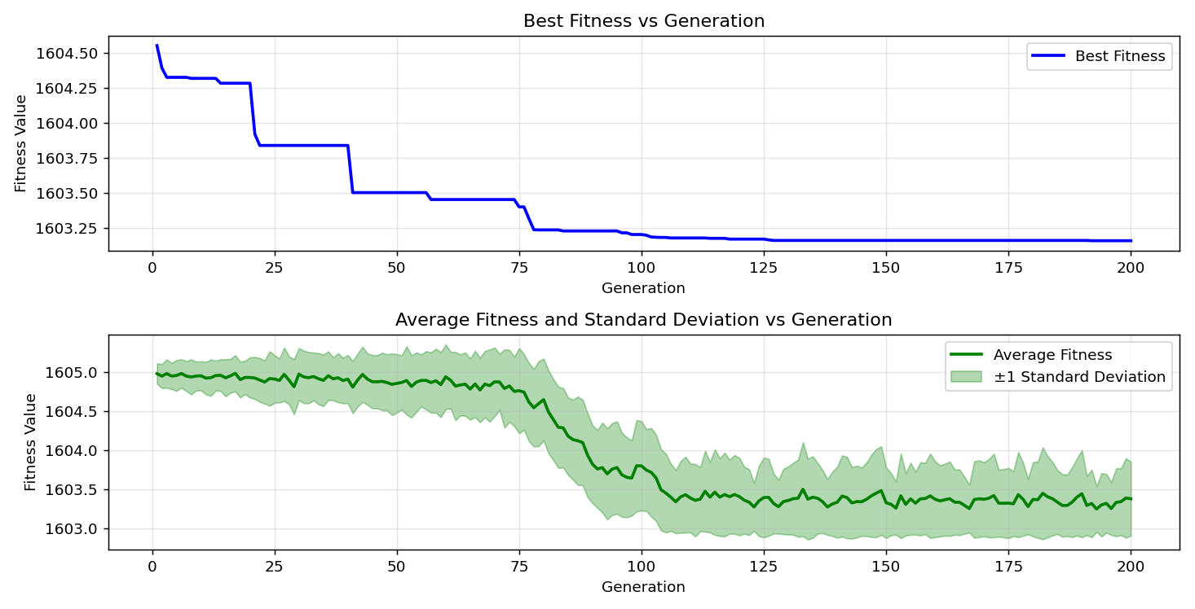
=== FINAL RESULTS ===
Best Fitness: 1602.924189
Best Solution: [-13.45543345543345, -70.79365079365078, 11.697191697191698, -81.29426129426129, -35.53113553113553, -18.827838827838832, -26.642246642246647, -33.87057387057388, 34.26129426129424, 25.567765567765562]
Total Time: 16.43s

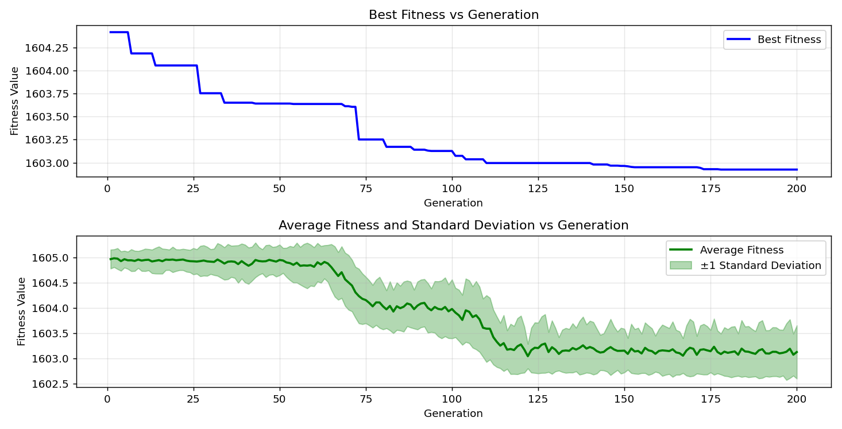

=== FINAL RESULTS ===
Best Fitness: 1603.251761
Best Solution: [0.952380952380949, -12.673992673992672, -66.98412698412699, 39.78021978021977, -52.86935286935287, 59.120879120879124, 36.45909645909646, -36.70329670329671, -4.713064713064725, -36.75213675213676]
Total Time: 16.23s

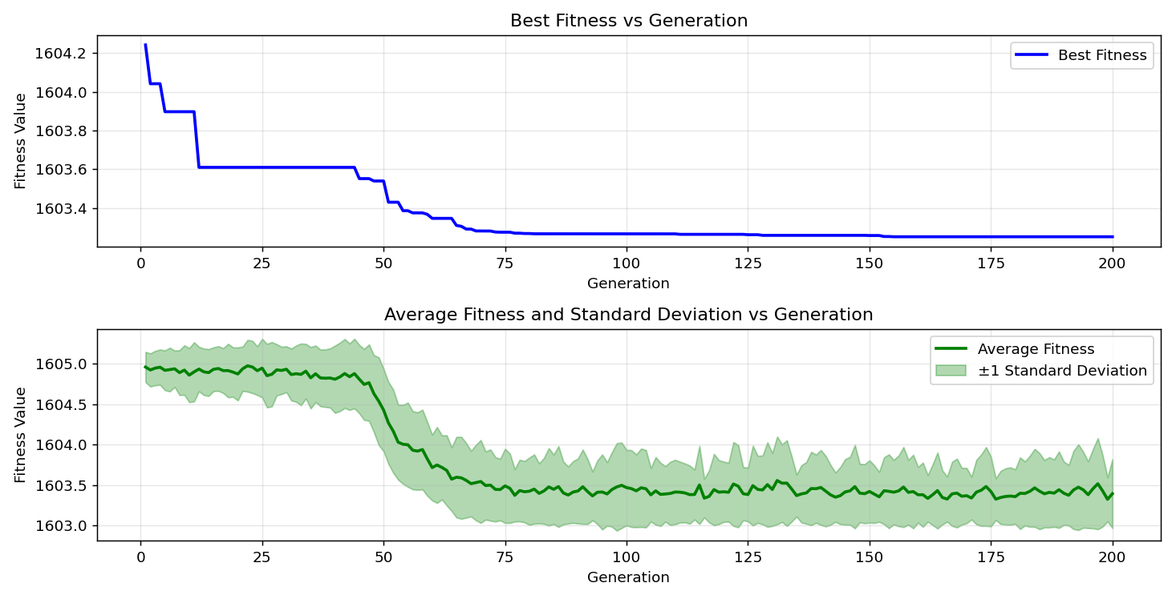
=== FINAL RESULTS ===
Best Fitness: 1603.202541
Best Solution: [44.02930402930403, 18.778998778998783, 17.362637362637372, 26.935286935286925, -28.888888888888886, -50.76923076923077, -23.27228327228326, -19.511599511599513, -54.676434676434674, -78.55921855921856]
Total Time: 16.10s

