=== FINAL RESULTS ===
Best Fitness: -8.785036
Best Solution: [2.159603382173382, 1.5711785885225884, 2.207168358974359, 1.1170097777777779, 1.7184765811965812, 1.5911251916971916, 1.4561020317460318, 2.3560007057387056, 2.2217447228327227, 1.5711785885225884]
Total Time: 7.02s

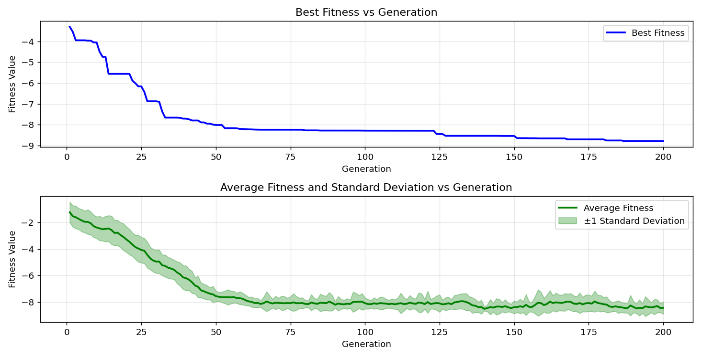
=== FINAL RESULTS ===
Best Fitness: -9.355027
Best Solution: [2.20946989010989, 1.5704114114774115, 1.2758154261294261, 1.9233128522588523, 0.9919599194139194, 1.5711785885225884, 1.4545676776556777, 1.3609720781440782, 1.9639732356532356, 1.8573356263736263]
Total Time: 7.09s

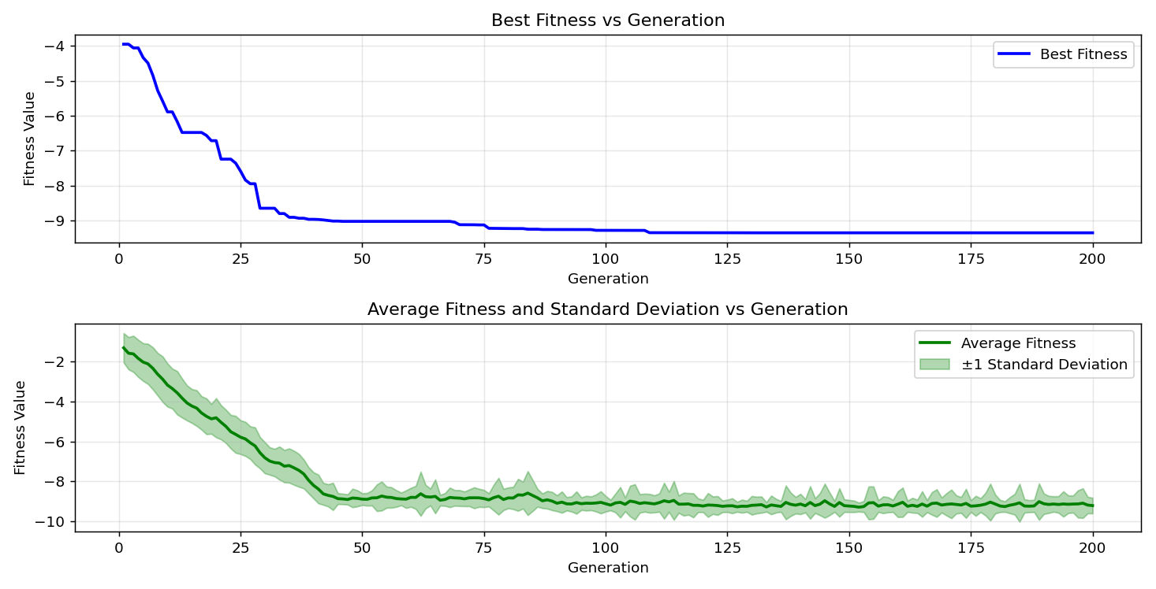

=== FINAL RESULTS ===
Best Fitness: -9.318911
Best Solution: [2.159603382173382, 1.5711785885225884, 1.2834871965811965, 1.9141067277167274, 2.2087027130647128, 1.5711785885225884, 1.4522661465201465, 1.3609720781440782, 1.2811856654456655, 1.5704114114774115]
Total Time: 7.18s

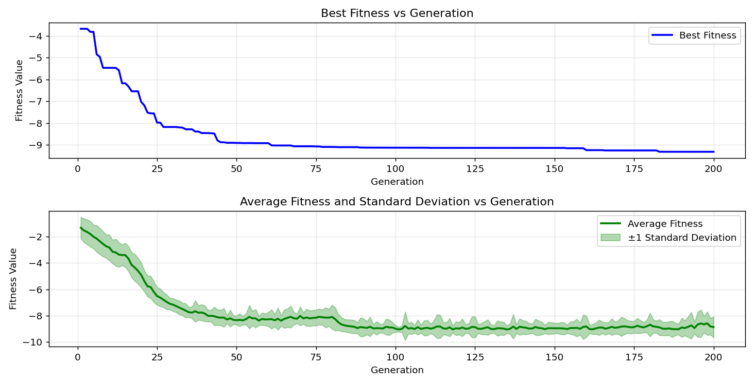
=== FINAL RESULTS ===
Best Fitness: -8.908516
Best Solution: [2.2179088376068377, 1.5704114114774115, 1.2857887277167277, 1.9286830915750917, 0.9812194407814407, 1.5704114114774115, 1.4722127496947497, 2.073679553113553, 0.7433945567765567, 1.5704114114774115]
Total Time: 7.00s

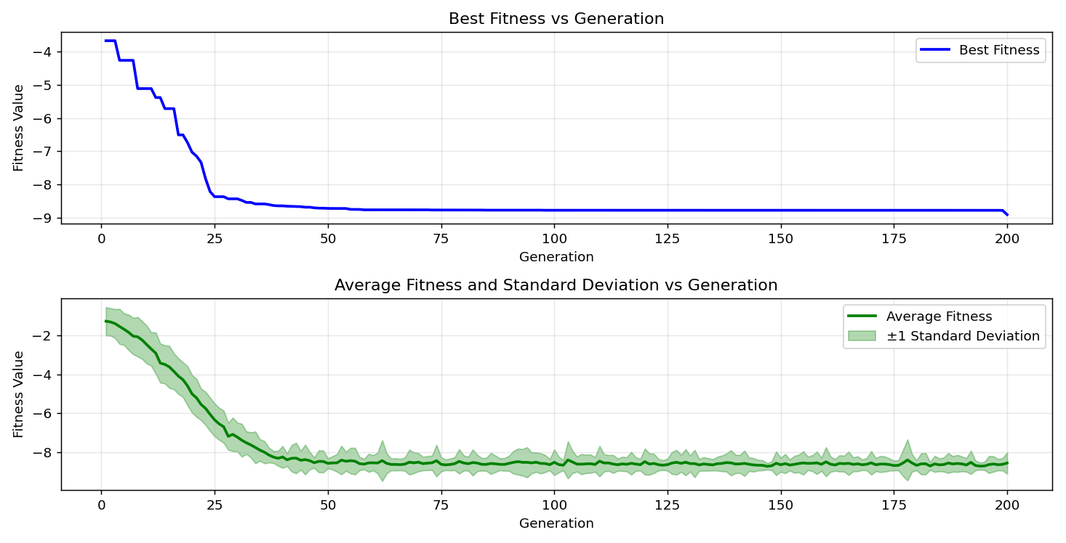

=== FINAL RESULTS ===
Best Fitness: -9.233658
Best Solution: [2.2033324737484734, 1.5711785885225884, 1.2850215506715505, 1.1024334139194139, 1.716942227106227, 1.5711785885225884, 1.4545676776556777, 1.3609720781440782, 0.7441617338217338, 1.8604043345543344]
Total Time: 7.15s

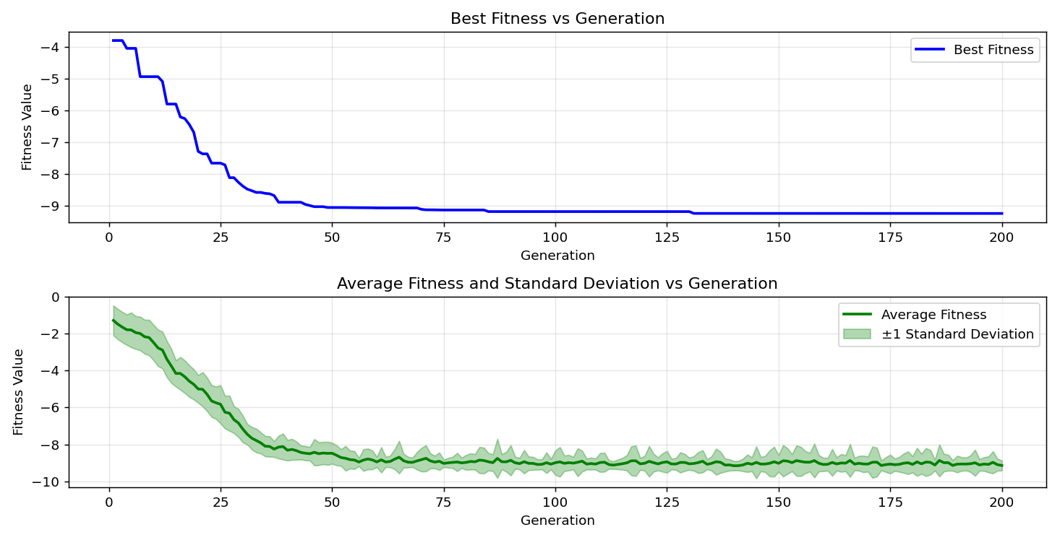
=== FINAL RESULTS ===
Best Fitness: -9.446831
Best Solution: [2.19642788034188, 1.5711785885225884, 1.2857887277167277, 1.1139410695970695, 1.7192437582417583, 1.5711785885225884, 1.4538005006105006, 1.3747812649572648, 1.9601373504273503, 1.5719457655677656]
Total Time: 7.19s

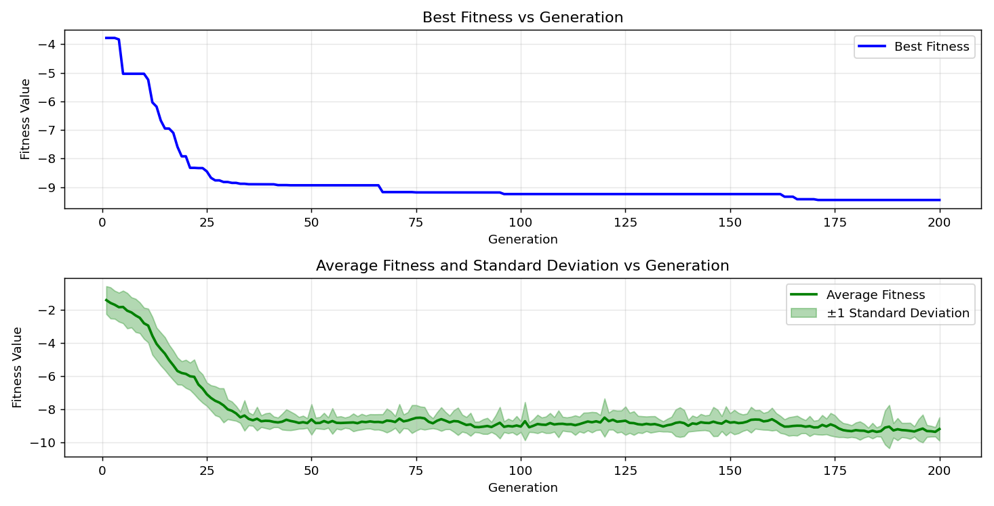

=== FINAL RESULTS ===
Best Fitness: -9.445127
Best Solution: [2.20946989010989, 1.5711785885225884, 1.2758154261294261, 1.1292846105006105, 1.7215452893772896, 1.5704114114774115, 1.4522661465201465, 2.076748261294261, 1.2819528424908424, 1.5704114114774115]
Total Time: 7.15s

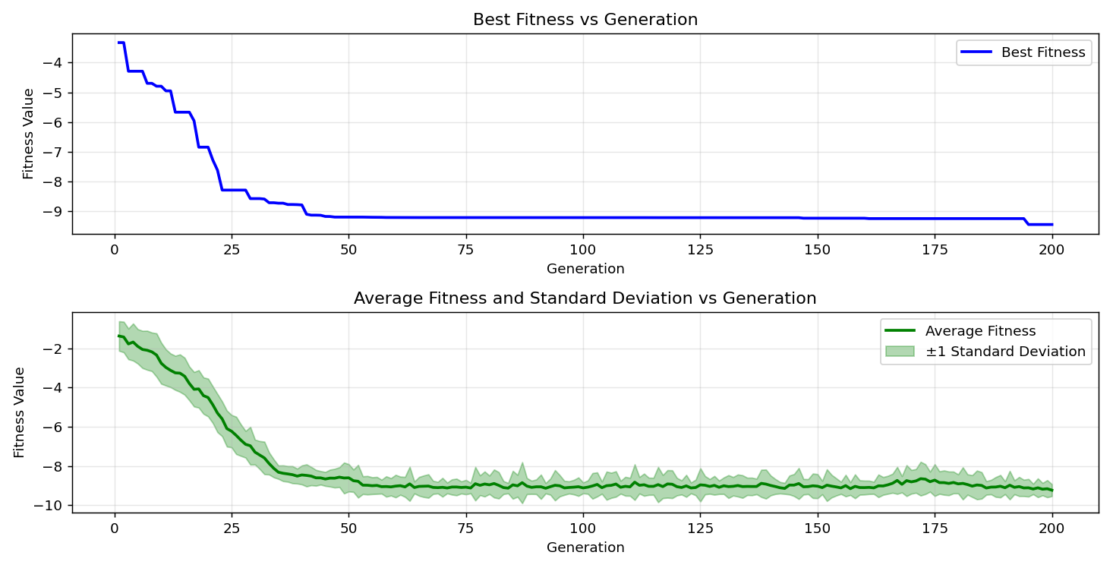
=== FINAL RESULTS ===
Best Fitness: -9.188594
Best Solution: [2.159603382173382, 1.5704114114774115, 1.2857887277167277, 1.9141067277167274, 0.9965629816849816, 1.5711785885225884, 1.8650073968253968, 1.767575912087912, 1.2804184884004883, 1.5704114114774115]
Total Time: 7.16s

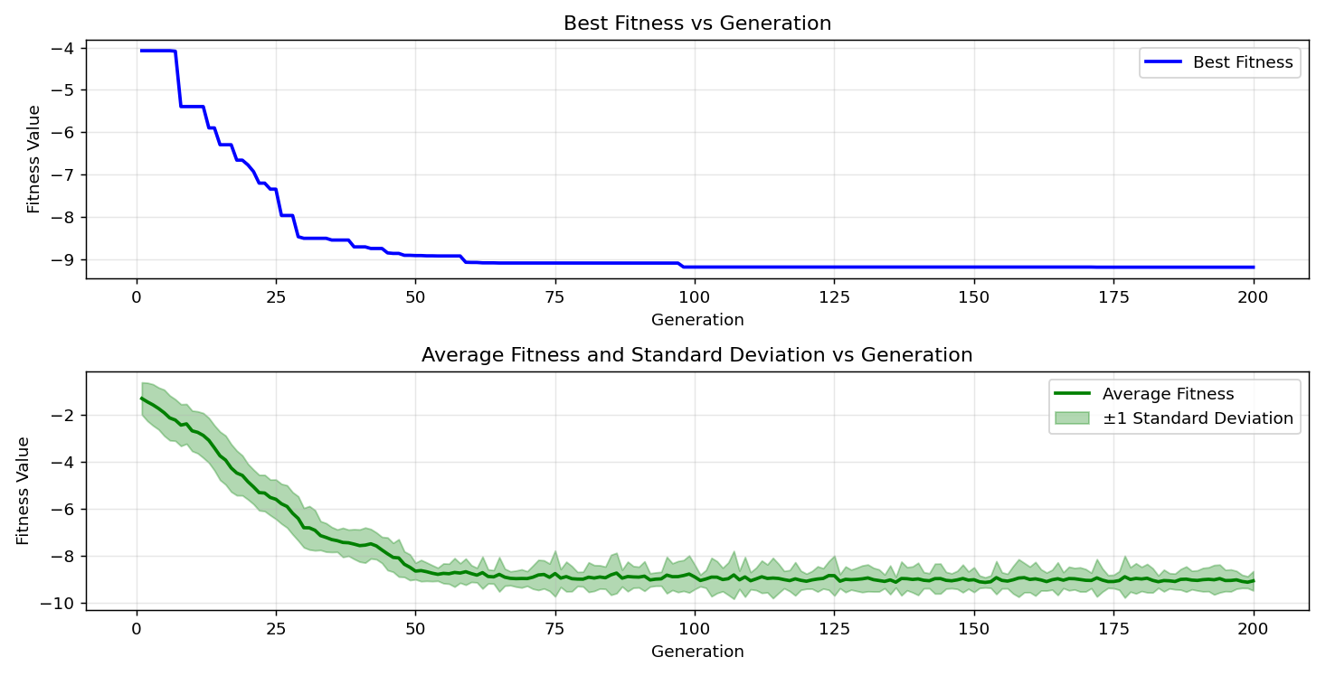

=== FINAL RESULTS ===
Best Fitness: -9.248378
Best Solution: [2.159603382173382, 1.5719457655677656, 1.2758154261294261, 1.9141067277167274, 0.9934942735042734, 1.5711785885225884, 1.4538005006105006, 2.077515438339438, 1.9639732356532356, 1.5711785885225884]
Total Time: 7.10s

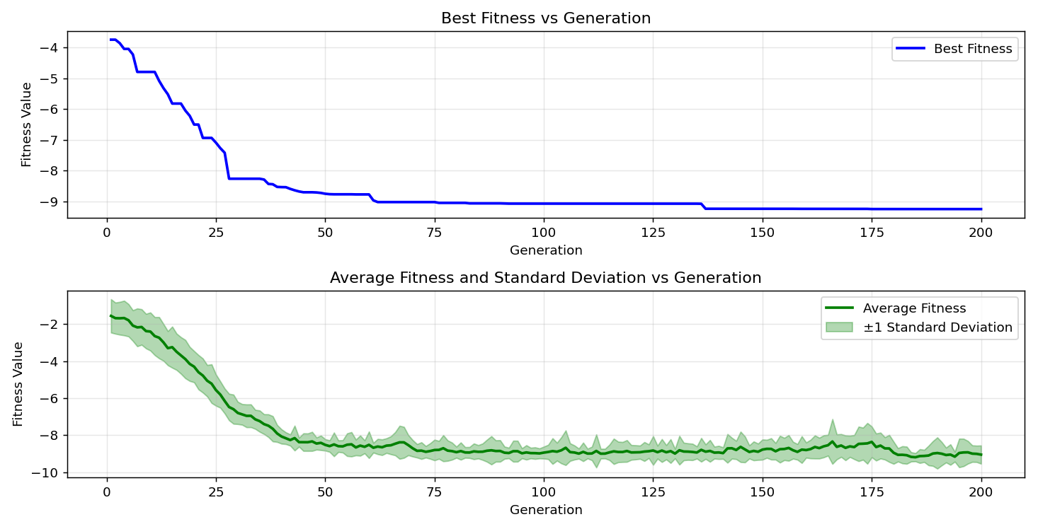
=== FINAL RESULTS ===
Best Fitness: -9.133239
Best Solution: [2.159603382173382, 1.5711785885225884, 1.2865559047619046, 1.1139410695970695, 2.223279076923077, 1.5742472967032966, 1.4561020317460318, 1.767575912087912, 1.6571024175824176, 2.1043666349206345]
Total Time: 7.14s

