=== FINAL RESULTS ===
Best Fitness: -4.680507
Best Solution: [2.2033324737484734, 1.5711785885225884, 1.2758154261294261, 1.9233128522588523, 1.7177094041514038]
Total Time: 5.77s

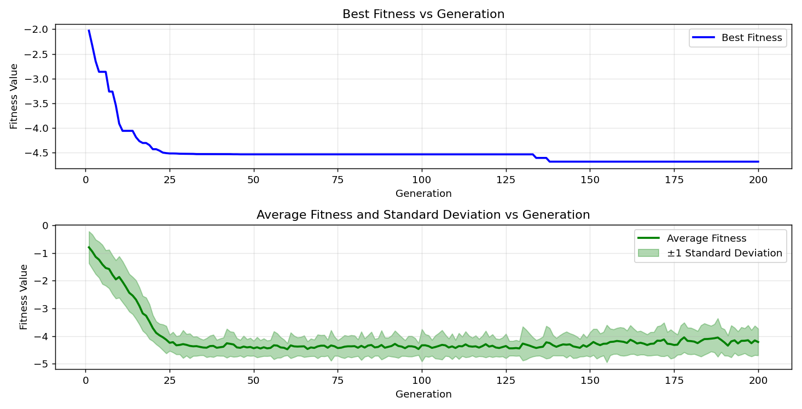
=== FINAL RESULTS ===
Best Fitness: -4.687355
Best Solution: [2.2025652967032965, 1.5711785885225884, 1.2842543736263736, 1.9240800293040294, 1.7207781123321124]
Total Time: 5.58s

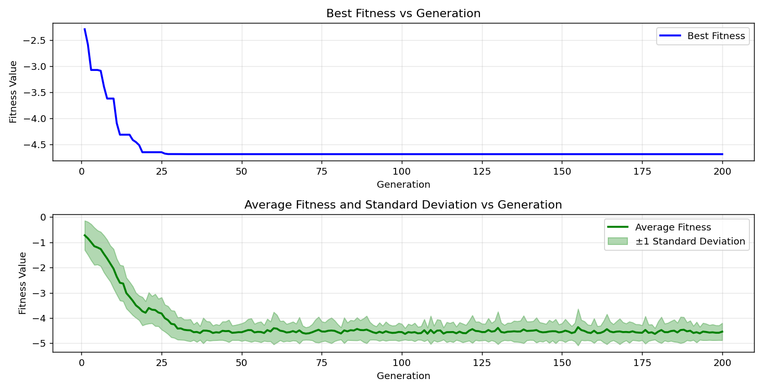

=== FINAL RESULTS ===
Best Fitness: -4.680928
Best Solution: [2.2025652967032965, 1.5704114114774115, 1.2896246129426128, 1.9233128522588523, 1.7161750500610498]
Total Time: 5.67s

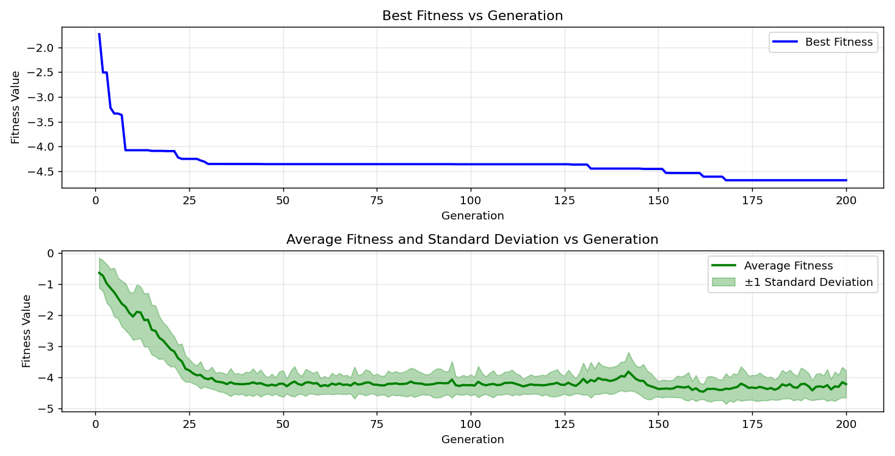
=== FINAL RESULTS ===
Best Fitness: -4.536735
Best Solution: [2.2033324737484734, 1.5711785885225884, 1.2857887277167277, 1.9233128522588523, 0.9934942735042734]
Total Time: 5.65s

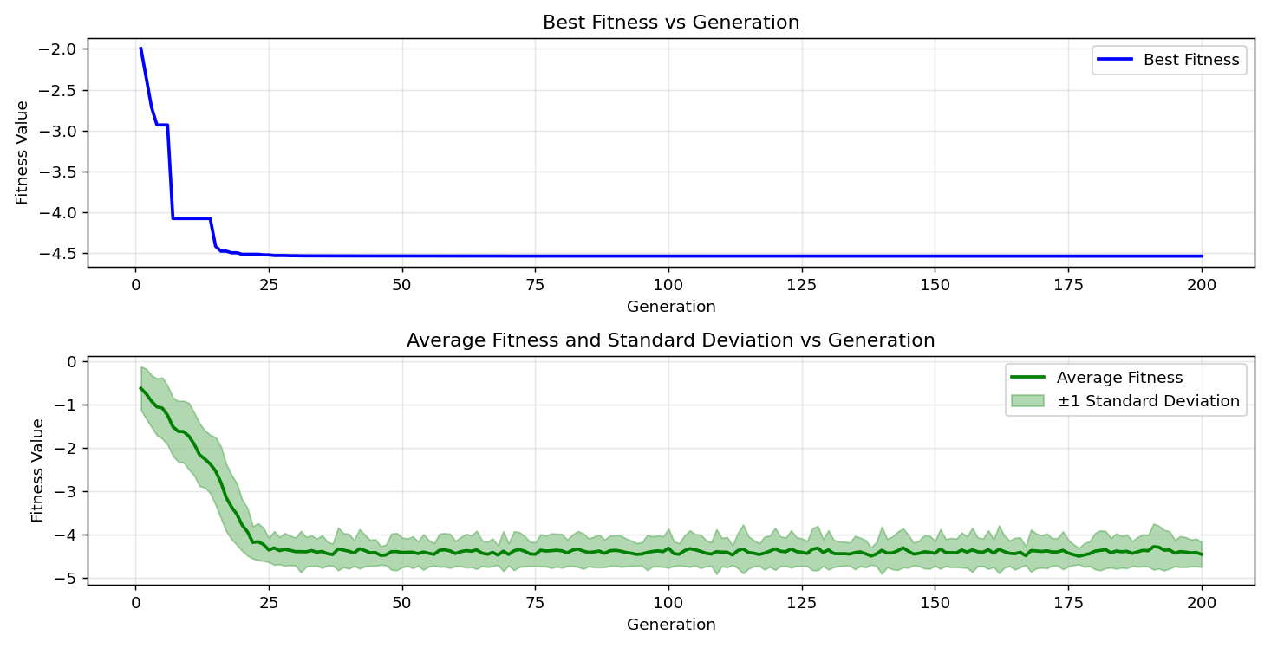

=== FINAL RESULTS ===
Best Fitness: -4.687255
Best Solution: [2.2025652967032965, 1.5704114114774115, 1.2834871965811965, 1.9240800293040294, 1.7207781123321124]
Total Time: 5.58s

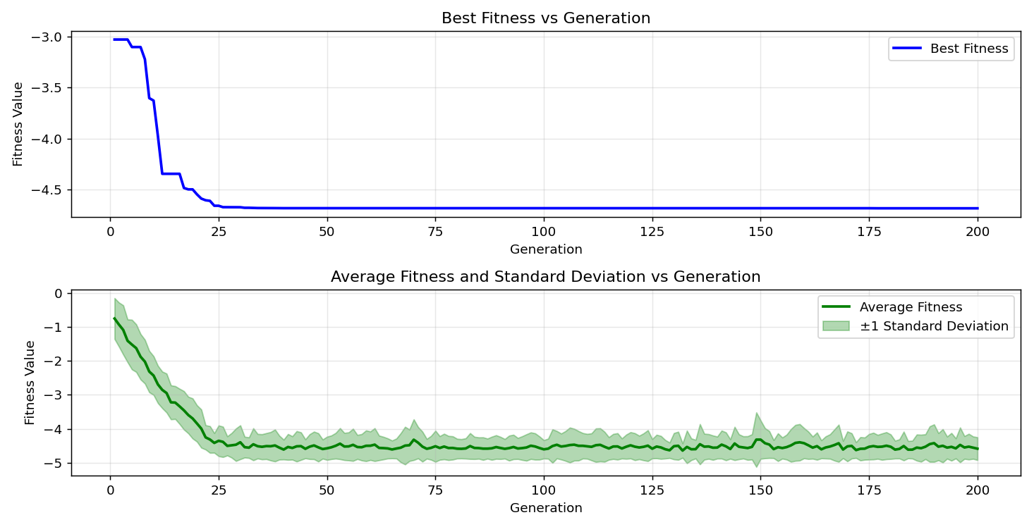
=== FINAL RESULTS ===
Best Fitness: -4.684848
Best Solution: [2.2033324737484734, 1.5688770573870574, 1.2842543736263736, 1.9217784981684982, 1.7177094041514038]
Total Time: 5.46s

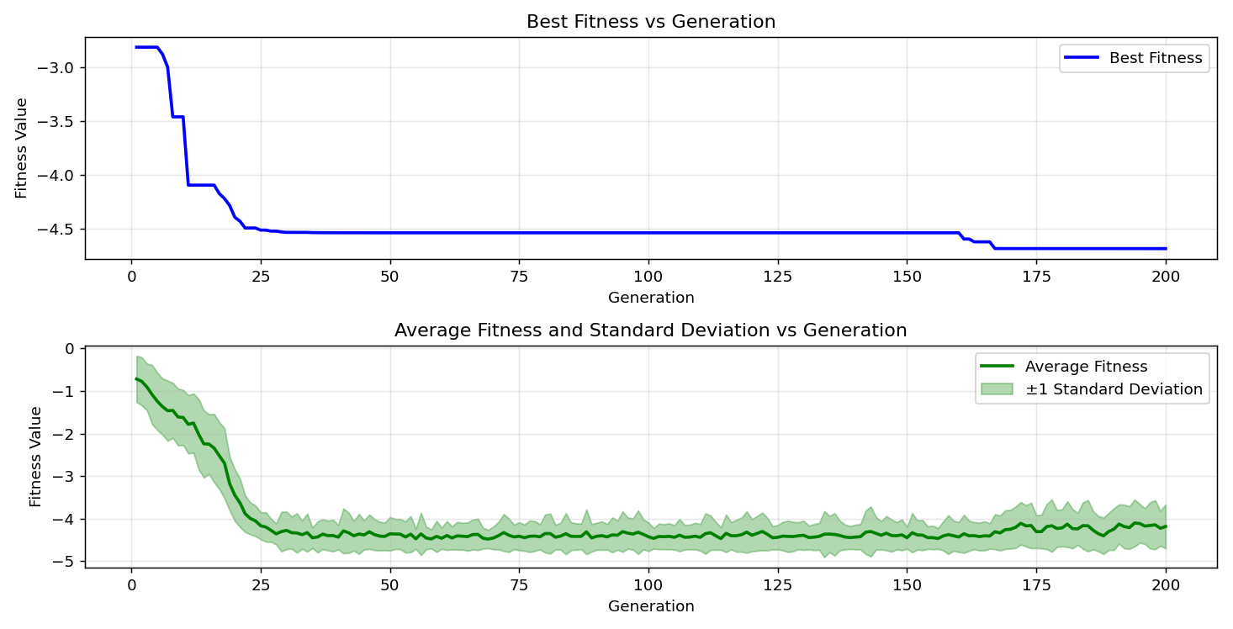

=== FINAL RESULTS ===
Best Fitness: -4.621458
Best Solution: [2.2033324737484734, 1.5711785885225884, 1.2819528424908424, 1.1170097777777779, 1.7115719877899875]
Total Time: 5.62s

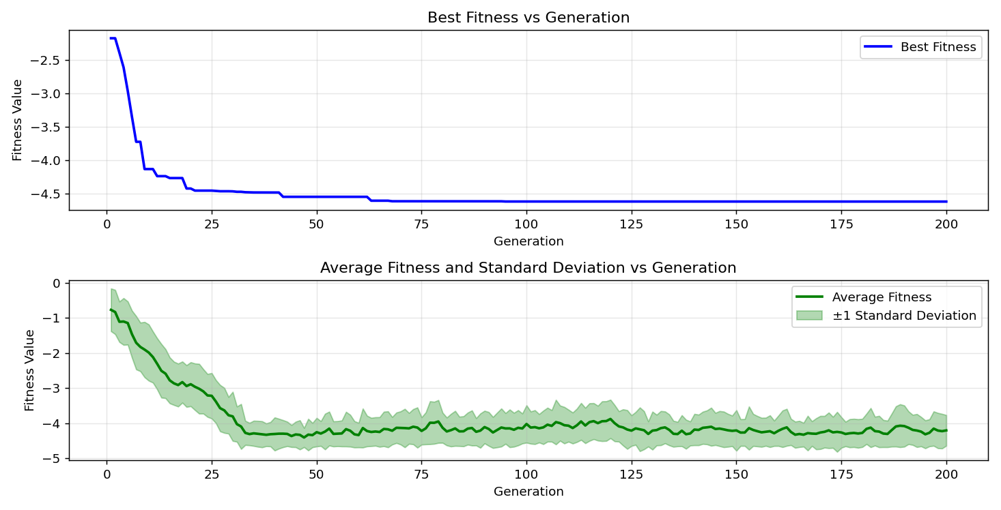
=== FINAL RESULTS ===
Best Fitness: -4.687510
Best Solution: [2.2048668278388277, 1.5704114114774115, 1.2857887277167277, 1.9233128522588523, 1.7207781123321124]
Total Time: 5.56s

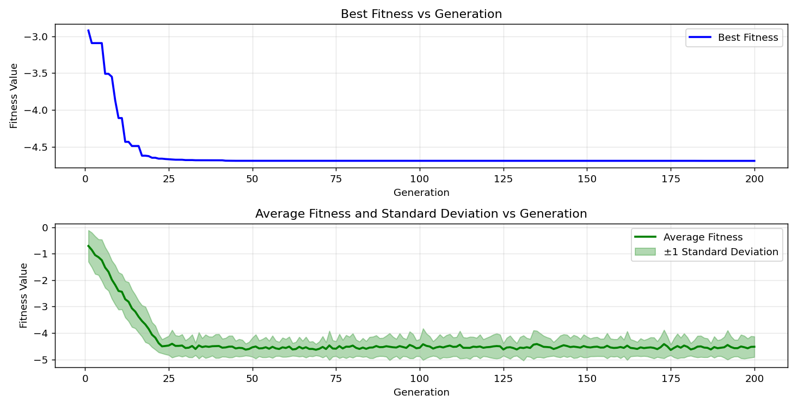

=== FINAL RESULTS ===
Best Fitness: -4.644248
Best Solution: [2.20946989010989, 1.5704114114774115, 1.2888574358974358, 1.1139410695970695, 1.7200109352869355]
Total Time: 5.73s

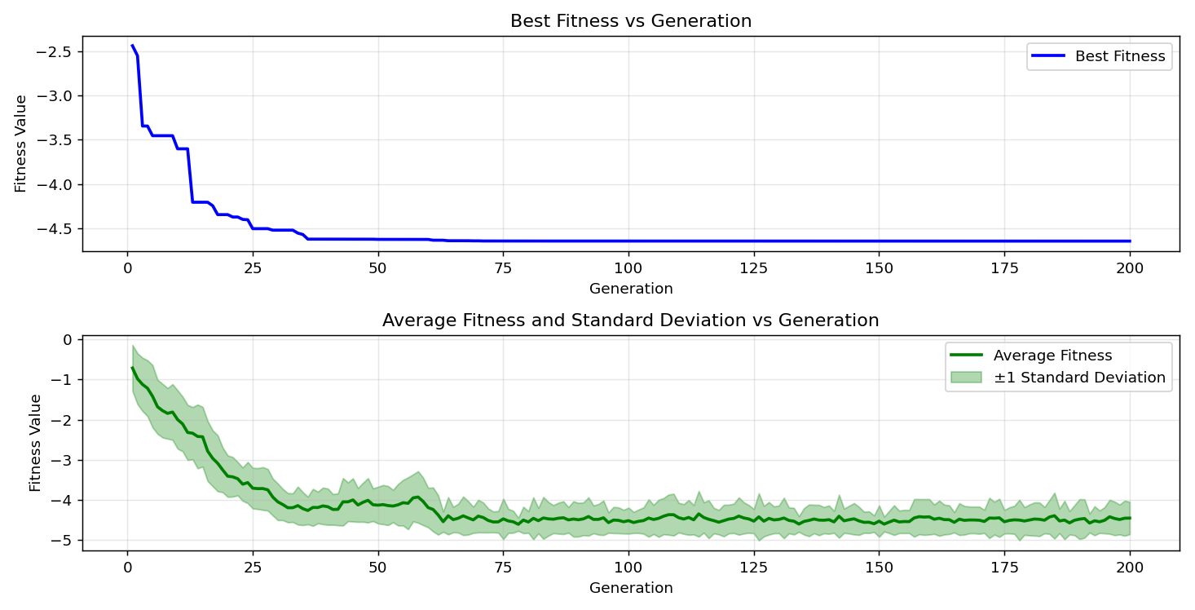

=== FINAL RESULTS ===
Best Fitness: -4.644780
Best Solution: [2.20946989010989, 1.5711785885225884, 1.2857887277167277, 1.1131738925518926, 1.7215452893772896]
Total Time: 5.61s

