=== FINAL RESULTS ===
Best Fitness: 1603.060121
Best Solution: [21.828399028000437, -21.247097648348728, 17.52064482865645, -22.858110513419707, -18.019172992504938, -27.148328109504263, -24.585661779230662, -13.459036161283235, 7.404932275233724, -43.648257762738915]
Total Time: 12.55s
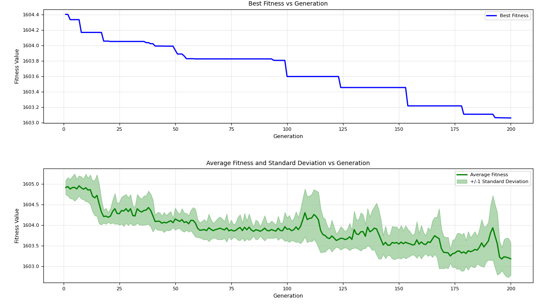
=== FINAL RESULTS ===
Best Fitness: 1603.206279
Best Solution: [3.13616170130238, 2.106327598959591, -12.281666238637403, -30.812382129079573, -20.431477537874002, -27.39138126473575, -35.69723568109627, 30.657682658318326, 9.096932193186444, -2.146626983354989]
Total Time: 12.35s
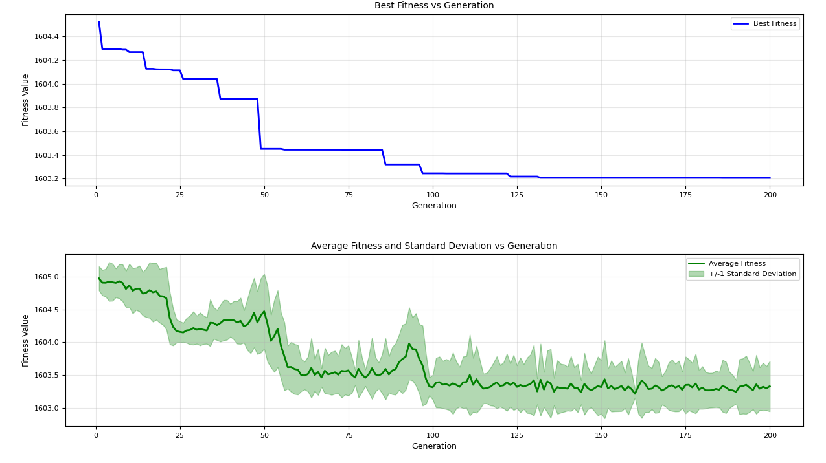
=== FINAL RESULTS ===
Best Fitness: 1603.285998
Best Solution: [-5.561952910619462, -15.768431384286727, -17.371710404178163, -6.837692381657716, -52.331834004756374, -7.032152730120915, 51.151902249160294, 4.231649035522596, 4.482713161590539, -14.420644840529057]
Total Time: 12.81s
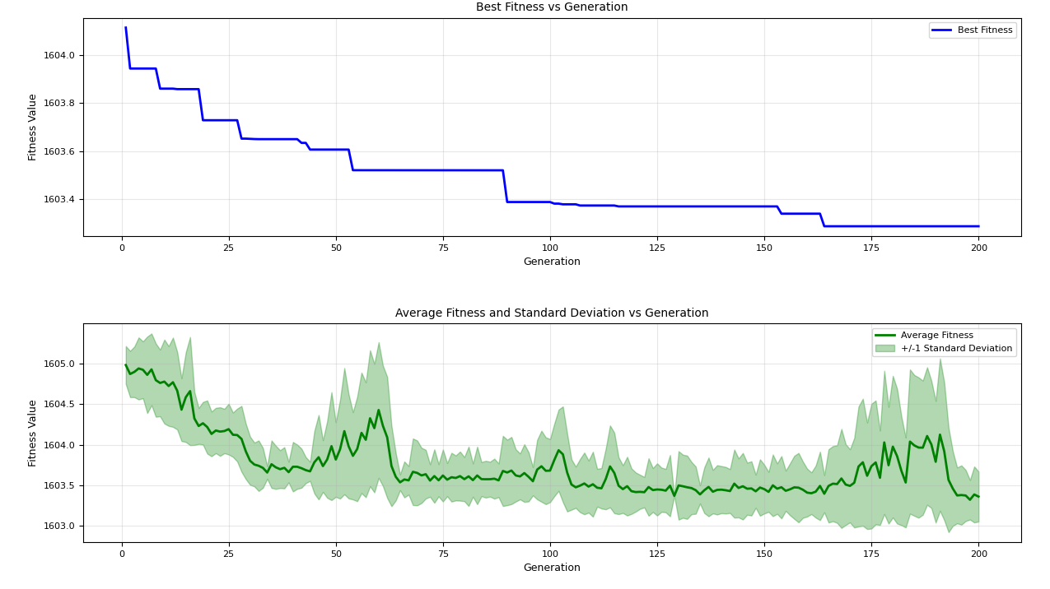
=== FINAL RESULTS ===
Best Fitness: 1603.297365
Best Solution: [-17.354744519049422, 51.88920359909057, -30.06093407308535, 6.343793107621661, -31.789864895719568, -34.27072627791304, 0.3124491230059965, 25.621756031851607, 28.132420931287825, -0.7792798512004834]
Total Time: 12.66s
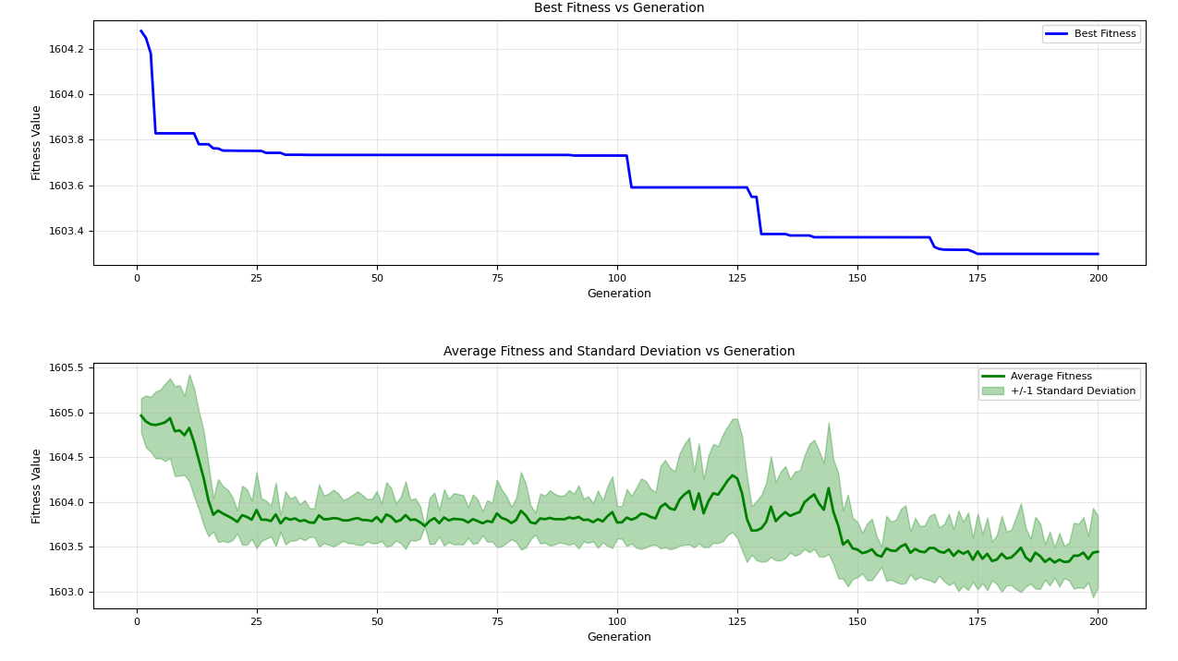
=== FINAL RESULTS ===
Best Fitness: 1603.233318
Best Solution: [-4.192088621569911, -40.554072644468256, -1.7560503946925952, -42.397332159399134, -25.510947667166917, -8.308424477441173, -9.979272166411791, 9.484861755456455, -6.34945588357318, 13.632031981772625]
Total Time: 12.40s
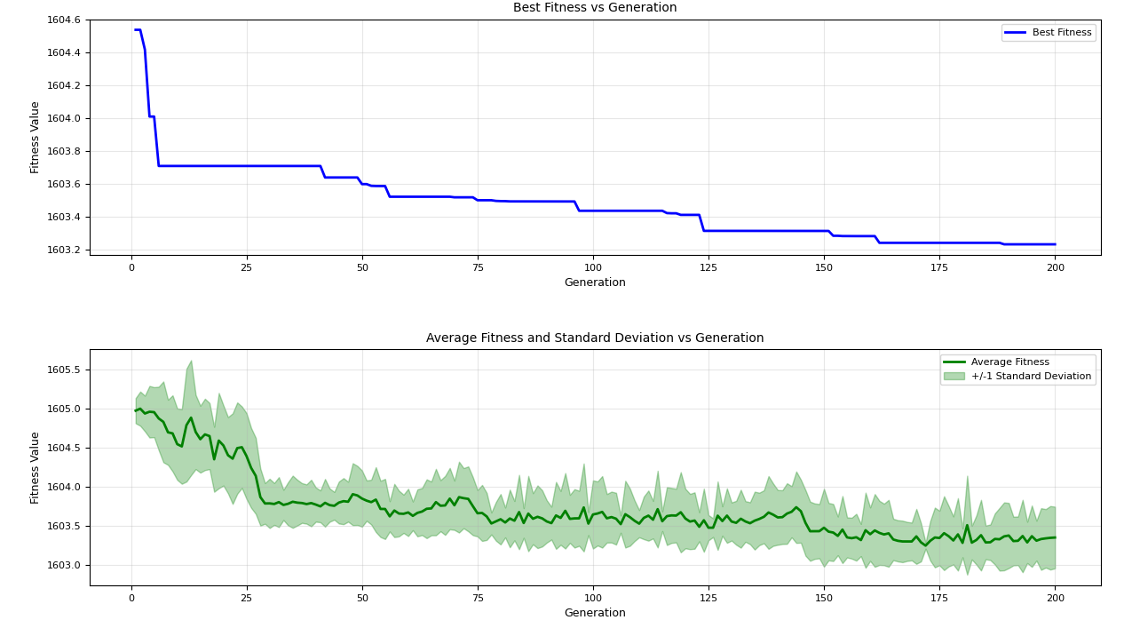
=== FINAL RESULTS ===
Best Fitness: 1603.143391
Best Solution: [-25.013785765158055, -53.08983675198154, -60.20893416012086, 17.426145192162604, -24.148010259499625, -36.30331198921919, -7.279375237751273, 74.24218971789449, 8.33037587793433, 0.7043243852233159]
Total Time: 12.38s
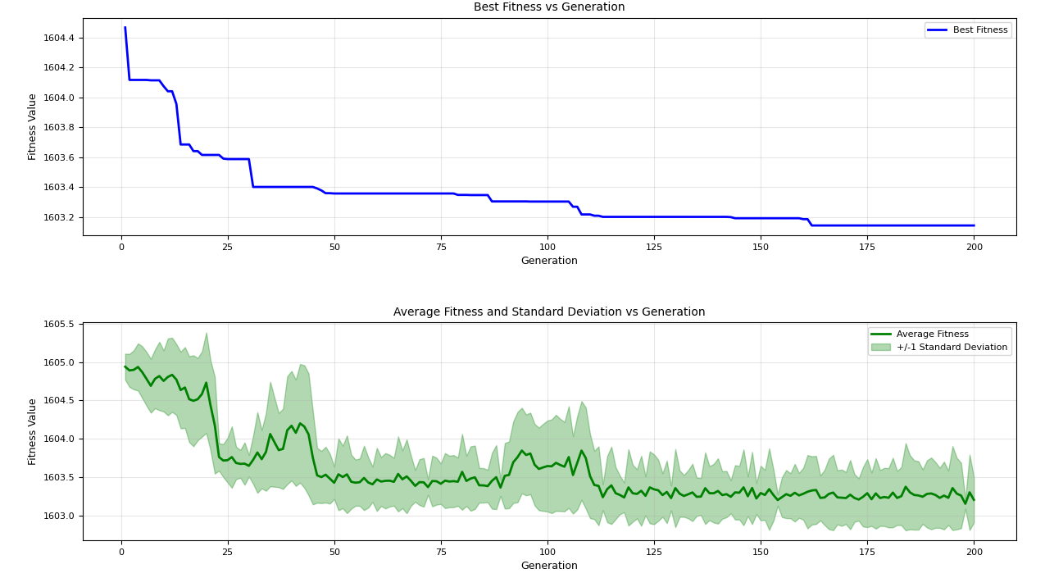
=== FINAL RESULTS ===
Best Fitness: 1603.011407
Best Solution: [-16.38082465756865, 1.4164252964969481, -5.922202861881939, -47.63184695631344, -18.01260151464341, -21.604123286707903, -21.85141192635215, 11.534306440803846, 20.863795603981504, 13.35477278509217]
Total Time: 12.31s
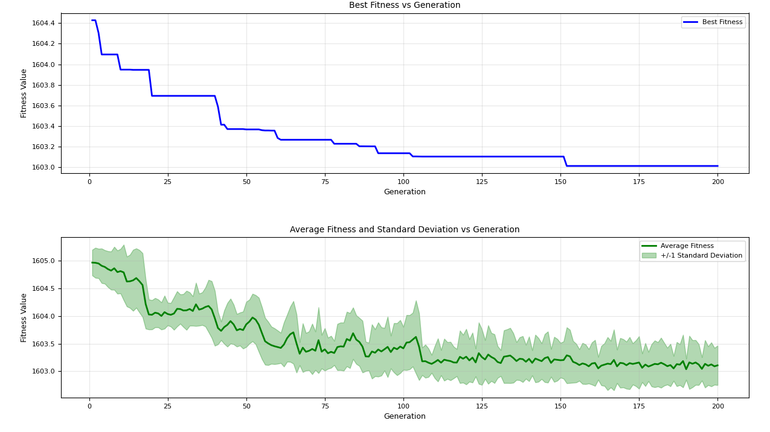
=== FINAL RESULTS ===
Best Fitness: 1603.726609
Best Solution: [3.479971914308873, -45.34402548460679, 0.3292123962960464, -13.371484460457683, 41.53290389341094, -32.76976445065563, 8.710353609759949, 60.31141334766801, -19.8259608099565, -17.514079609995562]
Total Time: 12.83s
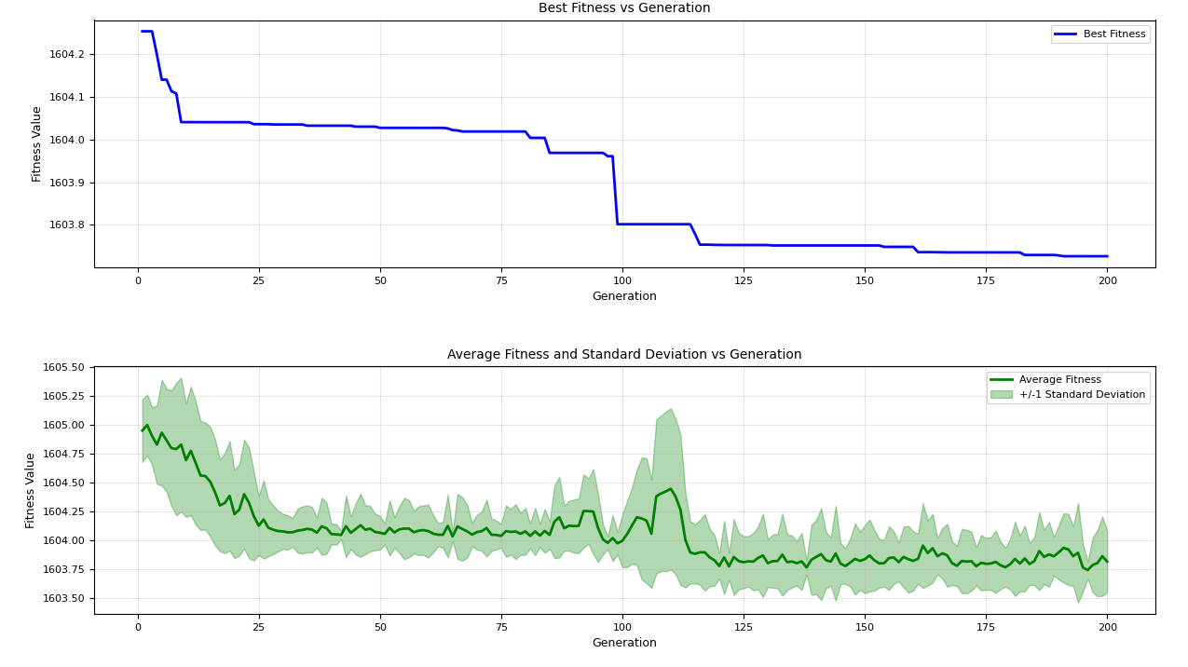
=== FINAL RESULTS ===
Best Fitness: 1603.494552
Best Solution: [35.34501747890441, 8.365305587602007, 23.647476159100158, -0.4462676283212207, -34.05122150673958, -4.594235553456203, 9.232692098342913, 66.77261023376717, 9.367449439707801, -56.70379349900928]
Total Time: 12.39s
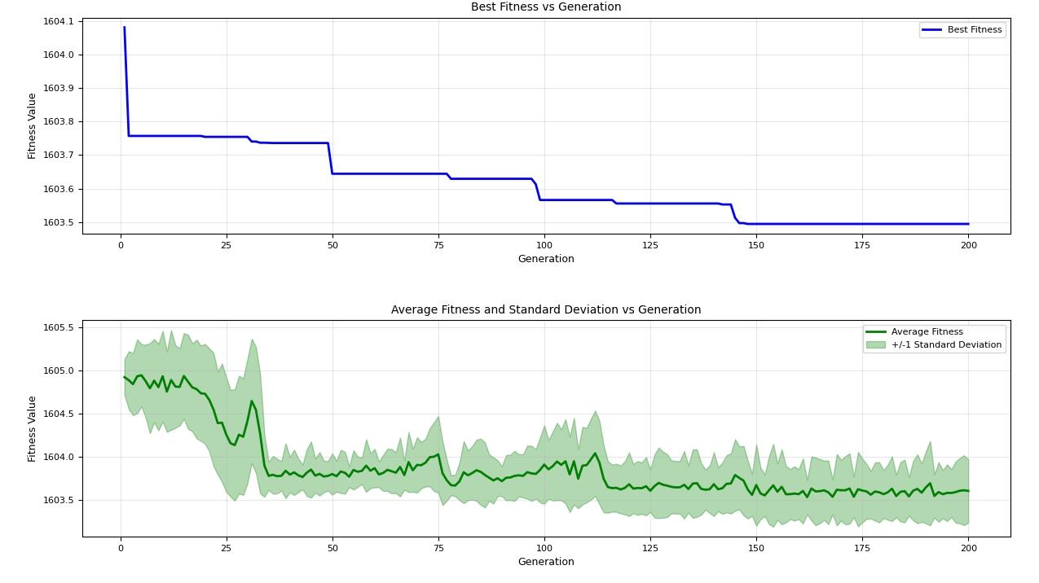
=== FINAL RESULTS ===
Best Fitness: 1603.450221
Best Solution: [-35.48288074880346, -5.895460241841299, -30.129533961887155, -17.177556696223867, -31.38816786248891, -14.84773464772686, -34.407220542813164, -14.81961366534679, 55.9937378735956, 43.14013322643555]
Total Time: 12.54s
