=== FINAL RESULTS ===
Best Fitness: 1607.157808
Best Solution: [-18.104358329172697, -8.130966786454037, -24.448788498246728, 31.859210341020248, 57.15431933027487, 24.508247485355742, -6.446477758773156, -63.821875885982585, -8.628336160993758, -54.95228504066359, -34.835402587277656, 48.80765517855704, -68.02361909204059, -1.7645815051213742, -55.049904313400035, -31.25429589402362, -21.094204453229153, 30.667843120294123, 57.77356095791151, -45.83227594437509]
Total Time: 15.21s
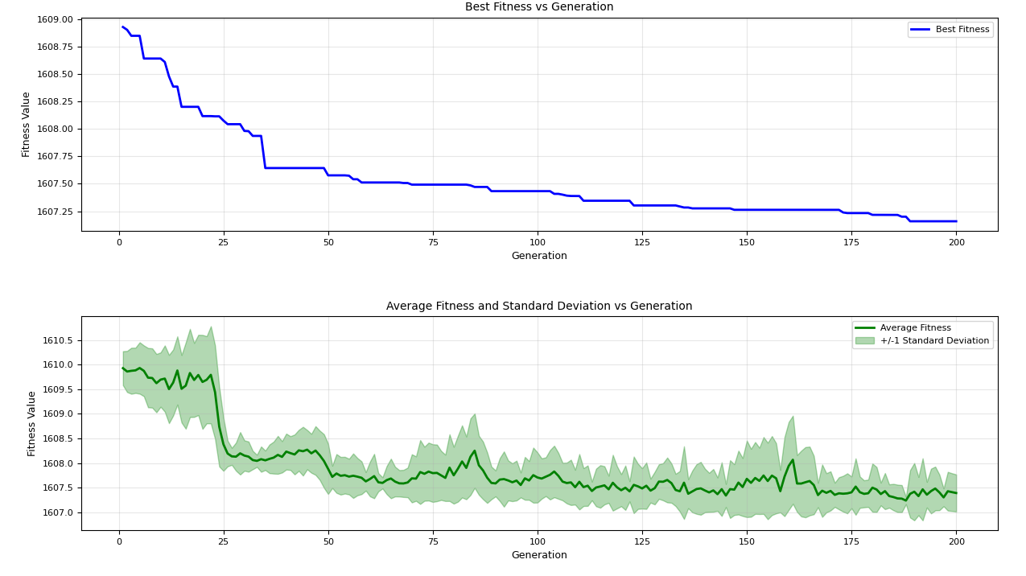
=== FINAL RESULTS ===
Best Fitness: 1607.445378
Best Solution: [15.736616691081121, 31.07718243709557, -44.442774258898936, -16.45479438622984, -17.98747629514133, 9.218902913827796, 1.1977207753052355, -18.375212069675836, -3.410607100076039, -29.54139065845384, -16.47703954785972, 37.715076494813886, -54.819399076836945, 22.740552405935542, -33.167243298108716, -24.60033069481072, -29.24562790147489, -27.874403559295864, 27.533162445003217, -12.258248575676815]
Total Time: 15.31s
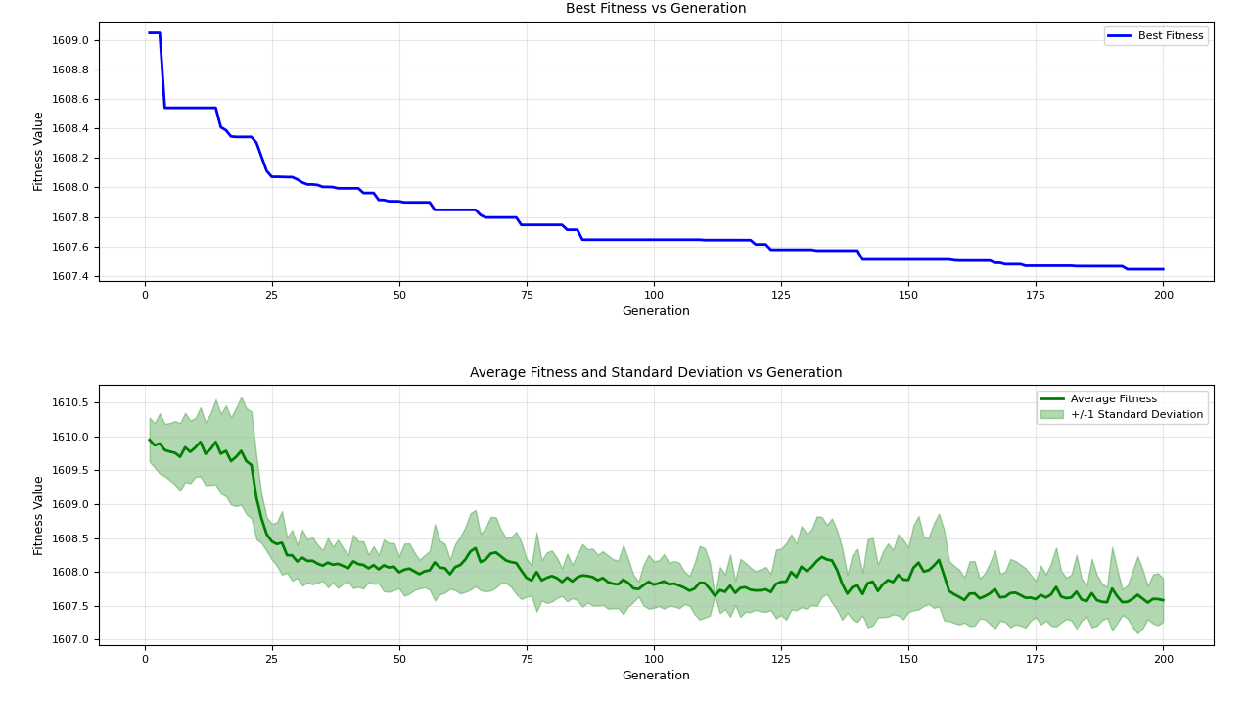
=== FINAL RESULTS ===
Best Fitness: 1607.024488
Best Solution: [9.629856936246528, 30.09240928026062, -17.29592686505466, -8.177003797975104, 2.2773419963052226, -2.0319043819323013, -3.2099364982781715, -41.42608294087708, -9.911277042205324, 21.466590409387592, 26.865894453118493, 34.72757217425212, -21.88168485855006, -6.914698675032655, 27.110352561060473, 9.708437903894405, 28.292017901597205, -35.51777458937978, -42.17006658303684, 0.40513062996504634]
Total Time: 15.42s
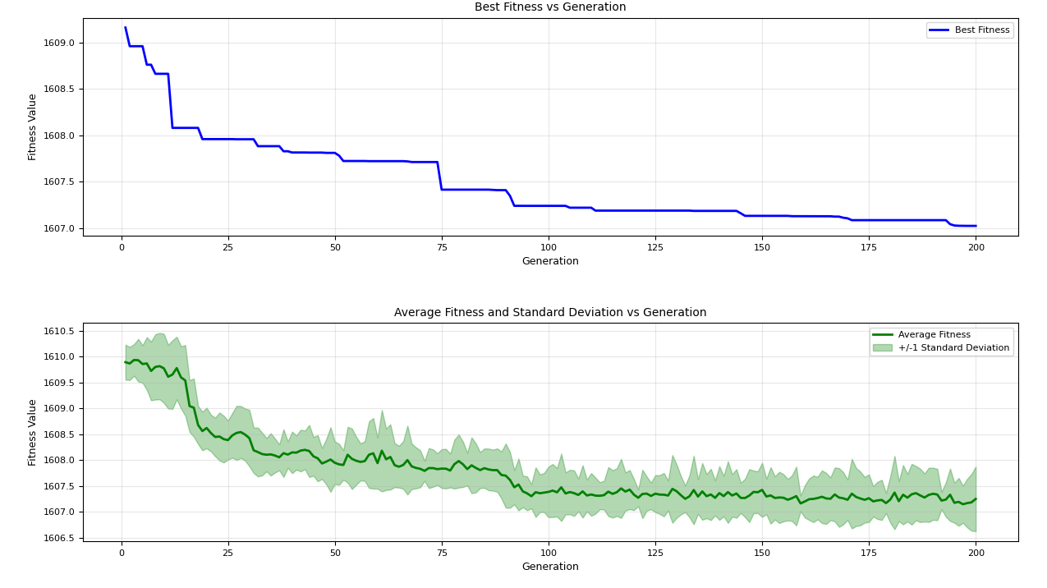

=== FINAL RESULTS ===
Best Fitness: 1606.915688
Best Solution: [-10.560821022338686, -39.9983415808494, -31.798145620036436, -12.443629062408505, -33.12862376713389, -12.568545747727782, -24.46485545916825, 10.54453072009516, -44.69439247873211, 7.350976806985618, 1.030931571633305, 43.21482692263264, -8.653428658731162, -39.82395306041032, -65.38096486644616, -27.783242959931314, -17.43797324017526, -21.476455917658964, 14.600189050261445, -18.824281924542888]
Total Time: 15.37s
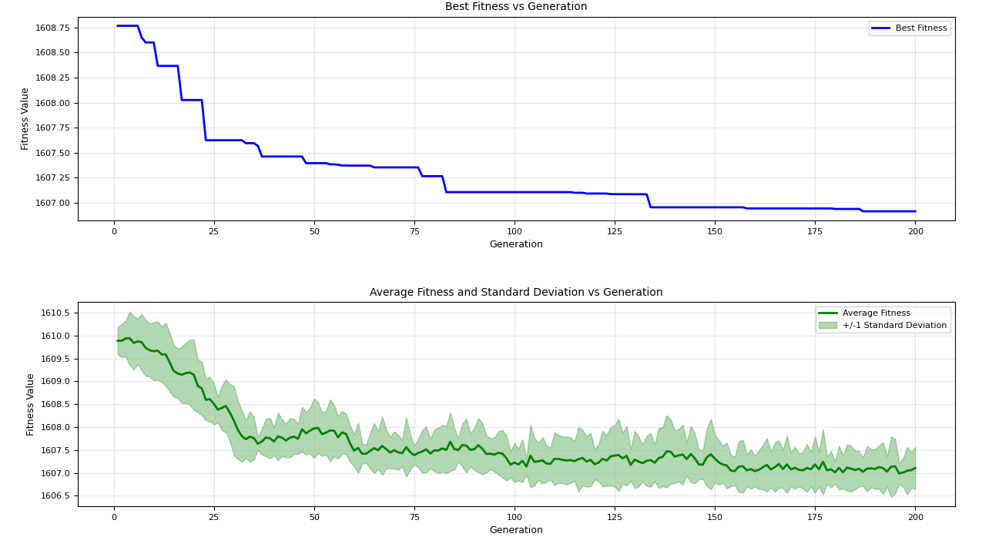
=== FINAL RESULTS ===
Best Fitness: 1608.013447
Best Solution: [30.162887251839642, 11.00304058550211, -19.277671171444688, -5.071987835065462, -35.24495551751662, 29.95249368545178, -6.145966690296403, 11.48447667388266, -4.921081480171097, 21.68556155058176, 19.126127783702128, 21.140236644211775, -13.552054877343839, -4.457460378454675, 16.939123839049532, 0.17048942301066994, -6.553297669227695, 51.141589871409565, -41.37867493624481, 20.135684281789878]
Total Time: 15.49s

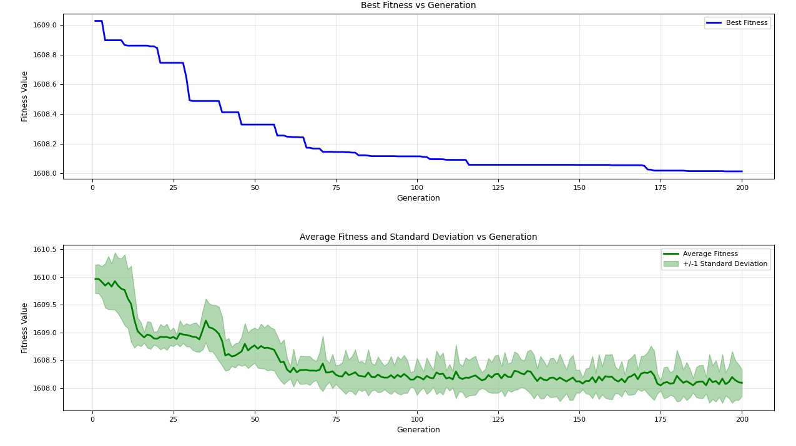
=== FINAL RESULTS ===
Best Fitness: 1607.682609
Best Solution: [7.270810122904654, -1.091084123119021, -0.8439211014393243, -14.849409012018931, 17.583024965480874, 8.72733550501622, -6.618978564337431, -30.595380402417113, -5.990743560106071, 23.528338793826606, -34.377645620028595, 8.944308462403264, 15.147327179981838, -14.227159638420698, -15.622490404272881, -27.91178812574929, -7.258472778211531, -21.243365477635518, -20.864451309626443, 24.4318641485362]
Total Time: 15.27s
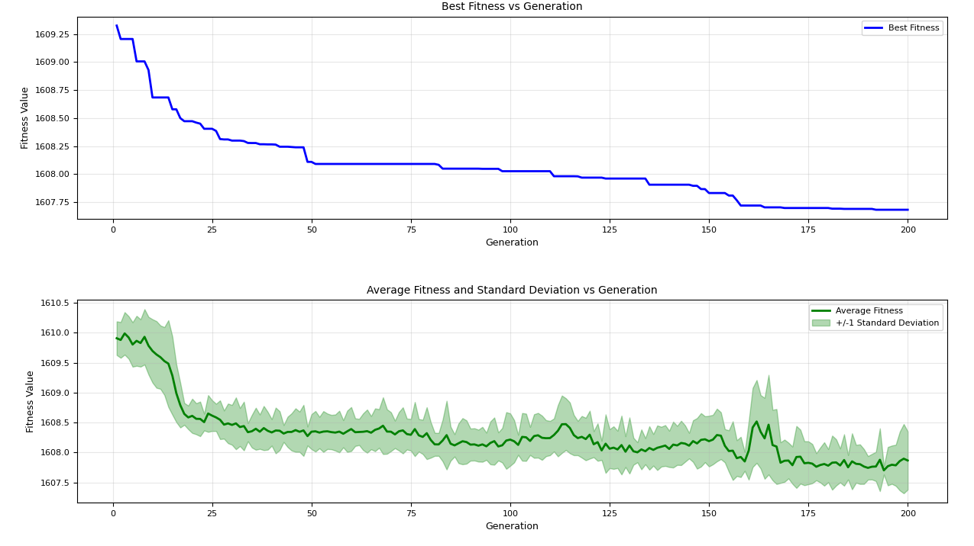

=== FINAL RESULTS ===
Best Fitness: 1606.591508
Best Solution: [-51.55145056315142, 1.9174949456251305, -4.165750776807881, 1.0939479572262645, -41.76795386660481, -16.484161312329178, -14.735350926850515, -23.313780123362005, 23.87889558042161, 22.409647093884253, -37.14734417713569, 49.95023053031424, 6.8184497194049545, 21.1159491887346, -14.505035334696693, -5.975929705802203, -22.509729092771728, -38.535041239478055, -51.32894190947195, -32.94423821663092]
Total Time: 15.23s
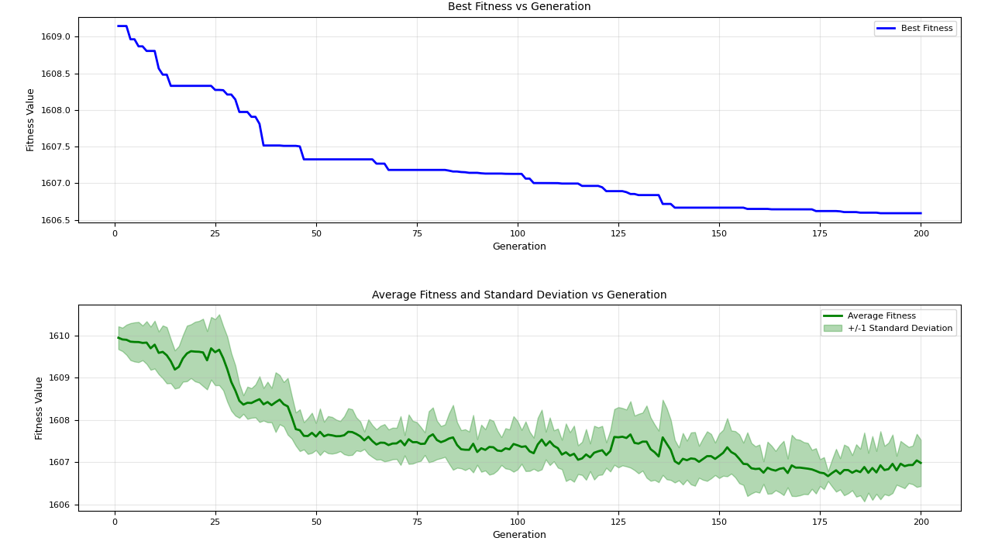
=== FINAL RESULTS ===
Best Fitness: 1606.787436
Best Solution: [-51.17281730284595, -51.801501835384215, -79.88982037567621, -35.96327399687446, -17.521118363505497, -37.24469301457629, -14.057791849772634, -70.51644217945548, 33.12154263988445, 28.47942676228913, 35.79214363671964, 30.390498466138897, 32.4819216951157, 22.552628946130394, 14.218388330791612, 29.573101776051367, 20.9589570444668, -6.902554120143025, 21.83064648590868, -90.22007532061514]
Total Time: 15.30s
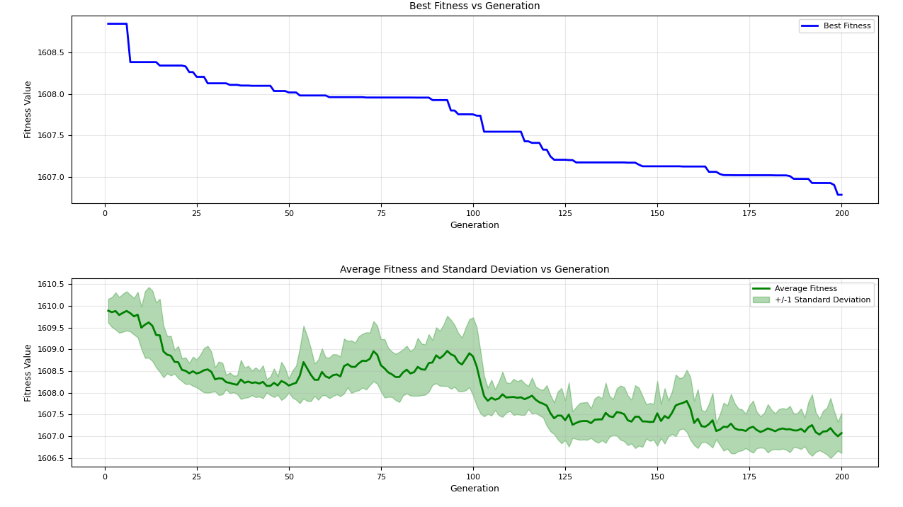
=== FINAL RESULTS ===
Best Fitness: 1607.227177
Best Solution: [-36.78128171886179, -35.684173077001255, -8.180056468848719, -20.760884349635866, 0.6409381234106242, -21.070301347075272, -21.956532845809697, -30.922842434437534, -2.0517817954987088, -28.20248916636452, 22.78190040418468, -7.784394974691832, -65.31566375427482, 0.9473527551734637, -38.63654089232041, 33.25575935647877, 0.43760986778025185, -44.68677465394679, 18.953454672125133, 0.3147402609493119]
Total Time: 15.04s

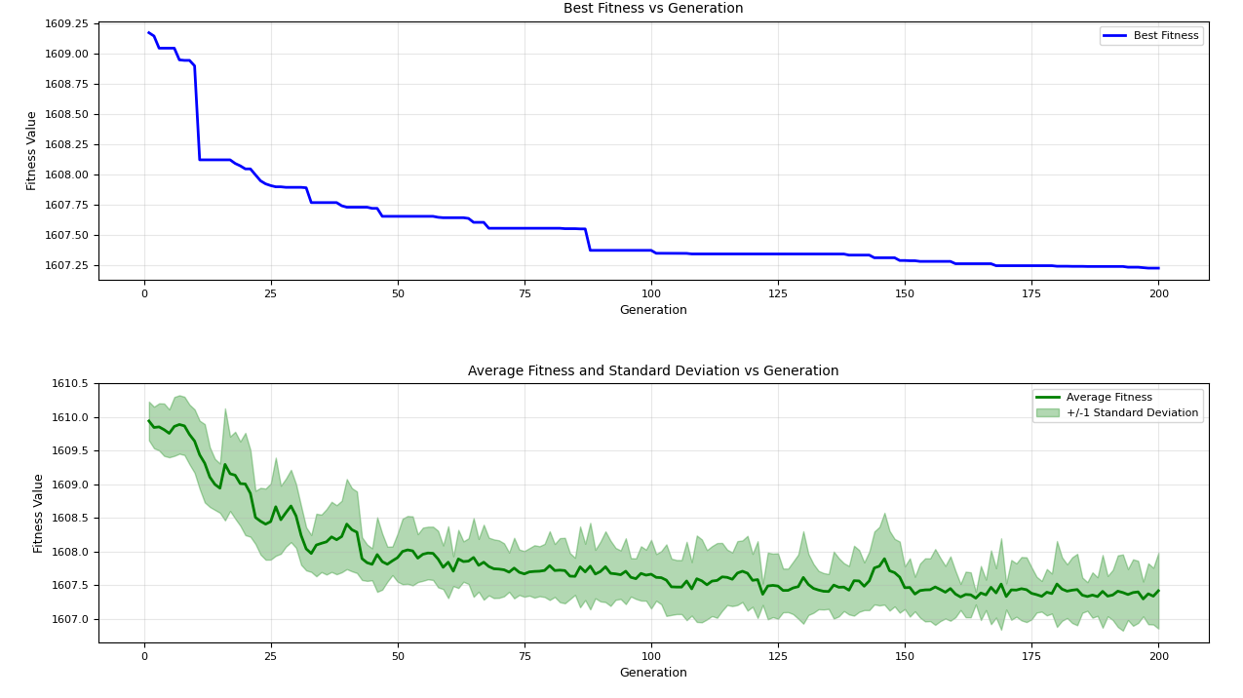

=== FINAL RESULTS ===
Best Fitness: 1606.897218
Best Solution: [-52.189143204526744, -20.25924627418228, -50.360890578971286, -11.062106919455928, -75.33805196141262, 1.9318471338699756, -13.931041107218341, -55.20412564433762, -43.09325309373274, 10.999062258811202, -7.1715528522969265, 8.483126482046103, 7.761886765930272, -55.601585127793484, 7.972080011688217, -19.684840874961303, -84.52008296892542, -48.389858809546915, -89.96652680143319, -67.78677561946981]
Total Time: 15.45s

