=== FINAL RESULTS ===
Best Fitness: 1612.277207
Best Solution: [40.71109779057039, 28.479078159428877, -13.779148574025768, -34.791498444243466, -7.520581453984372, 13.318480858748, 4.957926281389144, -51.26550650133472, -11.826327502167334, -25.992404004828707, -13.61730140376002, -5.99236108268861, -6.148257060477027, 14.414154512813635, -57.38176891247946, 37.96898757035682, -14.96129358830268, 1.9325335954156109, 22.12384862624557, 30.32560398394373, -15.816408581745646, 38.5771367814789, 38.197386975007305, 0.36433388789358834, 4.206847924901585, 64.21943075008464, 0.49835114196776015, -8.068670043367316, 35.5457578210309, -8.396507450369722]
Total Time: 18.56s
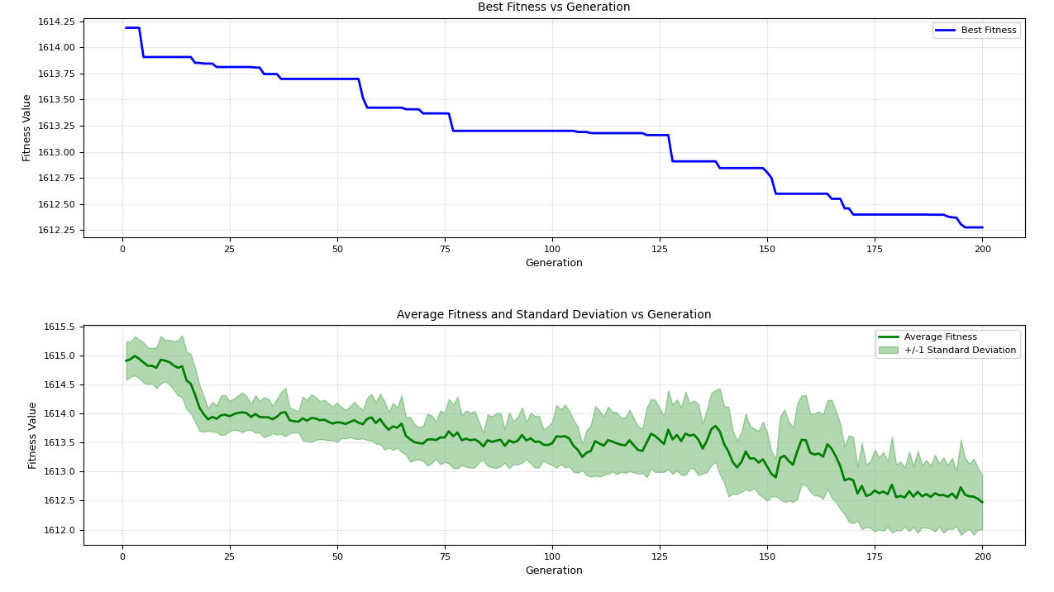

=== FINAL RESULTS ===
Best Fitness: 1612.238141
Best Solution: [-1.6266407304310098, -16.63618828627947, 2.804585021247446, -8.483274720885355, 32.49055954564526, 5.912157907470327, 10.396534423133486, -50.29217146853278, 30.705066055026247, -12.939161491891898, -7.8353860806358036, 9.032697622268673, -9.04071270396173, 25.504327969157757, -13.899510461303269, 13.84435996564681, 31.25303865760855, 13.053351750051192, 3.3893539826893053, 8.042373544225892, 23.186059471856964, -0.8291469035068211, -11.98070241157464, -20.970899175885165, -35.538887681050184, 16.98701645952336, -3.6488767767399617, -18.500727323607137, -6.311916008659654, -26.62831261003504]
Total Time: 18.77s
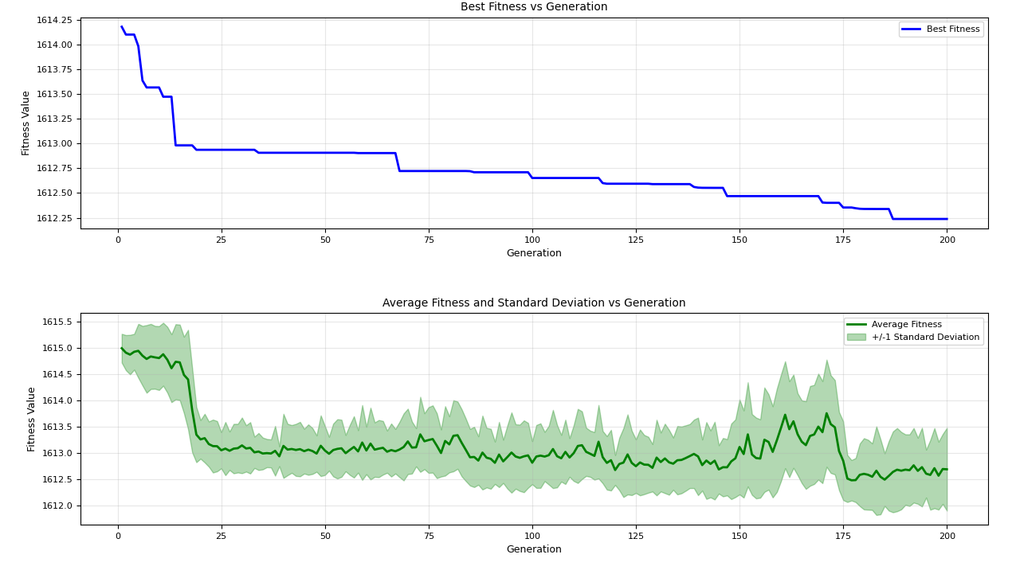
=== FINAL RESULTS ===
Best Fitness: 1612.397338
Best Solution: [-26.294573442173135, -3.237964288444243, -1.855588020433704, 9.570600914861405, 27.890865813469134, -34.43893719313907, -15.197573627386273, 4.761736006711215, -40.38853799061892, 5.544810750249056, -16.760482172350486, 18.660957269968552, 5.37128054942808, -19.818277642506057, -7.809861043229218, -8.355542211115504, -20.144337938806203, 3.7536022978555277, -18.84169754098677, 31.473373033174077, -6.725312974003012, -0.5739871870019674, -12.875751719806866, -17.259760987369116, -13.62071738420369, -7.282090713877155, 25.19890695373474, -8.932303743307436, -8.325834711652703, 0.22551734633398368]
Total Time: 18.50s

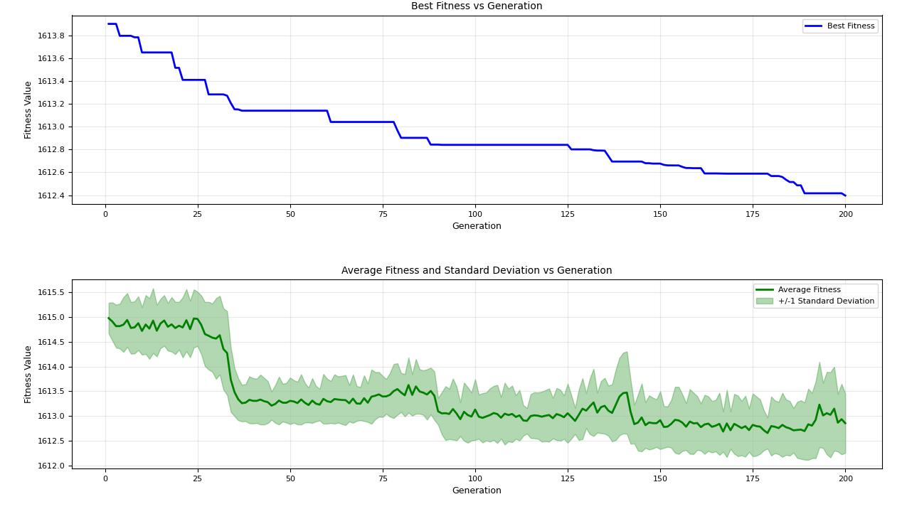
=== FINAL RESULTS ===
Best Fitness: 1612.816193
Best Solution: [7.594173376870582, 15.911851528100973, -0.9550188675607054, 17.788948855403277, -21.3066052757449, -6.543647658808478, 15.07251701538272, 2.4745658814302116, -19.04019918733353, 11.464135994563613, -10.303086801758372, -12.20693739835179, -31.32960871533618, 4.909520040487453, -17.27976155573414, -6.393054194198248, -29.76390229969765, -33.517153875910616, -27.104552717201464, 12.510705562365544, 23.4496205840109, 9.639162602600251, -0.4543610731088332, 20.246679314283266, 31.370388491727553, -28.414055077836665, 31.530267326382045, 17.592370927999283, -1.947770236315228, -2.4811763045838857]
Total Time: 18.55s

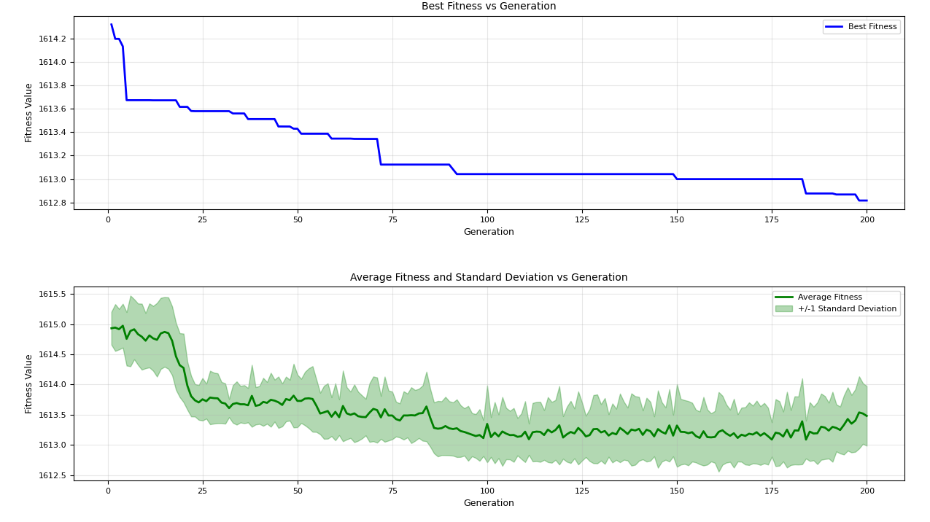
=== FINAL RESULTS ===
Best Fitness: 1612.519742
Best Solution: [-23.75909404582358, 1.843636972216435, -23.317687951232102, -43.813995398895976, 25.50718167015988, -10.271520677392086, 19.248207497621934, -7.112078000567775, 11.77731126407772, 10.035754685482587, 24.324816253683686, 31.162290727352296, 30.767756274807763, -23.175707883953848, 9.220020988198439, -8.024523746392129, -7.0683581865149065, -13.993438373427367, -28.26723709441515, 2.510178951360938, 31.74658258044922, -29.522782100443273, -15.337538449581281, 9.802141551060037, 53.429974045012024, -5.651624559238956, -4.181984081980714, 57.364140837503385, 5.47663171391633, -41.31164987332569]
Total Time: 18.54s

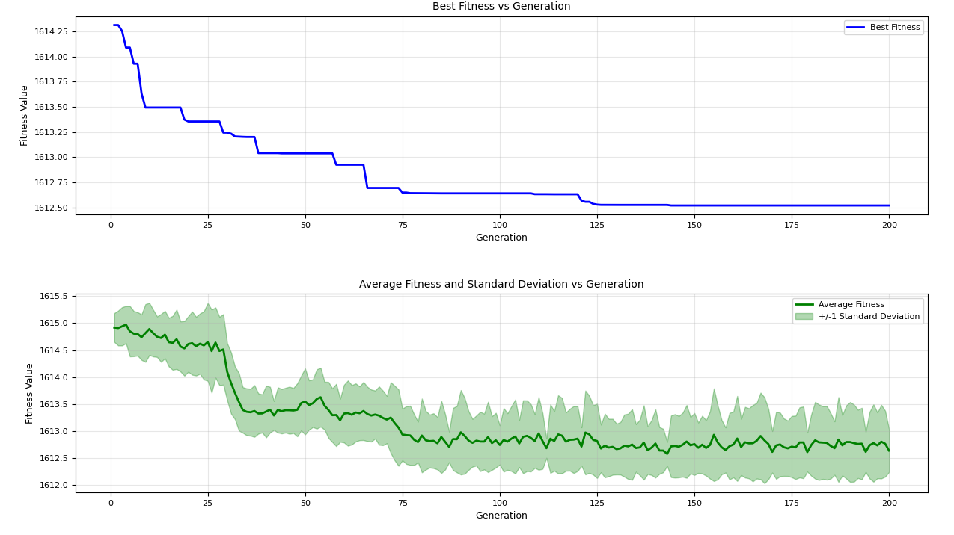
=== FINAL RESULTS ===
Best Fitness: 1611.145491
Best Solution: [22.23999459451506, 40.98656836931403, -7.507420666837767, -41.564016316350575, 1.2541989977477959, -5.4338817996710524, 21.227184608096493, -18.15715714379777, 0.985874257745052, -6.915566261277088, -16.08879593839515, -36.14920280162701, -39.29296799802642, 27.22417255326635, -7.758239881996403, -8.60758942073169, 25.736321368634272, 21.48493340202393, 52.37329614229116, 16.356376958509774, -5.337307626772881, -32.93951037846538, -20.083936593446616, 19.84942197508136, 14.874035428416754, 5.2137797108504484, 9.486685144330137, 48.36620733718044, 17.423581398755122, -29.77849679057401]
Total Time: 18.43s
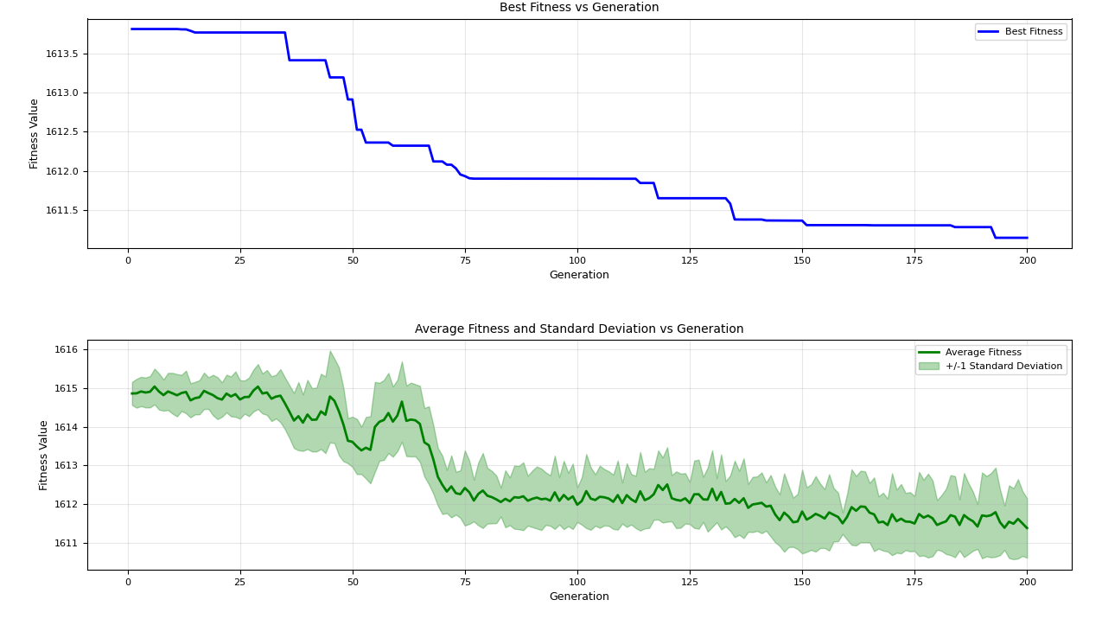
=== FINAL RESULTS ===
Best Fitness: 1612.010790
Best Solution: [1.0123014513662754, 5.3885060086338985, -39.68168362405424, 1.7670146516601004, 0.18743689835529315, -9.263027170299662, 6.392893999509992, 7.253830309564284, 15.426358089386781, 16.071682330986455, -24.00080958221704, 0.6521249311382737, 2.1981303587811483, -14.671144662423444, 0.20122842582986328, 1.2355816907487807, 8.201594729322132, -3.7485471810369146, 7.485866605996703, 19.533493878659982, 14.531841171178542, -17.035334205979677, 36.505074693903936, 0.31251200836298415, 2.0224884272333457, -7.290431598540416, -19.934138681550685, -3.0023251798779276, -2.7657720460227346, -29.933329747559156]
Total Time: 18.82s
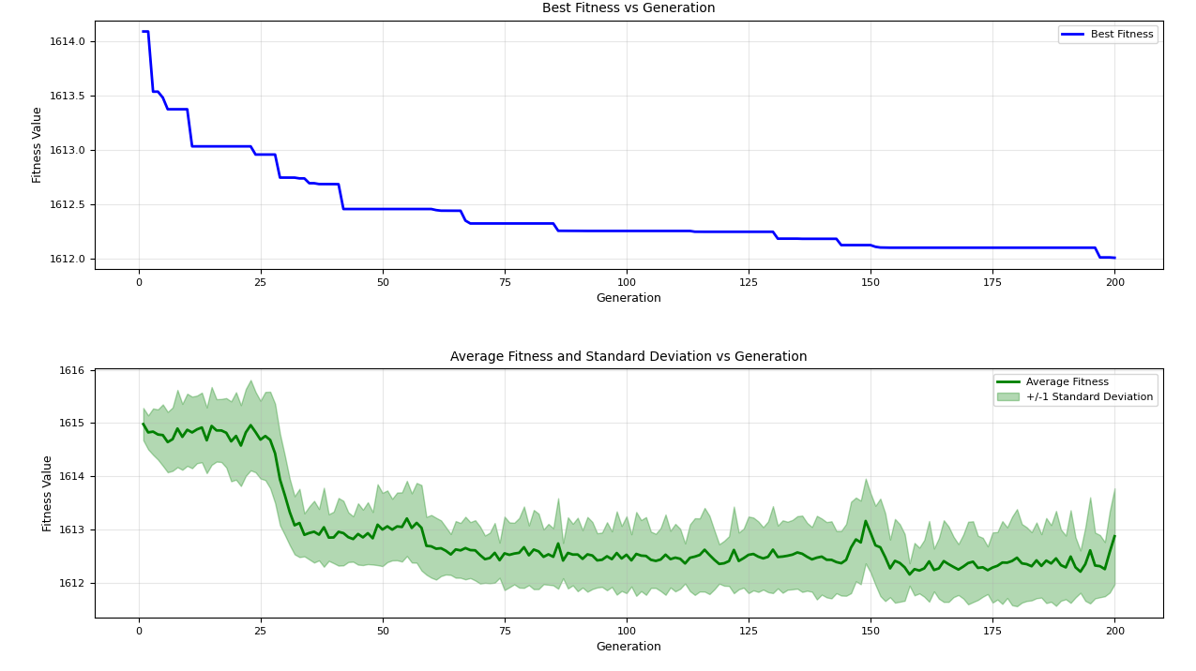
=== FINAL RESULTS ===
Best Fitness: 1613.315720
Best Solution: [19.259466408901222, -34.88955420482955, 58.26801793115783, -58.468723440526915, -63.22035086979094, 86.9665448745003, 12.647361253058008, -72.6823173218782, 52.7816023910587, 17.078694538773888, -36.21416017145034, 89.00585744363272, 46.960836757025035, 66.77806995417322, 0.7893771838803048, -99.98168161507749, -60.82138196131426, 55.25477634780013, 56.76556258351729, 35.08490358066908, -26.84694804148235, 14.298152327496453, 13.56466285508617, -61.17085427570069, 3.3764248332730205, 30.80696006861549, -26.789991073918912, 52.17903077334486, 1.6527844823103806, 92.44337661710227]
Total Time: 18.42s
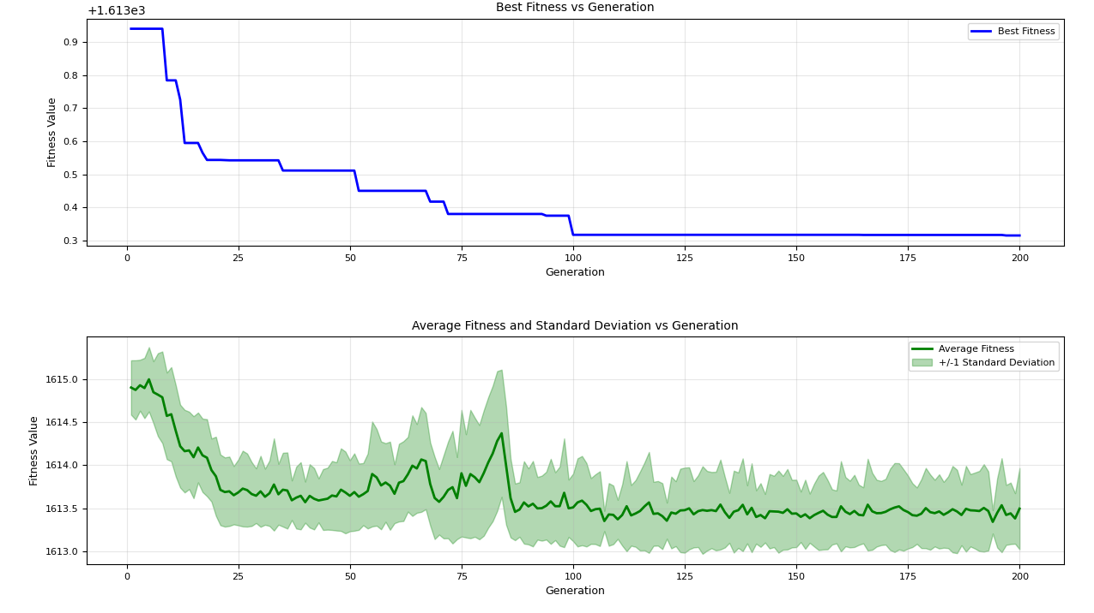
=== FINAL RESULTS ===
Best Fitness: 1611.688297
Best Solution: [-56.4167951997256, 20.19644785240889, 26.01639957041997, -46.2282812594043, 32.6186998386935, -9.051604316099446, -25.826109892181183, -47.5801170002829, 17.14376333163696, -16.69532636778495, -26.588313949235463, 51.357242153317834, -35.077999477728525, 50.263518381567934, -20.723808651729666, -12.213051634679449, -49.11480777366305, 32.66098359394965, 8.385697326337997, 34.58495738042775, -1.367598823586434, 1.2784381578385595, 28.97311103949912, 21.78853012702974, 47.119821625956234, 49.335588716348255, 61.43774964338264, 16.564626092122122, 21.455977180261222, -47.663451582427676]
Total Time: 18.63s
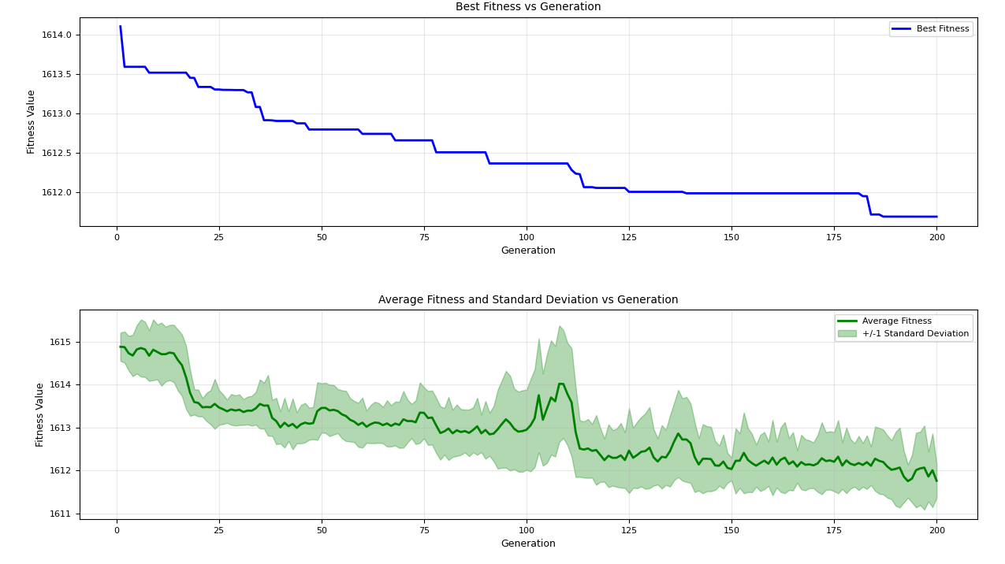
=== FINAL RESULTS ===
Best Fitness: 1612.766386
Best Solution: [25.74304617203197, 12.771361200290551, -25.53783800131122, -5.9137317219637096, -12.666998849102512, 9.526380742848872, 10.220222541349859, 0.6461439040799738, -24.94376650465405, -1.0733655082442721, 28.722985141104672, 21.69907053874003, -19.28806565549586, 21.216927252969157, 1.230913242615471, -20.371011751150988, 11.264783435741972, -18.723740670977914, 41.37338488333968, 19.8744526343427, 25.36211405554515, -24.83737289829986, 15.720175035565488, -16.06777969729267, 8.047676809684802, -8.814565927671381, -3.0876094216834504, -22.005356349773912, 2.466202868834265, -11.681725480015931]
Total Time: 18.34s
