=== FINAL RESULTS ===
Best Fitness: -9.289672
Best Solution: [2.2027232065420623, 1.5543196964762682, 1.271709572574879, 1.113703615756323, 1.7237532344396347, 0.9099149534140692, 1.4598268480568968, 1.3503244802892684, 1.6613336474246652, 1.5712127368412752]
Total Time: 3.31s
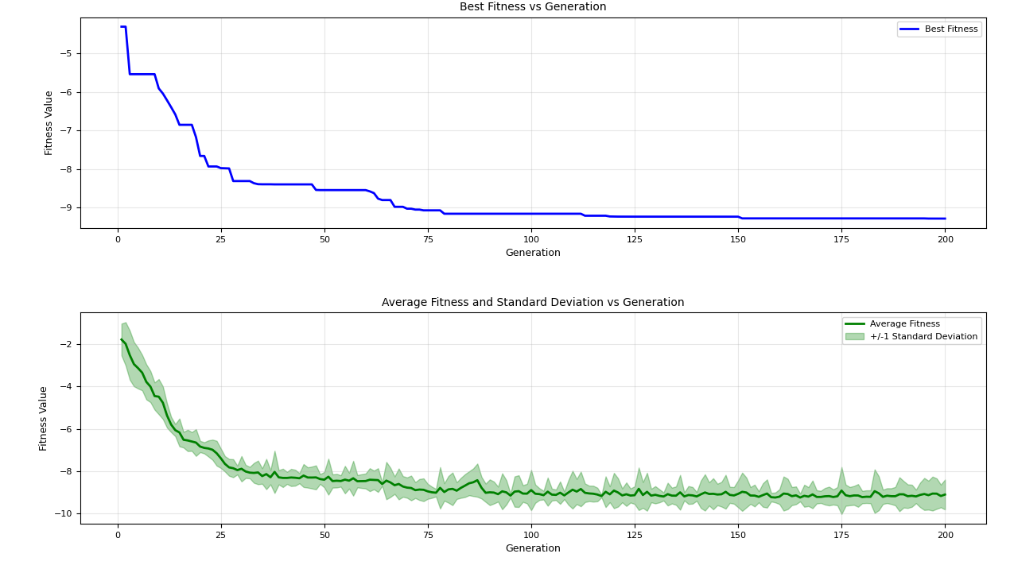
=== FINAL RESULTS ===
Best Fitness: -9.370961
Best Solution: [2.1864406546561685, 1.5637043488167277, 1.289971996810001, 1.124281437398302, 1.725113526504659, 1.564334569458615, 1.878329641086991, 1.7655041463128252, 1.2836613059600572, 1.2188533941993218]
Total Time: 3.41s
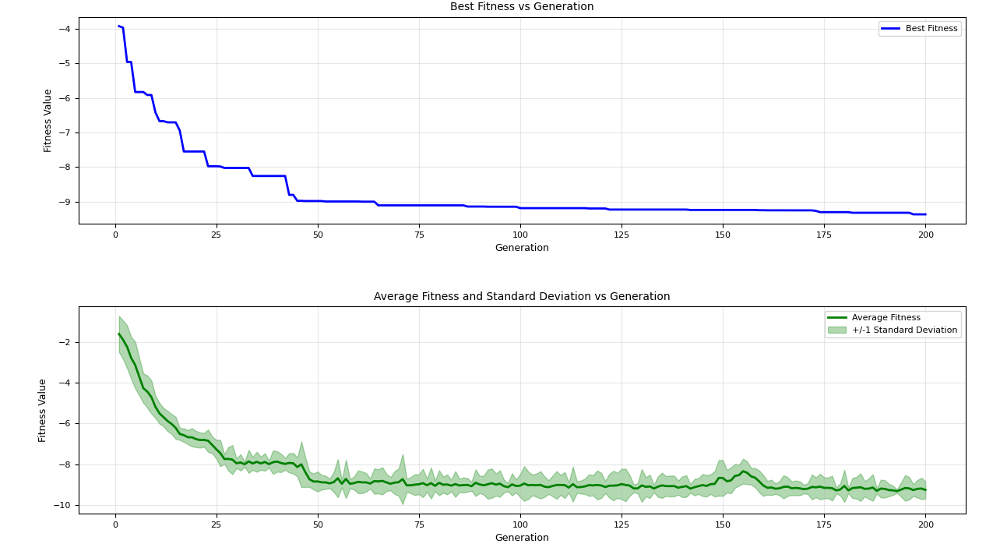
=== FINAL RESULTS ===
Best Fitness: -9.201918
Best Solution: [2.1816332283784483, 1.5758001483199378, 2.2168234242822633, 1.1137642710398863, 0.9952276798792923, 1.5702722585705868, 1.4544317369401063, 1.3580989469456557, 1.65896216749133, 1.2118370712929554]
Total Time: 3.30s
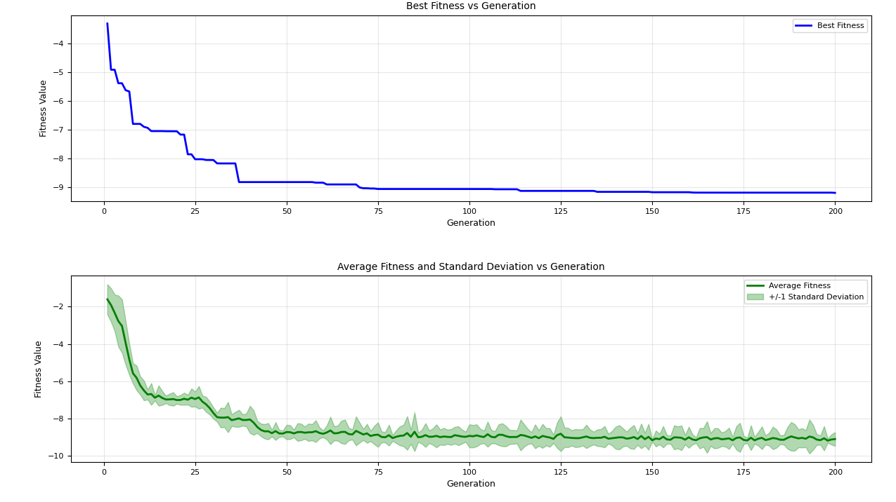
=== FINAL RESULTS ===
Best Fitness: -9.488603
Best Solution: [2.1972422403669793, 1.566261628758864, 1.2868853840622247, 1.9230513583079327, 0.9966766884444784, 1.5677271702326285, 1.4544139638085785, 1.751599924274075, 1.6550961991502762, 1.570032010894178]
Total Time: 3.37s
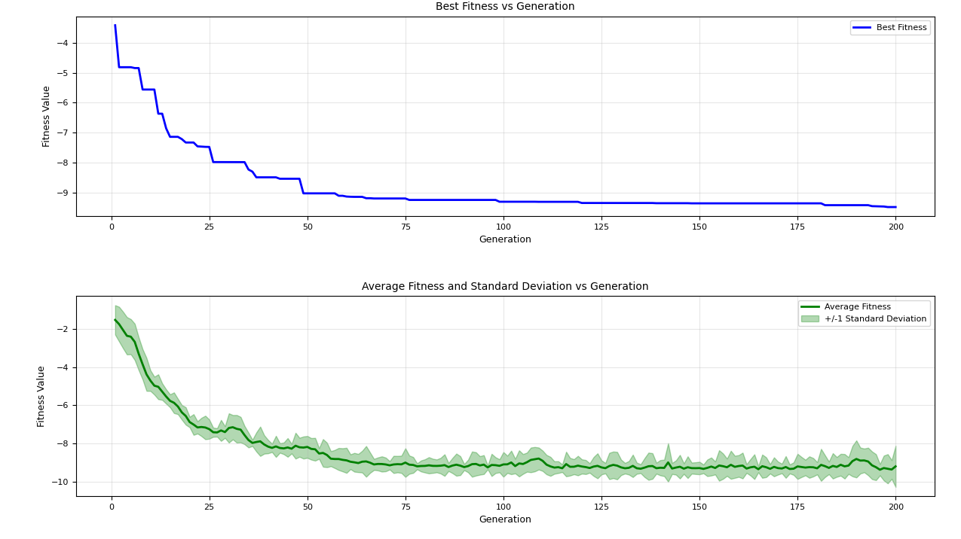
=== FINAL RESULTS ===
Best Fitness: -8.715408
Best Solution: [2.2040100373726115, 1.5707545688063478, 2.2123856463968528, 1.1173807682681651, 0.9852120653816046, 1.5600417568778098, 0.8377749576336145, 0.7899205765245556, 1.657123688544638, 1.5727086957996659]
Total Time: 3.33s
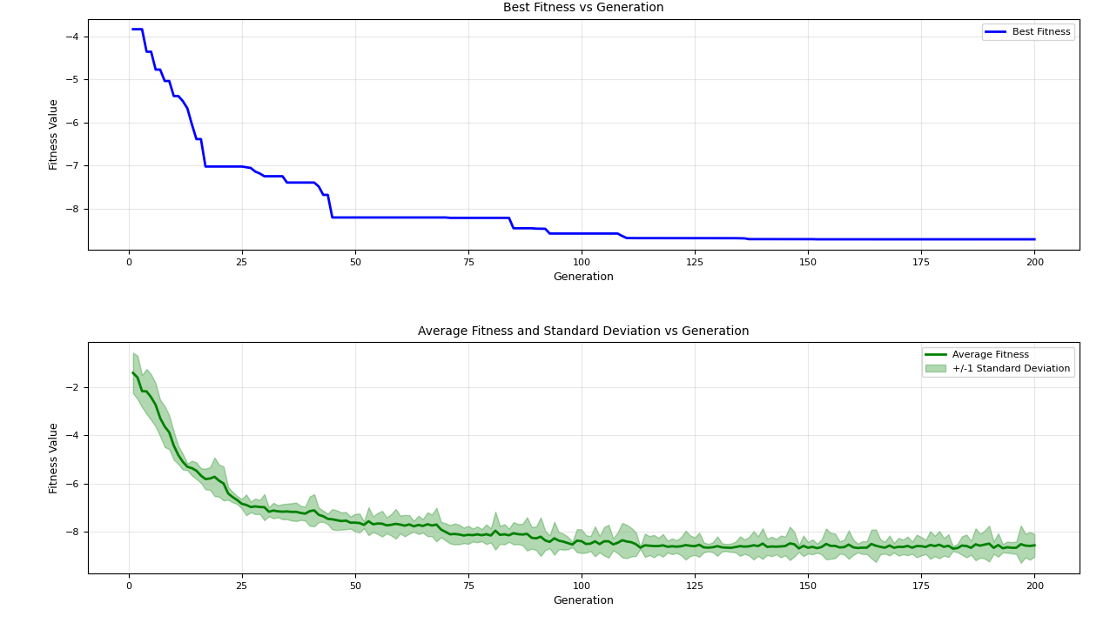
=== FINAL RESULTS ===
Best Fitness: -8.737058
Best Solution: [2.200848298961504, 1.5659182016556854, 1.27863876717494, 1.9084236366931844, 2.2161853888451493, 1.5707960143165378, 0.843507823093617, 1.3715921526565522, 1.6591095699263974, 0.7038508411397113]
Total Time: 3.43s
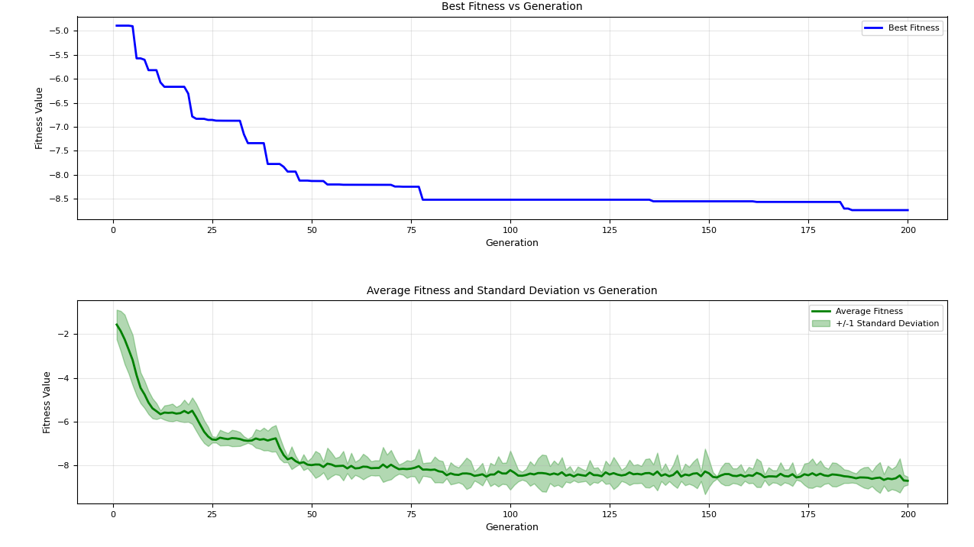
=== FINAL RESULTS ===
Best Fitness: -9.186322
Best Solution: [2.1940897183059747, 1.5743833251416826, 2.2193331849580895, 1.1157551894509998, 1.7146415553945153, 1.5706933970443324, 1.4616348193744466, 2.0752016993001696, 1.2765799892667515, 1.2184975071581527]
Total Time: 3.37s
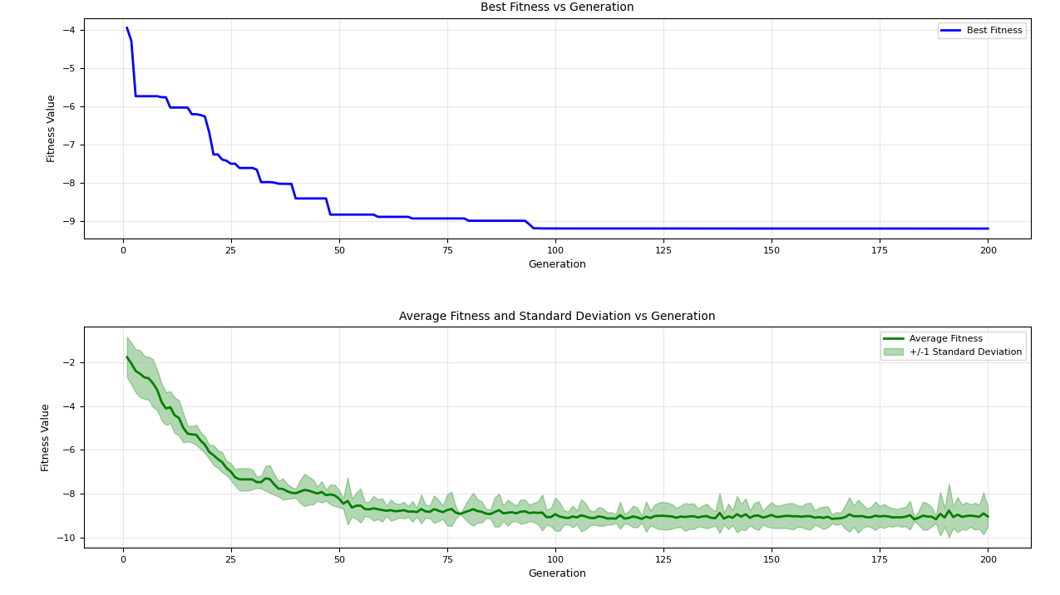
=== FINAL RESULTS ===
Best Fitness: -9.455956
Best Solution: [2.196547741746482, 1.5706088850695488, 1.2834683710509438, 1.1143109500237631, 1.7196835624851707, 1.5708242391685654, 1.8749531163747648, 2.0804870981643298, 1.6543052184960458, 1.5712119347283457]
Total Time: 3.43s
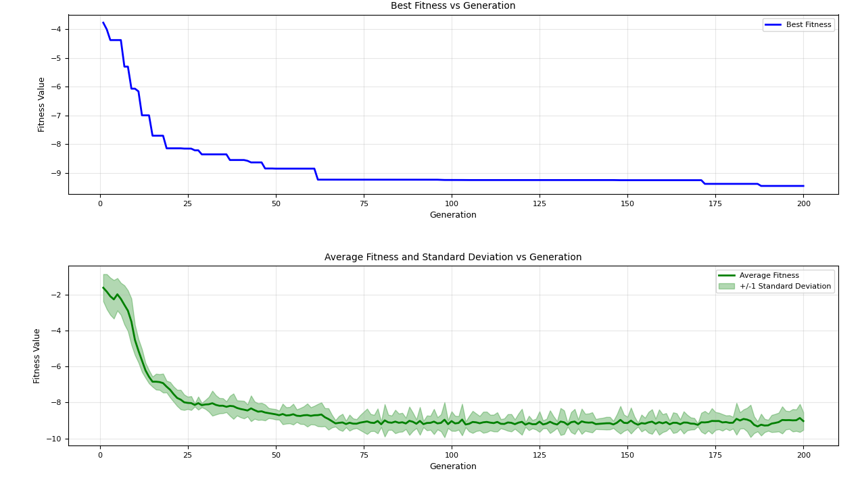
=== FINAL RESULTS ===
Best Fitness: -9.289612
Best Solution: [2.200299781463415, 1.5707963299812566, 1.2849125469791656, 1.1139903377883353, 0.9921924823642887, 2.0299320920283987, 1.449649446588028, 1.364310029544614, 1.2875423444356895, 1.5718573725727203]
Total Time: 3.35s
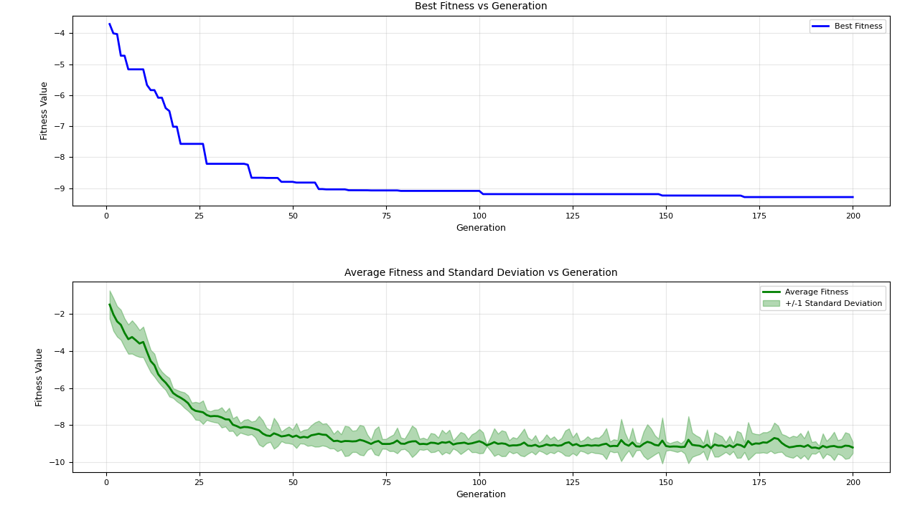
=== FINAL RESULTS ===
Best Fitness: -9.170287
Best Solution: [2.2051470608363966, 1.5609978089067678, 1.289357330393152, 1.1120359489460705, 1.0045146469613764, 1.570644423371706, 0.8442151509620233, 1.3680683356518808, 1.6526996275216694, 1.5713442848997938]
Total Time: 3.57s
