=== FINAL RESULTS ===
Best Fitness: -1.800796
Best Solution: [2.2027679401468134, 1.5743327592422869]
Total Time: 3.33s
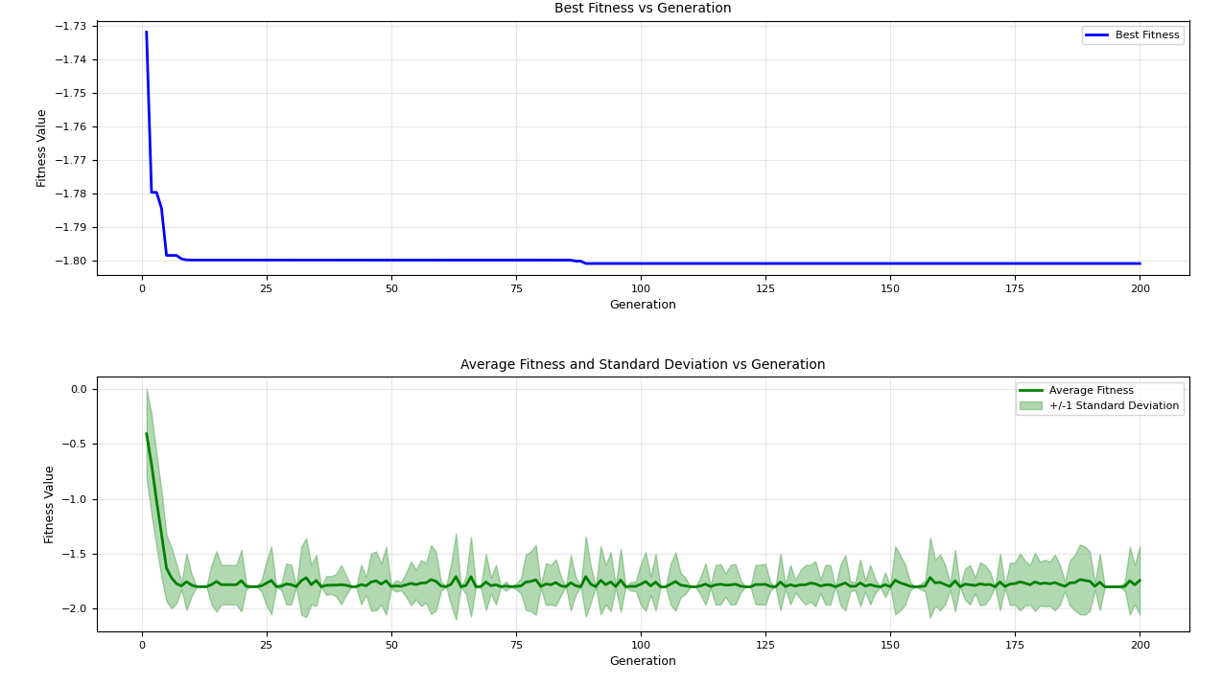
=== FINAL RESULTS ===
Best Fitness: -1.801271
Best Solution: [2.202905517759711, 1.57169400459281]
Total Time: 3.23s

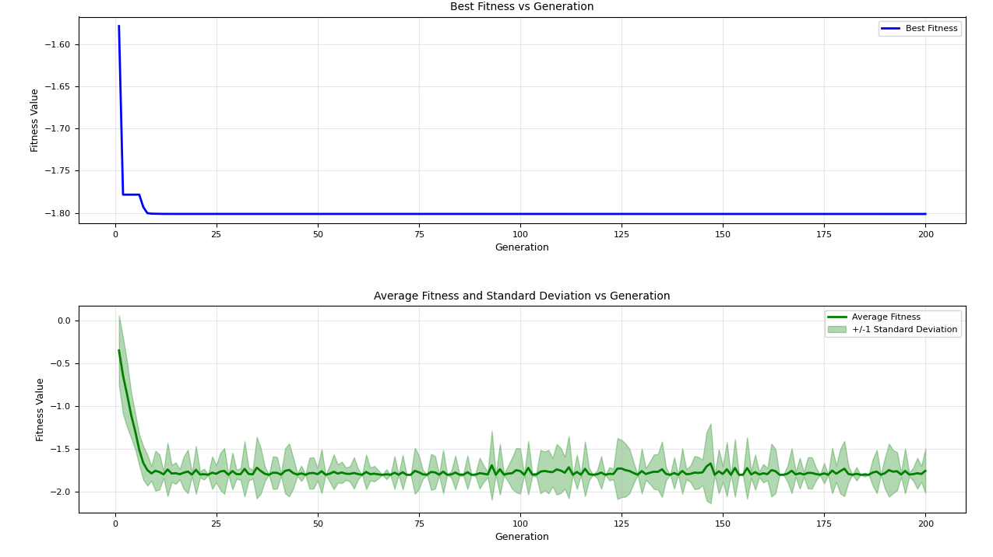

=== FINAL RESULTS ===
Best Fitness: -1.801299
Best Solution: [2.2032694850396997, 1.5710047120027704]
Total Time: 3.37s

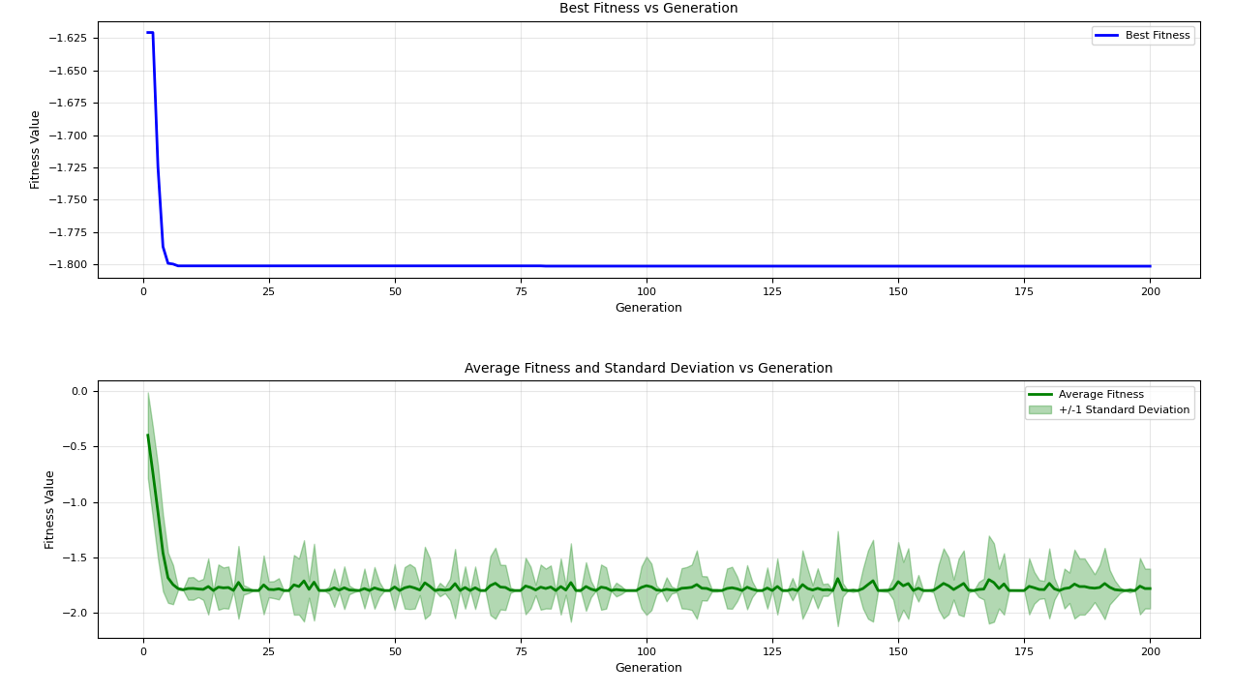
=== FINAL RESULTS ===
Best Fitness: -1.801303
Best Solution: [2.202893541830694, 1.570796229260196]
Total Time: 3.29s

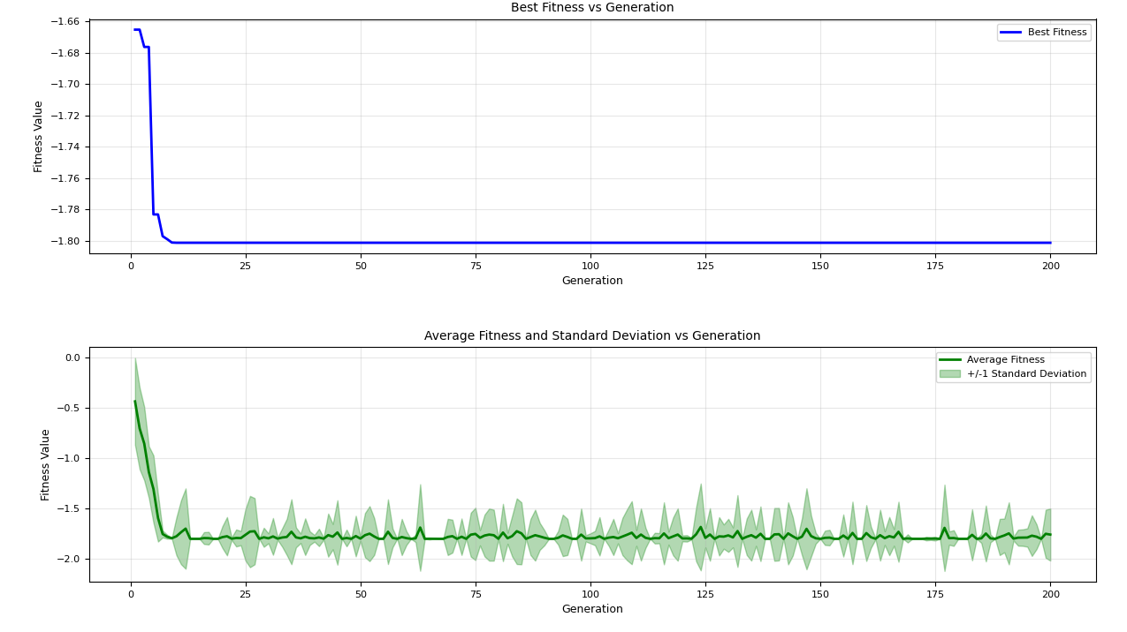

=== FINAL RESULTS ===
Best Fitness: -1.801303
Best Solution: [2.2029055202771772, 1.5707963249802737]
Total Time: 3.46s
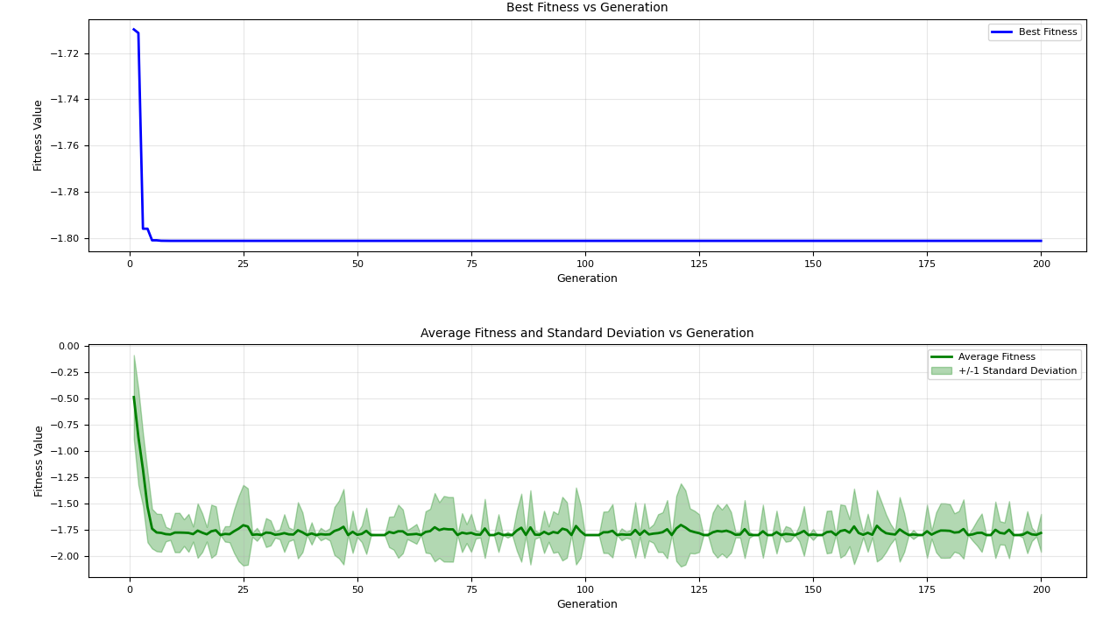
=== FINAL RESULTS ===
Best Fitness: -1.801303
Best Solution: [2.2029055203289865, 1.570796326856783]
Total Time: 3.34s

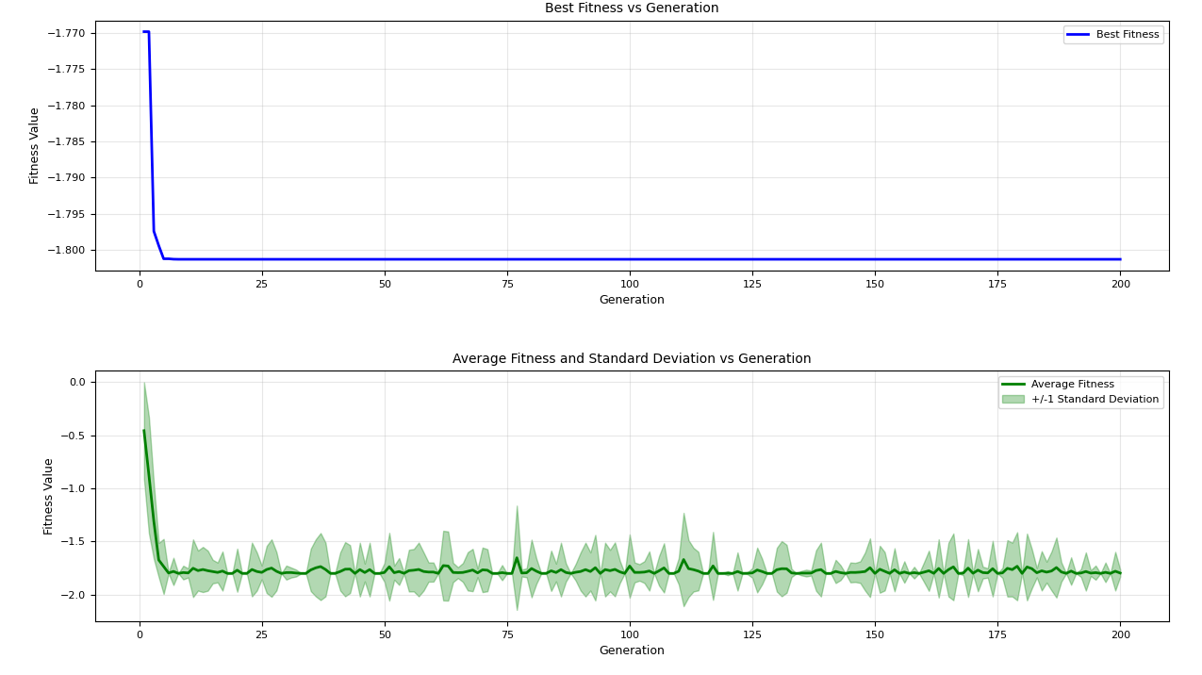

=== FINAL RESULTS ===
Best Fitness: -1.801196
Best Solution: [2.202313500032629, 1.569209707390846]
Total Time: 3.50s
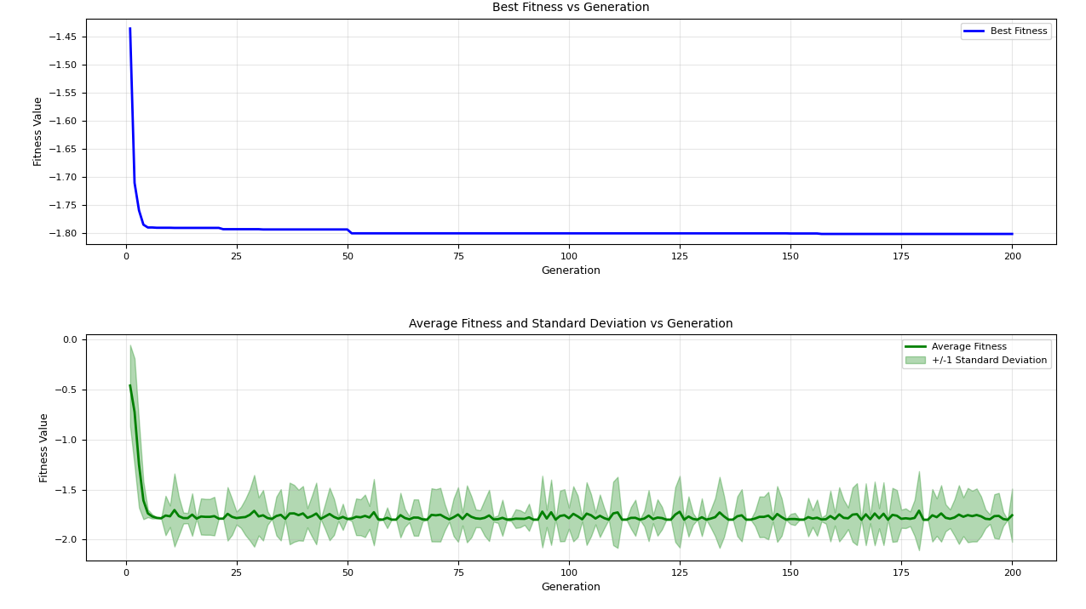
=== FINAL RESULTS ===
Best Fitness: -1.801293
Best Solution: [2.202905518415368, 1.570278761332411]
Total Time: 3.31s

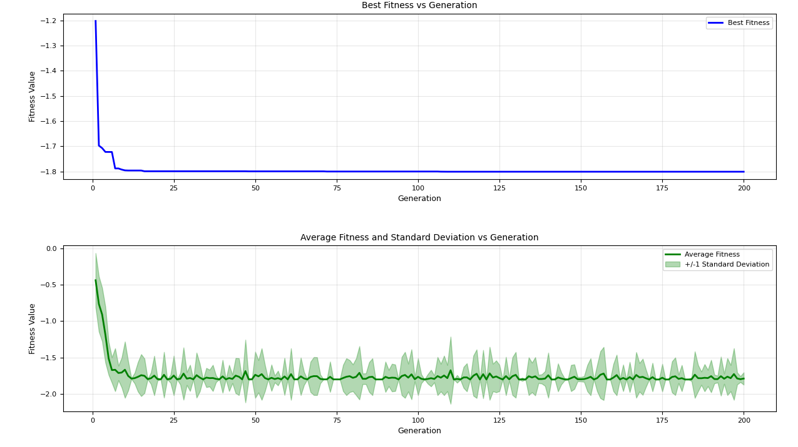

=== FINAL RESULTS ===
Best Fitness: -1.801303
Best Solution: [2.2029055186516366, 1.5707963307907091]
Total Time: 3.30s
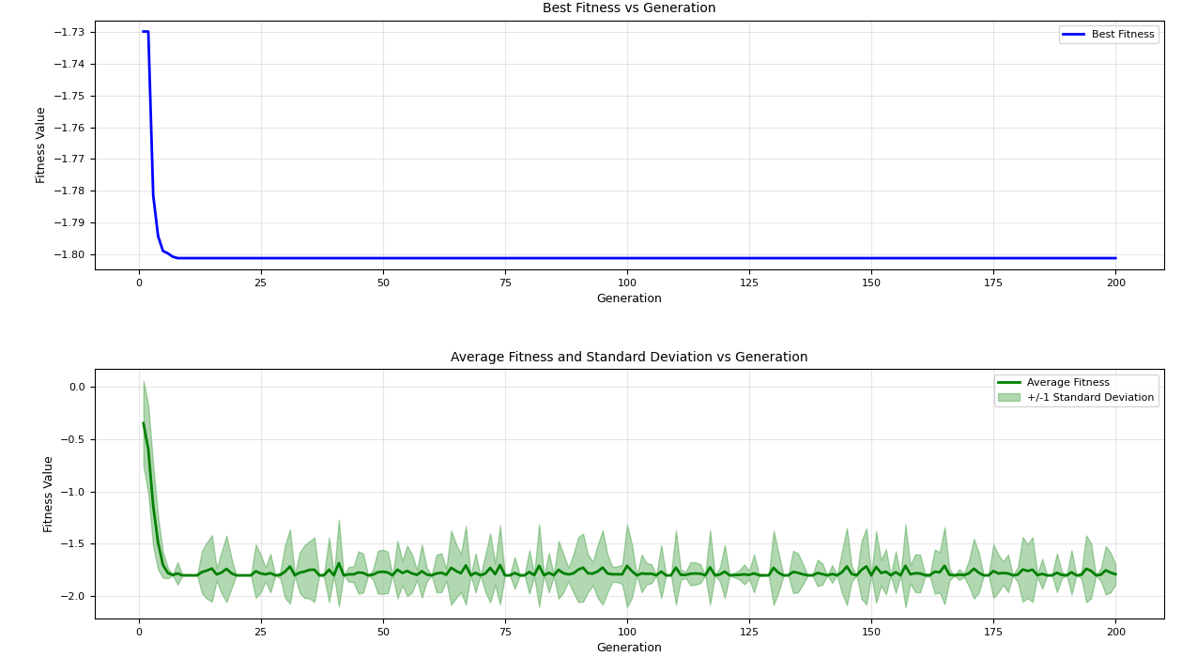
=== FINAL RESULTS ===
Best Fitness: -1.801303
Best Solution: [2.202914676196742, 1.5708080552351564]
Total Time: 3.38s

