=== FINAL RESULTS ===
Best Fitness: -4.683561
Best Solution: [2.2029045026248024, 1.5704587195183954, 1.2849882419674086, 1.9192951275618844, 1.7187177107603713]
Total Time: 3.37s
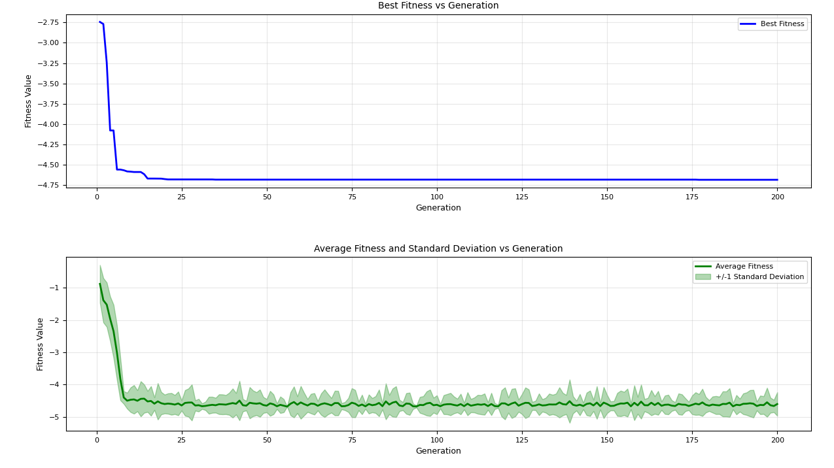

=== FINAL RESULTS ===
Best Fitness: -4.643934
Best Solution: [2.202905517247513, 1.5705259955888597, 1.2811091763709324, 1.1134678805537863, 1.7185664568168004]
Total Time: 3.35s
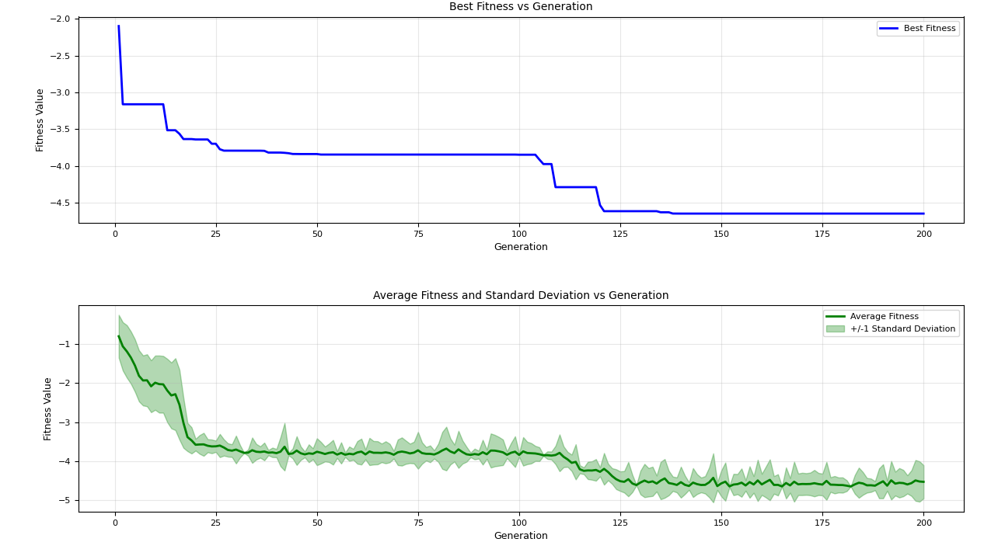

=== FINAL RESULTS ===
Best Fitness: -4.641340
Best Solution: [2.20288539297795, 1.562061541200565, 1.2849915685849131, 1.11748618341057, 1.719193853911368]
Total Time: 3.22s
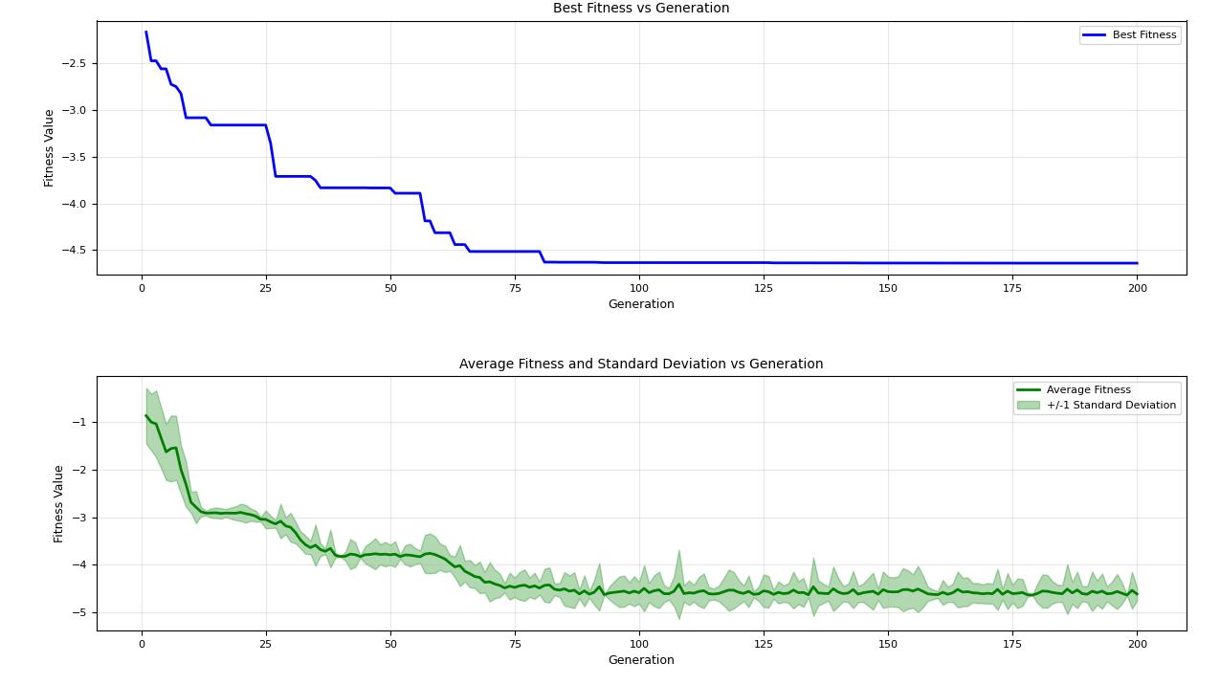
=== FINAL RESULTS ===
Best Fitness: -4.537332
Best Solution: [2.203598855723206, 1.572316658475039, 1.2866555847155903, 1.9234029062493732, 0.9973040961250721]
Total Time: 3.34s

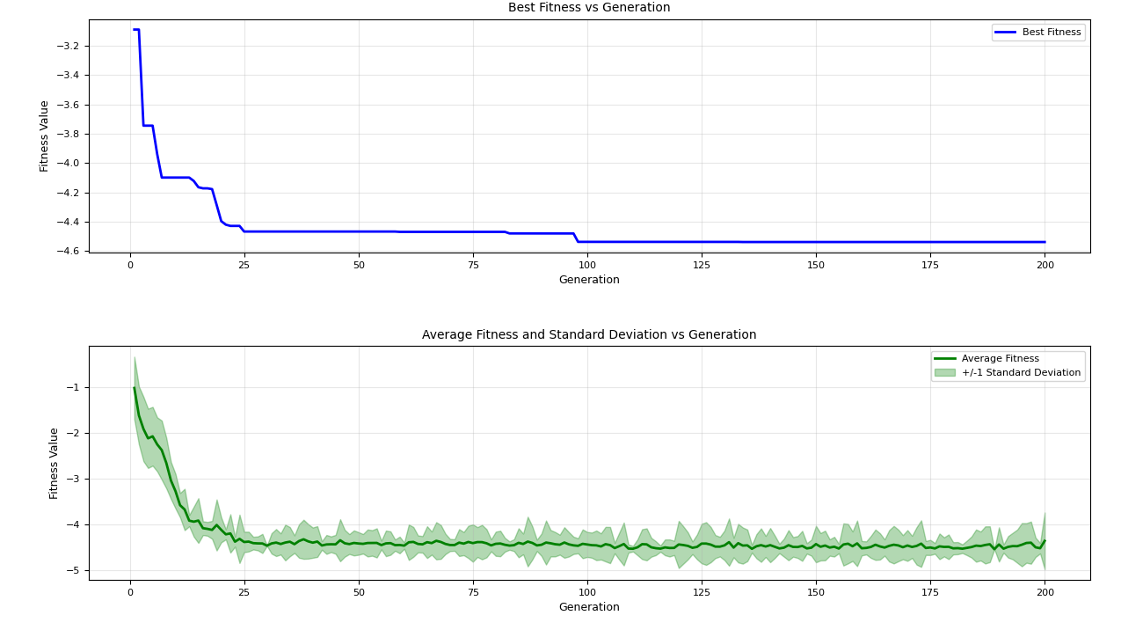
=== FINAL RESULTS ===
Best Fitness: -4.634025
Best Solution: [2.2028884679985183, 1.5672118452805135, 1.285255015222488, 1.1141971635394392, 1.714263877545699]
Total Time: 3.25s
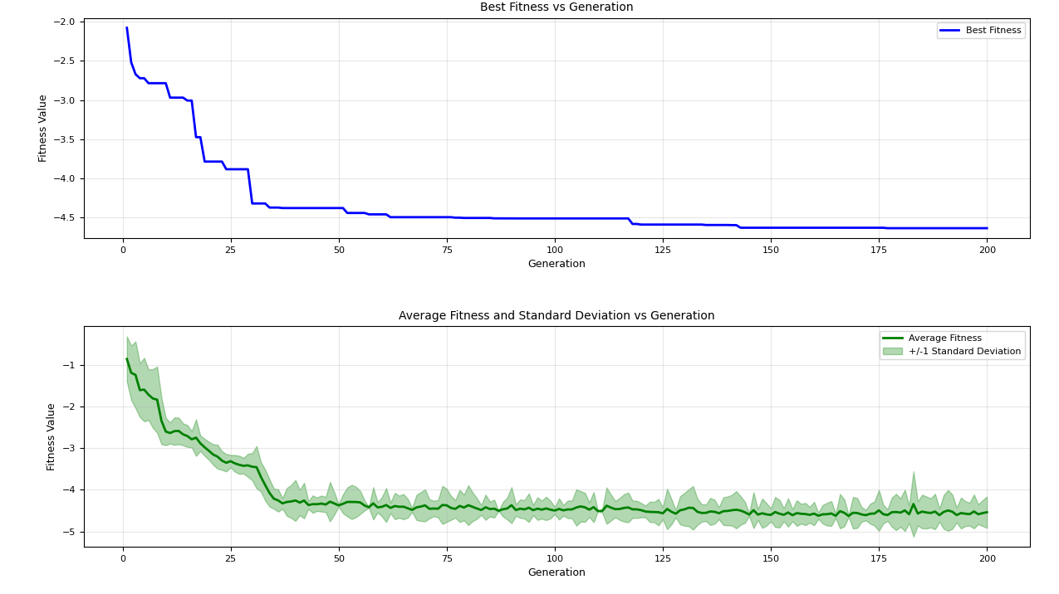
=== FINAL RESULTS ===
Best Fitness: -4.489732
Best Solution: [2.202905516178543, 1.5704061264807216, 1.2949474686224636, 1.1116248117634675, 0.9967161148863323]
Total Time: 3.35s
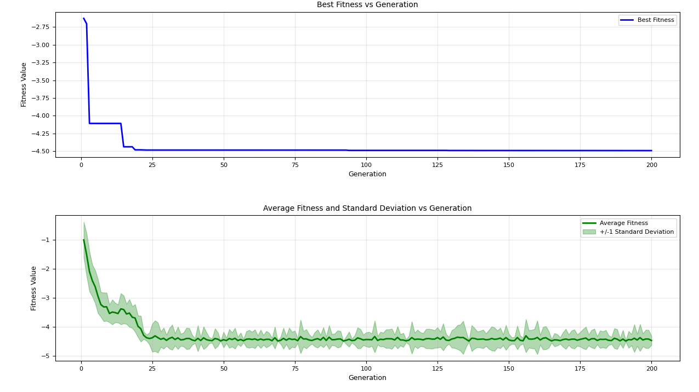

=== FINAL RESULTS ===
Best Fitness: -4.482702
Best Solution: [2.202878917799989, 1.5703463599307532, 2.2194058581930647, 1.1116553800465052, 1.7199010171501972]
Total Time: 3.39s

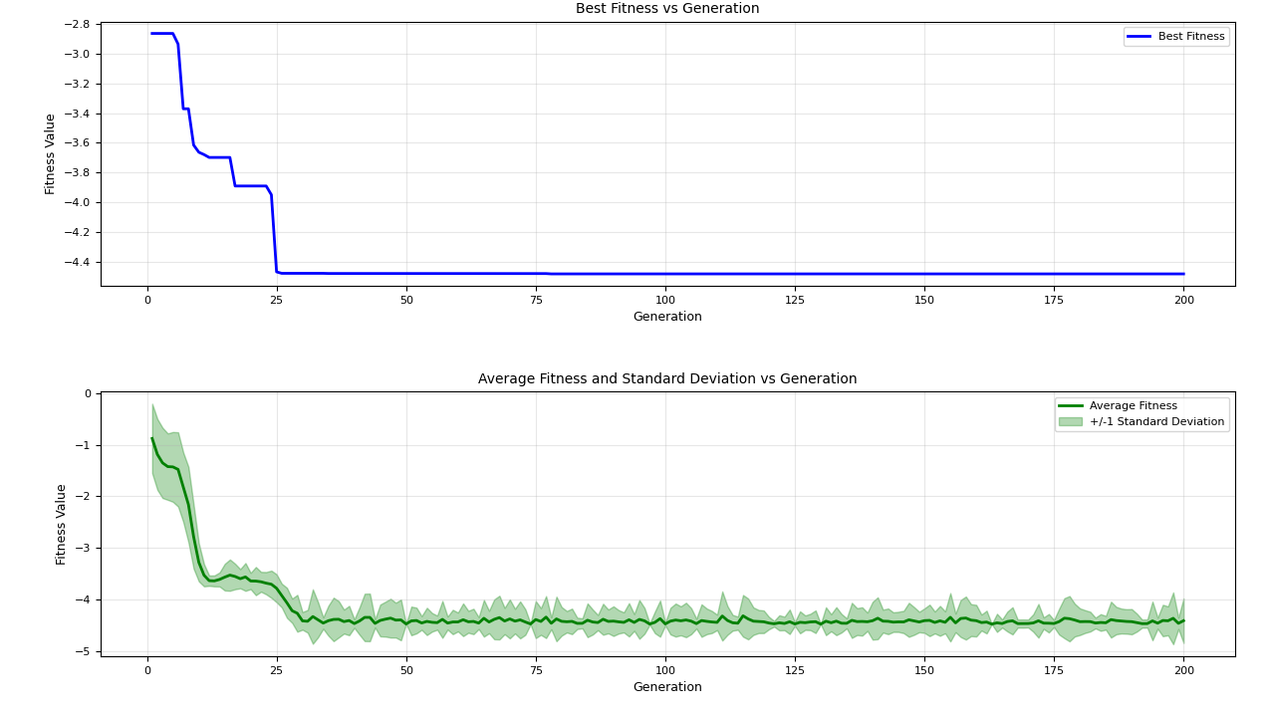
=== FINAL RESULTS ===
Best Fitness: -4.685651
Best Solution: [2.2025432702816925, 1.5707963265286597, 1.2885511645023813, 1.925333454939641, 1.7210374617181603]
Total Time: 3.28s
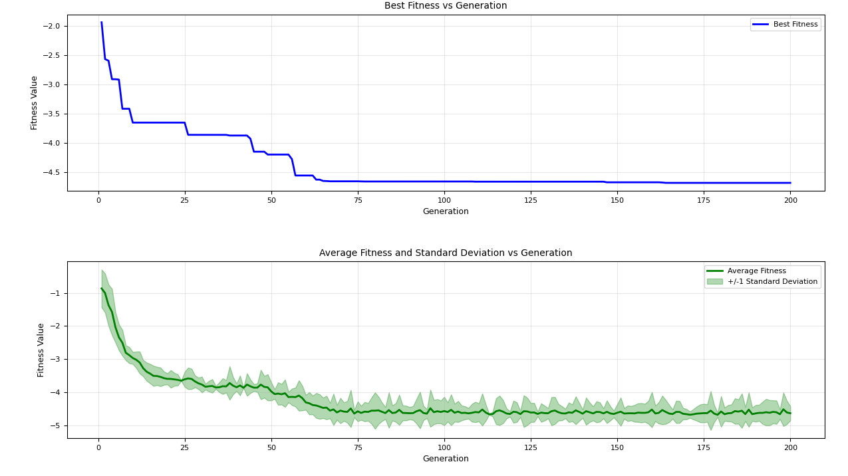
=== FINAL RESULTS ===
Best Fitness: -4.360522
Best Solution: [2.2028972334444097, 1.5723728727571578, 1.286261927672666, 2.4836105928551926, 1.720469794581283]
Total Time: 3.44s
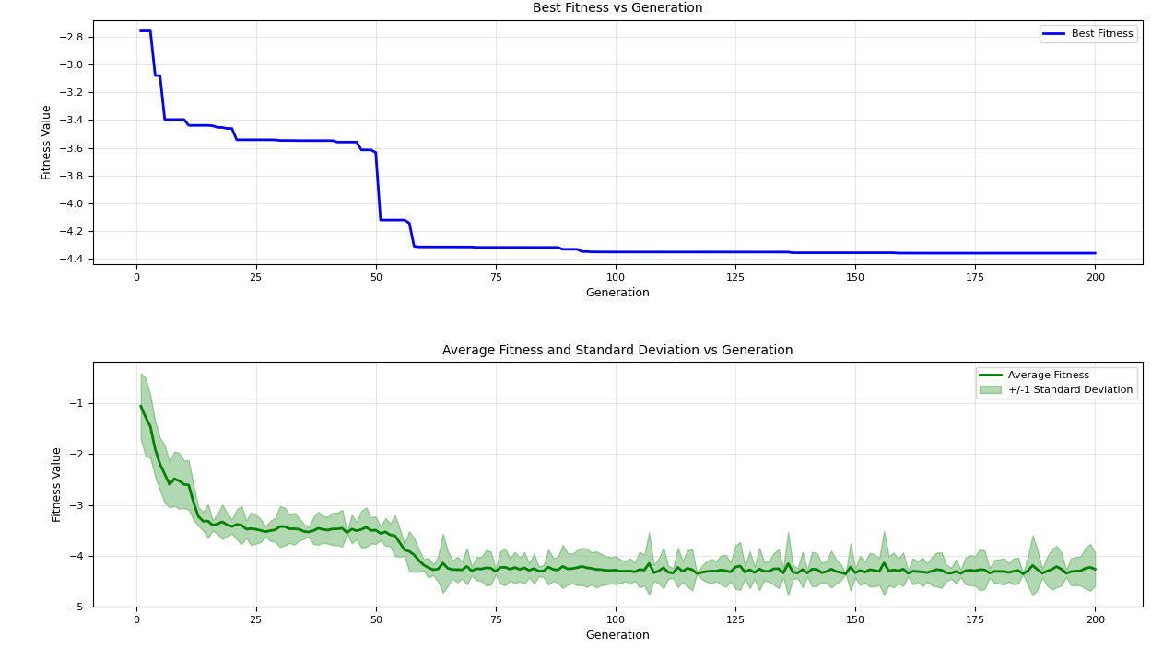
=== FINAL RESULTS ===
Best Fitness: -4.373058
Best Solution: [2.201259094333216, 1.5708853960570648, 2.2160984252934406, 1.9223075304073898, 0.9980791017540622]
Total Time: 3.29s

