=== FINAL RESULTS ===
Best Fitness: 1603.184103
Best Solution: [47.057387057387075, -65.90964590964592, -14.774114774114778, 59.413919413919416, -53.45543345543346, -36.459096459096465, 44.957264957264954, 13.406593406593402, 1.538461538461533, -99.60927960927961]
Total Time: 16.30s

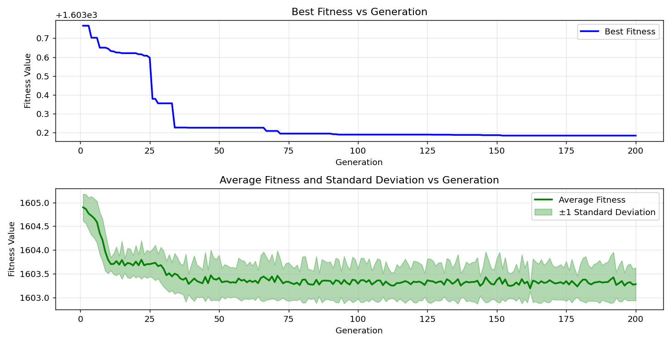
=== FINAL RESULTS ===
Best Fitness: 1603.826089
Best Solution: [-44.224664224664224, -44.71306471306471, -96.09279609279609, -7.057387057387061, -12.332112332112331, -75.04273504273505, -91.4041514041514, -80.56166056166056, -8.962148962148959, -93.35775335775335]
Total Time: 16.47s

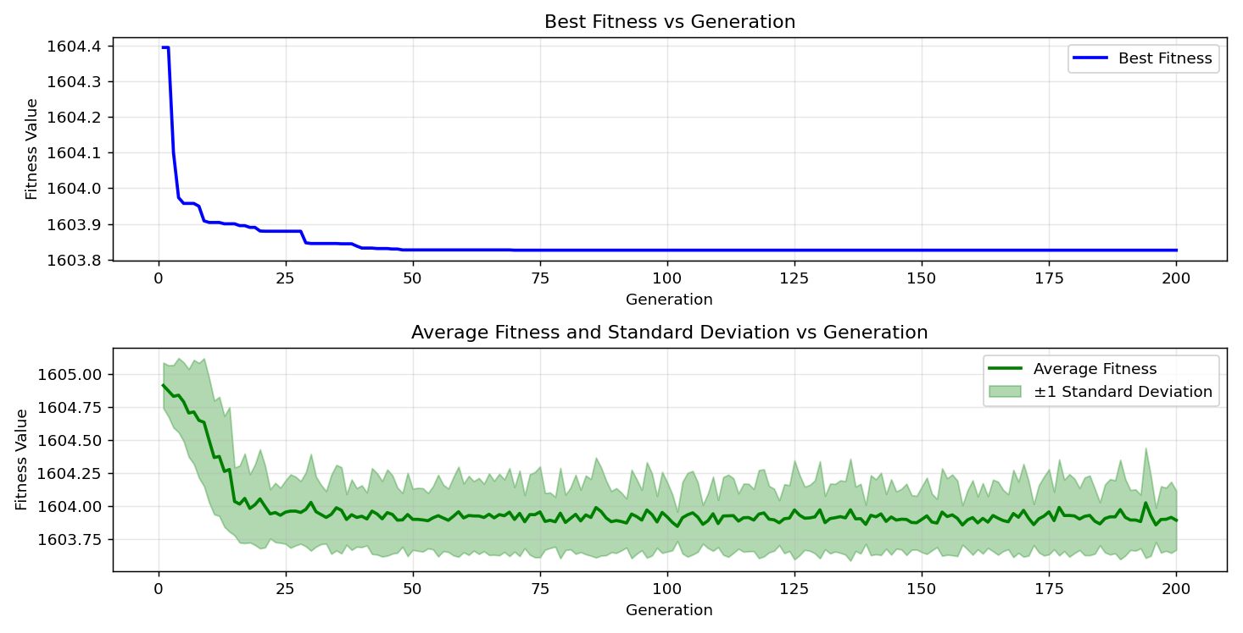

=== FINAL RESULTS ===
Best Fitness: 1603.078725
Best Solution: [11.64835164835165, 14.041514041514034, -57.02075702075702, 47.25274725274727, 2.9548229548229443, -30.109890109890117, -87.88766788766789, 33.04029304029302, 25.811965811965806, -68.84004884004884]
Total Time: 16.07s

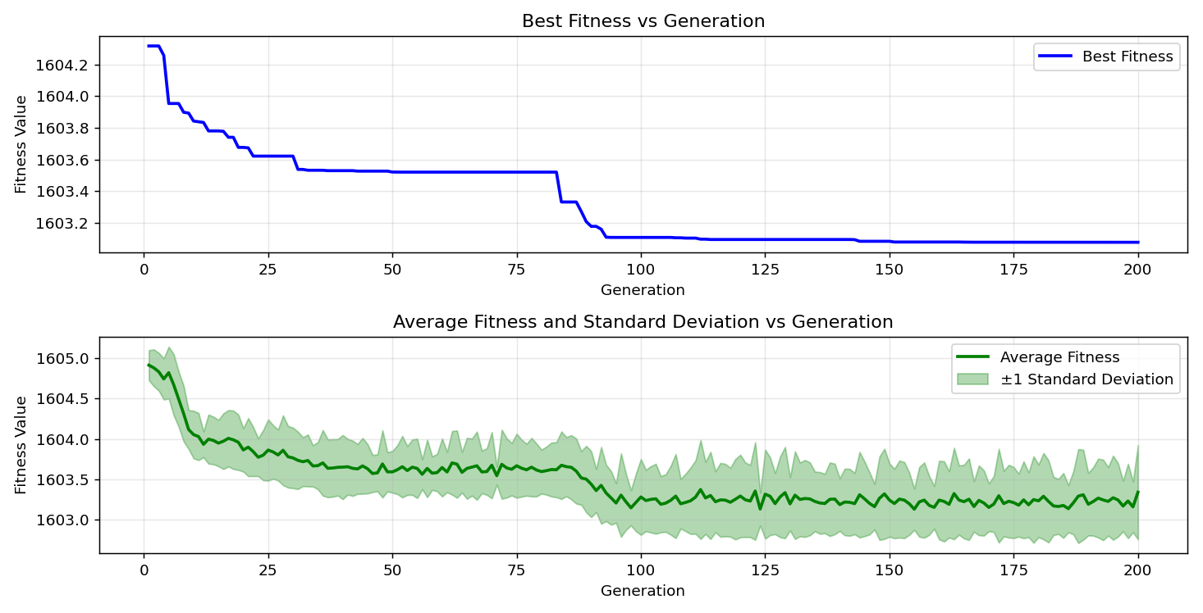
=== FINAL RESULTS ===
Best Fitness: 1603.265898
Best Solution: [-24.249084249084248, -85.2991452991453, -44.07814407814408, 26.593406593406584, -54.33455433455433, -48.91330891330892, -26.83760683760684, -82.02686202686203, -10.03663003663003, 81.2942612942613]
Total Time: 16.07s

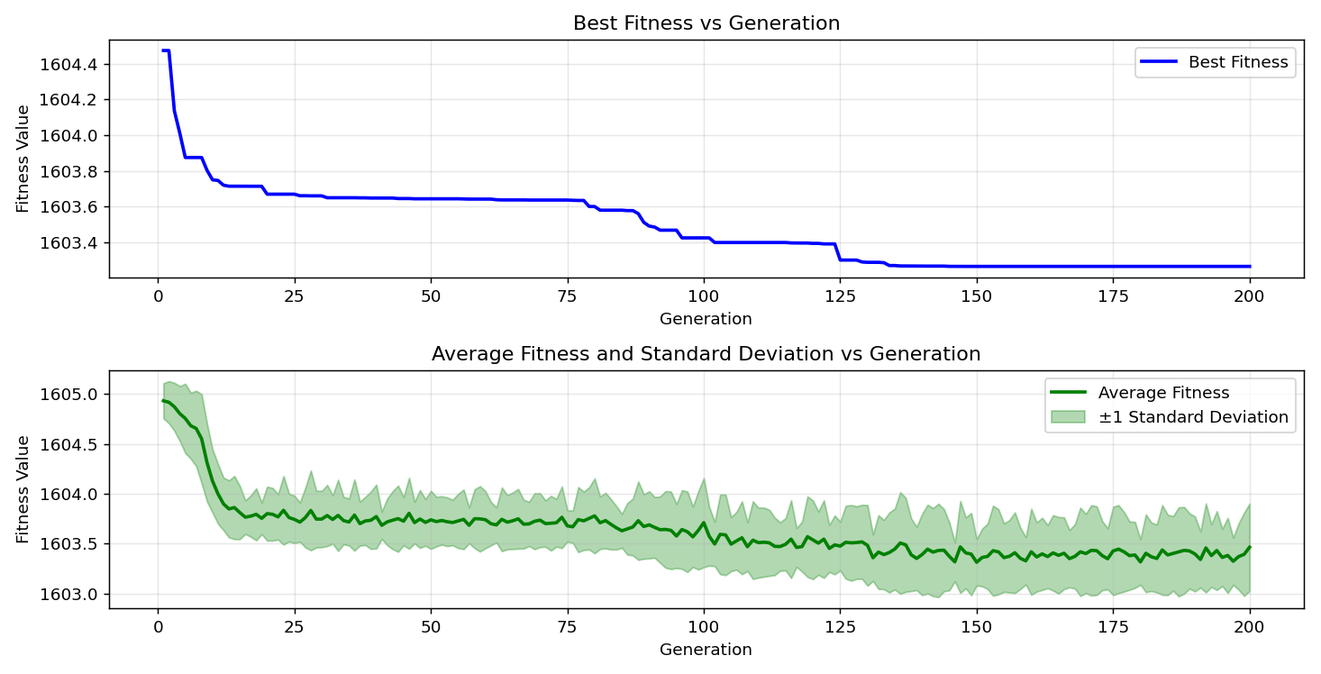

=== FINAL RESULTS ===
Best Fitness: 1602.725778
Best Solution: [-97.06959706959707, -43.3943833943834, -97.02075702075702, -71.57509157509158, -26.300366300366292, -40.26862026862027, 13.308913308913304, 91.45299145299145, 5.006105006105017, -31.08669108669109]
Total Time: 16.44s

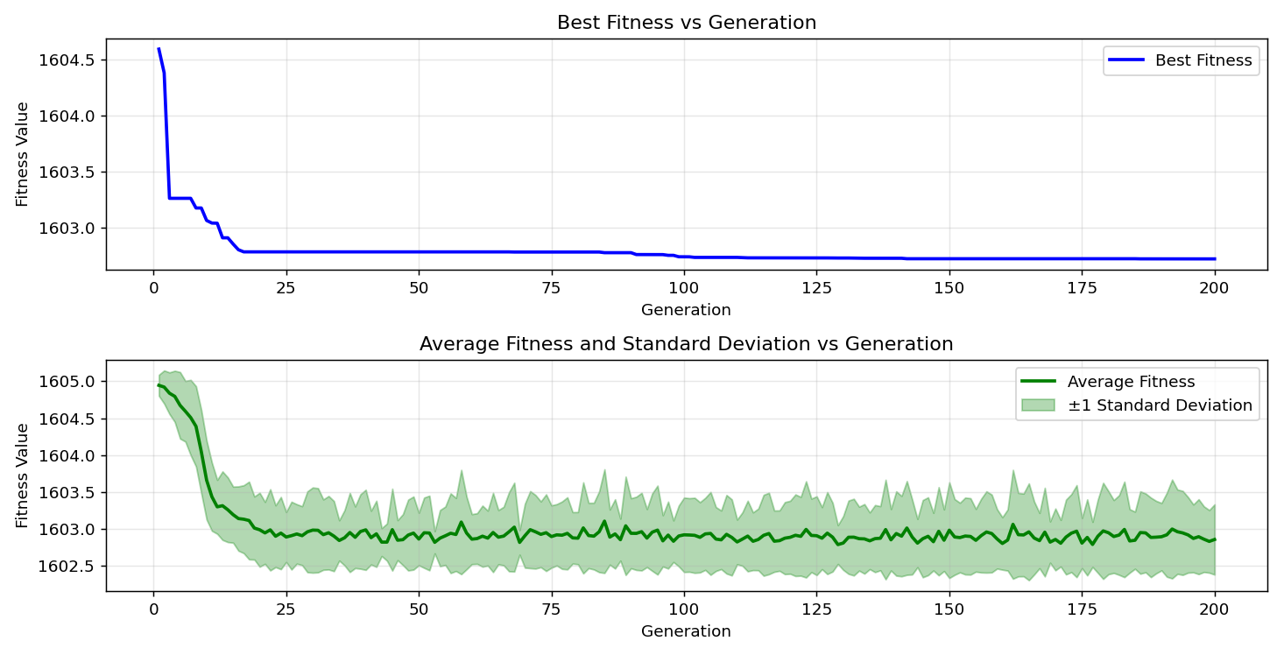
=== FINAL RESULTS ===
Best Fitness: 1603.164966
Best Solution: [-22.295482295482287, -11.452991452991455, -64.2979242979243, 50.036630036630044, 16.776556776556788, -14.041514041514034, -85.83638583638583, 99.41391941391942, -9.548229548229543, -34.60317460317461]
Total Time: 16.38s

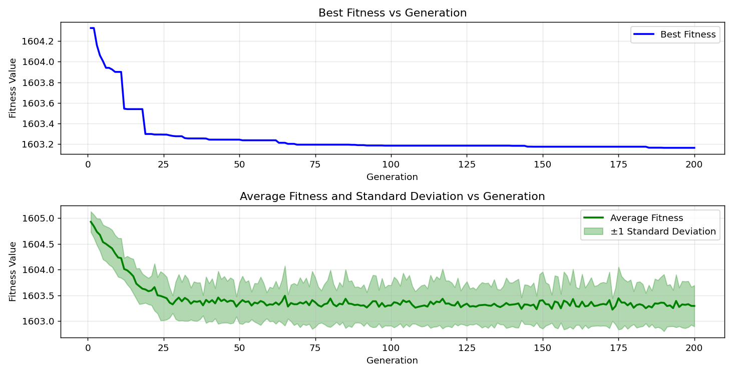
=== FINAL RESULTS ===
Best Fitness: 1603.022952
Best Solution: [-3.882783882783883, -39.48717948717949, 18.339438339438345, -66.44688644688645, -36.50793650793651, -80.02442002442002, 29.13308913308913, 81.24542124542126, 1.1965811965811923, 16.971916971916983]
Total Time: 16.34s

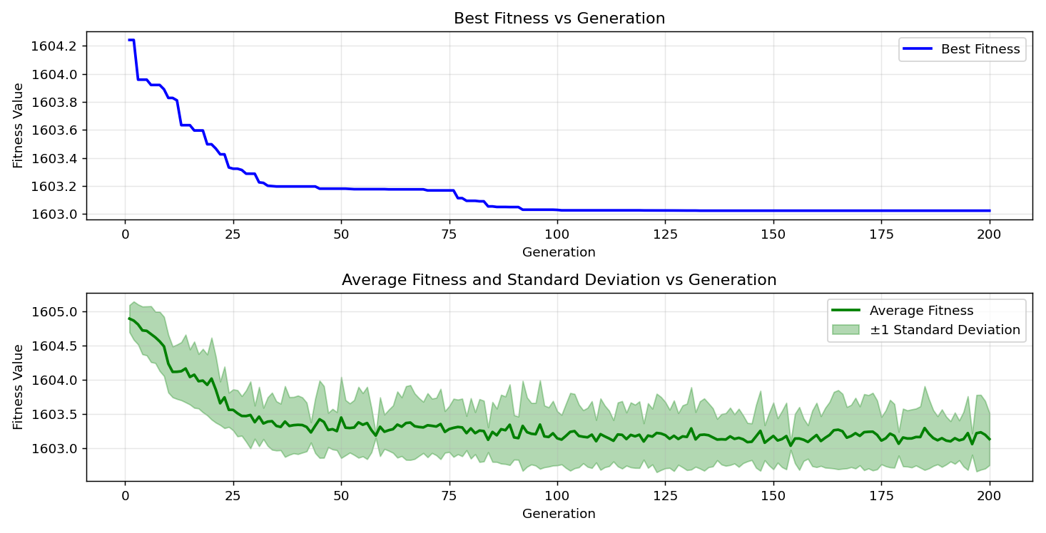
=== FINAL RESULTS ===
Best Fitness: 1603.536796
Best Solution: [-6.275946275946282, -13.553113553113548, -75.14041514041514, -1.0500610500610463, -13.504273504273499, -8.815628815628813, -25.030525030525027, 9.597069597069606, 18.339438339438345, 77.14285714285714]
Total Time: 16.37s

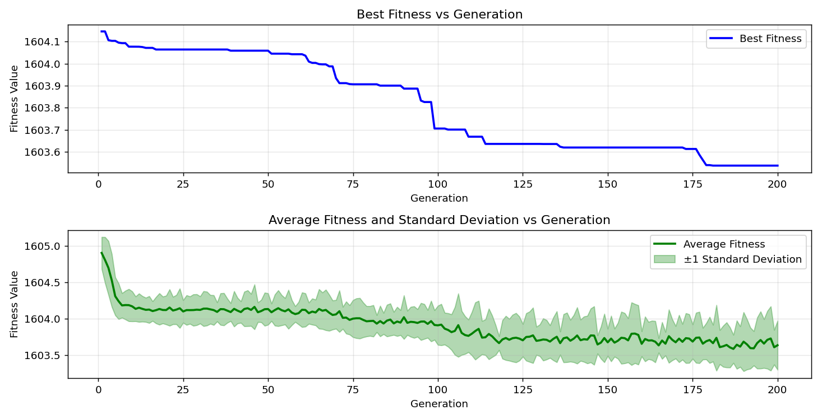

=== FINAL RESULTS ===
Best Fitness: 1602.660562
Best Solution: [-25.421245421245416, -37.191697191697195, -87.93650793650794, -17.85103785103786, 93.94383394383394, 79.4871794871795, 48.32722832722834, -66.73992673992674, -25.860805860805854, 41.78266178266179]
Total Time: 16.14s

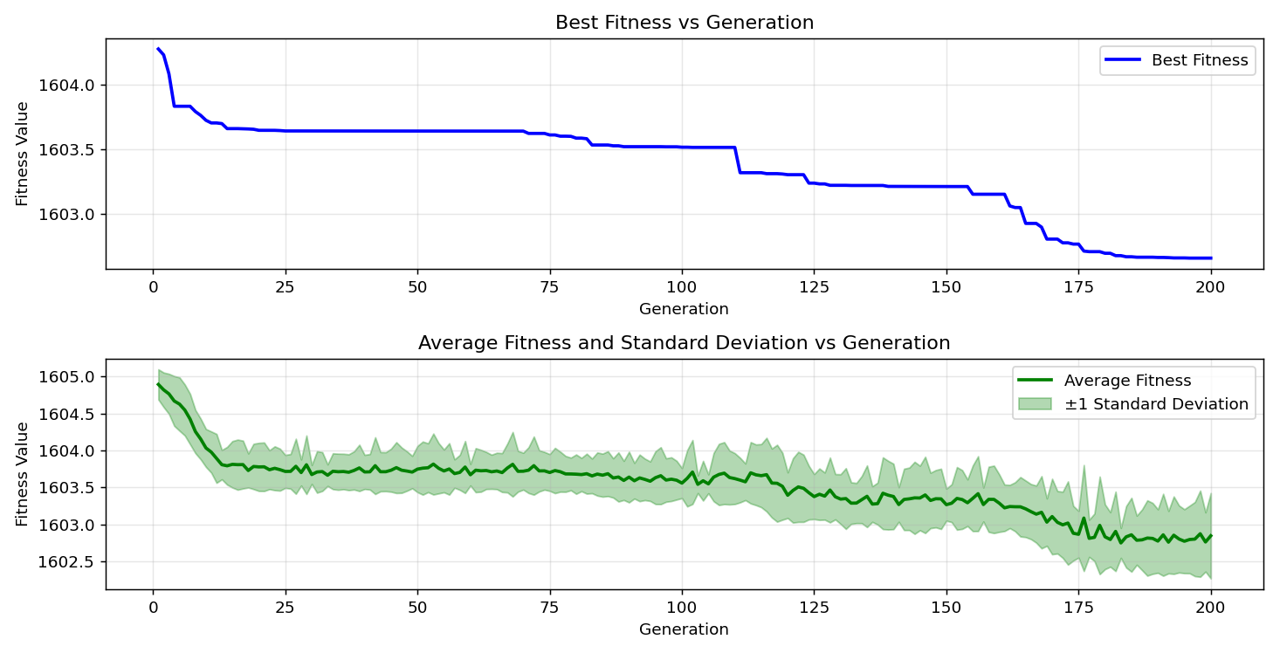
=== FINAL RESULTS ===
Best Fitness: 1603.034964
Best Solution: [3.2478632478632647, -89.4993894993895, 17.02075702075703, -55.018315018315015, -38.02197802197802, -18.14407814407815, 12.576312576312574, -76.06837606837607, -22.88156288156287, 0.7570207570207543]
Total Time: 16.23s

