=== FINAL RESULTS ===
Best Fitness: 1605.547544
Best Solution: [51.89255189255189, -90.96459096459097, 5.445665445665455, -23.516483516483518, -35.091575091575095, 65.47008547008545, 2.3687423687423603, -54.627594627594625, 2.5152625152625063, 22.832722832722837, -11.062271062271066, 40.46398046398045, -76.26373626373626, -45.299145299145295, -80.75702075702075, -41.831501831501825, 34.8962148962149, 55.26251526251528, -54.676434676434674, 74.45665445665446]
Total Time: 21.36s

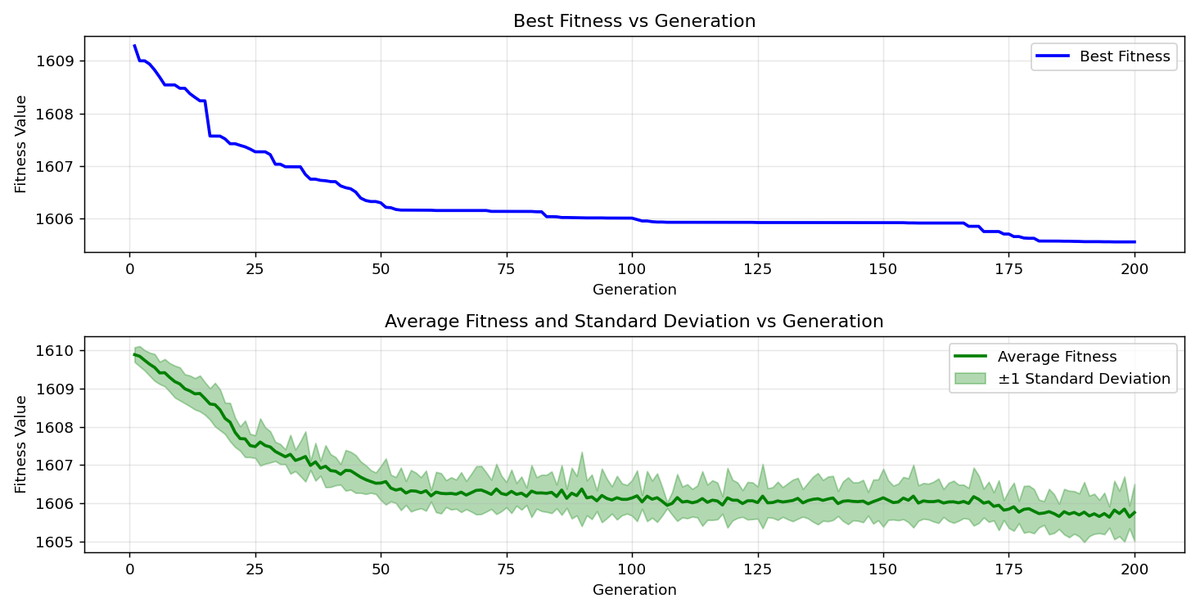
=== FINAL RESULTS ===
Best Fitness: 1605.566959
Best Solution: [-49.89010989010989, -39.48717948717949, -88.66910866910867, 2.9059829059828957, -13.84615384615384, -50.28083028083028, -5.787545787545795, -75.23809523809524, -8.131868131868131, -12.136752136752136, -54.676434676434674, 41.88034188034189, -56.19047619047619, 16.434676434676447, -75.04273504273505, -32.79609279609279, -41.880341880341874, -83.2967032967033, -42.85714285714286, -62.93040293040293]
Total Time: 21.57s

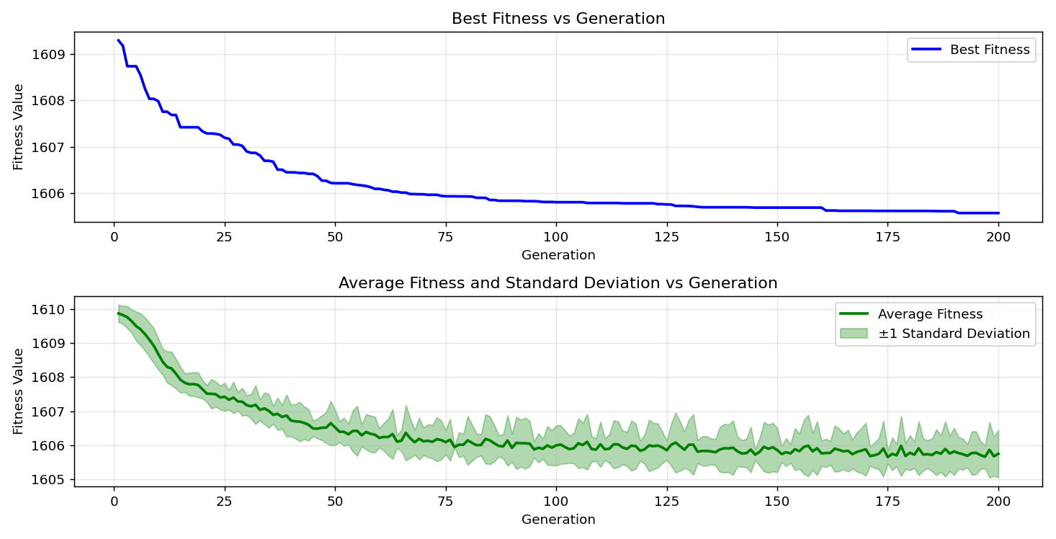
=== FINAL RESULTS ===
Best Fitness: 1605.959883
Best Solution: [-63.27228327228327, -82.61294261294262, 3.8827838827838974, 4.273504273504287, -7.936507936507937, -15.45787545787546, -9.3040293040293, -69.96336996336996, -7.203907203907207, 78.60805860805863, 56.77655677655679, 22.051282051282058, -76.75213675213675, 47.30158730158732, -97.11843711843711, 2.564102564102555, 43.101343101343105, -35.67765567765568, -62.979242979242976, -80.02442002442002]
Total Time: 21.62s

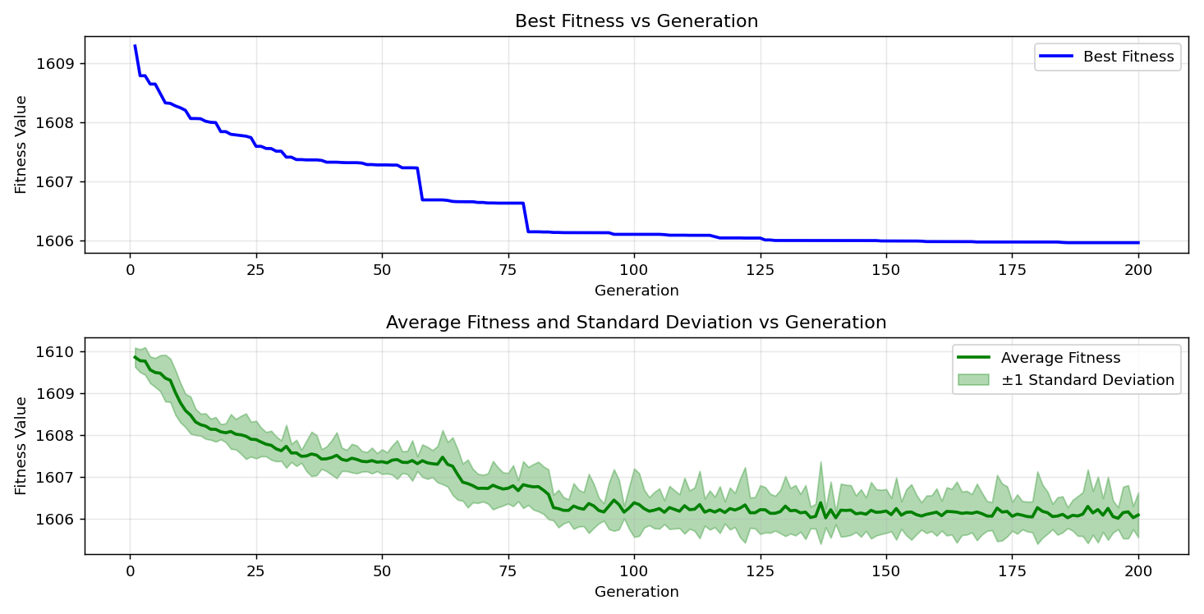

=== FINAL RESULTS ===
Best Fitness: 1605.469402
Best Solution: [-60.0976800976801, 12.478632478632477, -29.181929181929178, -20.244200244200243, -91.8925518925519, -79.73137973137973, -17.167277167277163, -72.64957264957265, 11.452991452991455, 23.80952380952381, 35.62881562881563, 57.655677655677664, -78.26617826617826, -93.84615384615384, -85.1037851037851, -62.588522588522586, 66.83760683760684, -79.82905982905983, -56.58119658119658, -92.18559218559218]
Total Time: 21.54s

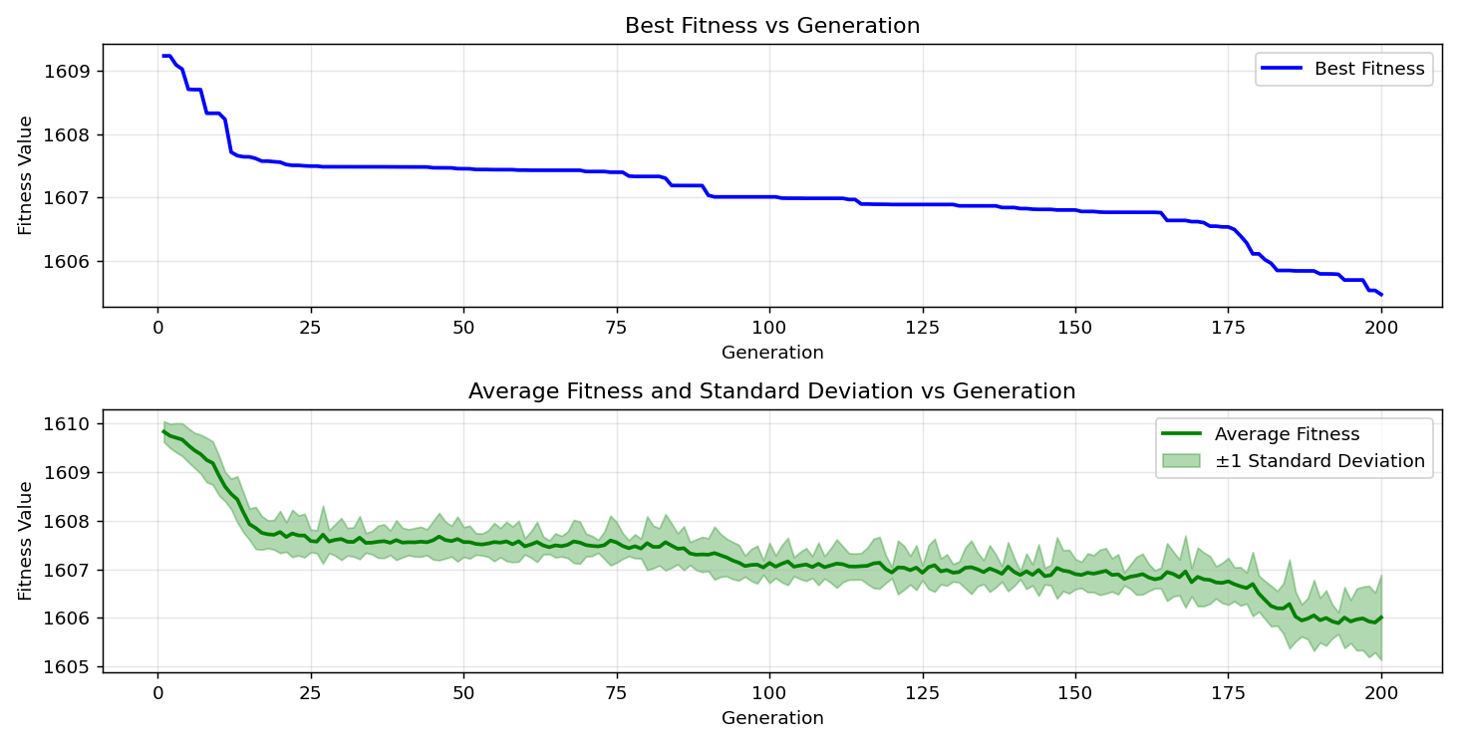
=== FINAL RESULTS ===
Best Fitness: 1605.686006
Best Solution: [-36.849816849816854, 15.897435897435912, 3.4432234432234594, 0.7570207570207543, -70.06105006105005, -70.35409035409035, -26.691086691086696, -54.87179487179487, 81.73382173382174, 23.711843711843713, -64.004884004884, 39.438339438339426, -75.23809523809524, 95.75091575091574, -82.22222222222223, -50.32967032967033, -23.223443223443212, -60.78144078144078, -70.1098901098901, -78.02197802197801]
Total Time: 21.77s

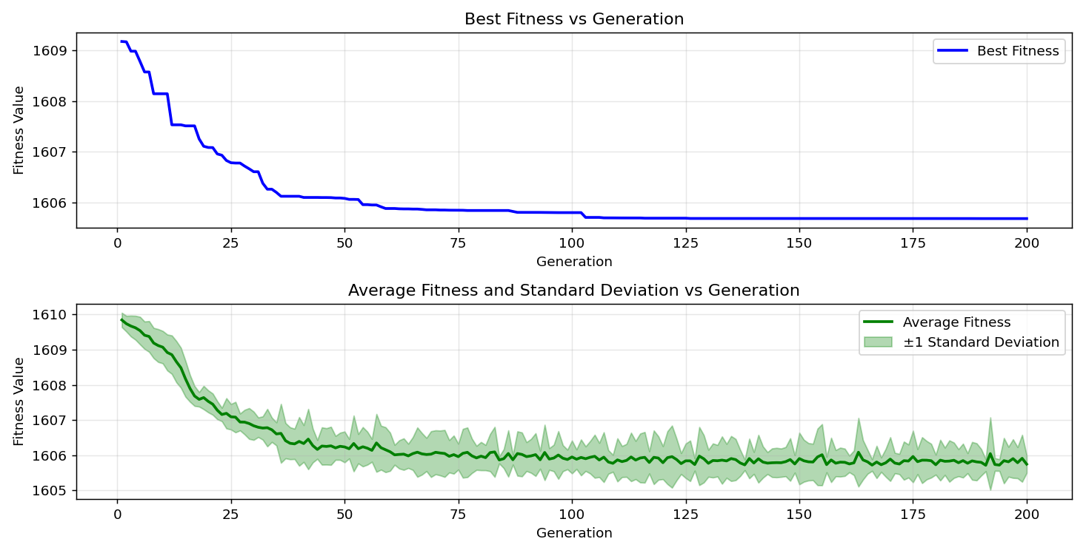
=== FINAL RESULTS ===
Best Fitness: 1606.340517
Best Solution: [-54.627594627594625, 98.04639804639805, 17.997557997558005, -14.041514041514034, -25.860805860805854, -89.25518925518925, 2.857142857142847, -65.71428571428572, -68.88888888888889, 37.58241758241758, 3.3943833943834107, 64.10256410256409, -65.66544566544567, -36.70329670329671, 32.161172161172146, -61.904761904761905, 77.72893772893772, -30.061050061050068, -75.87301587301587, -12.918192918192915]
Total Time: 21.80s

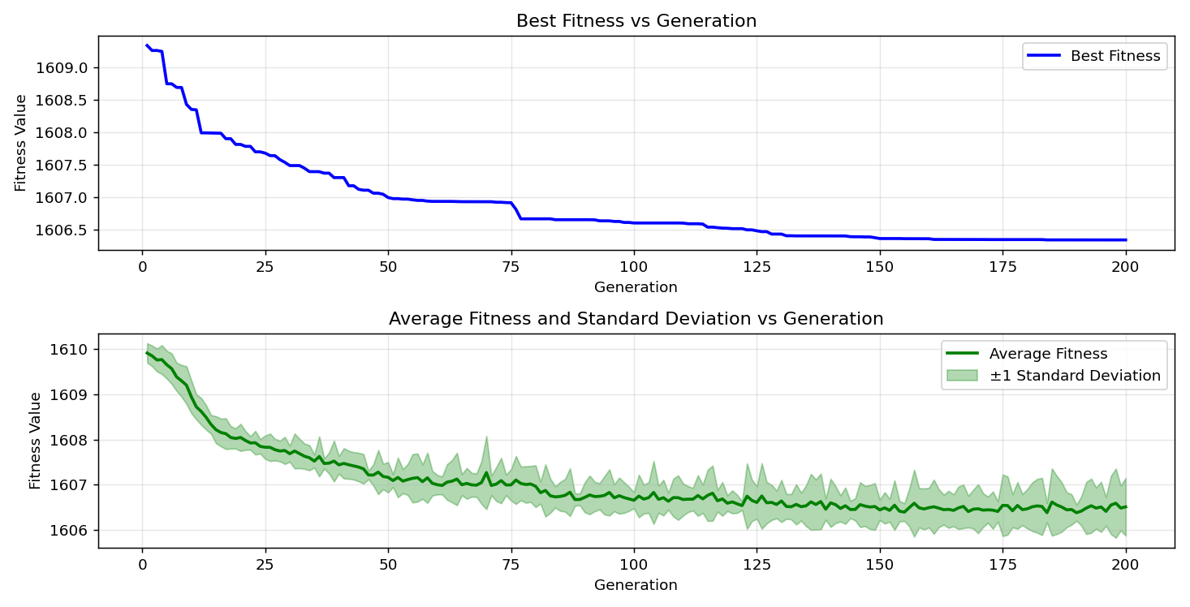

=== FINAL RESULTS ===
Best Fitness: 1605.970985
Best Solution: [-56.19047619047619, 71.08669108669108, 39.145299145299134, 2.857142857142847, -13.406593406593402, -1.6849816849816932, -12.625152625152623, -54.285714285714285, -4.2735042735042725, 32.79609279609278, -28.595848595848594, 64.10256410256409, -64.1025641025641, 22.73504273504274, -82.71062271062272, -50.18315018315018, 61.51404151404151, -55.84859584859585, -36.068376068376075, 27.228327228327217]
Total Time: 21.45s

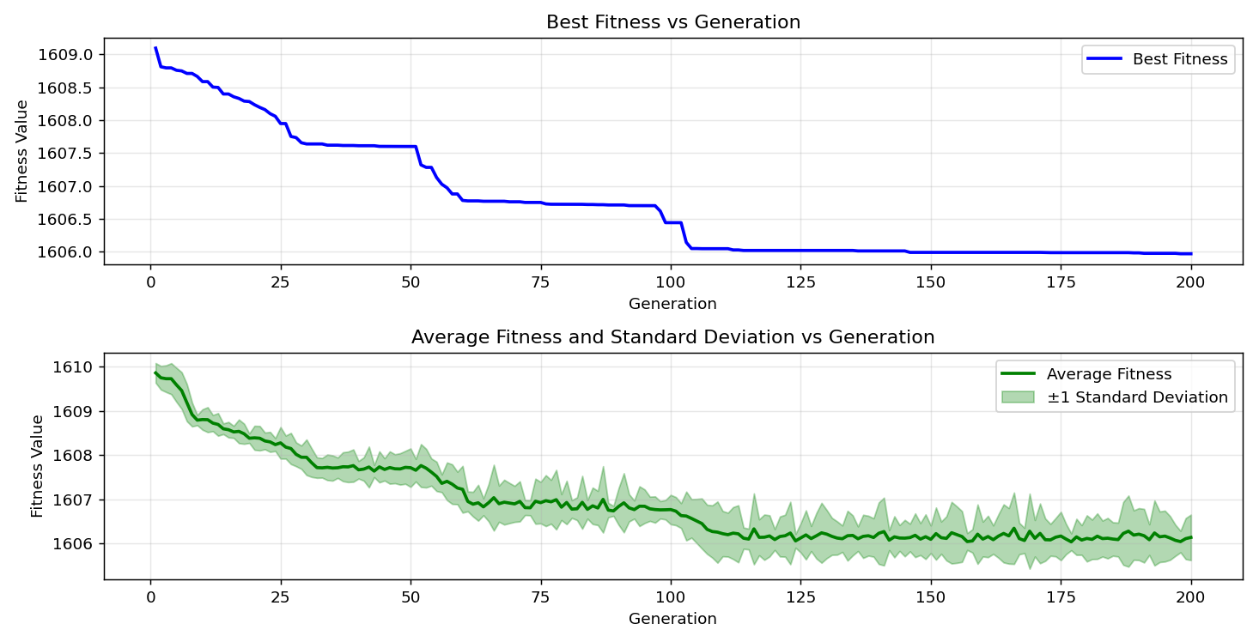
=== FINAL RESULTS ===
Best Fitness: 1605.364339
Best Solution: [-83.78510378510379, -31.08669108669109, -3.3943833943833965, 3.1013431013430903, -47.59462759462759, 49.987789987789995, -10.964590964590968, -54.676434676434674, 82.71062271062272, 30.109890109890102, -99.46275946275946, 36.214896214896214, -76.6056166056166, 75.62881562881563, -48.52258852258853, -48.669108669108674, -86.22710622710622, 59.413919413919416, -57.704517704517706, 53.943833943833965]
Total Time: 21.51s

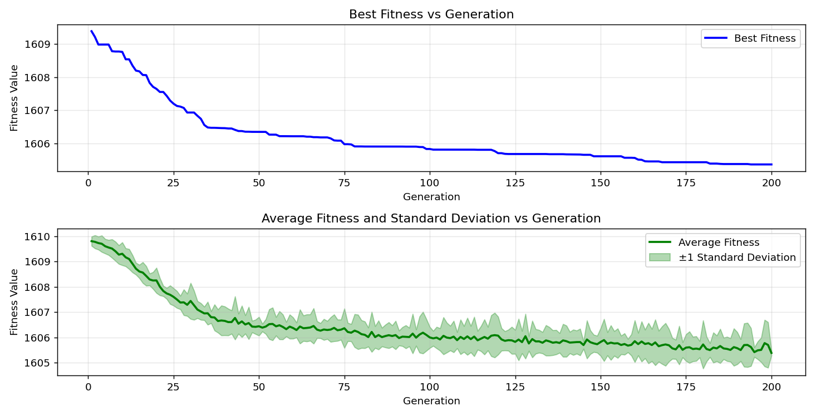

=== FINAL RESULTS ===
Best Fitness: 1605.465056
Best Solution: [-48.32722832722832, 24.053724053724054, 33.9194139194139, -17.069597069597066, 2.271062271062263, -13.308913308913304, -9.108669108669105, -62.1001221001221, 74.7985347985348, 77.92429792429792, 96.82539682539681, 39.73137973137972, -43.63858363858364, -74.55433455433456, -73.43101343101343, -42.95482295482296, 85.39682539682539, -65.37240537240538, -38.16849816849817, -10.866910866910857]
Total Time: 21.53s

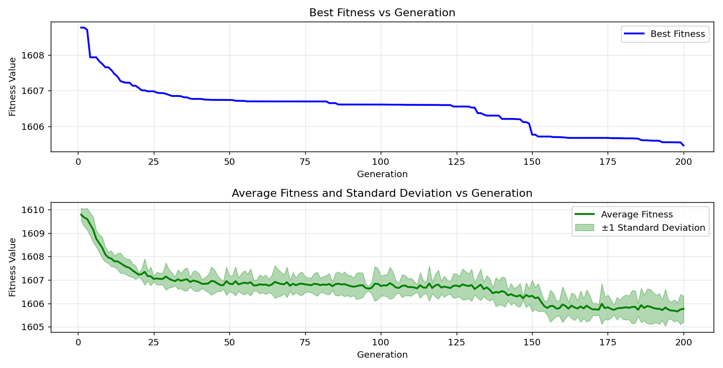

=== FINAL RESULTS ===
Best Fitness: 1606.094503
Best Solution: [-57.46031746031746, -37.875457875457876, 23.907203907203908, 1.684981684981679, -82.07570207570208, -29.719169719169727, -75.04273504273505, -59.26739926739927, 54.87179487179489, 31.135531135531124, 53.35775335775338, 52.08791208791209, -61.318681318681314, 33.43101343101341, -93.3089133089133, -61.7094017094017, -76.8009768009768, -31.77045177045177, -46.275946275946275, -70.69597069597069]
Total Time: 21.27s

