[Kenspeckle](http://inevitablekris.tumblr.com/post/128542061856/kenspeckle)

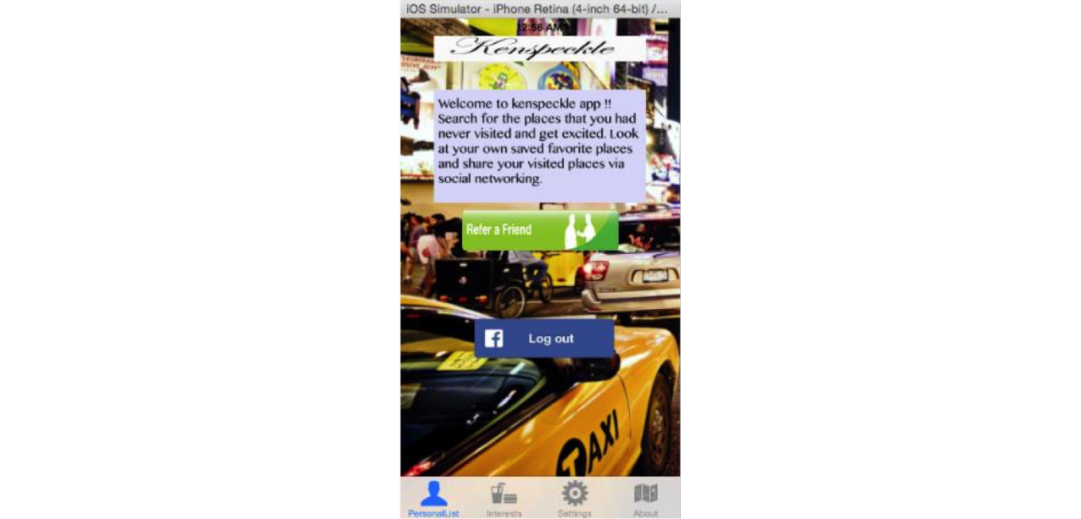

If an individual is driven by curiosity, it is obvious that he/she would explore prominent places in a particular location; for instance, I am standing near to Bull’s statue which is in Wall Street-New York and looking for good famous places being a new comer to the city. I would love to have an app handy on my phone which pulls out a list of prominent places to visit nearby that area based on the exact location of phone.

Isn’t that great???

One would feel relaxed and wise by looking at that list, perfect word for that feeling is awe-struck;

Features

Friends trust other friends for the recommendations on the places to eat, museums to go to and other activities/sightseeing. So, integration the app with Facebook and retrieving your interests (Facebook Page Likes) and your friends tagged locations and favorite places.

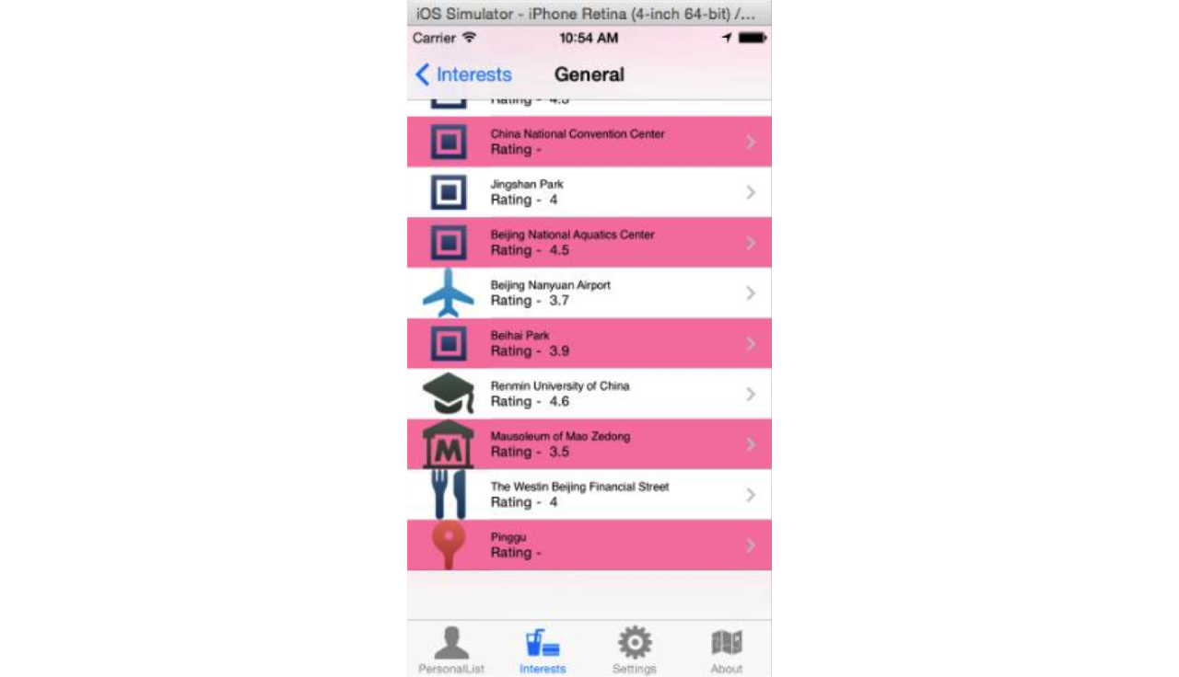

Displays list of places according to category(Dining, hangouts, shopping, cinemas, transportation, Art galleries, Historical monuments, Climate Updates & a Phrasebook of local language).

Register/Login & share your status using Facebook & other Social media.  
Know the current Events and happenings if you are in Europe, Asia or Australia or anywhere in the world using efficient API’s.

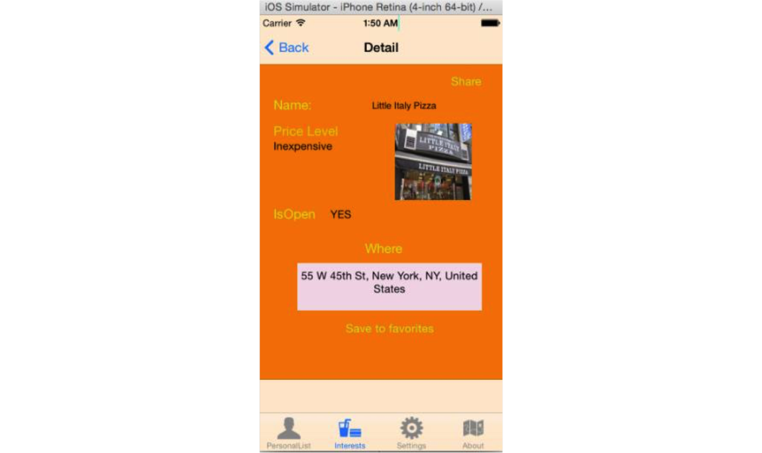

Get notifications on your home screen about latest activities in your current location. Save your favorite locations and track them in My Favorites.