3. Web Service Test

SOAPUI is required to do this. I have described the process of doing it in screenshots.

Step 1: Create a new SOAP project from the WSDL location given

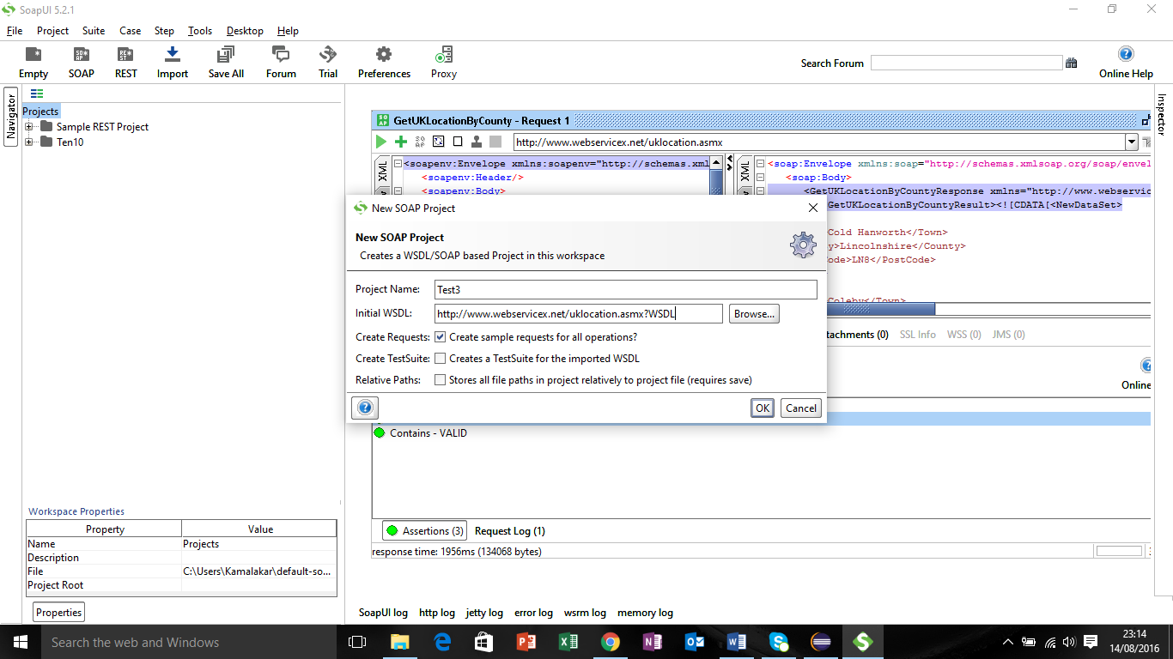

Step 2: Create a new Test Suite, Test Case for the request GetUKLocationByCounty

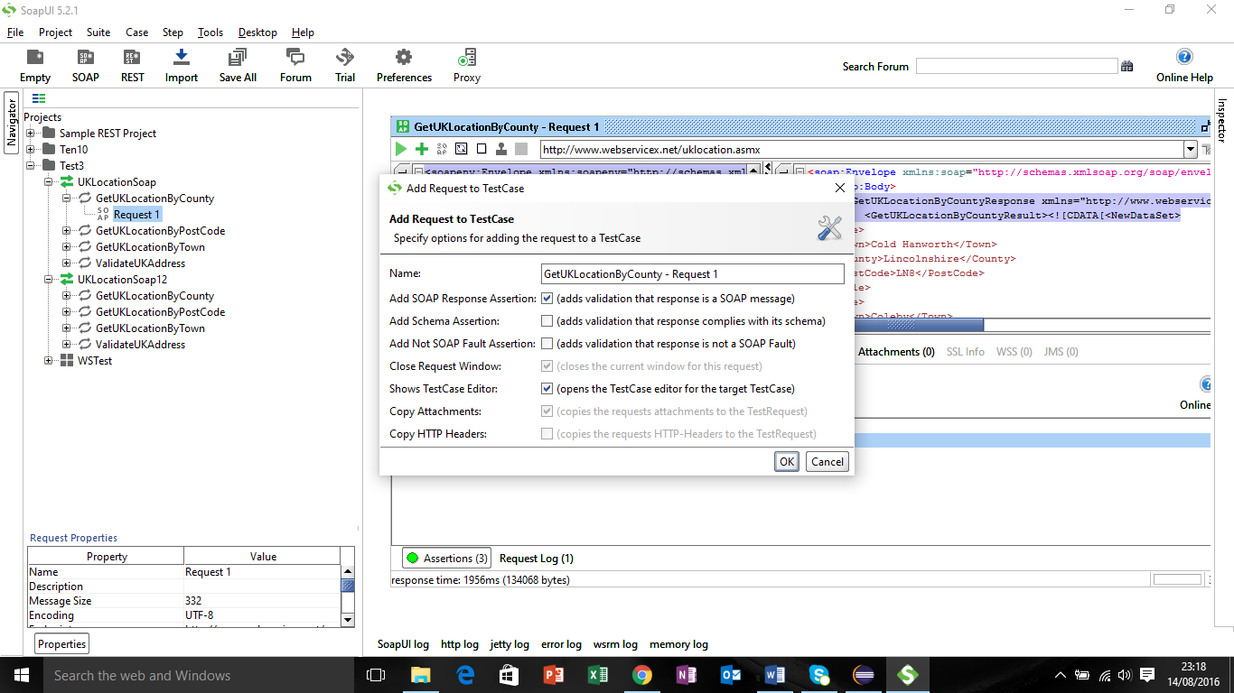

Step 3: Run the request by inputting the county “Lincolnshire” & results displayed.

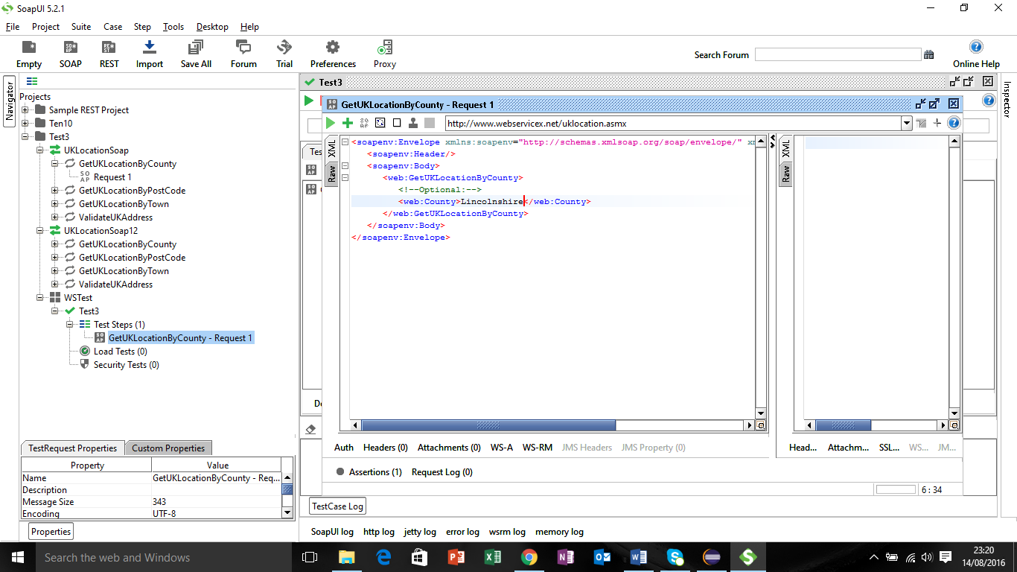

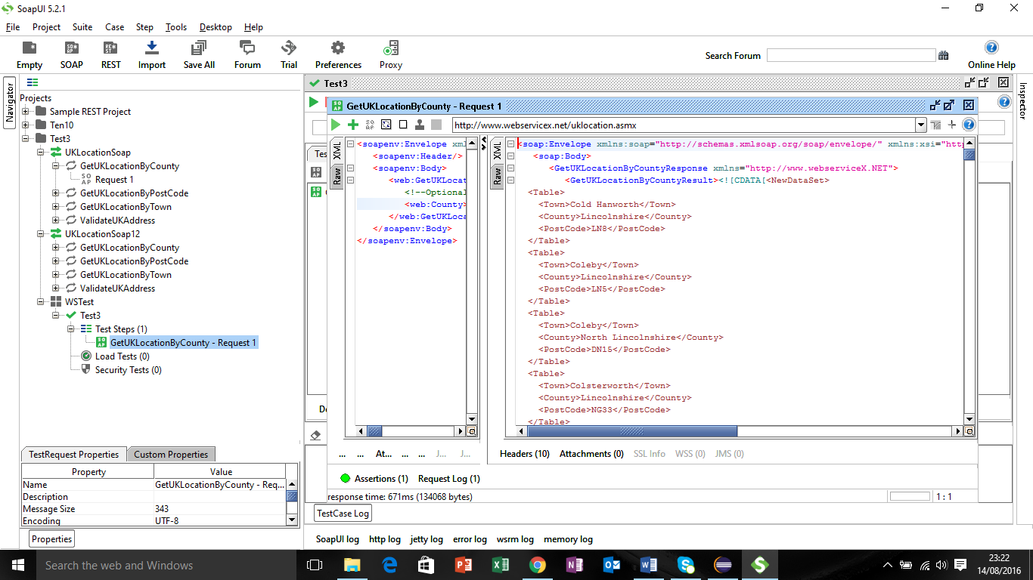

Step 4: Add Assertions

Assertion 1: To check the results are for the given county

Assertion 2: To check the results contain “Eagle”

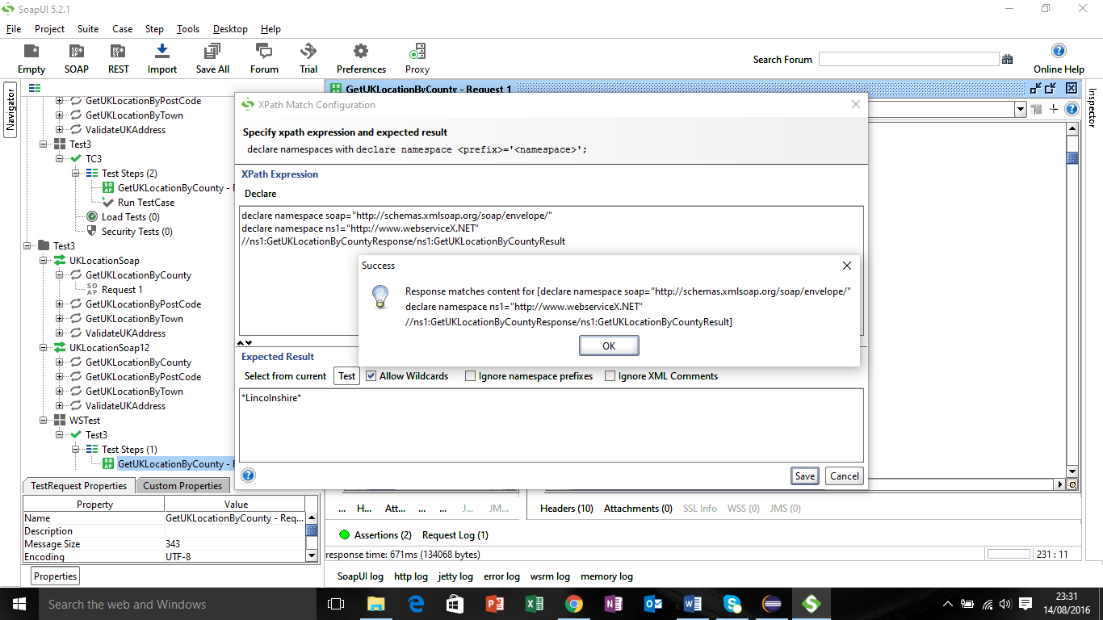

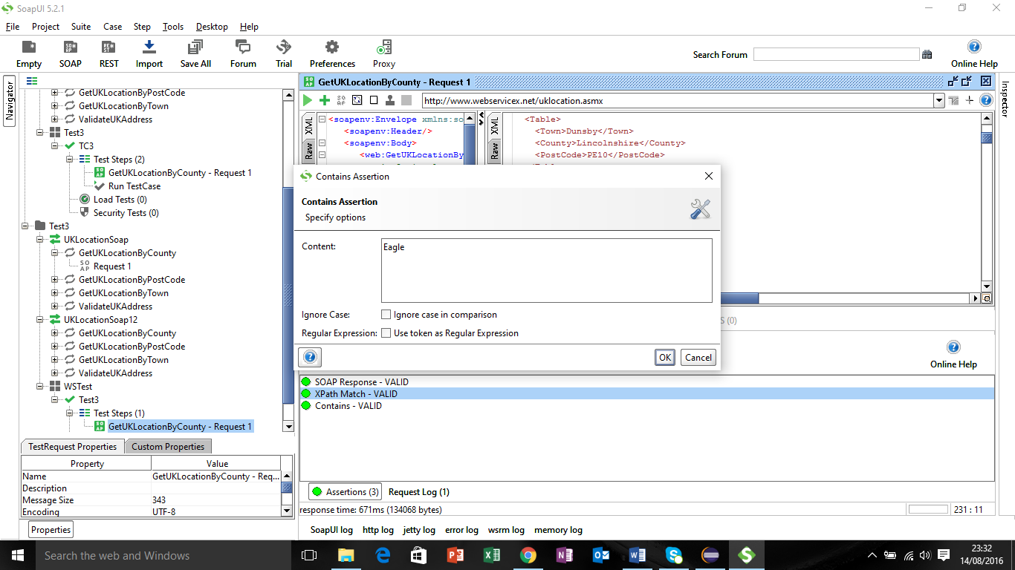

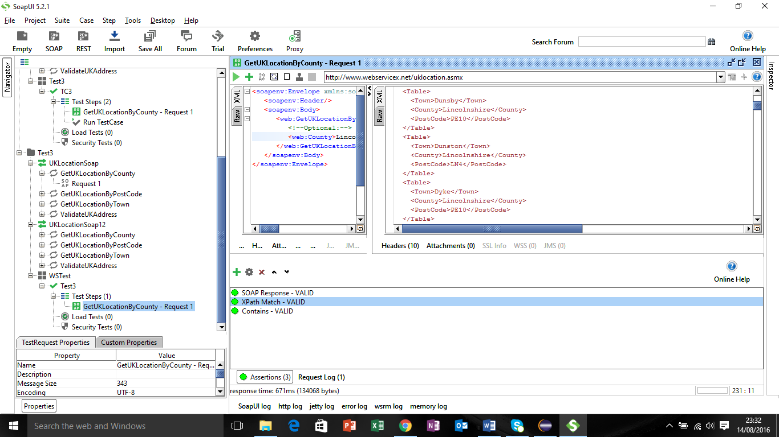

Step 5:

Launch Test Runner and run all the steps and view the results.

