**The effect of environmental factors on the distribution of DHA among neutral and phospholipids in microalgae.**

Konrad Kadzielawa

**Abstract**

*Crypthecodinium cohnii* is a species of dinoflagellate microalga that is frequently used in the industrial production of Docosahexaenoic acid (DHA), an essential fatty acid which is highly concentrated in the brain and whose consumption is associated with a number of health benefits. Most industrial production results in the triglyceride (TG) form of the DHA which is not effective in enriching brain DHA. Since recent studies show that there is a transporter at blood-brain barrier that transports exclusively the lysophosphatidylcholine (LPC) form of DHA (Mfsd2a), it is of great practical importance to develop an effective method to maximize the production of the phospholipid form of DHA, which is more desirable.

Hence, the focus of this study is to maximize the amount of DHA in the phospholipid form produced by the *C.cohnii* through varying their environmental growth factors, e.g. temperature, carbon source, cell concentration, pH etc. The preliminary analysis done by GC/MS and LC/MS of the total fatty acid composition as well as TG/phospholipid DHA composition, suggests that the environmental factors are a significant factor influencing the total amount as well as the chemical form of the DHA produced by the algae. Specifically, reducing the growth temperature and harvesting the algae in subconfluent conditions was found to enrich the phospholipids with DHA.

The results of this study might be used for the optimal preparation of the PC DHA which could then be easily converted to LPC DHA suitable for human consumption.

**Introduction**

Omega-3 fatty acids are polyunsaturated fatty acids (PUFAs) with a double bond at the third carbon atom from the methyl end of the carbon chain. The three types of ω-3 fatty acids which are a vital part of normal human metabolism and are involved in human physiology are α-linolenic acid (ALA) (found in plant oils), eicosapentaenoic acid (EPA), and docosahexaenoic acid (DHA), most commonly found in fish oil. Interestingly, all animals, including humans are unable to synthesize ω-3 fatty acids by themselves, with a small exception of a mechanism that allows α-linolenic acid to be converted into EPA, which can then be converted into DHA via docosapentaenoic acid (DPA, 22:5 ω-3) as an intermediate. However the brain cannot

synthesize significant amounts of DHA from its precursors. Therefore, for the optimal development and functioning of the brain, DHA along with all other fatty acids must be obtained directly from the diet with common sources including various plant oils for the EPA and fish oils, egg oil, squid oils, krill oil for the DHA.

The therapeutic importance of ω-3 PUFAs has been repeatedly demonstrated in many clinical studies, and a special emphasis has been put on the significance of DHA in proper functioning of human metabolism. DHA forms an integral part of the membranes in nervous, reproductive, visual tissues and is the principal fatty acid found in the grey matter of the brain. Many studies have been published on the connection between adequate PUFA consumption and healthy aging, cardiovascular health and fetal development. DHA is particularly important in infant nutrition for a variety of reasons - multitude of studies confirmed the benefit of omega-3 supplementation during pregnancy in terms of proper development of the brain and retina (1). DHA has also been demonstrated to possess potent anti-inflammatory properties (2) through regulation of NF-kB protein by up-regulating intracellular glutathione to a high enough level to balance the oxidative stress (3) as well as indirect mechanisms, such as the oxidation of potent signaling molecules, resolvins and protectins (docosanoids).

Additionally, DHA has also been associated with a number of neuroprotective factors. As reported by (4), studies in animals clearly show that oral intake of docosahexaenoic acid (DHA) can alter brain DHA concentrations and thereby modify brain functions with a strong association between high reported DHA consumption or high DHA blood levels and a lower risk of developing Alzheimer's Disease (AD) later in life.

Nevertheless, the actual mechanism of the delivery of DHA to the brain has been a subject of intense research. With brain being the second most lipid-dense organ (second only to adipose tissue), and phospholipids playing a critical role in membrane-rich tissues such as gray matter, many studies have been performed in order to discover the preferred chemical form of DHA for the brain uptake. More recently, a specific protein (Mfsd2a) has been identified as the primary endogenous transporter of DHA across the blood-brain barrier (BBB) which selectively transports the lysophosphatidylcholine (LPC) form of DHA (5). Mfsd2a was subsequently shown to be expressed in the endothelial cells which contribute to BBB formation. The inactivating mutations in Mfsd2a were also found to result in various neurodegenerative maladies, defective brain functioning and impaired cognition (6) with the lipidomic analysis of brain tissue demonstrating a significant decrease in number of neurons in the cerebellar and hippocampal regions of the brain.

It should not come as a great surprise to anyone that since the first studies on the positive brain health impact of DHA were published in the 1970s, the number of dietary supplements purporting to increase DHA concentration in the brain has exploded on the market(3). Given the fact that the two of the most common sources of DHA as a dietary supplement come from fish oil and krill oil, both of which acquire their DHA by consuming microalgae, that the industrial production of DHA has put much emphasis on microalgae utilization. As reported by (7) " In 2004, the global Omega-3 fatty acid market was worth US$ 690 million, and growing at about 12%. The Asian Omega-3 polyunsaturated fatty acids (PUFA) ingredients market alone is expected to reach $596.6 million in 2012". Additionally, " According to market research carried out by the European market analysts Frost & Sullivan, of all the fine foods ingredients, it is Omega-3 which is expected to have the greatest future.". The overall production process, as recounted by (7) is illustrated in Figure 1:

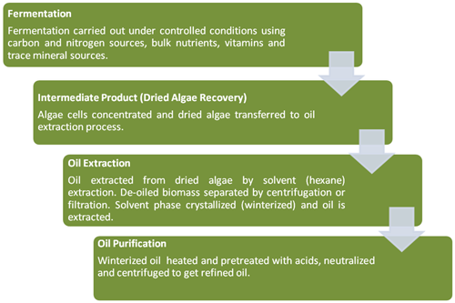

Figure 1

Yet, the industrial production of DHA so far has only focused on maximization of total DHA content, without much regard to its chemical form and its eventual bioavailability. As mentioned previously, the chemical form of DHA consumed has a significant effect on its absorption to the brain and as a result its value as a dietary supplement.

Digestion and absorption of lipids is a vast topic, yet a very brief overview might help you, the reader, to understand why, given the fact that LPC DHA is thought to be the primary form of DHA transport to the brain, it is so important for DHA to be in the phospholipid form. The majority of lipid digestion occurs in the small intestine. As the contents of the stomach enter the small intestine, bile containing bile salts, lecithin, and substances derived from cholesterol start to emulsify the fats. Emulsification increases the surface area by almost thousand-fold making lipids more accessible to the digestive enzymes. At this point the digestion of phospholipids and triglycerides slightly diverges. Since TG is a rather large, nonpolar molecule, it first needs to be disassembled with the assistance of the pancreatic triacylglycerol lipase which removes the fatty acids at position 1 and 3, resulting in 2 free fatty acids (FFAs) and a molecule of 2-monoacylglycerol (8). Subsequently, the monoglyceride and 2 FFAs are reesterified to TGs in the intestinal mucosa, are further joined with phospholipids and cholesterol to form chylomicrons. Chylomicron, a type of a lipoprotein, now enters the lymphatic system and is released into the bloodstream through the jugular vein in the neck. From then on chylomicrons transport TGs to various tissues. The phospholipid metabolism closely resembles that of TG with one exception - as pancreas liberates the proenzyme phospholipase A2, which is then converted into the active enzyme from trypsin, it removes the fatty acid at position 2 (sn-2) of the phospholipid. Once the fatty acid is removed, we are left with a lysophospholipid and a free fatty acid. Both of them get absorbed into chylomicron, with FFA becoming incorporated into the triglyceride. As can quite easily be seen, in order for our brain to effectively take up the DHA, its chemical form as well as position within the phospholipid need to be quite specific - otherwise enrichment of other tissues, but not the brain might take place. Interestingly, two main sources of DHA on the market are not equivalent in its efficacy. In fish oil, almost all of the DHA is in the neutral lipid (TG), while in krill oil roughly 35% of the DHA is in the phospholipid form (usually at sn-2 position of PC) with the rest in TG form, implying that krill oil might in fact be a better, albeit slightly, source of DHA for the brain.

As previously mentioned, DHA containing phospholipids have been noticed due to their specific functions and advantages over triacylglycerides e.g. superior accumulation and transportability across the blood brain barrier make *C. cohnii* studied hereby an attractive candidate for its industrial production.

It is quite time worthy to also remind the reader the basics of biosynthesis of DHA by various microorganisms in order to better appreciate the results of this study later on. In general, DHA is known to be synthesized through 2 pathways: one, the conventional fatty acid synthase (FAS) pathway and two, the polyketide synthaselike (PKS) pathway (9). In microorganisms with the FAS pathway, DHA is synthesized via alternating steps of desaturation and elongation; therefore, various kinds of PUFA including precursors of DHA are produced (10). On the other hand, in microorganisms with only the PKS pathway, their fatty acid profiles are most likely to be simpler because DHA is synthesized without intermediate products (11). In this study, *C. cohnii* was found to exhibit quite simple fatty acid composition, with DHA as the only major polyunsaturated fatty acid, consequently agreeing with the findings made by (12) which suggested PKS as a sole biosynthetic DHA pathway utilized by C. cohnii. Both illustrations taken from (13):

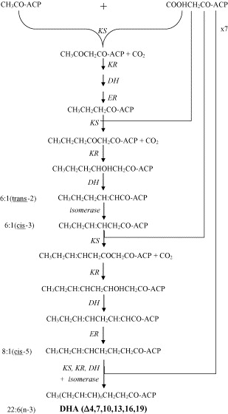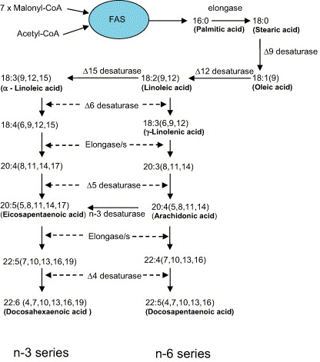

**Fatty acid synthase (FAS) pathway**

**Polyketide synthaselike (PKS) pathway**

In conclusion, given such a vast number of positive health effects on the brain associated with consumption of DHA, it is imperative that the optimal chemical form required for maximum bioavailability to the brain be produced. As stated previously, all clues point toward phospholipid form being the preferred form for the eventual uptake for the brain. With DHA industrial production being a multimillion dollar industry, it therefore quite appropriate to inquire into possible modifications of the industrial process in order to generate the appropriate form of DHA - one that can actually benefit our brains and protect us from a multitude of neurodegenerative disorders.

**Materials and Methods**

**Materials:**

All free fatty acids used as internal standards (15:0, 17:0, 22:3) were purchased from Nu-Chek Inc (Elysian, MN). C. cohnii strain ATCC 30772 was used for this experiment. C. cohnii cells were ordered from ATCC (30772) and stored in liquid nitrogen prior to cultivation. Two types of media were used: the starter medium (ATCC Culture Medium 460 A2E6) to inoculate the initial cultures and medium A, composed of (per liter): glucose (27 g), yeast extract (3.8 g) and sea salts (25 g) for the shake-flask cultures.(14) The pH of the medium was titrated to approximately 6.5 using hydrochloric acid (HCl) and sodium hydroxide (NAOH).

Challenges and Comments:

The choice of *Crypthecodinium cohnii*  as the subject of our experiments came about from studying the literature of the industrial production of docosahexaenoic acid (DHA). Other microalgal species such as *Schizochytrium* were also considered, however according to (15), DHA only constituted 32.29 to 39.14% of the total fatty acid composition, whereas *C. cohnii* were reported to have much higher DHA yield, routinely upwards of 40%. The two types of media that we used were taken from (14) as these were previously determined as the optimal conditions for growth and total DHA percentage maximization. Additionally, instead of using static flasks for growth, we grew the cells exclusively on the horizontal shaker set to 150 rpm, as these were shown to yield superior results.

**Culture Initiation:**

To initiate the culture, frozen ampoule was thawed by placing it in the water bath at 35°C, then immediately after thawing, the cells were aseptically transferred into a screw capped autoclaved test tube (10 mL) containing 5 mL of previously prepared ATCC Medium 460. Cells were subsequently grown for 5 days in ATCC Culture Medium 460, shaken continuously at 150 rpm on a horizontal shaker at room temperature. Upon visual inspection under a microscope to make sure that cells were mobile and active, 5 mL of ATCC 460 was added for the total of 10 mL. Subsequently, cells were split to three other 10 mL test tubes in order to ensure biological duplicates.

Challenges and Comments:

The procedure for the culture initiation was taken directly from ATCC product sheet.

**Initial Cell Growth:**

At the end of Day 7, cells were centrifuged (1000 rpm for 6 min.), the medium was discarded and cells were inoculated in 25 mL conical flask containing 10 mL of medium A with cells grown until confluence. Cells were then further inoculated in 250 mL conical flask, containing 100 mL of medium A and grown until confluence. All throughout the process, the cells were placed on a horizontal shaker at 150 rpm.

Challenges and Comments:

Few problems were encountered at this stage of the experiment. Two days after inoculation of the cells into media A, no cell growth or motility was observed. Initially, we suspected that the dilution ratio was too high, since, as mentioned in the ATCC product sheet, it is essential to first establish the culture in a small volume. We used our 10 mL culture replicate to test this hypothesis, however upon inoculating the cells with 10 mL of medium A (same as initial volume, no dilution) the same outcome was observed. At this point we suspected either our medium or the removal of ATCC 460 after centrifugation, which might have contained vital chemicals necessary for the first-phase growth of *C. Cohnii*. After further investigation it was determined that medium A was the culprit - after two week storage, it changed its pH value and became much more acidic (pH of 5.5). The pH was subsequently restored to its optimal value of 6.5 by adding an appropriate amount of dilute sodium hydroxide and cells from our third biological duplicate were inoculated in the volume of 25 mL of medium A. After restoring pH, cell motility and growth were re-established and upon reaching confluence, cells were further transferred to 250 mL conical flask containing 100 mL of medium A for the total volume of 125 mL. Cells were grown and shaken until confluence.

**Condition Experiments:**

A) Effect of varying initial cell density

Cells were split into 5 flasks – first three (3) were split based on different initial cell concentration - 25 mL of confluent cells was put in final volume of 125 mL, 200 mL, and 250 mL of cells combined with medium A (dilution factors of 1:5, 1:8 and 1:10). Aliquots of 10 mL were taken out daily, cell count was recorded as per 1ml of cell culture, aliquots were centrifuged and medium dispensed, cell were then frozen in phosphate buffered saline solution (2.5 mL). The remaining two flasks were used for cell propagation for further experiments.

Challenges and Comments:

In order to obtain an objective measurement of the environmental factors effect on the fatty acid composition of individual cells, determination of cell concentration throughout the course of the experiment was vital. To calculate the number of viable cells / mL, we followed the procedure outlined in (16) with few modifications. Since *C. cohnii* are not mammalian cells, we dispensed with Trypan-Blue treatment of the cells. Rather, we used the overall motility of the cells as a viability indicator. Since our cells were quite mobile, in order to obtain an accurate cell count, methanol (20 μL) was used to kill the cells. Daily aliquots of 10.5 mL were used - 10 mL was used for analysis, 0.5 mL was used as a cell count aliquot. Additionally, (16) suggests applying 100 μL of cell suspension to the hemocytometer, however in our case, the hemocytometer would not take more than 20 µL - hence we decided to only apply 20 μL and multiply by the recommended factor of 104. As our cells became more concentrated, it became necessary to dilute our .5 mL count suspension by a factor of 5 or 10, which was then taken into account during final cell count.

B) Effect of varying dodecane concentration

Based on the study done by (12) which concluded that the presence of n-dodecane positively affects the amount of DHA produced (both as total % of fatty acids (FA) and in terms of its dry weight), three flasks each containing 100 mL of medium A and inoculated with 25 mL of confluent cells from the cell propagation batch were prepared. Then, one was our control, while the remaining two were treated with 1.25 mL dodecane (1%) or .675 mL dodecane (.5%). Aliquots and cell count were performed as previously stated. Cells were grown for 7 days.

C) Effect of temperature variation

Based on the study (17) which concluded that different growth temperatures greatly affect both the % content of DHA as well the biomass concentration, three flasks each containing 100 mL of medium A and inoculated with 25 mL of confluent cells from the cell propagation batch were prepared. All three cultures were grown at different temperature: 15°C, 25°C and 35°C for seven days. Nevertheless, due to the difficulty of obtaining the aliquots, cell count and aliquots were obtained only during the first and last days of growth.

D) Effect of varying glucose concentration

To perform the next two experiments, medium A was slightly altered. In this study, media containing 3 different concentrations of glucose were prepared corresponding to x.5, x1 and x2 the glucose concentration used in all of the other studies. Cells were again grown for 7 days with cell counts and aliquots performed daily.

E) Effect of varying carbon source

Previous study by (12) reported that glycerol has a beneficial effect on DHA synthesis by *C. cohnii* . To investigate the effect of the carbon source, we varied the carbon source used by *C. cohnii* As in the previous study, three new flasks, each containing the medium A in which glucose, glycerol or acetate were used as carbon source. Care was taken to ensure that correct number of moles of carbon were present in 1L of medium. In short, the calculations yielded roughly (in g/L), 9.21 g/L of glycerol and 12.3 g/L of sodium acetate. Cells were grown in the same way as previously stated. Cell count and aliquots were taken out daily; aliquots were frozen in phosphate buffered saline solution.

Challenges and Comments:

Sodium acetate as a carbon source posed a significant problem in this study due to the rise in the pH level. Given 0.15M acetate concentration in our solution, pH expectedly rose to above 9, surpassing the recommended range by over 2 pH units. Also, quite expectedly the motility of the algae dropped and cells appeared still. Nevertheless, the pH level was not adjusted since cell number was increasing, implying that perhaps cell division still takes regardless of low motility.

**Lipid Extraction**

Lipids were extracted from the frozen saline/cell solution. Firstly, the cells were lysed with the freeze/thaw method. Each aliquot was initially thawed in water bath at 35°C, vortexed, then placed in liquid nitrogen for the total cycle of five repeats. Lipids were extracted using Bligh-Dyer method(18) (.9:1:1, water, methanol, chloroform), due to its simplicity, speed and relatively high total lipid content.

Challenges and Comments:

Algal cell walls, similarly to plant primary cell walls, consist largely of polysaccharides. In addition to cellulose, they can contain mannan (derived from mannose) or xylan (derived from xylose), which make their walls quite thick and resistant to lysis. Various cell lysis methods were considered, however after the preliminary analysis, the "freeze-thaw" method where the repeated cycles of freezing and thawing disrupt cells through ice crystal formation, was deemed sufficient. Additionally, for the lipid extraction method we considered two methods: Folch and Bligh-Dyer. However, based on the study (19) and with a safe assumption of less than 2% lipid content, we chose the Bligh-Dyer method due to its speed, simplicity and efficacy.

Out of each aliquot (2.5 mL), 0.8 mL of cell/saline suspension was taken out, 2 mL of methanol was added, the combination vortexed. Then, 1 mL of chloroform was added, tube vortexed, 1 mL chloroform again added, vortexed with final addition of 1 mL of deionized water. Entire content was again vortexed, centrifuged at 1000 rpm for 5 minutes, bottom chloroform layer was collected and stored for further lipid fractionation. The process was repeated once again to ensure total lipid extraction

**Lipid Fractionation**

Total lipid extract was evaporated under N2. Subsequently, 225 µl of CHCl3 was added together with 25 µL of each of the internal standards (15:0 TG and 17:0 PC, both of concentration 1 mg/mL) to yield the final volume of 275 µL. Sample was then vortexed, and approx. 50 µL was aliquoted and dissolved in 1 mL chloroform (total lipid fraction). The remaining total lipid extract (approximately 225 µL) was fractionated according to the procedure outlined by (20) using the aminopropyl (NH2) silica column. Firstly, the column was washed with chloroform (2 x 1.0 mL). Then the total extract and standards mixture was applied to the column. Column was then washed with 2 mL of chloroform (triglyceride, non-polar lipid fraction), followed by PC elution with chloroform - methanol (3:2, v/v; 1.5 mL) under gravity (phospholipid fraction). Lastly, the column was washed with methanol (2 mL) to remove any residual phospholipids and combined with the phospholipid fraction.

Challenges and Comments:

Initially, many different fractionation procedures were considered, however [8] was by far the most economical and time-saving. The separation quality of both neutral lipid and phospholipid was estimated using the internal standards 15:0 TG and 17:0 PC and was deemed to be satisfactory.

**Lipid Transmethylation**

Post-fractionation eluates were dried under N2. Samples were methylated using .5 mL Butylated Hydroxytoluene, combined with 1.5 mL of boron trifluoride in methanol (12-14% w/v). Unsaturated fatty acid 22:3 in the amount of 50 μg was added to samples as an internal standard. Sample were sealed with nitrogen to prevent oxidation and incubated on a hot stove at 90°C for 1 hour.

Challenges and Comments

Preparation of methyl esters of fatty acids for analysis by chromatographic means is one of the most important procedures in the analysis of lipids (21). Various methods can be employed towards transmethylation of fatty acids – one of the most common one includes using acidic reagent as a catalyst. Initially, boron trifluoride in methanol (12-14% w/v) was our transesterification catalyst of choice, however upon further research it was found that using commercial aqueous concentrated HCl (conc. HCl; 35%, w/w) as an acid catalyst yielded similar results. Both of these methods were used in sample preparation for the GC analysis.

**GC analysis**

The reaction mixtures were cooled and neutralized by adding 1 mL of deionized water, with fatty acid methyl esters isolated by addition of hexane (2 mL). Separation of organic and aqueous phases was achieved by centrifugation at 1000 rpm for 6 min at 25°C and collection of the hexane layer. The cycle was repeated for the complete extraction. The samples were evaporated under N2, redissolved in 20 µL of hexane and 1 µL was injected into GC/MS.

The analysis of fatty acid methyl esters (FAMEs) was carried out by GC/MS using Shimadzu QP2010SE equipped with a Supelco Omegawax column (30m x 0.25 mm x 0.25 µm film thickness). The temperature program was as follows: 165°C for 1 min, raised to 210°C at the rate of 6.5C/min, followed by raising to 240°C at the rate of 3.5C/min, and maintaining at 240°C for 10 min. The total analysis time was 26.5 min. The injection temperature was 250°C, ion source temperature 230°C and the interface temperature was 250°C. Total ion current in the range of 50-400 m/z was used to quantify the FAME, using 17:0 as the internal standard for the FAME derived from PC, and 15:0 for the FAME derived from TAG. The identification of individual FAME was done from comparison of retention times with the standard mixture (PUFA2, Sigma) as well as the characteristic fragment ions (m/z 74 for saturated, m/z 55 for mono unsaturated, m/z 67 for di-unsaturated, and m/z 79 for poly unsaturated).

**Post-Run Analysis**

The GC results were further analyzed with Microsoft Excel 2007. The calculation of the percentage of DHA as a fraction of total lipid, TG and PC was performed as follows: each value of sample's output was added vertically. Then from that sum, standards were subtracted along with all of the value of 18:0 and 25% of 16:0 (18:0 constitutes a negligible % of fatty acid composition in C. cohnii, it was therefore assumed to be a sample contamination. Empty test tubes were also analyzed and significant amounts of 16:0 were discovered, on the order of 25% of our average total sample output of 16:0. It was therefore assumed to be a sample contamination). The resulting sum was used as our % DHA denominator.

The calculation of the dry weight of PC DHA / 1 million cells at their peak value was done as follows: firstly, the total µg of each fatty acid was calculated by dividing each value by our standard and multiplying by 20 (in case of TG and PC fractions final weight of the standard was around 20 µg). Then each µg value was divided by # of cells in 10 mL of given extract. The result was then multiplied by the extraction factor (ratio of total extract volume/volume taken out for Bligh-Dyer extraction) and multiplied by 106 (# of μg / 1 million cells). Values were then plotted in Microsoft Excel.

**Results and Discussion:**

The purpose of this experiment was to study how different environmental factors affect the *C. Cohnii* DHA production, both in terms of absolute weight of the lipid, as well as, or even more importantly, in terms of the different lipids that DHA can be incorporated into. What is shown is the amount of DHA as a percentage of total lipids, triacylglycerols and phospholipids with regard to different environmental factors as well as the total amount of micrograms of PC FAs/ 1 million cells at the highest ratio of PC DHA / # of cells.

1. 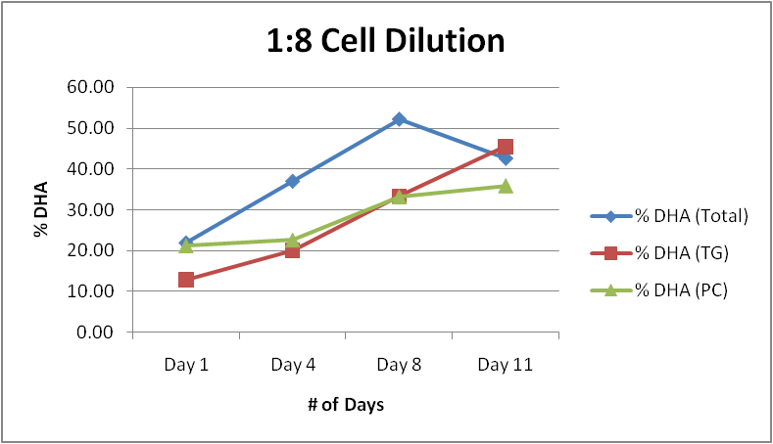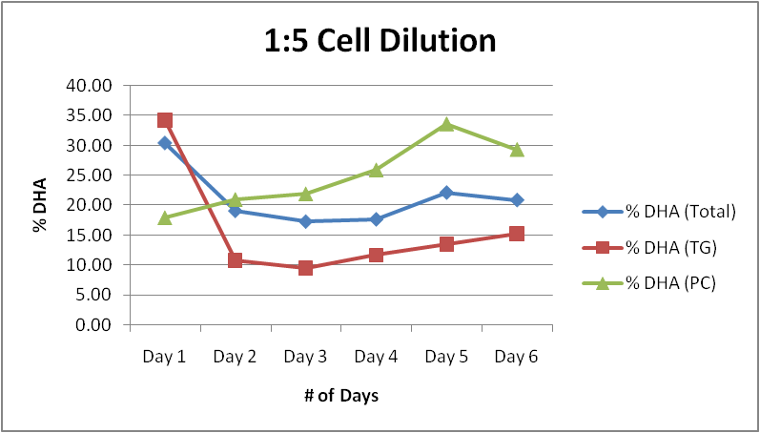Effect of varying initial cell density

Figure A1 Figure A2

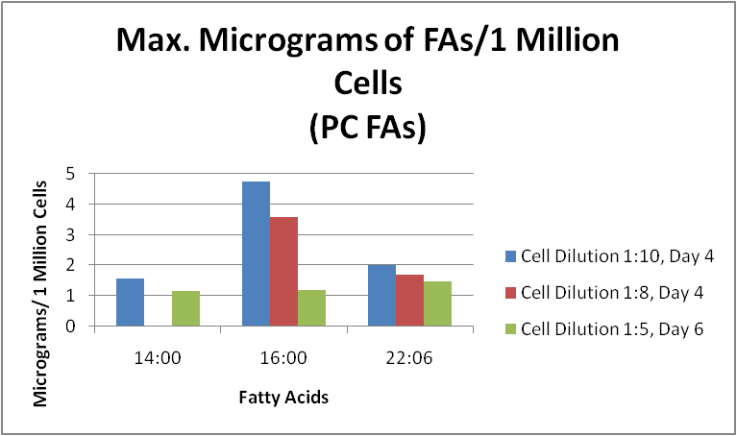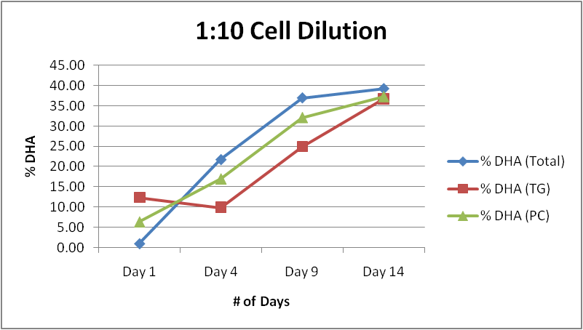Figure A3 Figure A4

It is quite evident that cell proliferation rate greatly affected the distribution and integration of DHA into different chemical forms. During the periods of high cell division (rapid growth), the percentage of DHA in a phospholipid form was greater than in a neutral lipid form, implying that harvesting the cells at its highest division time rather than its peak density will maximize the raw % of DHA incorporated into PC vs. TG form. Figure A4 presents the absolute weight of PC DHA in μg / 1 million cells taken out during the time of highest PC DHA / cells ratio.

Comments:

As can quite easily be seen, the timeframe of these three experiments was quite different which due to very low cell density in 1:10 and 1:8 experiments, necessitated longer timeframes in order to obtain meaningful data. Nevertheless, the 1:5 dilution study was done first, before 1:8 and 1:10 cells were grown. A very interesting trend has come to our attention as far as the cell generation after cell retrieval from liquid nitrogen. "First generation" cells were much more varied as far as their fatty acid composition - while 14:0 and 16:0 still predominated as a saturated fatty acid species (on average 50%), other fatty acids also play a major role, most notably 18:1. Oleic acid constituted close to 10% of total fatty acid composition in the 1:5 generation, while representing less than 3% in the subsequent studies. As stated, the overall fatty acid composition was much more even which led to the overall low percentage of total DHA as compared to e.g. 1:10 or 1:8 dilution studies. One of the possible directions that might be taken in the future studies would be to observe the changes in the total fatty acid composition occurring at the subsequent generations of *C. cohnii* after long liquid nitrogen-hibernation storage. Another direction that this result might lead to is the study of possible modifications to biosynthesis pathway utilized by *C. cohnii* after a long hibernation time, as mentioned in the introduction.

As Figure A4 demonstrates the absolute amount of DHA in the PC form taken out at their highest PC DHA / # of cells ratio is much greater when cells' initial concentration is minimized. As we increase the dilution factor, we increase the dry weight of PC DHA / 1 million cells. This is to be expected, since PC DHA plays an integral role in the cell membrane of *C. cohnii,*  hence as they multiply, their amount of DHA in the PC form is maximized. It is also interesting to note that when we compare the absolute weight of PC DHA / 1 million cells on the last day of the experiment, it greatly decreased, while TG DHA increased, implying that as cells became confluent, DHA started being incorporated into TG as means of long-term energy storage.

1. Effect of different carbon sources

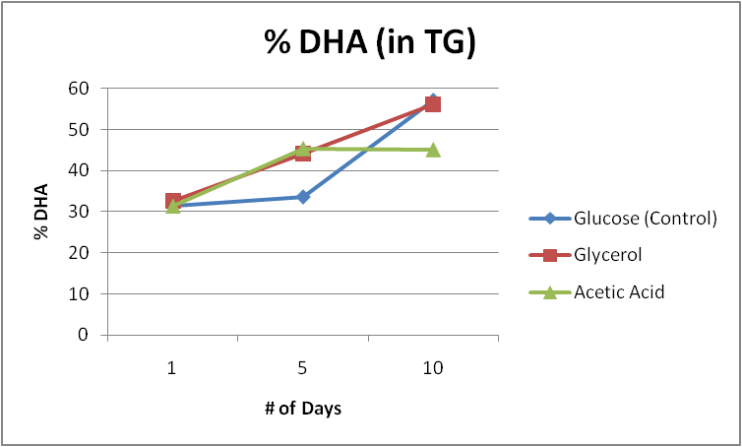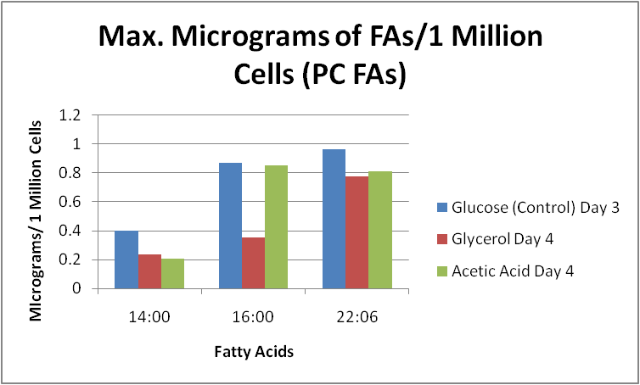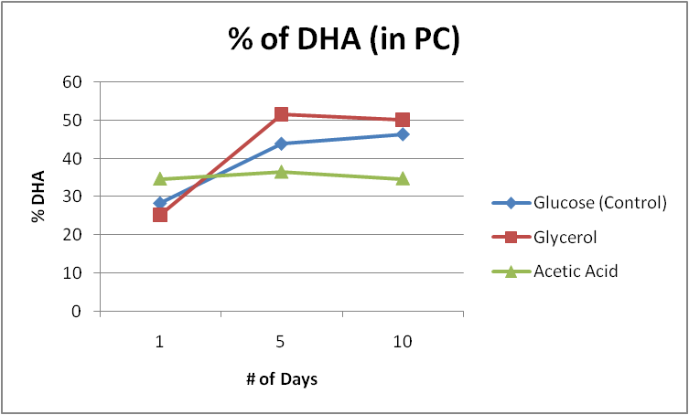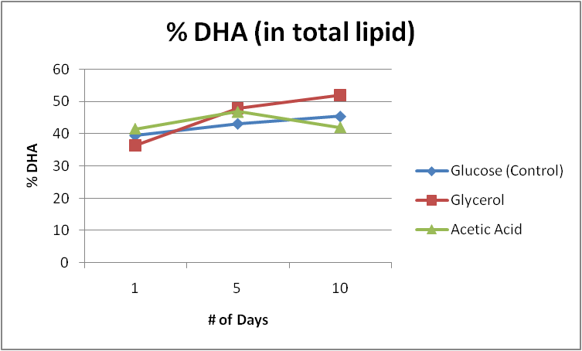Figure B1 Figure B2

Figure B3 Figure B4

Varying the carbon source provided to *C. cohnii* and the effect on DHA distribution among neutral and phospholipids has been the focus of this part of the study. Care was taken to ensure the same molar amount of carbon provided by each source. Figures B1, B2 and B3 provide the percentage distribution of DHA among all three species and Figure B4 provides the information about the amount of PC DHA per each carbon source as an amount of µg / 1 million cells at the highest ratio of PC DHA / # of cells.

Comments:

The total amount of DHA as a fatty acid percentage has uniformly increased in all three carbon sources, albeit the highest percentage was achieved by glycerol. The neutral lipid distribution of DHA showed an increase of TG DHA across all three carbon sources, yet during the first 5 days acetic acid and glycerol both proved superior to the glucose. In fact, sodium acetate proved to be a poor carbon source across all three categories after day 5. Lastly, as expected, the % of DHA in phospholipid started to decrease after day 5. However in case of acetate, the final % was quite low as compared to both glucose and glycerol.

Glycerol was found to be the optimal carbon source for the maximization of % of TG DHA - suggesting that it is easily metabolized and utilized in DHA biosynthetic pathway and that it is directly used as the backbone of TG synthesis. Nevertheless, the amount of PC DHA, even when taken at its highest PC /# of cells ratio, did not differ by much across all three carbon sources, with glycerol actually coming in last and our control coming closely to "standard" 1:5 dilution factor in the previous study. One of the reasons was the unusually fast growth of cells under glycerol - on Day 3, the concentration of cells was almost twice that of glucose or acetate, while the mass in µg of PC DHA even though higher in absolute amount, was less than in glucose or acetate.

C) Effect of varying glucose concentration

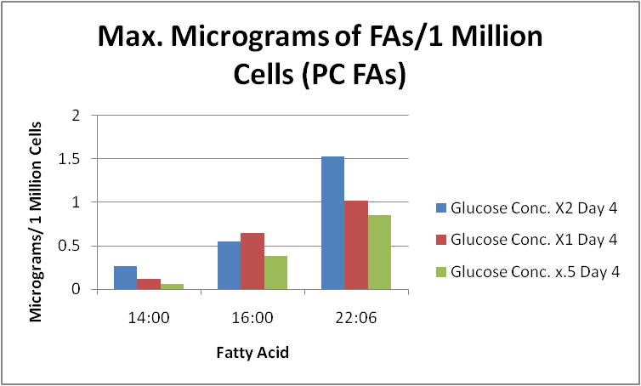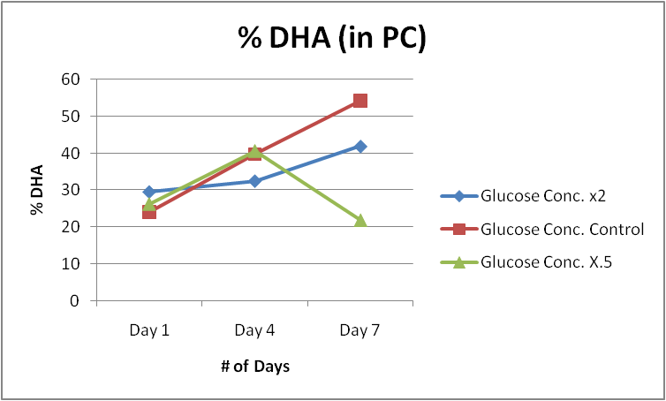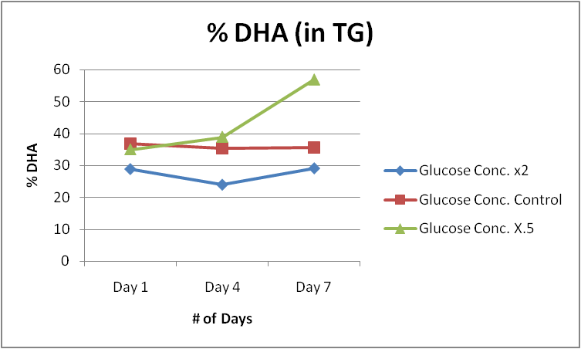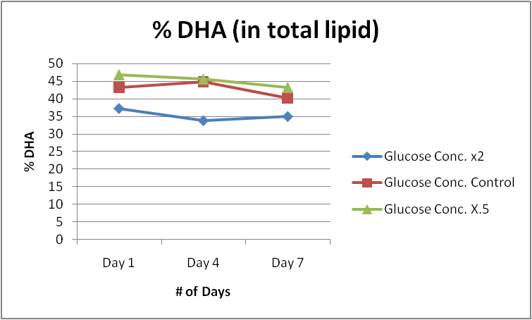Figure C1 Figure C2

Figure C3 Figure C4

Varying the glucose concentration provided to *C. cohnii* and the effect on DHA distribution among neutral and phospholipids has been the focus of this part of the study. Figures C1, C2 and C3 provide the percentage distribution of DHA among all three species and figure C4 provides the information about the amount of PC DHA per each glucose concentration as an amount of µg / 1 million cells at the highest ratio of PC DHA / # of cells.

Comments:

The total amount of DHA as % of total fatty acid composition has remained relatively stable throughout this experiment as opposed to the other studies. The possible reason for this is that upon inoculation, the cells were not diluted enough (perhaps the inoculant was more concentrated that in the other experiments) lowering the division rate of the algae and causing the fatty acid distribution to remain relatively stable. Nevertheless, an interesting result came from the cells that were treated with half of the normal glucose concentration: in the last 3 days, the % of DHA in TG increased dramatically while at the same time significantly decreasing the % of DHA in PC form. This very strongly suggests that as carbon source is being exhausted, *C.cohnii* cells switch from rapid division to stagnant phase, changing the distribution of DHA from phospholipid to neutral lipid from for long-term energy storage. *C. cohnii* cells sense the lack of nutrients and increased cell population and integrate their long-chain fatty acid (DHA) into the more stable triglyceride form. However, quite expectedly, in terms of µg of PC DHA / 1 million cells, the higher the concentration of the carbon source, in this case glucose, the higher the maximum amount of DHA. All of the concentrations were harvested at their peak absolute amount, yet it is clear that doubling the glucose from the normal increases the dry weight of DHA more than doubling the glucose from x0.5 to standard concentration, implying that microalgae cells might have the ability to sense the overall abundance of nutrients around them and change their overall fatty acid production (especially phospholipids due to cell division) to reflect those conditions accordingly. The relative stability of % of TG DHA throughout this study is unexpected - however if we analyze the results from published studies, all of them estimate the % of DHA in TG to hover around 40% on Day 7 - had we extended this study a few days more, we'd expect a rapid increase in TG DHA.

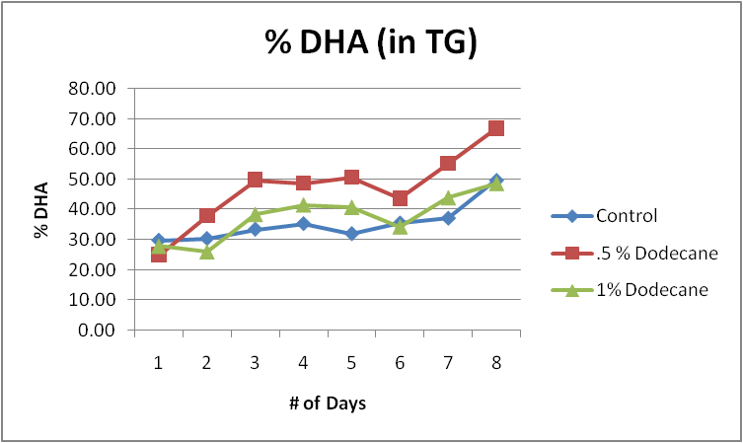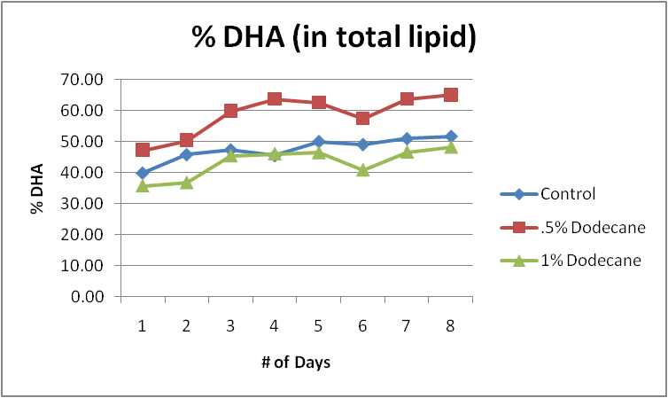 D) Effect of different dodecane concentrations

Figure D1 Figure D2

Figure D3 Figure D4

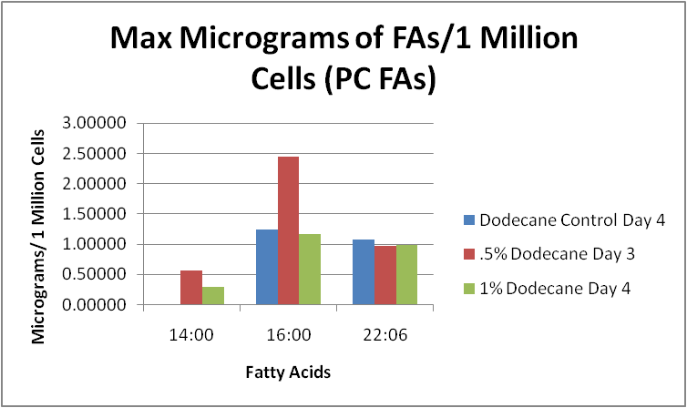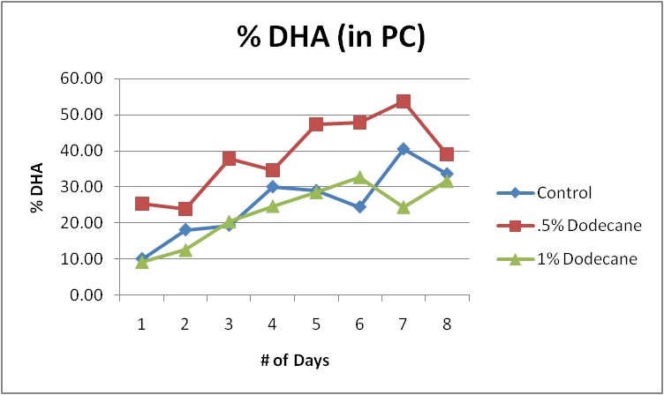

Varying the dodecane concentration provided to C. cohnii and the effect on DHA distribution among neutral and phospholipids has been the focus of this part of the study. The reason for this experiment comes from the study (12), where it was shown that the biomass concentration, the specific growth rate, the DHA, and total fatty acids (TFA) production were higher in Dodecane treated cells. Figures D1, D2 and D3 provide the percentage distribution of DHA among all three species and figure D4 provides the information about the amount of PC DHA per each dodecane concentration as an amount of µg / 1 million cells at the highest ratio of PC DHA / # of cells.

Comments:

As % of the total fatty acid composition, across all three categories, .5% dodecane turned out to be the optimal dodecane concentration with the final % of DHA much higher than either control or 1% dodecane. A quite expected trend of a significant increase in % of DHA in TG after Day 6, yet in terms of raw % values, 0.5% dodecane yielded the highest value. Nevertheless, quite the opposite trend, occurred upon extraction of cells at their highest PC DHA / # of cells ratio, where 0.5 % dodecane did not yield any significant increase in PC DHA dry weight per million cells. In fact, across all three categories. PC DHA yield remained relatively constant, close to the control. More interestingly, in 0.5% dodecane treated cells, we noted a significant increase of 16:0, and lesser increase of 14:0, and almost no significant differences in 1% dodecane concentration treated cells. Nevertheless, µg of TG DHA / 1 Million Cells at the last day of the experiments yielded, quite expectedly, a much higher result in dodecane treated cells vs. control cells - in fact, (data not shown here) the yield of µg of TG DHA was highest in 1% dodecane treated cells, almost doubling that of the control, agreeing with results by [silva].

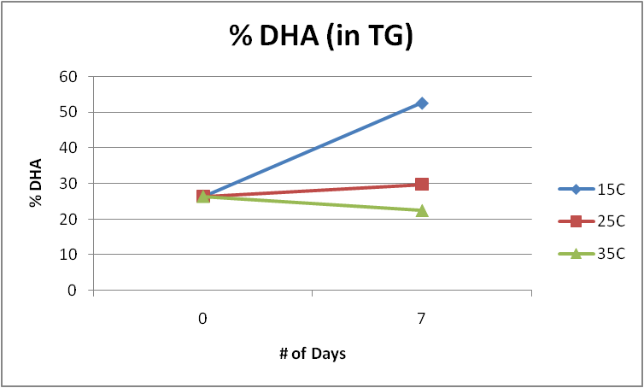 E) Effect of Temperature Variation

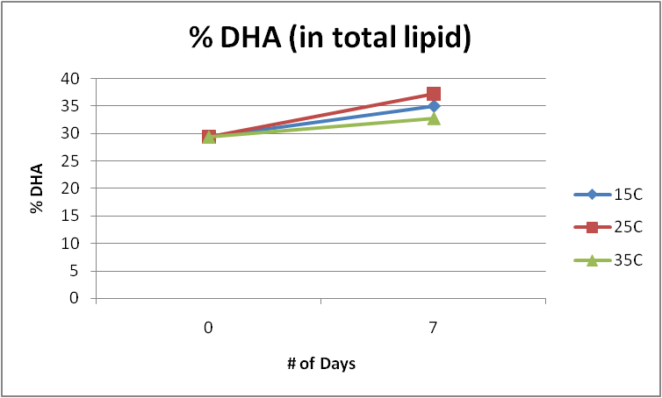Figure E1 Figure E2

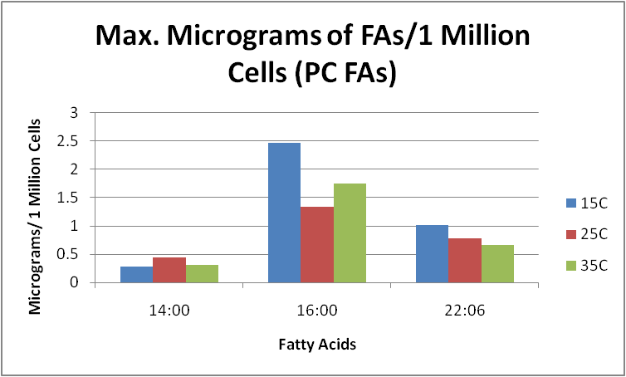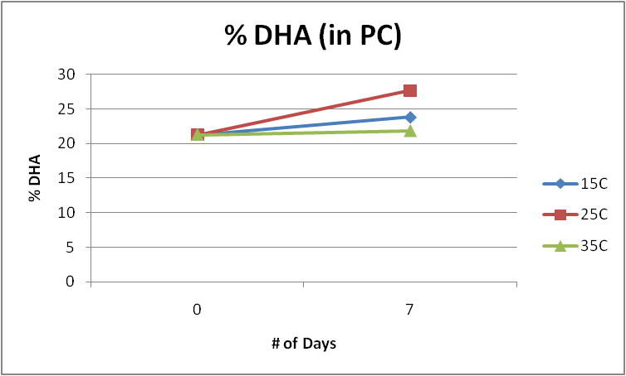Figure E3 Figure E4

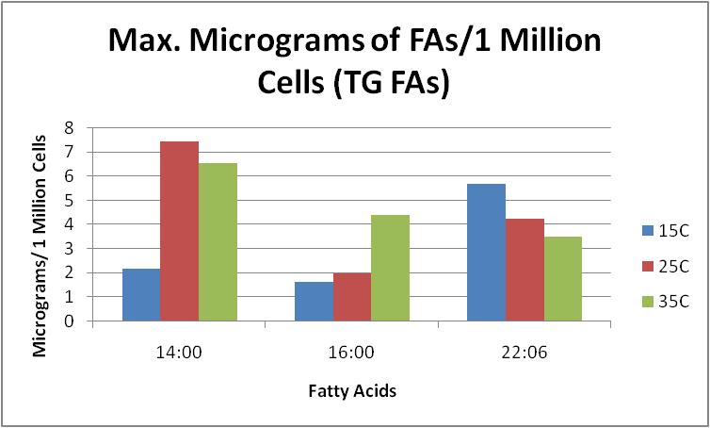Figure E5

Varying the growth temperature of *C. cohnii* and the effect on DHA distribution among neutral and phospholipids has been the focus of this part of the study. Figures E1, E2 and E3 provide the percentage distribution of DHA among all three species, figure E4 provides the information about the amount of PC DHA at each temperature in µg / 1 million cells at the highest ratio of PC DHA / # of cells, whereas figure E5 provides the information about the amount of TG DHA at each temperature in µg / 1 million cells at the highest ratio of TG DHA / # of cells.

Comments:

During this study, only two aliquots were taken - at the start and at the end of the 7-day experiment due to physical constraints of our setup. Nevertheless, quite a few inferences can be made from the data obtained. Firstly, the final % of DHA in total lipid increased the most at 25°C, albeit the difference was quite low. More interestingly, in neutral lipid (TG) DHA constituted over 50% of all fatty acids - almost 20% higher as compared to our control and 35°C. Nevertheless, the final % of PC DHA in 15°C was actually lower than the control (25°C) which implies that, quite possibly, during the course of 7 days, *C. cohnii* in 15°C flask, in order to increase the fluidity of their membranes due to lowered temperature, they switched quite radically towards unsaturated fatty acid synthesis (in this case DHA in PC form), and once their concentration increased, started to incorporate the DHA into TG form for long-term storage. For the final dry weight of PC DHA our 15°C yielded the highest dry weight, albeit not significantly so. Yet, as opposed to other studies, I have also included the final yield of DHA in TG form, which unsurprisingly, shows an increase of TG DHA yield in 15°C as opposed to 25°C and 35°C. Also, quite expectedly, the amount of saturated fatty acids was much higher in 35°C than 15°C, confirming the fact that as temperature lowers, *C. cohnii* tends to product more unsaturated fatty acids in order to increase its membrane permeability. What is also noteworthy is that the growth rate of *C. cohnii* was inhibited at both 15°C and 35°C - whereas the cell count at the end of Day 7 exceeded 3 million cells/ mL in temperature of 25°C, it decreased to below 1.5 million in both 15°C and 35°C.

**Conclusion:**

Figure 2

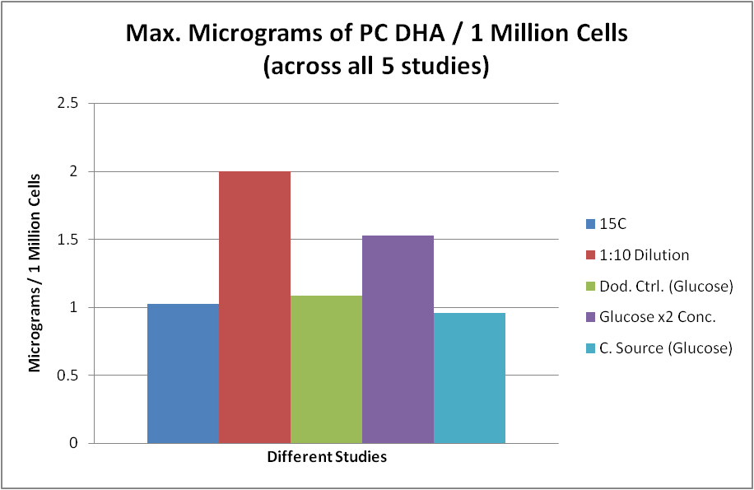

As stated previously, the purpose of this experiment was to study how different environmental factors affect the *C. Cohnii* DHA production, the different chemical forms that DHA will be in, both in terms of absolute weight of the lipid as well as in raw percentages. Each study has shown the amount of DHA as a percentage of total lipids, triacylglycerols and phospholipids with regard to different environmental factors as well as the total amount of micrograms of PC FAs/ 1 million cells at the highest ratio of PC DHA / # of cells.

The overall conclusion can be drawn from Figure 2 which quite succinctly summarizes the overall findings of the experiment. Using 5 different environmental factors as our variables and the amount of PC DHA / 1 million cells as our outcome, it can be stated that neither lowering the temperature, adding dodecane nor varying the carbon source yielded any significant differences in dry weight of PC DHA. The only two factors that affected our outcome were the dilution factor of our cells (by how much we diluted the cells in terms of initial : final volume of the cell suspension) and how much glucose was placed into the growth medium. This lies in stark opposition to a variety of studies hitherto cited which have shown quite significant increases in DHA when *C. cohnii* were exposed to dodecane, different carbon sources and temperature. Nevertheless, most of these studies focused on the total or neutral lipid form of the DHA and not the phospholipid, which according to very recent studies is the more bioavailable form of DHA and which, in near future, might be the recommended form of DHA to be produced.

The results of this study can be used to maximize the production of phospholipid DHA in the industrial setting.

**REFERENCES**

|  |  |
| --- | --- |
|  |  |
|  |  |

1. Greenberg JA, Bell SJ, Ausdal WV. Omega-3 Fatty Acid Supplementation During Pregnancy. Reviews in Obstetrics and Gynecology. 2008;1(4):162-169.
2. Wataru Komatsu, Kenji Ishihara, Masakazu Murata, Hiroaki Saito, Kazuki Shinohara, Docosahexaenoic acid suppresses nitric oxide production and inducible nitric oxide synthase expression in interferon-γ plus lipopolysaccharide-stimulated murine macrophages by inhibiting the oxidative stress, Free Radical Biology and Medicine, Volume 34, Issue 8, 15 April 2003, Pages 1006-1016
3. Bradbury J. *Docosahexaenoic acid* (*DHA): an ancient nutrient for the modern human brain*. Nutrients. 2011;3:529-554. Bazan NG, Molina MF, Gordon WC.

|  |  |
| --- | --- |
|  |  |

1. Barros MP, Poppe SC, Bondan EF. Neuroprotective Properties of the Marine Carotenoid Astaxanthin and Omega-3 Fatty Acids, and Perspectives for the Natural Combination of Both in Krill Oil. *Nutrients*. 2014;6(3):1293-1317. doi:10.3390/nu6031293.
2. Nguyen, L. N., D. Ma, G. Shui, P. Wong, A. Cazenave-Gassiot, X. Zhang, M. R. Wenk, E. L. K. Goh, and D. L. Silver. 2014. Mfsd2a is a transporter for the essential omega-3 fatty acid docosahexaenoic acid. Nature 509: 503-506.
3. Zhao Z, Zlokovic BV. Blood-Brain Barrier: A Dual Life of MFSD2A? *Neuron*. 2014;82(4):728-730. doi:10.1016/j.neuron.2014.05.012.
4. Omega_3 Fatty Acids, DHA,EPA, Algae - Oilgae - Oil from Algae. (n.d.). Retrieved April 27, 2016, from http://www.oilgae.com/non_fuel_products/omega_3fattyacids.html
5. NUTRIOLOGY | DIETARY LIPID METABOLISM. (n.d.). Retrieved April 27, 2016, from http://www.nutriology.com/TGmetab.html
6. Biosynthesis of docosahexaenoic acid (DHA, 22:6-4, 7,10,13,16,19): two distinct pathways, Qiu, Xiao,Prostaglandins, Leukotrienes and Essential Fatty Acids , Volume 68 , Issue 2 , 181 - 186
7. Ruiz-Lopez N, Usher S, Sayanova OV, Napier JA, Haslam RP. Modifying the lipid content and composition of plant seeds: engineering the production of LC-PUFA. *Applied Microbiology and Biotechnology*. 2015;99:143-154. doi:10.1007/s00253-014-6217-2.
8. Okuda, T., A. Ando, E. Sakuradani, J. Ogawa. Isolation and characterization of a docosahexaenoic acid-phospholipids producing microorganism Crypthecodinium sp. D31. J. Am. Oil Chem. Soc., **90 (12)**, 1837-1844 (2013)
9. T.L. da Silva, A. Mendes, R.L. Mendes, V. Calado, S.S. Alves, J.M.T. Vasconcelos, *et al.* Effect of n-dodecane on *Crypthecodinium cohnii* fermentations and DHA production, J. Ind Microbiol Biotechnol, 33 (2006), pp. 408–416
10. C. Ratledge Fatty acid biosynthesis in microorganisms being used for single cell oil production Biochimie, 86 (2004), pp. 807–815
11. C. Ratledge, K. Kanagachandran, A.J. Anderson, D.J. Grantham, J.C. Stephenson Production of docosahexaenoic acid by *Crypthecodinium cohnii* grown in a pH auxostat culture with acetic acid as principal carbon source Lipids, 36 (2001), pp. 1241–1246
12. Y. Jiang, K.-W. Fan, R.T.-Y. Wong, F. Chen, Fatty acid composition and squalene content of the marine microalga *Schizochytrium mangrovei* J Agric Food Chem, 52 (2004), pp. 1196–1200
13. "Counting Cells Using a Hemocytometer." *Antibodies, Proteins, Kits and Reagents for Life Science*. Web. 27 Apr. 2016.
14. Jiang Y, Chen F. Effects of temperature and temperature shift on docosahexaenoic acid production by the marine microalgae Crypthecodinium cohnii. J Am Oil Chem Soc. 2000;77:613–617.
15. Bligh E G & Dyer W J. A rapid method of total lipid extraction and purification. Can. J. Biochem. Physiol. 37: 911-917, 1959
16. Iverson, S. J., S. L. C. Lang & M. H. Cooper. 2001. Comparison of the Bligh and Dyer and Folch methods for total lipid determination in a broad range of marine tissue. *Lipids* 36:1283–1287
17. Caesar PA, Wilson SJ, Normand CS, Postle AD. A comparison of the specificity of phosphatidylcholine synthesis by human fetal lung maintained in either organ or organotypic culture. *Biochemical Journal*. 1988;253(2):451-457.
18. Christie WW (1982) A simple procedure for rapid transmethylation of glycerolipids and cholesteryl esters. Journal of Lipid Research 23: 1072–1075.