**COMP229 – Web Application Development**

**Welcome:**

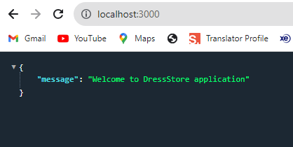

**Get All Products: (/api/products)**

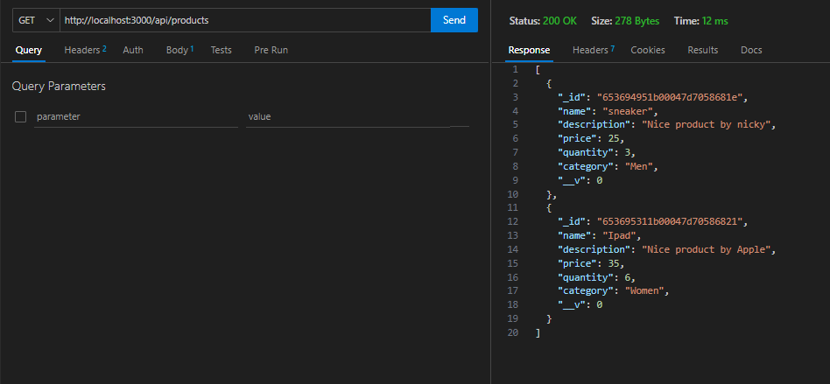

**Get Product by Id: (/api/products/:id)**

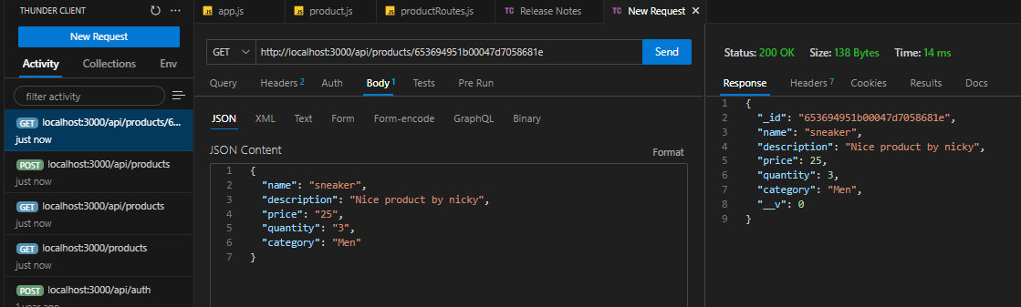

**Post Product: (/api/products)**

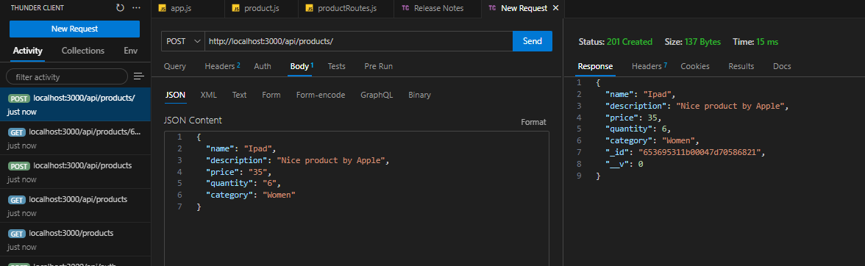

**Put Product: (/api/products/:id)**

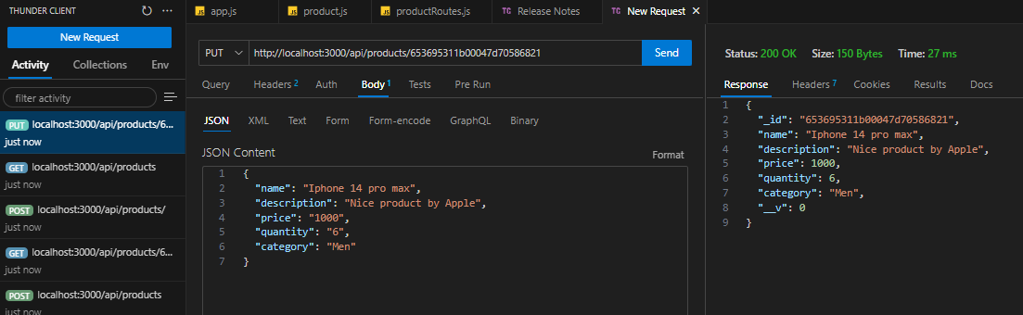

**Delete Product: (/api/products/:id)**

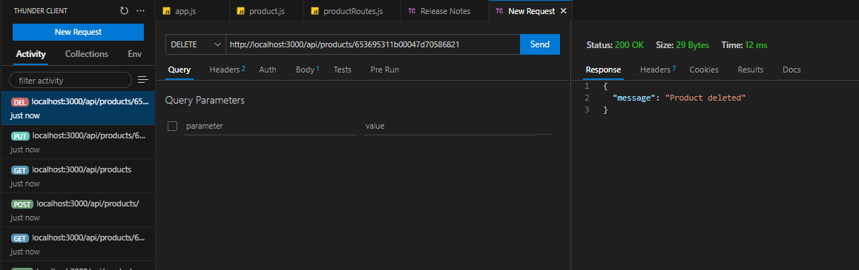

**Delete All Products: (/api/products)**

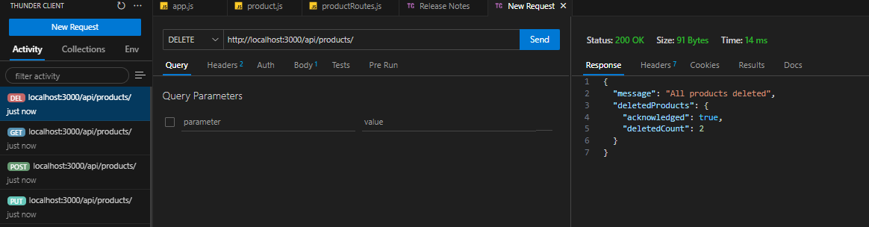

**Get by Name of the Product: (/api/products?name=[sneaker])**

