**Zomato Data Analysis**

1. 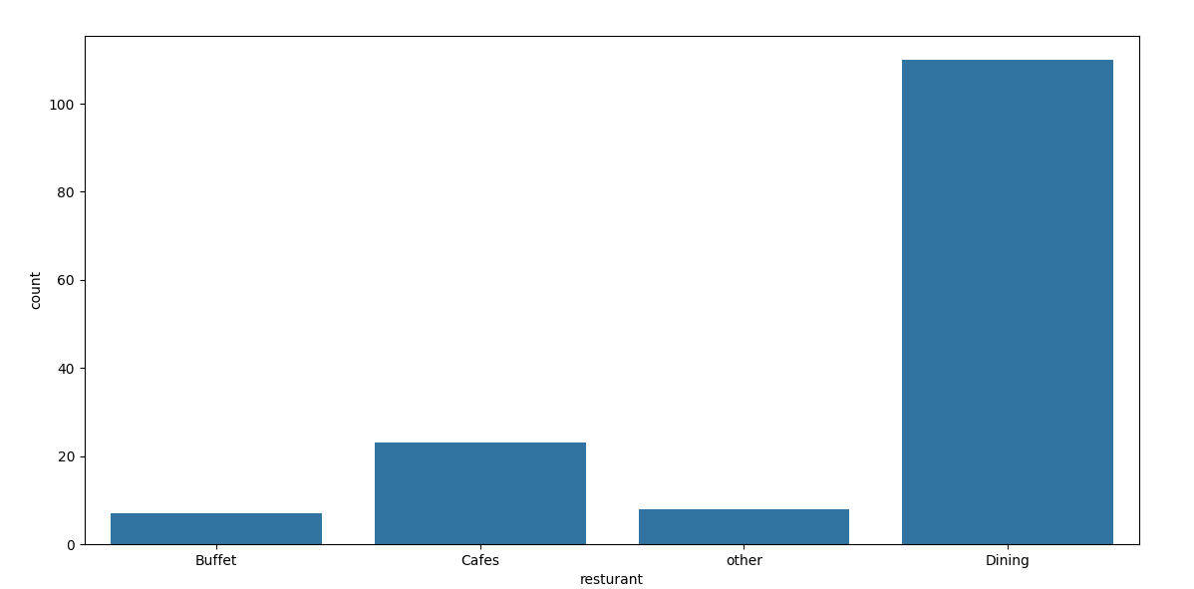**what type of restaurant do the majority of customers order from**
2. 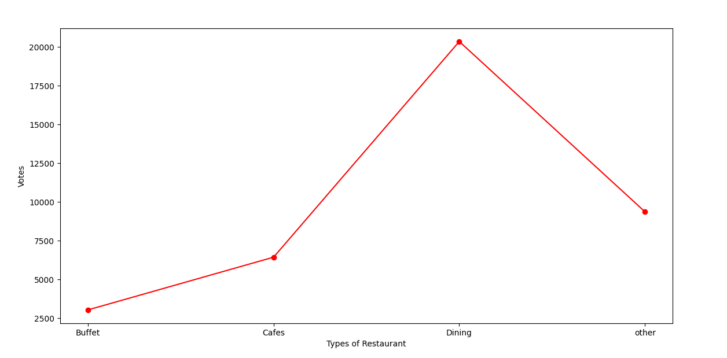**how many votes has each types of restaurant received from**
3. **what are the rating that the majority of restaurant have customer**

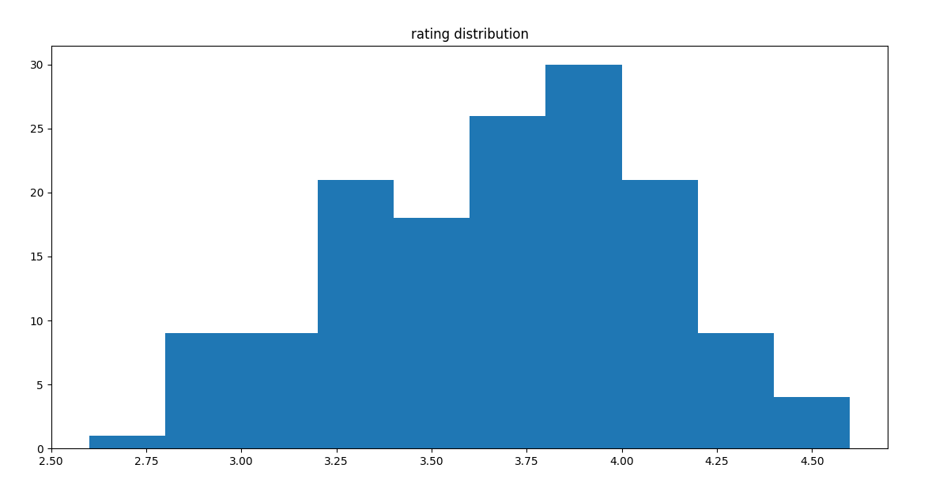

1. **Zomato has observed that most couples order. most of their food online what is the average spending on each order**

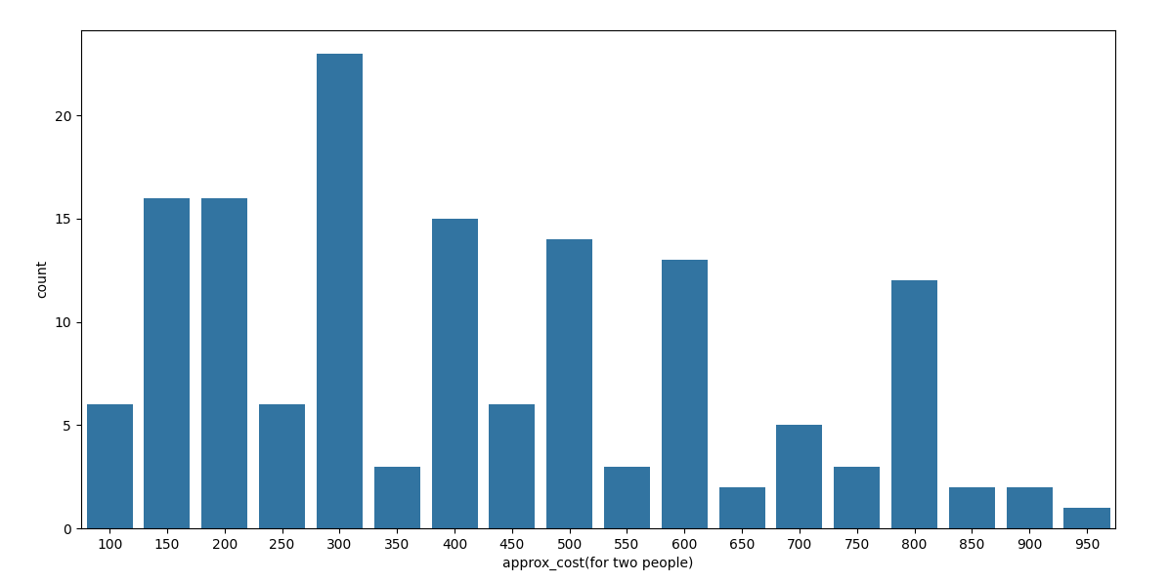

1. **which mode (online or offline) has received the maximum rating**

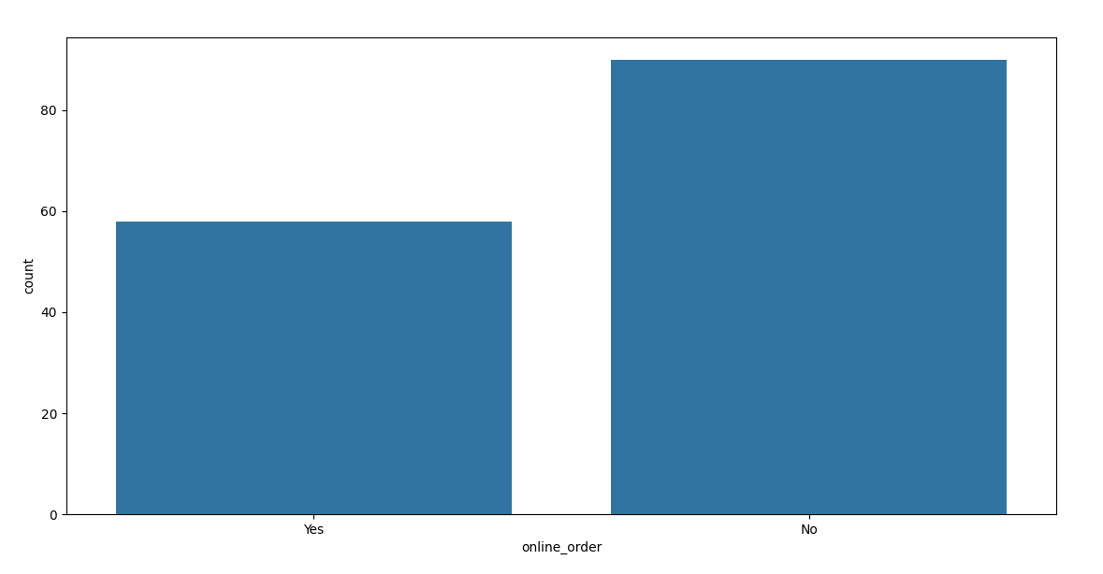

1. **which type of restaurant received moere offline orders, so that Zomato can provide customers with some good offers.**

