READ ME

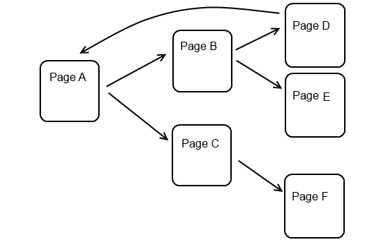

Working :

1. User gives the input URL for the Website they want to search and the search word which they want to search in that Webpage
2. The Search word is then subjected to removal of stopwords and giving a string containing only the keywords. List of stopwords are present in a file. Each stopwords are compared to each word given in the user input and if matched that particular word is dropped from the phrase there by giving you a string containing only the key words.
3. Then a function is called to get MAX 20 links linked with the URL specified by the user (using the concept of Webcrawler)
4. The Keywords are then searched with each body of the webpages links found. If all the keywords are present in a particular page then that webpage is returned with a success tag denoting that the user search word is found in that page.

Steps to run the project:

1. Open Eclipse and import the Maven project present in the submitted folder
2. Specify the path of the stopwordlist.txt file in function stopWordSeparation , which contains a list of stopwords.(This file is resent in the path “CS600-project/SearchEngine/src/com/search/engine/stopwordslist.txt “)
3. Then Update the maven project to include the necessary jars for this project.
4. Then run the project.
5. In the console window, please provide the input webpage URL and the Search word/Phrase.
6. The Output for the URLs associated to this page and the pages which contain the keywords mentioned are displayed.