**Question 3**

1. **0001100010000000000001010000**
2. AluOp = 00

Control input = 010100

1. PC+ 4

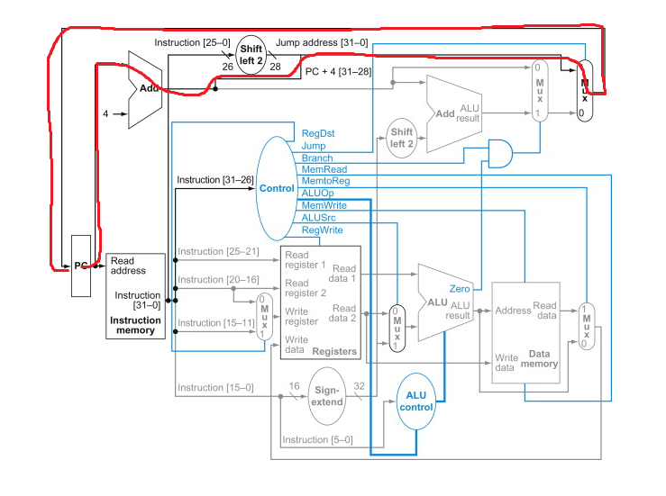

1. RegMux : X

Alu Mux: 0x00000014

Mem/Alu Mux: X

Branch Mux: Pc + 4

Jumpmux: Pc+ 4

1. ALU: -3 and 0x00000014

PC add: PC , 4

Branch add: Pc+ 4 and 0x00000014

RegWrite: 0

Reg A :3 Reg B : 2

Write Reg: X

Write Data: X

**Question 4**

Pc -> Instruction Memory -> Registers -> Mux -> ALU -> AND -> MUX ->PC

So 750 + 300 + 50 + 250 + 5 + 50 = 1405