Dr. Macadamia
1. Introduction
In commercial agriculture, early and accurate diagnosis of pests and diseases is critical for yield protection. This expert system provides a reliable diagnostic tool for Macadamia farmers by utilizing a rule-based approach to differentiate between similar-looking conditions. The system implements a hybrid inference engine featuring Forward Chaining for data-driven discovery and Backward Chaining for hypothesis verification.
2. Knowledge Representation
The system’s knowledge is encapsulated in a Knowledge Base (KB) consisting of unique facts and production rules.
2.1 Fact Base
The system tracks the following symptoms, environmental variables, and derived conclusions to satisfy the project requirements:
- Symptoms: yellow_leaves, wilting, water_logged_soil, holes_in_husk, sawdust_frass, larvae_present, yellow_spots_on_husk, high_humidity, sticky_honeydew, black_sooty_mould, white_powdery_mould.
- Derived Diagnoses: suspect_root_rot, diagnose_phytophthora, suspect_nut_borer, diagnose_borer_infestation, diagnose_husk_spot.
- Final Recommendations: recommend_drainage, apply_pesticide, apply_fungicide.

2.2 Rule Base
The system utilizes 10 production rules following the IF-THEN format:
- Rule R1 (Priority 1): IF yellow_leaves AND water_logged_soil THEN suspect_root_rot.
- Rule R2 (Priority 5): IF suspect_root_rot AND wilting THEN diagnose_phytophthora.
- Rule R3 (Priority 10): IF diagnose_phytophthora THEN recommend_drainage.
- Rule R4 (Priority 1): IF holes_in_husk AND sawdust_frass THEN suspect_nut_borer.
- Rule R5 (Priority 5): IF suspect_nut_borer AND larvae_present THEN diagnose_borer_infestation.
- Rule R6 (Priority 10): IF diagnose_borer_infestation THEN apply_pesticide.
- Rule R7 (Priority 5): IF yellow_spots_on_husk AND high_humidity THEN diagnose_husk_spot.
- Rule R8 (Priority 10): IF diagnose_husk_spot THEN apply_fungicide.
- Rule R9 (Priority 5): IF sticky_honeydew AND black_sooty_mould THEN diagnose_aphid_attack.
- Rule R10 (Priority 5): IF white_powdery_mould THEN diagnose_powdery_mildew.

3. Inference Engine Architecture
The system implements a hybrid logic engine capable of both directions of reasoning.
3.1 Forward Chaining (Data-Driven)
Forward chaining starts with known facts and applies rules to derive new facts until the goal is reached. This is the primary method used for autonomous diagnosis based on farmer observations.
3.2 Backward Chaining (Goal-Driven)
Backward chaining starts with the goal and works backward to find supporting facts. This is utilized for verifying specific hypotheses or treatment recommendations.

4. Conflict Resolution Strategy
To handle scenarios where multiple rules are eligible to fire simultaneously, the system uses Priority Sorting (Salience). Each rule is assigned a priority value. The engine sorts the active rules in descending order, ensuring that critical treatment recommendations (Priority 10) are prioritized over intermediate suspicions (Priority 1).

5. System Test Cases
Test Case A: Forward Chaining Diagnostic Path
- Input Facts: yellow_leaves, water_logged_soil, wilting
- Reasoning Path: 1. R1 triggers (priority 1) and adds "suspect_root_rot" to the knowledge base.
2. R2 triggers (priority 5) and adds "diagnose_phytophthora" to the knowledge base.
3. R3 triggers (priority 10) and adds "recommend_drainage" to the final conclusions.
- Result Evidence: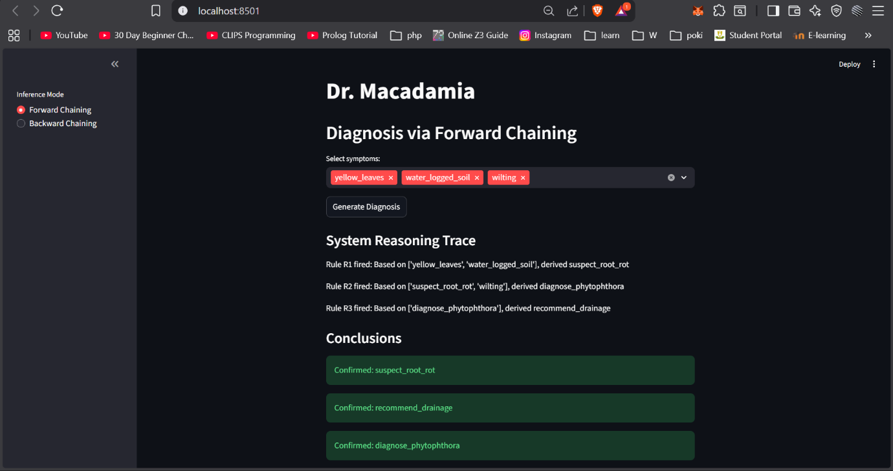
Test Case B: Priority-Based Conflict Resolution
- Input Facts: yellow_leaves, water_logged_soil, wilting, yellow_spots_on_husk, high_humidity
- Reasoning Path: Both R1 and R7 are triggered initially. Due to the higher priority value, the system fires R7 (priority 5) first to derive "diagnose_husk_spot" before proceeding with the secondary root rot chain.
- Result Evidence: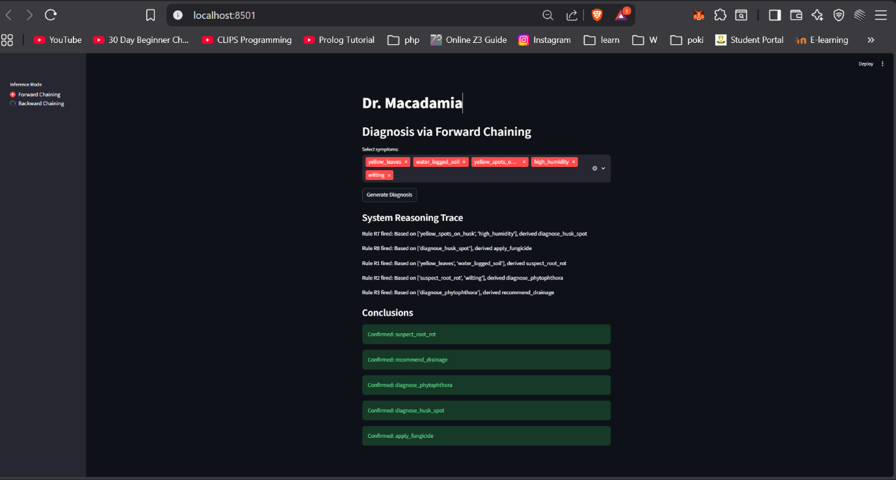
Test Case C: Backward Chaining Verification
- Goal: apply_pesticide
- Known Facts: holes_in_husk, sawdust_frass, larvae_present
- Reasoning Path: System identifies R6 for the goal, checks subgoals for R5, then R4, successfully verifying the goal against initial facts.
- Result Evidence: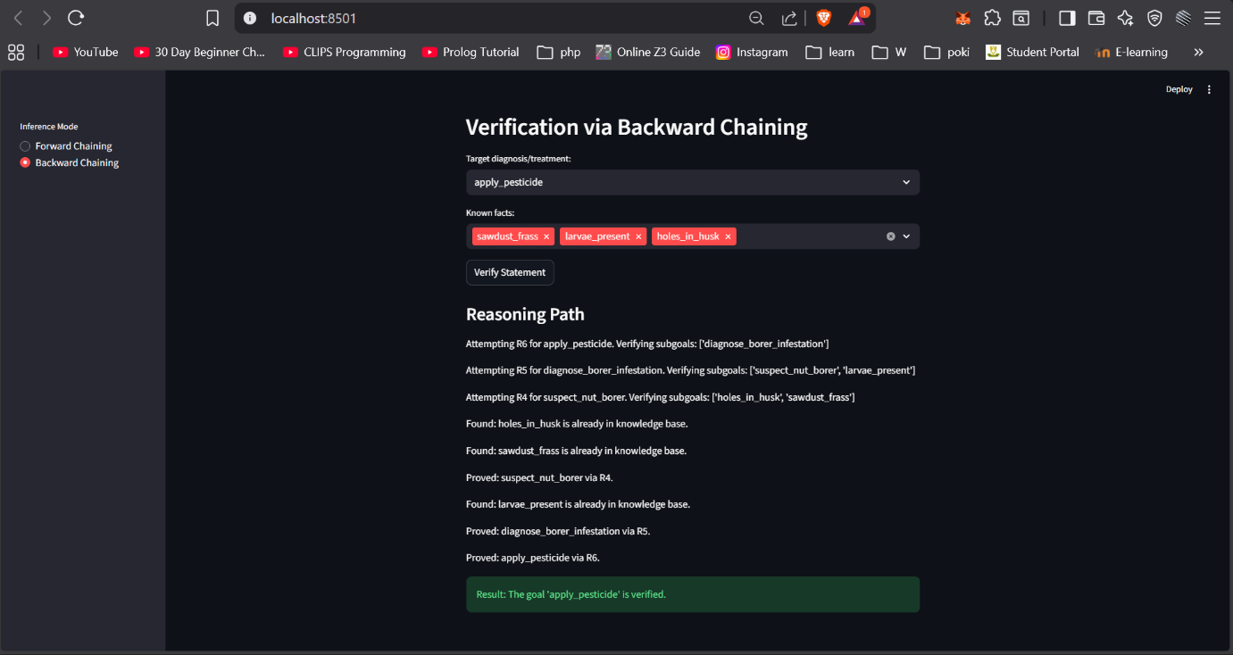

6. Conclusion
The Macadamia Expert System successfully demonstrates the application of symbolic AI to real-world agricultural problems. By separating the knowledge base (Production Rules) from the reasoning mechanism (Inference Engine), the system provides a robust platform for diagnosing diseases and verifying treatment plans.

