**CS307 Term Project Phase 2**

In this phase of the project, you are required to create a program which is able to simulate the execution of multiple processes. In previous phase, you wrote a program which is able to execute one process written by the given assembly language. In this phase, you will write a program which will be able to execute several processes in a way that is similar to how computer systems work. For this purpose, you will use methods and algorithms you have learned throughout the course.

For the second phase of the project, you will be given the solution of the first phase to work on. You are free to modify the given solution in any way you see fit.

**Outline**

With the second phase of the project and the execution of multiple processes, there are now additional concerns you have to give attention to: Loading multiple processes, limited memory and assigning I/O operations to blocked processes. In order to deal with multiple processes and input operations, you will implement additional queues.

From the first phase of the project, you already have the implemented versions of **Ready Queue** and **Blocked Queue**. To recap:

There are multiple processes but in the simulation, there will be only one CPU core. This means that at a given time, only one process will be able to run while the other processes will be waiting for their turns. For the processes which are waiting their turns, you will use a Java list structure as a queue like before to store the waiting processes. This list will be named as **Ready Queue**.

A process can give an output or receive an input depending on the value of V Register. When receiving an input, the process should wait for the user to give an input, if this waiting process were to be done in CPU, then the execution cycle of CPU would be blocked and other processes would not be able to run. Because of that, for the processes which are waiting for an input, you will use list as a queue and this queue will be called **Blocked Queue**.

In addition to these queues, you will need to implement two additional queues. There is an indeterminate number of processes which will be executed in the simulation, but the memory is limited. It may not be possible to load all of the processes into the memory at the same time. You will use a bounded buffer as a queue to keep the information of processes which will not be able to be loaded into the memory. This bounded buffer will be named as **File Input Queue**.

It is also possible for user to give an input while no process is waiting. Unlike the first phase, in this phase you should store these inputs for processes which will be waiting for an input. To store these inputs, you will use a bounded buffer as a queue and it will be named **Console Input Queue.**

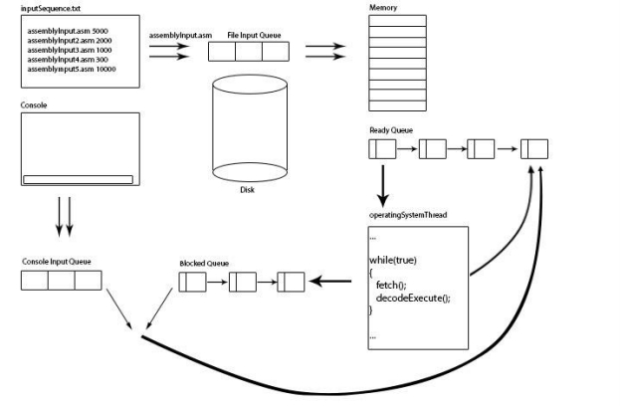Below you can find the outline of this phase:

As you may have noticed, some operations can and also should be run asynchronously. For example, the CPU always executes the fetch-decode-execute cycle and it is not logical to execute other operations in the same thread. Therefore, like the first phase, you will be using multiple threads for executing different operations. While accessing shared variables such as queue from different threads, you have to ensure mutual exclusion by using mutex to avoid any read/write conflicts.

**Implementation detail and Explanation of Threads**

In total, you will have 5 threads:

**Producer Thread for File Input**

This thread will receive the file paths from a file called **inputSequence.tx**t. A line in inputSequence.txt will contain the file path of the assembly file and the time the thread has to wait before the next file path is received. After reading the file path, the thread will open the assembly file, convert it to binary and write it to a binary file with the same name as the binary file (ie. If the name of the assembly file is assemblyInput1.asm, the binary file will be named as assemblyInput1.bin). To store the file name of the binary file, you will create a new instance of ProcessImage and store it in File Input Queue. Then the thread will sleep for the amount of time given in inputSequence.txt and receive the next file path. The thread should stop receiving file paths if the File Input Queue is full and it should sleep until there is an empty place in the queue.

The reason this thread is called as a Producer is actually because it produces input for the File Input Queue. As the File Input Queue is a bounded buffer, we want you to implement the producer implementation of producer-consumer problem to make the sleep if the queue is full and wake up if there is an empty space.

**Consumer Thread for File Input**

This is the consumer thread for File Input Queue. This thread will remove an item from the File Input Queue and then will look at the memory if there is an available space for the process. While there is no available space, it will sleep for 2 seconds and try again. After the thread finds an available space, it will open the binary file stored in the ProcessImage instance and load the binary version of instructions into the memory. Then, you will set base and limit register accordingly and add it to the end of the Ready Queue

To keep track of available spaces in memory, you will use a bitmap. Each character in the memory will be represented by one bit. If an index in the memory is not free, the bitmap will store 1 and if the index is free, the bitmap will store 0. You will use first fit algorithm for memory allocation.

As this thread is the consumer part of the File Input Queue, the thread should sleep if there are no elements in the queue and wake up if there is an element. This should be done using the consumer implementation of the Producer-Consumer problem.

**Producer Thread for Console Input**

This thread will receive an unsigned integer as an input from console and store it in Console Input Queue. The thread should stop receiving input if the Console Input Queue is full and it should sleep until there is an empty place in the queue.

The reason this thread is called as a Producer is actually because it produces input for the Console Input Queue. As the Console Input Queue is a bounded buffer, we want you to implement the producer implementation of producer-consumer problem to make the sleep if the queue is full and wake up if there is an empty space.

**Consumer Thread for Console Input**

This is the consumer thread for Console Input Queue. This thread will remove an item from the Console Input Queue and then will look at the Blocked Queue. If there is an item at the Blocked Queue, then it will remove a process from the Blocked Queue, set the value of its register V to the item it removed from Console Input Queue and put the process to the end of the Ready Queue. While there are no processes in Blocked Queue, the thread will sleep for 2 seconds and try again.

As this thread is the consumer part of the Console Input Queue, the thread should sleep if there are no elements in the queue and wake up if there is an element. This should be done using the consumer implementation of the Producer-Consumer problem.

**Operating System Thread**

This is the thread that is already implemented in the first phase of the project. To recap, this is the thread which CPU and operating system related operations will execute. As there are multiple processes waiting to run, these should be a scheduling algorithm for the processes. You will use Round Robin Scheduling with Quantum = 5 for the scheduling.

This thread will remove the first process from the Ready Queue and it will execute the process in the fetch-decode-execute cycle until its quantum is finished or the process is finished or the process is blocked waiting for input.

If a process finishes its quantum time and it is not finished or blocked, then it is sent back to the end of the Ready Queue.

If a process finishes executing before its quantum if over, then the thread should empty the memory allocated by the process.

The I/O operations will be handled in the operating system thread. At the end of each fetch-decode-execute cycle, you should check whether the current instruction is an I/O operation. If the process should give an output, then it will give it using System.out.println(“ ”)function to the console. If the process should receive an input, the process should be sent to the end of the Blocked Queue and the operating system thread should receive the next waiting process.

While there are no processes waiting to be executed, the thread should sleep for 2 seconds and then check Ready Queue again.

**Template of Project and Project Hints**

You are provided with the solution of the first phase of the project. As mentioned earlier, you are free to modify in any way you want.

During the simulation, please give informative outputs for the execution of processes. These outputs are up to you but please make it detailed enough so we can follow the execution of threads.

**Submission**

Submission of the homework will be through SuCourse under CS307--> Assignments-->Term Project Phase 2.

Archive all your class files in

username_termproject_2.zip

and submit this file.