**Name – Koushik Karmakar Date: 25/02/2025**

**Create new tables more than one or two.**

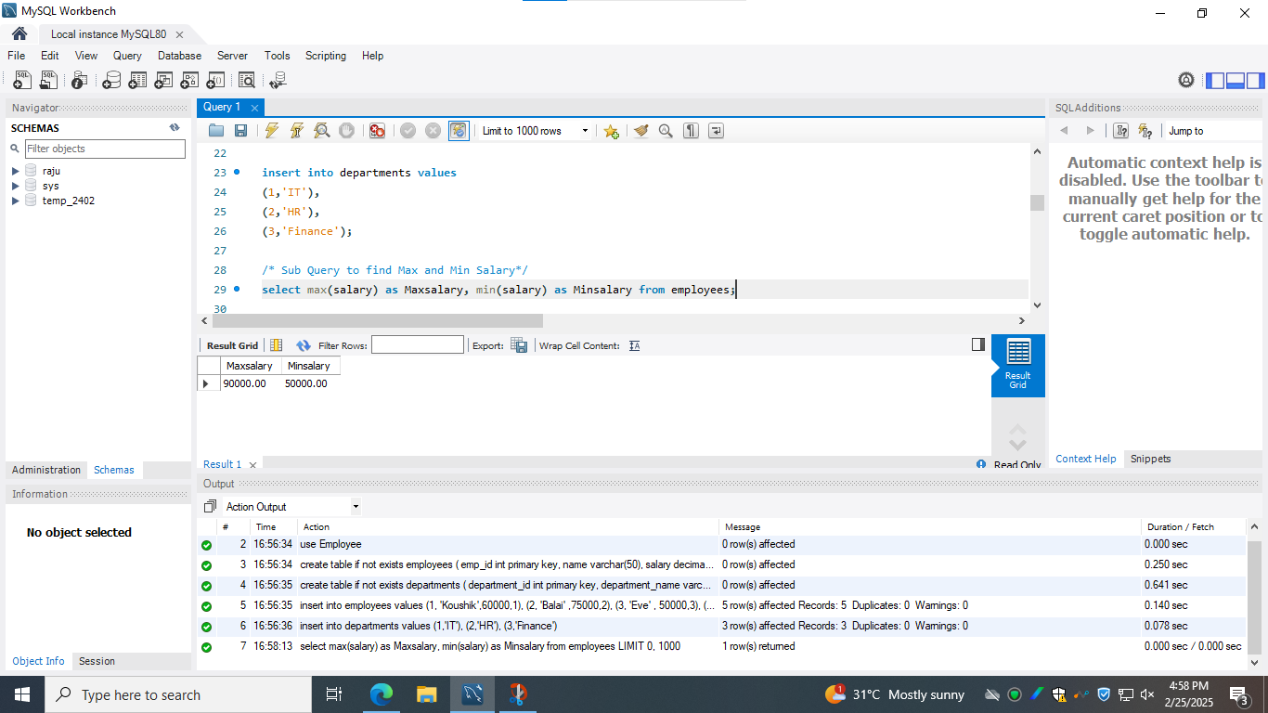

**1) Sub Query to find Max and Min Salary**

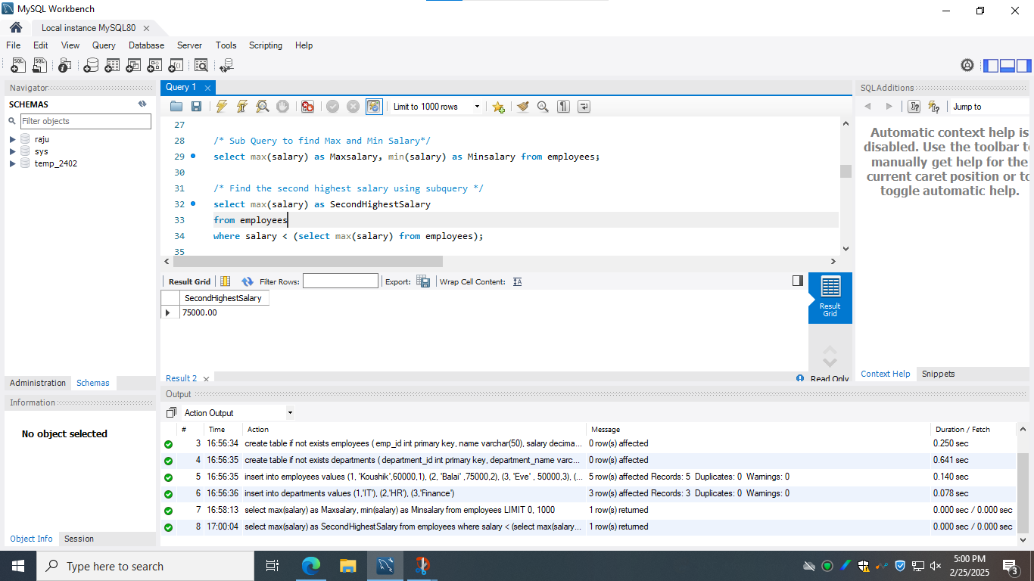

**2.1) Find the second highest salary using subquery**

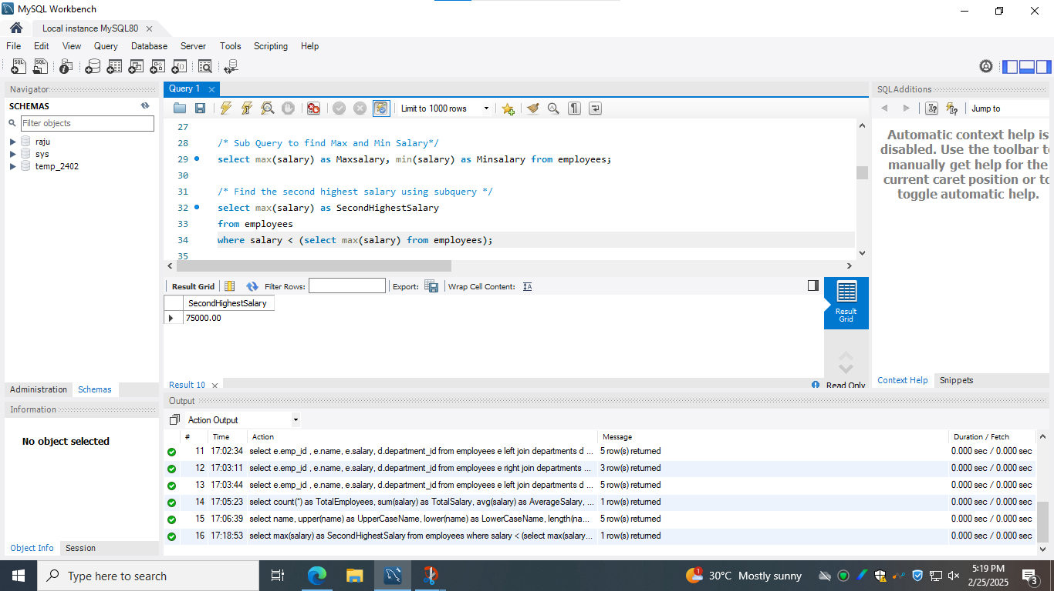

**2.2) Find the second highest salary using limit**

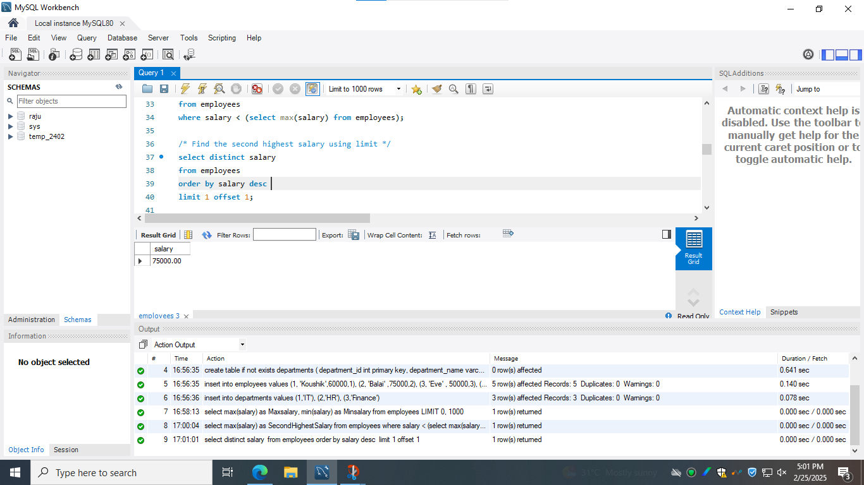

**3.1) Inner Join**

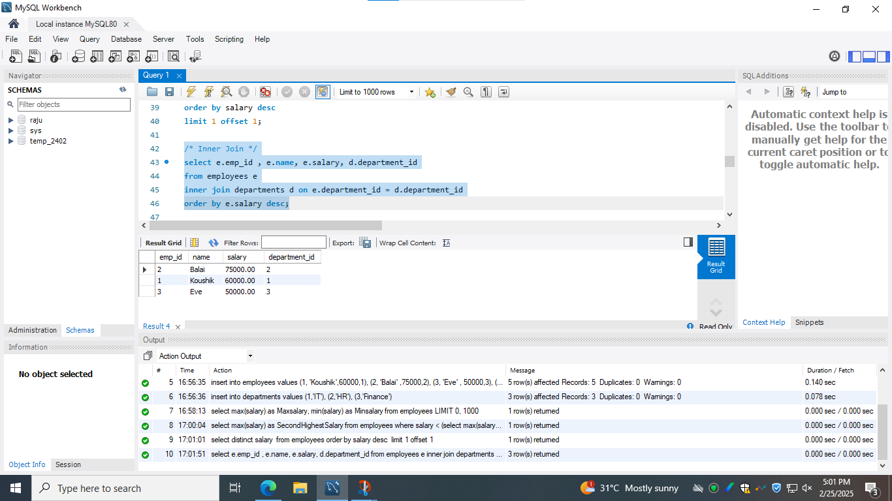

**3.2) Left Join**

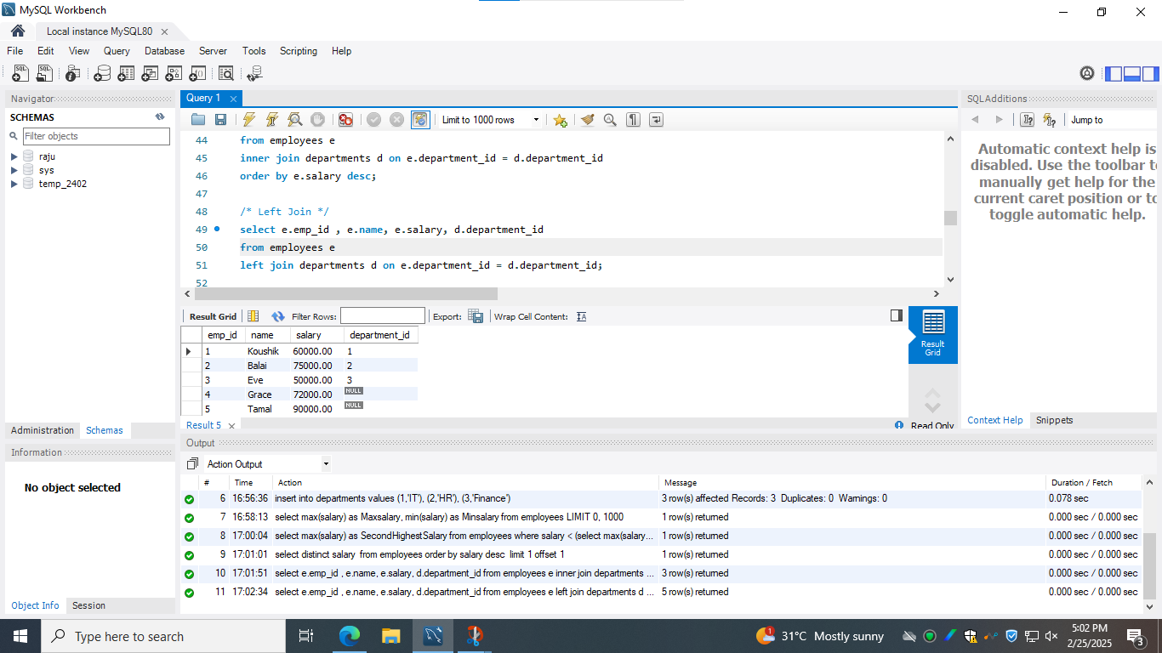

**3.3) Right Join**

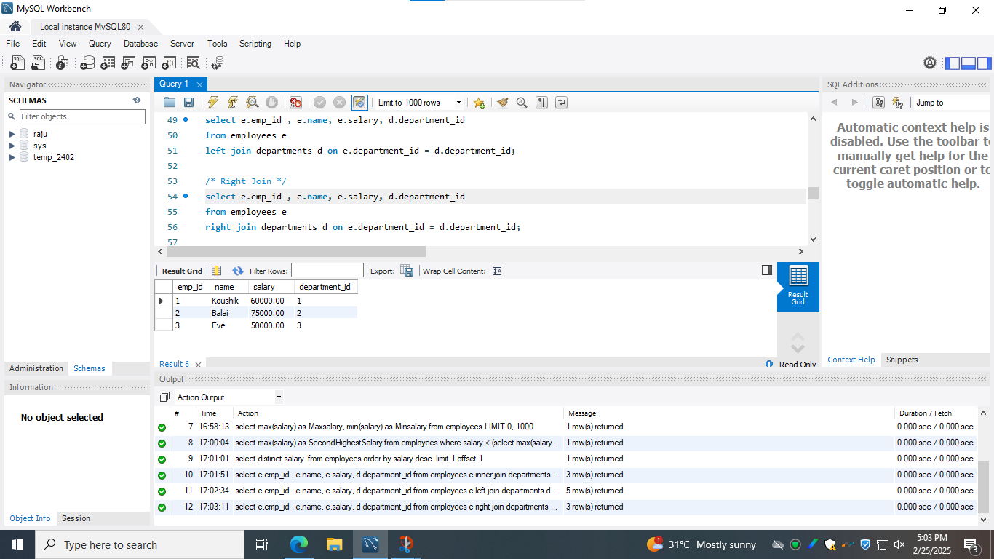

**3.4) Full outer Join**

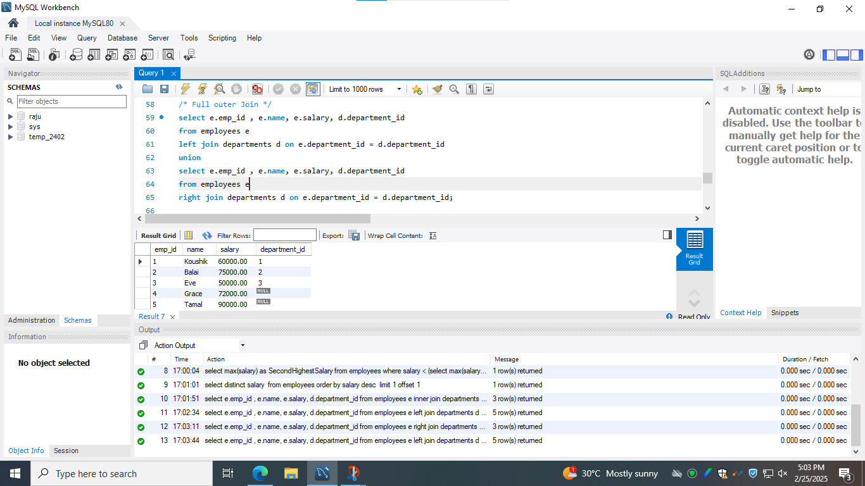

**4) Write a query to implement all aggregate functions**

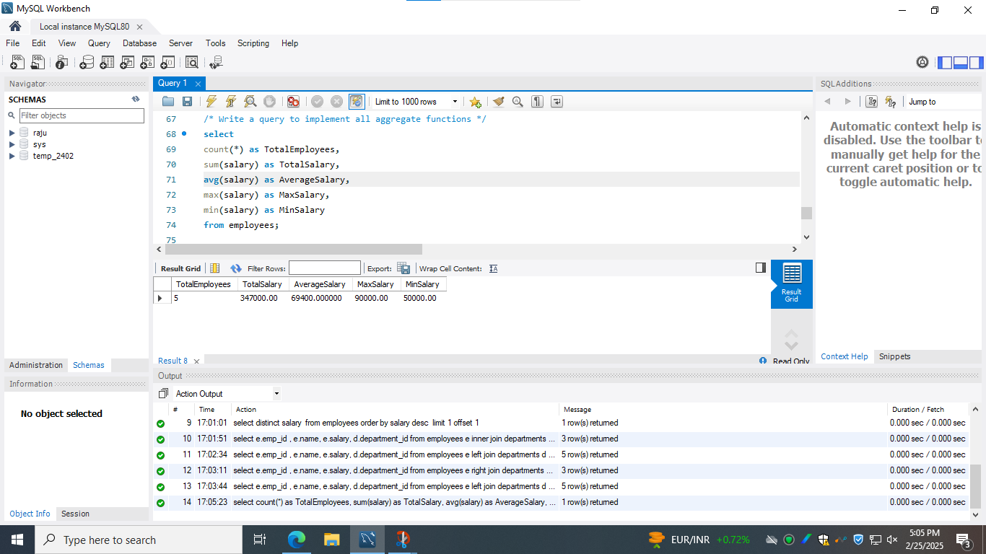

**5) Write a query using all string functions**

