Documentation for Using the New Pipeline for Analysis

Step 1: Click the “run” button in the PyCharm Window.

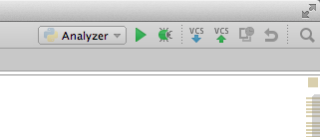

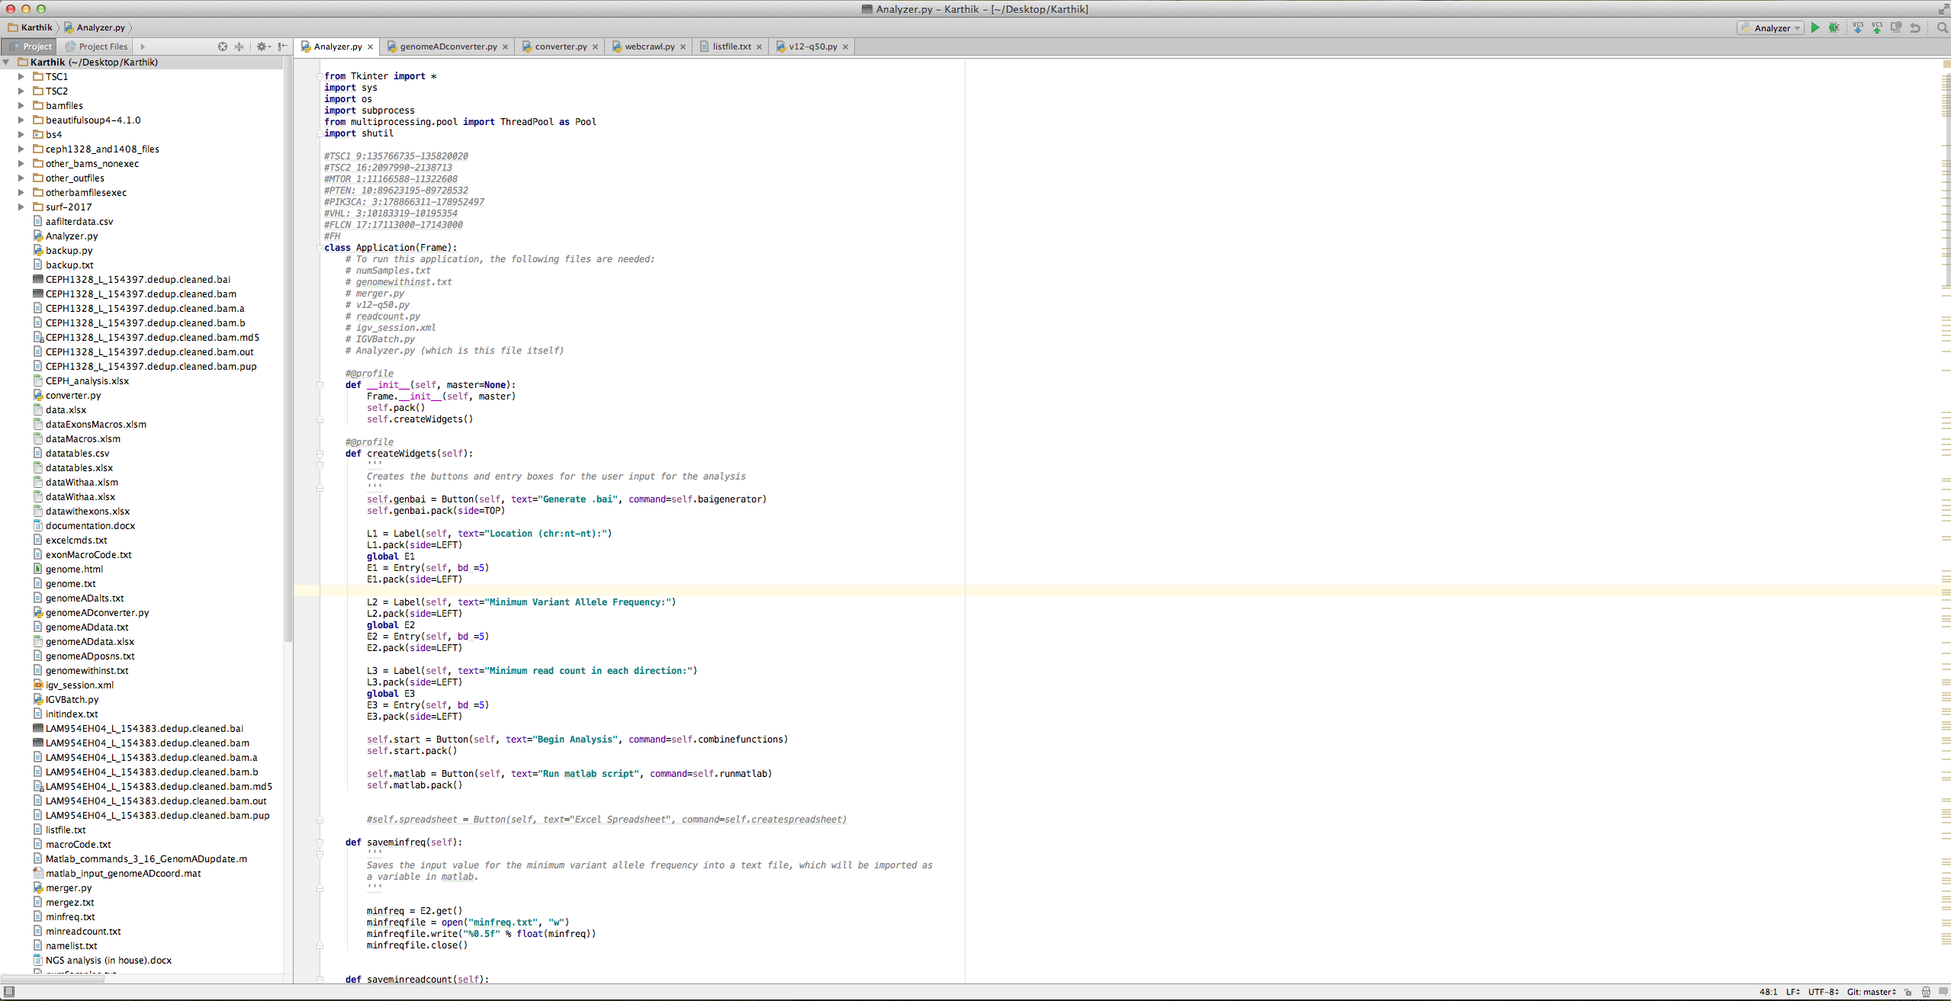

Step 2: Now, the following window should appear. Type in the location of interest for the analysis (in the form chr:nt-nt), the minimum variant allele frequency (as a decimal), and the minimum read count in each direction in the fields shown below.



Step 3: Click “Begin Analysis.” Now the mergez.txt and namelist.txt files are being generated. When these are generated, the following will be displayed:

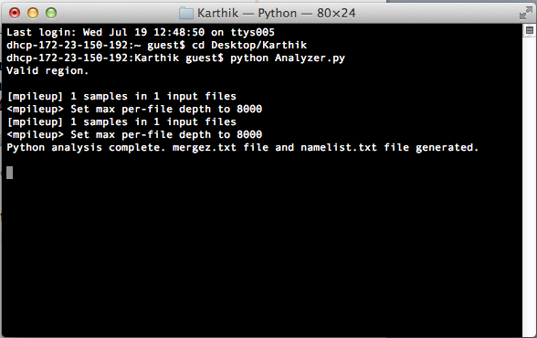

Step 4: Now, click “Run matlab script” in the previous window. Then, when the Matlab script has completed, then the filtered data of interest is in the file “aafilterdata.csv”, which can be opened in Excel.



