# Indigo International Business

# Introduction

This report provides a comprehensive analysis of international aviation operated from India, focusing on India-based airlines, their market presence, competition, and strategic outlook. The analysis includes data points such as airlines and their base countries, routes operated to and from India, total market size, market share, advantages and disadvantages for India-based airlines, competition, growth opportunities, and current and future strategies.

India is now the world’s third-largest aviation market, a milestone that has been highlighted in a new report released Sunday by the International Air Transport Association (IATA). India’s 174 million passengers in 2024 accounted for 4.2% of global air traffic, compared to China’s 16.7% and over 18% for the U.S. While that marks a major leap, more than double India’s passenger volume from just over a decade ago — the gap with the top two markets remains significant.

A comparison of routes that were in operation from India in 2014 with those in 2024 shows a significant increase in direct connectivity. Routes shown in red are those which were flown in 2014, but not in 2024. These are relatively few, with the vast majority linking India with China. Direct commercial flights between India and China have been suspended since 2020 but both nations are in discussions to explore resumption of flights soon.

The figure also depicts many blue routes, ending with a blue dot. These routes are new in the 2024 network structure, when compared to 2014. It shows that over the years several new long-haul connections were opened between India and both North America and Africa in particular. This is likely to translate into opportunities to increase economic activity, trade and tourism, and deliver related benefits to the Indian economy and its citizens.

**Legend:**

Blue routes & blue dots – routes and destinations available with a direct connection from India in 2024. Red routes & red dots – routes and destinations available with a direct connection from India in 2014. Purple routes and red/blue dots - routes and destinations available with a direct connection from India in both 2014 and 2024. Color ratio of the dot indicates the ratio in the number of arriving flights 2014 (red) and 2024 (blue)

Note: due to modelling limitation, a small number of routes is not shown.

Airlines regularly monitor and review their network structures to adapt and align to shifts in consumer demand. A five-year route network comparison shows that 37.5% of all routes operated from and within India in 2024 did not exist in 2019. In 2021, the share of new routes reached an observed high, accounting for 48.4% of all routes compared to 2016. These developments highlight the dynamic nature of the air transport market and underscore the airlines’ agility in adapting to evolving passenger travel patterns and needs.

# International Flights Operated from India

The Indian market has now fully recovered from the 2020 disruption, with the international and domestic air transport connectivity surpassing pre-covid levels by 13.2% and 19.6% in 2024, respectively.

## International air traffic accounted for 21% of total origin-destination (O-D) departures for India in 2023, equal to 33.9 million passenger departures. The Middle East is the largest international market for passenger flows from India, followed by Asia Pacific and Europe. Almost 13.7 million passengers departed from India to the Middle East (41% of the total), 9.4 million to another country in Asia Pacific (28% of the total), and 5.1 million to Europe (15% of the total).

International air traffic accounted for 21% of total origin-destination (O-D) departures for India in 2023, equal to 33.9 million passenger departures. The Middle East is the largest international market for passenger flows from India, followed by Asia Pacific and Europe. Almost 13.7 million passengers departed from India to the Middle East (41% of the total), 9.4 million to another country in Asia Pacific (28% of the total), and 5.1 million to Europe (15% of the total).

## Airlines and Their Base Countries

Key international airlines operating from India include:  
- India-based: Air India, IndiGo, Vistara  
- Foreign-based:  
 - Emirates (UAE)  
 - Qatar Airways (Qatar)  
 - Singapore Airlines (Singapore)  
 - Lufthansa (Germany)  
 - British Airways (UK)  
 - Thai Airways (Thailand)  
 - Etihad Airways (UAE)

# Factors Affecting a Nation’s Competitiveness (Porter’s Diamond Model)

This framework explains why certain industries within a nation are more competitive internationally. **India’s aviation sector** and **IndiGo’s international strategy**:

**1. Factor Endowments**

These are a nation’s position in factors of production such as skilled labor, infrastructure, and natural resources.

**India’s Position:**

* **Strengths:**
  + Large pool of skilled, low-cost labor (pilots, engineers, ground staff)
  + Strategic geographic location between Europe and Southeast Asia
  + Rapidly expanding airport infrastructure (e.g., Navi Mumbai, Jewar)
* **Weaknesses:**
  + Limited wide-body aircraft manufacturing or MRO (Maintenance, Repair, Overhaul) capabilities

**IndiGo’s Leverage:**

* Uses India’s cost advantage to maintain low operating costs
* Leverages geographic location to serve as a hub for East-West traffic
* Outsources wide-body operations via wet leases to overcome fleet limitations

**2. Demand Conditions**

The nature and size of domestic demand for an industry’s products or services.

**India’s Position:**

* Rising middle class with increasing disposable income
* Strong demand for international travel (business, tourism, diaspora)
* Price-sensitive market with growing expectations for quality

**IndiGo’s Response:**

* Offers affordable international fares with high frequency
* Expands into diaspora-heavy and leisure destinations (e.g., Dubai, Singapore, Colombo)
* Plans to enter premium markets (e.g., London, Amsterdam) with upgraded services

**3. Related and Supporting Industries**

The presence of capable, locally based suppliers and related industries.

**India’s Position:**

* Growing ecosystem of airport operators, ground handling, and logistics
* Weak domestic aircraft manufacturing and leasing ecosystem

**IndiGo’s Strategy:**

* Partners with global lessors and OEMs (e.g., Airbus)
* Uses international partnerships (e.g., Turkish Airlines, Qatar Airways) to fill capability gaps

**4. Firm Strategy, Structure, and Rivalry**

How companies are created, organized, and managed, and the nature of domestic rivalry.

**India’s Aviation Landscape:**

* Highly competitive with price wars and thin margins
* Consolidation (e.g., Air India–Vistara merger) increasing pressure on IndiGo

**IndiGo’s Strategy:**

* Maintains cost leadership through operational efficiency
* Expands internationally to diversify revenue and reduce domestic dependency
* Adopts a hybrid model (low-cost + premium partnerships) to compete globally

# IndiGo’s Motivation for International Expansion

**1. Market Diversification**

* Reduce dependency on domestic market (~60% share)
* Tap into high-yield international routes (e.g., Europe, Gulf)

**2. Diaspora and Tourism Demand**

* Serve large Indian diaspora in UAE, UK, Canada
* Capture outbound tourism to Southeast Asia and Europe

**3. Strategic Positioning**

* Build brand as a global Indian airline
* Compete with Gulf carriers and Air India on key corridors

**Risks in International Expansion**

|  |  |  |
| --- | --- | --- |
| Risk Type | Description | Mitigation |
| Operational | Limited wide-body fleet | Wet leases, future acquisitions |
| Regulatory | Bilateral air service agreements | Strategic partnerships, compliance |
| Brand Perception | Low-cost image may not appeal to premium travelers | Introduce business class, improve service |
| Geopolitical | Volatility in Middle East, Europe | Diversify route portfolio |

**Entry Modes of International Expansion**

|  |  |  |
| --- | --- | --- |
| Entry Mode | Description | IndiGo’s Use |
| Organic Expansion | Direct flights using own fleet | Most Southeast Asia and Gulf routes |
| Strategic Alliances | Codeshares and partnerships | Turkish Airlines, Qatar Airways |
| Wet Leasing | Leasing aircraft with crew | Boeing 777s from Turkish Airlines |
| Future Potential | Joint ventures or equity alliances | Not yet pursued, but viable for Europe/US |

**Progress So Far for Indigo:**

* Expanded to 40+ international destinations
* Added 10 new destinations in 2025 (e.g., London, Amsterdam, Tashkent)
* Wet-leased wide-bodies for long-haul routes
* Codeshare agreements with global carriers

**What Indigo Could Achieve:**

* Become India’s first low-cost carrier with a global long-haul network
* Compete with Gulf carriers on price and frequency
* Establish India as a global aviation hub

# How can Indigo achieve competitive advantage in Global Markets

**1. Global Strategy**

**Definition:**  
A global strategy emphasizes economies of scale and standardization. Firms using this approach offer the same products and services across all markets, aiming for cost leadership and operational efficiency.

**IndiGo’s Fit:**

* IndiGo’s **low-cost carrier (LCC)** model is a textbook example of a global strategy.
* It offers **standardized services** (no-frills, single-class cabins, uniform aircraft types) across all international routes.
* **Fleet commonality** (primarily A320neo and A321neo) reduces maintenance and training costs.
* **Example:** IndiGo’s operations on routes like Mumbai–Dubai and Singapore–Chennai mirror its domestic model—high frequency, low fares, and quick turnarounds.

**Strengths:**

* Cost efficiency
* Operational simplicity
* Fast scalability

**Limitations:**

* Limited appeal to premium international travelers
* Less flexibility in adapting to local preferences

**2. Multidomestic Strategy**

**Definition:**  
This strategy focuses on local responsiveness. Firms tailor their offerings to meet the specific needs and preferences of each market.

**IndiGo’s Fit:**

* IndiGo currently **does not follow** a multidomestic strategy.
* It does **not localize** services (e.g., language, cuisine, cultural preferences) for different international markets.
* **Example:** IndiGo’s in-flight experience on a route to Colombo is nearly identical to that on a route to Dubai or Kathmandu.

**Implication:**

* While this keeps costs low, it limits IndiGo’s ability to compete with full-service carriers that offer localized, premium experiences.

**3. Transnational Strategy**

**Definition:**  
A transnational strategy seeks to combine the efficiency of a global strategy with the responsiveness of a multidomestic strategy. It is the most complex but also the most rewarding in terms of global competitiveness.

**IndiGo’s Emerging Fit:**

* IndiGo is **transitioning** toward a transnational strategy.
* **Examples of Transnational Elements:**
  + **Wet-leased wide-body aircraft** (e.g., Boeing 777s from Turkish Airlines) for long-haul routes to Istanbul and Europe—offering premium cabins and services.
  + **Codeshare partnerships** with Turkish Airlines and Qatar Airways—expanding network reach and offering better connectivity.
  + **New long-haul destinations** like London, Amsterdam, and Manchester—indicating a shift toward premium international markets.

**Opportunities:**

* Combine cost leadership with selective premium offerings
* Expand into underserved long-haul markets
* Build brand recognition globally

**Challenges:**

* Managing complexity of dual strategies
* Maintaining cost efficiency while enhancing service quality

**Summary Table**

|  |  |  |
| --- | --- | --- |
| Strategy Type | IndiGo’s Alignment | Key Actions/Examples |
| Global | Strong | Standardized LCC model, uniform fleet |
| Multidomestic | Weak | Minimal localization |
| Transnational | Emerging | Wet leases, codeshares, long-haul expansion |

**References:**

<https://www.imarcgroup.com/india-aviation-market>

<https://www.mordorintelligence.com/industry-reports/analysis-of-aviation-industry-in-india>

<https://www.iata.org/en/iata-repository/publications/economic-reports/aviation-in-india/>

<https://skift.com/2024/11/05/indian-airlines-gain-share-in-international-travel-india-report/>

<https://skift.com/2025/06/01/india-is-now-a-top-3-global-aviation-market-5-takeaways-from-its-rapid-rise/>

<https://aviationa2z.com/index.php/2025/05/30/indigo-airlines-adding-10-new-international-destinations/>

<https://aviationa2z.com/index.php/2025/04/05/indigo-top-10-international-routes-2025/>

<https://aviationa2z.com/index.php/2025/04/19/air-india-top-10-international-routes-2025/>

Appendix

## Routes Operated To and From India

Top international routes (2024 data) include:  
- Middle East: UAE (Dubai, Abu Dhabi), Saudi Arabia, Qatar  
- Southeast Asia: Singapore, Thailand, Malaysia  
- Europe: UK (London), Germany (Frankfurt), France (Paris)  
- North America: USA (New York, San Francisco), Canada (Toronto)  
- Australia: Sydney, Melbourne  
These routes are driven by business travel, tourism, and a large Indian diaspora.

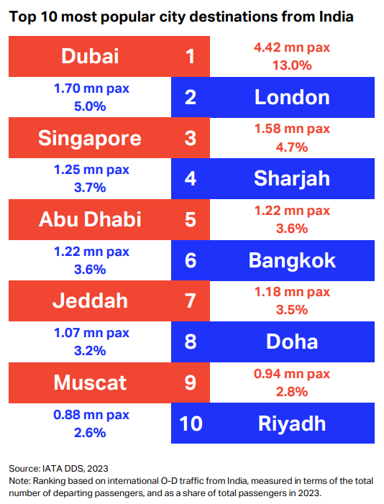

## Total Market Size (2024)

Total International Seats (April 2024): 7.3 million (up 17% from 2019)  
Top Carriers by Capacity Share:  
- Air India: 20%  
- IndiGo: 17%  
- Emirates: 7%  
Passenger Traffic: Over 70 million international passengers annually (2023 estimate)  
Revenue: Estimated at over $10 billion for international operations from India

## Market Share of India-Based Airlines

IndiGo: 17.6% of international market  
Air India: 20%  
Combined India-based share: ~40% of international traffic  
Foreign carriers dominate premium and long-haul segments, especially to Europe and North America.

## Advantages and Disadvantages for India-Based Airlines

Advantages:  
- Strong domestic feeder network  
- Cost-efficient operations (especially IndiGo)  
- Government support (e.g., bilateral agreements, UDAN scheme)  
Disadvantages:  
- Limited wide-body fleet (except Air India)  
- Lower brand recognition globally  
- Service quality and premium offerings lag behind Gulf and Western carriers

# Competition, Growth, and Potential in New International Routes

Air connectivity is fundamental to unlocking a country’s economic growth potential and prosperity; it enables industries across all regions within the country to engage in dynamic business activity. The extent of domestic and international connectivity is an enabler and an accelerator of both the generation and distribution of economic benefits.

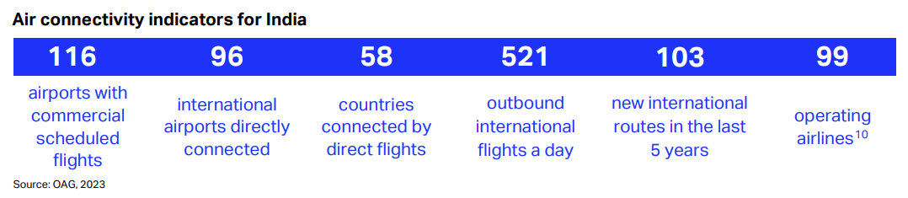

Since 2014, India’s international air connectivity index has decreased by 4.0% within the Asia Pacific region and increased by 59% with all other regions. Understanding the nature of that connectivity is also important. For India, 13% of all passengers arriving internationally continued their journey on a domestic connection. 85% of passengers either finished their journey at the point of entry to the country or continued traveling using a different mode of transport. 2% of all passengers arriving in India from abroad continued their journey to a destination in another country.

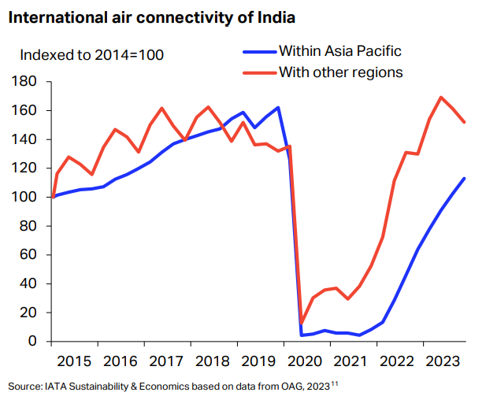

## Competition

Gulf carriers dominate West-bound routes with superior connectivity and service. Southeast Asian carriers are strong in East-bound routes. European and North American carriers offer direct long-haul services with premium products.

IndiGo dominates Indian air transport in terms of scheduled seat capacity (number of seats) in 2024, with a market share of around 53.4% (up from 23% in 2016). Air India and its subsidiary Air India Express, ranked second and third, follow at some distance with market shares of around 12.1% and 8.6%, respectively. Importantly, fourth ranked airline Vistara has completed its merger with Air India in November 2024, expanding Air India’s capacity. Emirates is the first overseas airline in the ranking, at #7, with a 1.4% market share.

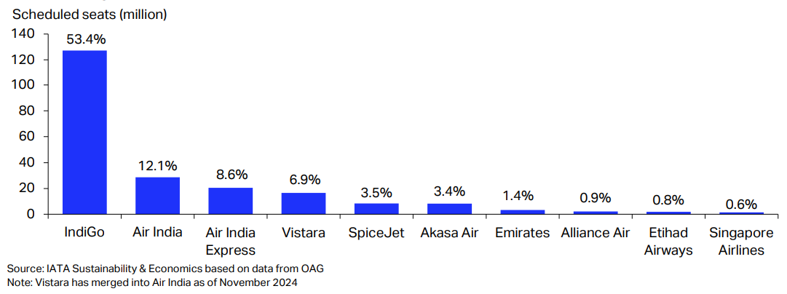

Over the past decade, the combined market share of the top 10 airlines has increased from 60.7% in 2014 to 90.9% in 2024 (Chart 20). The most recent notable consolidations have been AIX Connect’s (formerly Air Asia India) into Air India Express and Vistara’s merger into Air India. Such consolidation can provide the financial stability needed to withstand economic shocks and downturns and can lead to better connectivity and higher flight frequency. This has been observed in markets where the barriers to entry are relatively low and low-cost carriers have thrived post-consolidation, providing customers with more choices and competitive pricing.12 Combined with the appropriate safeguards for consumers and supportive market conditions, consolidation can enhance the competitiveness and health of the air transport industry, ensuring financially sustainable operations and benefiting passengers through improved services and competitive fares.

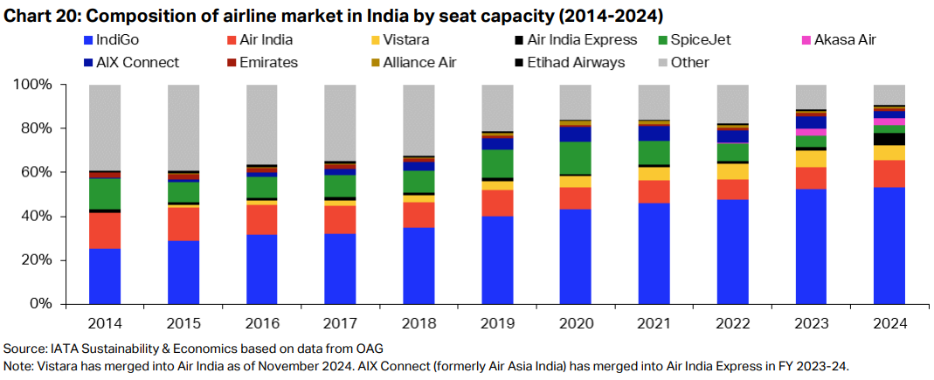

## Growth Opportunities

Compared to 2011, domestic and international airfares are around 79% and 62% of their 2011 levels, in real terms, respectively; in other words, airfares are 21% and 38% cheaper than they were in 2011. This again demonstrates the competitive pressures applied in the Indian air transport industry and the extent to which air travel has become more affordable and more accessible to a larger proportion of India’s population.

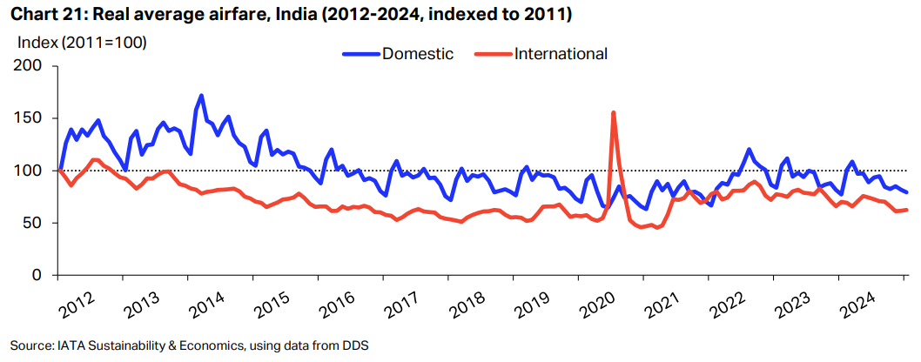

New Routes:  
- Tier-2 Indian cities to Southeast Asia and Middle East  
- Direct flights to Africa (e.g., Kenya, South Africa)  
- Expansion into Central Asia and Eastern Europe  
Fleet Expansion:  
- Air India’s wide-body fleet expansion (Boeing 777, Airbus A350)  
- IndiGo’s plans for long-haul operations  
Potential Growth Drivers:  
- Rising middle class and outbound tourism  
- Increasing business travel and global trade  
- Diaspora demand for direct connectivity  
- Government push for aviation infrastructure (new airports, air corridors)

# Current and Future Strategy for India-Based Airlines

## Current Strategy

Air India: Revamp under Tata Group with focus on premium service, fleet modernization, and global alliances.

IndiGo: Low-cost dominance, expanding international short-haul, exploring long-haul with A321XLR.

Vistara: Premium positioning, now merging with Air India to consolidate Tata’s aviation play.

## Recommended Future Strategies

India hosts one of the youngest and most fuel-efficient fleets in the industry, with the average aircraft age being only 7.3 years compared with 14.8 years globally. Unsurprisingly, given the importance of the domestic market, the composition of the current fleet is heavily skewed towards narrowbody aircraft (78.4%)

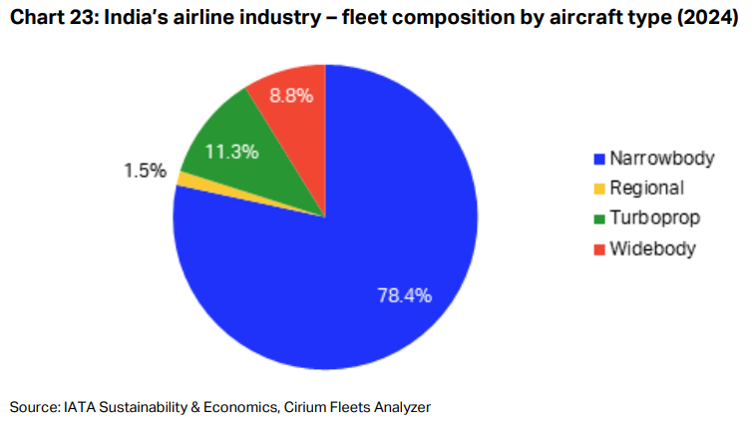

### a. Fleet and Network Expansion

Invest in wide-body aircraft for long-haul routes  
Expand direct connectivity from Tier-2 cities  
Leverage India’s geographic location as a hub

### b. Strategic Alliances

Join global alliances (e.g., Star Alliance for IndiGo)  
Code-share with international carriers for network reach

### c. Service Differentiation

Improve in-flight experience and loyalty programs  
Offer competitive premium economy and business class

### d. Digital and Operational Efficiency

Invest in AI and data analytics for route planning and pricing  
Enhance digital booking and customer service platforms

### e. Sustainability

Adopt fuel-efficient aircraft  
Participate in carbon offset programs and green airport initiatives