Illustration of how Gerlach’s method works for data with cluster structure

These R scripts perfom simulations (“Case with three clusters”) in Katahira et al. (Distribution of personality: types or skew?; Commentary: A robust data-driven approach identifies four personality types across four large data sets).

## Preparation

Install the required package (if not yet) by the following commands.

install.packages("tidyverse")  
install.packages("sn")  
install.packages("reticulate")  
install.packages("mixtools")  
install.packages("ks")  
install.packages("fields")  
install.packages("mvtnorm")

Also, please install Python to use scikit-learn library via reticulate library. (We recommend Anaconda dibribution <https://www.anaconda.com/> , which contains scikit-learn library.)

ref: <https://rstudio.github.io/reticulate/>

## Load library

library(tidyverse)  
library(reticulate)  
library(sn)  
library(mixtools)   
library(ks) # for kernel density estimation  
library(fields) # for image.plot  
library(mvtnorm)

# Case with three clusters

## Synthesize data

Samples are drawn from GMM with three components.

set.seed(1)  
  
n.sample <- 100000 # number of samples   
  
# true parameters of GMM  
true_means <- list(c(0,2),   
 c(-1.5,-0.5),   
 c(1.5,-0.5)  
 )  
true_sigmas <- list(diag(2)*0.5,  
 diag(2)*0.5,  
 diag(2)*0.5  
 )  
true_pi <- c(0.4,0.3,0.3)  
  
dat <- matrix(0,nrow = n.sample, ncol = 2)   
for (idx in 1:n.sample) {  
 idxk <- which.max(rmultinom(1,1,true_pi))  
 dat[idx,] <- rmvnorm(n = 1,  
 mean = true_means[[idxk]],  
 sigma = true_sigmas[[idxk]] )  
}  
  
df_data <- data.frame(scale(dat))

Plot samples and marginals distribution.

nplot <- 5000 # number of samples to plot  
  
par(pty = "s")  
plot(c(-5,6),c(-5,6),type="n",ann=F)  
points(df_data$X1[1:nplot],  
 df_data$X2[1:nplot],  
 pch=".",cex = 2)  
  
d1 <- density(df_data$X1,from = -4, to = 3)  
d2 <- density(df_data$X1,from = -4, to = 3)  
lines(d1$x, d1$y*3+4,  
 xlim=c(-6,6), ylim=c(0,0.3),lwd = 2)  
lines(d2$y*3+4, d2$x,  
 xlim=c(-6,6), ylim=c(0,0.3),lwd = 2)

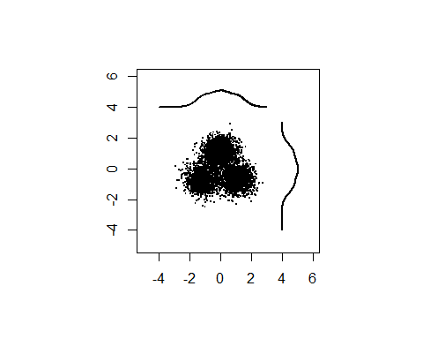

Plot shuffuled data.

N <- n.sample  
xdim <- ncol(df_data)  
x.shuffeled <- matrix(0,N,xdim)  
  
for (idx in 1:xdim)  
 x.shuffeled[,idx] <- df_data[sample(N),idx]  
  
par(pty = "s")  
plot(c(-5,6),c(-5,6),type="n",ann=F)   
points(x.shuffeled[1:nplot,1],  
 x.shuffeled[1:nplot,2],  
 pch=".",cex = 2)  
  
d1 <- density(x.shuffeled[,1],from = -4, to = 3)  
d2 <- density(x.shuffeled[,2],from = -4, to = 3)  
lines(d1$x, d1$y*3+4,   
 xlim=c(-6,6), ylim=c(0,0.3),lwd = 2)  
lines(d2$y*3+4, d2$x,   
 xlim=c(-6,6), ylim=c(0,0.3),lwd = 2)

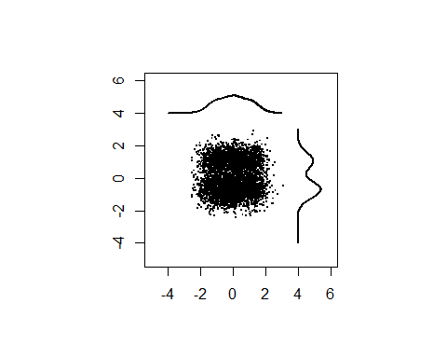

## Fitting GMMs

Following Gerlach et al., we choose initial parameters of GMMs from the results of K-means. If you select “random” initialization, the estimates will be different, suggesting that the GMM estimation for data of this kind is not robust.

sk <- reticulate::import(module = "sklearn")  
  
klist <- 1:20 # number of components  
n.rep <- 10 # number of runs from different intialization  
  
biclog <- numeric(length(klist)) # to store BIC  
gmm_list <- list() # to store GMM  
  
for (idxk in klist){  
 K <- klist[idxk]  
 ll.min <- -Inf  
   
 cat("\nfitting GMM... K =", K)  
  
 for (idxrun in 1:n.rep) {  
 cat("*")  
  
 initpar <- "kmeans"  
   
 ## uncomment if you want to include random intialization  
 # if (idxrun < n.rep*0.5)  
 # initpar <- "kmeans"  
 # else   
 # initpar <- "random"  
   
 sk_gmm <- sk$mixture$GaussianMixture  
 gmm <- sk_gmm(as.integer(K),  
 n_init = 1L,  
 max_iter = 200L,   
 init_params = initpar)   
 gmm$fit(df_data)  
   
 ll <- gmm$lower_bound_  
   
 if (ll > ll.min) {  
 ll.min <- ll  
 cluster.center <- data.frame(gmm$means_)  
 names(cluster.center) <- names(df_data)  
 biclog[idxk] <- gmm$bic(df_data)  
 gmm_list[[idxk]] <- gmm  
 }  
 }  
}

##   
## fitting GMM... K = 1**********  
## fitting GMM... K = 2**********  
## fitting GMM... K = 3**********  
## fitting GMM... K = 4**********  
## fitting GMM... K = 5**********  
## fitting GMM... K = 6**********  
## fitting GMM... K = 7**********  
## fitting GMM... K = 8**********  
## fitting GMM... K = 9**********  
## fitting GMM... K = 10**********  
## fitting GMM... K = 11**********  
## fitting GMM... K = 12**********  
## fitting GMM... K = 13**********  
## fitting GMM... K = 14**********  
## fitting GMM... K = 15**********  
## fitting GMM... K = 16**********  
## fitting GMM... K = 17**********  
## fitting GMM... K = 18**********  
## fitting GMM... K = 19**********  
## fitting GMM... K = 20**********

### Plot the locations of Gaussian components

Define a function for plotting cluster centers.

plot.cluster.center <- function(cluster.center) {  
   
 n.cluster <- nrow(cluster.center)  
 for (idxc in 1:n.cluster) {  
 points(x = cluster.center[idxc,1],  
 y = cluster.center[idxc,2],  
 pch = 4, cex = 1.5, col="red", lwd=2)  
 }  
}

Scatter plot of data with ellipses of Gaussian components.

par(mfrow=c(3,3), pty = "s",  
 mar=c(3.5, 3.5, 2, 1), mgp=c(2.4, 0.8, 0))  
  
for (idxk in 1:8) {  
 plot(df_data$X1[1:nplot],  
 df_data$X2[1:nplot], "p",   
 pch = ".",   
 xlab="Dimension 1",   
 ylab="Dimension 2",   
 main=paste("K:", idxk))  
   
 for (idxc in 1:idxk) {  
 mixtools::ellipse(mu=gmm_list[[idxk]]$means_[idxc,],   
 sigma=gmm_list[[idxk]]$covariances_[idxc,,],  
 alpha = 1-.6827, # 1 sigma   
 npoints = 250, col="red")   
 }  
 plot.cluster.center(gmm_list[[idxk]]$means_)  
}

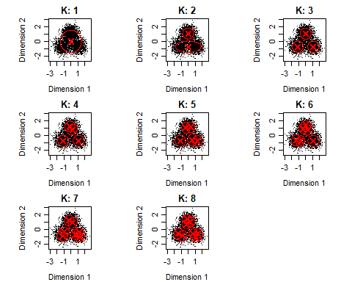

### Plot BIC

par(mgp=c(2, 1, 0), pty = "s")  
plot(klist,biclog, type = "o",   
 xlab = "Number of clusters", ylab = "BIC", lwd = 2,  
 cex = 1.5,  
 cex.lab = 1.2,  
 cex.axis = 1.2)

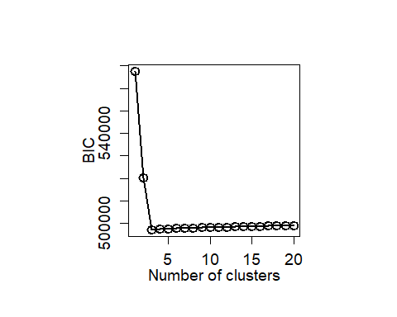

We select the GMM with three components (K=3).

K.selected <- 3

## Evaluate clusters

### Density estimation

Define a function ‘estkd’ for density estimation of original data and shuffled data

estkd <- function(x, xmin, xmax,   
 n.shuffle = 1000,   
 p.threshold = 0.01,   
 density.threhold = 0.05,  
 enrichment.threshold = 1.25) {  
   
 xdim <- ncol(x) # number of latent factors  
 N <- nrow(x)  
   
 # kernel density estiamtion of original data  
   
 Hpi <- ks::Hpi.diag(x = x, nstage = 2)  
   
 k <- ks::kde(x = x,verbose = TRUE, H = Hpi,   
 xmin = xmin,   
 xmax = xmax)  
 density.original <- k$estimate  
   
 # exceedance of original density  
 count_exceedance <- array(0, dim(density.original))  
   
 # shuffled data  
 cat("Density estimation for shuffled data...")  
 cat("\n 1/",n.shuffle, "\n")  
   
 for (idxs in 1:n.shuffle) {  
 if (idxs %% 100 == 0)  
 cat(idxs, " ")  
   
 fsc.s.shuffeled <- matrix(0,N,xdim)  
   
 for (idx in 1:xdim)  
 fsc.s.shuffeled[,idx] <- x[sample(nrow(x)),idx]  
   
 k.shuffle <- ks::kde(x = fsc.s.shuffeled, H = Hpi,   
 xmin = xmin,   
 xmax = xmax)  
   
 count_exceedance <- count_exceedance +   
 as.numeric(density.original < k.shuffle$estimate)  
   
 if (idxs == 1)  
 density.sum <- k.shuffle$estimate   
 else  
 density.sum <- density.sum + k.shuffle$estimate  
 }  
   
 d.shuffle <- density.sum / n.shuffle  
   
 p.value <- count_exceedance / n.shuffle  
 sig.region <- (p.value < p.threshold &   
 density.original > density.threhold &   
 density.original / d.shuffle > enrichment.threshold)  
   
 storage.mode(sig.region) <- "numeric"  
   
 list(k = k, # output of kde for original data  
 d.original = density.original,   
 count.exceedance = count_exceedance,   
 d.shuffle = d.shuffle,  
 p.value = p.value,  
 sig.region = sig.region)  
}

Prepare for plot.

xmin <- c(min(-5,min(df_data)),min(-5,min(df_data)))  
xmax <- c(max(5,max(df_data)),max(4,max(df_data)))   
  
# calculate density  
ret <- estkd(df_data, xmin, xmax,   
 n.shuffle = 1000,   
 density.threhold = 0)

## Density estimation for shuffled data...  
## 1/ 1000   
## 100 200 300 400 500 600 700 800 900 1000

zlim_max <- max(ret$d.original)  
zlim_min <- 0  
cex.main <- 1.8  
  
kd <- ret$k

### Scatter plot of original data and density plot

par(mfrow=c(1,2), pty = "s")  
par(mar=c(3.5, 3.5, 2, 1), mgp=c(2.4, 0.8, 0))  
  
xlim <- c(-4, 4)  
ylim <- c(-4, 4)  
  
# Panel 1 (density)  
image(kd$estimate,  
 x = kd$eval.points[[1]],  
 y = kd$eval.points[[2]],  
 xlab = "Dimension 1",   
 ylab = "Dimension 2",  
 xlim = xlim,  
 ylim = ylim,   
 col = viridis::viridis(10),  
 cex.axis = 1,   
 cex.lab = 1.2)  
  
# Panel 2 (scatter plot)  
plot(c(-4,4),c(-4,4),type="n",  
 xlab = "Dimension 1",   
 ylab = "Dimension 2",  
 xlim = xlim,  
 ylim = ylim,   
 cex.axis = 1,   
 cex.lab = 1.2)   
  
points(df_data$X1[1:nplot],  
 df_data$X2[1:nplot],  
 col = rgb(0.2,0.2,0.2,alpha=0.7),   
 pch=".",  
 cex = 2)

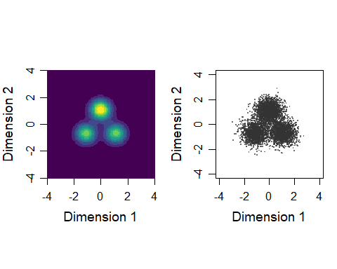

### Plot densities of original data and shuffled data

par(mfrow=c(1,2), pty = "s")  
par(mar=c(3.5, 3.5, 2, 1), mgp=c(2.4, 0.8, 0))  
  
log.density.original <- log(pmax(kd$estimate, 0.00001))  
log.density.shuffle <- log(pmax(ret$d.shuffle, 0.00001))  
  
# Panel 1 (original data)  
image(log.density.original,  
 x = kd$eval.points[[1]],  
 y = kd$eval.points[[2]],  
 xlab = "Dimension 1", ylab = "Dimension 2",  
 col = viridis::viridis(20),  
 cex.axis = 1.2, cex.lab = 1.5,  
 cex.sub = 1.2)  
  
plot.cluster.center(gmm_list[[K.selected]]$means_)  
  
title(main = sprintf("Original data"),   
 cex = 1.2, cex.main = cex.main)  
  
# Panel 2 (shuffled data)  
image(log.density.shuffle,  
 x = kd$eval.points[[1]],  
 y = kd$eval.points[[2]],  
 xlab = "Dimension 1", ylab = "Dimension 2",  
 col = viridis::viridis(20),  
 cex.axis = 1.2, cex.lab = 1.5,  
 cex.sub = 1.2)  
title(main = sprintf("Null model"),  
 cex = 1.5, cex.main = cex.main)

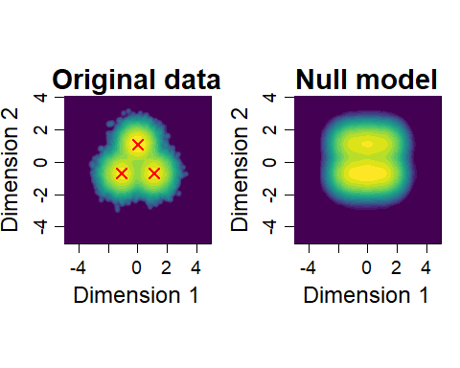

### Plot enrichment

color.palette = colorRampPalette(  
 c("#0080ff","white","#ff8000"))  
er <- exp(log.density.original - log.density.shuffle)  
par(pty="s")  
image.plot(kd$eval.points[[1]],  
 kd$eval.points[[2]],  
 pmax(pmin(er,1.5),0.5),  
 col = color.palette(30),  
 zlim = c(0.5,1.5),  
 xlab="Factor 1", ylab="Factor 2",  
 cex.axis = 1.2, cex.lab = 1.2,cex.sub = 1.2  
 )  
plot.cluster.center(gmm_list[[K.selected]]$means_)  
title(main = sprintf("Enrichment"),  
 cex = 1.8, cex.main = cex.main)

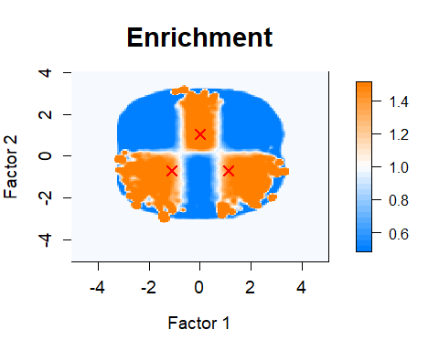

### p-value and enrichment thresholded

par(pty="s")  
# p-value (p < .01)  
image(kd$eval.points[[1]],  
 kd$eval.points[[2]],  
 z = (ret$p.value < .01),   
 col = c( rgb(0, 0, 0, alpha=0.0),   
 rgb(0.2,0.2, 0.2, alpha=0.5)),  
 xlim = c(-5,5),  
 ylim = c(-5,4.5),  
 zlim = c(0,1),  
 xlab = "Dimension 1", ylab = "Dimension 2",  
 cex.axis = 1.5, cex.lab = 1.5  
)  
# enrichment (> 1.25)  
image(kd$eval.points[[1]],  
 kd$eval.points[[2]],  
 z = exp(log.density.original - log.density.shuffle) > 1.25,   
 col = c( rgb(0, 0, 0, alpha=0.0),   
 rgb(0, 0, 0.8, alpha=0.5)),   
 zlim = c(0,1),  
 add = T  
)  
plot.cluster.center(gmm_list[[K.selected]]$means_)

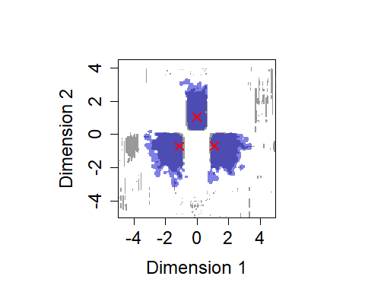

### Plot 3d density of GMM and and scatter disribution with GMM contours

par(mfrow=c(1,2), pty = "s")  
par(mar=c(3.5, 3.5, 2, 1), mgp=c(2.4, 0.8, 0))  
  
x <- seq(-4,4, by =0.2)  
y <- seq(-4,4, by =0.2)  
grid <- expand.grid(x1 = x, x2 = y)  
  
d <- matrix(0, nrow = length(x),  
 ncol = length(y))  
  
for (idxc in 1:klist[K.selected]) {  
 d <- d + gmm_list[[K.selected]]$weights_[idxc] *   
 matrix(dmvnorm(  
 cbind(grid$x1, grid$x2),  
 mean = gmm_list[[K.selected]]$means_[idxc,],   
 sigma = gmm_list[[K.selected]]$covariances_[idxc,,]),  
 nrow = length(x),  
 ncol = length(y))  
}  
persp(x, y, d,   
 theta=30,   
 phi=20, expand=0.5,   
 ticktype="detailed",  
 ltheta = 120, shade = 0.75,  
 xlab = "Dimension 1",  
 ylab = "Dimension 2",  
 xlim = xlim,  
 ylim = ylim,   
 zlab = "",   
 cex.axis = 0.8   
 )   
  
plot(df_data$X1[1:nplot],  
 df_data$X2[1:nplot],  
 "p",  
 col = rgb(0.2,0.2,0.2,alpha=0.7),   
 pch=".",  
 xlim = xlim,  
 ylim = ylim,   
 xlab="Dimension 1",   
 ylab="Dimension 2",  
 cex = 2,   
 cex.axis = 1,   
 cex.lab = 1.2)  
  
for (idxc in 1:klist[K.selected]) {  
 mixtools::ellipse(mu=gmm_list[[K.selected]]$means_[idxc,],   
 sigma=gmm_list[[K.selected]]$covariances_[idxc,,],  
 alpha = 1-.6827, # 1 sigma   
 npoints = 250, col="red", lwd =2)   
}  
plot.cluster.center(gmm_list[[K.selected]]$means_)

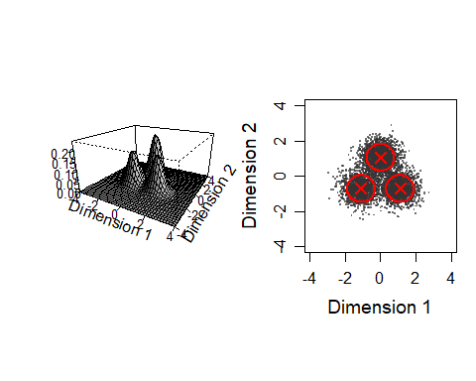

# Evaluate each cluter center

Define function for evaluate each cluter center

# Input：  
# x, # data matrix (factor scores) (respondent x dimension)  
# c.center, cluster center matrix (cluster center x dimension)  
# n.shuffle = 1000 number of shuffles  
#  
# Output:   
# $d.original # density of original data   
# $d.null # mean density of null model  
# $p.value # p-value  
# $enrichment # = d.original/d.null  
eval_component <- function(x, c.center, n.shuffle = 1000) {  
   
 xdim <- ncol(x)   
 N <- nrow(x)   
 n.component <- nrow(c.center)  
   
 p.value <- numeric(n.component)  
 enrichment <- numeric(n.component)  
   
 cat("Bandwidth selection...\n")  
 Hpi <- ks::Hpi.diag(x = x[1:min(N,1000),],   
 nstage = 2)  
 cat("kernel dinsity estimation for original data...\n")  
 k <- ks::kde(x = x, H = Hpi,  
 eval.points = c.center,  
 binned = FALSE)   
 density.original <- k$estimate  
   
 density.shuffle <- matrix(0, n.shuffle, nrow(c.center))  
   
 cat("kernel dinsity estimation for shuffled data...\n")  
 for (idxs in 1:n.shuffle) {  
 if (idxs %% 10 == 1)   
 cat("=")  
   
 sc_shuffeled <- apply(x, MARGIN = 2, sample)  
   
 k <- ks::kde(x = sc_shuffeled, H = Hpi,   
 eval.points = c.center,  
 binned = TRUE) # should be FALSE if the number of dimension >= 4  
   
 density.shuffle[idxs,] <- k$estimate  
 }  
 cat("\n")  
   
 density.null <- colMeans(density.shuffle)  
   
 for (idx in 1:n.component) {  
   
 p.value[idx] <- sum(density.original[idx] < density.shuffle[,idx]) / n.shuffle  
   
 enrichment[idx] <- density.original[idx] /  
 density.null[idx]  
   
 d.null.mean <- mean(density.shuffle[,idx])  
 }  
   
 list(d.original = density.original,  
 d.null = density.null,   
 p.value = p.value,  
 enrichment = enrichment )  
}

Evaluate clusters (Gaussian components).

res_ec <- eval_component(df_data,  
 gmm_list[[K.selected]]$means_)

## Bandwidth selection...  
## kernel dinsity estimation for original data...  
## kernel dinsity estimation for shuffled data...  
## ====================================================================================================

# FALSE: not meaningful, TRUE: meaningful  
flg_meaningful <- (res_ec$p.value < 0.01 &   
 res_ec$enrichment > 1.25)   
  
# 1: not meaningful,2: meaningful  
idx_meaningful <- flg_meaningful + 1

Calculate the fraction of samples classified into each cluster.

cluster_labels <- apply(gmm_list[[K.selected]]$predict_proba(df_data),1,which.max)  
  
(tb <- table(cluster_labels))

## cluster_labels  
## 1 2 3   
## 40292 29856 29852

cat("Fraction of samples classified into one of the meaningful clusters:",  
 sum(tb[flg_meaningful])/sum(tb))

## Fraction of samples classified into one of the meaningful clusters: 1