Embedded Lab #1
Khattiya Wiriyakeattipong | 6730054721

2.1 From STM32F4XX Reference manual, what are these GPIO registers
From STM32F4XX Reference manual, the addresses for GPIO registers are:
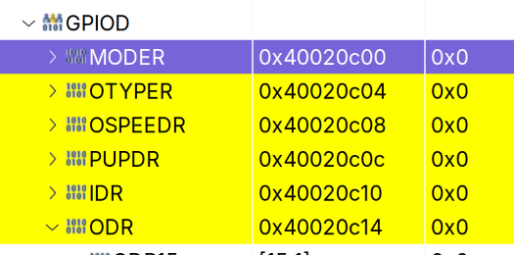
- GPOID_MODER : `0x40020c00`
- GPIOD_OTYPER : `0x40020c04`
- GPIOD_OSPEEDR : `0x40020c08`
- GPIOD_PUPDR : `0x40020c0c`
- GPIOD_ODR : `0x40020c14`

2.2 Using step/suspend/resume debugging feature on SW4STM32, what is the value of GPIOD_MODER and GPIOD_ODR from the start of debugging and breakpoint. What are the relations to LEDs’ Discovery Board.
Prior to the program, when at the HAL_Init() breakpoint, GPIOA_MODER and GPIOA_ODR has all the values set to 0xa8000000. At the first iteration (reached the loop breakpoint for the first time), GPIOA_MODER has its value set to 0xa8000400 and GPIOA_ODR has its value set to 0x20. After the next iteration, GPOIA_MODER still has its value set to 0xa8000400, but GPIOA_ODR’s value has been set to 0x0. When I resumed the iteration again, GPIOA_MODER’s value is still at 0xa08000400, but GPIOA_ODR’s value is changed to 0x20. (and the pattern keeps going on and on.)
The LED status will depend on the value of GPIOA_ODR. If GPIOA_ODR’s value is set to 0x20, the LED is on, and on the other hand, if it is set to 0x0, the LED is off.

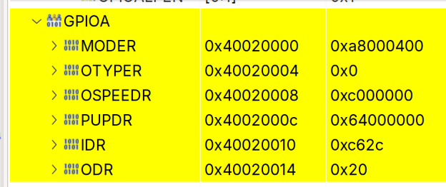
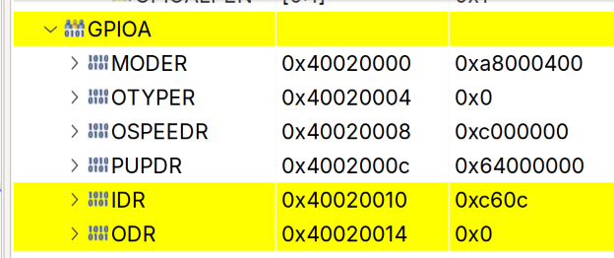

3. Create a new project with 4 times speed of System Clock using “Clock Configuration” on STM32CubeMX. What are the value of PLLP, PLLN and PLLM register, before and after set the new speed. (Look at RCC register on STM32F407 Reference manual)
Before modifying, the values are:
PLLM = 8
PLLN = 50
PLLP = 52

After changing the clock speed, the values are changed to
PLLM = 4
PLLN = 100
PLLP = 2

4. Use a STM32 Cube embedded software libraries instead of direct register assignation and for loop delay (using functions from stm32f4xx_hal.c and stm32f4xx_hal_gpio.c in STM32F4xx_HAL_Driver) to create a same behavior as example code on 1.
This can be obtained by modifying the while (1) block to this:
while (1)
{
/* USER CODE END WHILE */

/* USER CODE BEGIN 3 */
HAL_GPIO_TogglePin(GPIOA, GPIO_PIN_5);
HAL_Delay(300);
}
/* USER CODE END 3 */

HAL_GPIO_TogglePin(GPIOA, GPIO_PIN_5); replaces the behavior of the line
GPIOA->ODR ^= 1<<5; , and how fast the blinking of the LED can be adjusted in HAL_Delay(300);

