PIZZA SALES SQL QUERIES

A. KPI Requirement

1. Total revenue = Sum of total_price of all pizzas ordered.

select round(sum(total_price),0) as Revenue from pizza_sales;

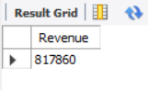

2. Average order value = total revenue/ total orders.

select sum(total_price)/count(distinct order_id) as Average_order_value from pizza_sales;

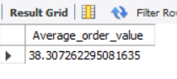

3. Total pizzas sold = Sum of quantities of all pizzas sold.

select sum(quantity) as Total_pizzas_sold from pizza_sales;

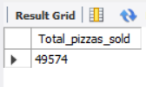

4. Total orders.

select count(distinct order_id) as Total_order from pizza_sales;

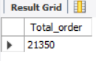

5. Average pizzas per order = total pizza sold / total order

select sum(quantity)/count(distinct order_id) as Average_pizza_per_order from pizza_sales;

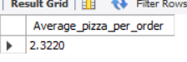

B. Daily trend for total orders

Calculating total orders from Monday to Sunday to observe fluctuations.

select dayname(cast(order_date as date)) as Days,count(distinct order_id) as Orders

from pizza_sales

group by days

order by Orders desc;

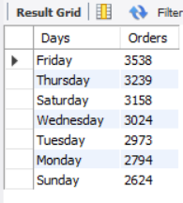

C. Monthly trend for total orders

Calculating total orders from Jan to Dec to observe fluctuations.

select monthname(cast(order_date as date)) as Months, count(distinct order_id) as Orders

from pizza_sales

group by Months

order by Orders desc;

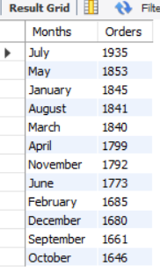

D. Percent of sales by Pizza category

Sales per pizza category / total sales

select pizza_category, round(sum(total_price),2) as Revenue, round((sum(total_price)/(select sum(total_price) from pizza_sales))*100,2) as Percentage

from pizza_sales

group by pizza_category;

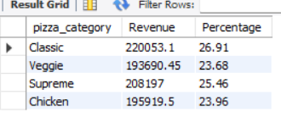

E. Percent of sales by Pizza size

Sales per pizza size / total sales

select pizza_size, round(sum(total_price),2) as Revenue, round((sum(total_price)/(select sum(total_price) from pizza_sales))*100,2) as Percentage

from pizza_sales

group by pizza_size;

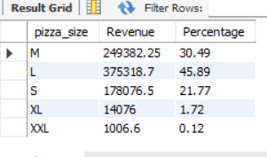

F. Top 5 pizza based on Revenue

select pizza_name, sum(total_price) as Revenue

from pizza_sales

group by pizza_name

order by revenue desc

limit 5;

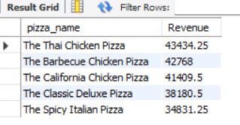

G. Top 5 pizza based on Quantity

select pizza_name, sum(quantity) as Quantity

from pizza_sales

group by pizza_name

order by Quantity desc

limit 5;

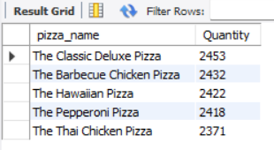

H. Top 5 pizza based on Orders

select pizza_name, count(distinct order_id) as Orders

from pizza_sales

group by pizza_name

order by Orders desc

limit 5;

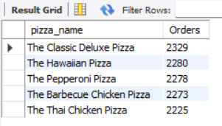

I. Bottom 5 pizza based on Revenue

select pizza_name, round(sum(total_price),2) as Revenue

from pizza_sales

group by pizza_name

order by revenue

limit 5;

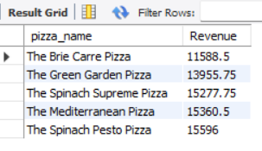

J. Bottom 5 pizza based on Quantity

select pizza_name, sum(quantity) as Quantity

from pizza_sales

group by pizza_name

order by Quantity

limit 5;

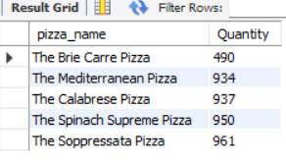

K. Bottom 5 pizza based on Orders

select pizza_name, count(distinct order_id) as Orders

from pizza_sales

group by pizza_name

order by Orders

limit 5;

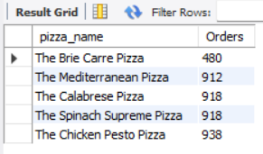

**NOTE:-**

Percent of sales by Pizza category for January month

select pizza_category, round(sum(total_price),2) as Revenue, round((sum(total_price)/(select sum(total_price) from pizza_sales))*100,2) as Percentage

from pizza_sales

where monthname(cast(order_date as date)) = "January"

group by pizza_category;

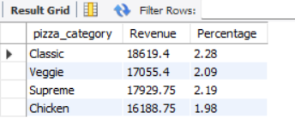

Percent of sales by Pizza category for 2nd quarter

select pizza_category, round(sum(total_price),2) as Revenue, round((sum(total_price)/(select sum(total_price) from pizza_sales))*100,2) as Percentage

from pizza_sales

where quarter(cast(order_date as date)) = 2

group by pizza_category;

