# Executive Summary

# Introduction

## Background of Project

## Problem Statement

## Current Status

## Scope & Organization

# Design Objective & Requirements

# System Design

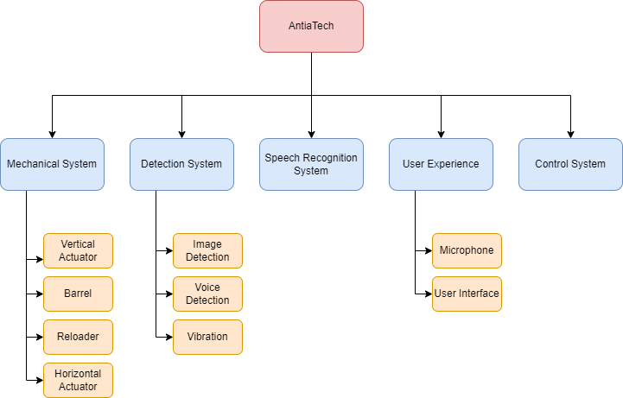

### Mechanical Subsystem

The mechanical system is a system that includes all of the moving parts of the Training Buddy project. This system is made up of the reloader, barrel, horizontal actuator, and vertical actuator. The system's goal is to launch balls from a ping pong ball dispenser at various speeds and angles in different directions, based on user commands.

#### Reloader

The reloader includes a ping pong ball tank and a mechanical system that propels the balls from the dispenser into the barrel. This system also provides space to house all other components such as power units and control units located under the ball chamber.

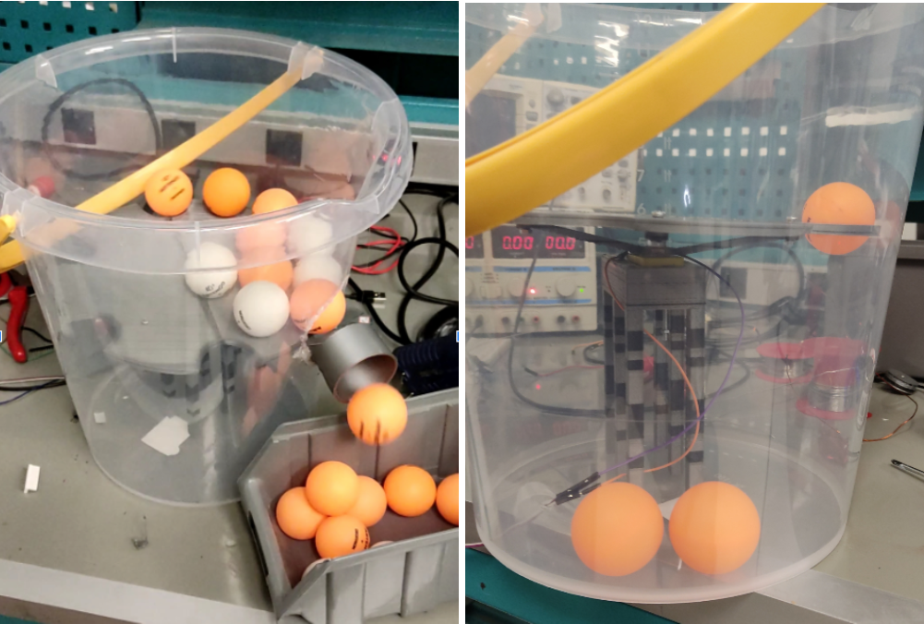

As seen above, the reloader consists of a platform that pushes the balls towards the side of the box with the help of a motor, and a connection point where the barrel and the chamber meet. The platform, which rotates at a constant speed with the help of a DC motor, is designed to push 6 balls into the barrel at each full turn. The engine carrying this platform needs to produce relatively high torque while rotating at a low speed.

Unfortunately, the engine we used in the first tests could not produce enough torque and ran too fast. Based on the failure in our tests, it was decided to put a more powerful but slower rotating motor here. For this reason, a stepper motor, which is easier to control by a controller, will be used instead of a continuously rotating motor in the following process. Stepper motors, as we want, can rotate one full turn around themselves at much lower speeds, but at the same time, they can produce higher torque than dc motors.

Finally, the area under the platform will be the place to house the power and control units of the project and related equipment. Therefore, the user will be able to use the entire system in an area only equal to the volume of the box.

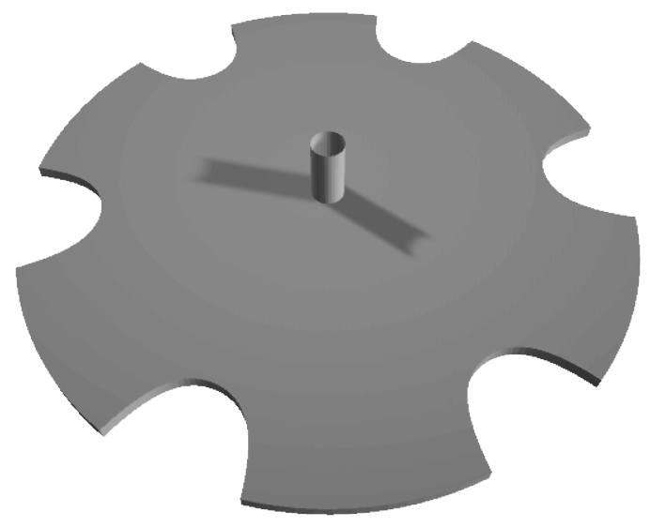

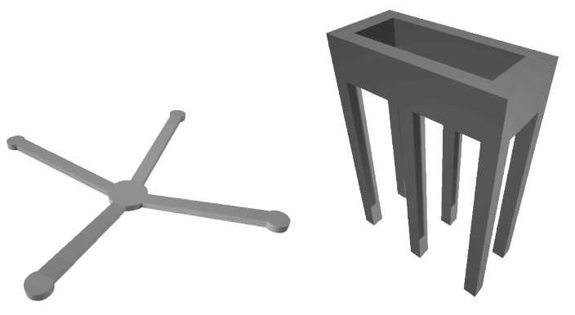

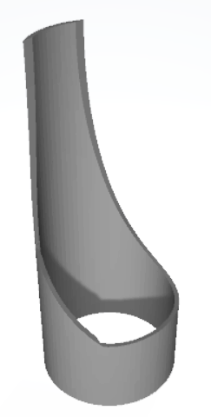

#### Barrel

The barrel is the system that throws the balls coming from the reloader in a certain direction, spin setting and speed according to the commands given by the user.

This system consists of wheels placed slightly inside a barrel and dc motors that rotate these wheels at specified speeds.

In this system, which is planned to consist of 2 dc motors, 3 dc motors can be used depending on the need. In the system with 2 dc motors, the balls are placed one on top of the other. It is planned to change the spin of the ball by changing the speeds of these motors. While choosing these dc motors, motors that can reach as high RPM values as possible were preferred.

In addition, very powerful motors were not used in order to balance the power consumption, as the motors rotate at almost no load.

In the first trials, it was tested whether the dc motors could throw the ball at the desired speed by rotating both motors at the same speed.

In these tests, various amounts of PWMs were given to the motors, and it was observed that the ball could be launched at speeds that could be changed manually by looking at the test results. In addition, it has been observed that the material used in the wheels has a significant effect on the speed of the ball. It has been observed that the ball accelerates more stably when using materials that are especially soft and that can be statically attached to the ball when it comes into contact with the ball.

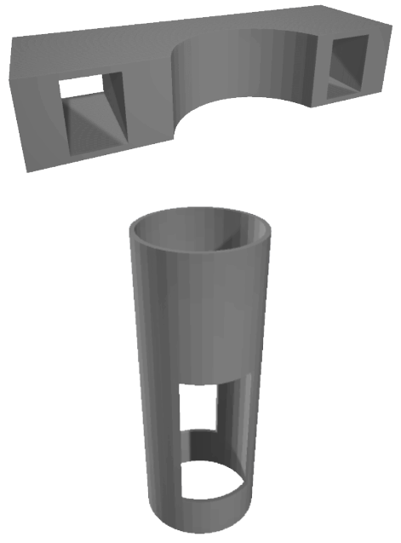

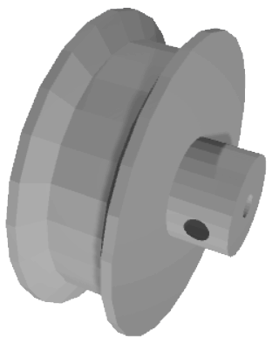

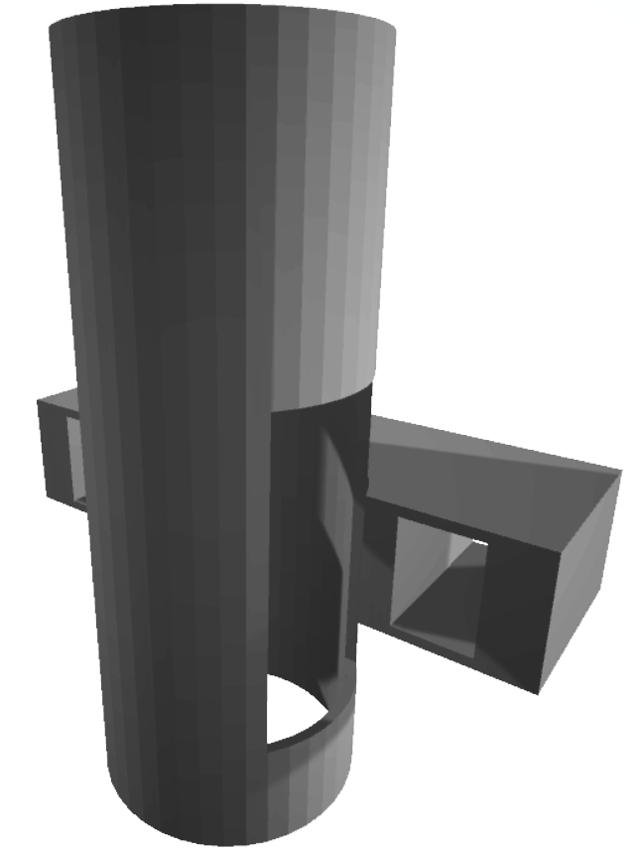

#### Horizontal Actuator

#### Vertical Actuator

### Detection Subsystems

### Speech Recognition Subsystem

### User Interface

### Control System

# Test Architecture

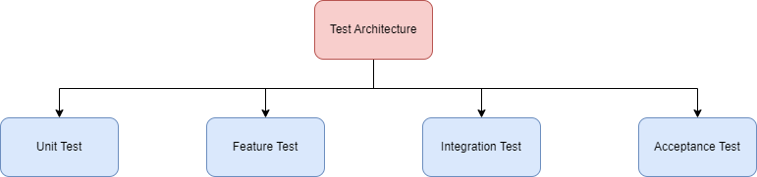

## Unit Test

Unit tests test whether the smallest components of the system are working properly for their intended purpose. For example, the test that checks whether a dc motor works in suitable current and voltage ranges is a unit test.

## Feature Test

Feature test is a type of test that checks the functionality of the parts that make up the sub-system.

For example, barrel-related tests that are part of the mechanical subsystem are in the feature test category.

These tests are tested independently of other parts and subsystems. For example, there is no need to have a barrel in the mechanism that pushes the ball into the barrel. If the ball comes out of the bucket in the defined amount in a certain time, this test is successful.

## Integration Test

Integration tests check the integration of parts containing a subsystem with each other and the relationships of smaller subsystems with other subsystems.

For example, in a feature test scenario, the ball entering the barrel is pushed into the barrel by hand, while in the integration test, the throwing of a ball pushed into the barrel through the reloader mechanism is controlled.

In addition, the relationship of one subsystem to another subsystem can also be included in the scope of integration testing.

For example, a test case involving throwing the ball to the right or left with a voice command from the user is an integration test.

## Acceptance Test

The Acceptance test is the type of tests that check whether all subsystems work in harmony with each other.

The Acceptance test also includes a checklist. This checklist checks how well the final product meets the requirements.

## First Test Results & Comments

|  |  |  |
| --- | --- | --- |
| **Test Case** | **Result** | **Comment** |
|  |  |  |
|  |  |  |
|  |  |  |
|  |  |  |
|  |  |  |
|  |  |  |

# Planning

## Schedule

## Risk Analysis

# Conclusion