**EE 494**

**ENGINEERING DESIGN II**

**Final Report**

# 

**ANTIATECH**

Department of Electrical and Electronics Engineering

Middle East Technical University

Çankaya, Ankara 06800, Türkiye

**Training Buddy**

**Presented by:**

Afer OLKAY

Başak KOCA

Çağrı ARI

Kubilay KAYA

Rana BÖĞREKCİ

# 

**Executive Summary 2**

**Introduction 3**

Background of the Project and Problem Statement 3

Current Status 3

Scope & Organization 3

**System Design 4**

3D CAD Model and Block Diagram of the Overall System 4

Electrification of the Systems 4

Mechanical Subsystem 4

Barrel 4

Reloader 4

Horizontal Actuator 4

Vertical Actuator 4

Detection Subsystem 4

Vibration 4

Image Detection 4

Speech Recognition Subsystem 4

Ball Tracking Subsystem 4

Control Algorithm 4

User Interface 4

**Design Requirements 4**

**Design Modifications 4**

**Compatibility Analysis 4**

**Compliance with Requirements 5**

**Test Results 5**

**Resource Management 5**

**Deliverables 5**

**Safety 5**

**Impact 5**

**Conclusion 5**

**References 5**

**Appendix 5**

# 

# Executive Summary

For any athlete to be successful in any sport branch, an immense amount of practice is necessary. But it is not always possible to find a partner with an appropriate skill level to practice. With TrainingBuddy, we as AntiaTech claim that our customers can practice their game at any level possible and for any desired scenario/routine. In addition, TrainingBuddy will analyze your playstyle and show you where your weaknesses reside. The innovation of technologies provides different solutions to this problem, and we as AntiaTech see ourselves as the bridge between cutting edge technology and your ambitions.

Our meticulously designed product has a mechanically state of the art thrower mechanism which makes it possible to serve the ball to the opposite side in specific locations, with any difficulty level by speeding the ball with cautiously controlled two DC motors. We can apply any desired spin and speed by independently powering the motors. Moreover, the ball can be launched to any place on the table with the help of our horizontal and vertical barrel actuators applied with servo and step motors.

The product can store approximately 50 balls with its large storage area to make sure it can keep up with the players heavy training without any undesired interruption. What's next, is that it offers several play modes to simulate even the toughest opponents and all the player has to do is vocalize the mode out-loud since our product can hear you and listens how you wish to train. Moreover, in order for players to keep track of their progress and analyze their performance, our system will monitor the gameplay with various sensors which are vibration sensor, microphone and camera and the data will be processed with our mathematical modeling. As a result our user interface will inform players visually about the training session and store the data in the device.

So far, our company created the prototype of the system and successfully created the proof of concepts and a fully functional prototype. Therefore we already proved that we’ll yield a successful product. Additionally, each day we apply several tests and identify if any weakness resides so that we can create an overall sturdy system.

The project is expected to finish before June 2023 and cost about 200 USD. It will offer the customer a 2-year warrant and user-guide documentation as well as an application to interface with the TrainingBuddy.

# Introduction

## Background of the Project and Problem Statement

Any sport requires practice if you want to improve your abilities. But also, it is important to practice efficiently: one does not become a weight champion by lifting pillows constantly nor starts training by lifting  hundreds of kilos. Table tennis is no exception, although it is not always possible to train with opponents at the same skill level as you. As AntiaTech, we aim to remove this problem and make it possible for our customers to reach their potential as soon as possible with our product TrainingBuddy. TrainingBuddy allows you to set its difficulty level by giving you control of its spin, speed adjustment and creating ball routines to make sure you can prepare for any scenario! It will show you where your weakness resides and will be ready for whenever you are ready.

## Current Status

## Scope & Organization

The purpose of this project is to design and develop a table-tennis training robot that can help players improve their skills through practice and feedback. The robot will be able to serve balls at different speeds, spins, and angles, and will use detection and speech recognition to provide feedback to the player on their form and performance. The system will consist of several subsystems, including the detection subsystem for tracking the ball's trajectory, the speech recognition subsystem for providing feedback to the player, and the ball tracking subsystem for monitoring the robot's movements.

This report provides an overview of the project's scope, organization, and design. The report is organized into several sections, starting with the executive summary, which provides a high-level overview of the project. The introduction provides background information on the project, including the problem statement and the current status. The scope and organization section outlines the project's objectives, the subsystems that comprise the system, and the structure of the report. The subsequent sections provide detailed information on each subsystem, including the design, modifications, compatibility analysis, compliance with requirements, and test results.

The report concludes with a summary of the design requirements, resource management, cost, power management, and schedule. Finally, the report includes references and an appendix that provides additional details on the project's design and development.

Overall, this report provides a comprehensive overview of the table-tennis training robot's design and development, from the project's inception to its current state. The report highlights the challenges and successes of the project and provides insights into the potential applications of the system.

# System Design

## 3D CAD Model and Block Diagram of the Overall System

## **3D CAD Model and Block Diagram of the Overall System**

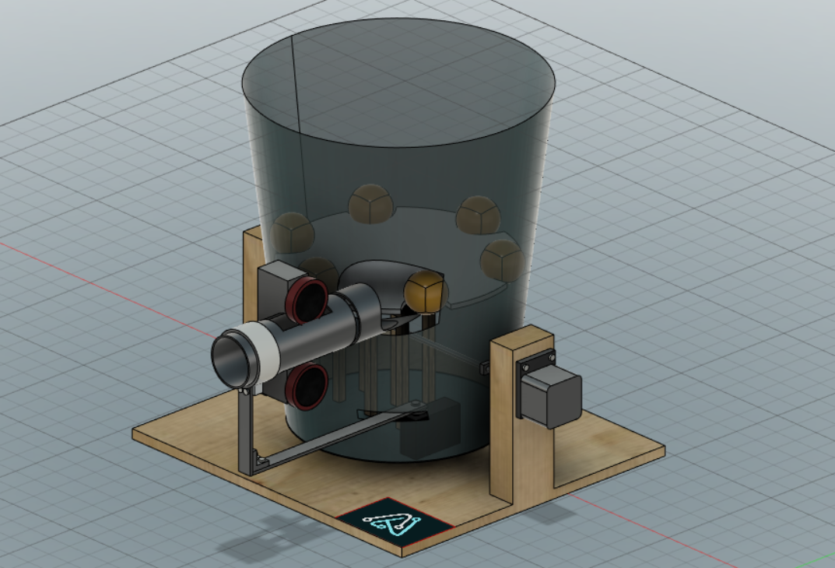

*Figure 1.* 3D CAD Model of Training Buddy

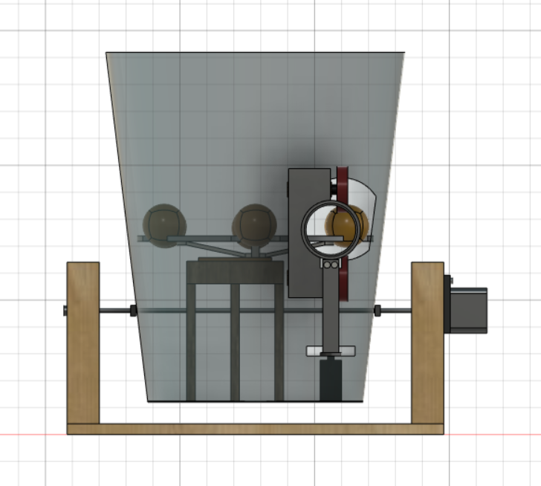

*Figure 2.* Front View of CAD Model

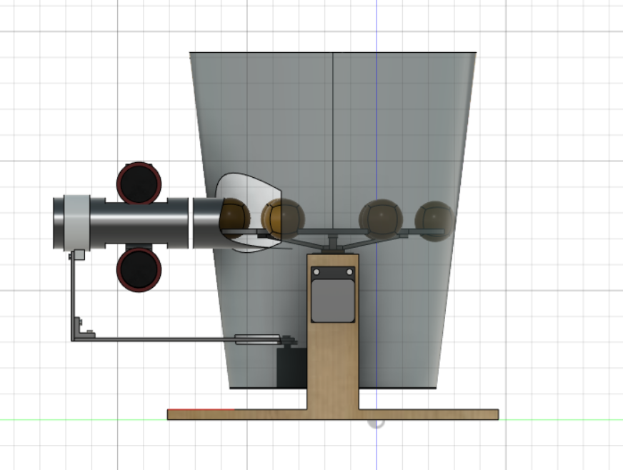

*Figure 3.* Side View of CAD Model

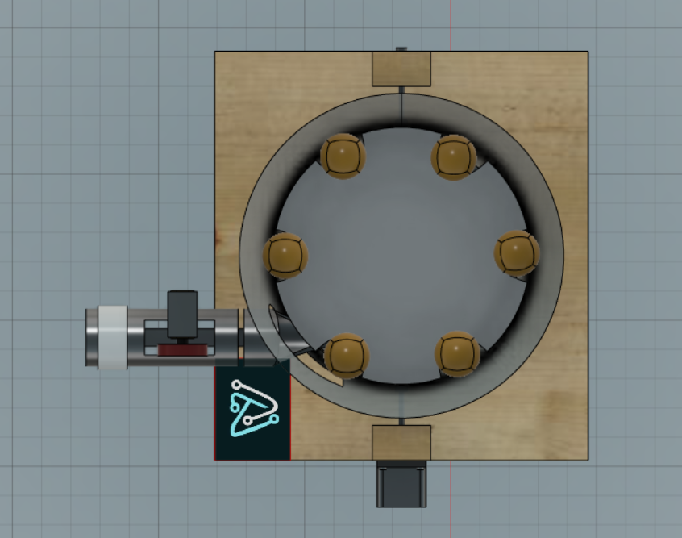

*Figure 4.* Top View of CAD Model

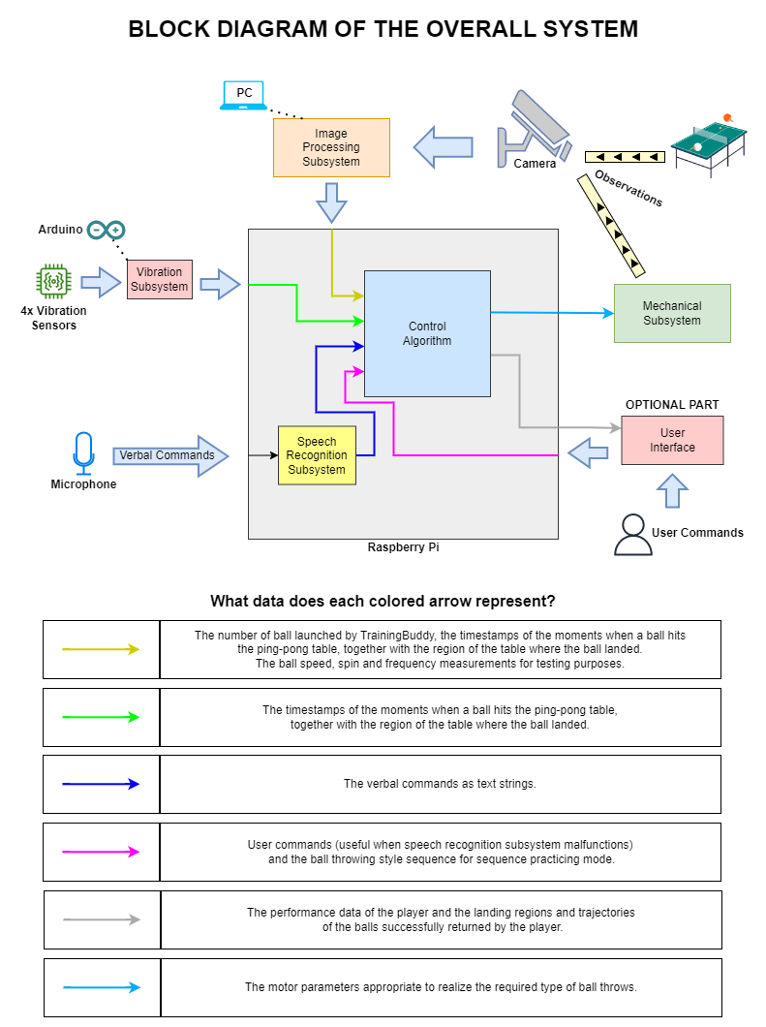  
*Figure 5.* Block Diagram of the Overall System

## Electrification of the Systems

At the beginning of the project, the prominent ideas for powering the system were to use batteries, grid electricity, or a hybrid system consisting of batteries for the motors and phone chargers for the controllers. However, as the project progressed, we were able to power nearly 90% of the system using 220V-12V AC/DC LED transformer and the 12V-5V converter provided by the L298N driver, which is an achievement. We used a 120W LED transformer for this purpose. Initial measurements indicate that the system will consume approximately 30W of power. Since the LED transformer is a relatively inexpensive component, we did not make a cut-off at this point and decided to use a 120W transformer.

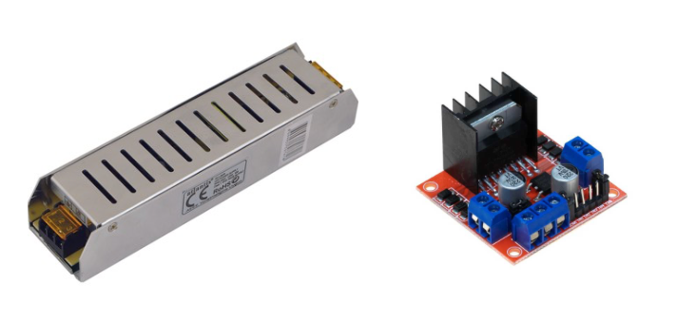

*Figure 6.* Transformer Circuit  and L298N Motor Driver

## Mechanical Subsystem

**Subsystem Requirements:**

The system must

* Hit the other side of the net with 90 % accuracy.
* Launch the ball with desired frequency.
* Apply at least 3 stages of linear speed for the balls from 1 m/s to 3 m/s
* Apply at least 3 stages of rotational speed between 0 to 100 rpm for topspin and backspin of the balls.
* Different speeds with different vertical angles

The mechanical system is a system that includes all of the moving parts of the Training Buddy project. This system is made up of the reloader, barrel, horizontal actuator, and vertical actuator. The system's goal is to launch balls from a ping pong ball dispenser at various speeds and angles in different directions, based on user commands.

### Barrel

### Reloader

### Horizontal Actuator

### Vertical Actuator

## Detection Subsystem

### Vibration

### Image Detection

## Speech Recognition Subsystem

## Ball Tracking Subsystem

## Control Algorithm

## User Interface

# Design Requirements

In this part, the finalized (sub)system-level requirements have been stated. Also, how and how well our current subsystems satisfy these requirements are discussed in detail.

|  |  |
| --- | --- |
| **The finalized (sub)system-level requirement** | **How and how well our current subsystems satisfy the corresponding requirement** |
| Hit the other side of the net with   90 % accuracy | It works pretty well on average, although it's not possible to fire both shots at exactly the same spot. |
| Launch one ball per 2 seconds. In other words, the time between two successive throws should be maximum 2 seconds at maximum frequency selection | We do not have a perfect design. However, there is no situation that negatively affects the user experience. The frequency varies between 1-4 seconds. |
| Apply at least 3 stages of linear speed for the balls from 1 m/s to 3 m/s | We can change the ball speed quite easily. Our barrel design and controller codes work quite well in this regard. |
| Apply at least 3 stages of rotational speed between 0 to 100 rpm for topspin and backspin of the balls | Our work on returning the ball has yielded results. But 3 stages seem not possible. Our 2 different spin options, Top-Back spins, work on a single level. |
| Throw balls at 5 departure angles between 75 and 115 degrees horizontally and 0 to 30 degrees vertically | The current version satisfies this requirement. |
| Throw the ball and change the parameters maximum in 3 seconds | The current version satisfies this requirement. |
| Identify if the player was successful at hitting the ball with 95% accuracy with vibration sensors | The current version satisfies this requirement. |
| Identify if the player was successful at hitting the ball with 90% accuracy with camera | The current version satisfies this requirement as long as tracking of the ball is also successful at more that 90% |
| The region detection algorithm of the vibration sensors detect the ball region 90%of the time when the ball is hit. | The current version is failing at this aspect. Test success rate is 20%, we will implement a better algorithm for the region detection and optimize the overall subsystem. |
| The tracking algorithm detect the ball 90% of the time when the ball is in frame | The current version satisfies this requirement. |
| The algorithm does not detect the ball when no ball is in the frame or the existing balls in frame is not in play, 95% of the time | The current version is failing at this aspect. We will implement a decision algorithm to detect if a ball is in play or how well the detected shape fits the shape of a ball. |
| Store the information of hits/mishits in a database for sport analytics and for game mode | To evaluate this, system integration   is required. |
| Detect the user’s verbal commands from a distance of at least 80 cm and respond correctly with 85% accuracy | The current version of our speech recognition subsystem more than satisfies the corresponding requirement. However, the performance may be affected when the communication between the microphone and Raspberry Pi 4 becomes wireless. |
| Have a time limit (300 ms) for data transmission and processing between application and the robot | To evaluate this, the user interface should be completed. |
| Have a repetition practicing mode that launches the balls consecutively  in the same style. | To evaluate this, system integration   is required. |
| Have a randomized repetition practicing mode that launches the balls consecutively in the same style, just varying linear speed, spin level, and launching angle of the balls slightly | To evaluate this, system integration   is required. |
| Have a sequence practicing mode that launches the balls one after the other following a specific order | To evaluate this, system integration   is required. |
| Have a randomized sequence practicing mode that launches the balls in a similar manner as in sequence practicing, just varying linear speed, spin level, and launching angle of the balls slightly | To evaluate this, system integration   is required. |
| Have a game mode that challenges the users by attacking their weaknesses considering the stored performance data | To evaluate this, system integration   is required. |
| The user should be able to control any feature of the Training Buddy by verbal commands | The current version of our speech recognition subsystem has a specific control command corresponding to each feature of the Training Buddy. |
| Operate when it is powered from the grid | The current version satisfies this requirement. |

# Design Modifications

# Compatibility Analysis

# Compliance with Requirements

# Test Results

# Resource Management

# Deliverables

# Safety

# Impact

## Social Impact

## Environmental Impact

# Conclusion

# References

# Appendix