MI300A BabelStream HBM Bandwidth
CPX vs TPX vs SPX Partition Modes
HLRS — High Performance Computing Center Stuttgart
BabelStream benchmark · double-precision · arraysize=2²⁸ · numtimes=1500
Theoretical peak: 5.3 TB/s per APU · 21.2 TB/s per node

Executive Summary
This report presents a systematic HBM bandwidth characterization of the AMD MI300A APU in CPX (6×1-XCD), TPX (3×2-XCD), and SPX (1×6-XCD) partition modes using the BabelStream benchmark. The MI300A node comprises 4 APUs, each with 6 XCDs sharing a common HBM memory subsystem with a theoretical peak bandwidth of 5.3 TB/s per APU (21.2 TB/s per node).
The experiments progress from isolated single-XCD baselines through incremental contention studies to full-node saturation across all three partition modes. The central finding is that TPX mode achieves the highest aggregate node bandwidth at 16.7 TB/s Triad (79% of theoretical peak), followed closely by CPX at 16.4 TB/s (77%), while SPX significantly trails at 14.6 TB/s (69%). The Dot product reduction operation amplifies these differences further, with TPX at 71% of peak versus CPX at 62% and SPX at only 51%.
Mode | Layout | Triad (TB/s) | % of Peak | Dot (TB/s) | % of Peak | Devices
CPX | 24 × 1 XCD | 16.4 | 77% | 13.2 | 62% | 24
TPX | 12 × 2 XCD | 16.7 | 79% | 15.1 | 71% | 12
SPX | 4 × 6 XCD | 14.6 | 69% | 10.7 | 51% | 4
Table 1: Full-node aggregate bandwidth by partition mode. TPX row highlighted as best performer.

1. Isolated Baseline: 1 XCD per APU Shows Zero Contention
The first experiment establishes a contention-free baseline by running BabelStream on a single XCD per APU (devices 0, 6, 12, 18). This configuration eliminates any intra-APU bandwidth contention.
Results are remarkably uniform: cross-APU spread is less than 0.04% on all operations. Every XCD achieves approximately 711 GB/s on Copy/Mul, 715 GB/s on Add/Triad, and 704 GB/s on Dot. This confirms that each APU’s HBM subsystem delivers identical per-XCD bandwidth when uncontested, establishing the performance ceiling for subsequent experiments.
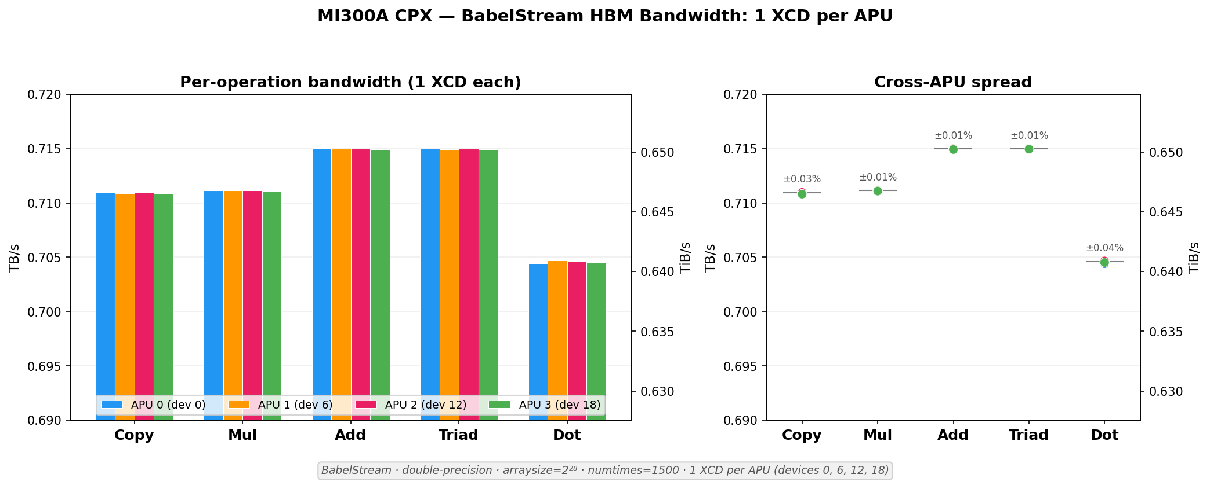
Figure 1: 1 XCD per APU — virtually zero cross-APU variation.

2. Intra-APU Contention: 6 XCDs on a Single APU
Running all 6 XCDs on APU 0 reveals which devices suffer under contention. Devices 0, 1, 3, and 5 maintain near-baseline bandwidth (approximately 100% efficiency), while devices 2 and 4 consistently drop to around 95% on streaming operations and approximately 80% on the Dot product. This asymmetry is hardware-level and reproducible: the same device pairs underperform regardless of run ordering.
The cumulative APU 0 bandwidth reaches 4.19–4.20 TB/s on Triad, meaning the strong devices compensate for the weak ones. However, the device-level variance foreshadows the full-node contention patterns observed later.
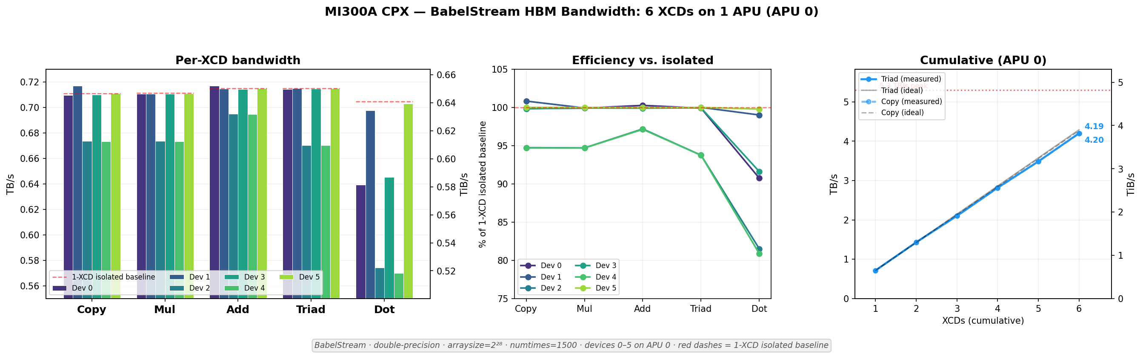
Figure 2: 6 XCDs on APU 0 — devices 2 and 4 show consistent degradation.

3. Larger Arrays Amplify Contention
Doubling the array size from 2²⁸ to 2²⁹ worsens the contention picture significantly. The already-weak devices 2 and 4 degrade further (from 95% to 89% on Copy), and previously strong devices 1 and 5 also begin to suffer (device 1 drops from approximately 100% to 88% on Copy). Devices 0 and 3 remain rock-solid at approximately 100% efficiency in both configurations.
Despite wider per-device variance, the aggregate Triad only drops from 4.20 to 4.16 TB/s (approximately 1%) because the strong devices compensate. The Dot product gap, however, widens considerably. This demonstrates that larger memory footprints increase HBM controller contention pressure.
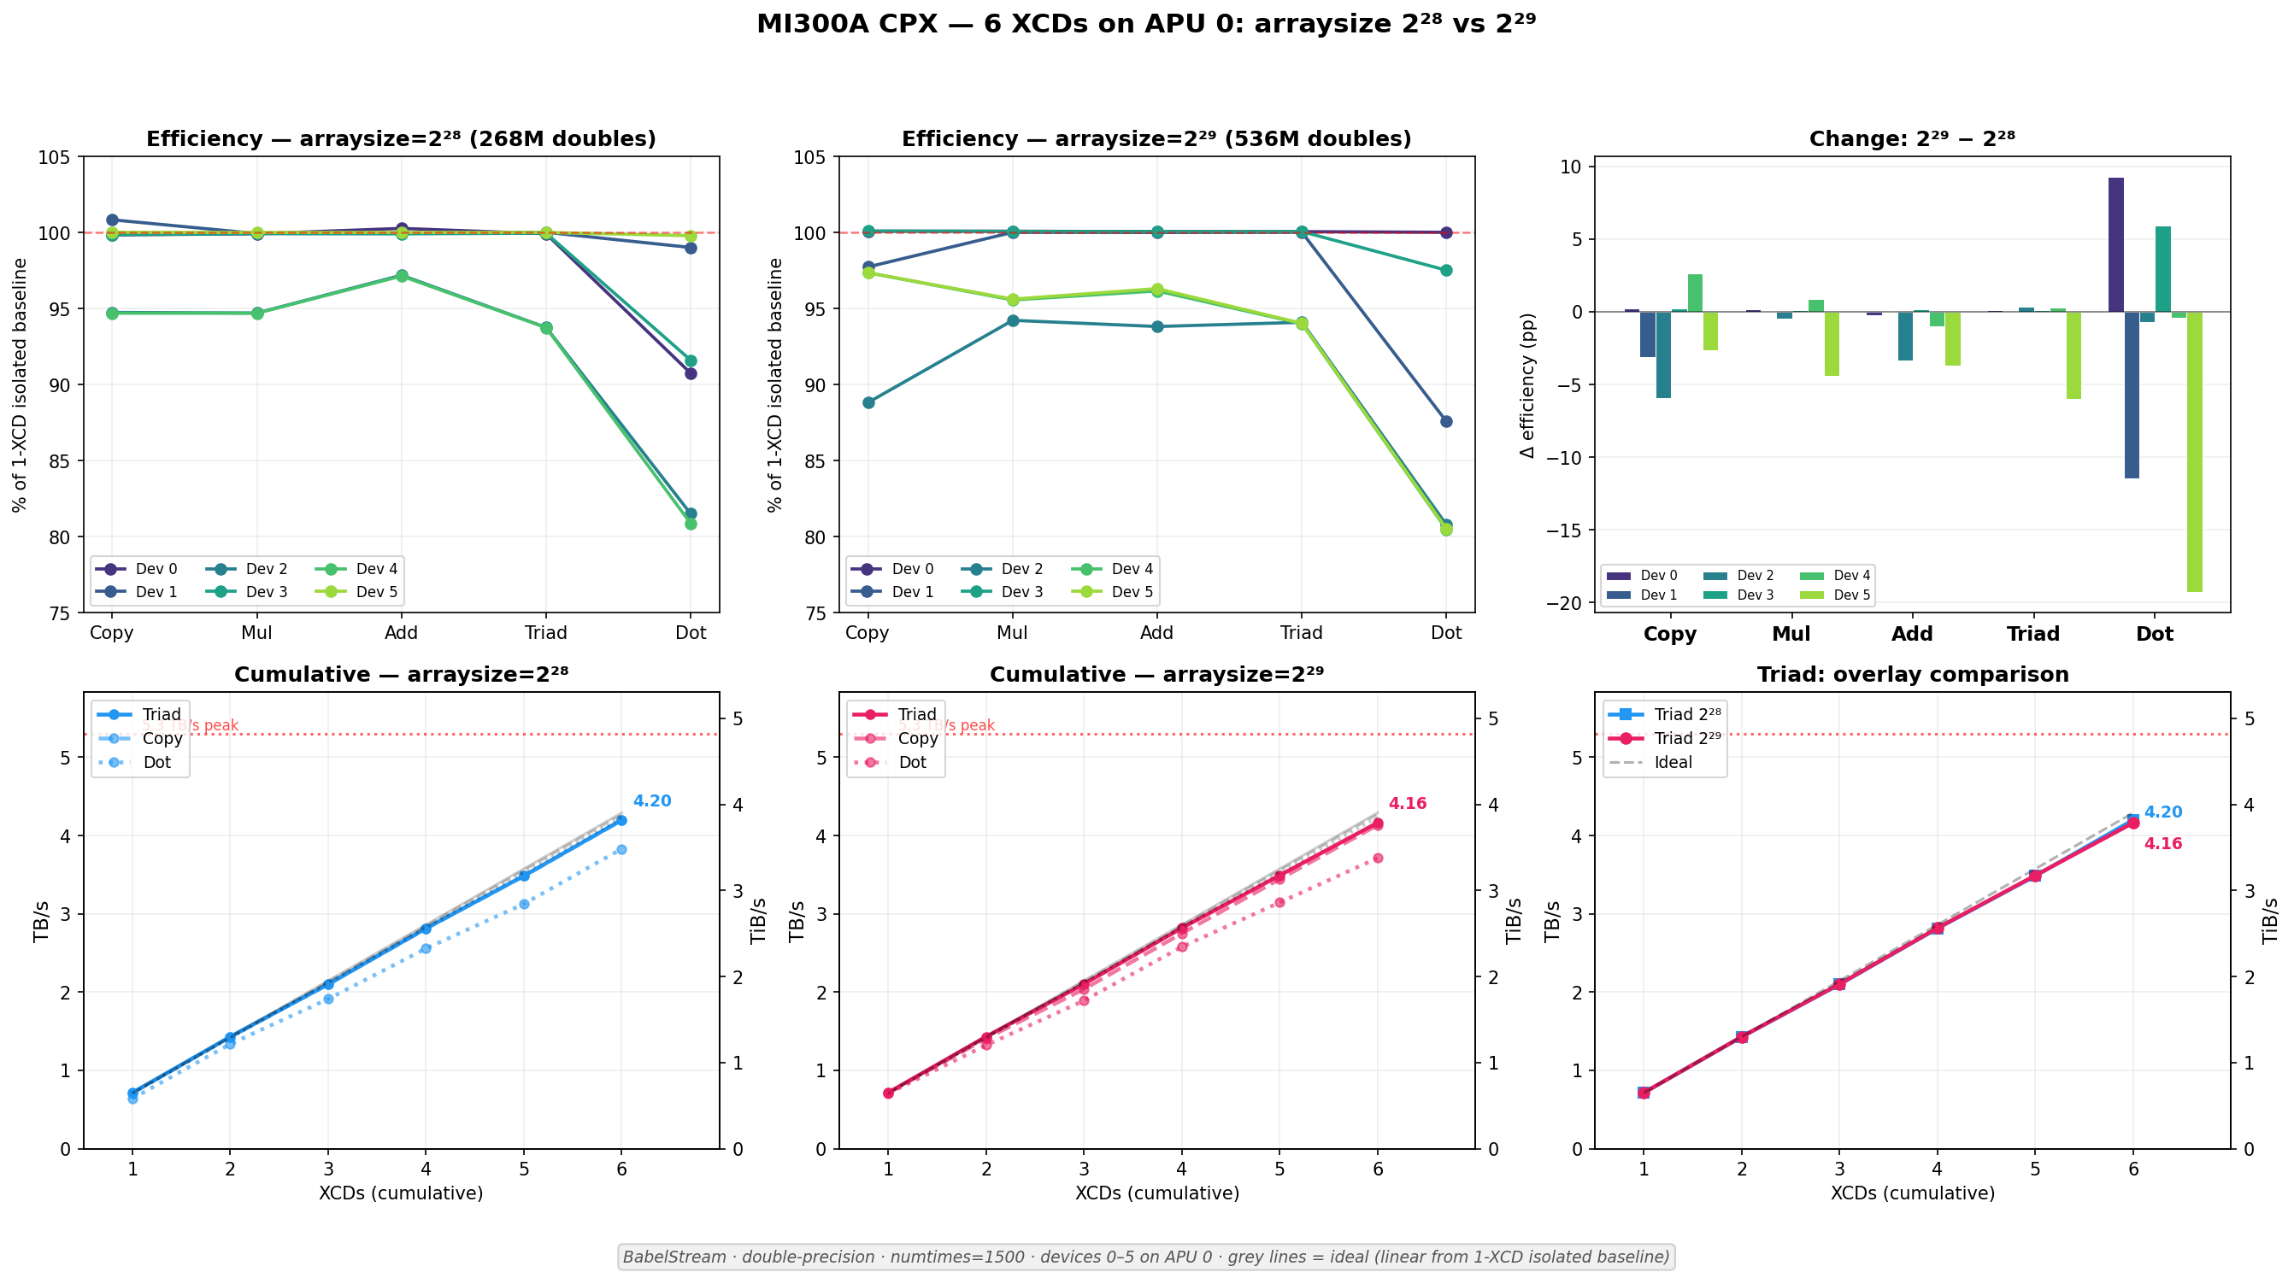
Figure 3: Array size 2²⁸ vs 2²⁹ — larger arrays amplify device-level contention.

4. Emulated TPX: 2 XCDs per APU Eliminates Contention
Running only 2 XCDs per APU (emulating the first TPX partition of each APU within CPX mode) produces results as clean as the single-XCD baseline. Cross-device spread remains below 0.05% on all streaming operations and 0.26% on Dot. Every device hits the isolated baseline within measurement noise.
This critical finding demonstrates that the HBM controller handles 2 concurrent XCD streams without any measurable degradation. The contention only manifests when going beyond 2 XCDs per APU, which explains why TPX mode (with its 2-XCD devices) performs so well at full node utilization.
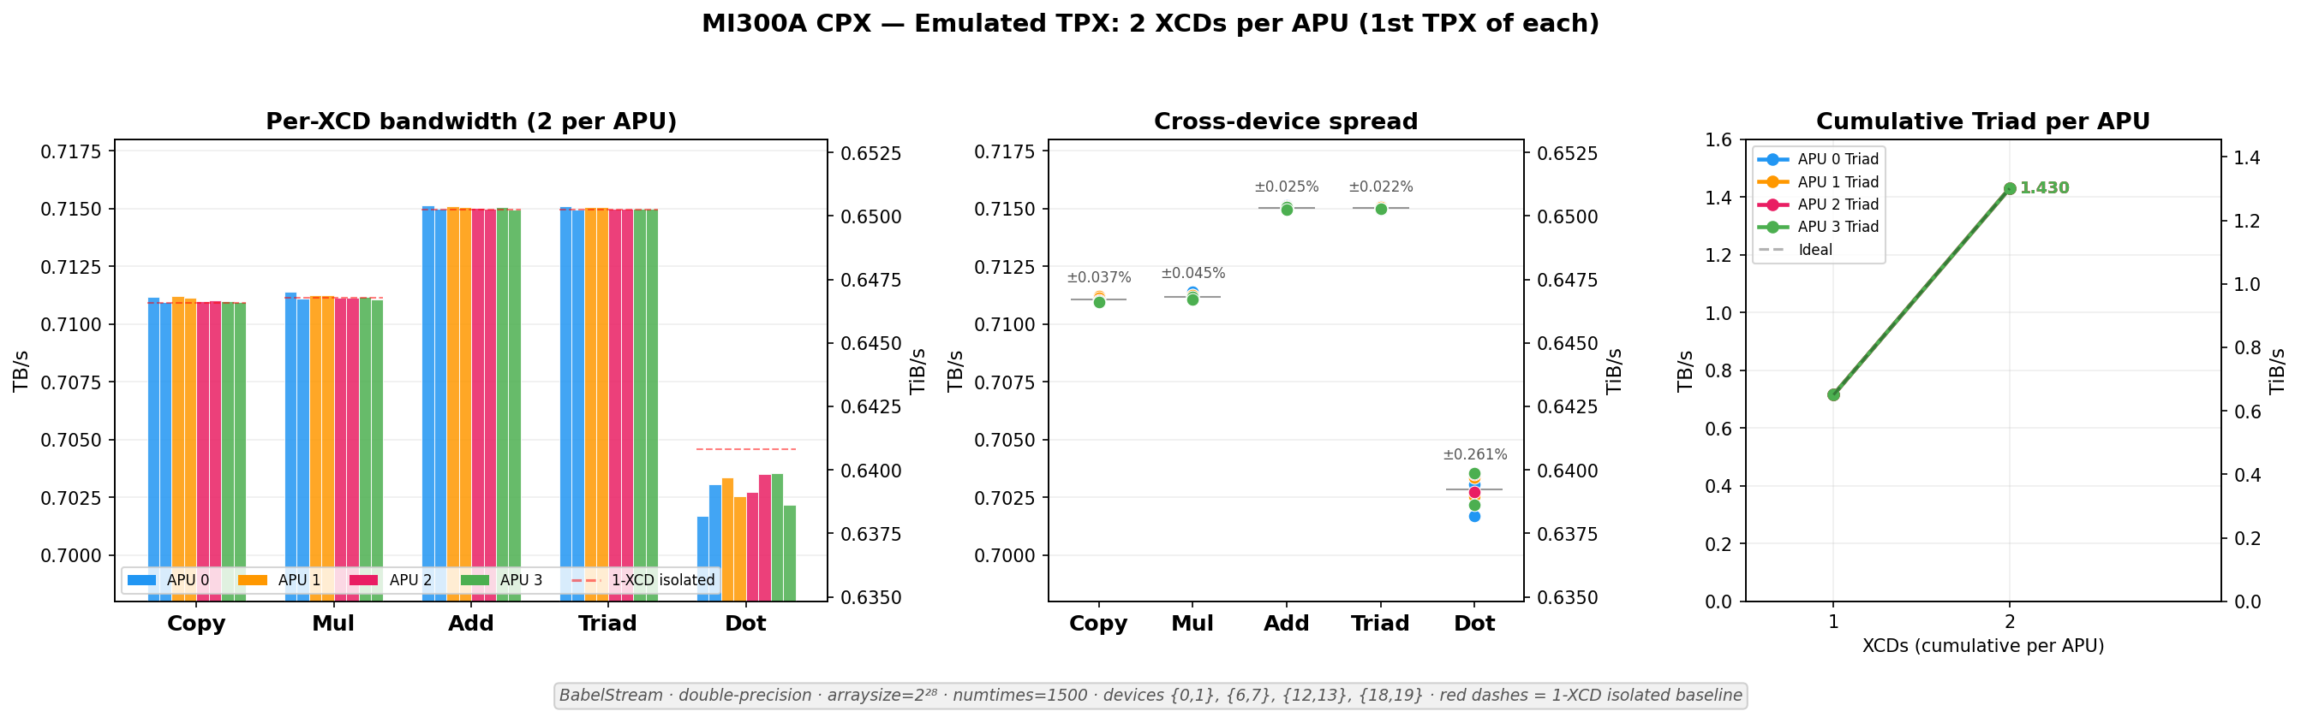
Figure 4: 2 XCDs per APU — no contention, all devices at baseline.

5. Real TPX vs Emulated: Slight Overhead from Fused Devices
Comparing real TPX mode (1 device with 2 XCDs) against emulated TPX in CPX mode (2 separate 1-XCD devices) reveals that real TPX is approximately 0.3% slower on streaming operations and approximately 2.5–3% slower on the Dot product. The two independent CPX processes slightly outperform the single TPX process because each runs its own reduction independently, avoiding cross-XCD coordination overhead within a fused device.
For embarrassingly parallel streaming workloads, CPX’s process-level parallelism provides a marginal edge over TPX’s unified device model. However, this difference is small enough that it is negligible for most practical applications.
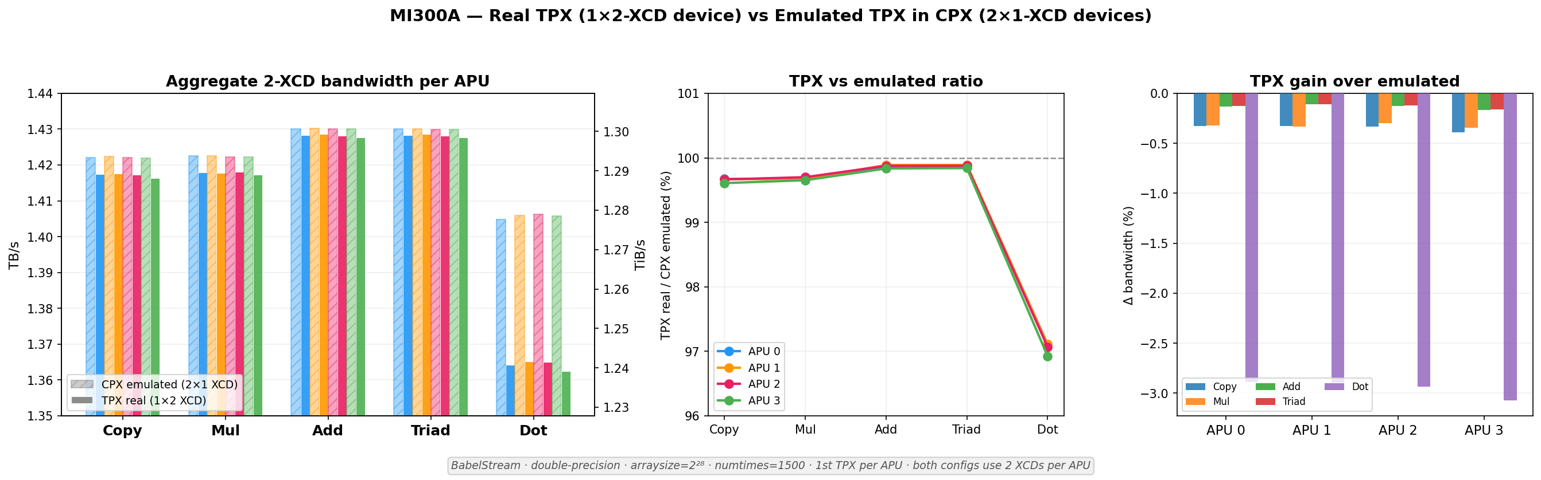
Figure 5: Real TPX is approximately 0.3% slower on streaming, approximately 3% on Dot vs emulated CPX.

6. Full-Node TPX: Consistent but with 3rd-Device Contention
At full-node TPX utilization (12 devices, 3 per APU), the contention pattern mirrors CPX: the 3rd TPX device per APU faces the most bandwidth pressure. Devices like 5 (APU 1), 8, and 9 (APU 2) drop to 80–93% efficiency on streaming operations and as low as 77% on Dot. The stronger devices (those that happen to be the 1st or 2nd in each APU) maintain near-peak performance.
Aggregate per-APU Triad bandwidth ranges from 4.10 to 4.19 TB/s (77–79% of the 5.3 TB/s theoretical peak). The Dot product shows the widest device-level spread, confirming that reduction operations are disproportionately affected by HBM contention.
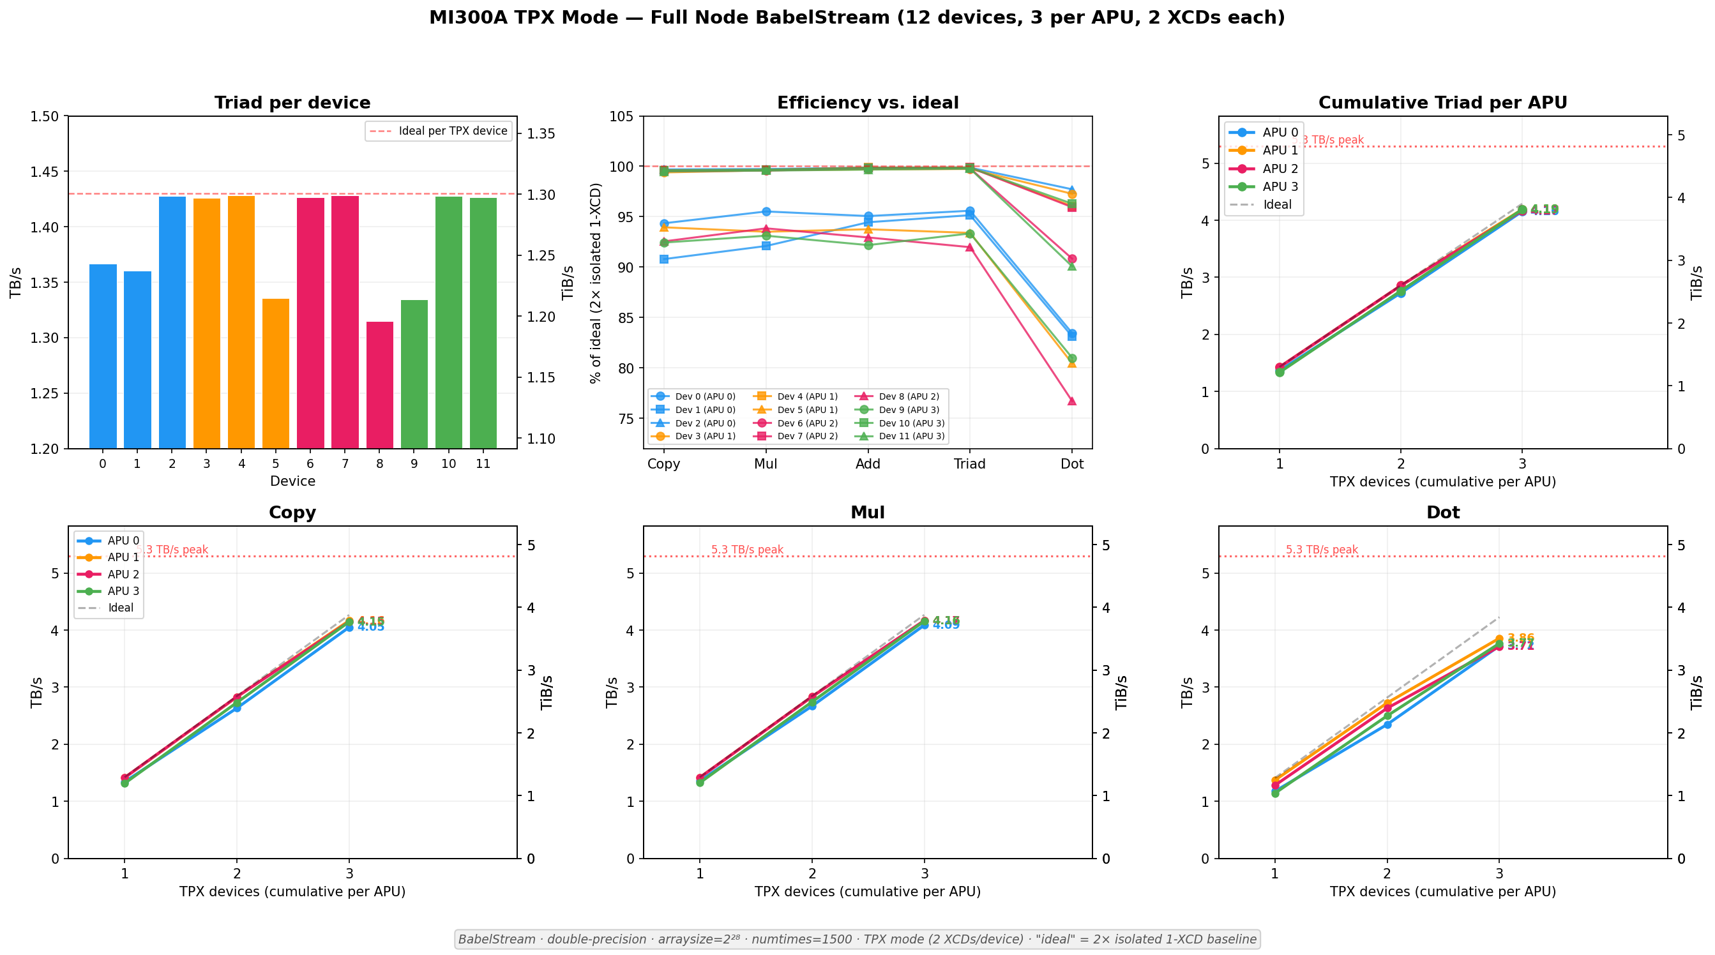
Figure 6: TPX full node — 3rd device per APU is the contention bottleneck.

7. Full-Node SPX: Uniform but Inefficient
SPX mode (4 devices, 1 per APU, 6 XCDs each) delivers the most uniform results across APUs: all 4 devices land within 0.4% of each other on Triad at 3.64–3.65 TB/s. The inter-device contention variance that plagued CPX and TPX is eliminated because there is only one process per APU.
However, efficiency is substantially lower: approximately 69% of peak on Triad and only approximately 51% on Dot. With a single process coordinating all 6 XCDs internally, the intra-device overhead dominates. The Dot product reduction across 6 XCDs within one device is far more expensive than 6 or 3 independent reductions in CPX or TPX mode respectively.
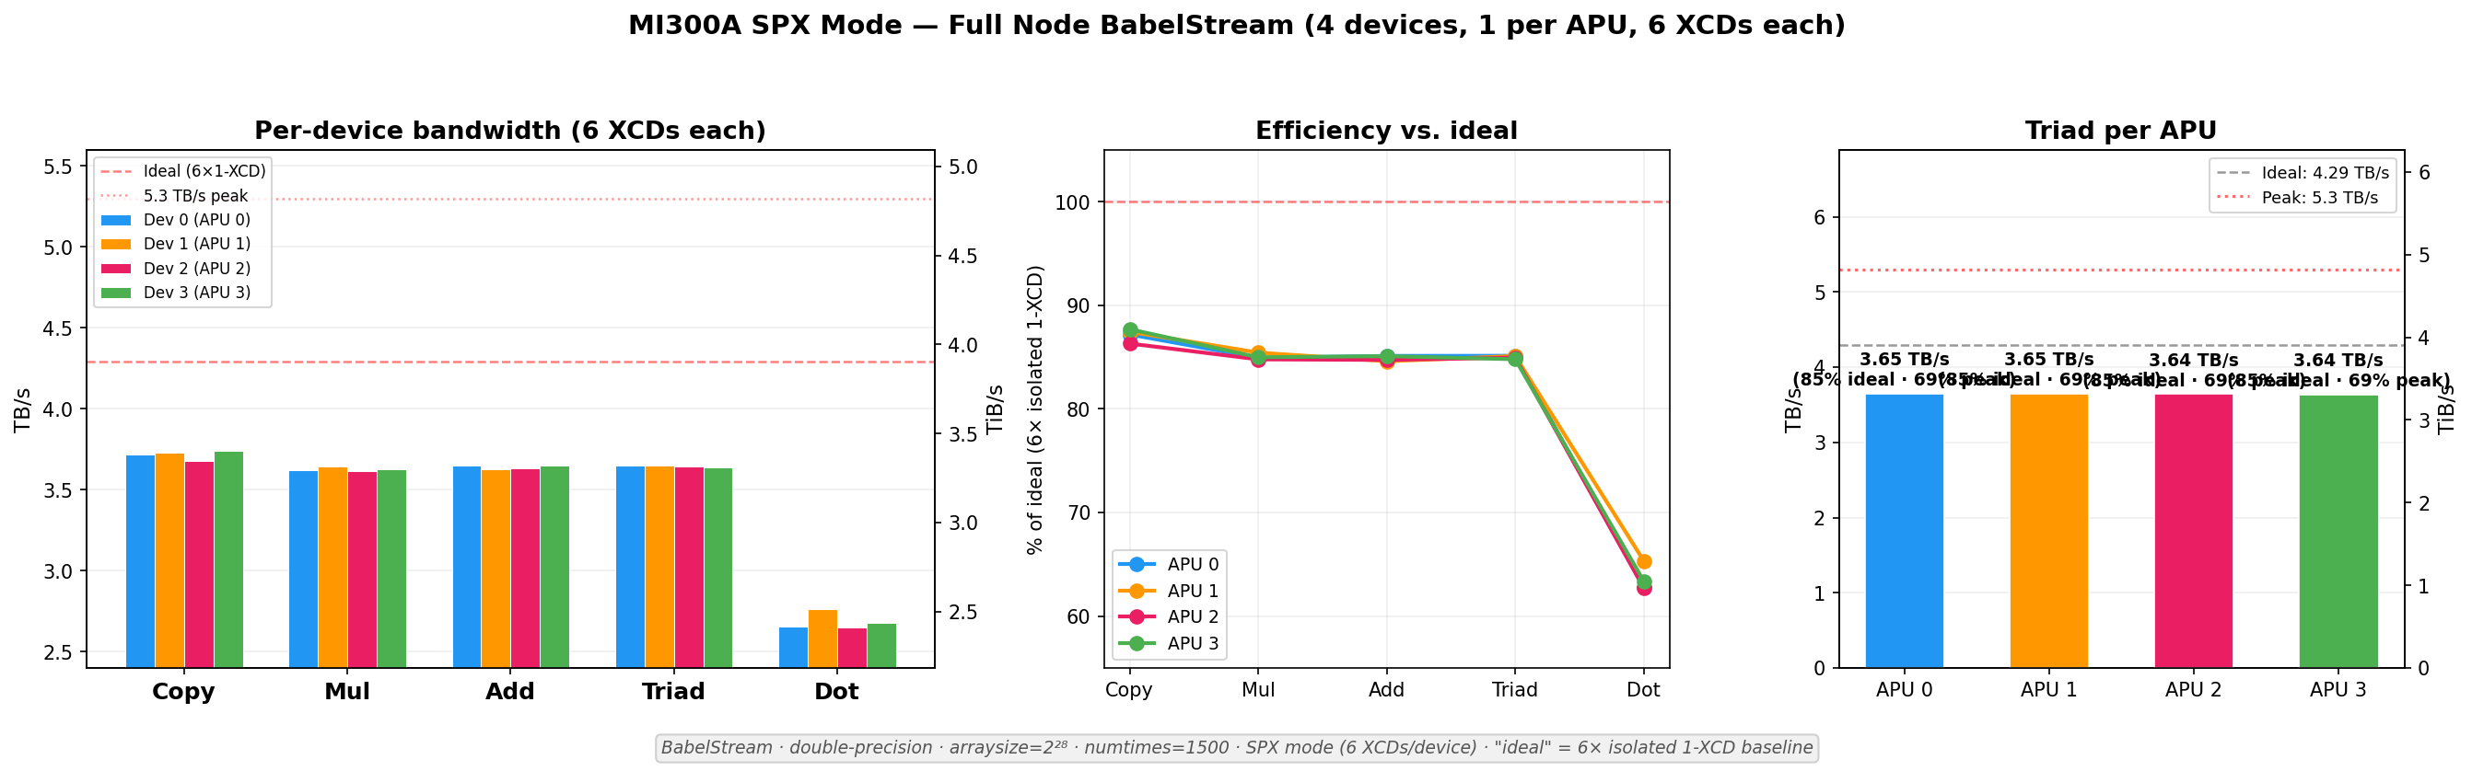
Figure 7: SPX full node — uniform across APUs but only 69% of peak on Triad.

8. Closing the Loop: CPX vs TPX vs SPX
The final experiment re-runs CPX at full-node utilization alongside the TPX and SPX data to produce a definitive three-way comparison. The results are unambiguous:
TPX achieves the highest whole-node Triad bandwidth at 16.7 TB/s (79% of the 21.2 TB/s theoretical node peak), followed by CPX at 16.4 TB/s (77%) and SPX at 14.6 TB/s (69%). On the Dot product, the gap widens further: TPX at 15.1 TB/s (71%), CPX at 13.2 TB/s (62%), and SPX at 10.7 TB/s (51%).
The device-level distribution plots reveal why: CPX’s 24 devices show the widest spread (some devices at full speed, others heavily degraded), TPX’s 12 devices have moderate variance, and SPX’s 4 devices are tightly clustered but at a lower absolute level. TPX represents the best compromise between parallelism and coordination overhead.
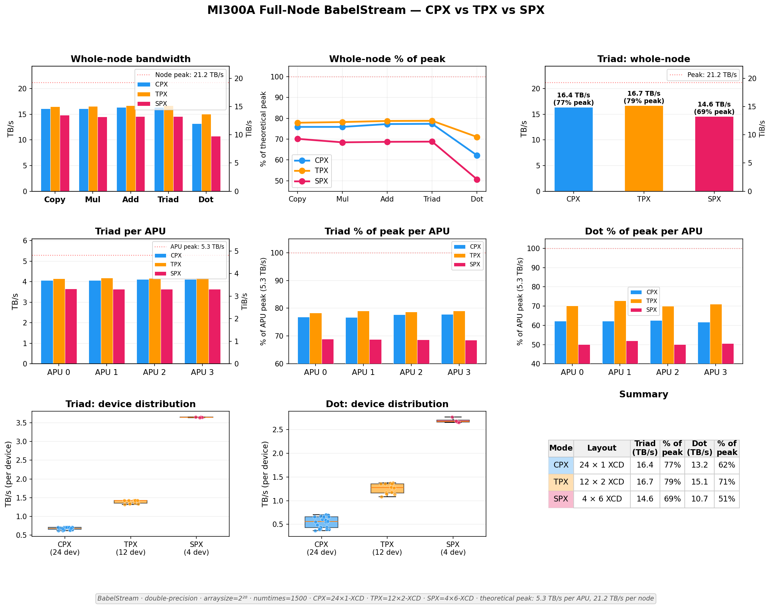
Figure 8: Full three-way comparison — TPX leads on both aggregate bandwidth and Dot efficiency.

Key Takeaways

TPX is the overall winner for streaming bandwidth
At 79% of theoretical peak on Triad, TPX delivers the best aggregate node bandwidth. Its 2-XCD-per-device granularity hits the sweet spot: enough parallelism (12 processes) to saturate the HBM controllers without the coordination overhead of SPX’s monolithic 6-XCD devices.

CPX is competitive but suffers from device-level variance
CPX’s 24 independent processes achieve 77% of peak on Triad, only 2 percentage points behind TPX. However, the wide device-to-device bandwidth spread (some XCDs at full speed, others degraded by 15–20%) makes performance less predictable. For workloads that are sensitive to load balancing, this variance can become a practical issue.

SPX trades efficiency for uniformity
SPX’s single-device-per-APU model eliminates inter-device contention but pays a heavy price in coordination overhead, achieving only 69% of peak on Triad and 51% on Dot. SPX is best suited for workloads that genuinely require a unified address space across all 6 XCDs within an APU.

HBM contention onset threshold is 2 XCDs per APU
The emulated-TPX experiment (Section 4) demonstrates that 2 concurrent XCD streams produce zero measurable contention. Degradation begins at 3 XCDs and grows progressively. This threshold is a fundamental property of the MI300A’s HBM controller design.

Dot product (reductions) are disproportionately affected
Across all experiments, the Dot product consistently shows the largest contention penalties. Reduction operations require cross-XCD coordination that streaming operations avoid, making Dot the most sensitive indicator of HBM contention pressure.

Device-level asymmetry is hardware-intrinsic
Within each APU, specific XCDs (notably devices 2 and 4 in APU 0, and analogous positions in other APUs) consistently underperform under contention. This is reproducible across runs and array sizes, indicating a physical asymmetry in the HBM interconnect topology rather than a software scheduling artifact.

