“Kazakh-British Technical University”



**Principles of Programming – GameJam**

**Title: Flood- pygame**

**4th group:** Armanov Kazhymukhan, Sofya Yugai, Rasul Serikuly, Bissengaliev Sanzhar

**Lecturer:** Arnur Kelgenbaev

# Definition, investigation and analysis

**Game description**

"The Flood" is a platform game in which the main character decides to deal with the increasingly frequent occurrence of floods in his home country. The player will have to go to the dungeon where the Water Monster lives and solve the mystery of the occurrence of floods.

**The purpose of creating the game**

To create a fun and interesting platformer with a unique mechanic of moving between levels that will attract players of different age groups.

**2. Game review**

**Game genre**

• Platformer

**Plot and characters**

• The main character is a researcher who is looking for the cause of the floods and strives to find a way to stop the Water Monster.

**Main features and mechanics of the game**

• Unique mechanics of moving between levels

•Various levels with unique obstacles and riddles

**3. Target audience**

• Description of the potential audience

• The game will be of interest to both experienced platformers and beginners, as well as those who are looking for new and interesting mechanics in games.

**Age and demographic characteristics**

* The target audience includes players of all age groups, especially those interested in adventure and puzzle games.

**Research and analysis**

Analysis of existing games in the selected genre

• Research was done on popular platforms to understand the mechanics and trends in the genre.

• For example, we did a survey among people and the results:

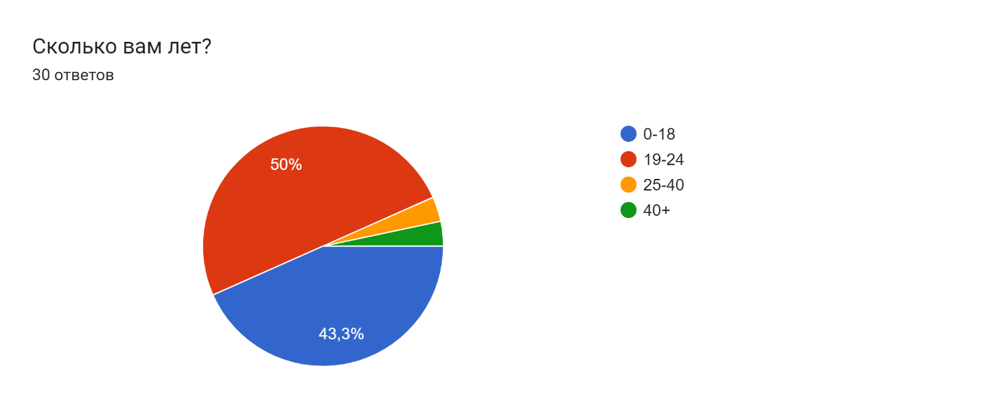

we took about 30 people of different ages and 70% of people know 3 or many types of games.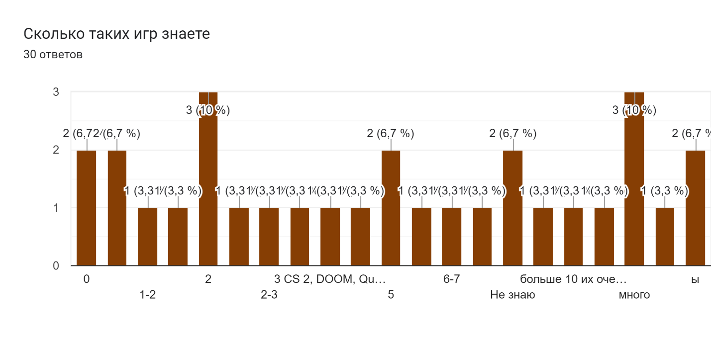

After that, they conducted a survey and many of them chose the game and decided to make a 2D and RPG adventure 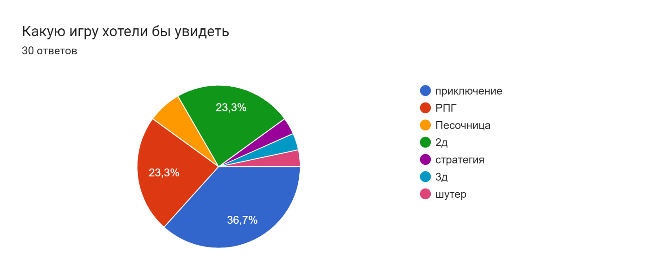

# **Requirements for the platformer being developed:**

**1. Game mechanics:**

• Controls – The player controls the character using buttons WASD for movement.

• Dungeon– You have to go through floors to get to the water monster one after another.

• Obstacle - on each floor there are various monsters or climatic conditions to prevent you from completing the game, you must deal with them in order to get to the boss

**2. Control:**

- Responsive Controls: Provide smooth and fast control of character movement

- Intuitive Interface: Create a user-friendly interface that allows players to easily understand and interact with game mechanics.

**3.Level design:**

- Diverse environment. Various climatic environments associated with water.

**4. Progress of the game:**

- Level Completion Requirements: Set clear goals for level completion, such as killing the floor boss or completing the boss room challenge.

**5. Testing and feedback:**

- Quality assurance. Conduct thorough testing to identify and resolve bugs, glitches, and gameplay issues.

**These requirements serve as a guide for the development team in creating a successful and enjoyable platformer for players.**

# **Design&Coding process**

At the design stage, sprites were drawn, such as the our hero and textures that appear in the dungeon.

For all sprites we use Pixilart!!!

Below sprite of hero:

Walk 

And when hero is attack  


Below we show you map create stages:

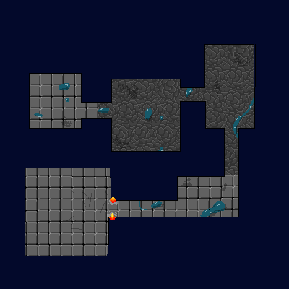

After we need the walls

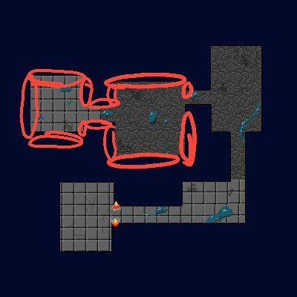

Like this and our solve is  this sprite.

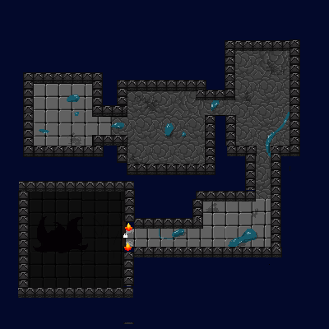

After this we need to health point of hero like this 

We need enemy and boss sprites:



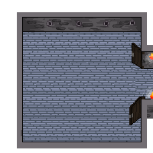

This is a boss room that fills with water and the player, to avoid damage, stands on the platform and when the water goes away, attack again

**Coding process**

**Below the code to walk hero and monsters**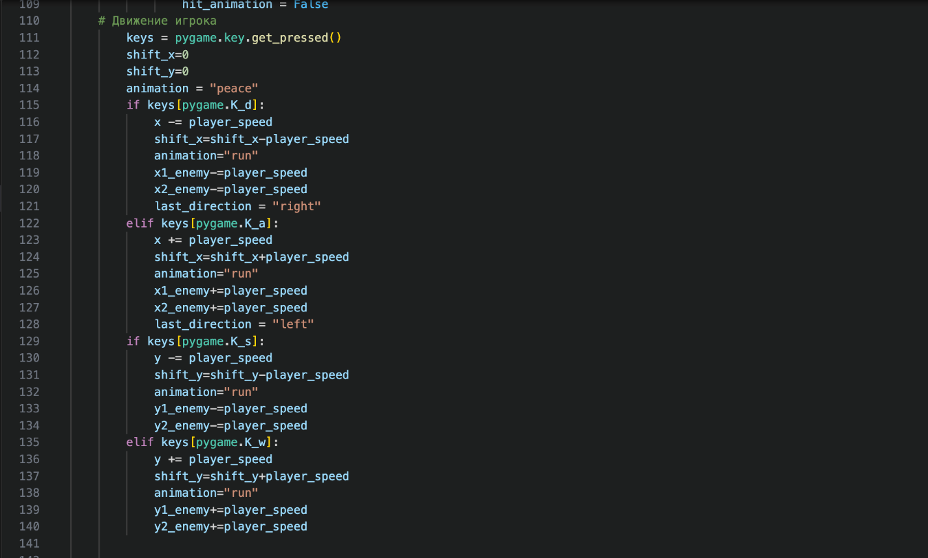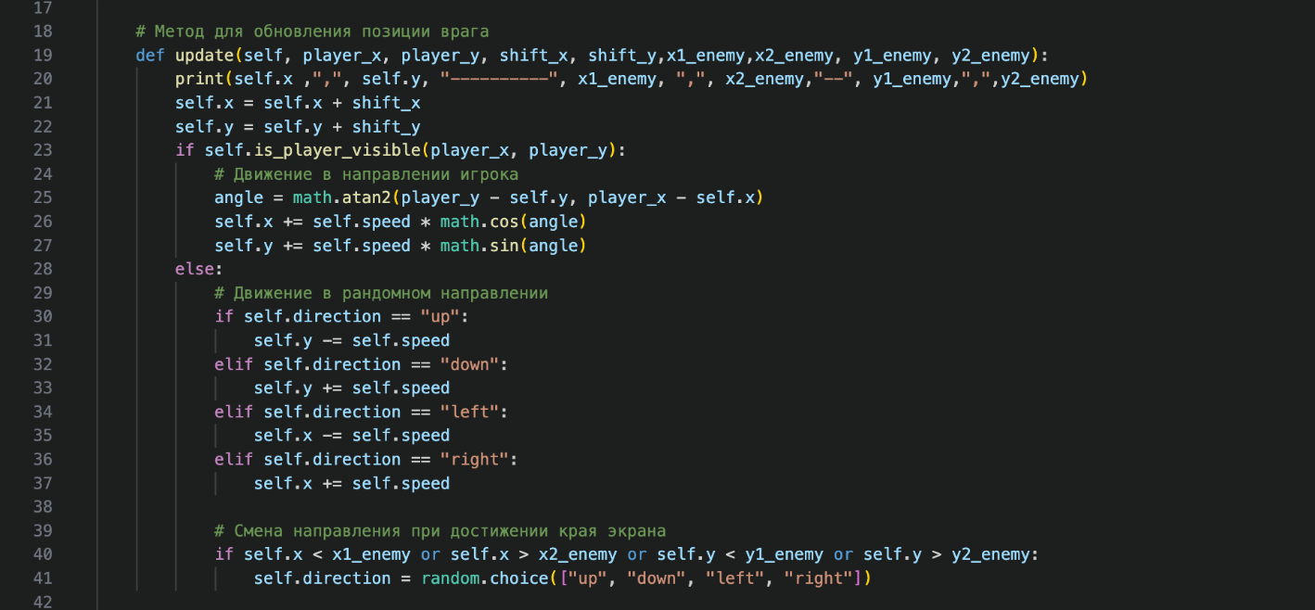

**Collision code**

**When hero and enemy is collide hero take damage**

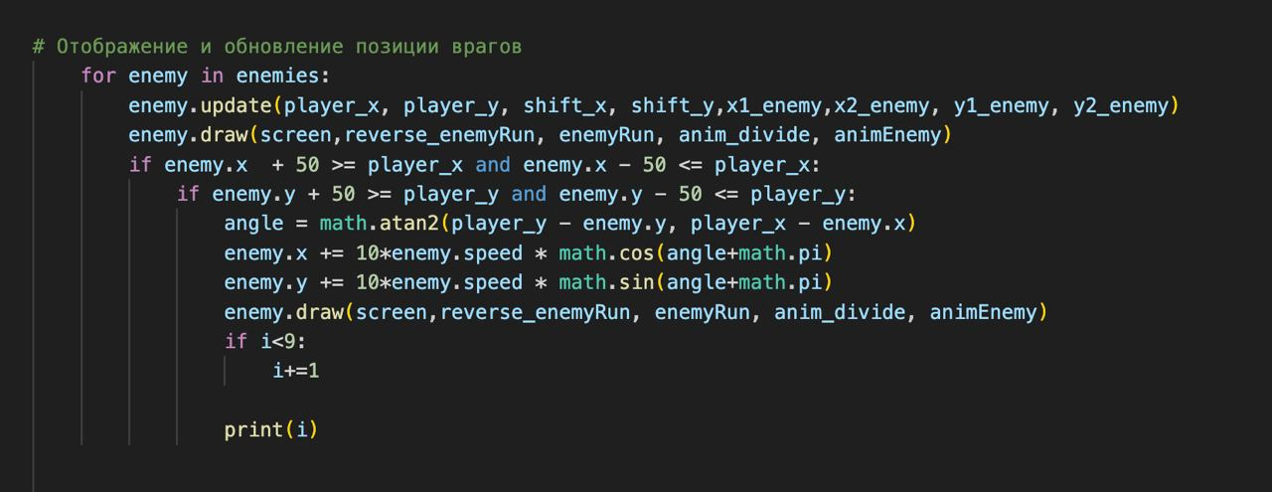

**When hero is lose have button again   
**

**Menu Button  
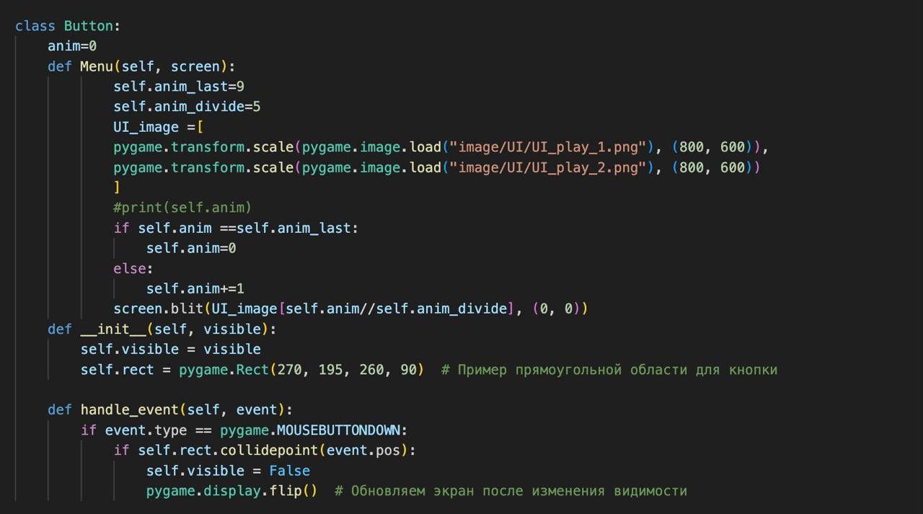**

# Software requirements

|  |  |
| --- | --- |
| Software | Why I use it |
| Windows 10 | I can work with several windows on one screen, this system runs on almost all computers and does not depend on the age of devices. |
| Python | Using Python for game development offers simplicity, with its easy-to-learn syntax and wide range of libraries like Pygame, enabling rapid prototyping and cross-platform compatibility, making it an excellent choice for indie developers and small teams. |
| Visual Code | Convenient source code editor, which is convenient to work with html, javascript and php. |
| Chrome | Used to collect information, and find some unknown information about code |

# **Hardware requirements**

|  |  |
| --- | --- |
| Monitor | Used to visualize the result of a written program, allows you to see the input and output data |
| Keyboard | To enter data and print code |
| Mouse | Switch between applications, helps with long-term work with the project |
| Modem | Opens Internet access to view the results of the project under development |

**Benefits of Game Development**

1. Creative freedom - Game development gives you the opportunity to unleash your creative visualization through the design of characters, plots and slot machine mechanics.

2. Interdisciplinarity: Game development is carried out in various fields such as music, design, art and art, which provides a variety of skills and career opportunities.

3. Practical application of knowledge: Game development allows students to put into practice their knowledge in the field of programming and computer graphics.

4. Development of social skills: Working in a team on game projects provides the development of communication, project management and collaboration skills, which are important aspects in the information technology industry.

5. Career Preparation: Experience gained in game development can be valuable when seeking active work in the software development industry, including in the areas of reality, mobile applications and interactive systems.

**Game Development Limitations**

1. Time Constraints: Games require significant time to design and develop, which can be difficult to balance with academic schedules and other student demands (time to decide game type, analysis, coding, graphics)

2. Lack of experience and knowledge: Students may face difficulties due to lack of experience in programming, designing or other aspects of game development, which can slow down the learning and development process.

3. Technical Limitations: Some game ideas may be technically difficult to implement, especially for students with limited programming or design experience.