**333333**

Visio Diagram for SQL Server Infrastructure

V 1.1.0

* User Guide

**Table of Contents**

I. Introduction to SQL Infrastructure 3

II. Prerequisites 3

III. Dependencies 3

IV. How to install 3

V. Usage 5

1. The User Interface 5

2. The Visio 12

3. Exploring the functionalities 16

a) Clusters 16

b) Filtering 17

c) Server Upgrades 18

d) Import from Excel 20

e) Export to Excel 20

VI. Appendix 21

1. Naming Conventions 21

2. Symbols Used 22

3. Clusters Supported 24

VII. Troubleshooting 26

# Introduction to SQL Infrastructure

Visio Infrastructure for SQL Servers is a tool which is meant for IT administrators who require constant interactions with the users for the installations of the SQL server in any IT infrastructure.

This tool eases the constant communication between the end user and the administrator where administrators will have a ready to install visual representation of data which can be executed later to build the infrastructures efficiently.

This diagrammatic representation of SQL Servers with the configuration data of each server will help installation implementation with less communication with the end user.

The objective of this tool is to prove the capabilities of Visio to draw the effective diagrams using Visio SDK.

# Prerequisites

The following software has to be installed in your machine for running the tool:

1. Microsoft Visio 2007.
2. Microsoft Office 2007.
3. Microsoft .Net framework 2.0 or above.

# Dependencies

The Visio Infrastructure for SQL Servers project assumes the availability of the following assemblies for its implementation.

1. Microsoft.Office.Interop.Visio.dll
2. Interop.Microsoft.Office.Interop.Excel.dll
3. Office.dll
4. Microsoft.Office.Interop.Word.dll

# How to install

The tool is shipped as an addin for Microsoft Visio 2007 in the form of an .msi (VisioAddinforSQLServer.msi) file.

Double clicking on this file will guide you through the installation steps for the addin. Once the installation is finished, all the necessary files are installed in the Program Directory and the addin is installed.

Open Microsoft Visio 2007, to run the addin that is installed.

**Note**: Operating environments, on which this tool has been tested are Windows XP …………Professional edition, Windows Server 2003 Enterprise edition with SP1 and …………Windows Vista Enterprise edition (96 DPI and 120 DPI).

Following screen shot explains the addition of the addin for our tool.

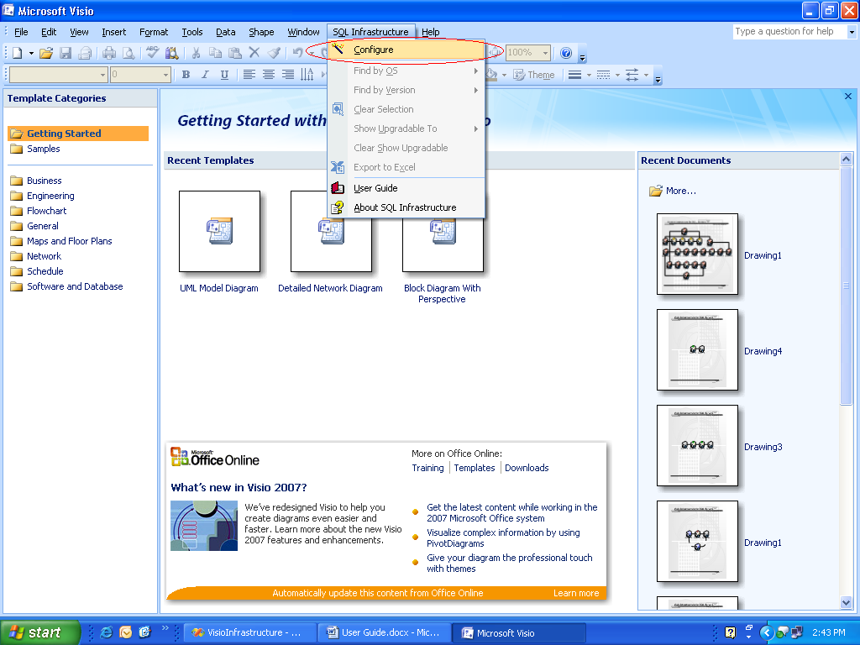

Fig. 1.0

Click on the “Configure” button to setup the required SQL Infrastructure.

The first screen that will appear is the Welcome screen. This screen provides two options for SQL Server configuration.  
a. Configure using the wizard – This is used to input all Server configurations details via the Wizard.

b. Microsoft Office Excel Workbook - This is used to input an Excel file with the configuration details to generate the Visio diagram.

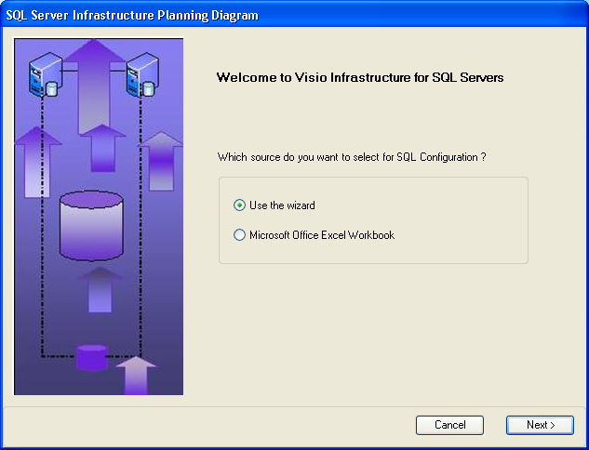

Fig. 1.1

# Usage

## The User Interface

As shown in Fig. 1.1, the welcome screen provides two options for inputting the SQL Server configuration details.

Let’s say, we select the “Use the Wizard” option. Click “Next”.

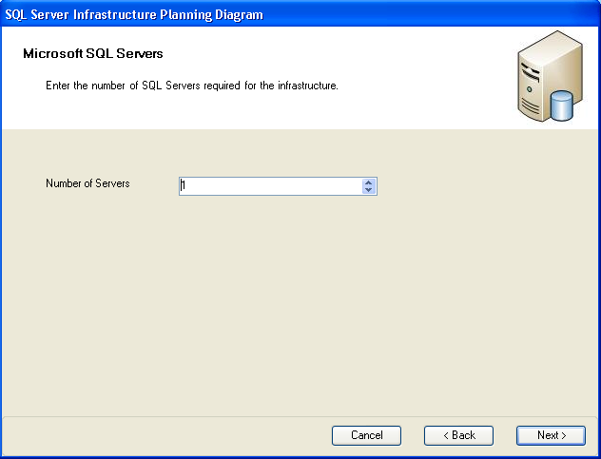

Fig. 1.2

In this screen, User needs to enter the number of SQL servers required in the infrastructure. Those many numbers of SQL servers will be shown diagrammatically by the Visio.

Once the number of SQL servers is chosen, automatic default names of SQL servers will be populated in the checkbox list of the next screen. From this, user can select a single or multiple servers for which he wishes to enter the configuration. If user wishes to have the same configuration for more than one server then he can select those many servers from the selection as shown in Fig 1.3.

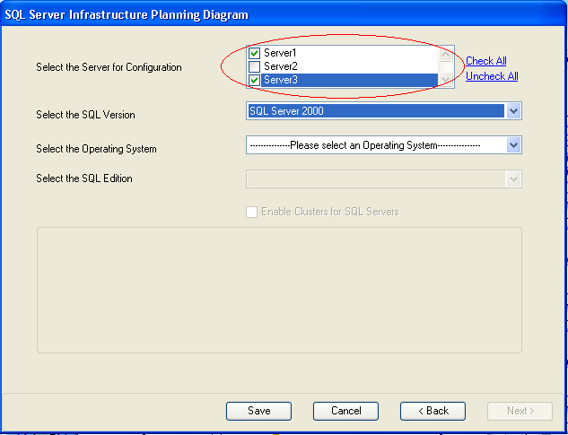

Fig 1.3

Once servers are chosen for the configuration, the SQL Server version can be chosen from the “Select the SQL Version” combo box.

The compatible operating systems will be populated in the next combo box based on the SQL Version selected. User can choose an Operating System from this and depending on the combination of the SQL Version & Operating System; the compatible Editions of the SQL server are populated in the “Select SQL Edition” combo box.

The edition of the SQL Server is chosen from this combo box & the whole data is now ready to add.

*If a particular combination of an SQL Version and Edition supports Failover Clustering*, the “Enable Clusters for SQL Servers” checkbox is enabled. The user now has the choice to enabling clustering for the selected servers.

Once checked, the user is further given an option of selecting a two node or four node clustering based on its availability. For the combination selected, the user can further select the number of Active Nodes desired for the server along with it Storage Media.

(Note: Currently this tool supports creation of **new** nodes for two and four node clustering and the existing server always remains as an active node.)

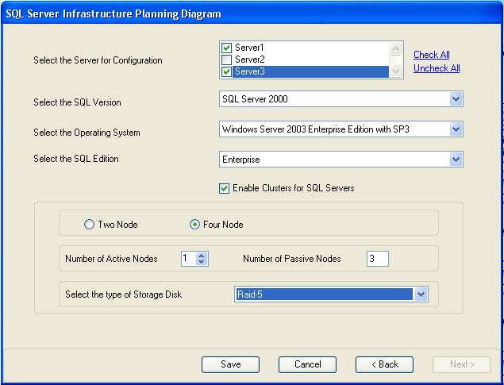

Fig 1.4

The “Save” button is used to enter the required record into the data grid shown in the next screen.

Button “Next” is enabled only when all the Servers are configured.

Clicking “Next” generates the Summary form with all Servers and their configuration details.

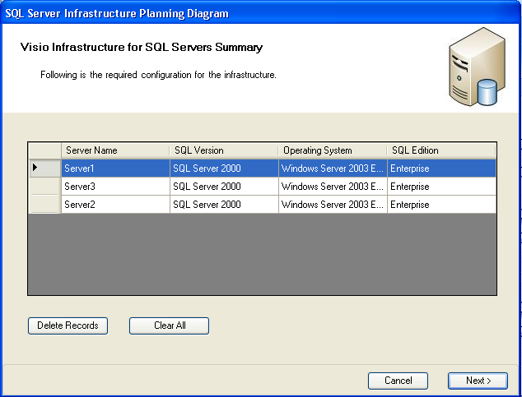

Fig 1.5

The Summary screen shows the configuration details of all Servers.  
  
The “Delete Records” button is used to delete a particular record from the data grid if the user desires a change in its configuration. The “Clear All” button is used to clear all configurations and start afresh.

If a record is deleted, clicking “Next” goes back to the Server Configuration form as shown in Fig 1.4.

If all records are cleared, clicking “Next” goes back to the Enter the number of Servers form as shown in Fig 1.3.

Currently, the tool supports configuration of maximum 100 Servers in one Visio Diagram.

Once all the servers are configured and the data is added into the gird, the “Next” button generates the required Visio Diagram.

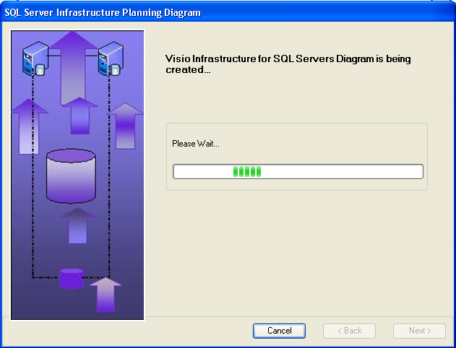

Fig. 1.6  
The finish screen is as below.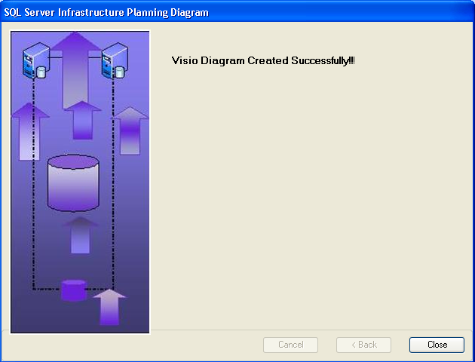

Fig. 1.7

As shown in Fig. 1.1, the welcome screen provides two options for inputting the SQL Server configuration details.

Now let’s say, we select the “Microsoft Office Excel Workbook” option. Click “Next”.

The “Select an Excel file” screen allows User to select an existing Excel file with all the configuration details.

PLEASE NOTE: The selected Excel file should be in the format required with no blank spaces as shown in the sample file below:



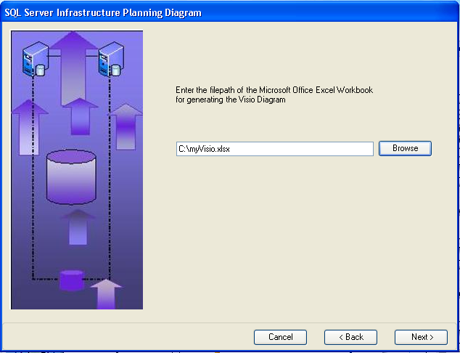

Fig. 1.8

Clicking on next generates the Visio diagram as shown in screens 1.6 and 1.7.

If the file is not in the required format, an appropriate message is displayed.

## The Visio

Once the diagram is generated in the Visio, User can right click on the individual SQL servers and have a look at the configuration pre-requisites for the installation. Properties of each server are populated with its respective configuration details.

Following is a snapshot of how the Visio diagram looks for the configuration selected:

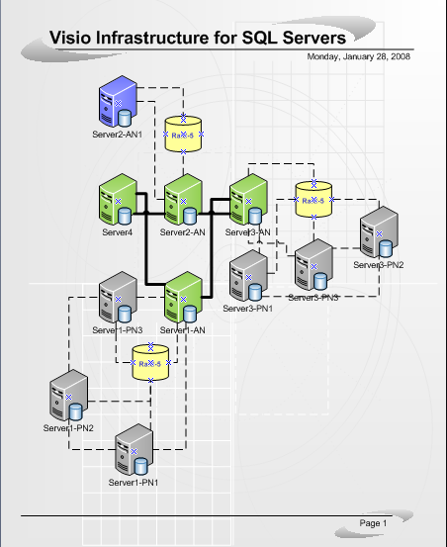

Fig 2.1

The above diagram shows the following infrastructure:

Number of Servers: 4

Server 1: Has four nodes clustering with three passive nodes.

Server 2: Has two nodes clustering with both active nodes.

Server 3: Has four nodes clustering with three passive nodes.

Server 4: Has no clustering enabled.

If user wishes to have a look at the filtered SQL servers, he can go to main menu bar. Click on the menu button “SQL Server”.

The three menu options will appear in relevance to filtering -

* Find by OS
* Find by Version
* Clear selection

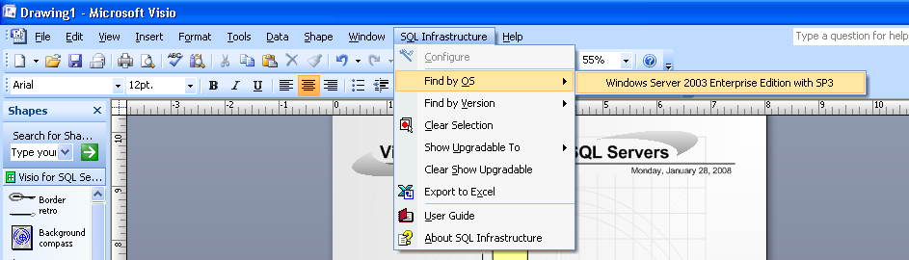

Fig 2.2

Here, user can choose an Operating System. When user clicks on the Operating System button the SQL servers having that particular Operating System will get highlighted on the diagram.

The color codes used to describe various functionalities is shown in the appendix.

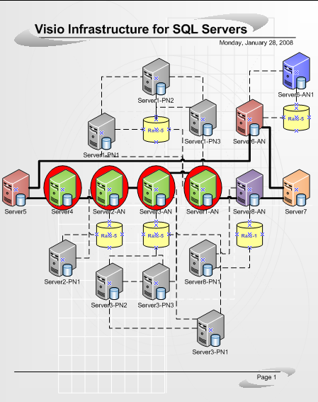

Fig 2.3

To further the selection, the menu offers an option of showing all servers in the infrastructure that can be upgraded to a particular combination of an SQL Server Version and Operating System.

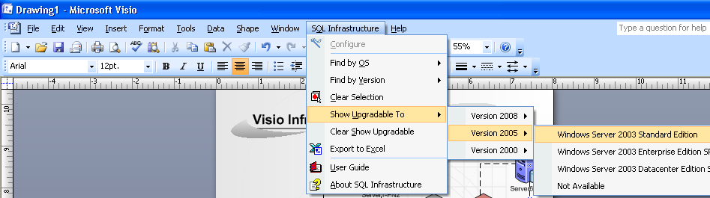

Fig 1.11

Based on the selection, *only the servers that can be upgraded* to the selected SQL Version and Operating System are highlighted and a smart tag appears on each of them. Further, the properties of each server show all the properties that will be applied if the server is upgraded.

If the user selects the smart tag for upgrade, the server is upgraded to the SQL Version desired and the properties are updated accordingly.

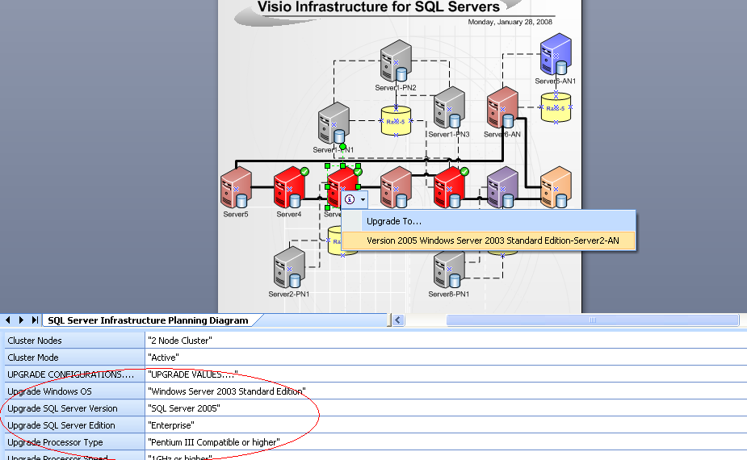

Fig 2.4

Thirdly, the Visio Diagram also gives an option of migrating the data to a Microsoft Office Excel Workbook file.

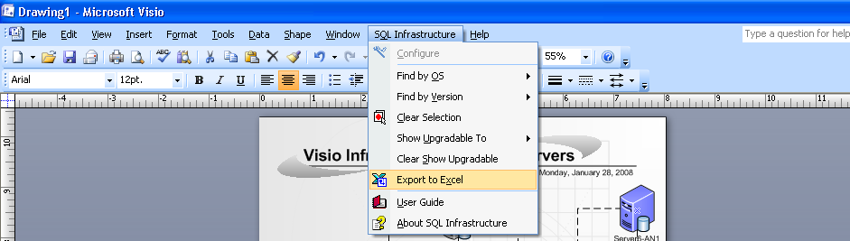

Fig 2.5

## Exploring the functionalities

### Clusters

Visio Infrastructure for SQL Servers tool enables user to select an infrastructure setup with an option of providing clusters for failovers. In the configuration through the Wizard, a particular combination of an SQL Version, Edition and Operating System for a Server provides Clusters’ configuration based on its availability. If available, the “Enable Clusters for SQL Servers” checkbox is enabled. Once, checked, the clusters configuration controls are visible.   
Based on the requirement, the User can select two nodes or four node clustering. (This tool can further be extended to include n number of nodes.). Once the number of nodes is selected, the User can select the number of active nodes required by using the numeric up-down control “Number of Active Nodes”. Further, the User has to select the type of Storage Media required for the clustered environment.   
Once finished, clicking of “Save” generates the Visio Diagram with the clusters. As shown in the Fig. 3.2.  
  
NOTE: Please refer the Appendix for the list which supports clustering.

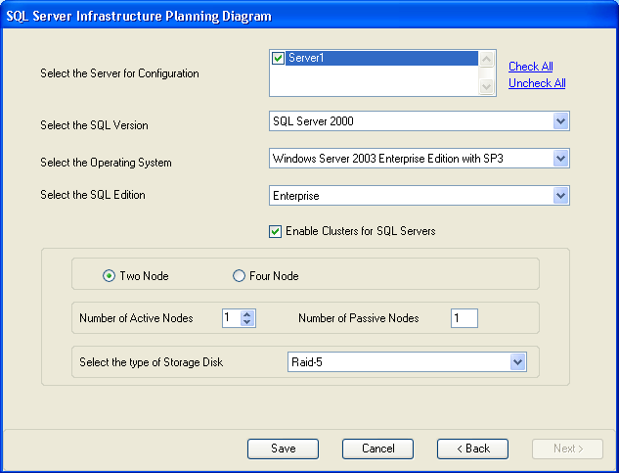

Fig. 3.1

The diagram below shows a single server “Server1” with Four Node clustering. It includes 2 Active Nodes and 2 Passive Nodes with a “Raid-5” storage media.

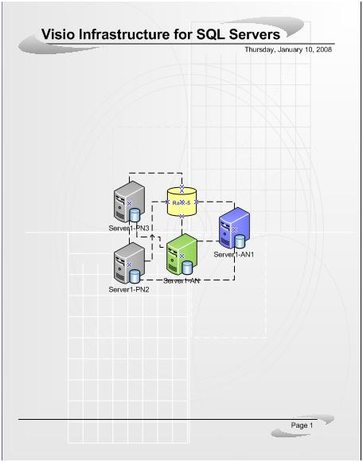  
Fig. 3.2

### Filtering

Filtering is used to filter the Visio Diagram generated based on a particular SQL Version or Operating System. Based on a selection for filtration, the Servers which qualify for the requirement are highlighted in the Diagram. Selection of “Clear Selection” clears the selection for a filtered option.  
The following diagram shows the menu options for filtering.

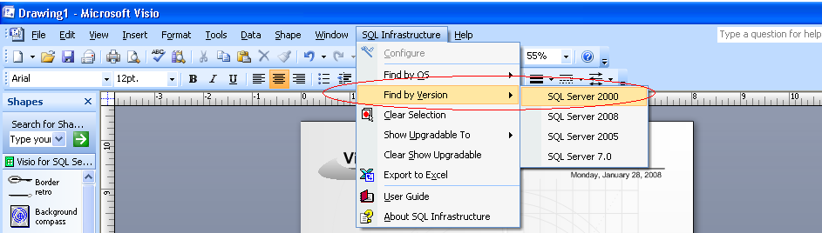

Fig. 3.3

Based on the selection for filtering, the corresponding Servers in the diagram are highlighted as shown below.

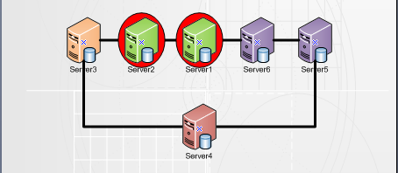

Fig. 3.4

### Server Upgrades

For a particular infrastructure, the tool provides with an option to upgrade a Server to a version higher. This functionality allows the user to first analyze the properties of the Server, if upgraded and do it if required.   
In the menu, the user can select “Show Upgradable to” menu to highlight servers which are upgradable to the required version and operating system combination. Once selected, the properties of the highlighted servers show the Upgrade values as well for the user to analyze. If deemed fit, the user can go ahead with the Upgrade for the Server.  
The following diagram shows the menu options for Upgrades.

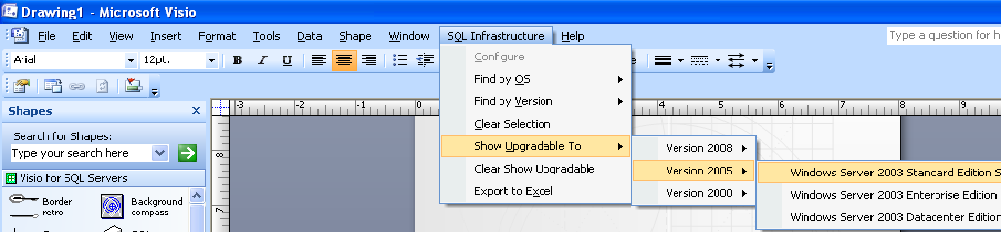Fig. 3.5

The following diagram shows the Server that is upgradable to Server Version 2005.

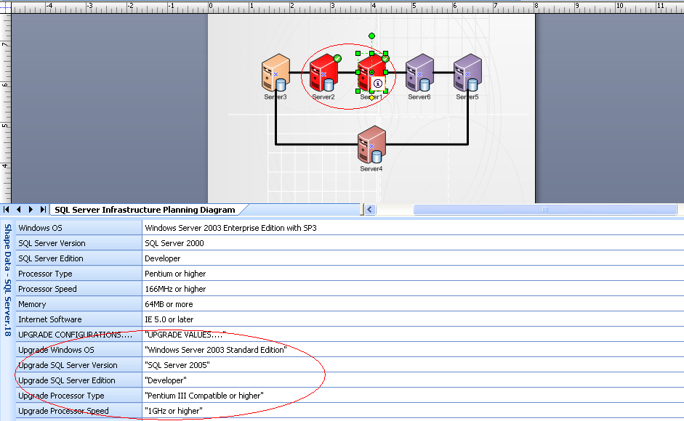

Fig. 3.6

Clicking on the smart tag  upgrades the server if desired. Clicking of “Clear Show Upgradable” clears the selection.

**NOTE: Once the Visio diagram is created, the menu gives an option for SQL Server Upgrades.Clicking on “Show Upgradable” gives a list of sub menus. i.e. “Version 2000”, “Version 2005”, & “Version 2008”. Now on further implementation each of these sub menus further show the list of all Operating Systems that the servers in the network can be upgraded to. Clicking on a particular operating system, shows the servers in the diagram which can be upgraded to the combination of the selected “Version” and “Operating System” for upgrade.   
However, since the upgrade properties i.e. “Operating System” information for Server being upgraded to “Version 2008” are “Not Available”, current implementation shows “Not Available” under “Version 2008”. Clicking of this sub menu pops up a message of no data available, hence cannot be upgraded. Once a validated data for SQL Server 2008 upgrades is available, a minor change to the config.xml to change the OS from “Not Available” to the actual Operating System will list the OS under sub menu “Version 2008” and show upgradable servers as in normal scenarios.**

### Import from Excel

The tool provides an option for generating the diagram from a Microsoft Office Excel Workbook which has the data for configuration. Select the second option in the Welcome screen followed by the path of the Excel file. Clicking “Next” now generates the diagram as shown in Fig. 1.8.  
  
NOTE: Importing of data from Excel requires the Excel to be in a format as attached without any blank rows.

### Export to Excel

Once the Visio diagram is created, the tool provides an option to Export the generated diagram to a Microsoft Office Excel Workbook. In the menu, just select the “Export to Excel” option and select the target location for the file in the “Save File” dialog that pops up.

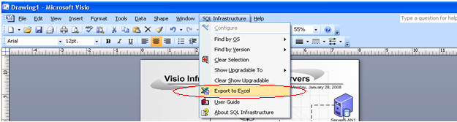

# Appendix

## Naming Conventions

Following are the naming conventions used on each server in the Visio Diagram.

**Server n** – This denotes the main server with the required configurations where n denotes the server number.

e.g. *Server 8* – This denotes Main Server 8.

**Server n – AN** - This denotes the main server with the required configurations in the clustered environment where n denotes the server number and AN denotes Active Node in clusters. The Main Server selected by the user is always Active in a clustered scenario.

e.g. *Server1-AN* – This denotes Main Active Node.

**Server n – AN p** - This denotes the clustered active node server for Main Server n in the clustered environment where n denotes the Main Server number, AN denotes Active Node in clusters and p denotes the pth Node is the clusters.

e.g. *Server1 -AN2* -- This denotes the 2nd Active Cluster Node for the Main Server 1.

**Server n – PN p** - This denotes the clustered passive node server for Main Server n in the clustered environment where n denotes the Main Server number, PN denotes Passive Node in clusters and p denotes the pth Node is the clusters.

e.g. *Server1 -PN2* -- This denotes the 2nd Passive Cluster Node for the Main Server 1.

## Symbols Used

Following are the conventions used to denote various scenarios in the Visio Diagram.



This denotes a **Main Server** selected in the configuration User Interface with SQL Server Version “SQL Version 7.0”.



This denotes a **Main Server** selected in the configuration User Interface with SQL Server Version “SQL Version 2000”.



This denotes a **Main Server** selected in the configuration User Interface with SQL Server Version “SQL Version 2005”.



This denotes a **Main Server** selected in the configuration User Interface with SQL Server Version “SQL Version 2008”.



This denotes an **Active Node** Server in a clustered environment.



This denotes a **Passive Node** Server in a clustered environment.



This denotes a selection of a particular Server based on the **filtering** selected (**SQL Version or Operating System**)



This denotes a selection of a particular Server based on the **filtering** selected (**Upgrades**)

This **connector** for the Servers denotes the connection of all **Main Servers** in the infrastructure.

This **connector** for the Servers denotes the connection of all **nodes** for a particular Main Server in a clustered environment.

## Clusters Supported

Following are the list of SQL Server Version, Operating System and Edition combination that support clustering.

|  |  |  |  |
| --- | --- | --- | --- |
| SQL Server Version | Operating System | SQL Server Edition | Nodes Supported |
| SQL Server 2005 | Windows 2000 Advanced Server SP4 | Enterprise | 2 |
| SQL Server 2005 | Windows 2000 Datacenter Edition SP4 | Enterprise | 2 |
| SQL Server 2005 | Windows Server 2003 Enterprise Edition SP1 | Enterprise | 2/4 |
| SQL Server 2005 | Windows Server 2003 Datacenter Edition SP1 | Enterprise | 2/4 |
| SQL Server 2005 | Windows Server 2003 64-Bit x64 Datacenter Edition SP1, WOW64 | Enterprise | 2/4 |
| SQL Server 2005 | Windows Server 2003 64-Bit x64 Enterprise Edition SP1, WOW64 | Enterprise | 2/4 |
| SQL Server 2000 | Windows Server 2003 Enterprise Edition with SP3 | Enterprise | 2/4 |
| SQL Server 2000 | Windows Server 2003 Datacenter Edition with SP3 | Enterprise | 2/4 |
| SQL Server 2000 | Windows 2000 Advanced Server | Enterprise | 2/4 |
| SQL Server 2000 | Windows 2000 Datacenter Serve | Enterprise | 2 |
| SQL Server 2000 | Windows NT Server Version 4.0 Enterprise Edition with SP5 | Enterprise | 2 |
| SQL Server 7.0 | Windows 2000 Advanced Server Edition | Enterprise | 2 |
| SQL Server 7.0 | Windows 2000 Datacenter Server | Enterprise | 2 |

# Troubleshooting