Network propagation enhances power of GWAS analysis for PGC schizophrenia cohort

FIGURES

Figure 1: GWAS gene significance is correlated to number of SNPs per gene

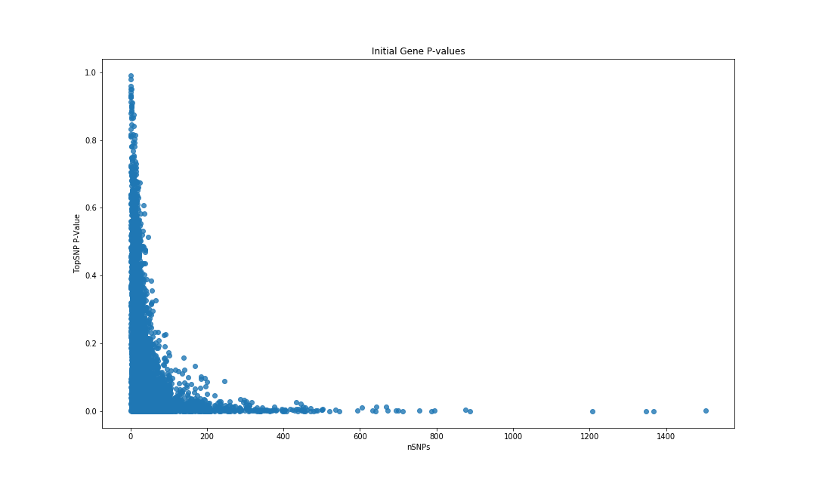

Number of SNPs per gene plotted against top SNP p-value. There is a correlation between number of SNPs per gene and the significance of the top SNP p-value per gene. Pearson correlation coefficient =-0.202, p = 5.58 × 10-137.

Figure 2: Network propagation boosts gene significance

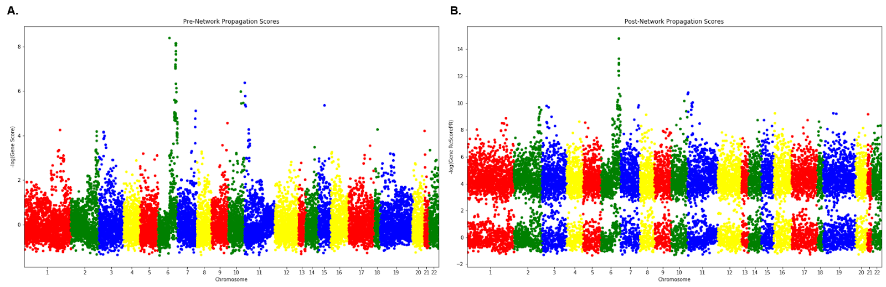

Gene score prior to network propagation



Gene score after network propagation using Personalized PageRank shows noticeable boosting of genes contained within the GIANT network.

Figure 3: Pathway enrichment for top significant genes

1. Jensen Disease Terms

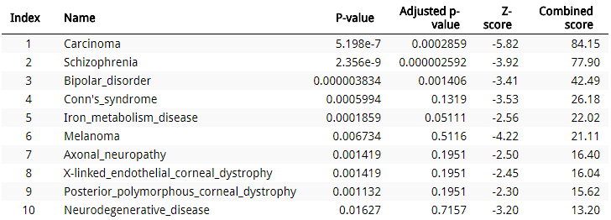

1. KEGG

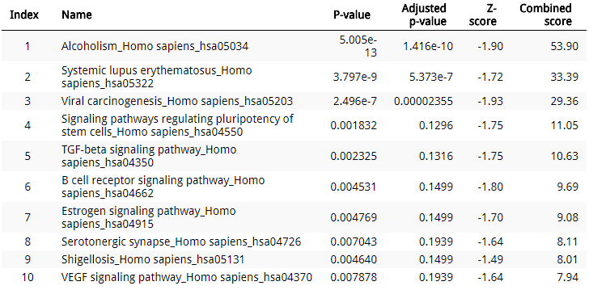

1. miRTarBase 2017

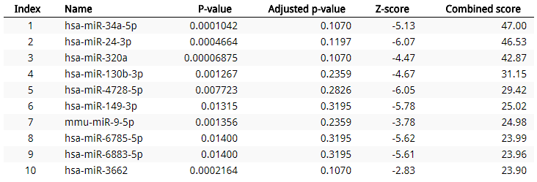

1. Transcription Factor PPIs

