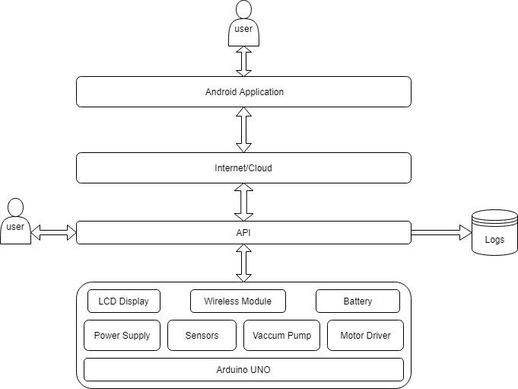

**Layered Architecture**

We have used the **layered architecture,** pattern is the separate the concerns among components. Components within a specific layer deal only with logic that pertains to that layer.

**Layer 1 :** Level 1 contains all the hardware devices like Arduino, Sensors, Motors , Controllers, Battery

**Layer 2 :** Level 2 contains the API through which we will interact with the device either thought mobile app or socket.

**Layer 3:** Level 3 contains the network through which the signal will travel, in our case this is the Internet

**Layer 4:** Layer 4 is the Application layer form where user gives the commands or interact with the system, there can be a multiple level of abstraction on this level like user can simply turn ON or OFF the device or can control the device, or can be used for testing purpose.

**Connecting the components:**

