**Use Case Diagram**

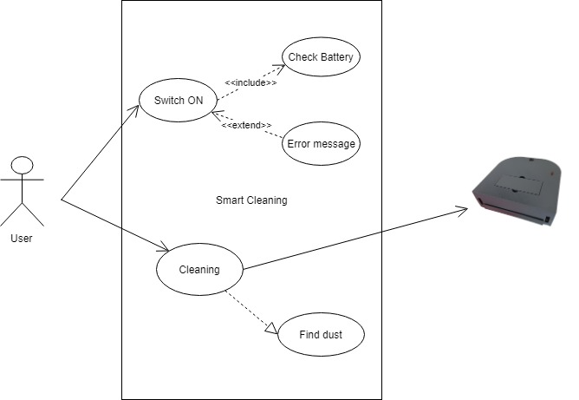

# Use Case

Version 1

|  |  |
| --- | --- |
| **Use Case ID** | UC- 001 |
| **Use Case** | Cleaning System |
| **Use Case Purpose** | Provides the overview of the Smart Cleaning System |
| **Use Case Description** | User trigger the ON/OFF switch on the device. The system will check the battery if there is enough power then will find the dust and clean it otherwise indicates error message. |
| **Assumptions** | There should be an active internet connection on mobile and the on the cleaning device. |
| **Variations** | Instead of directly press the ON/OFF switch on the machine user can control the system through the mobile app. |
| **Trigger** | User trigger the ON/OFF switch. |
| **Primary Actors** | User/Customer |
| **Secondary Actors** | Cleaning device |
| **Pre-Conditions** | Devices should be connected to the internet. |
| **Normal Scenario** | 1. User Switch ON device 2. Device checks the battery 3. Device find the dust. 4. Device continuously clean surface and avoid obstacles. |
| **Extension points** | 4a. In step 4, if the system has accumulated obstacle   1. System turn left if obstacle is on right. 2. System turn right if obstacle is on left. 3. System turn in either direction if obstacle is on front. |
| **Alternate Scenario** | 2a. In step 2, if the system has accumulated low battery   1. System will indicate error if battery is low 2. Customer charges the system 3. Use Case resumes on step 4. |
| **Post Conditions** | Success end condition  Surface is cleaned  Failure end condition:  System crashed  System battery exhausted  Minimal Guarantee  Indicate error |
| Special Requirements | Performance  The device should clean the entire room in one charge.  User Interface  The interface of the machine should be simple and functional.  Reliability  The system should be reliable enough to ease the human effort instead of make it worse. |

**Tasks**

**Completed:**

**Research papers**

Study of the research papers will help to understand the concepts of different hardware’s and software coding used in building the robots for example:- IOT, ML, Arduino based papers.

**3D model**

We got our 3D model printed from a local vendor with PLA filament, design is created according to the space required by the hardware so that everything can be fitted into the design.

**Collection of Hardware’s.**

Hardware are collected from different markets and some of the hardware materials are collected from online sites.

**To be Done:**

**Assembling and calibrating hardware.**

Assembling the hardwares collected into the 3D model, and connecting the different softwares with jumper wires.

Calibrating the hardware if it donot work properly.

**Arduino coding**

Working of the model will be dependent on the coding of arduino as it will be the heart of the vaccum robot.

**Android app**

Creating Android app so that the model will be operated with the help of mobile phones

It can be turned off and on with the help of mobile phone even if we are away from the model.

**Machine Learning**

Machine learning model will be used that will help in the working of the vacuum cleaner.

It will help the sensors to detect the big objects and change its position accordingly.

**IOT**

Making the robot controlled by app through the internet.

**Testing**

After all the procedures, coding, installations will be done , the robot will be tested first before presenting it to the market.

**Activity Diagrams**

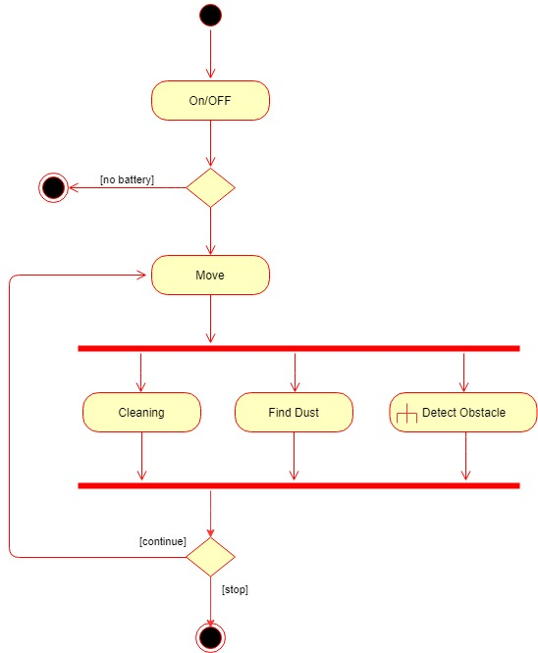

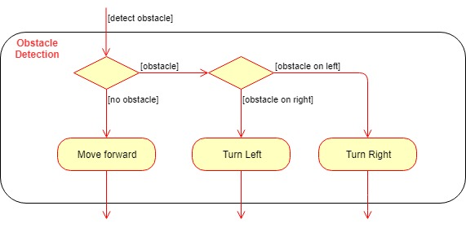

**Work Breakdown Structure using Gantt chart**

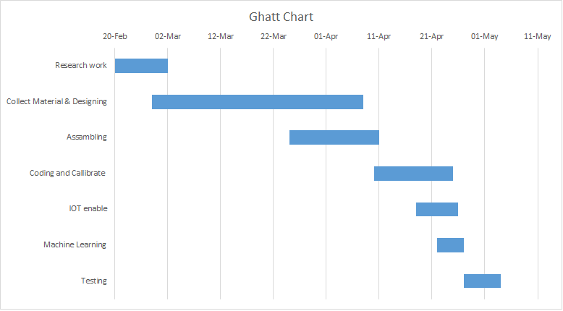

**Functional and Non-Functional Requirements**

**Functional Requirement:**

1. It should be able to clean the surface.

2. It should be compatible with the surface.

3. Should record the sensor values.

4. be able to send values of sensor over the internet for making the graph in Thing-speak.

5. Model should be trained according to the values received through sensors.

**Non-Functional Requirement:**

1. Performance requirement- It should be able to clean the room in a single charge of battery.

2. Safety requirement- It should be kept away from children.

3. Security requirement-As Robot is IOT enabled so we have to use secured browser for collection of data from sensors.

4. Usability-Simple to use for a person as he just has to switch ON the device.

5. Intuitiveness-It is a simple interface for user to understand the model.

**Working principles**

In recent years, robotic cleaners have taken major attention in robotics research due to their effectiveness in assisting humans in floor cleaning applications at homes, hotels, restaurants, offices, hospitals, workshops, warehouses and universities etc.

Basically, robotic cleaners are distinguished on their cleaning expertise like floor mopping, dry vacuum cleaning etc. Some products are based on simple obstacle avoidance using infrared sensors while some utilize laser mapping technique. Each cleaning and operating mechanism of robotic floor cleaners has its own advantages and disadvantages. For example, robots utilizing laser mapping are relatively faster, less time consuming and energy efficient but costly, while obstacle avoidance based robots are relatively time consuming and less energy efficient due to random cleaning but less costly.

Countries like India are way back in manufacturing low cost robotic cleaners. Importing them from abroad increases their costs. The main objective of this work is to provide a substantial solution to the problem of manufacturing robotic cleaner utilizing local resources while keeping it low costs

The majority of the vacuums have a motor with a fan. As the fan blades turn, they force air forward, toward the exhaust port. At the exhaust port it has a filter which prevents the dust particles being thrown away again.

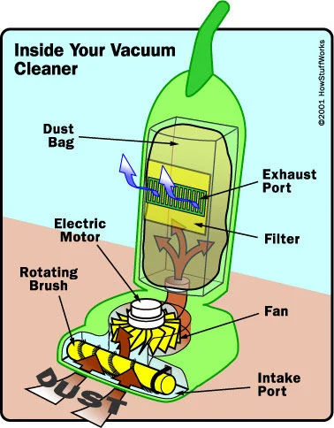

**How does a vacuum robot work?**

The principle is pretty similar but as you can see in the second picture, the fan motor is at the last step which means that the dust is not driven through it. The air that is being sucked is first filtered and then pushed toward the exhaust port.

The main difference between each of the vacuums is that the robot one has a microcontroller and sensors which let the robot make decisions so that it can vacuum your room autonomously. Most of the vacuum robots nowadays have really nice algorithms built-in, for instance, they can map your room so that they can plan a path and perform a faster cleaning. They also have other features like side brushes, collision detection, return to its charging base, etc.

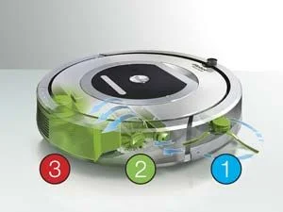

In this work, “smart cleaning robot ” has been designed for consumer/office environments and its each component in accordance with IEEE Standard. Proposed design is being operated in dual modes. In one of the modes, the robot is fully autonomous and making decisions on the basis of the outputs of infrared proximity sensors values being processed by Arduino (mega) controller and control the actuators (2 DC encoder motors) by the H-bridge driving circuitry. This robot can be controlled by the Android app connected thought the internet so make it IoT enable.

**Software Requirements Specification Document**

**Version 1.0**

**Smart Cleaning Robot**

**TABLE OF CONTENTS**

|  |  |  |
| --- | --- | --- |
| **Chapter No.** | **Topic** |  |
| 1. | Introduction |  |
| 1.1 | Purpose of this Document |  |
| 1.2  1.3 | Scope of the Development Project    Overview |  |
| 2. | Overall Description |  |
| 2.1 | Product Perspective |  |
| 2.2 | Product functions |  |
| 2.3 | User Characteristics |  |
| 2.4 | General Constraints, Assumptions and Dependencies |  |
| 2.5 | Apportioning of the requirements |  |
| 3 | Specific Requirements |  |
| 3.1 | External Interface Requirements |  |
| 3.2 | Detailed Description of Functional Requirements |  |
| 3.3 | Performance requirements |  |
| 3.4 | Logical database requirements |  |
| 3.5 | Quality attributes |  |
| 4 | Change History |  |
| 5 | Document Approvers |  |

**1.INTRODUCTION**

**1.1 Purpose**

Purpose of this robot is to make floor cleaning very easy and a fast process. The user may sit at a place, start the robot and clean wherever needed. The system consists of a transmitter app. This app is run in an android mobile phone that allows user to transmit command based on user input. Based on these commands the transmitter sends movement commands to the robot. The transmitter is an android mobile phone that allows user to transmit commands to the robot.

**1.2 Scope of Development of Project**

Goal of this Project is to design a Smart cleaning robot using Arduino UNO. In this project when user switch ON the robot it will start cleaning the room wherever dirt is present. It will detect any obstacle or wall if present in front of it with the use of sharp distance sensor. And the sensors will also send the values recorded to the internet using the concept of IOT and website thus used for storing the values is Thingspeak.

Robot must be able to perform the following operations:

1. Identify the dirt - Robot should be able to sense the the dirt present in the room.
2. Clean the dirt - Clean the dirt observed in the room.
3. Sensor should - be able to record the values and send the values over the internet.

**1.3 Overview**

The remaining sections of this document provide a general description, including characteristics of the users of this project, the product's hardware, and the functional and data requirements of the product. General description of the project is discussed in section 2 of this document. Section 2 gives the functional requirements, data requirements and constraints and assumptions made while designing the multi-utility system. It also gives the user viewpoint of product use. Section 3 gives the specific requirements of the product. Section 3.0 also discusses the external interface requirements and gives detailed description of functional requirements.

**2. Overall Description**

**2.1 Product Perspective**

The Product will run with the help of Arduino UNO Microcontroller and with help of sensors it will detect the dirt in the room and move accordingly. User has to switch it ON with the button placed on top of the robot. After switching ON it will autonomously in any direction and will detect the dirt and start cleaning it. It will protect itself from hitting any obstacle with the help of Sharp distance sensors.Values thus recorded by the sensors will be transmitted over the internet with the help of wifi module ESP8266. Data from sensors is collected on the website Thingspeak and according to the values graphs are made on the site.

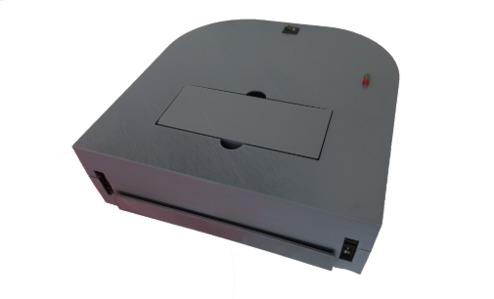

**2.2 Product Functions**

The product must be able to perform the following operations:

1. Robot should be able to detect the dirt.
2. It should be able to detect the obstacle if present and move accordingly.
3. It should be able to clean the dirt and sensors thus used should record the values.
4. Wifi module should be able to send the values collected from sensors over the internet without any manual assistance.
5. Graph should be properly made using the data provided by the sensors on thingspeak.

**2.3 User Characteristics**

The goal is to design an arduino based smart cleaning robot. The user types are listed below as follows:

1. Housewife.
2. Old aged women
3. Men who are living away from his family.
4. Cleaning Staff of a large organisation.

Our goal is to developing the robot that should be easy to use for all types of users, including the cleaning staff.Thus while designing the robot one can assume that each user type has the following characteristics:

1. User should be computer literate and has no difficulties in seeing the graph on the thingspeak site
2. .User should be able to switch ON the robot.

**2.4 General Constraints, Assumptions and Dependencies**

The following list presents the constraints, assumptions, dependencies or guidelines that are imposed upon implementation of arduino based smart cleaning robot:

* The product must have a user friendly interface that is simple enough for all types of users to understand.
* Response time for robot to start processing should be no longer than five seconds.
* Large objects cannot be sucked by the cleaner.
* Garbage bucket will be cleaned manually.
* Cannot dock itself to charging point due to cost constraints.

**2.5 Apportioning of requirements**

The Arduino based Smart cleaning robot (including IOT enabled access) is to be implemented in the following five phases:

1.Ideal phase: Before Switching ON the robot it is in idle state on the floor.

2.Working state: When robot is switched ON it will start moving in autonomous direction and will detect the dirt present on the floor.

3.Cleaning Phase: Once dirt have been detected it will start cleaning the dirt.

4.Recording of values by sensors; Once the robot is switched ON the sensors will start collecting some values on the basis of dirt present in the room or on the existence of any obstacle in front of robot.

5.Graph display:After collection of values by the sensors it will be transmitted over the internet with the help of wifi-module by which graphs can be made.

**3. Specific Requirements**

**3.1 External interface Requirements**

The following list presents the external interface requirements:

* Arduino UNO board as microcontroller for working of robot.
* ESP8266 Wifi-module for transmitting the data form sensors over to the internet.
* Sharp distance sensors for detection of any obstacle.
* Cleaner bag for collection of dirt.
* Wheels for movement of robot.
* D.C motor for rotation of wheels.
* Wires for connection.

**3.2 Detailed Description of Functional Requirements**

Functional Requirement:

1. It should be able to clean the surface.
2. It should be compatible with the surface.
3. Should record the sensor values.
4. Should be able to send values of sensor over the internet for making the graph in Thing-speak.
5. Model should be trained according to the values received through sensors.

**3.3 Performance Requirements**

* Surface Should be plane for movement of robot.
* Internet connectivity for transferring data from sensors over the internet.
* Objects to be cleaned have to be small in size.

**3.4 Quality attributes**

The product is target towards a wide variety of users such as Housewife,Men,Cleaning staff of large organisation, etc.Project must load quickly.

**3.5 Other requirements**

None at this point of time.

**4. Change History**

**5. Document Approvers**

SRS for Arduino based and IOT enabled Smart cleaning Robot approved by:

(name)

Designation

Date:

**Class Diagram :**

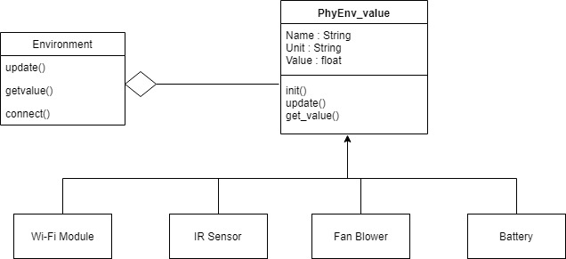

**Component Diagram :**

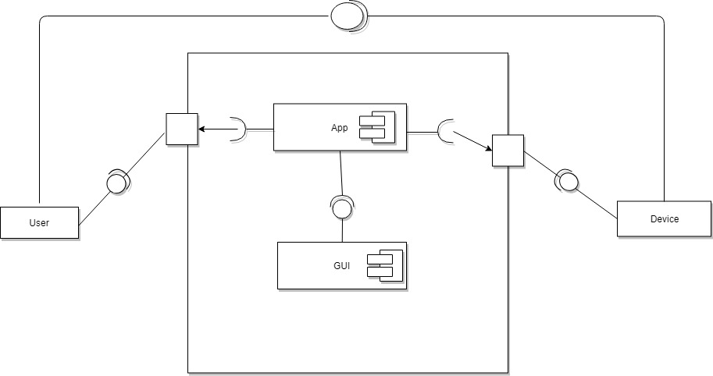

**DFD level 0**

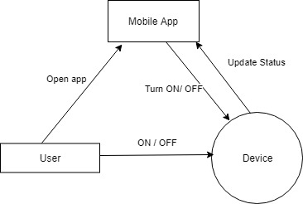

**Sequence Diagarm**

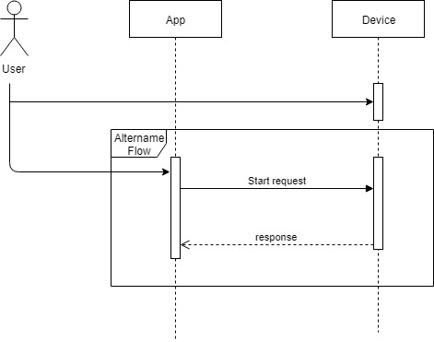

**State chart Diagram**

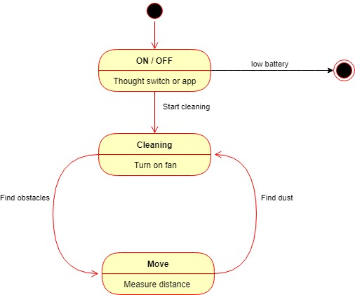

**Cost Analysis**



**Architecture**

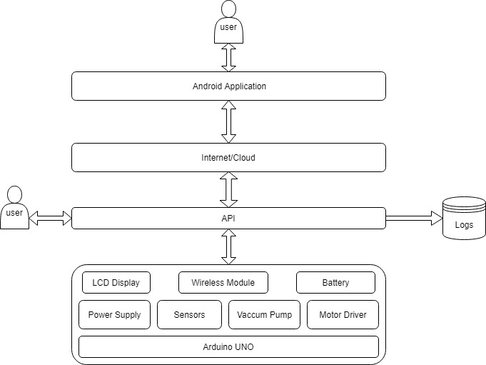

**Layered Architecture**

We have used the **layered architecture,** pattern is the separate the concerns among components. Components within a specific layer deal only with logic that pertains to that layer.

**Layer 1 :** Level 1 contains all the hardware devices like Arduino, Sensors, Motors , Controllers, Battery

**Layer 2 :** Level 2 contains the API through which we will interact with the device either thought mobile app or socket.

**Layer 3:** Level 3 contains the network through which the signal will travel, in our case this is the Internet

**Layer 4:** Layer 4 is the Application layer form where user gives the commands or interact with the system, there can be a multiple level of abstraction on this level like user can simply turn ON or OFF the device or can control the device, or can be used for testing purpose.

