Git is a free and open-source version control system.
GitHub is a repository.

https://git-scm.com/docs/git-add

- Download git and to check if it is installed, run command “git –version” on command prompt
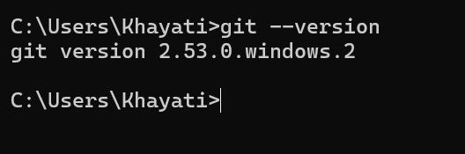

- Creating a new GitHub repository
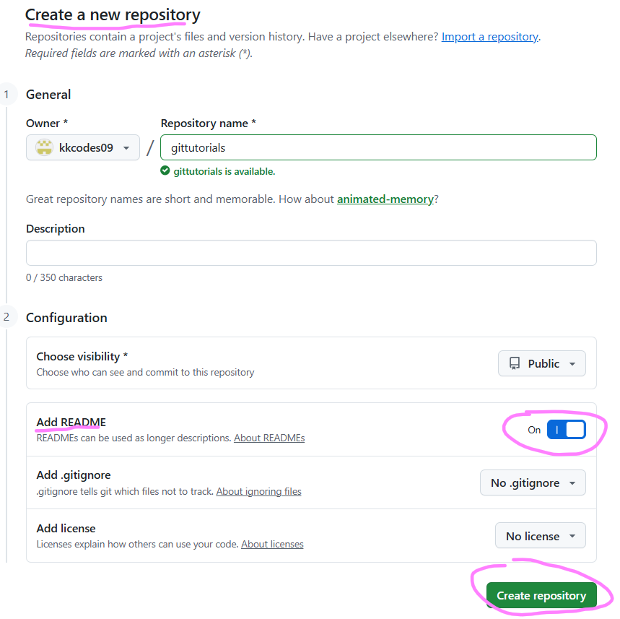
- Initialize git using command “git init”
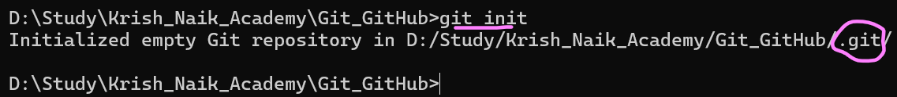

This creates .git folder which need not get committed into GitHub repository. This is just for configuration purpose.

- Configuration changes
Since, we need to commit in GitHub repository, we have to setup basic configuration, this is w.r.t user.name and user.email, so that it will be able to authenticate

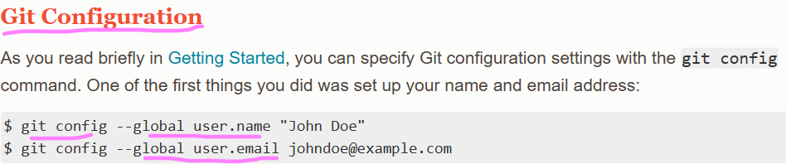

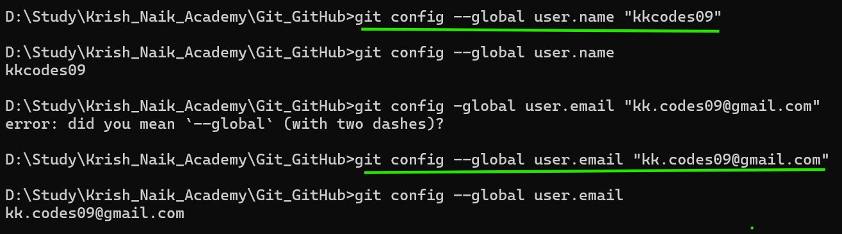
We are doing this because, later on when we push the code, it will ask for authentication for the highlighted email ID along with your GitHub.

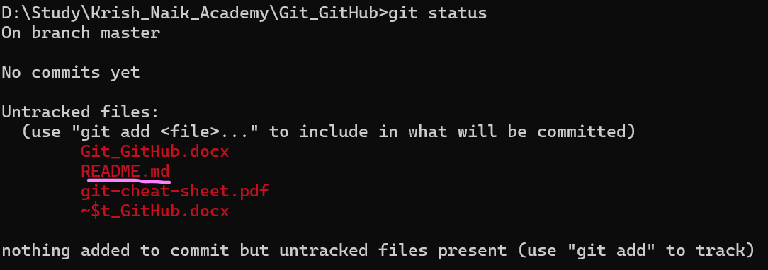

If we want to track README.md file (highlighted above), to make sure that the changes are also tracked, we need run “git add README.md” command (so that the file gets tracked)
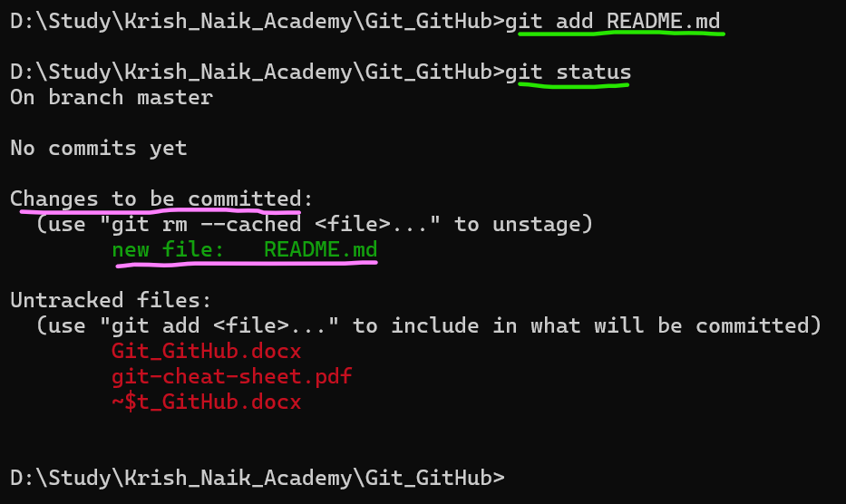

Now, this will get tracked. This file needs to be committed in staging environment. Files that need to be pushed are send to staging environment and then from staging environment, it is pushed in the repository. In short, staging environment is just a playground where we are keeping all the things that needs to be pushed.

“Git commit” command will make sure that the file goes to the staging environment.

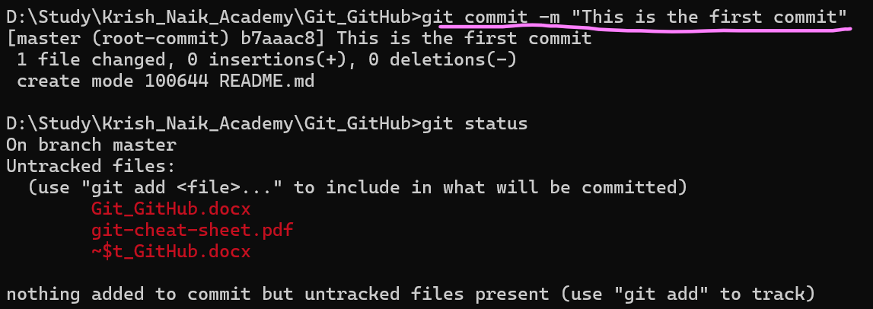

Git branch
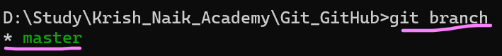

Whenever you create your GitHub repository, by default there is master branch.

We will rename this branch “git branch -M main”
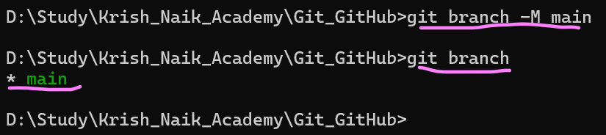

The name of branch is changed from master to main.

How to we make sure that the local repository is connected to main repository?
This means that once “git push” is performed, it should be able to recognize which is the repository it should send it to.
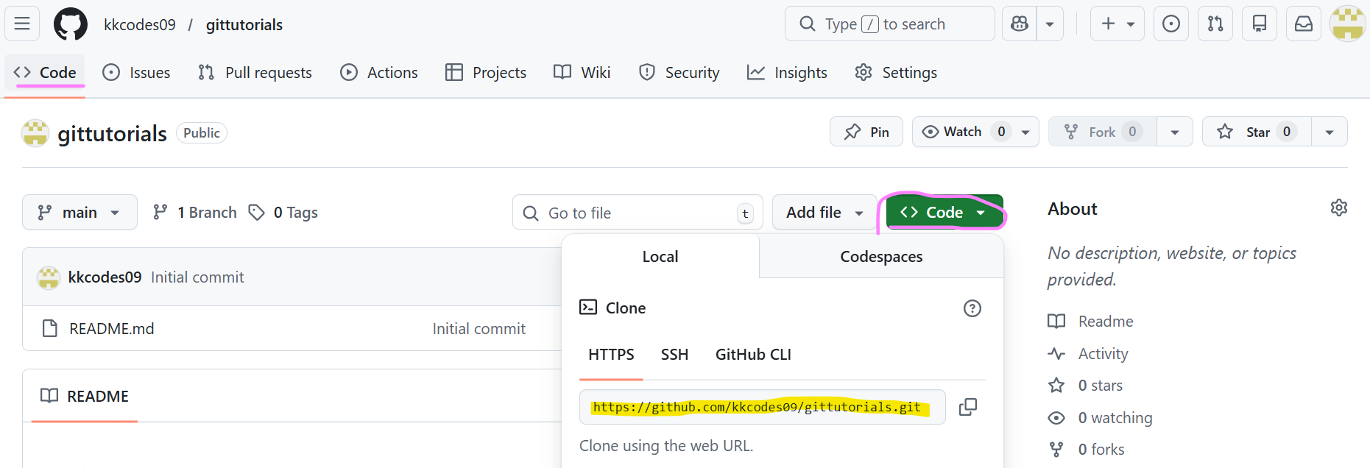

Using command “Git remote add origin https://github.com/kkcodes09/gittutorials.git” we are telling that this is the place where you need to commit.

Git remote -v
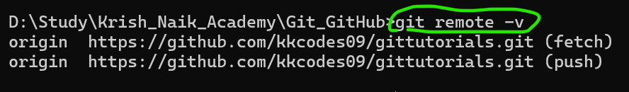

Now, we will push README.md from origin to main branch using command “git push origin main”.

I got below error after running command “git push origin main”.
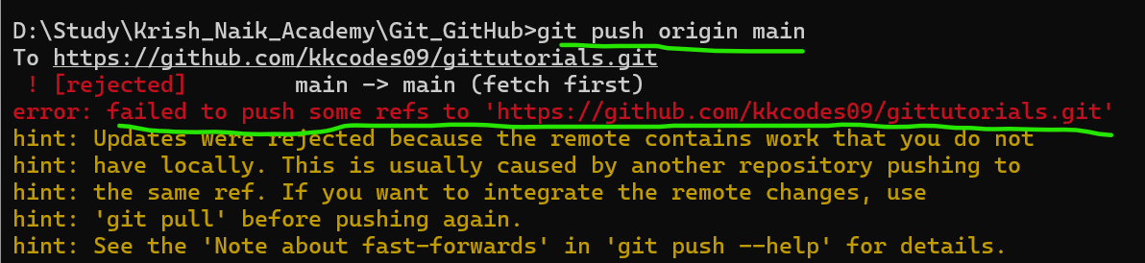

On Git, you will see that there is a README.md file (sometimes it is present by default). One option to resolve this error is to delete this file. But in case, you do not have the permission to remove file from repository, the other option is to run command “git pull origin main –rebase”
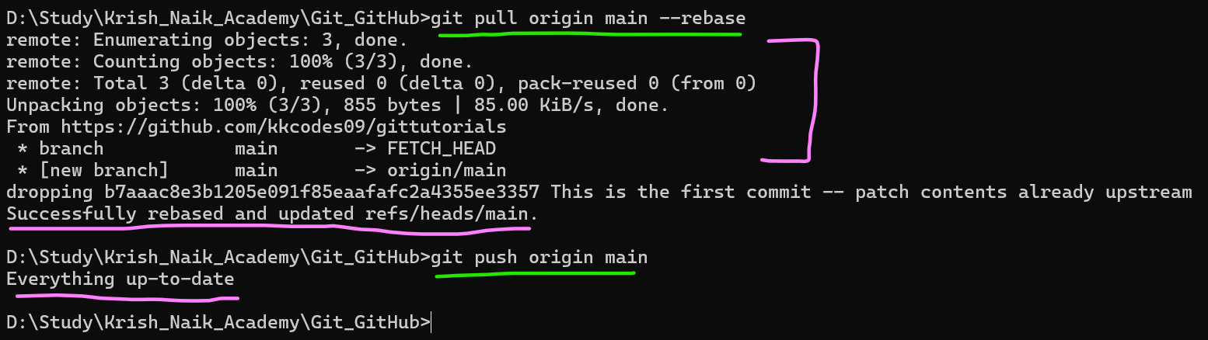

Explanation of “git pull origin main –rebase”
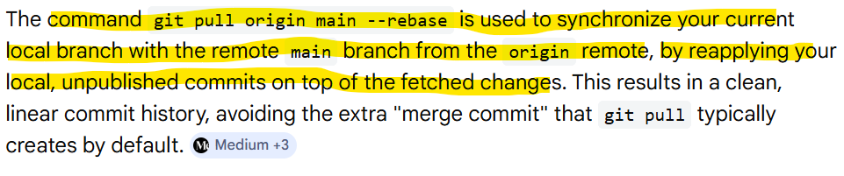

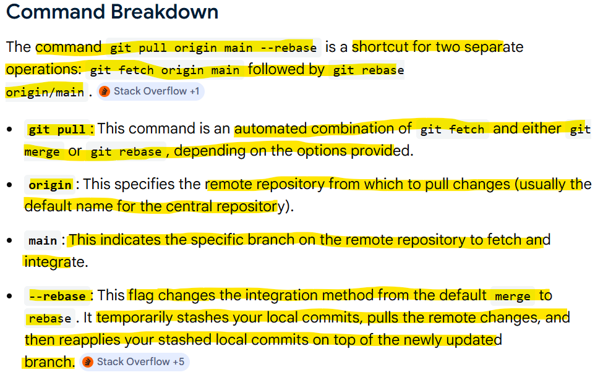

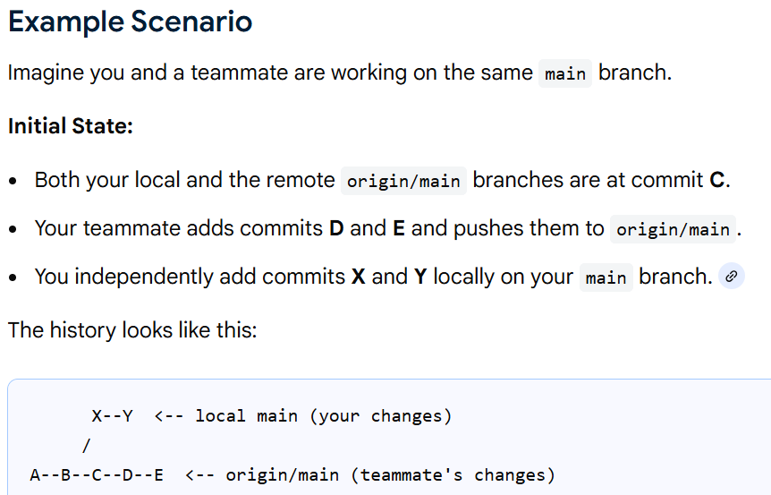

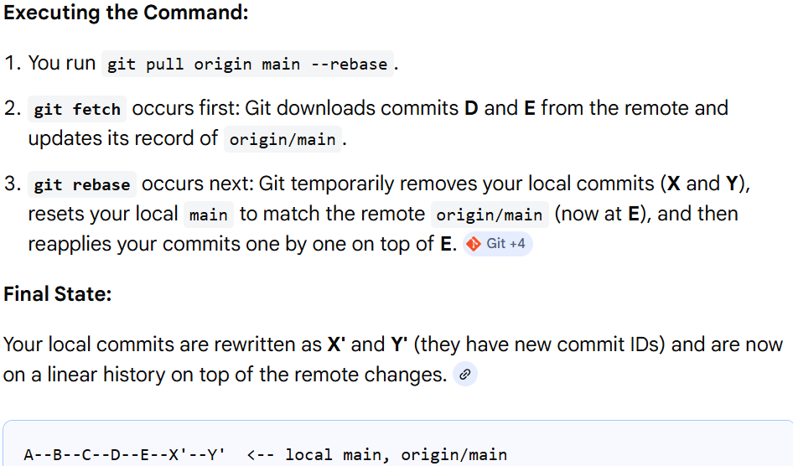

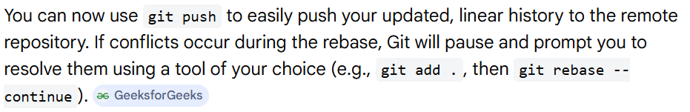

Change something in README.md in D directory (where the file is residing)
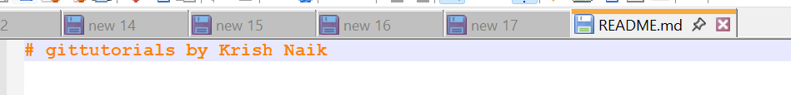
Run command “git status”
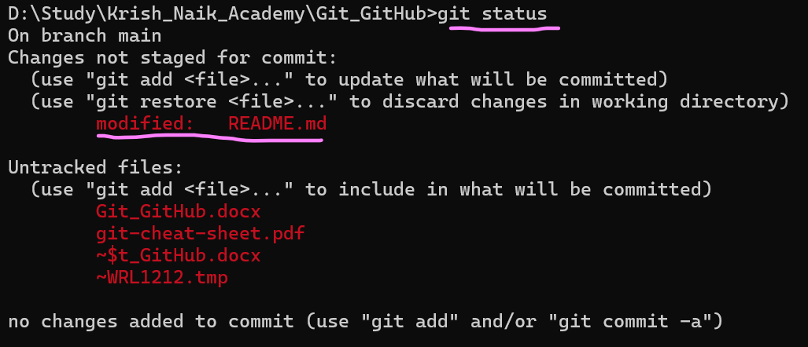

- git restore file_name
If you feel the changes made were not correct, you can restore to previous version by using command “git restore file_name”.
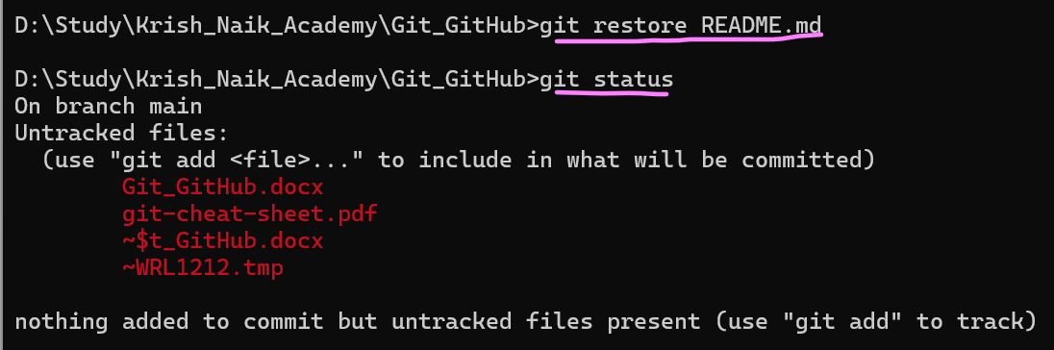

Now, make changes in README.md and add a new file.

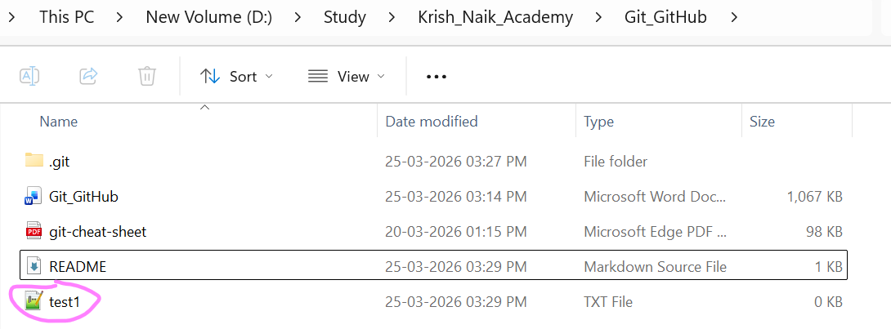
If want to that all files present in the above path go, then run command “git add .”, instead on mentioning the file name.

