Project-3 Report
Kush Dave

1. Project Description:

Project 3 was about observing and studying the realtime aspect of Raspberry Pi. In our toolkit, we already had a vga camera that we connected to the onboard CSI Camera Port and we had the ability to capture photos and videos in realtime using various commands. For the final project, we were given a C++ script that initialized the camera, took a picture and then ran the canny edge detection program that we worked with on the past projects and produced abstract images in realtime! The canny edge program given to us was the basic one where the gaussian smoothing function was not optimized and we were tasked with optimizing the same. The original C++ script only captured one image during its execution but we had to modify it so that it can take and process multiple images. For the sake of testing purposes, my results will include taking 10 pictures and processing them. The results should include the total time taken to process these 10 images as well as average frames per second which is number of frames (pictures taken) divided by the total time taken to process all images. The results should show both times for single and multi threaded operations.

2. Experimental Setup:

As stated above, the camera unit was connected to onboard CSI port which allowed the Raspberry Pi unit to interface, control and take pictures and videos. We were provided with a basic C++ script that interfaced with the camera from the program, took images, ran the canny edge detection program on the captured images and then reported the time taken process the frame(s). Looking deeper into the C++ script, we see that the script uses a built in library <raspicam/raspicam.h> to interface with the camera. The required code is linked dynamically at runtime using the ‘-lraspicam’ flag. Instead of changing the defined variable ‘N_FRAME’, I simply added one more command line argument that takes in an integer specifying the number of images to be captured and process. Rest of the functionality, i.e. specifying the sigma, thigh and tlow is the same as in previous projects. To initialize the camera, the code makes a camera object using the line ‘raspicam::RaspiCam Camera;’ , sets the format of the image to gray and then sets the size of the image using defined width and height. The code then tries to open the camera and displays an error message if it is unable to do so. Here I added a loop that counts up to the number of images specified to process more than 1 image. Inside the loop, the function sleeps for 3 seconds to allow the camera to stabilize. Next an unsigned char buffer is created of size of that of the camera buffer to store in incoming image. This is the part where the actual processing is done and we need to time it, hence we record the start time from this point onwards. Next the camera is ordered to grab the image and the image is copied to the unsigned char buffer by retrieving it. Now an appropriate filename is assigned to the image and the canny edge algorithm is run on the image. After the canny edge algorithm finishes processing the image, it is written to the output file and the clock is stopped since we finished the processing. Time is then recorded and the unsigned char buffer is freed to allow the next image to be processed. This loop is run several times (as directed by the command line argument) and the total time taken to process all the images is aggregated into total time elapsed. At the end, we display the total time taken to process all the frames and the average frame rate which is number of images processed divided by total time elapsed. This is how the C++ script works. In order to streamline my work, I created a Makefile that handled the compilations for me as well as cleaning intermediate files between executions such as core dumps, processed images and binaries. I created a script that ran the binary using the default parameters and specified processing 10 images in the run. To compare single threaded and multi threaded timing, I created 2 versions of the canny edge detection program called ‘canny_local_raspicam.c’ and ‘canny_local_raspicam_multi.c’ and used openmp to multi thread gaussian smoothing function. I added pre processor directives to the C++ script to help me choose whether I wanted to run the single threaded version or the multi threaded version. The results are in the results section.

2. Results:

I ran the script for 10 images using both the single threaded and multi threaded version of the canny edge algorithm. Before I get into the results, there is a small caveat in the C++ script that reported false timings for the multi threaded version. The script originally used the function ‘clock()’ to record the start and end time and then time elapsed to be the difference between the two. This function records the time spent by the thread in the processor as opposed to the actual time taken between processing. The consequence of this was that it reported that it took more time executing the multi threaded version rather than the single threaded version. This was obviously false since I checked the system time by timing my script. The fix for this wasn’t obvious and I had to use a different clock function ‘clock.gettime(CLOCK_THREAD_CPUTIME_ID, struct timepec* t)’. The flag ‘CLOCK_THREAD_CPUTIME_ID’ measures the amount of CPU time consumed by the thread which was the accurate time spent by the script thread in the canny edge process. This was a change that needed to be made in order to obtain correct times for single and multi threaded versions.

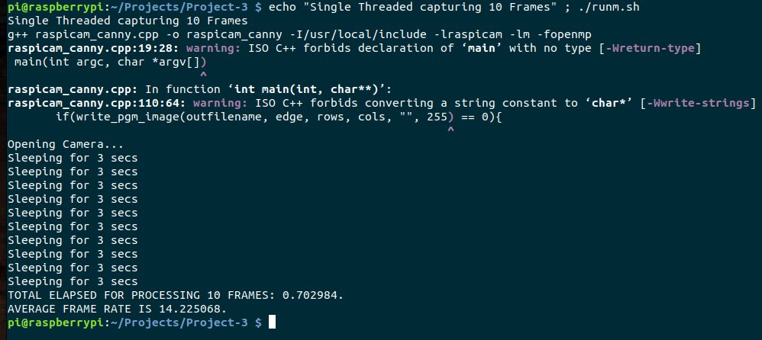
The figure above shows the time taken for the program running single threaded operations to process 10 images. Total time taken is about 0.703 seconds which brings it to about 14.23 frames per second.

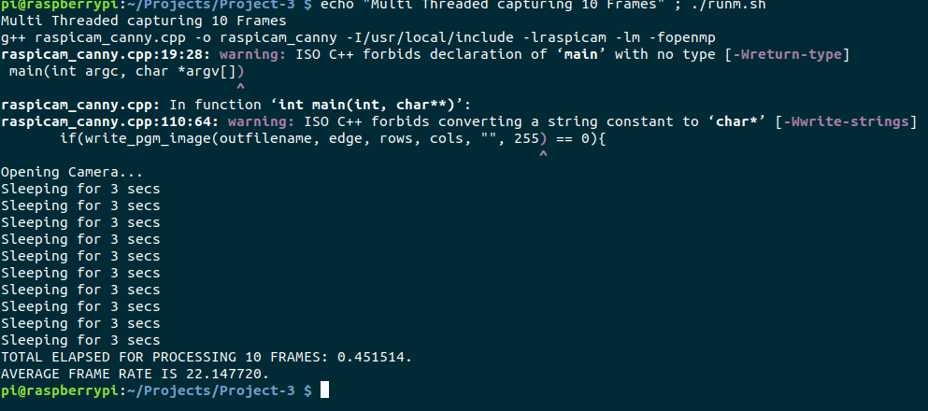
On the contrary, if we multi thread the gaussian smoothing function, the same 10 frames can be processed in little under 0.5 seconds which makes the script about 36 % faster than the single threaded version. We don’t get to see linear gains (such as 4 times the performance) since multithreading adds CPU overhead of setting up and managing these threads.

4. Discussion:

The challenge I faced while doing this project was to figure out why the multi threaded time was significantly larger than the single threaded time. Fortunately, other people faced this same problem and I was able to find the reason behind this anomaly using the help of peers on Piazza. For once, I thought that the CPU overhead exceeded the performance gains and that was why the multi threaded version (on paper and in clock () results) performed worse than its single threaded counter part. However, by studying the nature of these functions, I was able to use the right function for the job and also learned quite a bit about how different versions of the same function measure clock time with respect to the CPU, System time and aggregate time spent in threads.

5. Conclusion:

In this project, we get to experience the real time aspect of these embedded devices. Raspberry Pi being a prototyping board is extremely configurable by allowing users to connect a wide array of peripherals and IO devices to it. We also get to see firsthand the amount of performance gains we get in real time processing by paralleling our tasks. Real time operations have usually an allotted time limit beyond which they can cause multiple types of problems for the system. By using parallelism in our tasks, we can make sure that time critical tasks complete in the given time limit and don’t hinder other time critical/non time critical tasks that depend on it.

