Driver Monitoring System Report

Driver: Sagar (ID: D1)
Driver ID : D1
Driver Name : Sagar
Travel Time : 59 Minutes
Distance Covered : 59.00 km
Average Eye Closure : 16.30 %
Average Blink Rate : 15.35 blinks/min
Average Head Pitch : 3.30°
Attention Score : 87.18
Driver State : Alert
Driving Session : Morning
Driver Assessment:
Driver is highly alert and maintaining good attention throughout the journey. No signs of fatigue detected.

Performance Summary
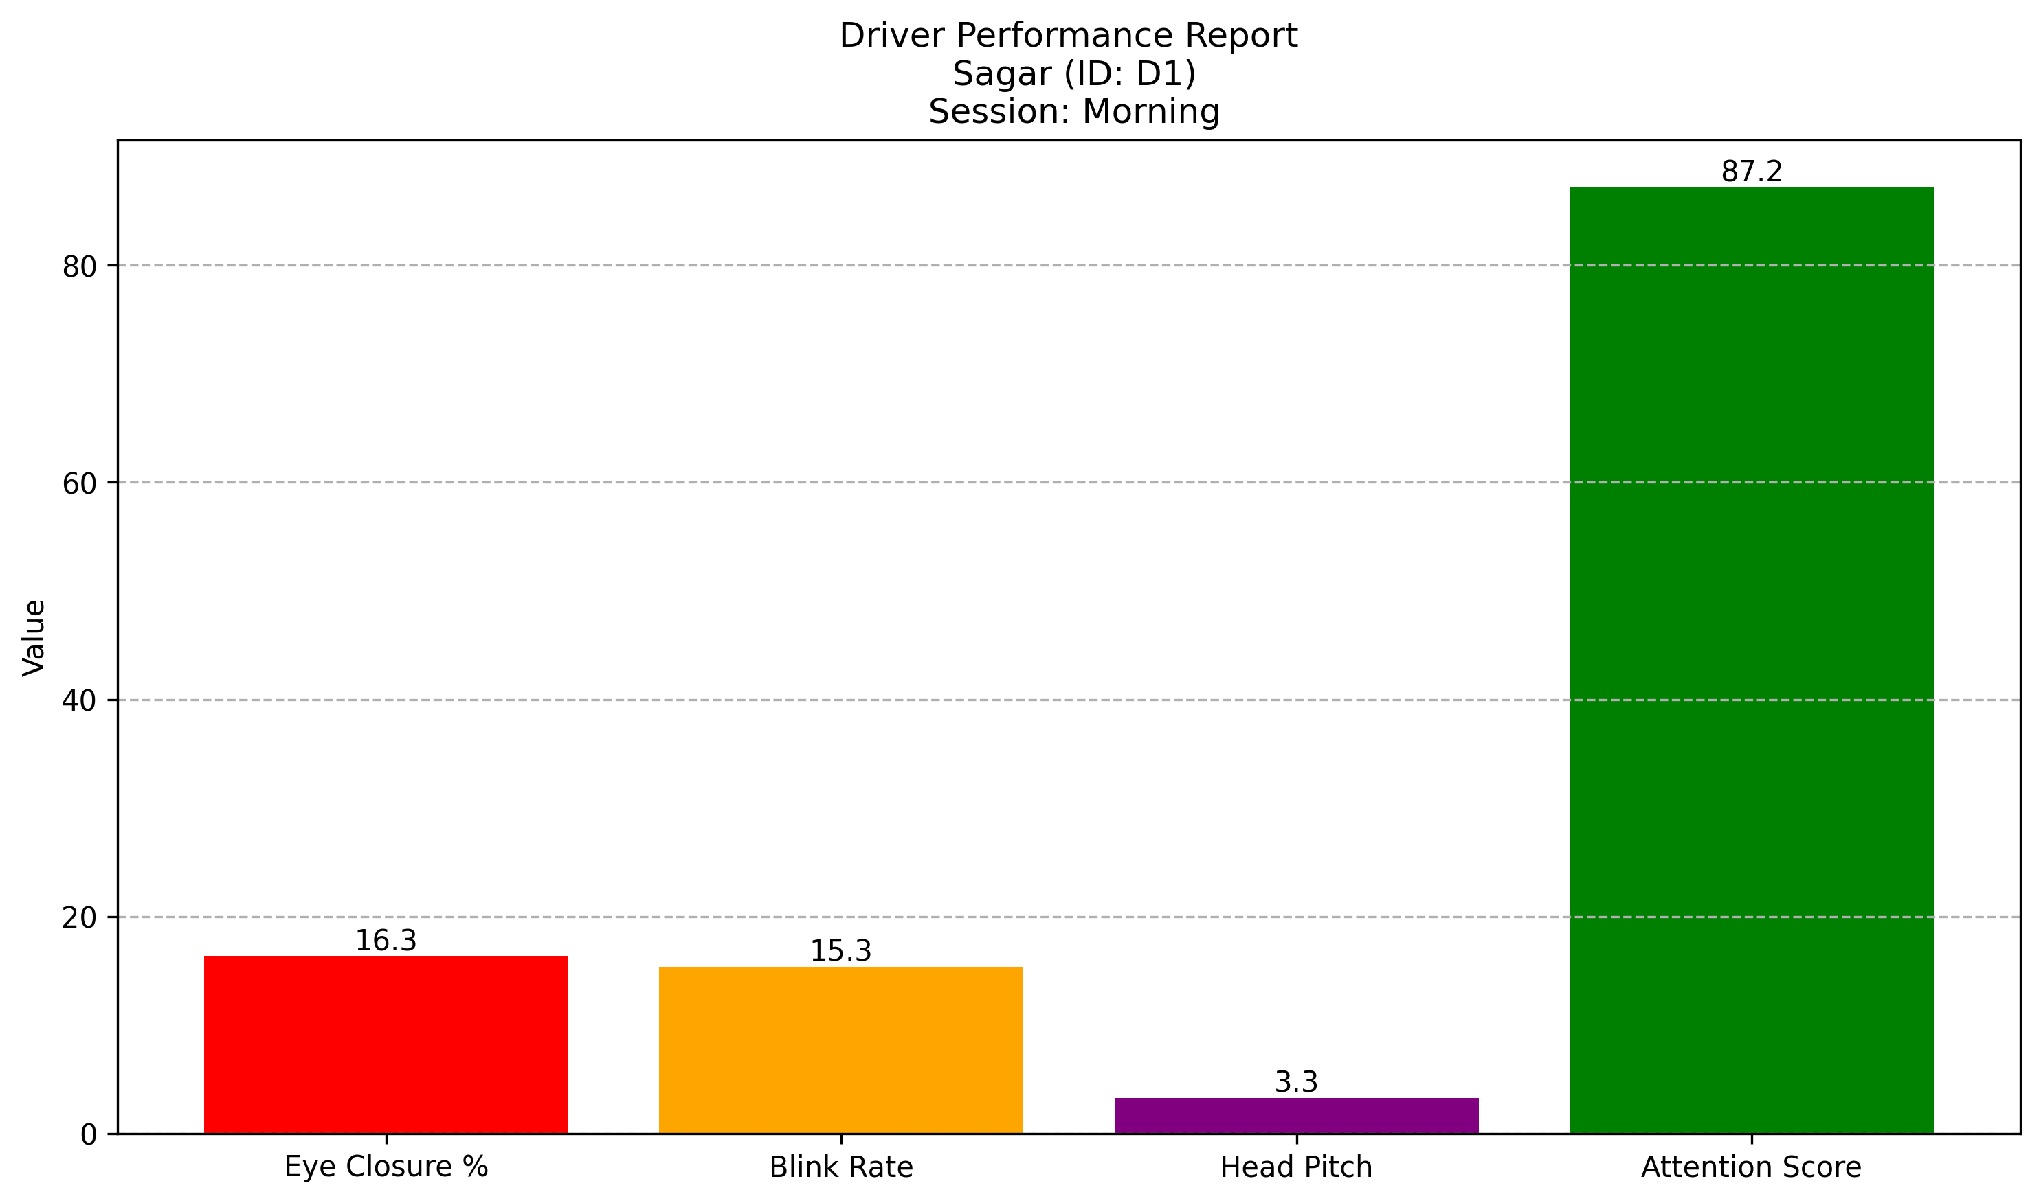

Attention Score Trend
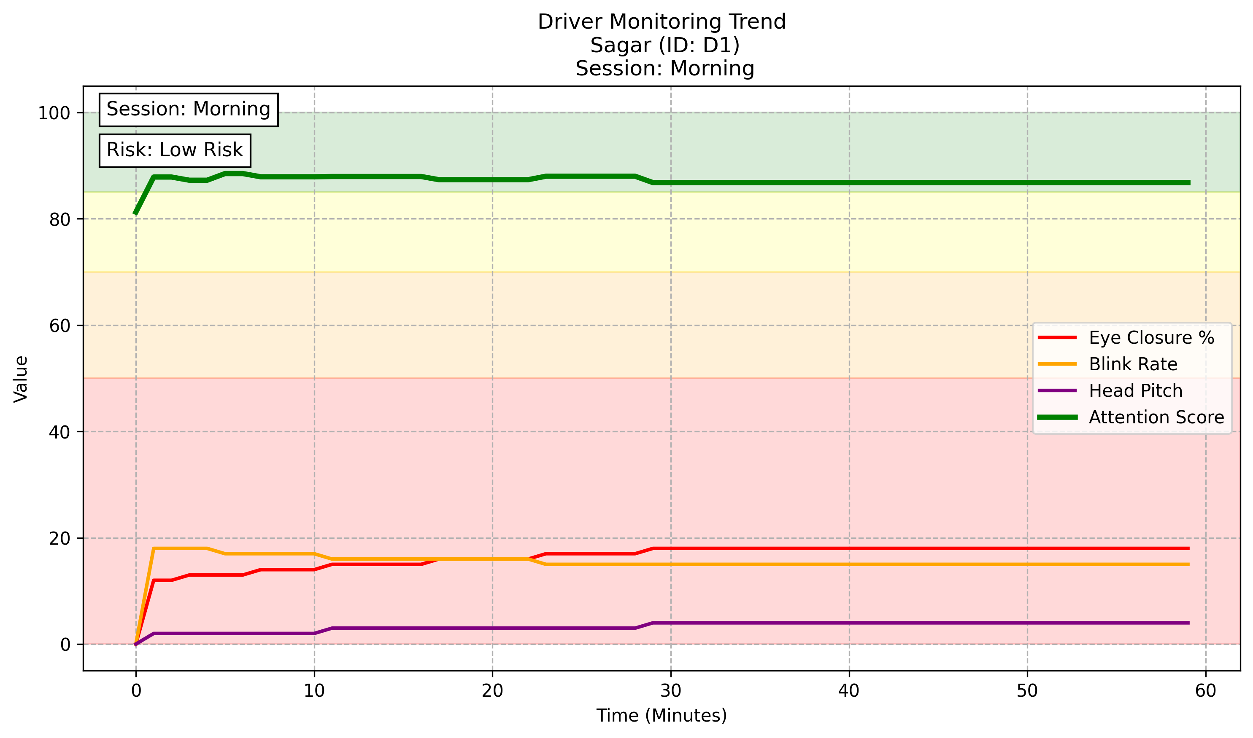

Driver: Mohit (ID: D2)
Driver ID : D2
Driver Name : Mohit
Travel Time : 59 Minutes
Distance Covered : 48.97 km
Average Eye Closure : 36.10 %
Average Blink Rate : 10.77 blinks/min
Average Head Pitch : 6.93°
Attention Score : 68.89
Driver State : Slight_Fatigue
Driving Session : Afternoon
Driver Assessment:
Driver is showing signs of fatigue. Continuous driving may affect safety and concentration.

Performance Summary
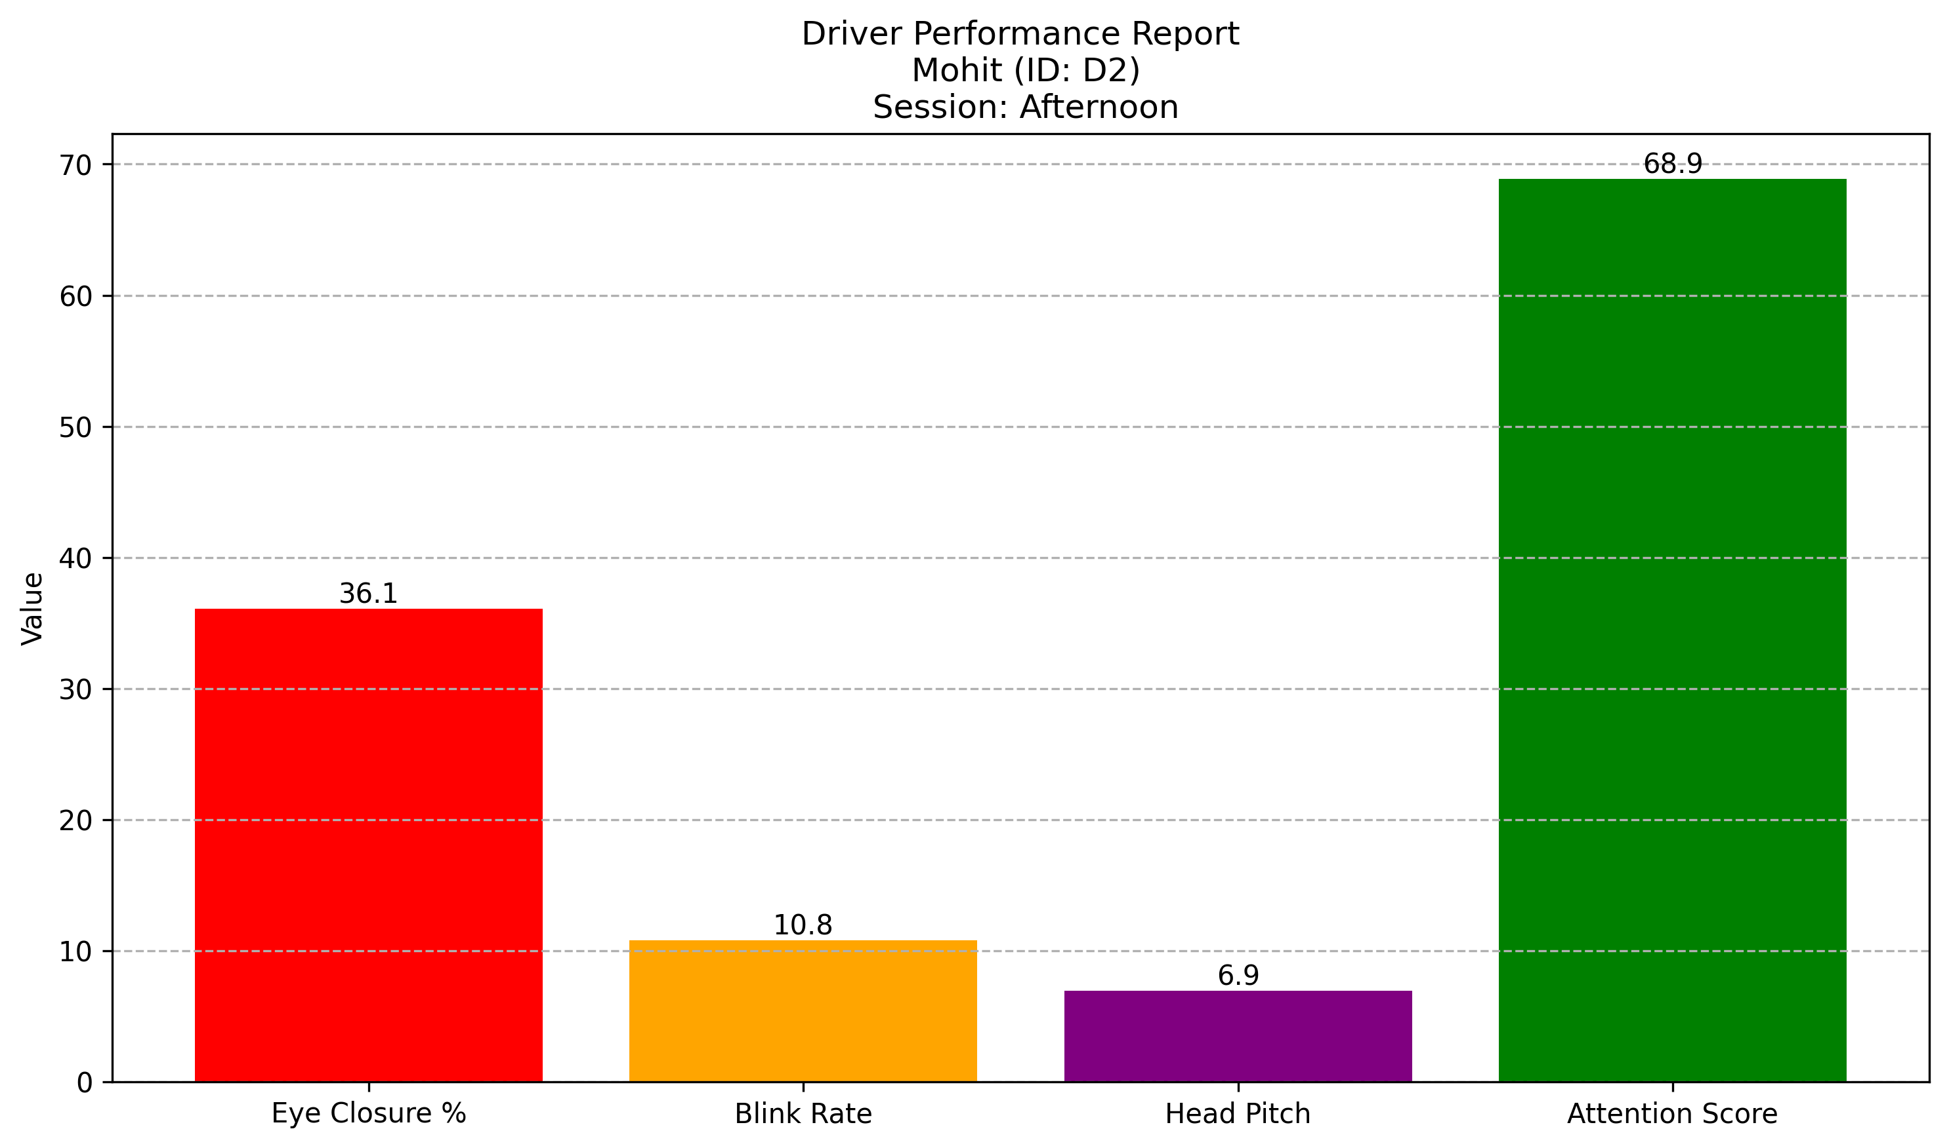

Attention Score Trend
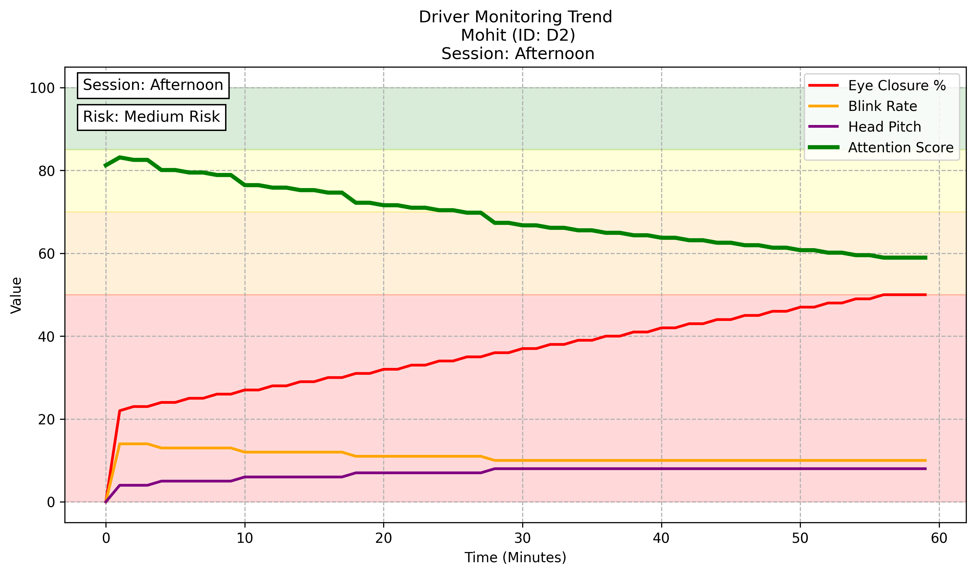

Driver: John (ID: D3)
Driver ID : D3
Driver Name : John
Travel Time : 60 Minutes
Distance Covered : 54.60 km
Average Eye Closure : 47.54 %
Average Blink Rate : 8.97 blinks/min
Average Head Pitch : 7.79°
Attention Score : 59.26
Driver State : Slight_Fatigue
Driving Session : Night
Driver Assessment:
Driver is showing signs of fatigue. Continuous driving may affect safety and concentration.

Performance Summary
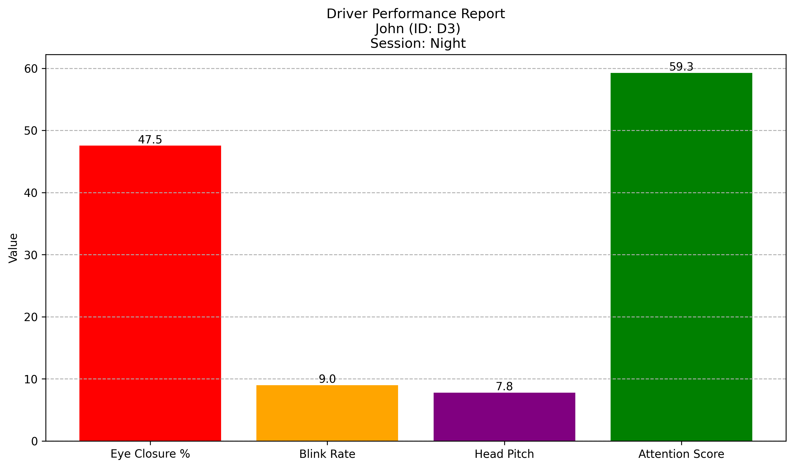

Attention Score Trend
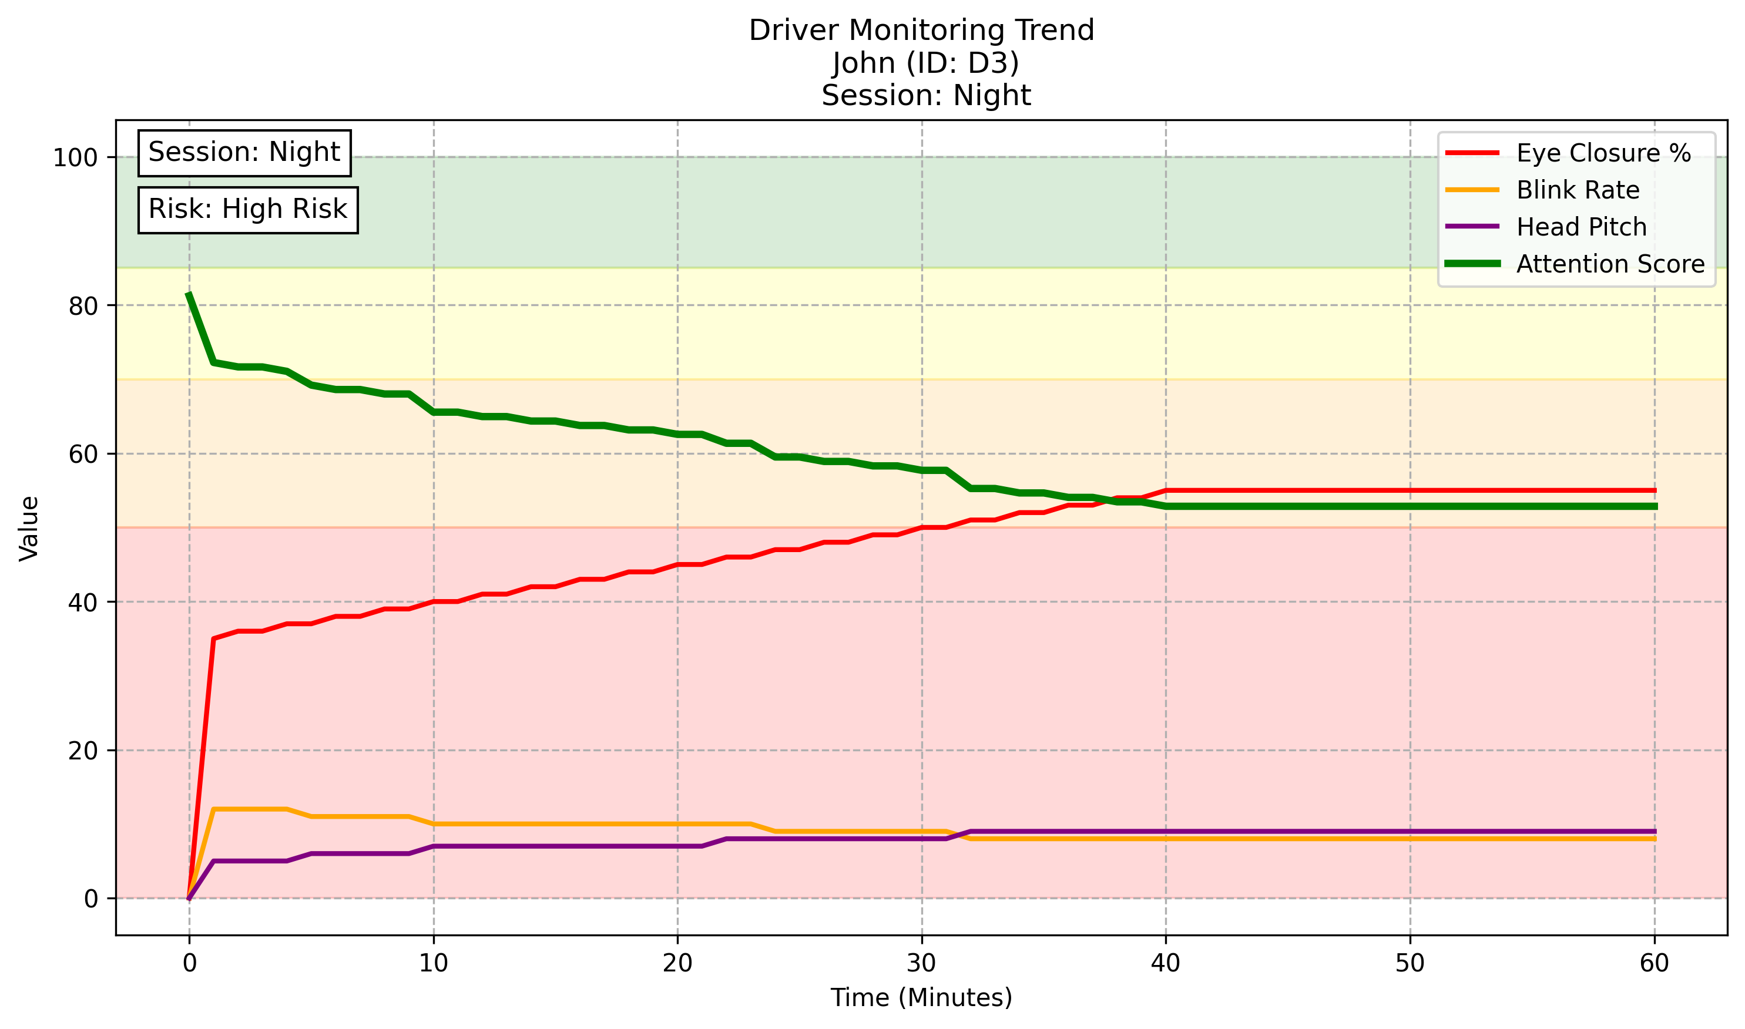

Driver: Harry (ID: D4)
Driver ID : D4
Driver Name : Harry
Travel Time : 60 Minutes
Distance Covered : 49.80 km
Average Eye Closure : 67.54 %
Average Blink Rate : 4.31 blinks/min
Average Head Pitch : 12.92°
Attention Score : 38.36
Driver State : Drowsy
Driving Session : Early Morning
Driver Assessment:
Driver is highly drowsy and at significant risk. Immediate rest is strongly recommended.

Performance Summary
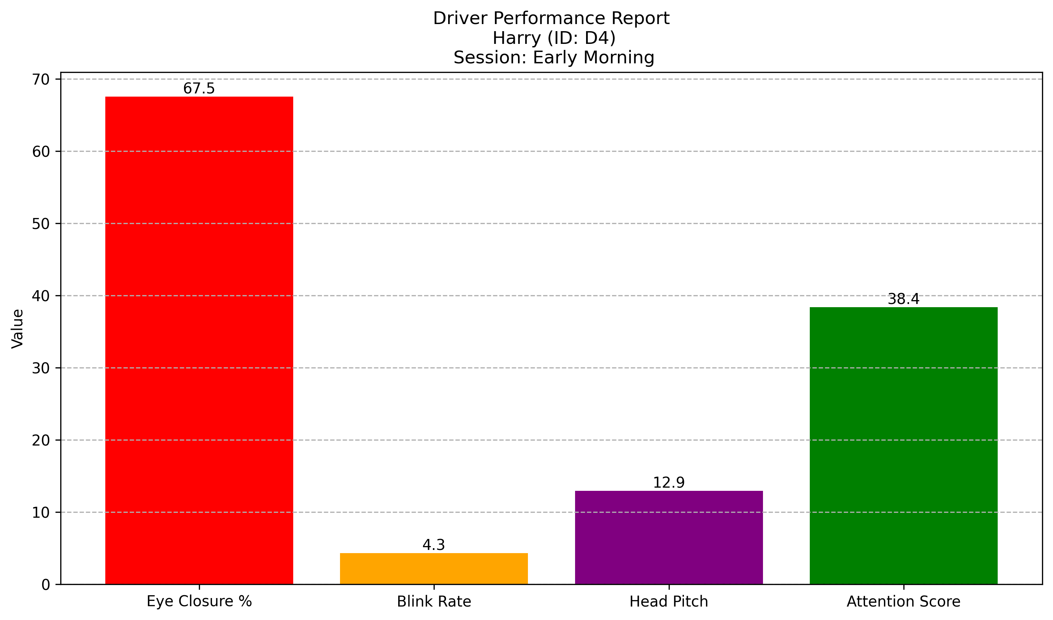

Attention Score Trend
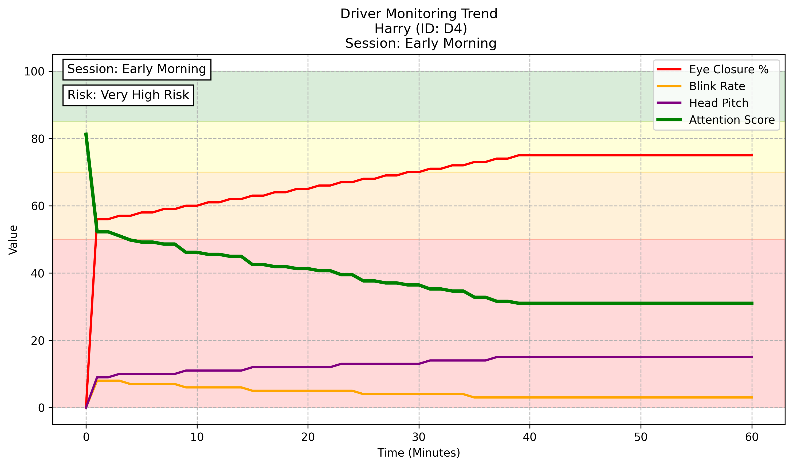

Driver Attention Score Comparison
