Driver Monitoring System Report

Driver: Sagar (ID: D1)
Driver ID : D1
Driver Name : Sagar
Travel Time : 59 Minutes
Distance Covered : 59.00 km
Average Eye Closure : 16.58 %
Average Blink Rate : 15.61 blinks/min
Average Head Pitch : 3.36°
Attention Score : 87.28
Driver State : Alert
Driver Assessment:
Driver is highly alert and maintaining good attention throughout the journey. No signs of fatigue detected.
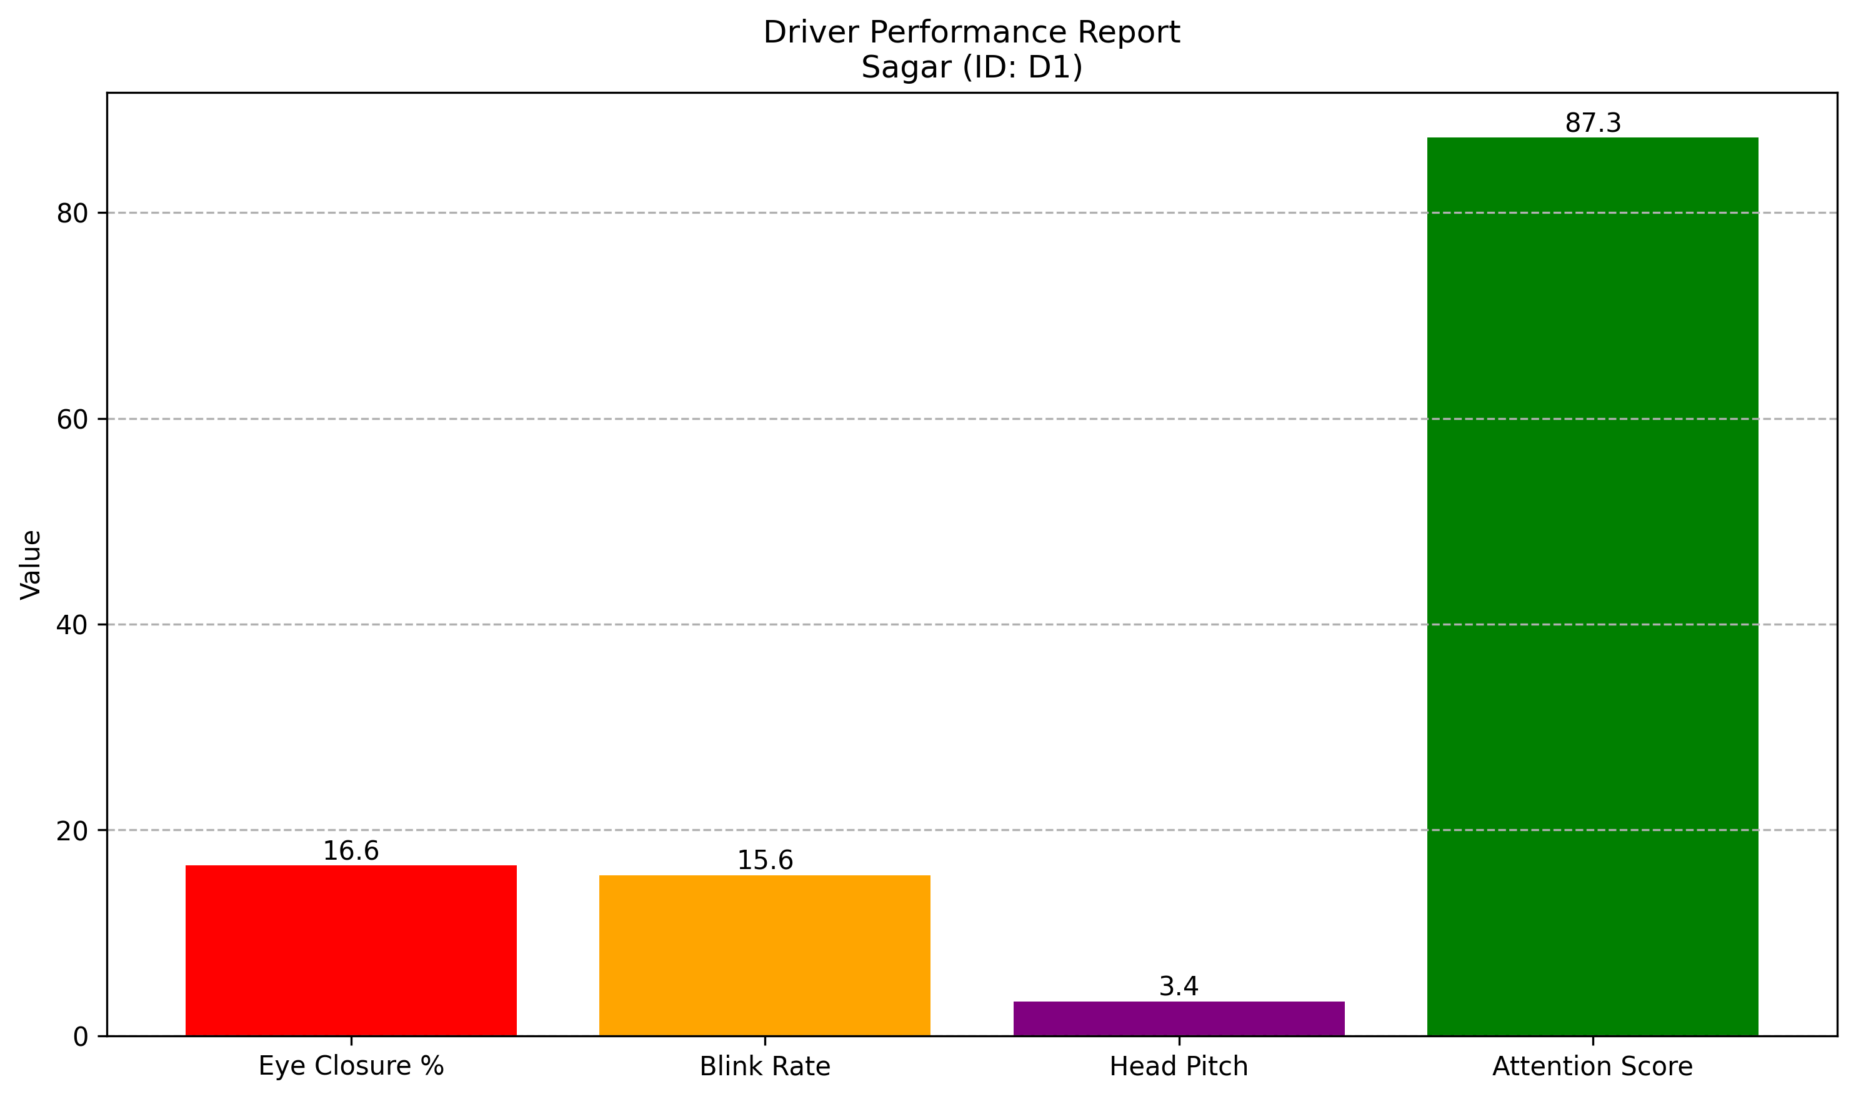

Driver: Mohit (ID: D2)
Driver ID : D2
Driver Name : Mohit
Travel Time : 59 Minutes
Distance Covered : 48.97 km
Average Eye Closure : 36.44 %
Average Blink Rate : 10.85 blinks/min
Average Head Pitch : 7.07°
Attention Score : 68.56
Driver State : Slight_Fatigue
Driver Assessment:
Driver is showing signs of fatigue. Continuous driving may affect safety and concentration.
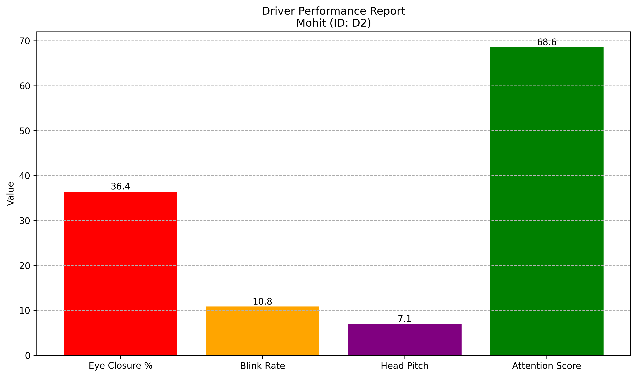

Driver: John (ID: D3)
Driver ID : D3
Driver Name : John
Travel Time : 60 Minutes
Distance Covered : 54.60 km
Average Eye Closure : 47.55 %
Average Blink Rate : 9.13 blinks/min
Average Head Pitch : 7.90°
Attention Score : 59.00
Driver State : Slight_Fatigue
Driver Assessment:
Driver is showing signs of fatigue. Continuous driving may affect safety and concentration.
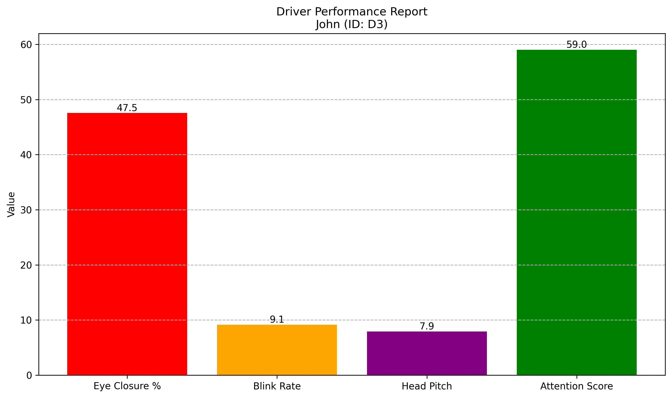

Driver: Harry (ID: D4)
Driver ID : D4
Driver Name : Harry
Travel Time : 60 Minutes
Distance Covered : 49.80 km
Average Eye Closure : 67.75 %
Average Blink Rate : 4.47 blinks/min
Average Head Pitch : 13.17°
Attention Score : 37.52
Driver State : Drowsy
Driver Assessment:
Driver is highly drowsy and at significant risk. Immediate rest is strongly recommended.
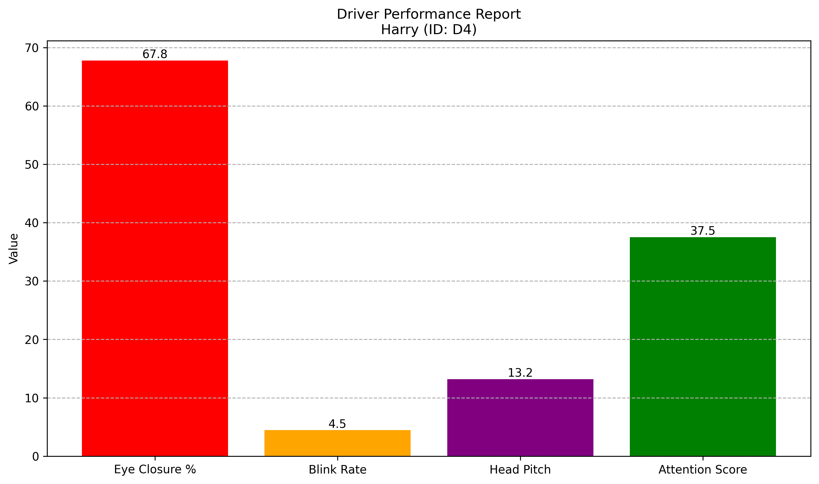

Driver Attention Score Comparison
