Project Flow & System Design Document

Prepared by | - Sumith Dhage  - Vedant Mohite  - Yash Potdar
Project domain | Automotive simulation and vehicle dynamics
Document purpose | Python Megaproject Documentation

Project Overview
The Car Emulator GUI & Vehicle Motion Simulator is a Python desktop application that reproduces core longitudinal vehicle operations - engine start, acceleration, braking and stop - through a responsive graphical interface. It combines an Excel-driven parameter layer, a deterministic physics engine, and a continuously updated velocity-time graph.

Project Objective
- Develop a realistic vehicle motion simulator using Python and CustomTkinter.
- Model longitudinal vehicle dynamics using real automotive physics equations.
- Implement an Excel-driven architecture where vehicle parameters and torque maps can be modified without changing code.
- Simulate key vehicle operations such as Start, Accelerate, Brake, and Stop through an interactive GUI.
- Visualize vehicle performance through a live-updating Velocity-Time (v-t) graph using Matplotlib.

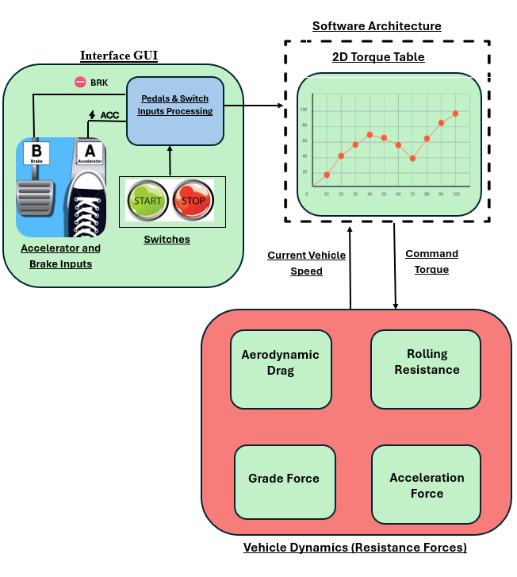
System Architecture:

What Data the System Uses:

Data Group | Example Fields
Vehicle Constants | Vehicle Mass (M_v), Equivalent Mass (M_e), Drag Coefficient (Cd), Frontal Area (Af), Rolling Resistance Coefficient (f_r), Tire Radius, Air Density (ρ), Gravity (g)
Powertrain | Engine RPM, Throttle Position (%), Torque Output (Nm), Torque Map Lookup Values
Vehicle Motion States | Vehicle Speed (km/h), Vehicle Speed (m/s), Acceleration (m/s²), Simulation Time (s)
Force Calculations | Traction Force (Ft), Aerodynamic Drag Force (Fa), Rolling Resistance Force (Fr), Brake Force (F_brake), Net Force
Driver Control | Start Engine Command, Accelerate Command, Brake Command, Stop Engine Command, Throttle Level (%)
Graph & Telemetry Data | Time History Array, Velocity History Array, Live Speed Display, Engine RPM Display, Force Readout Display

Expected Analytical Output:

- Engine ON/OFF state monitoring
- Vehicle speed monitoring in km/h
- Real-time Velocity-Time (v-t) graph generation
- Engine ON/OFF state monitoring
- Time-history data collection for graph plotting
- Simulation runtime tracking

Python Technologies and Their Roles:
Python
- Controls simulation logic, GUI functions, and vehicle dynamics calculations.
CustomTkinter
- Creates the interactive GUI, buttons, and telemetry displays.
Pandas
- Loads vehicle constants and torque map data from Excel files.
NumPy
- Performs numerical and mathematical calculations efficiently.
Matplotlib
- Generates the real-time Velocity-Time (v-t) graph.
OpenPyXL
- Supports reading and writing Excel-based vehicle data.
Vehicle Physics Engine
- Calculates traction, drag, rolling resistance, braking force, and acceleration.

Flow Diagram:
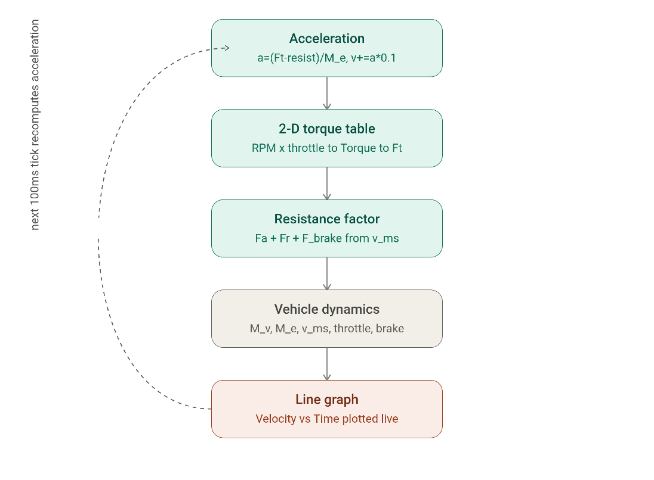

Flow Diagram Explanation:
1. Vehicle Dynamics
- Initializes and stores the main vehicle parameters such as mass, equivalent mass, speed, throttle input, and brake status.
- Acts as the core simulation module for vehicle motion calculations.

2. 2-D Torque Table
- Uses engine RPM and throttle position to obtain torque from the Excel-based Torque Map.
- Converts engine torque into traction force (Ft) that drives the vehicle forward.

3. Resistance Factor
- Calculates the opposing forces acting on the vehicle.
- Includes aerodynamic drag (Fa), rolling resistance (Fr), and braking force (F_brake).

4. Acceleration
- Computes vehicle acceleration using the net force acting on the vehicle.
- Updates vehicle speed every 100 ms using Euler integration.

5. Line Graph
- Continuously plots Vehicle Speed versus Time.
- Provides real-time visualization of acceleration and braking performance.

Overall Working
- Vehicle parameters are processed through the torque lookup and force calculation stages.
- Net acceleration is determined and vehicle speed is updated.
- The updated speed is displayed on the live Velocity-Time graph, and the process repeats until the simulation is stopped.

Analysis Logic:

1. Vehicle Parameter Initialization
- Load vehicle constants and torque map data from the Excel workbook.
- Initialize speed, throttle position, engine RPM, and simulation variables.

2. RPM Calculation
- Convert vehicle speed from km/h to m/s.
- Calculate engine RPM using tire radius and gear ratio relationships.

3. Torque Lookup Analysis
- Use the calculated RPM and current throttle position to access the 2-D Torque Map.
- Retrieve the corresponding engine torque value.

4. Traction Force Calculation
- Convert engine torque into traction force acting at the wheels.
- Determine the driving force available for vehicle motion.

5. Resistance Force Analysis
- Calculate aerodynamic drag force.
- Calculate rolling resistance force.
- Apply brake when the brake function is active.
- Determine the total resistive force acting against vehicle motion.

6. Acceleration Analysis
- Compute the net force acting on the vehicle.
- Calculate acceleration using Newton's Second Law and the equivalent vehicle mass.

7. Graphical Analysis
- Store current time and speed values.
- Plot a live Velocity-Time (v-t) graph to visualize vehicle performance.

Illustrative Decision Rules :

Condition | Example Rule | Result
Vehicle Acceleration | Throttle position increases and traction force exceeds resistance forces | Vehicle speed increases
Vehicle Braking | Brake button is active and brake force is applied | Vehicle speed decreases
Engine Start | Start Engine button is pressed | Simulation loop begins
Engine Stop | Stop Engine button is pressed | Vehicle states and graphs are reset
High Resistance Load | Aerodynamic drag and rolling resistance increase with speed | Acceleration reduces
Torque Generation | RPM and throttle position match a torque map entry | Traction force is generated
Maximum Throttle | Throttle reaches the limit of 85% | Maximum available torque is applied
Vehicle at Rest | Speed is near 0 km/h and no throttle is applied | Vehicle remains stationary
Live Graph Update | New speed value is calculated | Velocity-Time graph is refreshed
Continuous Simulation | Engine remains ON | Physics calculations repeat in a loop

Dashboard and Report Structure:
User Inputs
- Click START ENGINE to begin the simulation.
- Use ACCELERATE to increase the throttle position.
- Use BRAKE to apply vehicle braking and reduce speed.
- Monitor live vehicle parameters and graph updates.
- Click STOP ENGINE to end and reset the simulation.
Example Final Summary
- Simulation Time: 60 seconds
- Maximum Vehicle Speed: 78 km/h
- Average Vehicle Speed: 42 km/h
- Maximum Engine RPM: 3800 RPM
- Peak Traction Force: 4200 N
- Total Brake Applications: 5
- Velocity-Time Graph Generated: Yes
- Engine Status: Successfully Operated
- Vehicle Response: Stable Acceleration and Deceleration Achieved
- Final Vehicle Speed: 0 km/h (After Stop Engine)
- Overall Simulation Status: Vehicle Dynamics Successfully Simulated

Report Outputs
- Vehicle speed profile over time
- Engine RPM variation over time
- Force analysis (Ft, Fa, Fr, F_brake)
- Acceleration and deceleration performance
- Velocity-Time graph
- Vehicle dynamics performance summary
- Simulation statistics and operational results

Final System Architecture:

Vehicle Data Excel File (Vehicle Constants + Torque Map)
↓
Data Loading & Validation (Pandas/OpenPyXL)
↓
Vehicle Parameter Initialization
↓
RPM & Torque Map Lookup Analysis
↓
Traction Force and Resistance Force Calculation
↓
Acceleration & Vehicle Dynamics Computation
↓
Speed Update using Euler Integration
↓
Real-Time Telemetry Display & Velocity-Time Graph
↓
Vehicle Performance Analysis and Simulation Results

Python Syllabus Coverage:
Syllabus | Use in Project
Fundamentals | Variables, constants, operators, input/output, and state variables
Decision Making | Engine ON/OFF states, throttle control, braking logic, force evaluation
Loops | Continuous 100 ms simulation update cycle
Functions | Separate functions for RPM calculation, torque lookup, force calculation, plotting, and simulation control
Collections | Lists and arrays for storing time-history and velocity-history data
File Handling | Reading vehicle parameters and torque maps from Excel files
Exception Handling | Handling missing Excel files, invalid data, and runtime errors
OOP | Classes such as Vehicle Simulator, Physics Engine, ExcelDataLoader, and Graph Manager
Modules/Packages | CustomTkinter, Pandas, NumPy, Matplotlib, OpenPyXL, Math

Project Deliverables
- Python source code for the Vehicle Motion Simulator
- Vehicle data Excel workbook (vehicle_data.xlsx)
- CustomTkinter-based graphical user interface
- Real-time Velocity-Time (v-t) graph visualization
- Vehicle dynamics and force analysis results
- Project documentation and presentation

Key Point
- Excel Data = Provides vehicle constants and torque map information.
- Pandas/OpenPyXL = Loads and processes vehicle data.
- Physics Engine = Calculates RPM, torque, forces, acceleration, and speed.
- Vehicle Dynamics Model = Simulates real-world vehicle motion.
- Matplotlib Graph = Visualizes vehicle speed over time.
- CustomTkinter GUI = Presents telemetry, controls, and simulation results.

