Vehicle Wear & Tear Prediction System
A Python-Based Vehicle Health Analytics & Maintenance Alert System
Prepared by: Parth Ugare & Riddhi Sawarkar
Understanding
To develop a system which can monitor and collect vehicle sensor values and compare them with standard threshold values. If any servicing is required after analysis, the system gives alerts accordingly based on the severity level.
Description
A Python-based analytics system that collects vehicle sensor and operational data from any dataset and predicts wear and tear conditions of vehicle components using data analysis and visualization techniques, and alerts about the servicing required for the vehicle.

1. Project Overview
The Vehicle Wear & Tear Prediction System is a Python-based project that helps monitor the condition of a vehicle by analyzing its sensor data. The system compares the current sensor readings with standard threshold values to check the health of different vehicle components.
Based on the analysis, it shows the condition of each component and provides maintenance alerts. This helps users identify potential issues early and schedule servicing before major problems or failures occur.

2. Problem Statement
Vehicle parts such as the engine, brakes, battery, and cooling system wear out over time with regular use. If these problems are not detected early, they can reduce vehicle performance, increase repair costs, and even cause unexpected breakdowns.
The aim of this project is to monitor important vehicle parameters, compare them with standard values, and alert the user whenever maintenance is required.

3. Project Objectives
- Monitor important vehicle sensor values.
- Store standard threshold values for different vehicle components.
- Compare actual sensor readings with standard values.
- Check the health condition of each component.
- Generate maintenance alerts when needed.
- Help users plan vehicle servicing before failures happen.
- Display vehicle health using a simple dashboard and report.

4. System Architecture — Block Diagram
The diagram below shows the flow of data through the system, from the two input Excel sources, through each processing module, to the final health report and visualization output. The dashed outer boundary represents the Main Controller, which connects and coordinates all modules.
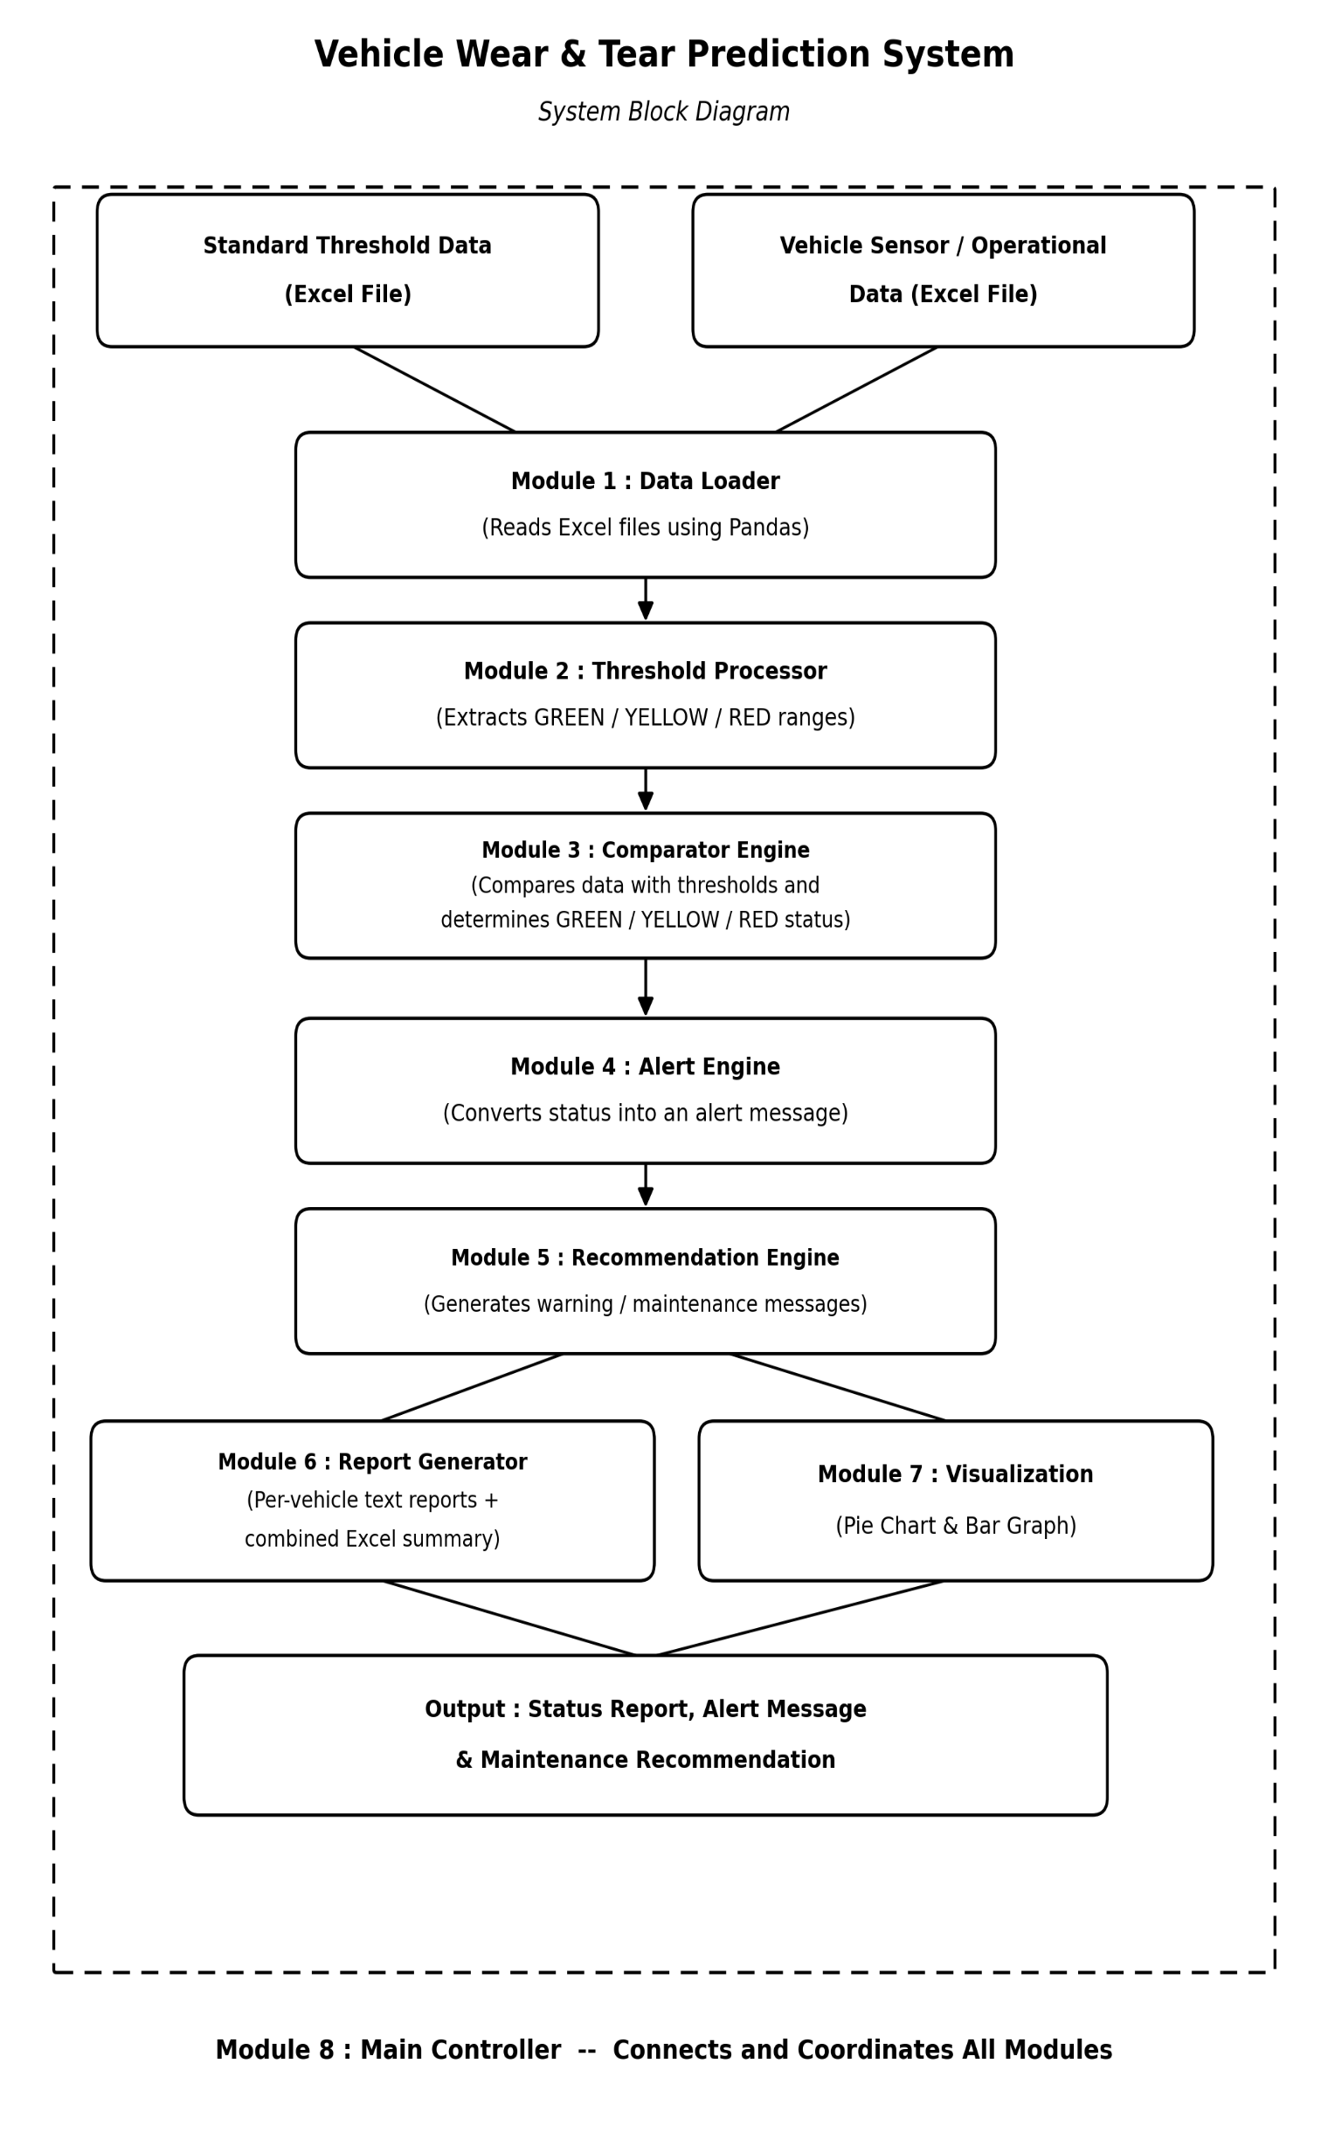
Figure 1. System Block Diagram
5. Module Description
The system is organized into eight independent modules, each responsible for a specific part of the data flow, as summarized below.
Module No. | Module Name | Responsibility
Module 1 | Data Loader | Read both Excel files using Pandas
Module 2 | Threshold Processor | Extract GREEN / YELLOW / RED ranges
Module 3 | Comparator Engine | Compare vehicle data with thresholds
Module 4 | Alert Engine | Generate GREEN / YELLOW / RED status
Module 5 | Recommendation Engine | Generate warning / maintenance messages
Module 6 | Report Generator | Generate Vehicle Service Card (Excel)
Module 7 | Visualization | Pie Chart & Bar Graph
Module 8 | Main Controller | Connect all modules together

6. Working Principle
The system works in the following steps:
- Store Standard Values — An Excel file contains the standard operating limits for different vehicle parameters such as Engine Temperature, Engine Oil Life, Brake Pad Wear, Battery Voltage, Coolant Temperature and Vehicle Mileage.
- Collect Vehicle Data — Another Excel file stores the actual sensor readings collected from the vehicle (or sample data).
- Compare the Data — The Python program reads both Excel files and compares the actual values with the standard limits.
- Analyzing the Condition — Based on the comparison, the system decides whether each component is in good condition or needs attention.
- Generate Alerts — The system displays maintenance alerts depending on the condition of each component.

7. Alert Levels
The system uses three alert levels to make the vehicle's condition easy to understand:
Alert Level | Meaning | Example | Action
GREEN | Healthy — values within safe range | Engine Temperature = 90°C | No maintenance required
YELLOW | Service recommended soon | Battery Voltage = 12.1V | Plan servicing soon
RED | Immediate service required | Brake Pad Wear = 90% | Immediate servicing needed

8. Vehicle Parameters Monitored
The system checks the following parameters:
1. Engine Temperature
2. Engine Oil Life (%)
3. Engine Oil Temperature
4. Front Brake Pad Wear (%)
5. Rear Brake Pad Wear (%)
- Brake Fluid Condition
- Battery Voltage
- Battery Charging Voltage
- Vehicle Mileage
- Engine RPM
- Coolant Temperature
- Engine Operating Hours

9. Technology Stack
The following Python libraries are used to build the system:
Library | Purpose
pandas | Read Excel files
openpyxl | Excel support
matplotlib | Pie Chart & Bar Graph
seaborn | Styled bar graph visualisation

10. Expected Output
After analyzing the data, the system displays:
- Vehicle ID
- Green, Yellow, or Red alert
- Overall Vehicle Health Score
- Maintenance recommendations
- Service priority level
- Alert Messages
Vehicle ID: CAR_004
Status: YELLOW
Alert: Service Recommended
Recommendation: Schedule Service Within 7 Days

11. Benefits of the System
- Detects maintenance needs at an early stage.
- Reduces unexpected vehicle breakdowns.
- Improves vehicle safety and reliability.
- Helps plan maintenance more effectively.
- Reduces the risk of major component damage.
- Uses simple color-based alerts that are easy to understand.

12. Future Scope
The project can be improved by adding:
- Real-time data collection from the vehicle's CAN Bus.
- Direct connection with the vehicle's ECU.
- Machine learning for predicting component wear.
- Email and mobile app notifications.
- Cloud-based monitoring dashboard.
- Service history tracking and performance analysis.

Conclusion
The Vehicle Wear & Tear Prediction System helps monitor important vehicle parameters and compares them with standard operating limits. It classifies the condition of each component as Green, Yellow, or Red and provides maintenance recommendations accordingly.
This project demonstrates how Python, Excel, and data analysis can be used to create a simple and effective vehicle maintenance system that improves reliability, safety, and maintenance planning.

