Project Report

DRIVER MONITORING SYSTEM DATA ANALYSIS TOOL
Presented By
- Prajwal Phalke
- Vanshita Sonule
- Afreen Ansari

1. Project Title
Driver Monitoring System (DMS) Data Analysis Tool
DMS is a Python tool that reads driver-behaviour sensor data and automatically generates a driver safety report.
2. Project Overview
What it does: DMS reads eye closure, blink rate, head pitch and yawning readings for 5 drivers from an Excel file, calculates an Attention Score for every driver in every shift, ranks the drivers from safest to riskiest, and generates a Word (and PDF) report of the results.
Purpose: To replace manual checking of driver fatigue data with an automatic, consistent, and easy-to-share safety report — useful for a fleet manager to quickly see which driver or shift needs attention.
The project has 5 Python files working together:
- main.py — runs the whole program, step by step.
- loader.py — reads and validates the Excel dataset.
- evaluator.py — calculates the weighted attentiveness scores and ranking.
- report.py — builds the Word report with tables and charts.
- word_to_pdf.py — converts the finished Word report into a PDF.
3. Project Flow Diagram
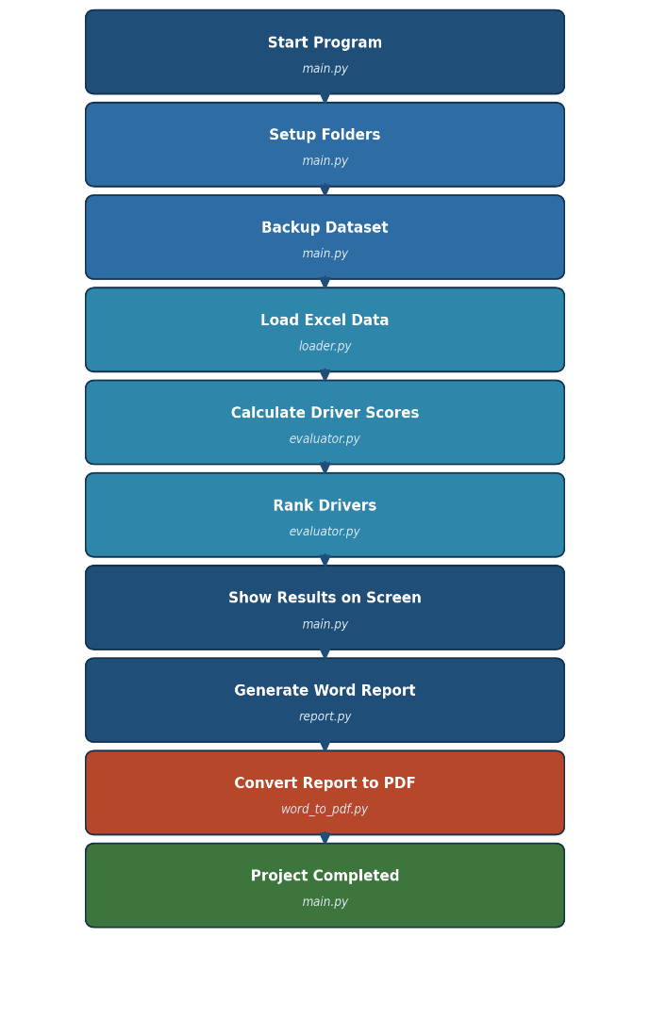
The diagram below shows the step-by-step execution flow, from running main.py to the final Word + PDF report being saved on disk.

4. Project Execution — File-by-File Breakdown
This section documents every source file: its purpose, its functions, and what each one does. All descriptions are based on a direct reading and an actual dry run of the provided code.
4.1 main.py — Entry Point / Orchestrator
Purpose: The file the user runs (python main.py). Prepares folders, triggers backup, runs the scoring pipeline, prints results, and builds the Word + PDF report.
Function | What it does
create_folders() | Creates the data/, reports/ and backup/ folders if they don't exist.
backup_dataset(file_path) | Copies the Excel dataset into backup/ before it's used, skipping quietly if the file is missing or locked.
show_driver_results(ranking) | Prints a clean console table of all 5 drivers' overall score/status, then highlights the single best driver.
main() | Runs everything in order: folders → backup → load data → score drivers → rank → print results → build Word report → convert it to PDF → print file locations.
Step-by-Step Working
- Step 1: Create the data/, reports/ and backup/ folders if they don't already exist.
- Step 2: Back up the Excel dataset into the backup/ folder.
- Step 3: Load the dataset — stop the program here if it fails to load.
- Step 4: Calculate the weighted Attention Score for every driver/shift.
- Step 5: Rank all 5 drivers by their overall score.
- Step 6: Print the ranking table and the best driver to the console.
- Step 7: Build the Word report (tables + 19 charts) and save it.
- Step 8: Convert the saved Word report into a matching PDF.
- Step 9: Print the Word and PDF file locations — 'PROJECT COMPLETED'.
If/Else Conditions Used in main.py
Condition (in code) | Purpose
if not os.path.exists(file_path) | Skip the backup step if the dataset file isn't found.
try / except PermissionError | Avoid crashing if the backup file is locked/open.
if data is None | Stop the program if the dataset failed to load.
if pdf_report is not None | Only print a PDF location if the PDF was actually created.
if __name__ == "__main__" | Run main() only when the file is executed directly.

4.2 modules/loader.py — DataLoader class
Purpose: Safely reads and validates the Excel dataset before anything else runs.
Function | What it does
show_excel_sheets() | Opens the workbook and prints the names of every sheet it contains.
load_data() | Checks the file exists, reads the 'Driver Monitoring Data' sheet, checks that all 9 required columns are present, converts the 6 numeric columns properly (turning bad/text values into blanks), fills any remaining blanks with 0, then returns the cleaned data.
If/Else Conditions Used in load_data()
Condition (in code) | Purpose
if not os.path.exists(self.file_path) | Stop and report an error if the Excel file itself is missing.
if missing (required columns check) | Stop if any of the 9 expected columns aren't in the sheet — prevents the rest of the program from crashing later.
pd.to_numeric(..., errors="coerce") | Any non-numeric/corrupt reading in a sensor column becomes blank instead of crashing the load.
data[numeric] = data[numeric].fillna(0) | Any remaining blank sensor readings are treated as 0 rather than being dropped.
try / except Exception | Catches any other read error and reports it instead of crashing.
4.3 modules/evaluator.py — DriverEvaluator class
Purpose: The scoring engine. Converts the 4 raw sensor readings into a single weighted 0–100 Attention Score per driver/shift, then ranks all drivers.
Function | What it does
eye_score / blink_score / head_score / yawn_score | Each converts one raw sensor reading into its own 0–100 sub-score using fixed value ranges (see formula below).
status(score) | Converts a score into a label: Attentive (≥85), Moderately Attentive (≥70), or Inattentive (below 70).
recommendation(status) | Returns a one-line suggestion matching the status (e.g. 'Take a short break').
calculate_row_scores() | Applies all 4 sub-score functions to every row, then combines them into the weighted Attention_Score for that row.
calculate_scores() | Groups the scored rows by driver + shift and averages them into one row per driver/shift, with a Status and Recommendation.
create_ranking(driver_report) | Averages each driver's shifts into one Overall_Score, sorts drivers from best to worst, and assigns Rank 1–5.
Scoring Formula Used
Every reading is first converted into its own 0–100 sub-score, using fixed thresholds:
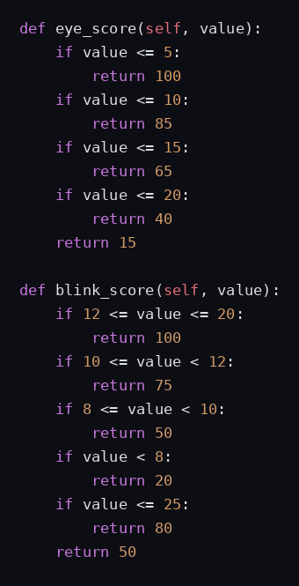
Actual code — Eye Closure and Blink Rate sub-scores (modules/evaluator.py)
- Why eye_score is written this way: eye closure % is the most direct sign of drowsiness — the longer the eyes stay shut, the closer the driver is to falling asleep. So the code scores it in falling steps (5/10/15/20%): a small closure barely matters, but every step past that drops the score faster, since risk grows quickly once eyes start staying shut.
- Why blink_score is written this way: a healthy driver blinks at a steady 12–20 times/minute. Blinking much slower is a classic drowsiness sign, so it's scored low. But blinking too fast can mean strain or distraction, so very high rates aren't scored perfectly either — this is why the code checks a range (12–20) instead of just one direction.
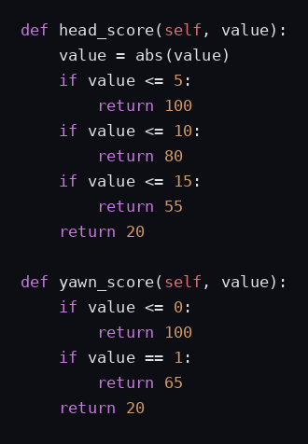
Actual code — Head Pitch and Yawning sub-scores (modules/evaluator.py)
- Why head_score is written this way: a driver's head tilts down or to the side when they're nodding off, so abs(value) is used — the direction of the tilt doesn't matter, only how far off-centre the head is. Bigger tilt = more likely they're dozing, so the score drops faster the more it exceeds normal posture.
- Why yawn_score is written this way: yawning is a strong, unmistakable fatigue signal, so the score is written to fall sharply — even a single yawn (score 65) is treated as a real warning, not a minor deduction, because by the time a driver yawns, fatigue is already noticeable.
The 4 sub-scores are then combined using fixed weights to get the final Attention Score, which decides the status:
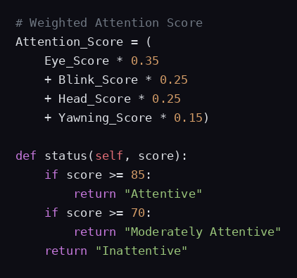
Actual code — Final weighted score and status (modules/evaluator.py)
Why these particular weights: not every reading is an equally reliable sign of fatigue, so the code doesn't treat them equally.
- Eye Closure — 35% weight — the biggest factor; it's the single most reliable physical sign of drowsiness, so it drives the score the most.
- Blink Rate — 25% weight — a strong supporting signal to eye closure, so it's weighted second-highest alongside Head Pitch.
- Head Pitch — 25% weight — equally important, since a drooping head is an easy, visible confirmation of fatigue.
- Yawning — 15% weight — kept lowest only because yawning happens less often in the data than the other 3 readings, even though each yawn is treated harshly by yawn_score itself.
Unlike a penalty system, every reading always contributes something — there's no '0 deduction' case, so the final score is a smooth blended average, not a start-at-100-and-subtract number. This is why the formula reads as an addition of weighted parts rather than 100 minus a list of penalties.
4.4 modules/report.py — WordReport class
Purpose: The presentation layer. Turns the scored data into a fully formatted Word document with a running header/footer, 9 tables, and 19 charts.
Function | What it does
__init__ / prepare_status_data() | Sets up the document (header, footer, font), and splits each shift's score into an Attentiveness_Score (Eye+Head) and Alertness_Score (Blink+Yawn) for extra detail.
cover_page() / executive_summary() / dashboard() | Build the title page, a one-line scoring summary, and a dashboard table of fleet-wide totals/averages.
all_driver_shift_status() | Builds one big table listing every driver's every shift with Attentiveness, Alertness and Overall scores/status side by side.
driver_summary() | Builds the final ranking table (Rank, Driver, Overall, Status, and all 4 component scores).
create_overall_charts() | Generates the 4 fleet-wide charts: ranking bar, driver comparison bar, all-drivers-all-shifts line chart, and component comparison chart.
overall_driver_comparison() | Adds a best/worst driver & shift summary table, then embeds the 4 fleet-wide charts.
create_driver_charts() / driver_analysis() | For every driver: builds a per-shift table plus 3 charts (score trend, component scores, raw sensor trend), one dedicated subsection each.
conclusion() | Auto-writes a closing paragraph naming the best/worst driver and shift, using the real numbers from this run.
generate_report() | Runs all the above in order, backs up any existing report first, saves the .docx, deletes temporary chart files, and returns the file path.

4.5 word_to_pdf.py — PDF Export
Purpose: Takes the finished Word report and exports a matching PDF, using Microsoft Word itself via Windows automation (pywin32).
Function | What it does
convert_word_to_pdf(word_file) | Opens the Word file in the background using MS Word, exports it as a PDF next to the original, then closes Word again.
If/Else Conditions Used
Condition (in code) | Purpose
if not os.path.isfile(word_path) | Stop if the Word file to convert can't be found.
except ImportError | If pywin32 isn't installed (e.g. on Mac/Linux), print instructions instead of crashing.
except Exception | Catches any other conversion error (e.g. Word not installed) and reports it safely.
finally: close Word / quit application | Always closes the Word document and application, even if the conversion failed.
Note: this only works on Windows with Microsoft Word installed. On Mac/Linux (or without pywin32), the program still completes normally — it just skips the PDF and keeps the Word file.
4.6 Supporting Files
File / Folder | Purpose
data/DMS_Final_Workbook_Final.xlsx | The source dataset — 300 rows across 5 drivers, read from its 'Driver Monitoring Data' sheet.
backup/ | Auto-filled with a fresh dataset copy every run, plus a timestamped copy of the previous Word report each time a new one is generated.
reports/ | Holds the current Analysis_Report.docx (and its .pdf, when PDF export succeeds).
modules/analyzer.py | Legacy file — still contains a DataAnalyzer class, but it is no longer imported or called anywhere in the current project.
modules/__pycache__/, __pycache__/ | Auto-generated compiled Python bytecode; not source code, safe to ignore/delete.
5. Program Output — Dry Run Results
The project was run successfully on the real dataset (300 records, 5 drivers). It produces 3 outputs: console summary text, a backup Excel file, and a Word report (plus a PDF, on Windows).
5.1 Console Output
On loading, the program confirms the sheet names and record count, then prints the driver ranking straight away:
Rank | Driver | Overall Score | Status
1 | Rahul | 100.00 | Attentive
2 | Priya | 97.02 | Attentive
3 | Aman | 93.95 | Attentive
4 | Neha | 86.16 | Attentive
5 | Arjun | 63.43 | Inattentive
Result: Rahul is the best driver overall (100.00/100, Attentive). Arjun is the only Inattentive driver, mainly dragged down by a poor Night shift.
5.2 Excel Backup
A copy of the dataset is auto-saved to backup/DMS_Dataset_Backup.xlsx on every run, so the original file is never lost.
5.3 Word Report (reports/Analysis_Report.docx)
The main deliverable — a formatted report with tables and charts. Sample pages from the actual generated file:
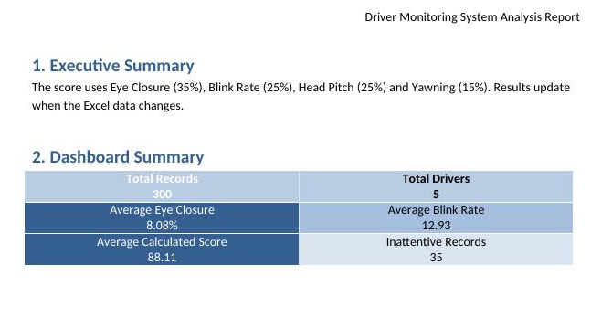
Sample output — Executive Summary and Dashboard Summary
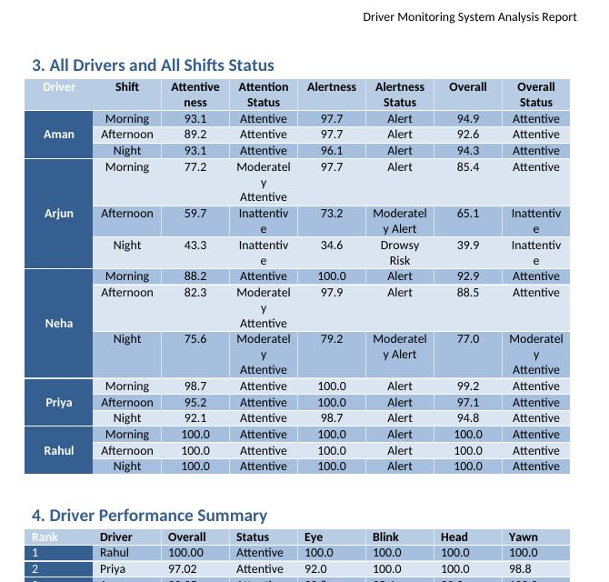
Sample output — All Drivers and All Shifts Status, and Driver Performance Summary

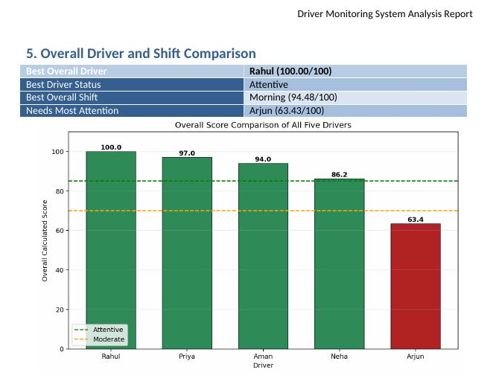
Sample output — Overall Driver and Shift Comparison charts
6. Chart & Table Reference — What Each Output Specifies
A short explanation of what each table and chart in the report tells you.
6.1 Data Tables
Table | What it tells you
Dashboard Summary | Fleet-wide totals and averages — records, drivers, eye closure, blink rate, score, inattentive count.
All Drivers and All Shifts Status | Every driver's every shift, with Attentiveness, Alertness and Overall scores side by side.
Driver Performance Summary (Ranking) | Ranks all 5 drivers from best to worst by Overall Score.
Overall Driver and Shift Comparison | Names the single best/worst driver and best/worst shift in one glance.
Per-Driver Shift Table | One driver's full breakdown across Morning/Afternoon/Night, with every component score.
6.2 Charts in the Word Report
Chart | What it tells you
Overall Score Bar Comparison | Quick leaderboard of all 5 drivers' overall scores, colour-coded by status.
Overall Driver Attentiveness Ranking (horizontal bar) | Same ranking, sorted top to bottom for easy reading.
All Drivers and All Shifts (line chart) | Shows every driver's score trend across the day in one chart — easiest way to spot who declines by Night.
Component Comparison (bar chart) | Compares each driver's 4 sub-scores (Eye/Blink/Head/Yawn) side by side.
Calculated Attention Score by Shift (per driver) | One driver's score trend across their 3 shifts.
Calculated Component Scores (per driver) | One driver's 4 sub-scores plotted across their shifts.
Sensor Parameter Trend (per driver) | The driver's raw, un-scored sensor readings across shifts, for reference.
7. Libraries Used & Their Purpose
Every library actually imported in the code, where it's used, and why.
Library | Used in | Purpose in this project
pandas | loader.py, evaluator.py, report.py | Reads the Excel sheet, cleans the numeric columns, and powers every groupby/aggregation used to build the scores and ranking.
numpy | evaluator.py | Used to detect and round the numeric columns in the ranking table.
openpyxl | loader.py | The engine pandas uses to read the .xlsx file and list its sheet names.
matplotlib (pyplot) | report.py | Draws all 19 charts — the 4 fleet-wide charts and the 3 per-driver charts × 5 drivers.
python-docx (docx) | report.py | Builds the Word document: headings, header/footer, styled tables, and embeds every chart image.
pywin32 (win32com.client) | word_to_pdf.py | Automates Microsoft Word (Windows only) to export the finished report as a PDF. Optional — the program still works without it.
os | main.py, loader.py, report.py, word_to_pdf.py | Standard library — creates folders and checks whether files exist before acting on them.
shutil | main.py, report.py | Standard library — copies the dataset and old reports into backup/.
datetime | report.py | Standard library — builds the timestamped backup filenames.
Three groups: pandas/numpy/openpyxl handle data loading and scoring, matplotlib handles the 19 charts, and python-docx + pywin32 (with os/shutil/datetime) turn everything into a shareable Word and PDF report.
8. Conclusion
The Driver Monitoring System successfully automates the full journey from raw sensor readings to a decision-ready safety report. It reads eye closure, blink rate, head pitch and yawning data for 5 drivers, converts each reading into a weighted 0–100 Attention Score (35% Eye, 25% Blink, 25% Head, 15% Yawning), and ranks every driver from safest to riskiest — with no manual spreadsheet work needed.
The code was dry-run in full while preparing this documentation and completed without errors, correctly scoring all 300 records for 5 drivers and producing a 19-chart Word report. On this run, Rahul was the safest driver (100/100, Attentive) and Arjun needed the most attention (63.43/100, Inattentive), driven mainly by a weak Night shift — showing the scoring model correctly separates safe driving from risky driving.
More than just a report generator, this project shows how simple sensor data can be turned into meaningful, actionable safety decisions — replacing guesswork with a consistent, repeatable scoring method that anyone can run in a few seconds.

