DRIVER MONITORING SYSTEM
Driver Attention Analysis Report
Generated Using Python
20 July 2026, 09:51 AM

1. Executive Summary
This report analyses driver attention across Morning, Afternoon and Night shifts. The analysis uses eye closure, blink rate, yawning, head pitch, driving duration and travel distance.

2. Dashboard Summary
Total Records  300 | Total Drivers  5
Average Eye Closure  8.04% | Average Blink Rate  12.93
Average Distance  26.70 km | Average Yawning  0.11

3. Driver Performance Summary
Rank | Driver | Score | Status | Distance | Yawns
1 | Rahul | 100.00 | Safe | 104.78 km | 0
2 | Priya | 100.00 | Safe | 104.31 km | 2
3 | Aman | 100.00 | Safe | 107.12 km | 0
4 | Neha | 86.00 | Safe | 105.36 km | 4
5 | Arjun | 54.00 | At Risk | 103.80 km | 26
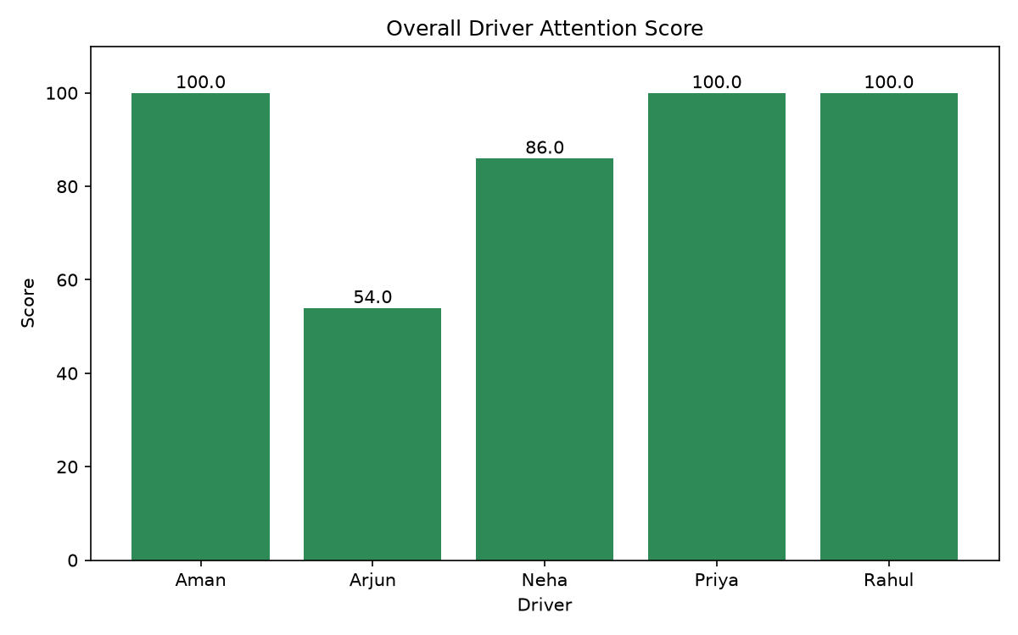
Overall Driver Attention Score

4. Individual Driver Analysis

4.1 Aman
Driver ID: D003 | Overall Score: 100.00 | Status: Safe
Shift | Score | Status | Duration | Distance | Eye Closure | Blink Rate
Morning | 100 | Safe | 20 min | 18.13 km | 5.58% | 12.85
Afternoon | 100 | Safe | 20 min | 35.65 km | 6.37% | 13.10
Night | 100 | Safe | 20 min | 53.34 km | 5.69% | 13.00
Observation: Excellent performance across all shifts.
Recommendation: Continue safe driving.

Driver Performance Charts
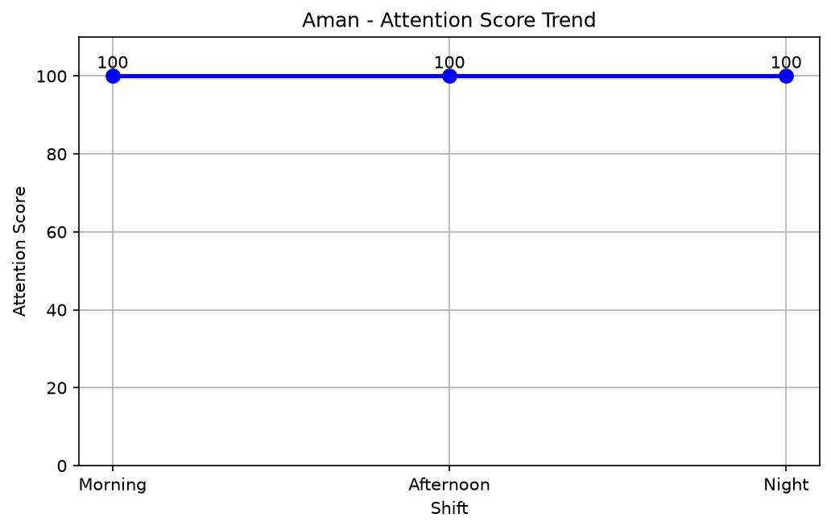
Line Chart: Attention Score Trend
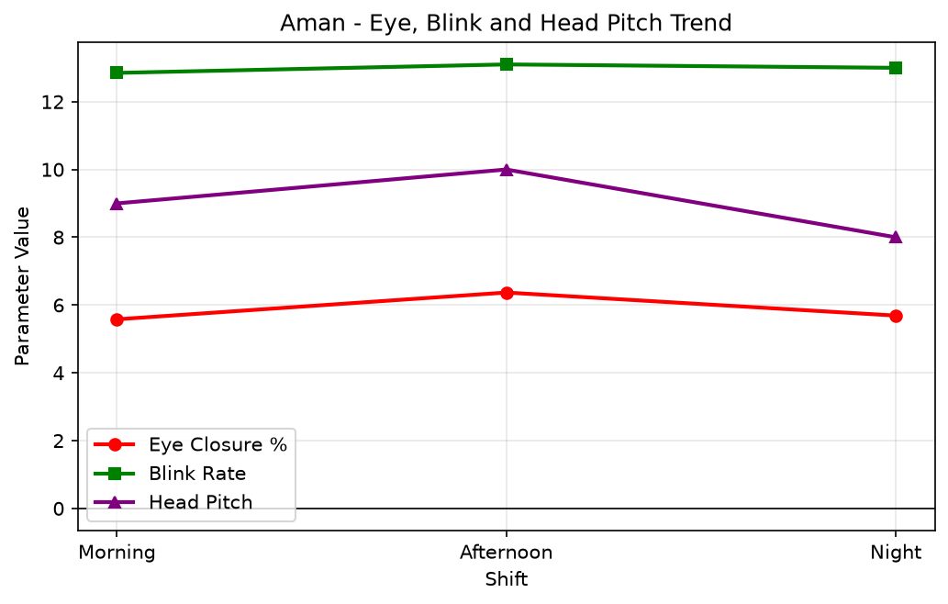
Line Graph: Eye Closure, Blink Rate and Head Pitch
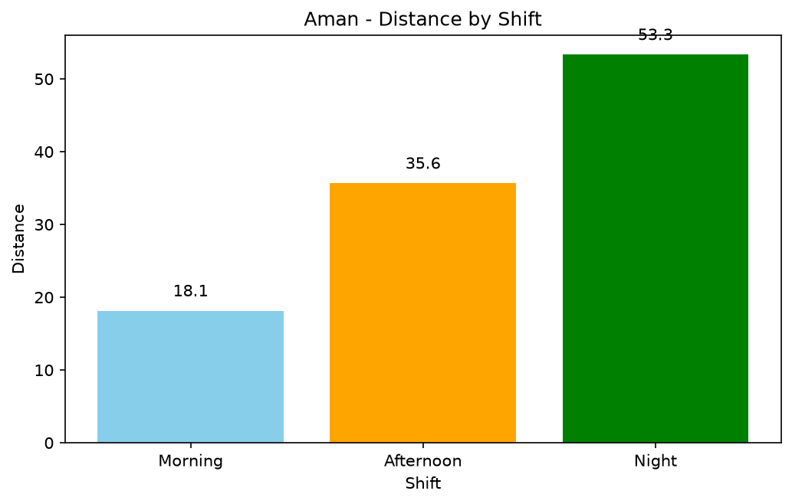
Bar Chart: Distance by Shift
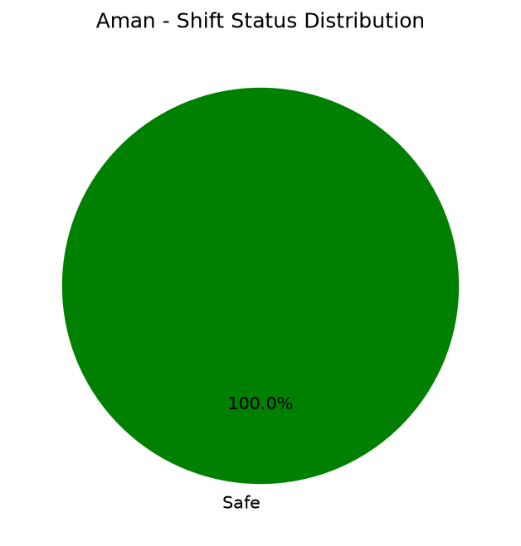
Pie Chart: Shift Status Distribution

4.2 Arjun
Driver ID: D005 | Overall Score: 54.00 | Status: At Risk
Shift | Score | Status | Duration | Distance | Eye Closure | Blink Rate
Morning | 85 | Safe | 20 min | 17.55 km | 8.56% | 12.65
Afternoon | 50 | At Risk | 20 min | 34.28 km | 15.76% | 9.35
Night | 27 | At Risk | 20 min | 51.97 km | 22.80% | 6.05
Observation: High fatigue risk during the Night shift.
Recommendation: Stop and take sufficient rest.

Driver Performance Charts
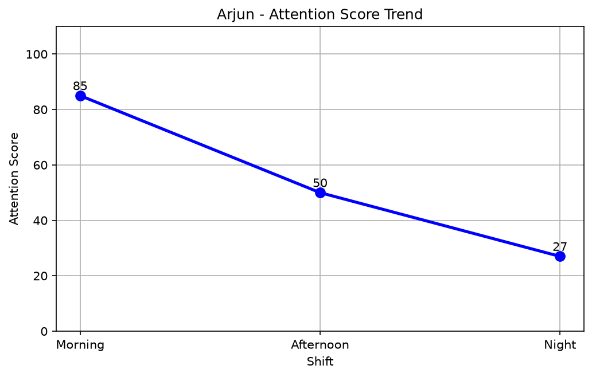
Line Chart: Attention Score Trend
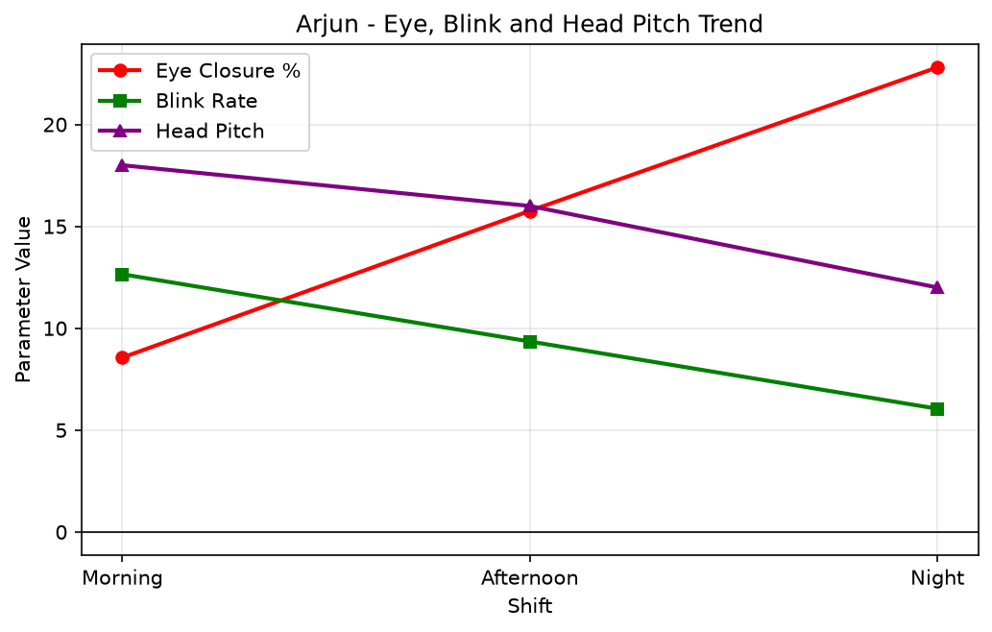
Line Graph: Eye Closure, Blink Rate and Head Pitch
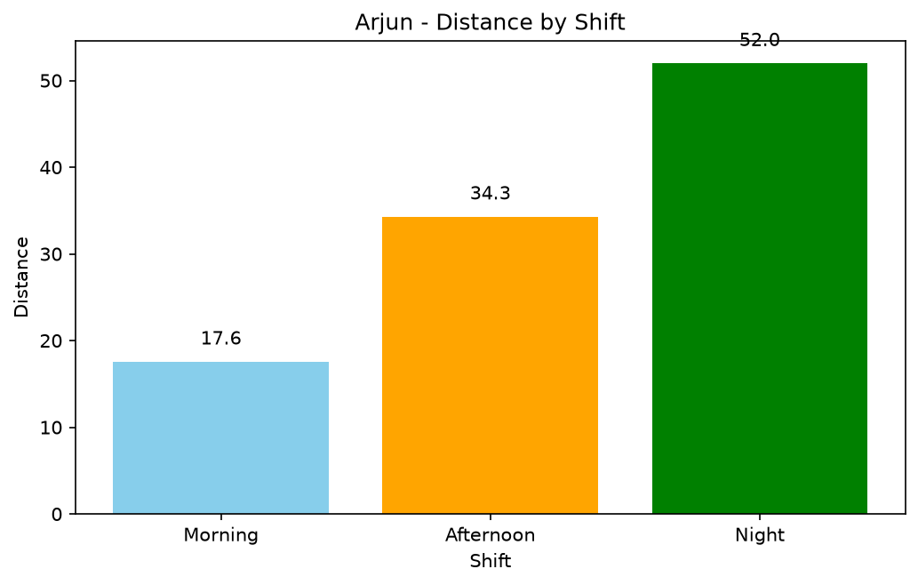
Bar Chart: Distance by Shift
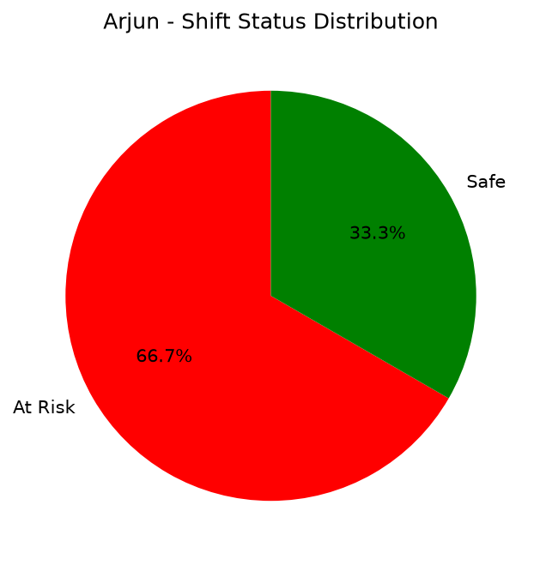
Pie Chart: Shift Status Distribution

4.3 Neha
Driver ID: D004 | Overall Score: 86.00 | Status: Safe
Shift | Score | Status | Duration | Distance | Eye Closure | Blink Rate
Morning | 92 | Safe | 20 min | 17.98 km | 5.97% | 15.10
Afternoon | 92 | Safe | 20 min | 35.16 km | 9.38% | 12.65
Night | 74 | Moderately Alert | 20 min | 52.22 km | 13.08% | 10.10
Observation: The Night shift needs additional attention.
Recommendation: Take scheduled breaks.

Driver Performance Charts
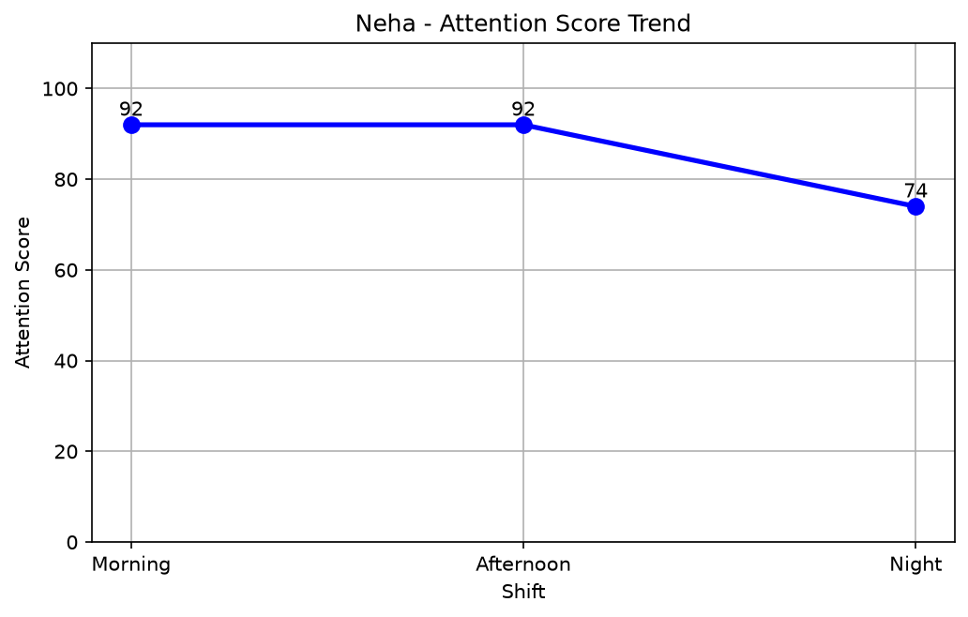
Line Chart: Attention Score Trend
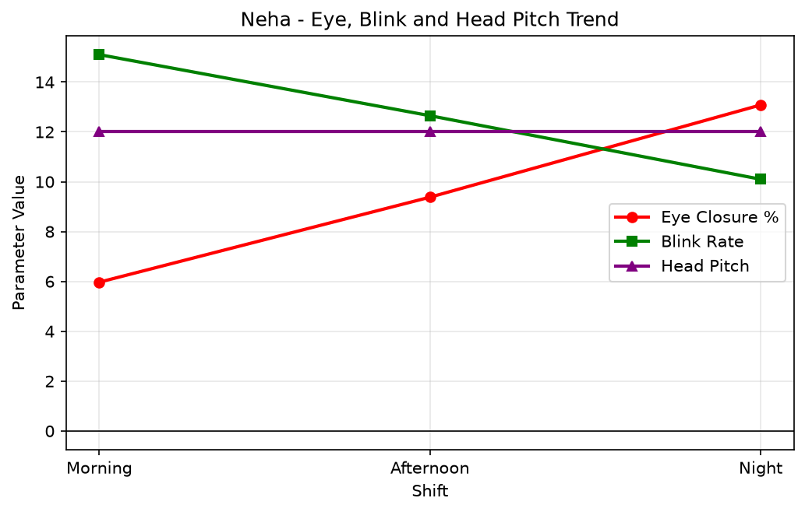
Line Graph: Eye Closure, Blink Rate and Head Pitch
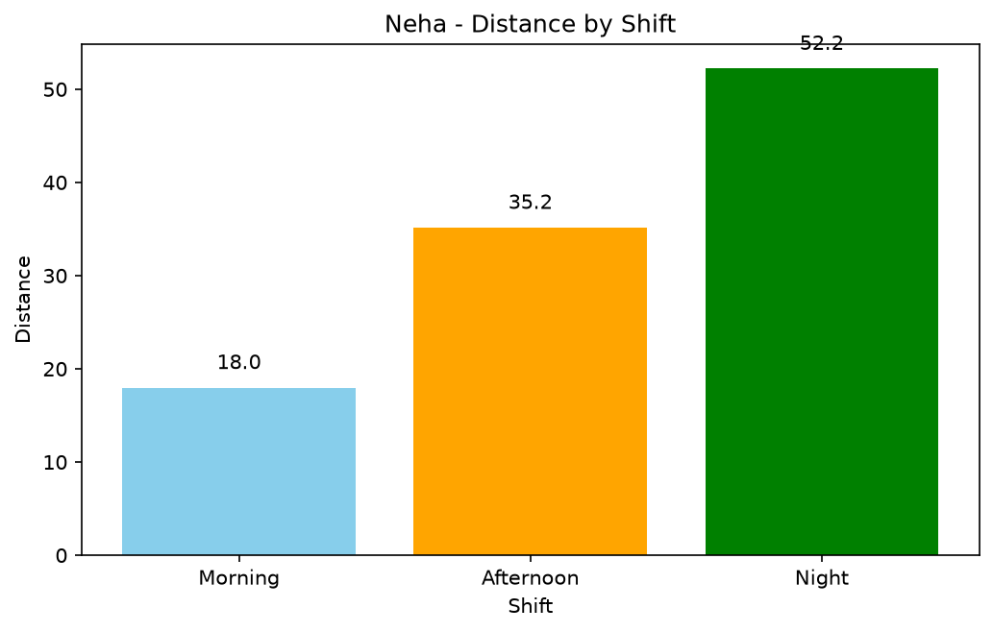
Bar Chart: Distance by Shift
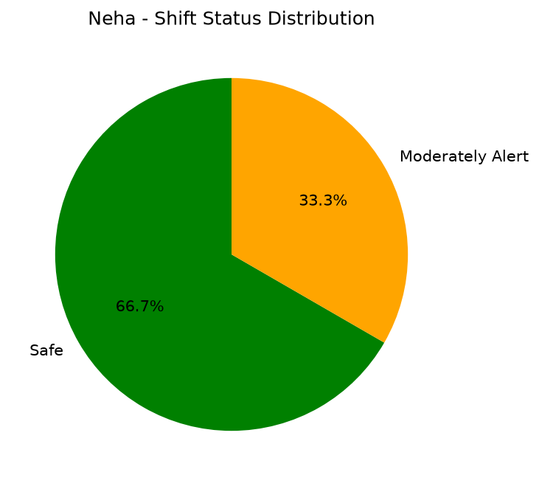
Pie Chart: Shift Status Distribution

4.4 Priya
Driver ID: D002 | Overall Score: 100.00 | Status: Safe
Shift | Score | Status | Duration | Distance | Eye Closure | Blink Rate
Morning | 100 | Safe | 20 min | 17.65 km | 4.66% | 13.25
Afternoon | 100 | Safe | 20 min | 34.81 km | 5.49% | 13.70
Night | 100 | Safe | 20 min | 51.85 km | 6.45% | 14.05
Observation: Excellent performance across all shifts.
Recommendation: Continue safe driving.

Driver Performance Charts
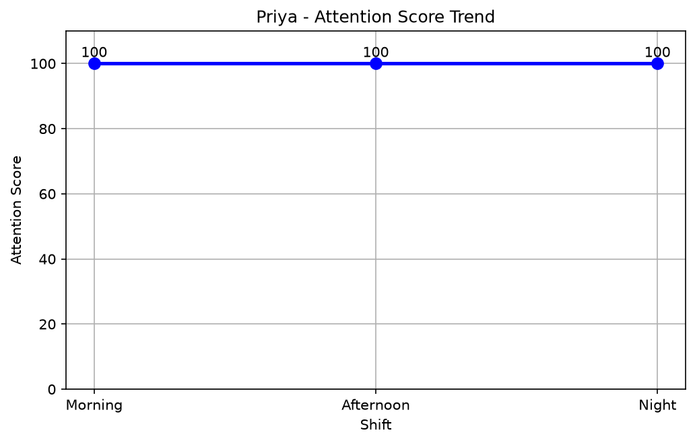
Line Chart: Attention Score Trend
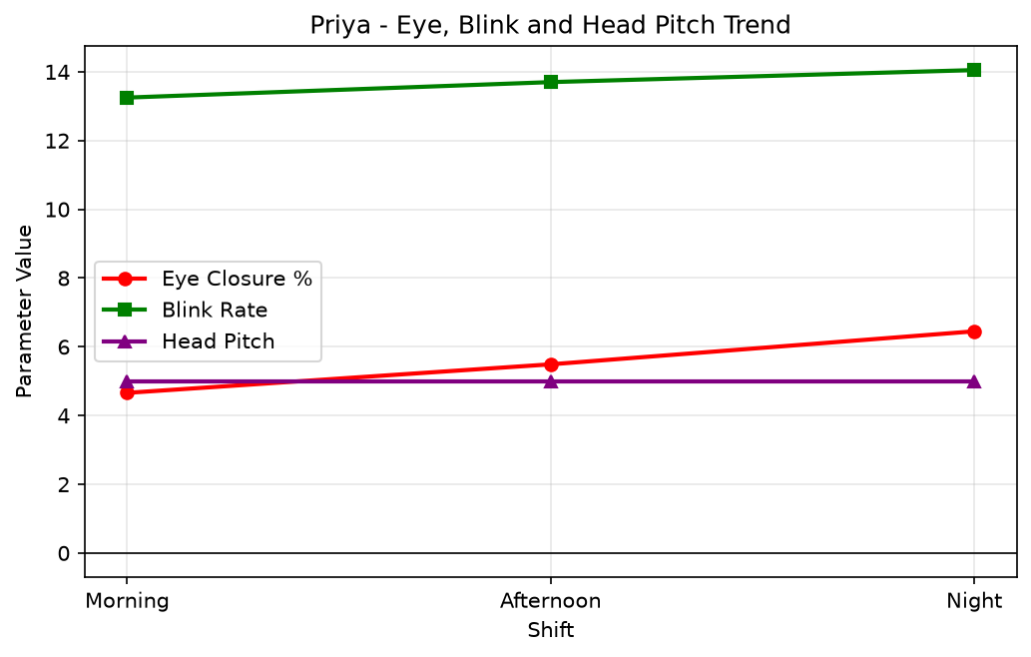
Line Graph: Eye Closure, Blink Rate and Head Pitch
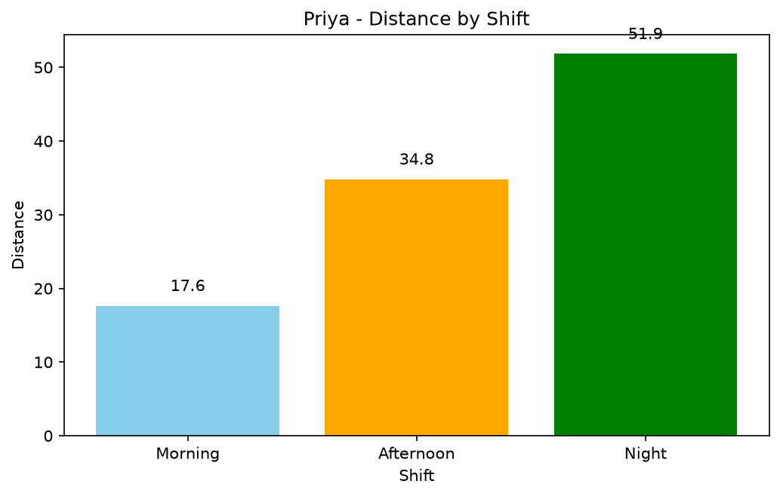
Bar Chart: Distance by Shift
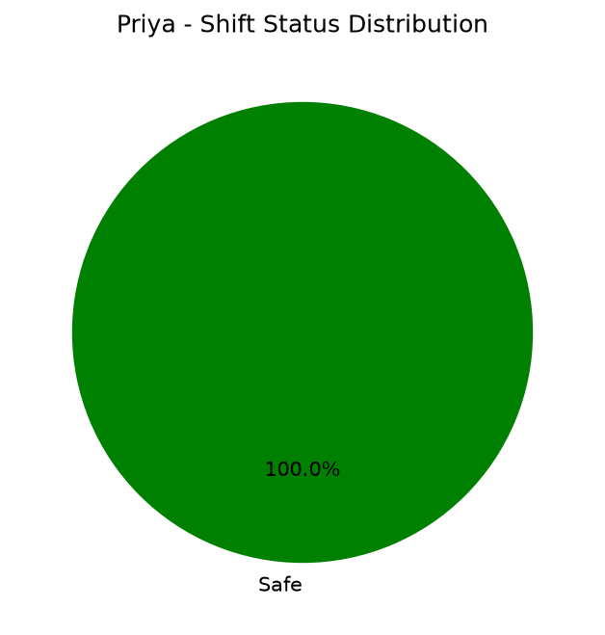
Pie Chart: Shift Status Distribution

4.5 Rahul
Driver ID: D001 | Overall Score: 100.00 | Status: Safe
Shift | Score | Status | Duration | Distance | Eye Closure | Blink Rate
Morning | 100 | Safe | 20 min | 17.32 km | 3.80% | 16.20
Afternoon | 100 | Safe | 20 min | 34.70 km | 3.79% | 16.05
Night | 100 | Safe | 20 min | 52.76 km | 3.26% | 15.90
Observation: Excellent performance across all shifts.
Recommendation: Continue safe driving.

Driver Performance Charts
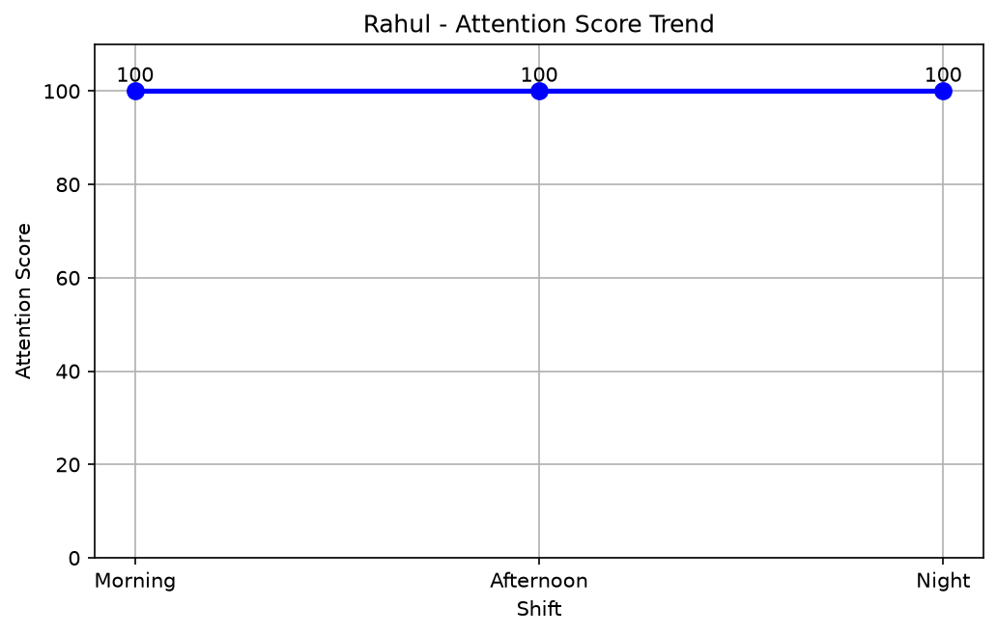
Line Chart: Attention Score Trend
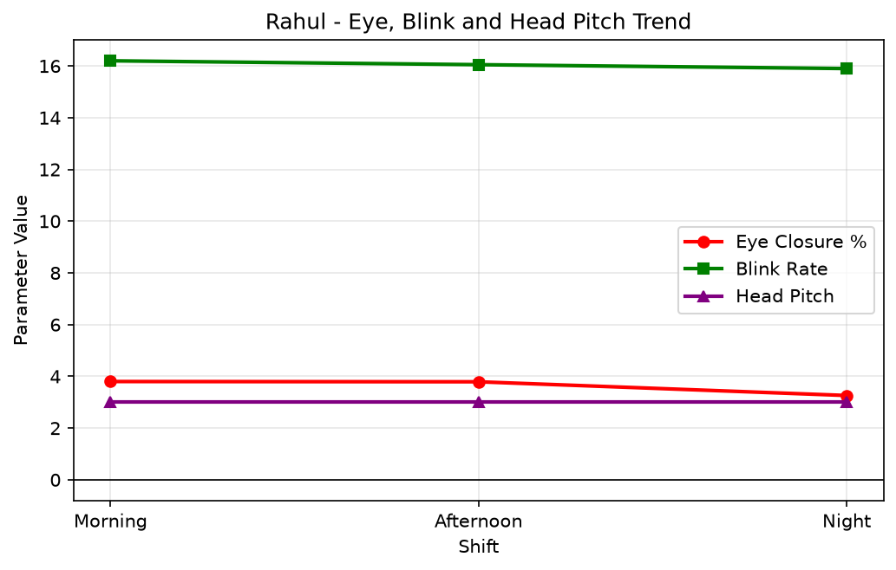
Line Graph: Eye Closure, Blink Rate and Head Pitch
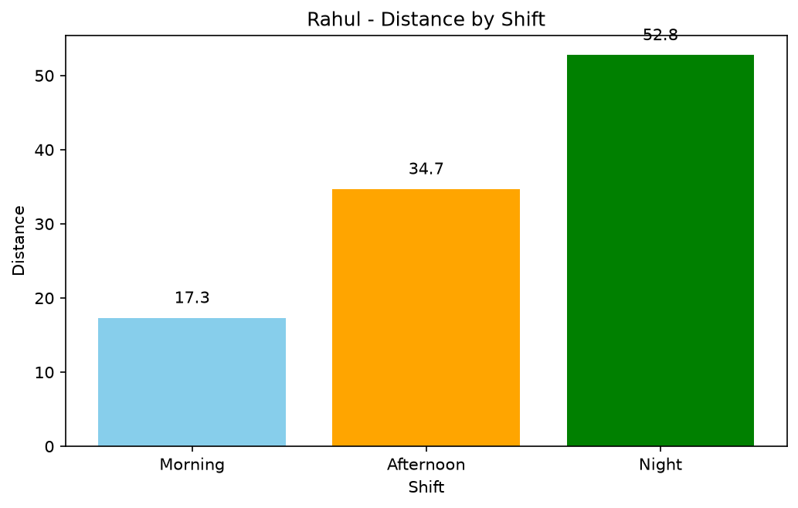
Bar Chart: Distance by Shift
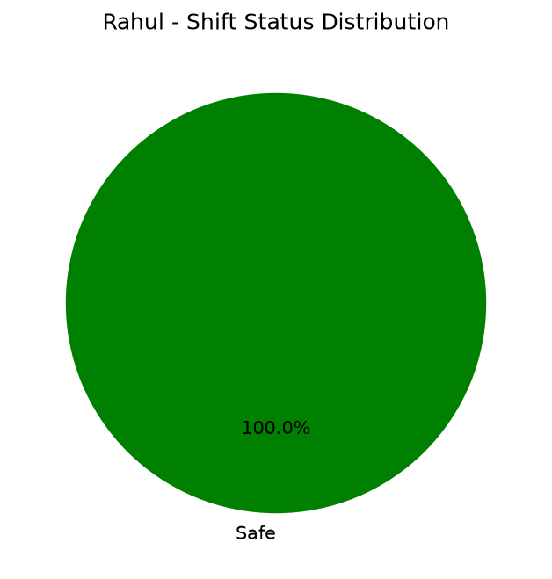
Pie Chart: Shift Status Distribution

5. Overall Graphical Analysis
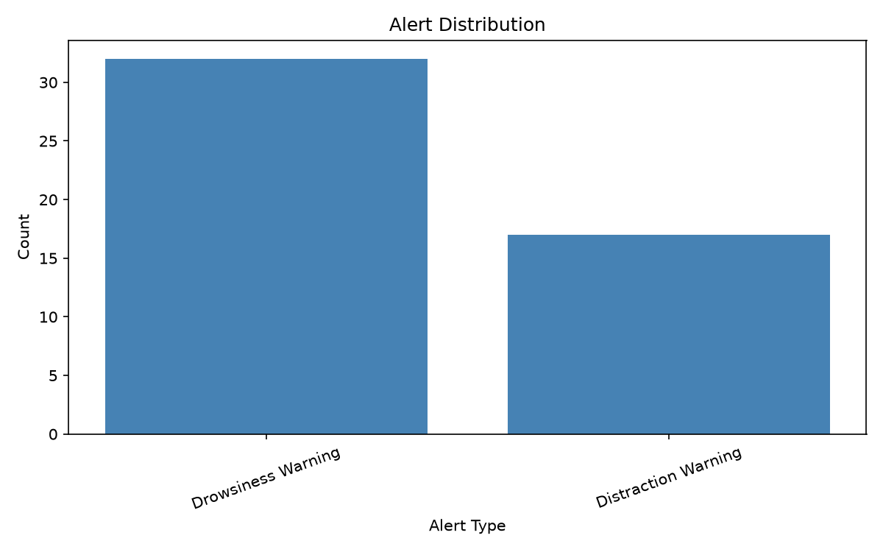
Alert Distribution
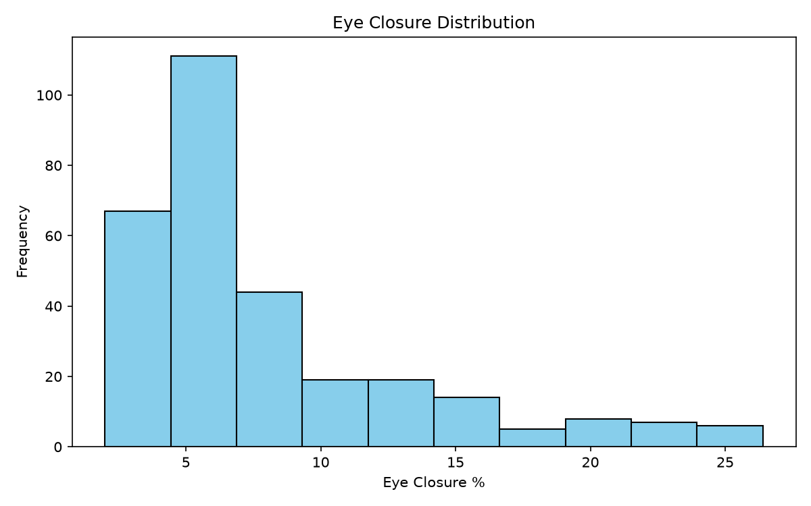
Eye Closure Histogram
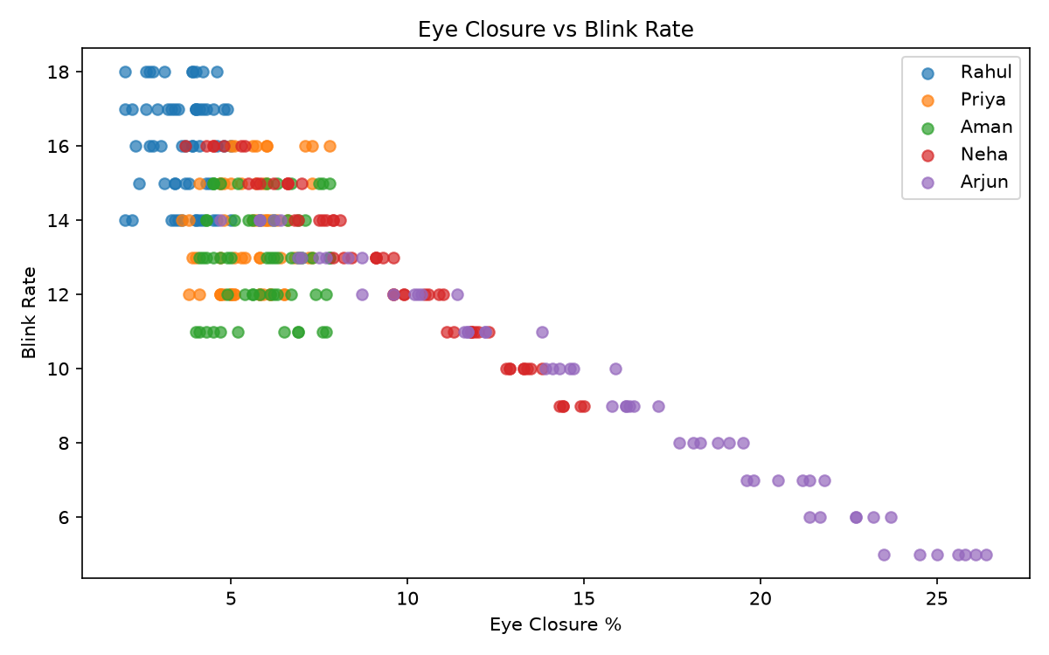
Eye Closure vs Blink Rate
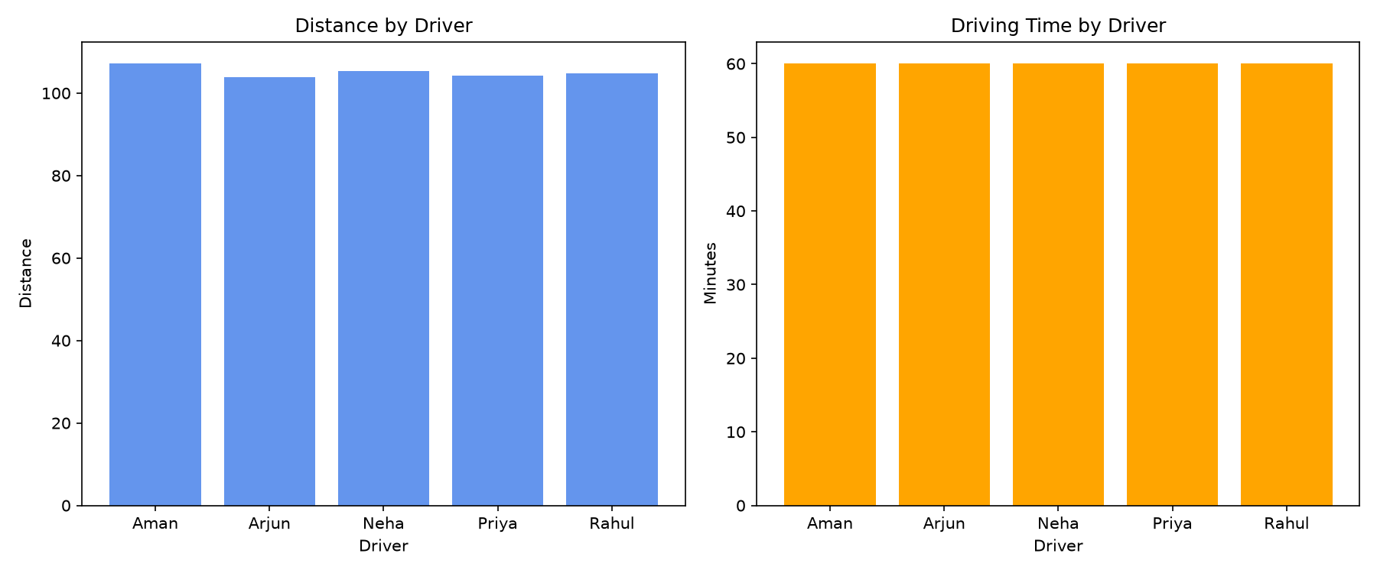
Distance and Time Subplots
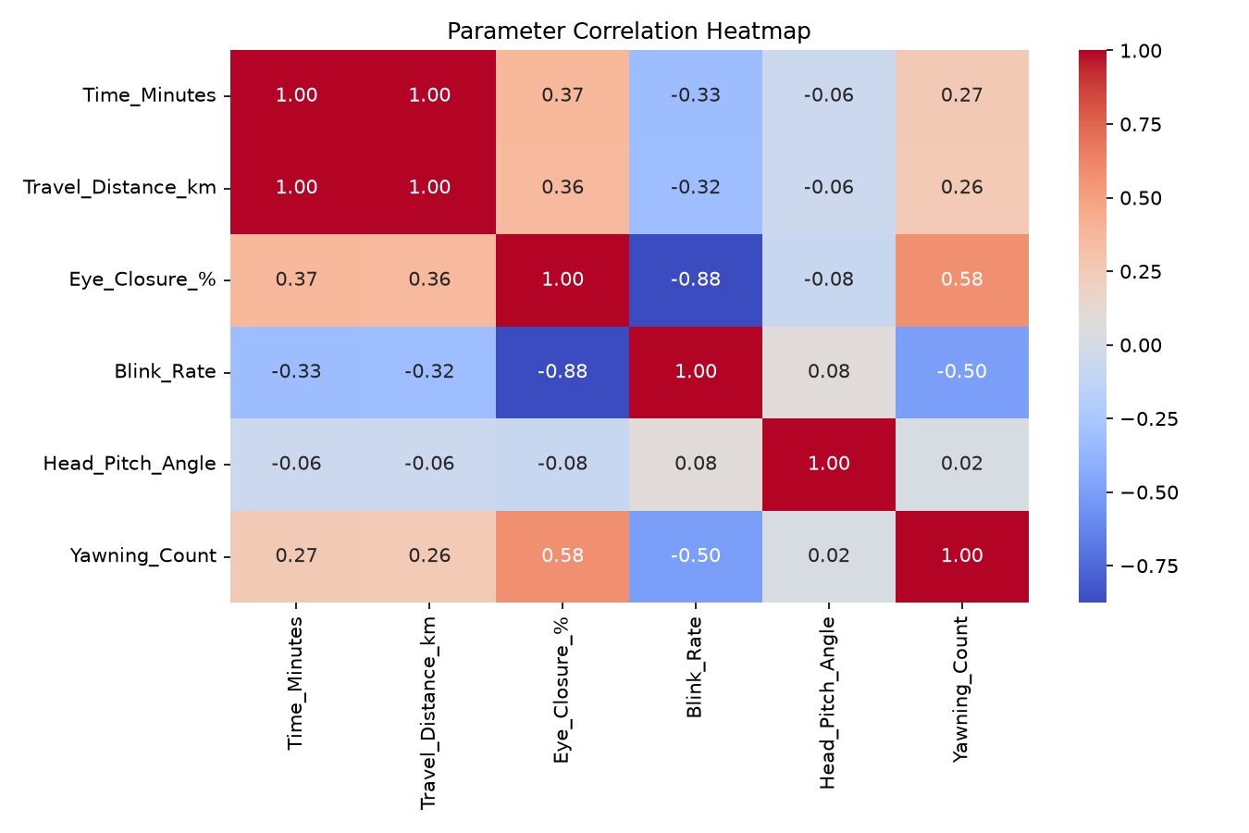
Correlation Heatmap
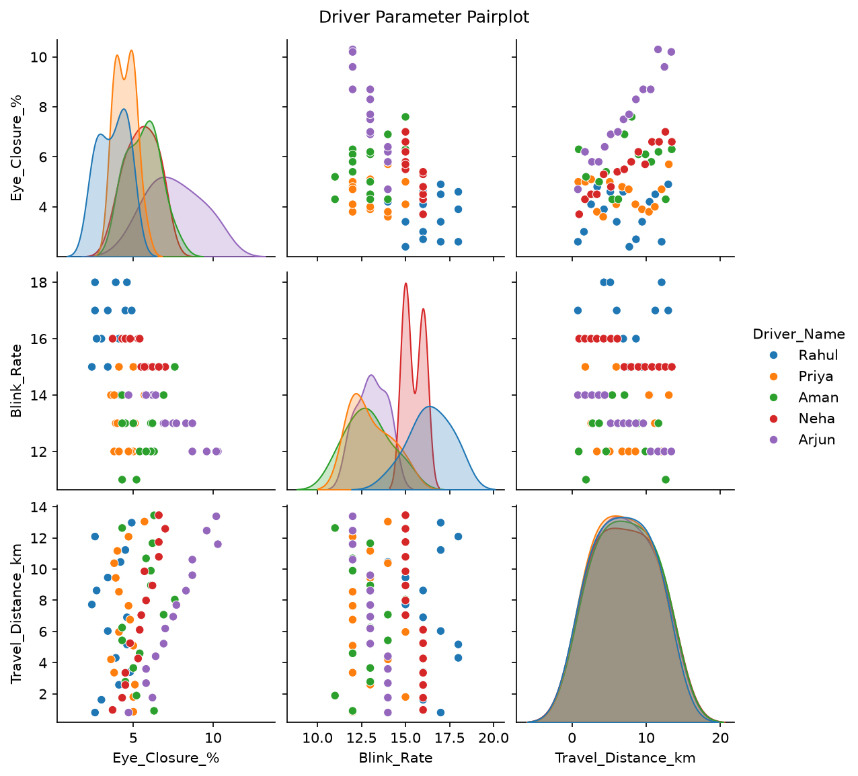
Driver Pairplot

6. Conclusion
The Driver Monitoring System uses NumPy, Pandas, Matplotlib and Seaborn to analyse driver behaviour and identify fatigue risks.

