DRIVER MONITORING SYSTEM
Calculated Driver Attentiveness Report
Generated Using Python
20 July 2026, 01:35 PM

1. Executive Summary
This report calculates driver attentiveness from the original sensor data. The weighted formula uses Eye Closure Score (35%), Blink Rate Score (25%), Head Pitch Score (25%) and Yawning Score (15%). Every score, status, ranking and chart changes automatically when the Excel sensor values change.

2. Dashboard Summary
Total Records  300 | Total Drivers  5
Average Eye Closure  8.08% | Average Blink Rate  12.93
Average Calculated Score  88.11 | Inattentive Records  35

3. Driver Performance Summary
Rank | Driver | Overall | Status | Eye | Blink | Head | Yawn
1 | Rahul | 100.00 | Attentive | 100.0 | 100.0 | 100.0 | 100.0
2 | Priya | 97.02 | Attentive | 92.0 | 100.0 | 100.0 | 98.8
3 | Aman | 93.95 | Attentive | 90.8 | 95.4 | 93.3 | 100.0
4 | Neha | 86.16 | Attentive | 78.4 | 89.2 | 87.1 | 97.7
5 | Arjun | 63.43 | Inattentive | 50.2 | 59.7 | 73.9 | 83.2

4. Overall Driver and Shift Comparison
Use this section to identify the best driver before reviewing the individual reports. All values are calculated from the four weighted sensor components.
Best Overall Driver | Rahul (100.00/100)
Best Driver Status | Attentive
Best Overall Shift | Morning (94.48/100)
Needs Most Attention | Arjun (63.43/100)
Overall Finding: Rahul is the best-performing driver with a calculated score of 100.00. Arjun has the lowest score and requires the greatest attention.
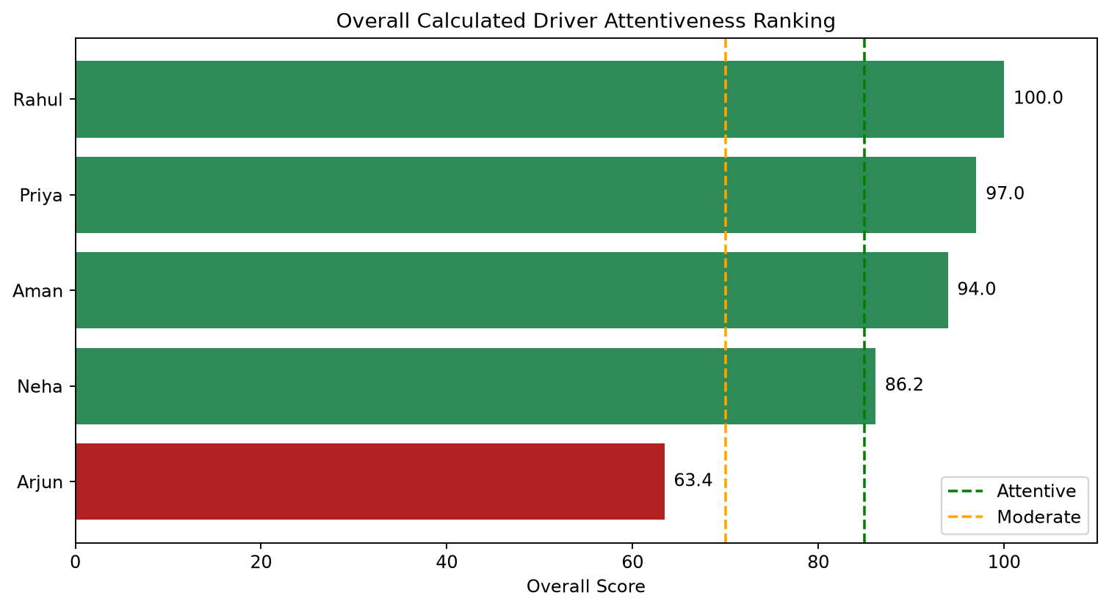
Overall Driver Attentiveness Ranking
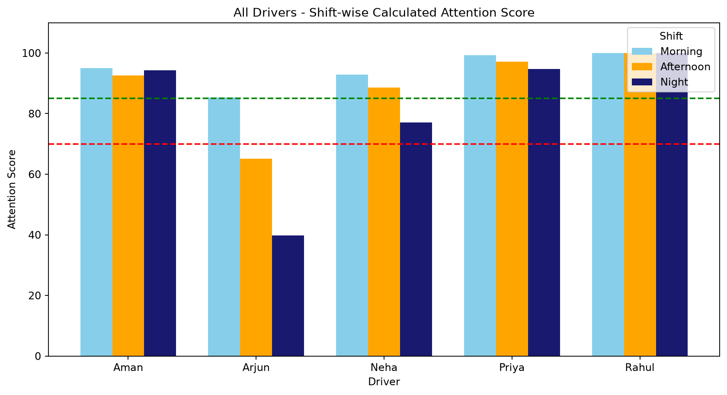
Morning, Afternoon and Night Comparison
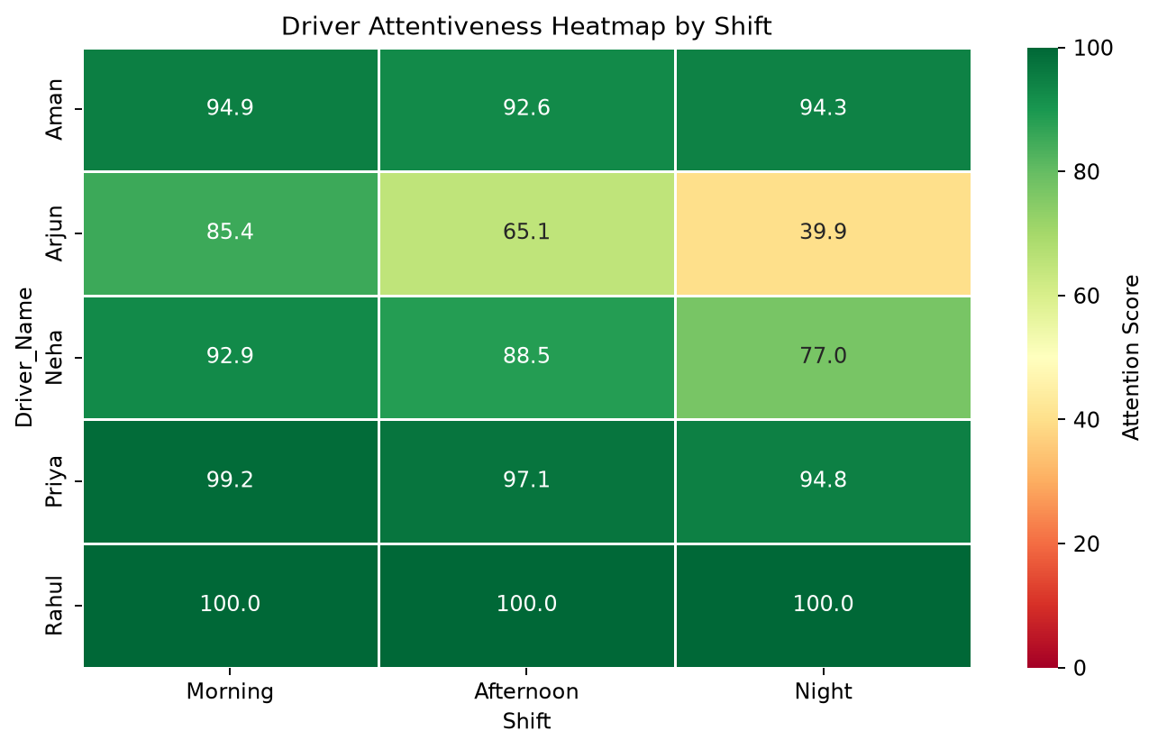
Driver Attentiveness Heatmap by Shift
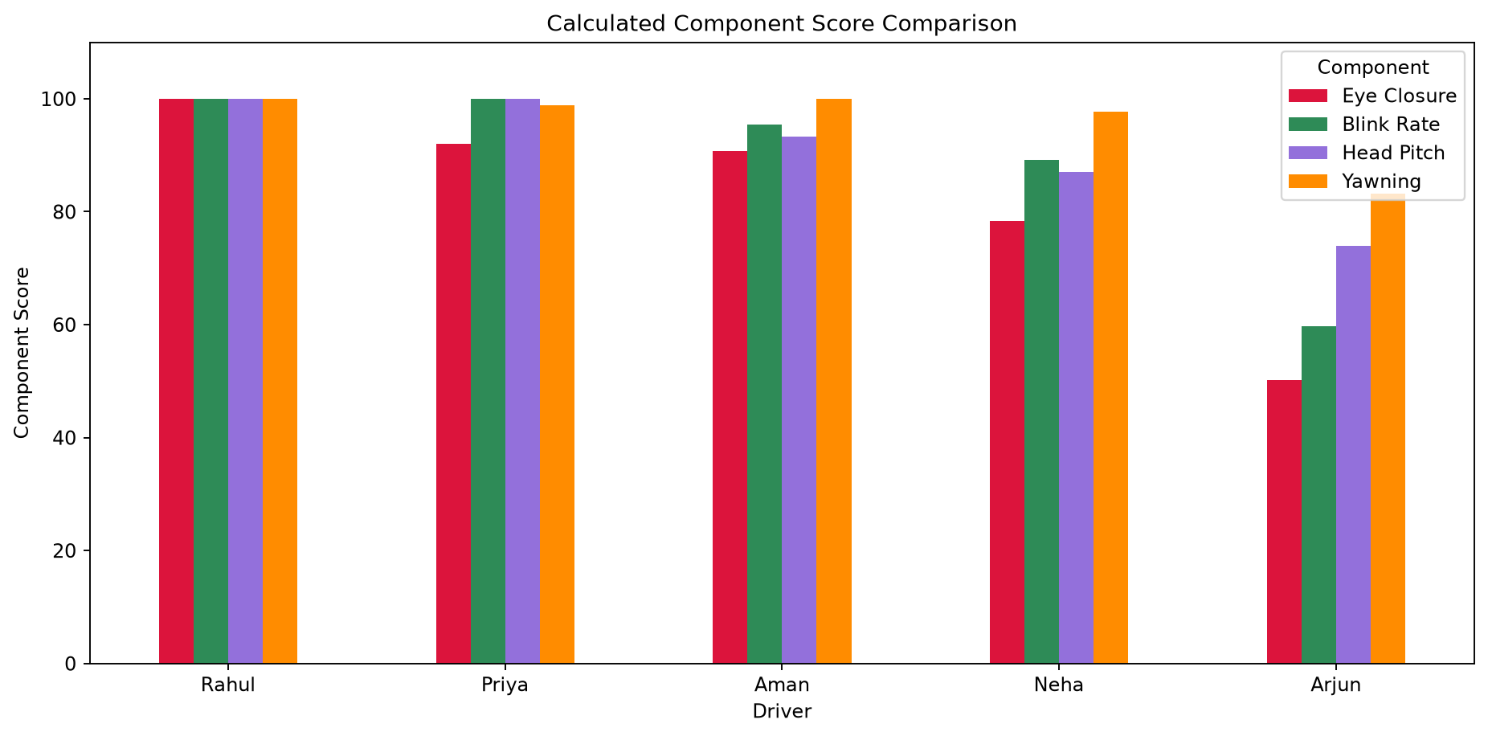
Eye, Blink, Head Pitch and Yawning Component Scores

5. Individual Driver Analysis

5.1 Aman
Driver ID: D003 | Calculated Score: 93.95 | Status: Attentive
Shift | Overall | Status | Eye | Blink | Head | Yawn | Distance | Duration
Morning | 94.9 | Attentive | 92.5 | 96.2 | 94.0 | 100.0 | 18.1 | 20 min
Afternoon | 92.6 | Attentive | 88.0 | 96.2 | 91.0 | 100.0 | 35.6 | 20 min
Night | 94.3 | Attentive | 91.8 | 93.8 | 95.0 | 100.0 | 53.3 | 20 min
Observation: Strong calculated attentiveness. Weakest component: Eye Closure.
Recommendation: Continue safe driving and regular monitoring.
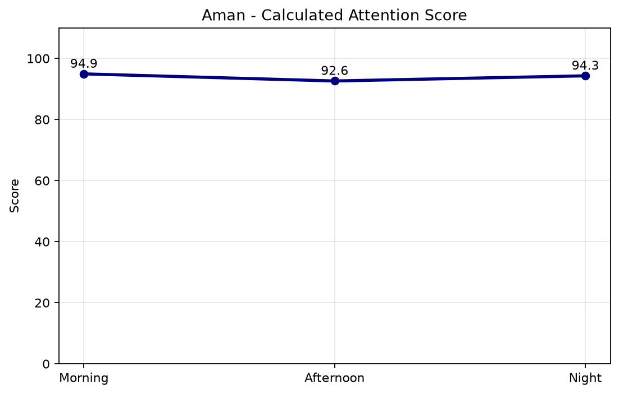
Calculated Attention Score by Shift
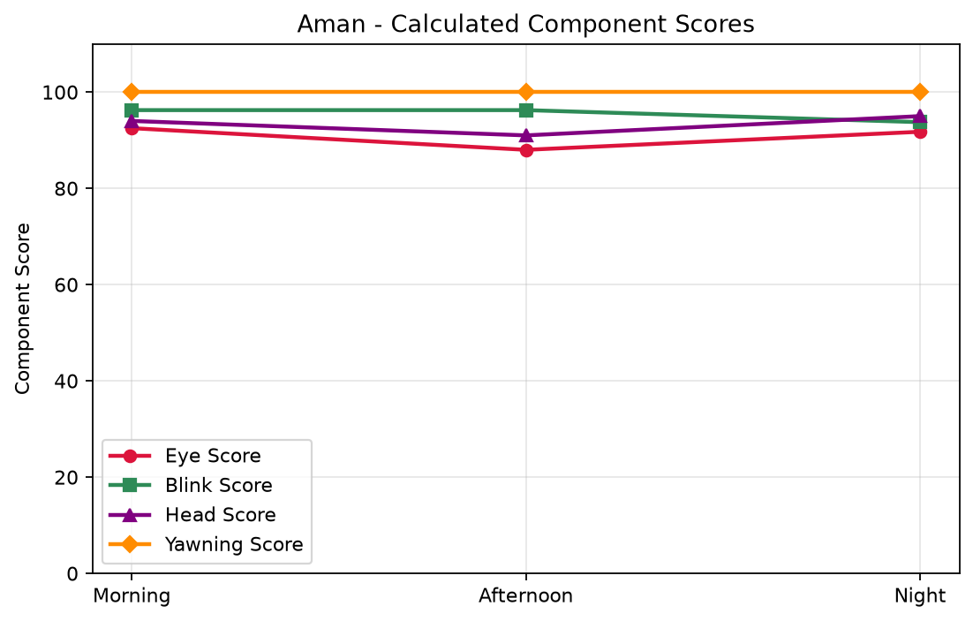
Calculated Eye, Blink, Head Pitch and Yawning Component Scores
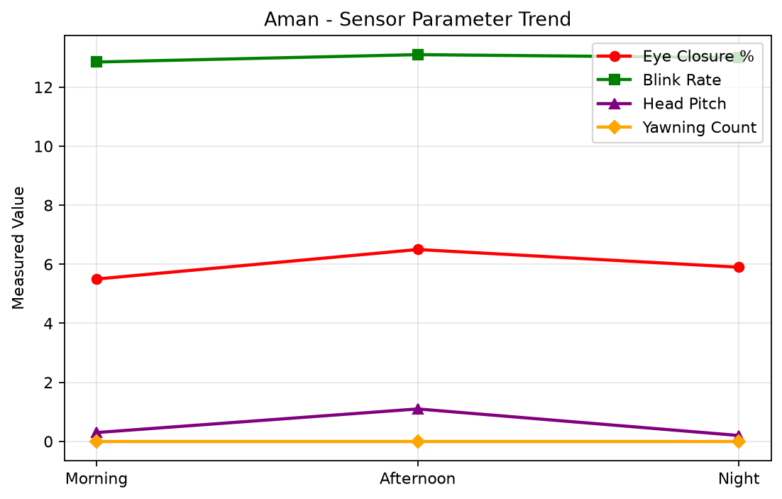
Measured Eye Closure, Blink Rate, Head Pitch and Yawning
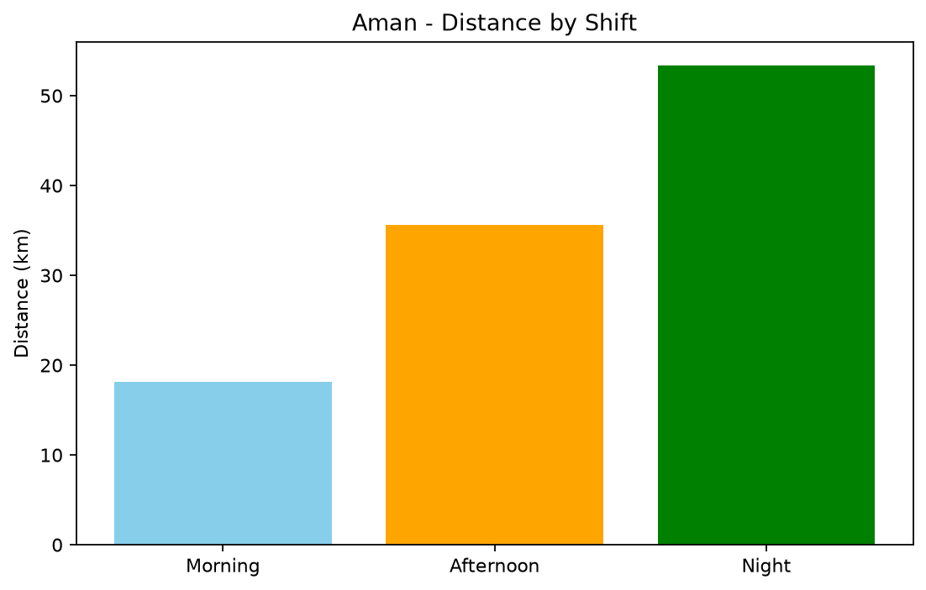
Distance by Shift
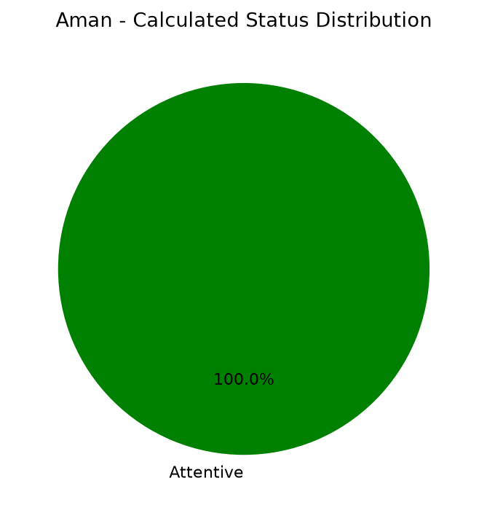
Calculated Attentiveness Status Distribution

5.2 Arjun
Driver ID: D005 | Calculated Score: 63.43 | Status: Inattentive
Shift | Overall | Status | Eye | Blink | Head | Yawn | Distance | Duration
Morning | 85.4 | Attentive | 81.8 | 96.2 | 70.8 | 100.0 | 17.6 | 20 min
Afternoon | 65.1 | Inattentive | 50.0 | 61.2 | 73.2 | 93.0 | 34.3 | 20 min
Night | 39.9 | Inattentive | 18.8 | 21.5 | 77.8 | 56.5 | 52.0 | 20 min
Observation: Low attentiveness, especially in the Night shift. Weakest component: Eye Closure.
Recommendation: Stop driving and take sufficient rest.
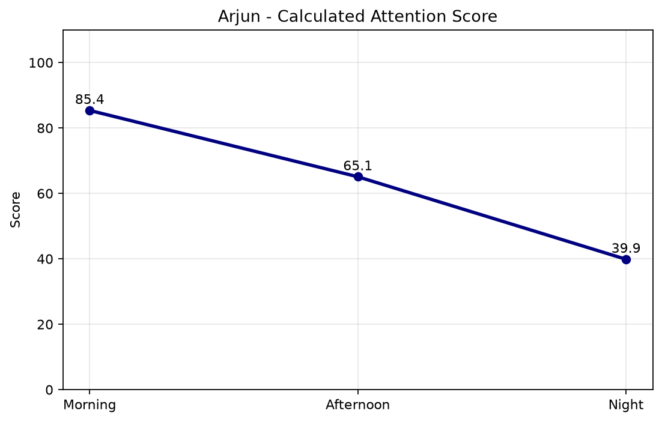
Calculated Attention Score by Shift
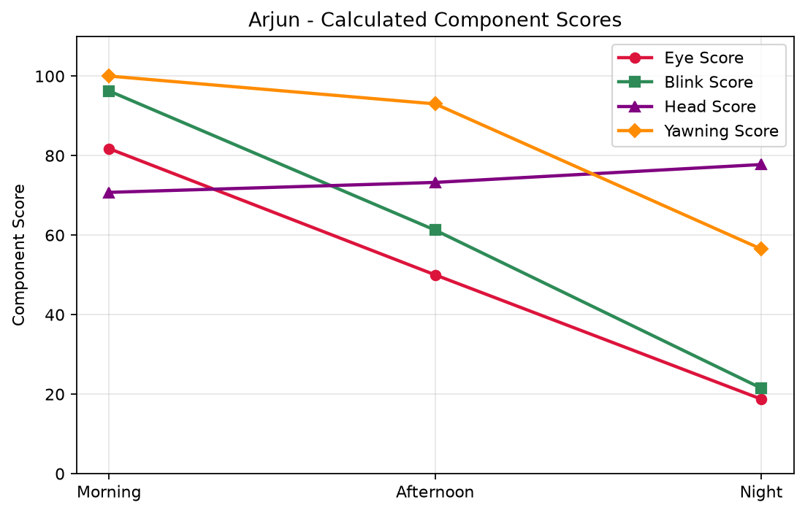
Calculated Eye, Blink, Head Pitch and Yawning Component Scores
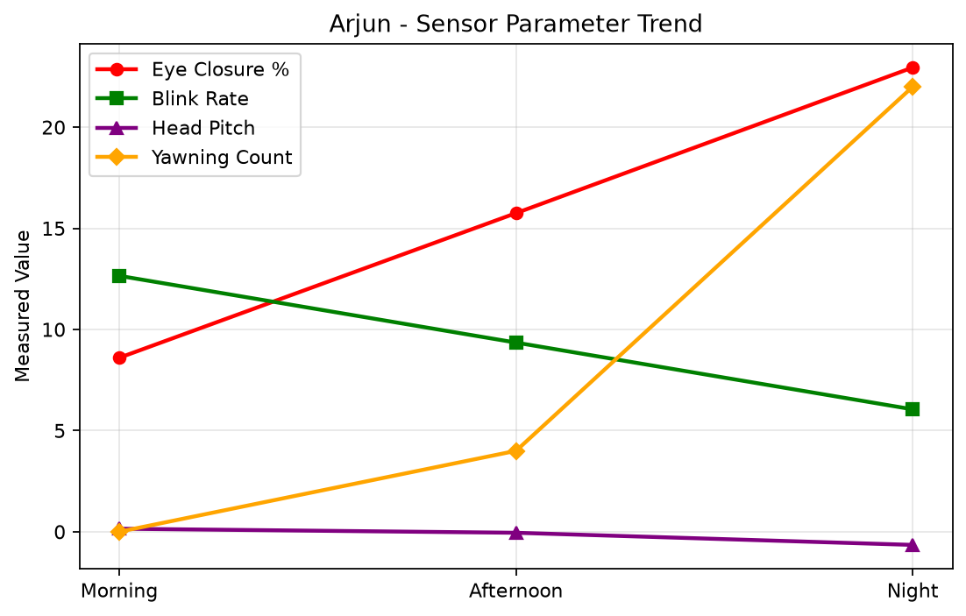
Measured Eye Closure, Blink Rate, Head Pitch and Yawning
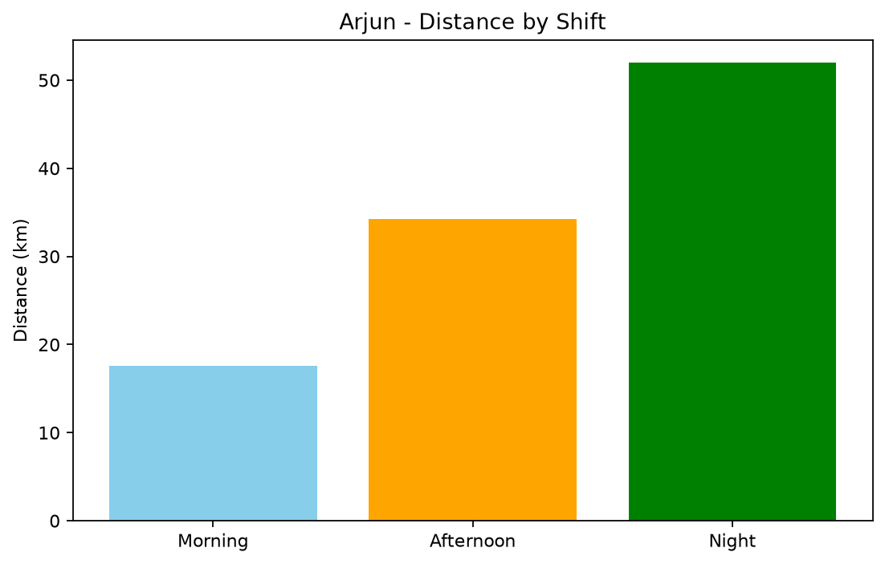
Distance by Shift
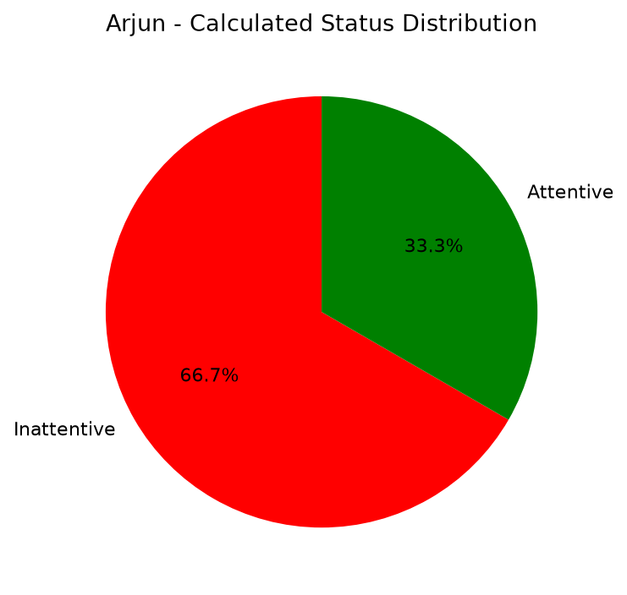
Calculated Attentiveness Status Distribution

5.3 Neha
Driver ID: D004 | Calculated Score: 86.16 | Status: Attentive
Shift | Overall | Status | Eye | Blink | Head | Yawn | Distance | Duration
Morning | 92.9 | Attentive | 90.2 | 100.0 | 85.2 | 100.0 | 18.0 | 20 min
Afternoon | 88.5 | Attentive | 80.0 | 98.8 | 85.5 | 96.5 | 35.2 | 20 min
Night | 77.0 | Moderately Attentive | 65.0 | 68.8 | 90.5 | 96.5 | 52.2 | 20 min
Observation: Strong calculated attentiveness. Weakest component: Eye Closure.
Recommendation: Continue safe driving and regular monitoring.
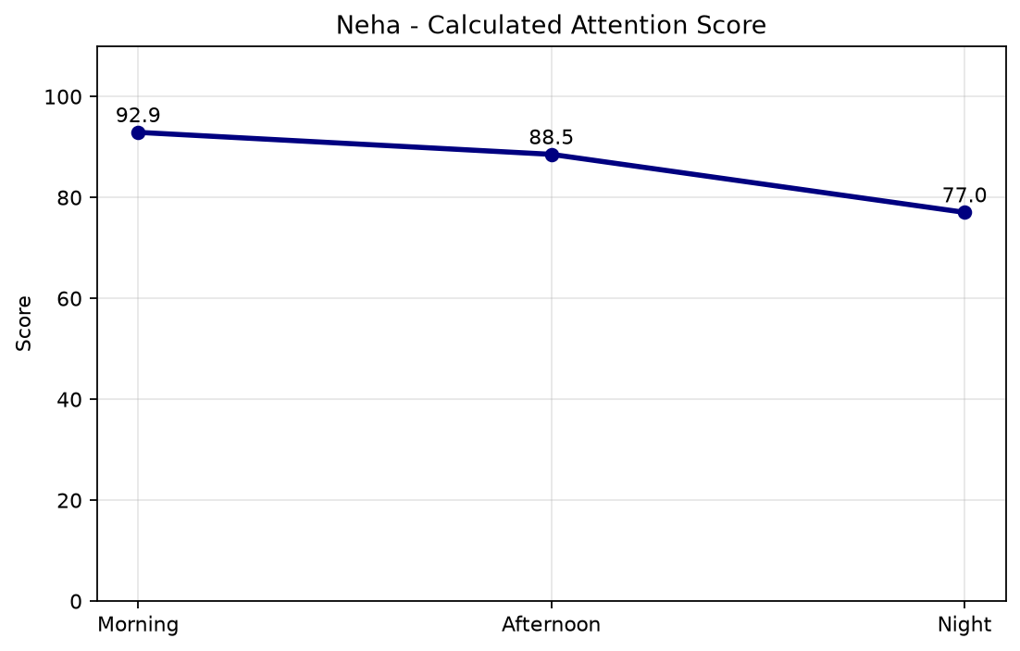
Calculated Attention Score by Shift
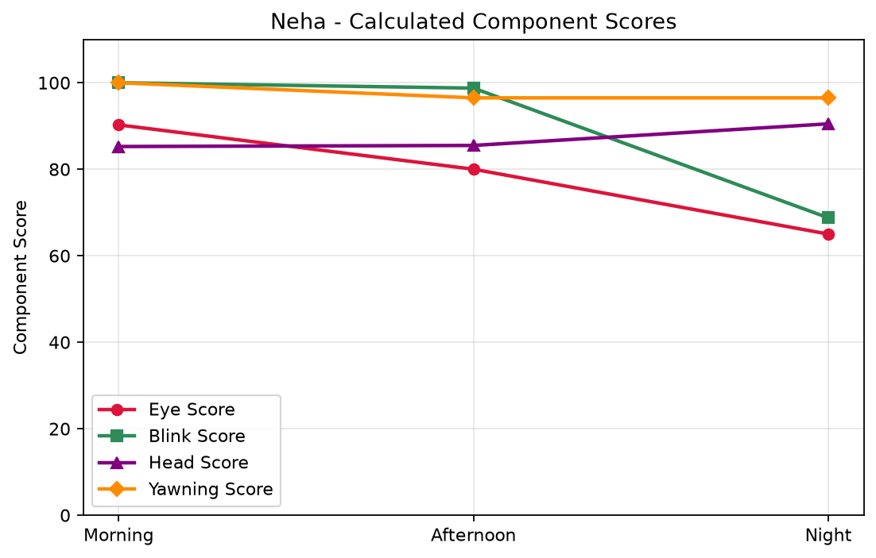
Calculated Eye, Blink, Head Pitch and Yawning Component Scores
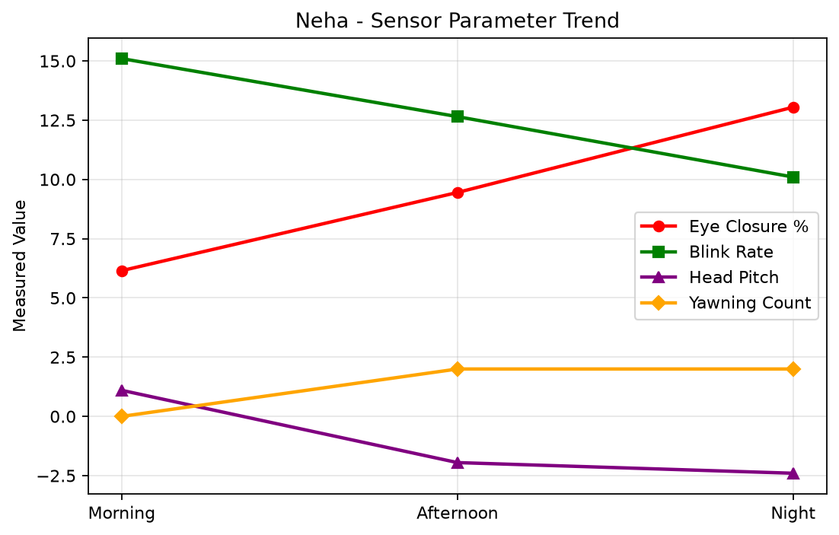
Measured Eye Closure, Blink Rate, Head Pitch and Yawning
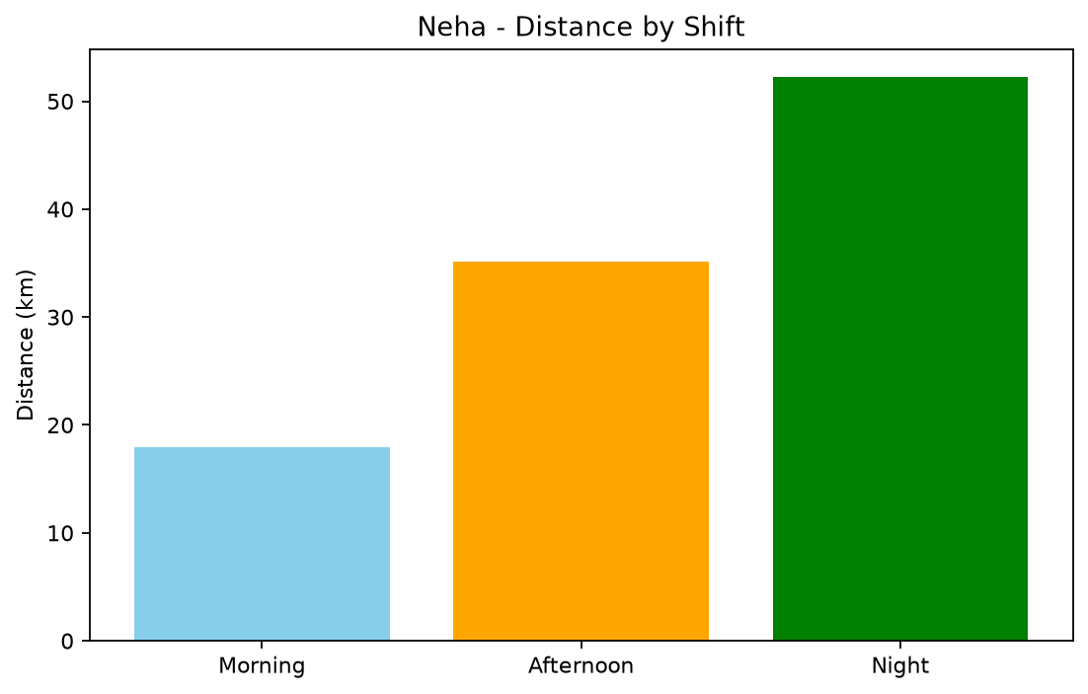
Distance by Shift
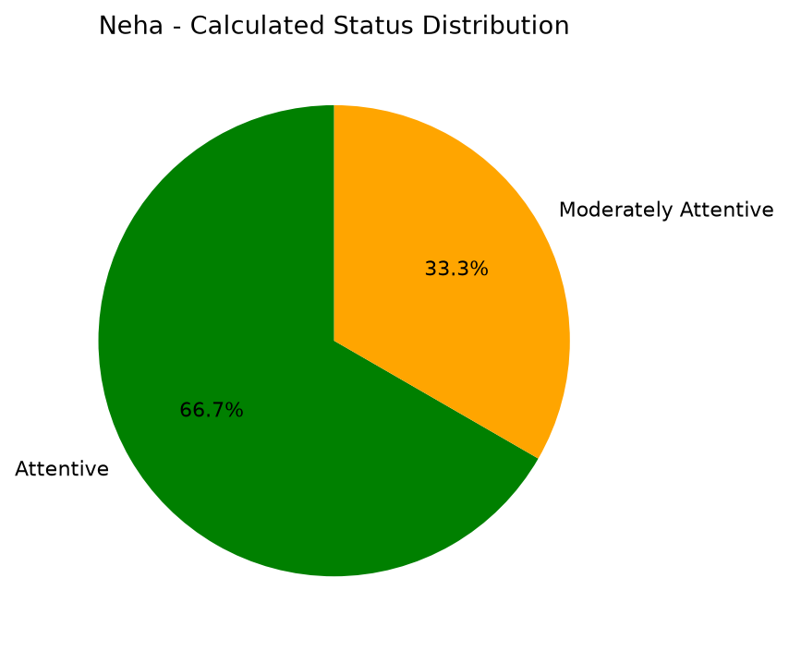
Calculated Attentiveness Status Distribution

5.4 Priya
Driver ID: D002 | Calculated Score: 97.02 | Status: Attentive
Shift | Overall | Status | Eye | Blink | Head | Yawn | Distance | Duration
Morning | 99.2 | Attentive | 97.8 | 100.0 | 100.0 | 100.0 | 17.6 | 20 min
Afternoon | 97.1 | Attentive | 91.8 | 100.0 | 100.0 | 100.0 | 34.8 | 20 min
Night | 94.8 | Attentive | 86.5 | 100.0 | 100.0 | 96.5 | 51.9 | 20 min
Observation: Strong calculated attentiveness. Weakest component: Eye Closure.
Recommendation: Continue safe driving and regular monitoring.
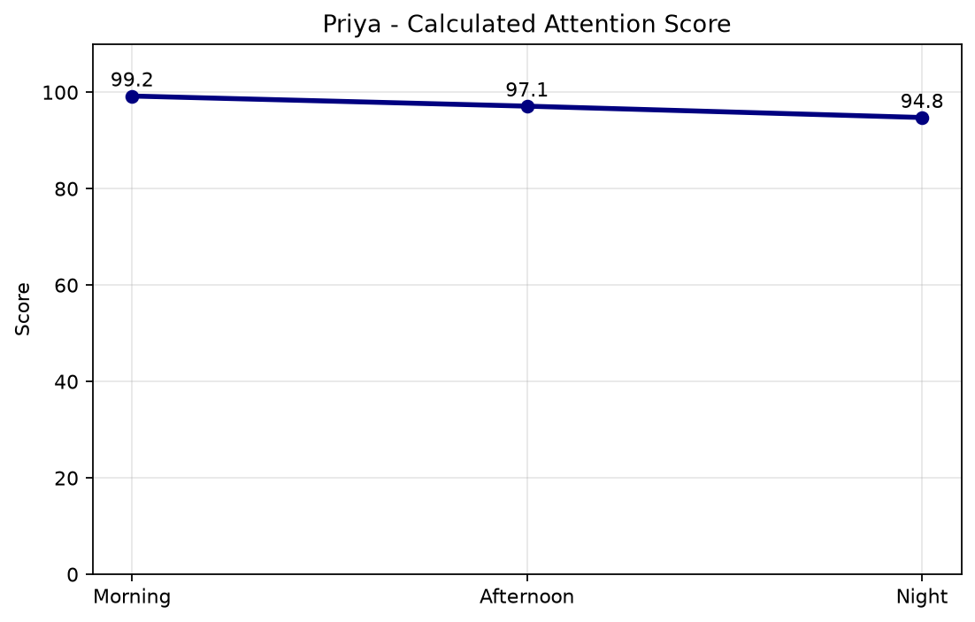
Calculated Attention Score by Shift
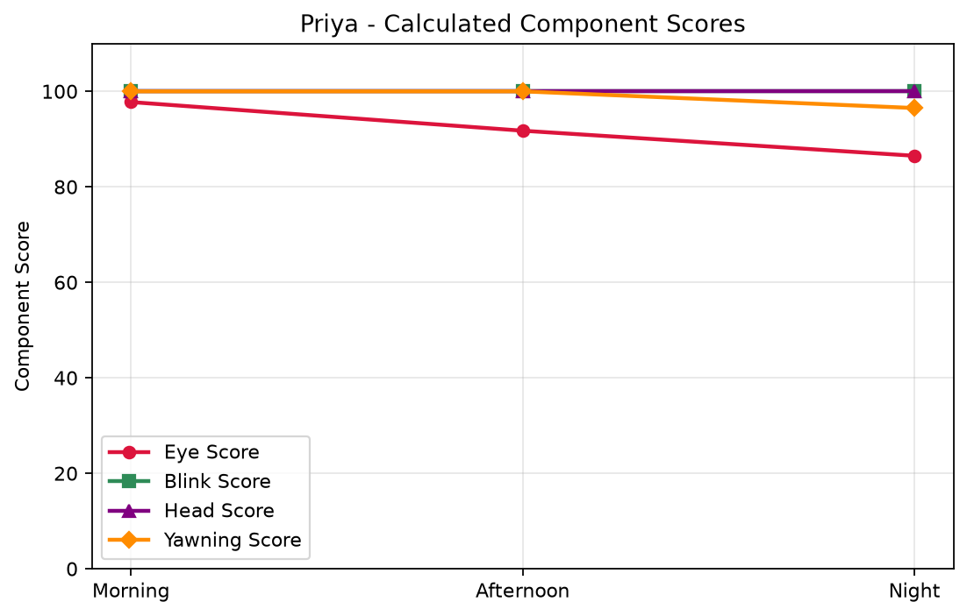
Calculated Eye, Blink, Head Pitch and Yawning Component Scores
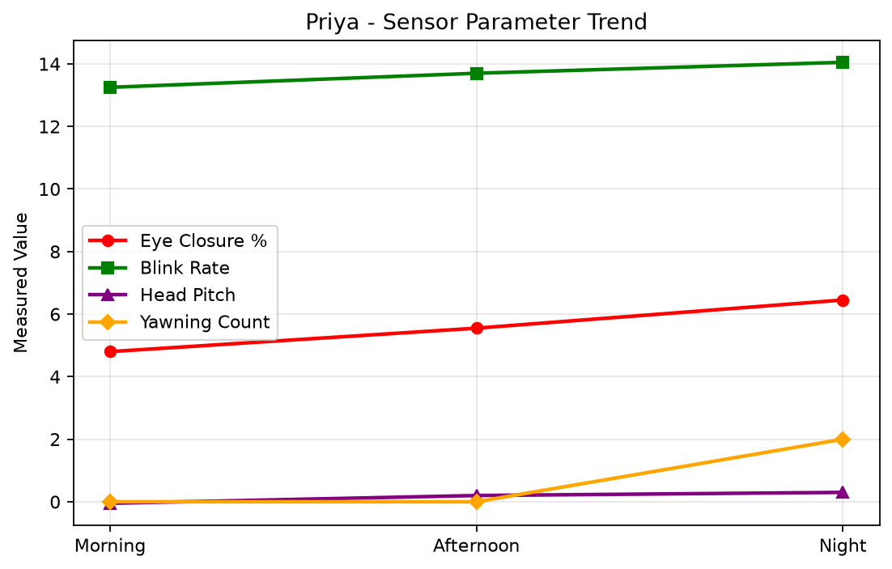
Measured Eye Closure, Blink Rate, Head Pitch and Yawning
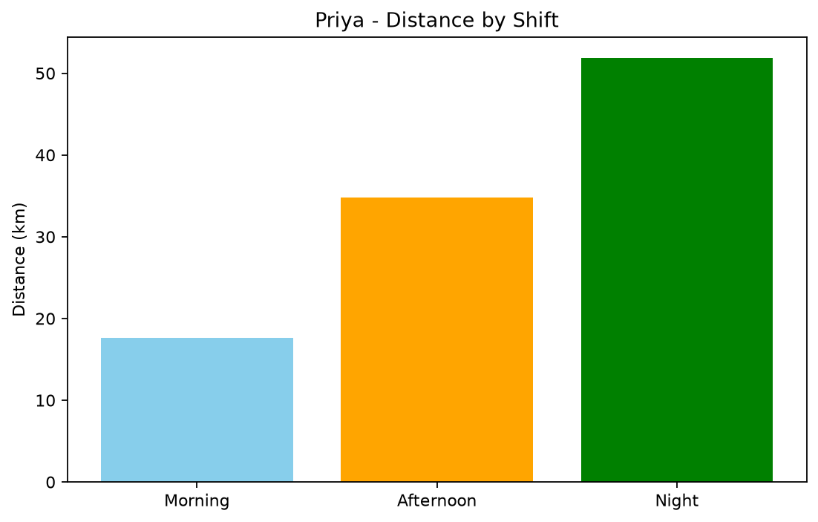
Distance by Shift
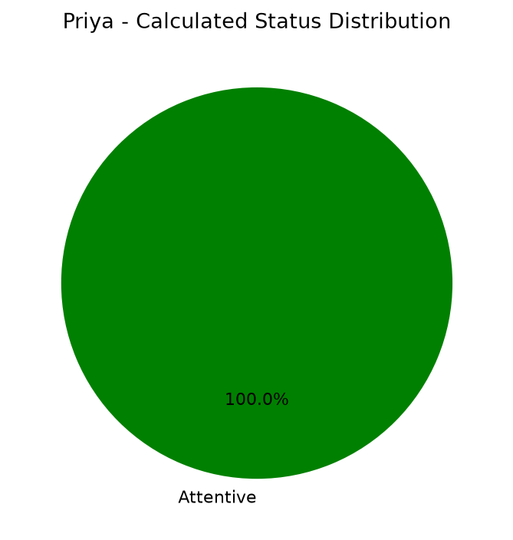
Calculated Attentiveness Status Distribution

5.5 Rahul
Driver ID: D001 | Calculated Score: 100.00 | Status: Attentive
Shift | Overall | Status | Eye | Blink | Head | Yawn | Distance | Duration
Morning | 100.0 | Attentive | 100.0 | 100.0 | 100.0 | 100.0 | 17.3 | 20 min
Afternoon | 100.0 | Attentive | 100.0 | 100.0 | 100.0 | 100.0 | 34.7 | 20 min
Night | 100.0 | Attentive | 100.0 | 100.0 | 100.0 | 100.0 | 52.8 | 20 min
Observation: Strong calculated attentiveness. Weakest component: Eye Closure.
Recommendation: Continue safe driving and regular monitoring.
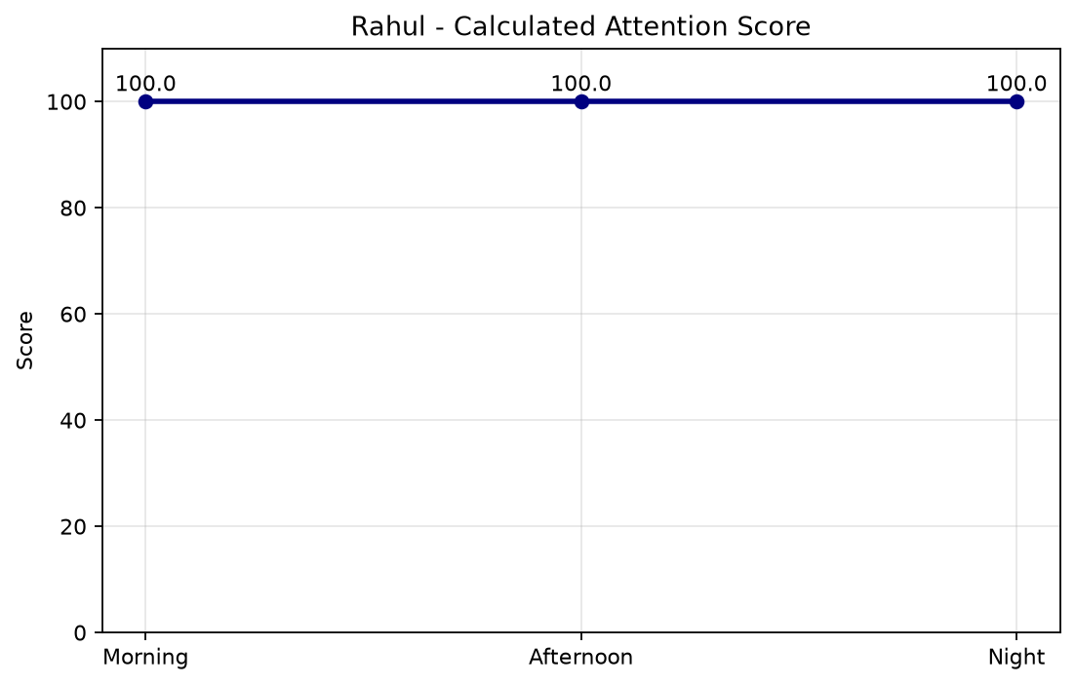
Calculated Attention Score by Shift
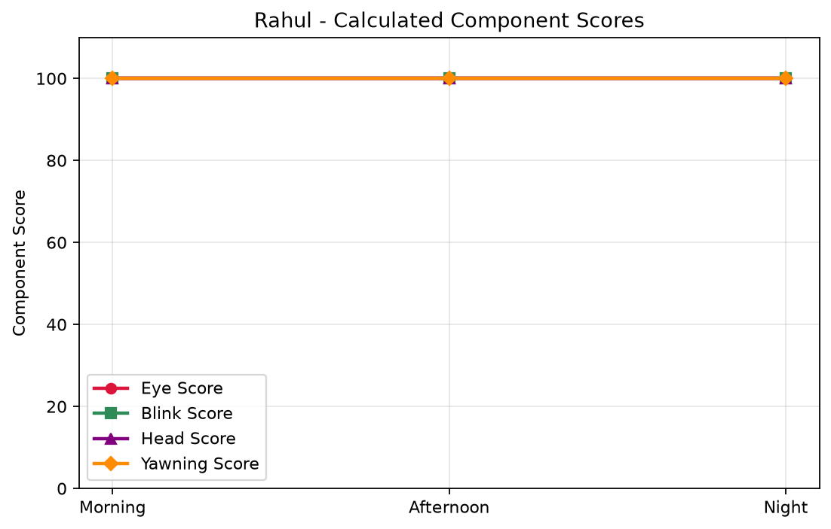
Calculated Eye, Blink, Head Pitch and Yawning Component Scores
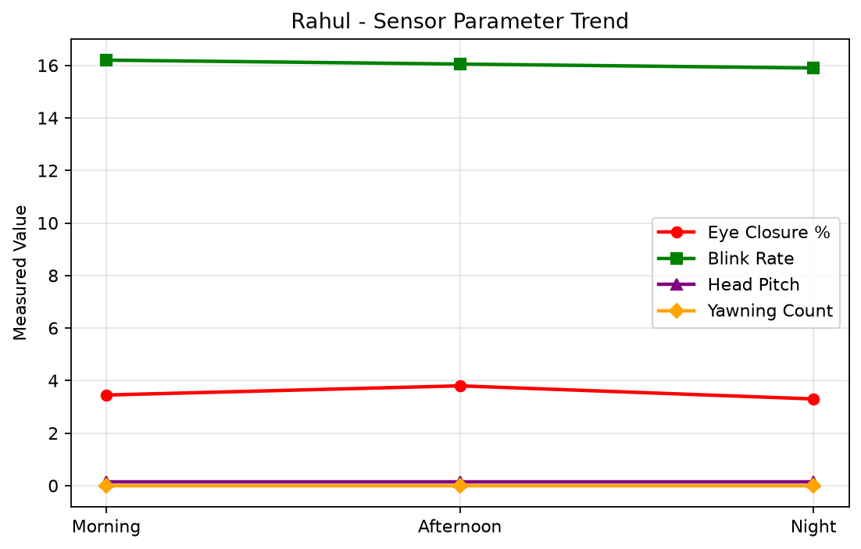
Measured Eye Closure, Blink Rate, Head Pitch and Yawning
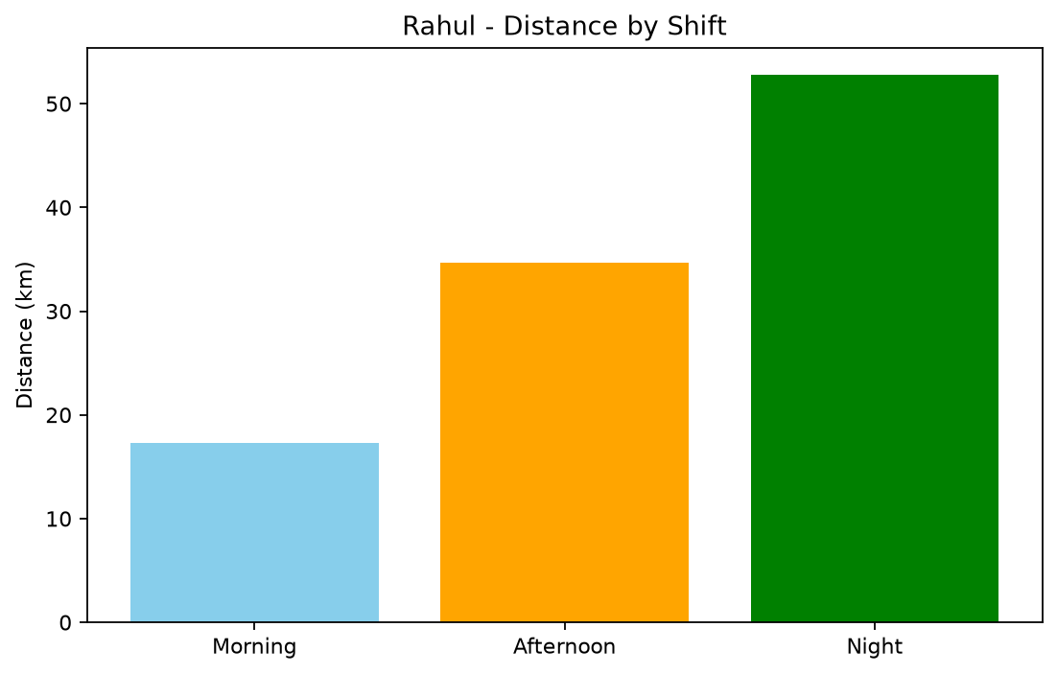
Distance by Shift
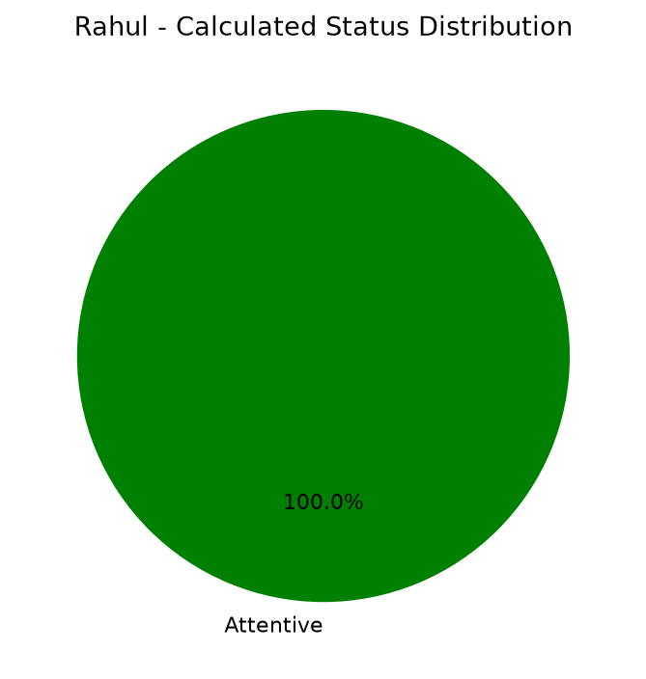
Calculated Attentiveness Status Distribution

6. Overall Sensor and Score Analysis
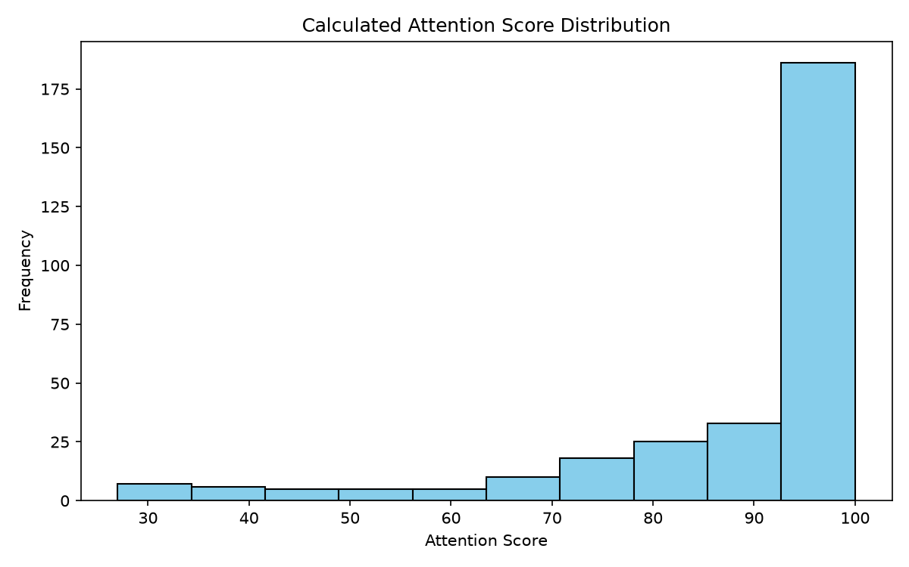
Calculated Attention Score Distribution
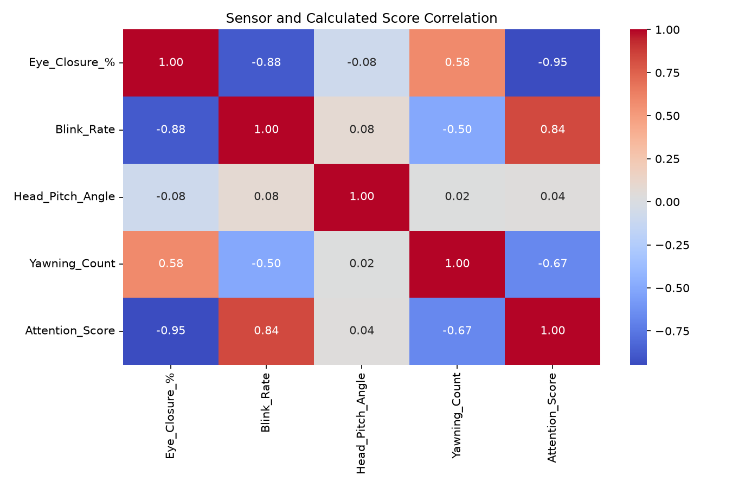
Sensor and Calculated Score Correlation
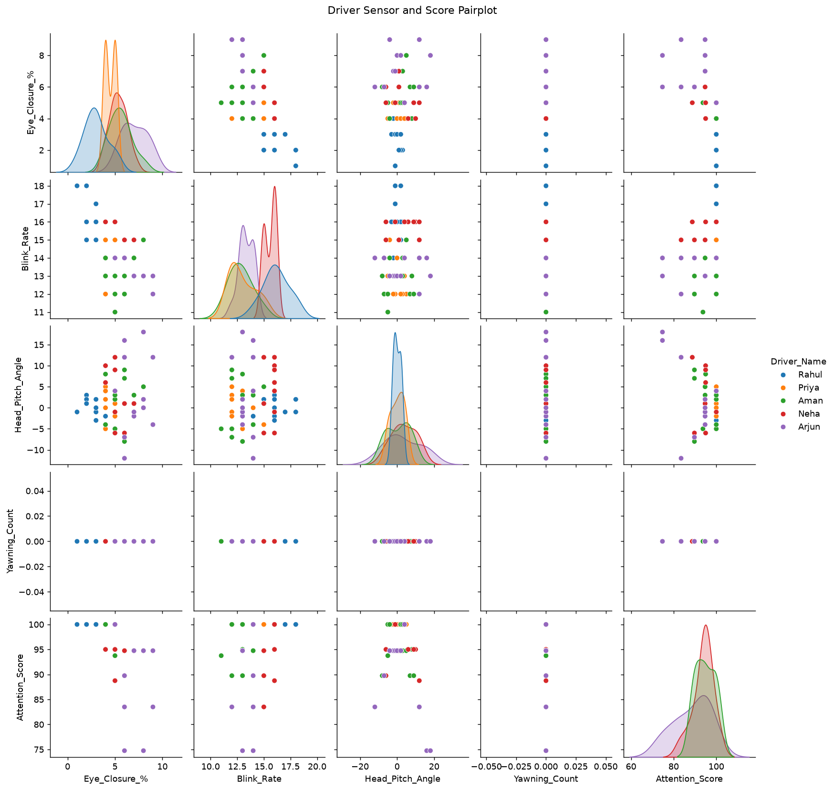
Driver Sensor and Calculated Score Pairplot

7. Conclusion
The calculated model identifies Rahul as the best driver with an overall score of 100.00. The results are fully data-driven: modifying eye closure, blink rate, head pitch or yawning values in Excel changes the scores, rankings, statuses, charts and this report on the next execution.

