DRIVER MONITORING SYSTEM
Calculated Driver Attentiveness Report
Generated Using Python
20 July 2026, 03:43 PM

1. Executive Summary
The score uses Eye Closure (35%), Blink Rate (25%), Head Pitch (25%) and Yawning (15%). Results update when the Excel data changes.

2. Dashboard Summary
Total Records  300 | Total Drivers  5
Average Eye Closure  8.08% | Average Blink Rate  12.93
Average Calculated Score  88.11 | Inattentive Records  35

3. All Drivers and All Shifts Status
Driver | Shift | Attentiveness | Attention Status | Alertness | Alertness Status | Overall | Overall Status
Aman | Morning | 93.1 | Attentive | 97.7 | Alert | 94.9 | Attentive
 | Afternoon | 89.2 | Attentive | 97.7 | Alert | 92.6 | Attentive
 | Night | 93.1 | Attentive | 96.1 | Alert | 94.3 | Attentive
Arjun | Morning | 77.2 | Moderately Attentive | 97.7 | Alert | 85.4 | Attentive
 | Afternoon | 59.7 | Inattentive | 73.2 | Moderately Alert | 65.1 | Inattentive
 | Night | 43.3 | Inattentive | 34.6 | Drowsy Risk | 39.9 | Inattentive
Neha | Morning | 88.2 | Attentive | 100.0 | Alert | 92.9 | Attentive
 | Afternoon | 82.3 | Moderately Attentive | 97.9 | Alert | 88.5 | Attentive
 | Night | 75.6 | Moderately Attentive | 79.2 | Moderately Alert | 77.0 | Moderately Attentive
Priya | Morning | 98.7 | Attentive | 100.0 | Alert | 99.2 | Attentive
 | Afternoon | 95.2 | Attentive | 100.0 | Alert | 97.1 | Attentive
 | Night | 92.1 | Attentive | 98.7 | Alert | 94.8 | Attentive
Rahul | Morning | 100.0 | Attentive | 100.0 | Alert | 100.0 | Attentive
 | Afternoon | 100.0 | Attentive | 100.0 | Alert | 100.0 | Attentive
 | Night | 100.0 | Attentive | 100.0 | Alert | 100.0 | Attentive

4. Driver Performance Summary
Rank | Driver | Overall | Status | Eye | Blink | Head | Yawn
1 | Rahul | 100.00 | Attentive | 100.0 | 100.0 | 100.0 | 100.0
2 | Priya | 97.02 | Attentive | 92.0 | 100.0 | 100.0 | 98.8
3 | Aman | 93.95 | Attentive | 90.8 | 95.4 | 93.3 | 100.0
4 | Neha | 86.16 | Attentive | 78.4 | 89.2 | 87.1 | 97.7
5 | Arjun | 63.43 | Inattentive | 50.2 | 59.7 | 73.9 | 83.2

5. Overall Driver and Shift Comparison
Best Overall Driver | Rahul (100.00/100)
Best Driver Status | Attentive
Best Overall Shift | Morning (94.48/100)
Needs Most Attention | Arjun (63.43/100)
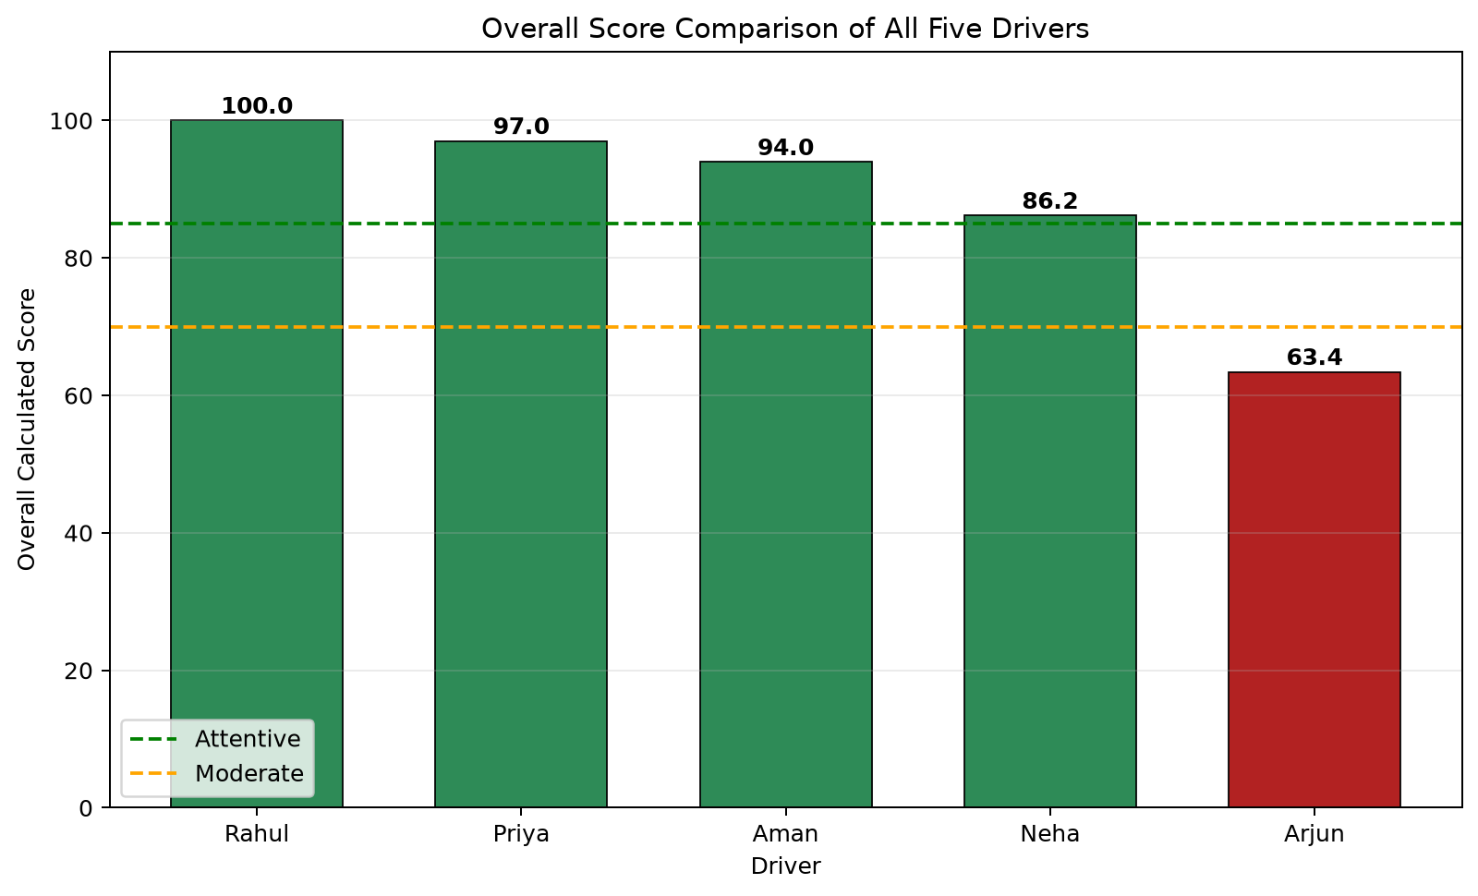
Overall Score Bar Comparison of All Five Drivers
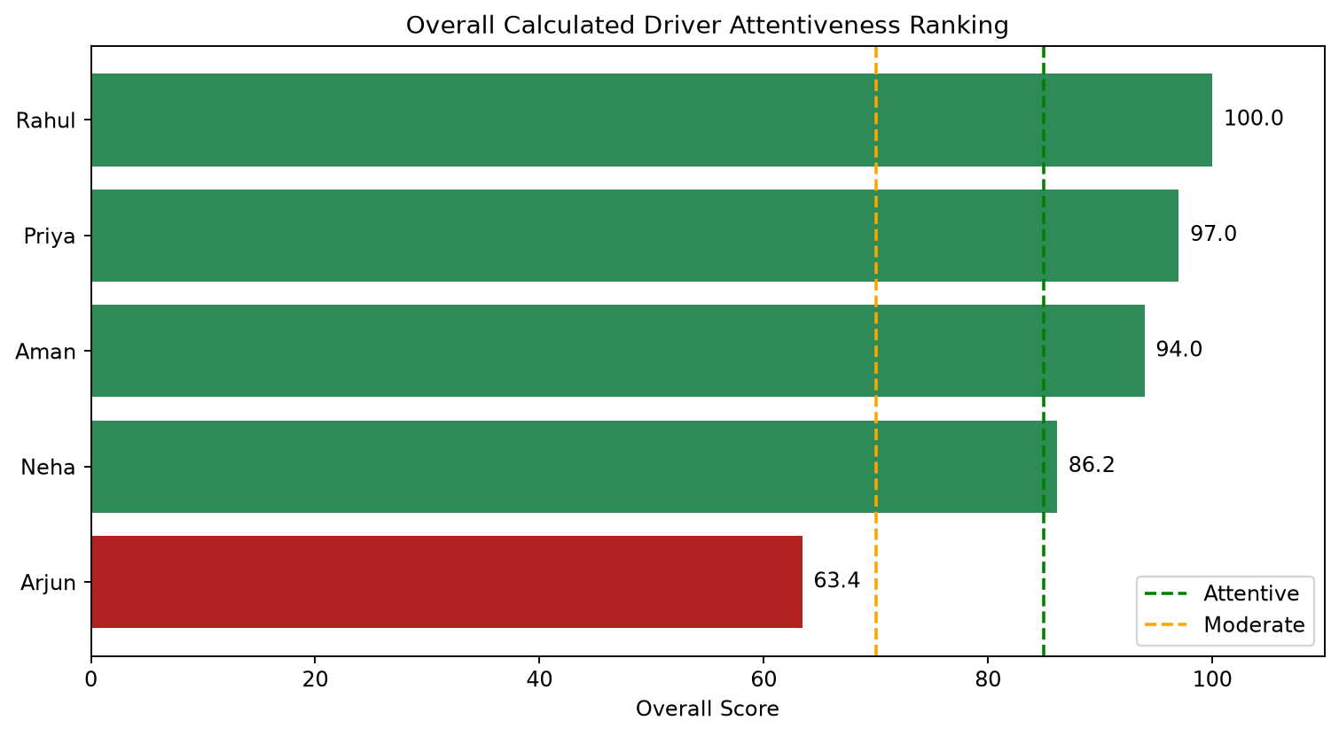
Overall Driver Attentiveness Ranking
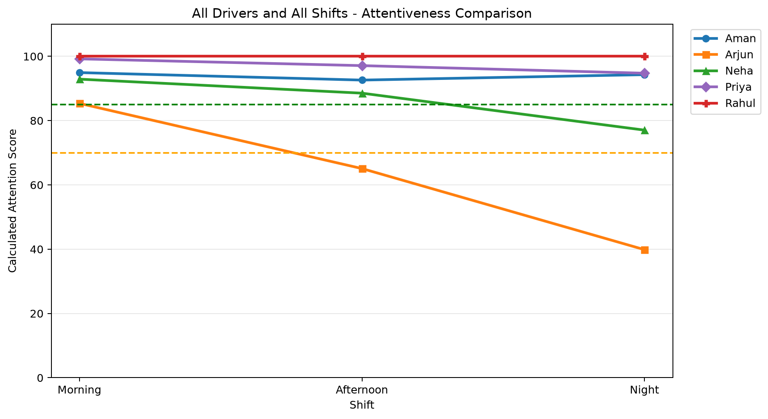
All Drivers and All Shifts in One Chart
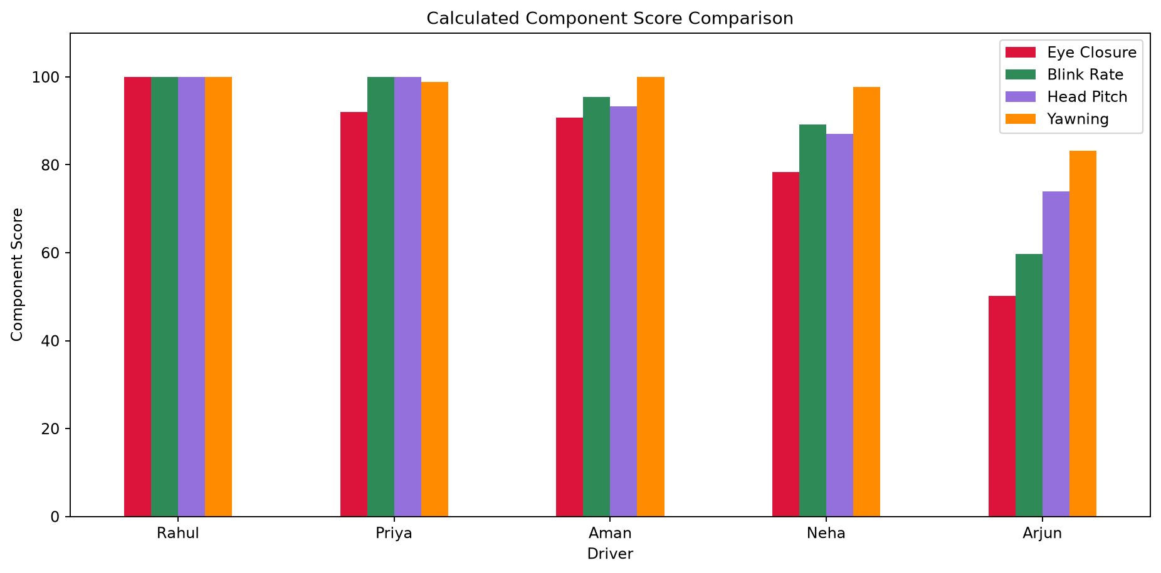
Eye, Blink, Head Pitch and Yawning Component Scores

6. Individual Driver Analysis

6.1 Aman
Shift | Overall | Status | Eye | Blink | Head | Yawn | Distance | Duration
Morning | 94.9 | Attentive | 92.5 | 96.2 | 94.0 | 100.0 | 18.1 | 20 min
Afternoon | 92.6 | Attentive | 88.0 | 96.2 | 91.0 | 100.0 | 35.6 | 20 min
Night | 94.3 | Attentive | 91.8 | 93.8 | 95.0 | 100.0 | 53.3 | 20 min
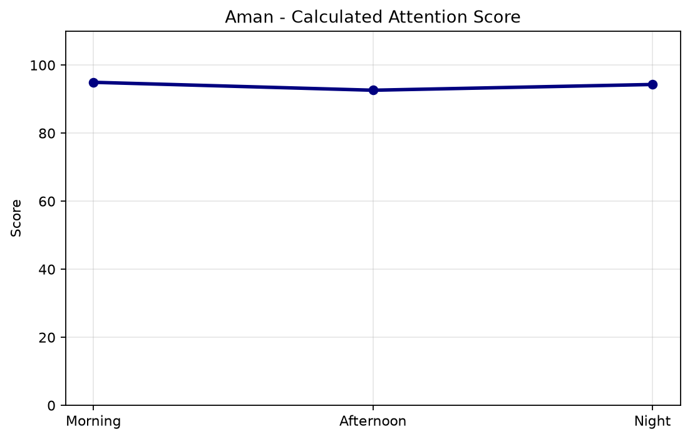
Calculated Attention Score by Shift
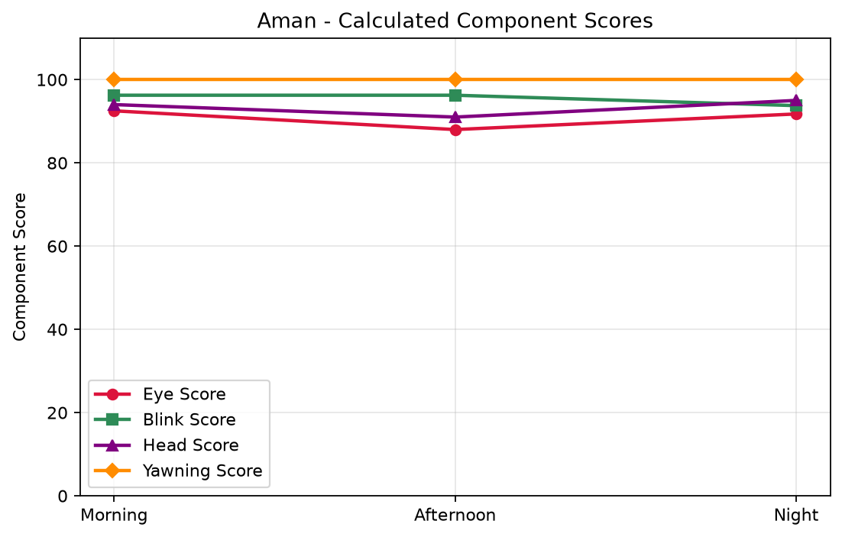
Calculated Eye, Blink, Head Pitch and Yawning Component Scores
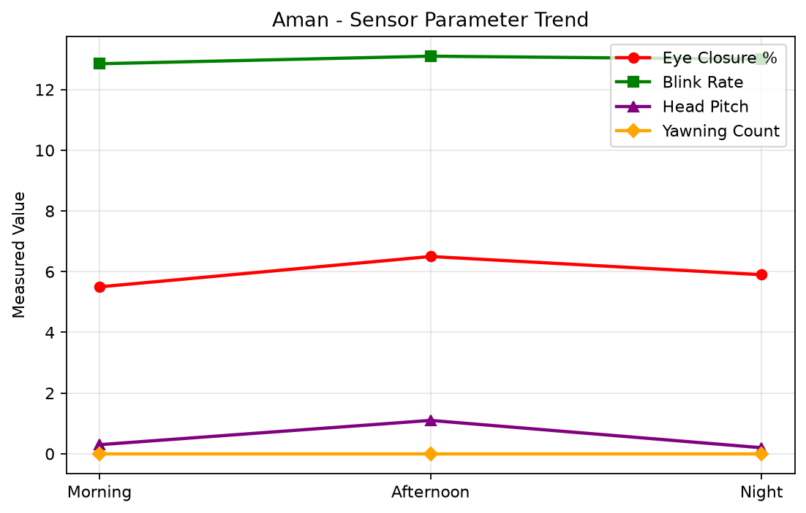
Measured Eye Closure, Blink Rate, Head Pitch and Yawning

6.2 Arjun
Shift | Overall | Status | Eye | Blink | Head | Yawn | Distance | Duration
Morning | 85.4 | Attentive | 81.8 | 96.2 | 70.8 | 100.0 | 17.6 | 20 min
Afternoon | 65.1 | Inattentive | 50.0 | 61.2 | 73.2 | 93.0 | 34.3 | 20 min
Night | 39.9 | Inattentive | 18.8 | 21.5 | 77.8 | 56.5 | 52.0 | 20 min
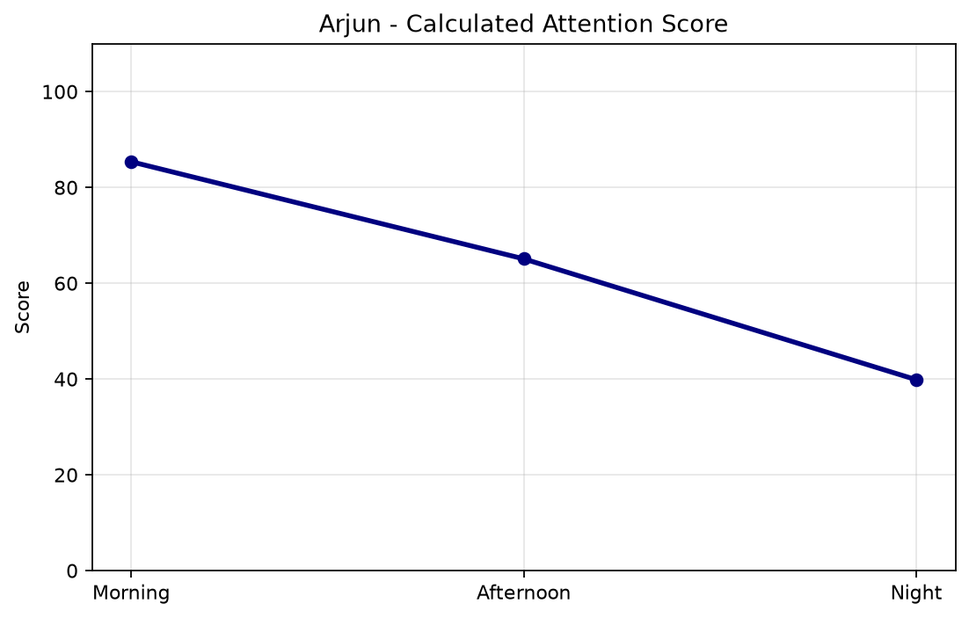
Calculated Attention Score by Shift
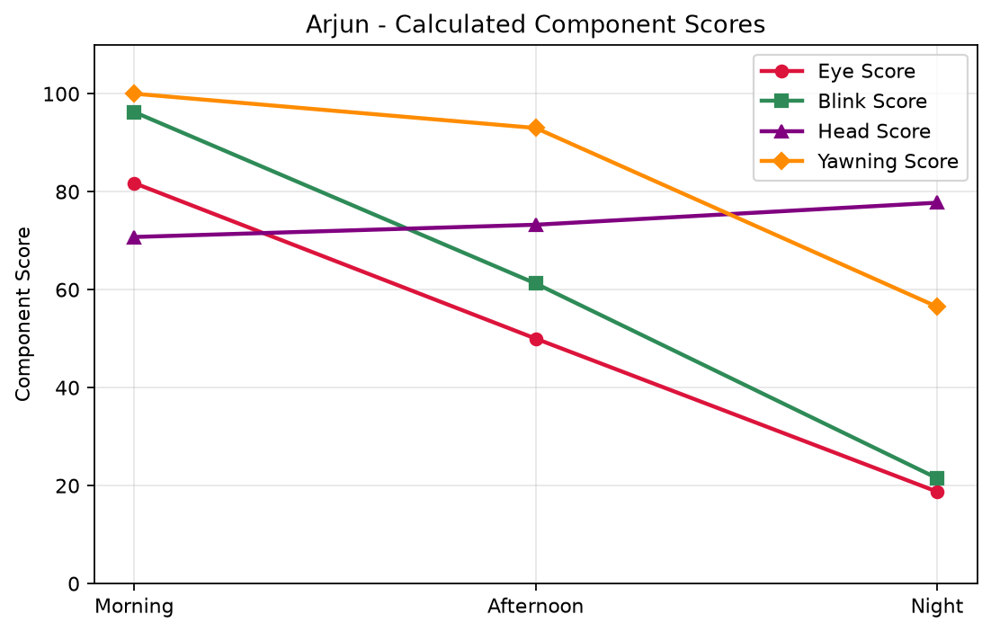
Calculated Eye, Blink, Head Pitch and Yawning Component Scores
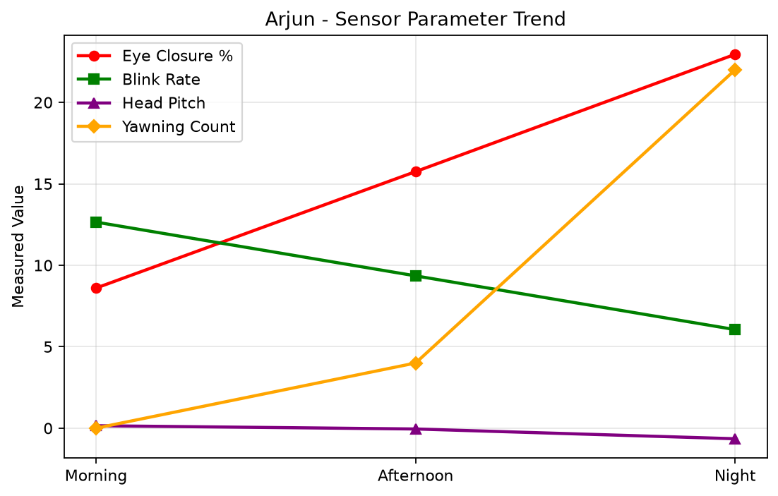
Measured Eye Closure, Blink Rate, Head Pitch and Yawning

6.3 Neha
Shift | Overall | Status | Eye | Blink | Head | Yawn | Distance | Duration
Morning | 92.9 | Attentive | 90.2 | 100.0 | 85.2 | 100.0 | 18.0 | 20 min
Afternoon | 88.5 | Attentive | 80.0 | 98.8 | 85.5 | 96.5 | 35.2 | 20 min
Night | 77.0 | Moderately Attentive | 65.0 | 68.8 | 90.5 | 96.5 | 52.2 | 20 min
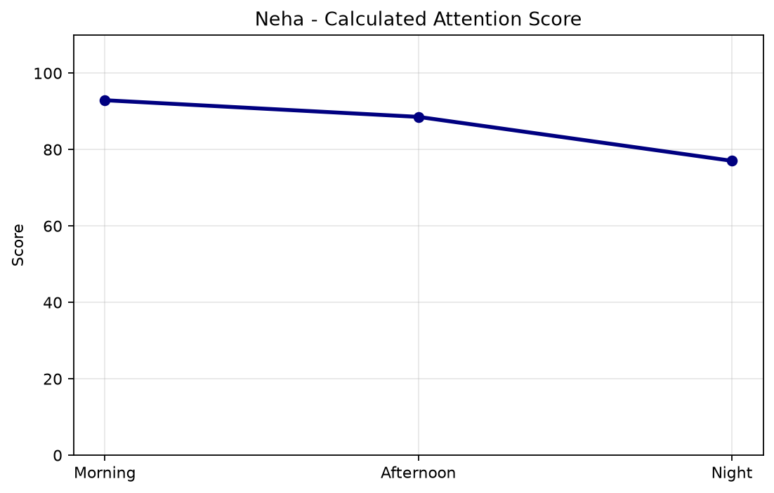
Calculated Attention Score by Shift
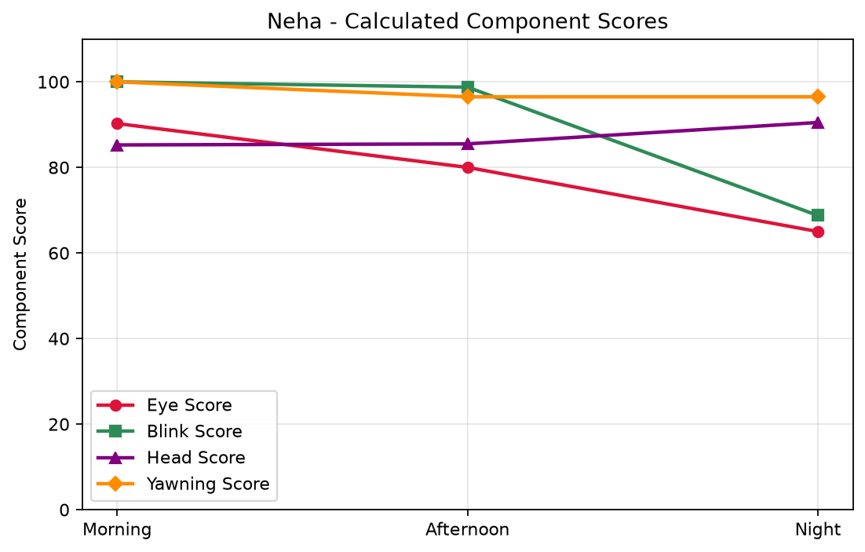
Calculated Eye, Blink, Head Pitch and Yawning Component Scores
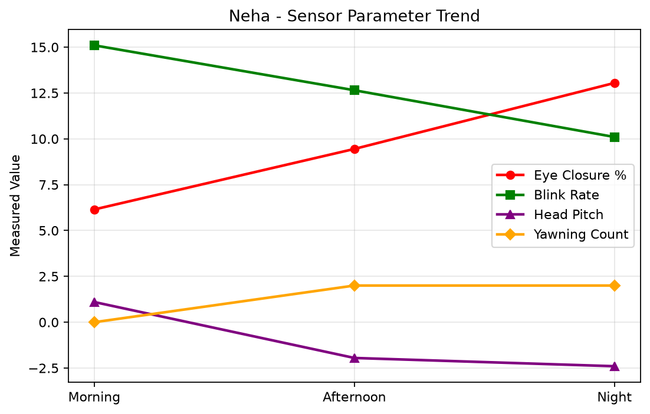
Measured Eye Closure, Blink Rate, Head Pitch and Yawning

6.4 Priya
Shift | Overall | Status | Eye | Blink | Head | Yawn | Distance | Duration
Morning | 99.2 | Attentive | 97.8 | 100.0 | 100.0 | 100.0 | 17.6 | 20 min
Afternoon | 97.1 | Attentive | 91.8 | 100.0 | 100.0 | 100.0 | 34.8 | 20 min
Night | 94.8 | Attentive | 86.5 | 100.0 | 100.0 | 96.5 | 51.9 | 20 min
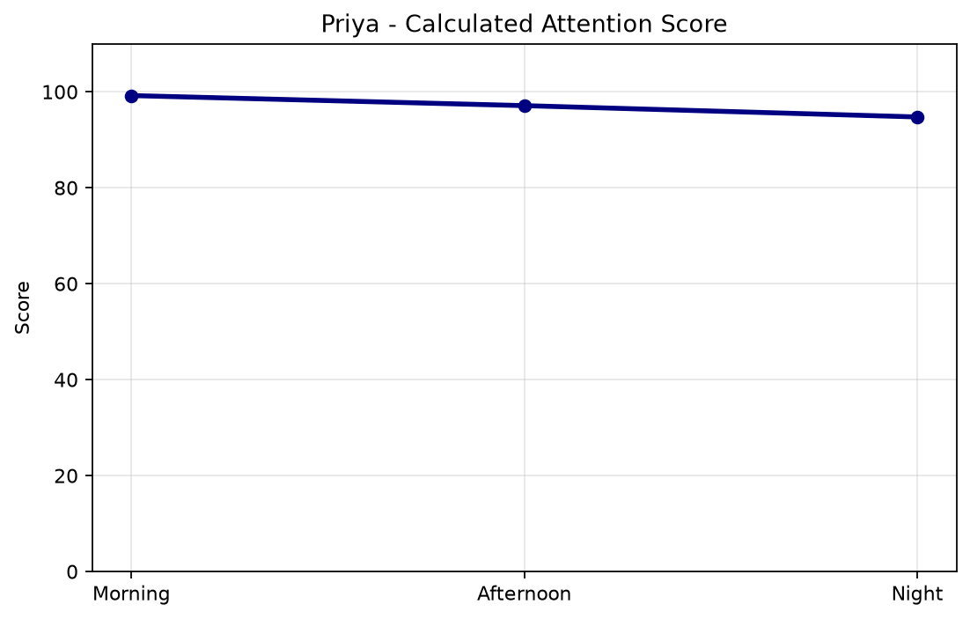
Calculated Attention Score by Shift
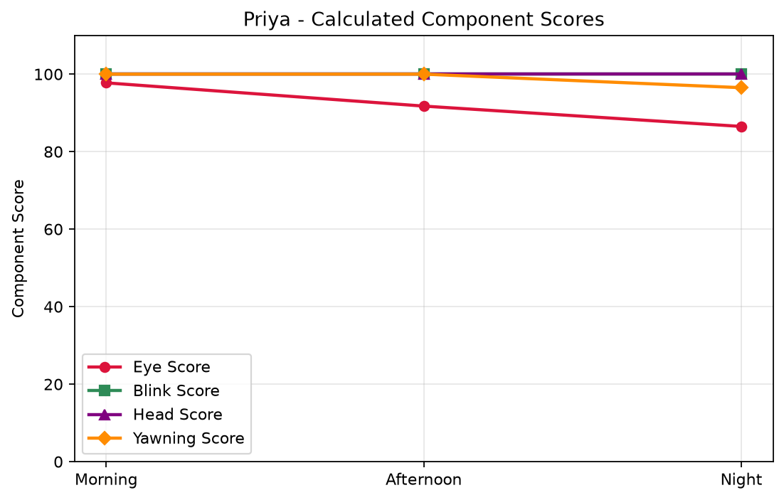
Calculated Eye, Blink, Head Pitch and Yawning Component Scores
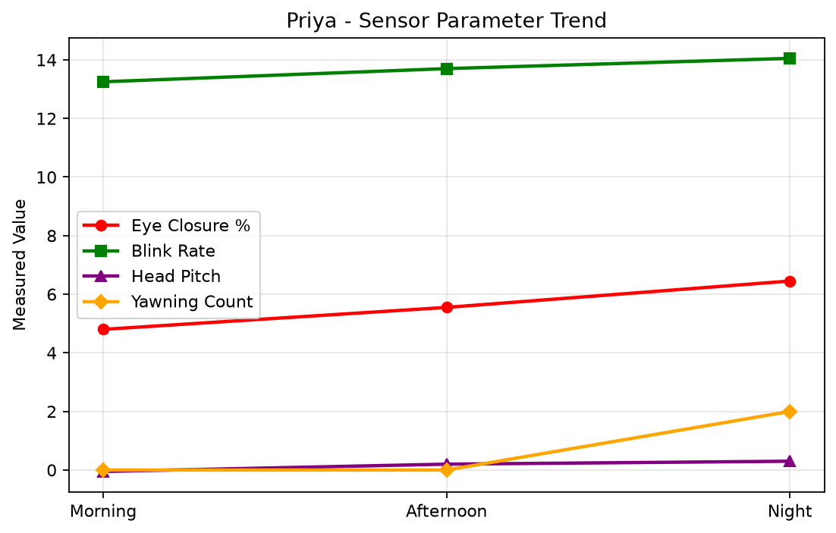
Measured Eye Closure, Blink Rate, Head Pitch and Yawning

6.5 Rahul
Shift | Overall | Status | Eye | Blink | Head | Yawn | Distance | Duration
Morning | 100.0 | Attentive | 100.0 | 100.0 | 100.0 | 100.0 | 17.3 | 20 min
Afternoon | 100.0 | Attentive | 100.0 | 100.0 | 100.0 | 100.0 | 34.7 | 20 min
Night | 100.0 | Attentive | 100.0 | 100.0 | 100.0 | 100.0 | 52.8 | 20 min
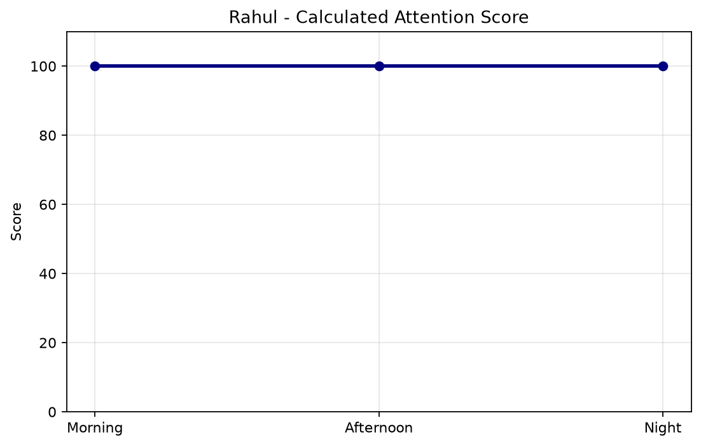
Calculated Attention Score by Shift
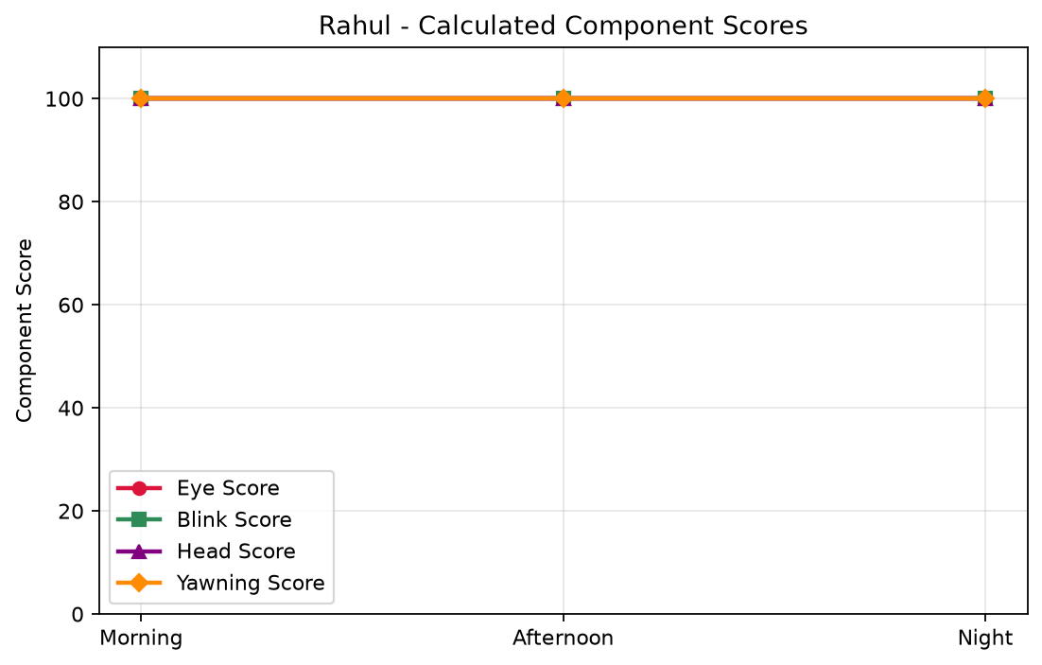
Calculated Eye, Blink, Head Pitch and Yawning Component Scores
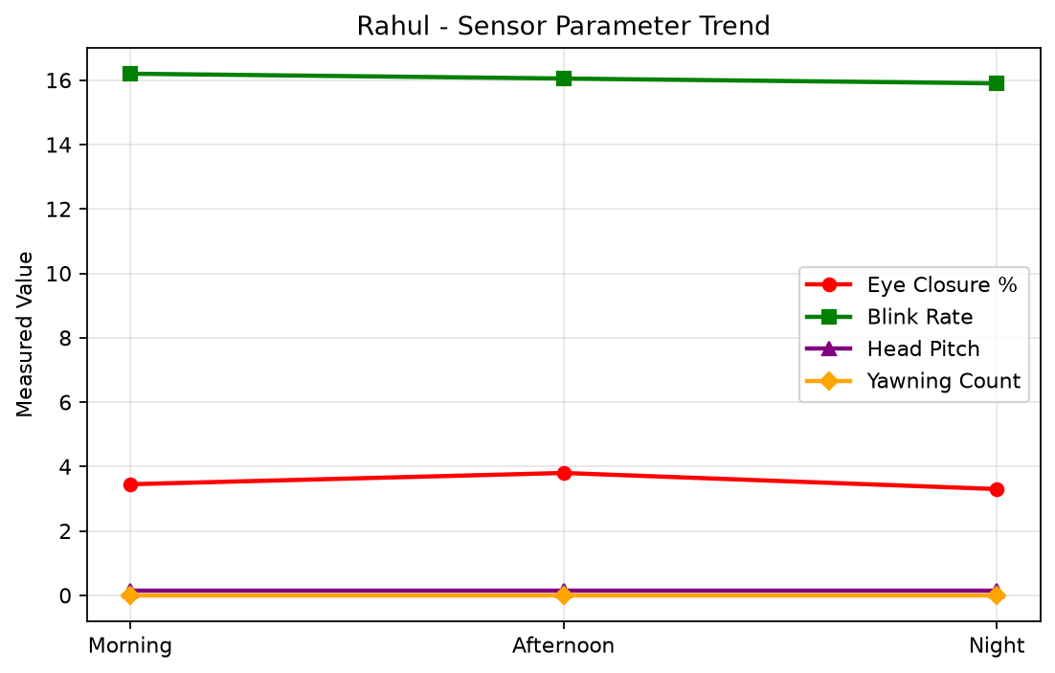
Measured Eye Closure, Blink Rate, Head Pitch and Yawning

7. Conclusion
The calculated analysis produced an average driver score of 88.11/100.Rahul is the best-performing driver with an overall score of 100.00/100 and a status of Attentive.Arjun recorded the lowest overall score of 63.43/100 and requires the greatest attention. Morning is the best-performing shift with an average score of 94.48/100, while Night is the lowest-performing shift with an average score of 81.19/100.Among the 5 drivers,4 are Attentive,0 are Moderately Attentive, and 1 are Inattentive. The results are generated dynamically from eye closure, blink rate, head pitch and yawning measurements. Therefore, changing these values in the Excel dataset and running the project again will automatically update the scores, statuses, rankings, charts and this conclusion.

