PYTHON MEGA PROJECT
Vehicle Telematics & GPS Analytics Platform
Prepared By | Sudharsana R, Yashraj Patil, Venu Gadekar
Project Topic | Vehicle Telematics & GPS Analytics
Document purpose | Mega Project Documentation

1. Introduction
1.1 Project Overview
The Vehicle Telematics & GPS Analytics Platform is a cloud-connected system that collects vehicle telemetry data and GPS information, stores it in Firebase, performs analytics, and presents insights through a Streamlit dashboard. The platform is designed to give a fleet manager or vehicle owner a real-time, data-driven view of how a vehicle is being driven, where it has travelled, how much fuel it is consuming, and whether any unsafe driving behavior or mechanical irregularity has occurred during a trip.
2. System Architecture
2.1 Architecture Overview
The Vehicle Telematics & GPS Analytics Platform follows a cloud-based architecture in which vehicle telemetry data is generated, stored in Firebase, processed using Python, analyzed through multiple analytics modules, and visualized on a Streamlit dashboard. The architecture enables real-time vehicle monitoring, driving behavior analysis, fuel monitoring, and alert generation.
2.2 Block Diagram
Vehicle telemetry data is stored in Firebase in JSON format. The Python backend retrieves this data and splits processing into two parallel stages — Pandas for data cleaning/processing and the Analytics Engine for speed, distance, driving pattern, fuel and idle-time analysis. The combined results are then visualized using Folium (maps) and Plotly (charts) before being presented on the Streamlit dashboard.
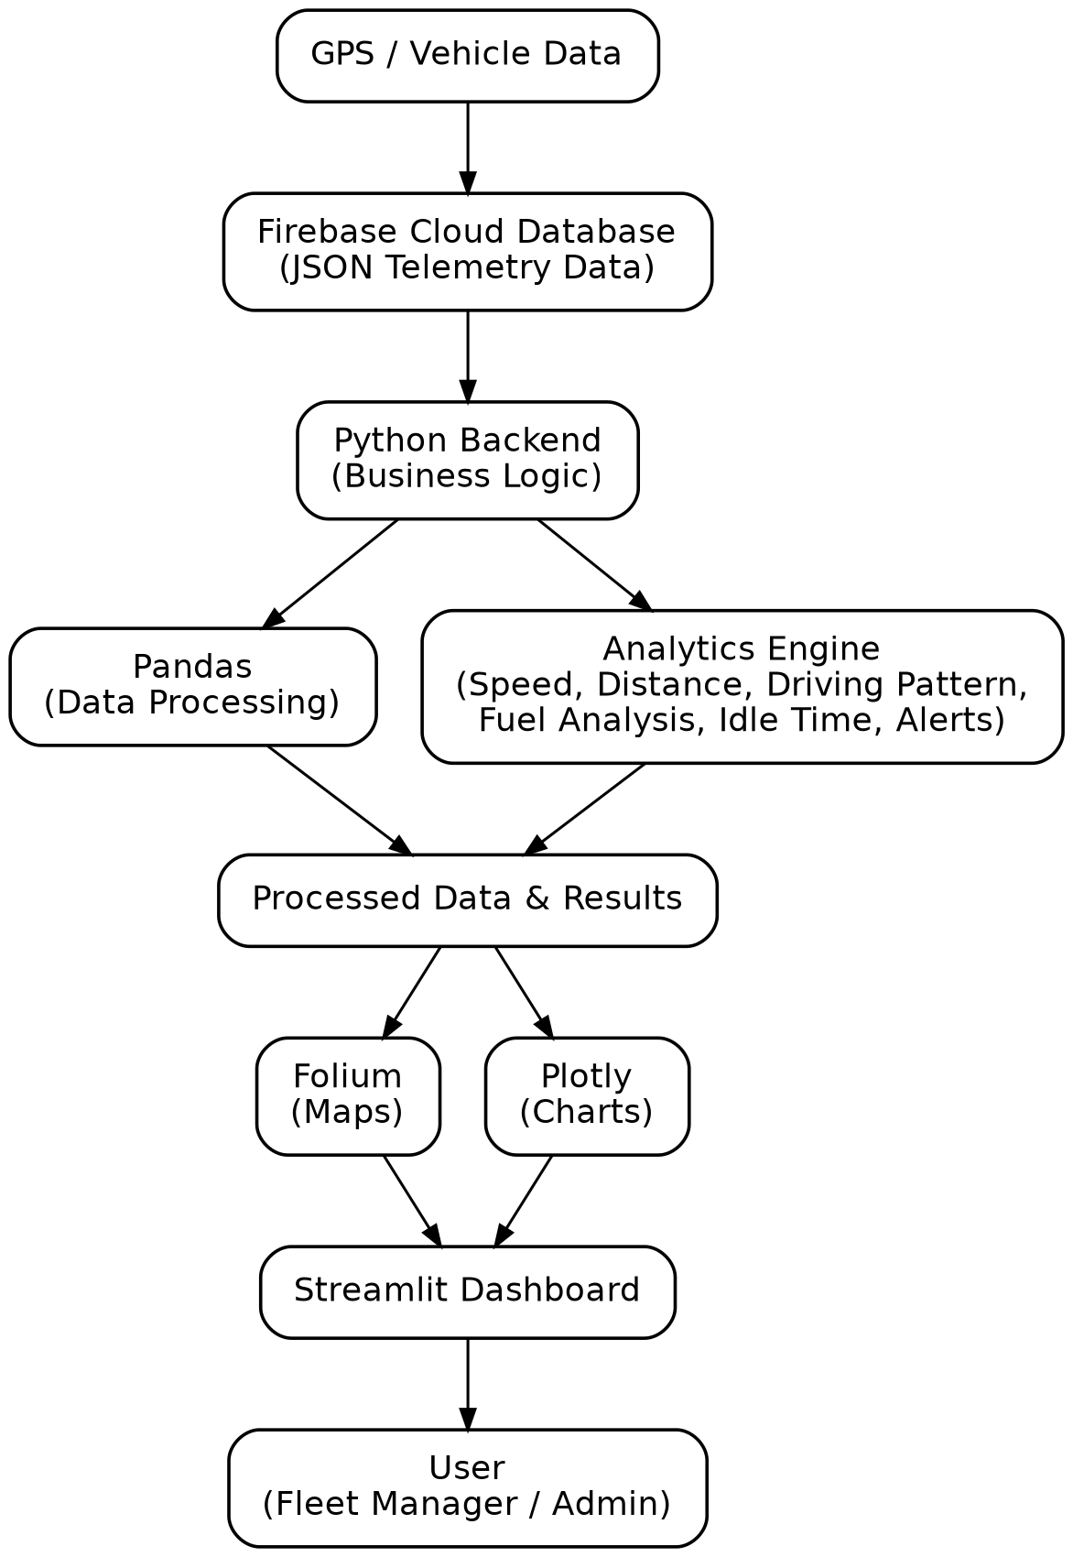
Figure 1: System block diagram of the Vehicle Telematics & GPS Analytics Platform
3. Data Collection Module
3.1 Telemetry Data Generation
Vehicle telemetry data is generated using a Python-based vehicle simulator that models realistic GPS movement, speed, fuel consumption, and engine temperature. The simulated data is transmitted to a cloud database for further processing.
3.2 Input Parameters
Parameter | Description
Timestamp | Time record
Latitude | GPS coordinate
Longitude | GPS coordinate
Speed | Vehicle speed
Fuel Level | Fuel data
Engine Temperature | Engine temperature reading
4. Data Processing Module
4.1 Data Retrieval
Telemetry records are retrieved from the Firebase Cloud Database and loaded into a Pandas Data Frame through the Python backend for data processing, analysis, and manipulation.
5. Analytics Module
5.1 GPS Analytics
GPS Analytics processes latitude and longitude coordinates to track vehicle movement, identify start and end locations, calculate the total distance travelled, and generate route maps for visualization and monitoring purposes.
5.2 OSRM Route Analytics
The Open-Source Routing Machine (OSRM) API is used to snap raw GPS coordinates to the actual road network, calculate route distance, and estimate travel time, thereby providing more accurate route analytics and navigation-related insights.
6. Alert Management System
6.1 Alert Generation
The system automatically generates Overspeed Alerts, High Engine Temperature Warnings, Low Fuel Warnings, and Vehicle Status notifications that are displayed in real time on the dashboard. A manual Emergency SOS feature is also available for raising instant alerts when required.
7.Driving Behavior Analytics
The Driving Behavior Analytics module evaluates driver performance by analyzing speed changes between consecutive telemetry records to identify unsafe driving patterns such as normal driving, over speeding, harsh acceleration, and harsh braking in real time. The detected behavior is automatically classified and displayed on the Streamlit dashboard.

7.1. Normal Driving
The first telemetry record is always classified as Normal Driving because there is no previous speed available for comparison. Vehicle movement remains within normal operating conditions when no abnormal speed variation is detected.
7.2. Overspeed Detection
If the vehicle speed exceeds 80 km/h, the event is classified as Overspeed. Overspeed events indicate that the driver has crossed the predefined speed threshold. These events are also used to trigger dashboard alerts and notifications.
7.3. Harsh Acceleration Detection
If the increase in speed between two consecutive records is 8 km/h or more, the event is classified as Harsh Acceleration. This represents sudden acceleration and aggressive driving behavior. Frequent harsh acceleration events may increase fuel consumption and reduce vehicle efficiency.
7.4. Harsh Braking Detection
If the decrease in speed between two consecutive records is 8 km/h or more, the event is classified as Harsh Braking. This indicates abrupt braking behavior that may impact passenger comfort and vehicle safety. Repeated harsh braking events may indicate unsafe driving patterns.
8. Dashboard and Visualization
8.1 Streamlit Dashboard
The Streamlit Dashboard displays vehicle telemetry data, GPS information, driving behavior analytics, fuel consumption, trip statistics, real-time alerts, and an Emergency SOS module.
9. Firebase Integration
9.1 Role of Firebase
Firebase acts as the cloud database of the project and stores both live and historical telemetry data.

10. Libraries Used
Library | Purpose
Pandas | Data Reading & Analysis
Plotly | Interactive Charts
Folium | Map Visualization
Firebase Admin SDK | Cloud Database Connectivity
Streamlit | Dashboard Development
Datetime | Time Calculations
OSRM | Road Routing & Travel Time Estimation
11. Workflow Description
The vehicle simulator generates telemetry data and stores it in Firebase Cloud Database (JSON format). The Python backend retrieves the data, where Pandas performs data cleaning and processing while the Analytics Engine calculates speed, distance, driving pattern, fuel analysis, engine temperature, and alerts. GPS coordinates are processed using the OSRM API for route and travel-time estimation, and the results are visualized using Folium and Plotly in the Streamlit dashboard for real-time vehicle monitoring.
12. Conclusion
The Vehicle Telematics & GPS Analytics Platform provides an efficient solution for fleet monitoring and vehicle analytics using Firebase, Python analytics, and Streamlit dashboards. The system enables route tracking, speed monitoring, fuel management, and driver behavior analysis while detecting overspeed and harsh-driving events in real time, giving fleet managers a clear view of vehicle and driver performance.

