**Reduced-intensity and myeloablative conditioning in patients with adult acute lymphoblastic leukemia undergoing hematopoietic stem cell transplantation: a meta-analysis and systematic review**

**ABSTRACT:**

**Background:** We performed a systematic review and meta-analysis to compare the clinical outcomes and toxicity of reduced-intensity conditioning (RIC) and myeloablative conditioning (MAC) in patients with adult acute lymphoblastic leukemia (ALL) undergoing hematopoietic stem cell transplantation (HSCT). **Materials and Methods:** A comprehensive COCHRANE LIBRARY, MEDLINE, EMBASE and GOVERNMENT CLINICAL TRIAL REGISTRY search was performed using the following keywords ‘REDUCED INTENSITY CONDITIONING REGIMEN’ , ‘MYELOABLATIVE CONDITIONING REGIMEN’, ‘HEMATOPOIETIC STEM CELL TRANSPLANT’ and ‘ADULT ACUTE LYMPHOBLASTIC LEUKEMIA’. The primary endpoints were overall survival (OS) and disease-free survival (DFS) and relapse incidence (RI) while the secondary endpoints were non-relapse mortality (NRM), grade II-IV acute graft-versus-host disease (aGVHD), and chronic GVHD (cGVHD).

**Results:** Four studies (3 prospective and 1retrospective) involving 2458 patients who received RIC (n = 486) or MAC (n = 2366) before undergoing HSCT were included in the analysis. Median age and the number of patients with Philadelphia Chromosomes were higher in the RIC arm than in the MAC arm. Significant heterogeneity was not found among the studies for any of the endpoints except for cGVHD. OS (Relative Risk [RR], RR, 1.00; 95% CI, 0.90-1.12;p=0.98) , cGVHD (RR, 1.02; 95% CI, 0.89-1.16; p = 0.81) and NRM (RR, 0.90; 95% CI, 0.77-1.05; p = 0.18) were similar in the RIC and MAC arms, whereas DFS (RR, 0.83; 95% CI, 0.73-0.95; p =0.005) and grade II-IV aGVHD (RR, 0.86; 95% CI, 0.76-0.98; p = 0.02) were higher in the RIC arm than in the MAC arm. The incidence of RI (RR, 1.51; 95% CI, 1.30-1.76; p < 0.00001) was higher in MAC compared to RIC.

**Conclusion:** RIC before HSCT may not be an effective treatment strategy for adult ALL patients who are not suitable candidates for MAC before undergoing HSCT due to its high rate of relapse incidence and poorer disease free survival. However, heterogeneity in baseline patient characteristics and treatment protocols may have influenced the outcomes of RIC HSCT in our analysis. Future randomized controlled trials are needed to confirm our findings.

**INTRODUCTION:**

Acute Lymphoblastic Leukemia (ALL) has traditionally being labelled as a disease of the paediatric population. There is an estimation that around 6000 cases of ALL are found in the USA [1,2] out of which roughly 40% are adult ALL [3]. Treatment of adult ALL has been plagued by poorer prognosis unlike that of paediatric ALL. This has led to undertaking of many studies to find out better treatment protocols for adult ALL. [4]. Allogeneic SCT has long been considered the standard treatment of adult ALL with good prognosis. [5,6,7,8] Chemotherapeutic conditioning regimen play a pivotal part in the process of allogeneic stem cell transplantation in adult ALL patients. Understandably, as a part of pre transplant procedure it is very important for us to decide the best possible conditioning regimes so as to reduce mortalities and morbidities associated with it. Myeloablative conditioning (MAC) involves the complete destruction of all the hematopoietic cells in the bone marrow, whereas in Reduced Intensity Conditioning (RIC) the dose of chemotherapy or Total Body Irradiation (TBI) is reduced by at least 30%. [9]The early conventional conditioning regimes relied primarily on myeloablation to remove the malignant tumour cells but gradually low intensity regimes were undertaken to leverage the benefits of graft versus Leukemia effects rather than the cytoreductive effects so as to benefit from the reduced toxicities of RIC. [10,11] Recent studies have shown promising results with the use of RIC for the treatment of adult ALL,[12,13,14] especially in elderly patients with co-morbidities.[15] Although very few trials have verified this claim . The aim of our study is to undertake a systematic review of literature and analyze the outcome of myeloablative and non-myeloablative conditioning in patients with adult acute lymphoblastic leukemia undergoing hematopoietic stem cell transplantation. This, in turn, will help us to reach a conclusion on the best possible conditioning regimen for adult ALL patients undergoing hematopoietic stem cell transplantation which can pave way to answer a pivotal issue in clinical practice.  
  
**OBJECTIVES:**

To evaluate the effectiveness and safety of Reduced Intensity Conditioning(RIC) compared to Myeloablative Conditioning (MAC) in adult patients with Acute Lymphocytic Leukemia (ALL) undergoing hematopoietic stem cell transplant .

**MATERIALS AND METHODS:**

**Selection criteria**

Prospective and retrospective clinical trials comparing RIC vs MAC regimen in in adult patients with Acute Lymphocytic Leukemia (ALL) undergoing hematopoietic stem cell transplant.

**Data sources and searches**

We conducted a comprehensive search strategy with no restriction on study years to identify published trials. Relevant trials were identified by searching the COCHRANE LIBRARY, MEDLINE,EMBASE and GOVERNMENT CLINICAL TRIAL REGISTRY till April 2015 using the search words ‘REDUCED INTENSITY CONDITIONING REGIMEN’ , ‘MYELOABLATIVE CONDITIONING REGIMEN’, ‘HEMATOPOIETIC STEM CELL TRANSPLANT’ and ‘ADULT ACUTE LYMPHOBLASTIC LEUKEMIA’. A number of relevant search results were found by typing them separately and using different meaningful combination of these search words.

**Data collection and analysis**

Two review authors (A.D and S.K ) independently screened studies and had planned to extract data and assess risk of bias using standard Cochrane Collaboration methodologies. Disagreements were resolved through discussion or through a third reviewer (K.K.D ).We included trials that included patients receiving RIC versus patients receiving MAC in adult patients suffering from ALL before undergoing hematopoietic stem cell transplantation, irrespective of the stage of complete remission that the patients were having at the time of intervention. Trials were included only once in the analysis using the most updated data. Interventions that were assessed include RIC and MAC in adult patients suffering from ALL.

**Data Extraction**

Two reviewers independently extracted data from included trials (A.D , and ).

**Quality Assessment**

Because the different trial arms are not randomized, various characteristics may not be well balanced and carry a potential for bias. Thus, trials that fulfilled the review inclusion criteria were assessed for methodological quality by reviewers (A.D ,). Not reporting of any of the items was considered as high risk for bias. First, we evaluated whether the trial was analyzed with intention-to-treat (ITT) methodology. ITT was defined as the number of patients that were excluded from their allocated intervention group for outcome assessment and the number of the patients included. This was done because an ‘‘as treated’’ analysis might introduce bias in favour of MAC in the process of patient selection. We considered any violation of ITT as the sole most important risk of bias domain for clinical trials.

**Primary outcomes:**

1.Overall survival (OS) of the transplanted patients irrespective of the complications of transplantation (either disease progression, relapse or partial remission or adverse effects of the transplant procedure like graft failure, grade III/IV acute GVHD, or both) and the quality of life after transplantation. Time period to be reported after at least 24 months of follow-up.

2. Disease-free survival (DFS) (event is defined as either ALL manifestations or adverse effects of the transplant procedure like graft failure, grade III/IV acute GVHD, or both) the interval from time of randomisation or study entry to the first recurrence of event or to death of any cause. Time period to be reported after at least 24 months of follow-up.

3. Relapse Incidence (RI) (defined as time to relapse) indicates the deaths without relapse and applies to patients previously in disease remission.

**Secondary Outcomes:**

1. Acute GVHD (aGVHD) (Grade 2-Grade 4) which determines the immediate success of the transplantation and implies the need for second transplantation and is significant controller of the mortality in transplanted patients.

2.Chronic GVHD (cGVHD) (Limited and extensive) which determines the morbidity of the transplanted patients and governs the quality of life post transplant.

3. Non-Relapse Related Mortality (NRM) which determines the time to deaths without relapse/recurrence indicating deaths from any cause without prior progression are events in transplanted patients.

**Data Synthesis and Analysis**

Dichotomous data (Occurrence / Non-occurrence) were analyzed for each effect - Primary (Overall Survival, Disease Free Survival and Relapse Incidence ) and Secondary (acute GVHD, chronic GVHD and Non-relapse Related Mortality), by calculating the relative risk (RR) for the effect corresponding to each individual trial along with the 95% confidence interval(CI). Our principal goal is to present a comparative analysis of MAC and the RIC procedures for both primary and the secondary effects, through the meta analysis of 4 trials. From the primary effects forest plot (**Fig 1**), it appears that MAC has higher chances of overall survival than RIC but in terms of disease free survival, both RIC and MAC seem to be equivalent in effectiveness. However, the relapse incidence rate is found to be higher for MAC compared to RIC. As far as the secondary effects are concerned, it seems MAC leads to higher occurrence of chronic GVHD and lesser occurrence of acute GVHD compared to RIC (**Fig 2**). However, overall across all the secondary effects, not enough evidence was found to choose one method over the other. We tested if there is publication bias for any trial corresponding to any of the primary or secondary effects, but the funnel plot and Begg and Egger’s test seemed to indicate the lack of any publication bias (**Fig 3**). The entire analysis and the plots were done using the packages **metaphor** and **rmeta**  in R 3.2.0 [16,17,18].

**RESULTS:**

Using electronic searches in MEDLINE, EMBASE, Google Scholar and the Cochrane Central Register of Controlled Trials, 84 citations were obtained. After removal of 66 duplicates and irrelevant articles, we screened 18 references through title and abstract review. Of these, 7 studies underwent full-text review. After full-text review, 3 studies were excluded. Reasons for exclusion were single-arm prospective clinical trials or single-arm phase 2 prospective clinical trials. A total of 4 studies were included (2 evaluating Philadephia Chromosome positive patients in a subgroup analysis) enrolling 2852 patients. Among 4clinical trials, 486 patients were assigned to receive RIC and 2366 patients were assigned to receive MAC. The quality of the evidence was moderate to high for all outcomes.

Duplicate Manuscripts, Reviews and Case Reports (n=66)

Total electronic search results (n=84)

Relevant references through titles and abstract review (n=18)

Articles that did not get full text review after abstract review (n=11)

Articles undergone full text review (n=7)

Studies that were excluded for single-arm prospective clinical trials or single-arm phase 2 prospective clinical trials (n=5)

Clinical trials that were included in our study (n=4)[19,20,21,22]

**Fig1. Trial flow according to quality of reporting Meta-analysis**

**(QUOROM) is shown.Superscript indicate the Clinical Trials.**

**Baseline characteristics**

The main characteristics of the included studies are summarized in Table 1 and table 2 and the baseline characteristics of the of patients undergoing treatment with RIC and MAC are summarized in Table 1-3.

Table.1

Characteristics of Eligible Study Trials included in Meta Analysis :

|  |  |  |  |
| --- | --- | --- | --- |
| Reference | Disease | Study Type | Centers |
| Marks et al  2010 | ALL  Ph – Negative | Prospective | Single |
| Mohty et al  2010 | ALL | Retrospective | Single |
| Eom et al  2013 | ALL | Prospective | Single |
| Tanaka et al  2013 | ALL | Prospective | Single |

Table.2

Characteristics of Patients undergoing Clinical Trials included in Meta Analysis

|  |  |  |  |  |  |
| --- | --- | --- | --- | --- | --- |
| Study | Median Age | Philadelphia  (n) | Disease Status before Transplantation  (n) | | |
| **CR1** | **CR2** | **Missing** |
| Marks et al  2010 | 45/28 yrs | - | 55/747 | 38/681 | - |
| Mohty et al  2010 | 56/50 yrs | 41/104 | 105/391 | 22/58 | - |
| Eom et al  2013 | 46/33 yrs | 38/76 | 52/104 | 8/16 | - |
| Tanaka et al  2013 | 58/51 yrs | 125/188 | 160/310 | 40/55 | 6 / 4 |

Table.3

Outcome of Patients undergoing Clinical Trials included in Meta Analysis

|  |  |  |  |  |  |  |  |  |
| --- | --- | --- | --- | --- | --- | --- | --- | --- |
| Study | Intervention Arms | No of Patients | OS  (n) | DFS  (n) | RI  (n) | NRM  (n) | aGVHD  (100 days)  (II – IV)  (n) | cGVHD  (n) |
| Marks et al  2010 | RIC vs MAC | 93/1428 | 35/614 | 29/585 | 33/371 | 30/471 | 36/657 | 32/600 |
| Mohty et al  2010 | RIC vs MAC | 127/449 | 61/202 | 41/171 | 60/139 | 27/130 | 37/166 | 48/162 |
| Eom et al  2013 | RIC vs MAC | 60/120 | 33/68 | 30/66 | 21/32 | 13/29 | 29/60 | 34/54 |
| Tanaka et al  2013 | RIC vs MAC | 206/369 | 109/188 | 80/173 | 54/55 | 74/140 | 84/170 | 72/122 |

.

**Assessment of Risk of Bias**

Three trials that compared RIC vs MAC were prospective clinical trials were prospective controlled trials. One clinical trial (Mohty 2010 et al) which compared RIC vs MAC was retrospective clinical study. Most of the studies reported data on potential confounders (Table 2).None of the trials were blinded.

**Primary Outcomes**

**Overall Survival (OS)**

There was no significant difference in OS in patients receiving treatment with RIC compared to MAC before undergoing hematopoietic stem cell transplantation (RR, 1.00; 95% CI, 0.90-1.12, 4 trials, 2852 patients) .We considered the trials individually where Marks et al showed increase in OS with RIC compared MAC (RR, 0.88; 95% CI, 0.67-1.14, 1 trial, 1521 patients) and Eom et al whose result toed similar lines in terms of increase in OS with RIC compared to MAC(RR, 0.97;95% CI, 0.74-1.28, 1 trial, 180 patients). The exception was marked by the other two clinical trial, Mohty et al where OS for RIC was decreased compared to MAC (RR, 1.07; 95% CI, 0.87-1.31, 1 trial, 576 patients) and Tanaka et al ( RR, 1.04; 95% CI, 0.88-1.22, 1 trial, 575 patients) as shown in Fig 1.

**Disease-Free Survival (DFS)**

DFS analysis shows a slight increase in patients receiving RIC compared to MAC (RR, 0.83; 95% CI, 0.73-0.95, 4 trials, 2852 patients) in total. This is marked by the increase in DFS in patients RIC compared to MAC unanimously in all the four studies namely Marks et al (RR, 0.76; 95% CI, 0.56-1.04, 1 trial, 1521 patients), Mohty eta al (RR, 0.85; 95% CI, 0.64-1.12, 1 trial, 576 patients), Eom et al (RR,0.91; 95% CI, 0.67-1.23, 1 trial, 180 patients) and Tanaka et al (RR, 0.83; 95% CI, 0.73-0.95, 1 trial, 575 patients) as is shown in Fig 1.

**Relapse Incidence (RI):**

Relapse Incidence (RI) , which was another very important factor in primary outcome showed patients receiving MAC had a significant increase compared to MAC before undergoing hematopoietic stem cell transplantation (RR, 1.51; 95% CI, 1.30-1.75, 4trials ,2852 patients). This is significant as this increase in Relapse Incidence (RI) in patients RIC compared to MAC was noted unanimously in all the four studies namely Marks et al (RR, 1.37; 95% CI, 1.02-1.82, 1 trial, 1521 patients), Mohty eta al (RR, 1.53; 95% CI, 1.21-1.92, 1 trial, 576 patients), Eom et al (RR,1.31; 95% CI, 0.82-2.07, 1 trial, 180 patients) and Tanaka et al (RR, 1.76; 95% CI, 1.26-2.46, 1 trial, 575 patients) but none of these results attained statistical significance as is shown in Fig 1.

**Secondary Outcomes**

**Acute GVHD:**

A significant increase in acute GVHD (II-IV) can be seen in patients receiving RIC compared to MAC which follows the uniform pattern in all the 4 clinical trials (RR, 0.86; 95% CI, 0.76-98, 4 trials, 2852 patients) which is demonstrated in Fig 5. This trend is unanimous and followed by all the four clinical trials where Marks et al (RR, 0.84; 95% CI, 0.65-1.09, 1 trial, 1521 patients), Mohty eta al (RR, 0.79; 95% CI, 0.59-1.06, 1 trial, 576 patients), Eom et al (RR,0.97; 95% CI, 0.70-1.33, 1 trial, 180 patients) and Tanaka et al (RR, 0.89; 95% CI, 0.73-1.08, 1 trial, 575 patients) all showed similar outcomes in terms of acute GVHD (II-IV).

**Chronic GVHD**

No statistically significant increase in chronic GVHD can be seen in patients receiving RIC compared to MAC undergoing stem cell transplantation (RR, 1.02; 95% CI, 0.89-1.16, 4 trials, 2852patients) which is demonstrated in Fig 5. We considered the trials individually where Marks et al showed increase in GVHD with RIC compared MAC (RR, 0.82; 95% CI, 0.61-1.09, 1 trial, 1521 patients) but all other studies namely Eom et al (RR, 1.26;95% CI, 0.94-1.69, 1 trial, 180 patients) , Mohty et al (RR, 1.05; 95% CI, 0.81-1.35, 1 trial, 576 patients) and Tanaka et al ( RR, 1.06; 95% CI, 0.83-1.34, 1 trial, 575 patients) where chronic GVHD for MAC was increased as shown in Fig 2. There is also marked heterogeneity in this study outcome regarding Chronic GVHD.

**Non-Relapse Related Mortality (NRM):**

Non-Relapse Related Mortality (NRM) , which was an important factor in secondary outcome showed patients receiving RIC had no significant increase compared to MAC before undergoing hematopoietic stem cell transplantation (RR, 0.90; 95% CI, 0.77-1.05, 4trials ,2852 patients). This is marked by the increase in acute NRM in patients RIC compared to MAC unanimously in all the four studies namely Marks et al (RR, 0.98; 95% CI, 0.72-1.33, 1 trial, 1521 patients), Mohty eta al (RR, 0.73; 95% CI, 0.51-1.06, 1 trial, 576 patients), Eom et al (RR,0.90; 95% CI, 0.50-1.60, 1 trial, 180 patients) and Tanaka et al (RR, 0.95; 95% CI, 0.76-1.18, 1 trial, 575 patients) but none of these results attained statistical significance as is shown in Fig 2.

PUBLICATION BIAS:

The results of the Begg’s and Egger’s tests showed no significant indication of publication bias (Figure 3). Therefore, it is unlikely that publication bias had a major influence on the results of the study.

**DISCUSSION:**

Allogeneic SCT has long been associated with improved prognosis and the best mode of existing treatment in Acute Lymphoblastic Leukaemia (ALL) [5,23]. In post transplant period the common causes of mortality and morbidity are chemotherapy-related toxicity, graft rejection and Relapse. [24,25] The use of RIC should be theoretically associated with decreased increased graft rejection compared to the traditional MAC . Also the reduced doses must be associated with decreased regimen related toxicities which can be used for haematopoietic transplantation in patients with advanced age and comorbidities. This led to the exploration and development of different reduced intensity regimens for the treatment of adult ALL patients. Likewise, the use of RIC before stem cell transplantation has shown promising results in a study. [26] In spite of all the mentioned benefits, the question still lingers whether RIC can achieve the same level of engraftment of donor stem cell like MAC which can be easily quantified by the relapse incidence with each conditioning regimen.

In our analysis of the studies comparing MAC to RIC, there was a clear increase in DFS among patients receiving MAC compared to RIC (RR, 0.83; 95% CI, 0.73-0.95). Relapse Incidence (RI) showed a significant increase in RIC compared to MAC before undergoing hematopoietic stem cell transplantation (RR, 1.51; 95% CI, 1.30-1.75). Unexpectedly, a significant increase in acute GVHD (II-IV) can also been seen in patients receiving MAC compared to RIC (RR, 0.86; 95% CI, 0.76-98). In 2011, Cantu- Rodriguez OG et al had also found that the incidence of acute GVHD decreased with the use of RIC as compared to the conventional myeloablative regimens. [27]. However, we cannot elicit any significant difference in the OS in patients receiving treatment with RIC as compared to MAC (RR, 1.00; 95% CI, 0.90-1.12). The results for GVHD (RR, 1.02; 95% CI, 0.89-1.16) and Non-Relapse Related mortality (RR, 0.90; 95% CI, 0.77-1.05), we did not find any evidence that RIC can be touted as a better conditioning regimen than MAC. This is significantly deviant of what is generally expected of RIC and MAC given the cytotoxic nature of MAC.

Our study has several limitations. We only included retrospective clinical studies and they also lacked randomisation, so the chance of bias is quite high. We lack data on the initial level of WBCs in the patients, presence of Ph chromosome and age which are themselves poor prognostic markers [28] and needed to be considered, but could not be done due to lack data regarding it. The mean age of patients receiving RIC was 51.25 years as compared to MAC group where the mean age of patients were 40.5 years. So while comparing the cohorts in both the intervention arms, both the cohorts need to be more age matched. Decreased number of Philadelphia Chromosome (Ph) positive patients in RIC intervention arm ( 204) compared to MAC group (368) must have had an overall effect in the overall favourable outcome in MAC group as Ph positive is an independent poor prognostic factor in adult ALL patients. A stratified analysis which will contain Ph positive and Ph negative adult ALL patients in RIC and MAC patients would have been ideal to answer whether RIC or MAC is a better regimen in Ph positive adult patients. Data on MRD needs to be studied in greater details as MRD is an important cause of Relapse incidence, but due to the lack of data on MRD in the included studies we were not being able to get any conclusion regarding this.

In conclusion, we can state that the results of our analysis suggest that RIC before HSCT may not be as effective a treatment strategy for adult ALL patients who are not suitable candidates for MAC before undergoing HSCT. However, heterogeneity in baseline patient characteristics and treatment protocols may have influenced the outcomes of RIC HSCT in our analysis. Future randomized controlled trials are needed to confirm the results of our study in adult ALL patients undergoing HSCT.

**Future Recommendations for Practice and Research:**

1. RIC cannot be accepted as a better option of conditioning regimen before allogeneic stem cell transplantation in patients with adult ALL mostly due to its inferior disease free survival and more frequent relapse incidence.
2. MAC can significantly increase the morbidity in post-transplant patients with adult ALL by increasing the chances of acute GVHD (II-IV).
3. Large Randomized Clinical Trial needs to be undertaken to validate our study results and confer whether RIC may be considered a better conditioning regimen alternative to MAC in adult ALL patients undergoing hematopoietic stem cell transplantation.

**REFERENCES:**

1. National Cancer institute.NCI: *Adult Acute Lymphoblastic Leukemia Treatment–for health professionals* http://www.cancer.gov/types/leukemia/hp/adult-all-treatment-pdq#link/_14_toc Accessed July 29, 2015.
2. Rebecca Siegel, Jiemin Ma, Zhaohui Zou, et al. Cancer statistics 2014.CA *Cancer j clin; 64(1): 9-29.*
3. Inaba H, Greaves M, Mullighan CG. Acute Lymphoblastic Leukaemia. *Lancet*.2013;381(9881).
4. Mark R. Litzow . Evolving paradigms in the therapy of Philadelphia chromosome–negative acute lymphoblastic leukemia in adults. *Haematology* 2009;362-70.
5. Xavier Thomas, Jean-Michel Boiron, Françoise Huguet, et al. Outcome of Treatment in Adults With Acute Lymphoblastic Leukemia: Analysis of the LALA-94 Trial. *Journal of Clinical Oncology* 2004;22(20): 4075-86.
6. B-S Cho,S Lee,Y-J Kim, et al. Reduced-intensity conditioning allogeneic stem cell transplantation is a potential therapeutic approach for adults with high-risk acute lymphoblastic leukemia in remission: results of a prospective phase 2 study. *Leukemia.2009;* *23, 1763–1770.*
7. David I. Marks, Waleska S. Pérez, Wensheng He, et al. Unrelated donor transplants in adults with Philadelphia-negative acute lymphoblastic leukemia in first complete remission. *Blood*,2008;112( 2),426-434.
8. Avivi I, Rowe JM, Goldstone AH. Stem cell transplantation in adult ALL patients. *Best Pract Res Clin Haematol*. 2002 ;15 (4):653-74.
9. Mengarelli A, Iori A, Guglielmi C, et al. Standard versus alternative myeloablative conditioning regimens in allogeneic hematopoietic stem cell transplantation for high-risk acute leukemia. *Haematologica* 2002; 87(1):52-58.
10. Boglarka Gyurkocza and Brenda M. Sandmaier. Conditioning regimens for hematopoietic cell transplantation: one size does not fit all. *Blood* 2014;124 (3), 344-353.
11. Giralt S, Estey E, Albitar M, et al. Engraftment of Allogeneic Hematopoietic Progenitor Cells With Purine Analog-Containing Chemotherapy: Harnessing Graft-Versus-Leukemia Without myeloablative Therapy. *Blood* 1997 ; 89( 12): 4531-4536.
12. Anthony S. Stein, Joycelynne M. Palmer, Margaret R. O'Donnell, et al. Reduced intensity conditioning followed by peripheral blood stem cell transplantation for adult patients with high-risk acute lymphoblastic leukemia. *Biol Blood Marrow Transplant* 2009;15(11):1407-1414.
13. McSweeney PA, Niederwieser D, Shizuru JA, et al. Hematopoietic cell transplantation in older patients with hematologic malignancies: replacing high-dose cytotoxic therapy with graft-versus-tumor effects. *Blood* 2001; 97 (11):3390 – 3440.
14. Marks DI, Wang T, Pérez WS, et al. The outcome of full-intensity and reduced-intensity conditioning matched sibling or unrelated donor transplantation in adults with Philadelphia chromosome– negative acute lymphoblastic leukemia in first and second complete remission. *Blood* 2010;116 (3):366-374.
15. Urs Schanz. Allogeneic haematopoietic stem cell transplantation with reduced intensity conditioning regimens (“minitransplants”).*Swiss med wkly* 2001;131:59–64.
16. R Development Core Team. *R: a language and environment for statistical computing*., Vienna, Austria. R Foundation for Statistical Computing,2012
17. Wolfgang Viechtbauer. Conducting Meta-Analyses in R with the metafor Package. *Journal of statistical software 2010;36(3):1-48*
18. Thomas Lumley*.* *Package ‘rmeta’* 2.16, 2012; 1-17.
19. Mohamad Mohty, Myriam Labopin, Liisa Volin, et al. Reduced-intensity versus conventional myeloablative conditioning allogeneic stem cell transplantation for patients with acute lymphoblastic leukemia: a retrospective study from the European Group for Blood and Marrow Transplantation. *Blood* 2010; 116(22):4439-4443
20. David I. Marks, Tao Wang, Waleska S. Pe´rez, et al*.* The outcome of full-intensity and reduced-intensity conditioning matched siblingor unrelated donor transplantation in adults with Philadelphia chromosome–negative acute lymphoblastic leukemia in ﬁrst and second complete remission. *Blood* 2010; 116 (3): 366-374
21. Ki-Seong Eom, Seung-Hwan Shin, Jae-Ho Yoon, et al. Comparable long-term outcomes after reduced-intensity conditioning versus myeloablative conditioning allogeneic stem cell transplantation for adult high-risk acute lymphoblastic leukemia in complete remission. *Am J Hematol* , 2013. 88(8):634-41
22. J Tanaka, H Kanamori, S Nishiwak, et al. Reduced-intensity vs myeloablative conditioning allogeneic hematopoietic SCT for patients aged over 45 years with ALL in remission: a study from the Adult ALL Working Group of the Japan Society for Hematopoietic Cell Transplantation (JSHCT). *Bone Marrow Transplantation*, 2013. 48: 1389 – 1394.
23. Denise M. Oliansky, Richard A. Larson, Daniel Weisdorf, et al. The Role of Cytotoxic Therapy with Hematopoietic Stem Cell Transplantation in the Treatment of Adult Acute Lymphoblastic Leukemia: Update of the 2006 Evidence-Based Review Denise. *Biol Blood Marrow Transplant 2012;18: 18-36.*
24. Hill GR, Crawford JM, Cooke KR, et al. Total Body Irradiation and Acute Graft-Versus-Host Disease: The Role of Gastrointestinal Damage and Inflammatory Cytokines. *Blood* 1997*;*90(8):3204-3213.
25. Gratwohl A, Brand R, Frassoni F, et al. Cause of death after allogeneic haematopoietic stem cell transplantation (HSCT) in early leukaemias: an EBMT analysis of lethal infectious complications and changes over calendar time. *Bone Marrow Transplantation* 2005; 36,757–769.
26. A Bacigalupo. Hematopoietic stem cell transplants after reduced intensity conditioning regimen (RI-HSCT): report of a workshop of the European Group for Blood and Marrow Transplantation (EBMT). *Bone Marrow Transplantation* (2000); 25, 803–805.
27. Cantú-Rodríguez OG, Gutiérrez-Aguirre CH, Jaime-Pérez JC, et al. Low incidence and severity of graft-versus-host disease after outpatient allogeneic peripheral blood stem cell transplantation employing a reduced-intensity conditioning. *Eur J Haematol*. 2011 Dec; 87(6): 521-30.
28. Hoelzer D, Thiel E, Löffler H, et al. Prognostic Factors in a Multicenter Study for Treatment of Acute Lymphoblastic Leukemia in Adults *Blood 1988;* 71(1): 123-131.

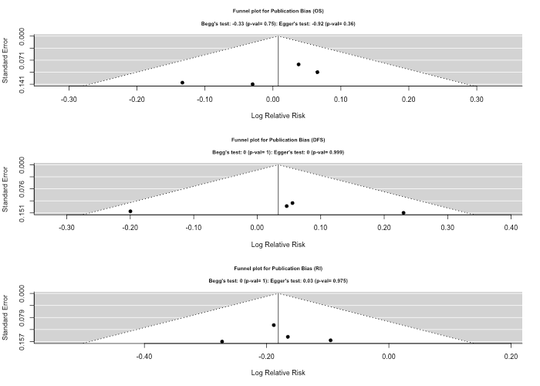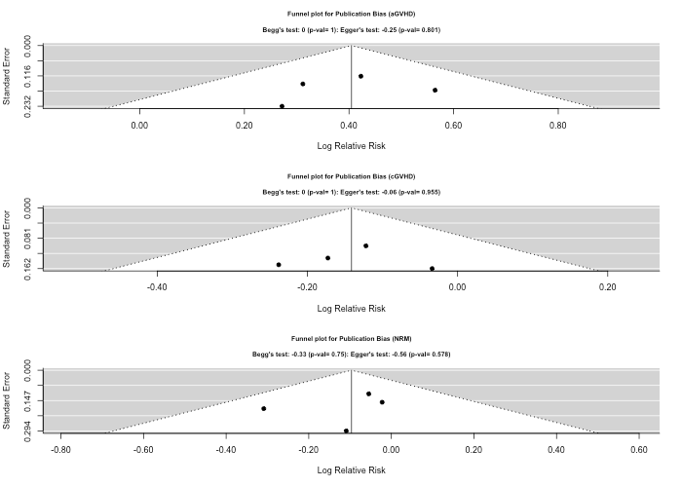

**Fig 2**: Forest plot of the secondary effects (acute GVHD -aGVHD, chronic GVHD - cGVHD, Non relapse Related Mortality- NRM )

**Fig 3**: Funnel plot of the effects (primary and secondary) showing no publication bias in any of the effects

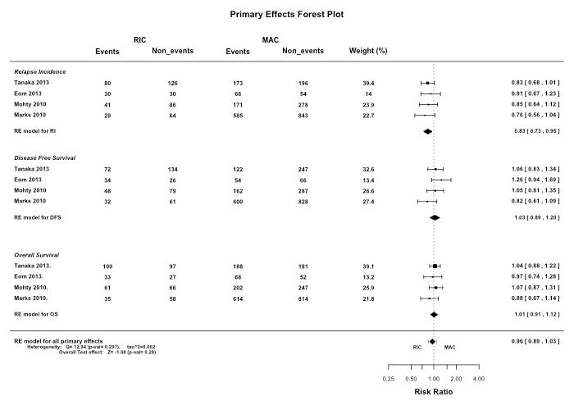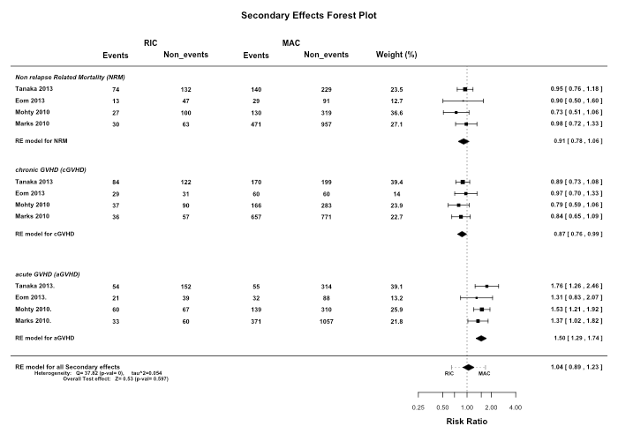

**Figures**

**Fig 1**: Forest plot of the primary effects (Overall Survival-OS, Disease Free Survival-DFS, Relapse Incidence- RI )

**Fig 1**: Forest plot of the primary effects (Overall Survival-OS, Disease Free Survival-DFS, Relapse Incidence- RI )