EzPdf User Manual

|  |  |
| --- | --- |
| **Version** | **0.2** |
| **Date** | **June 14, 2018** |

# Overview

*EzPdf*  is a simple, standalone desktop application for generating PDF documents from a *template* and a set *dictionary*. Below is a table that lists the terminology related to this project.

|  |  |
| --- | --- |
| **Terminology** | **Definition** |
| Template file | A text file (.txt or a plain document) that holds the final document contents with *placeholder(s)* for value substitution |
| Dictionary file | A text file (.properties or a plain document) that holds key-value pairs of placeholder key, mapping to their replacement value.  Examples:  username=Hello World  user.name=Hello World |
| Placeholder | An identified key that the application will use to lookup the actual value from the dictionary file - i.e. ${username} |

# System Requirements

|  |  |  |
| --- | --- | --- |
| **Mac** | **Unix/Linux** | **Windows** |
| JRE is packaged with .app folder | JDK 1.8 | JDK 1.8 |
| PDF reader application | PDF reader application | PDF reader application |

# Installation

*EzPdf* can be installed and run on a Mac OSX, Windows, or Unix/Linux desktop environment. Below is a table listing the installation artifacts.

|  |  |
| --- | --- |
| **Artifact** | **Description** |
| ezpdf-<version>.dmg | Mac installation distribution |
| ezpdf-<version>.tar | Linux or Windows installation distribution |
| ezpdf-<version>.zip | Linux or Windows installation distribution |

The sections below detail the installation for each artifact.

## Installation EzPdf on a Mac Desktop

1. Download the .dmg distribution
2. Double click the .dmg file

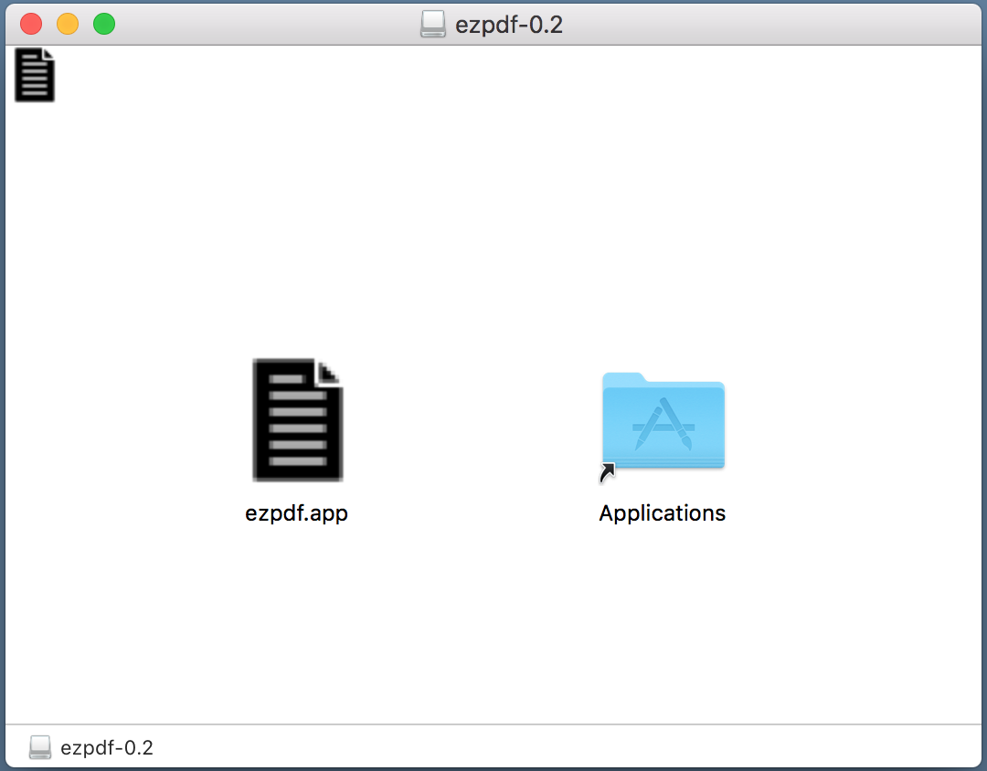

1. Drag the *ezpdf.app* icon into your *Applications* folder, your Desktop, or another destination of your choice
2. The *ezpdf.app* application icon should be installed where you dragged the icon from Step #3; double-click the icon to run the application

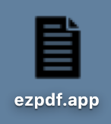

1. Cleaning up - There should be the mounted .dmg image drive on your Desktop

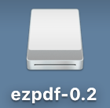

1. Cleaning up – Right-click and Eject the disk image

## Installation EzPdf on a Unix/Linux Desktop

1. Download the .tar or the .zip distribution
2. Decompress the distribution – i.e. to $HOME
3. Execute the *ezpdf* script - i.e. $HOME/ezpdf-<version>/bin/ezpdf

## Installation EzPdf on a Windows Desktop

1. Download the .zip distribution (or the .tar if you have a compatible application for Windows)
2. Decompress the distribution – i.e. to c:\Documents and Settings\<user>
3. Execute the *ezpdf.bat* script - i.e. c:\Documents and Settings\<user>\ezpdf-<version>\bin\ezpdf.bat

# Using EzPdf

1. Create a PDF template using a text editor and save it off - i.e. $HOME/template.txt

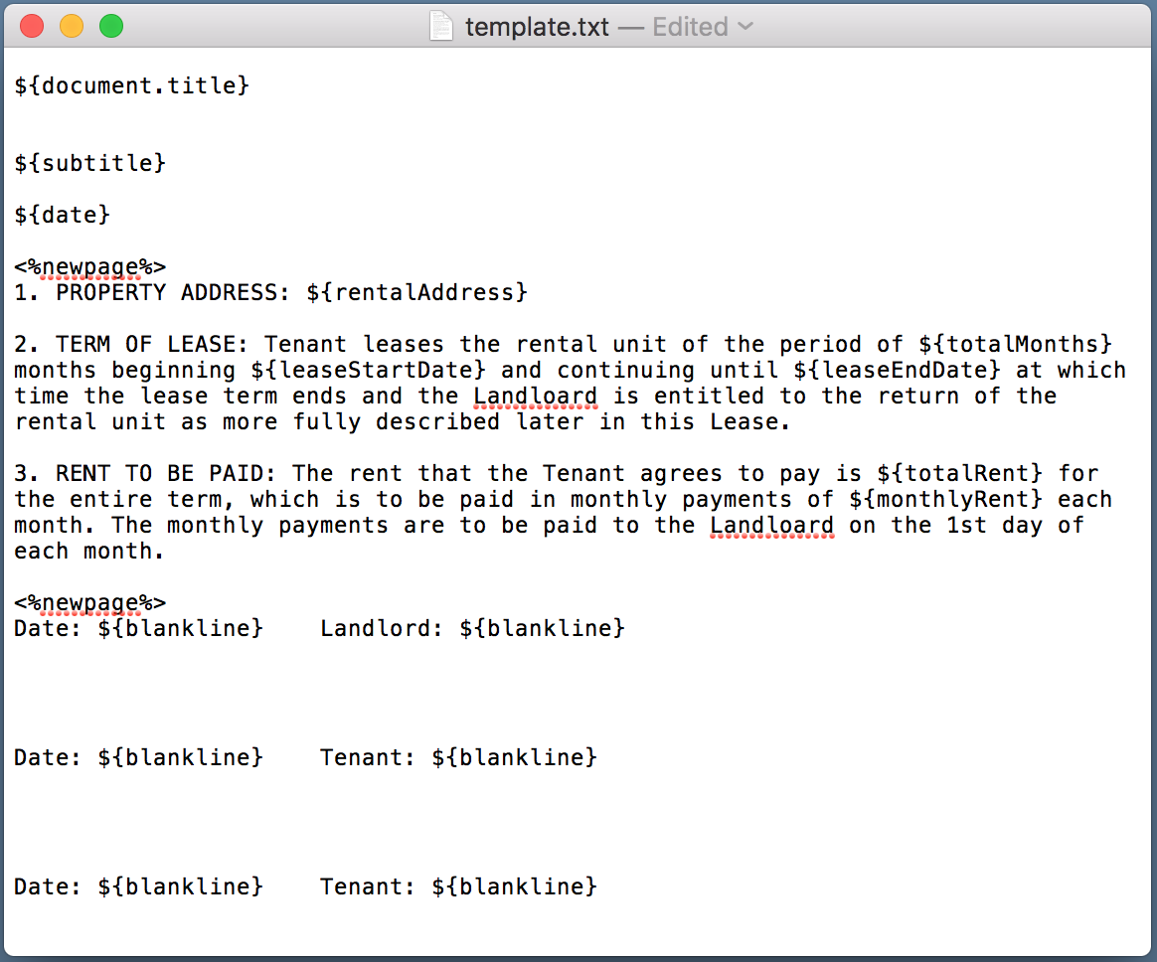

1. Create a dictionary file with key(s) that are used in the template from Step #1

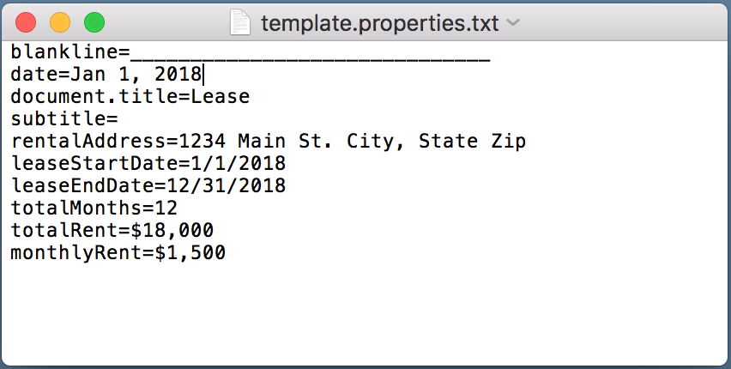

1. Launch *EzPdf*

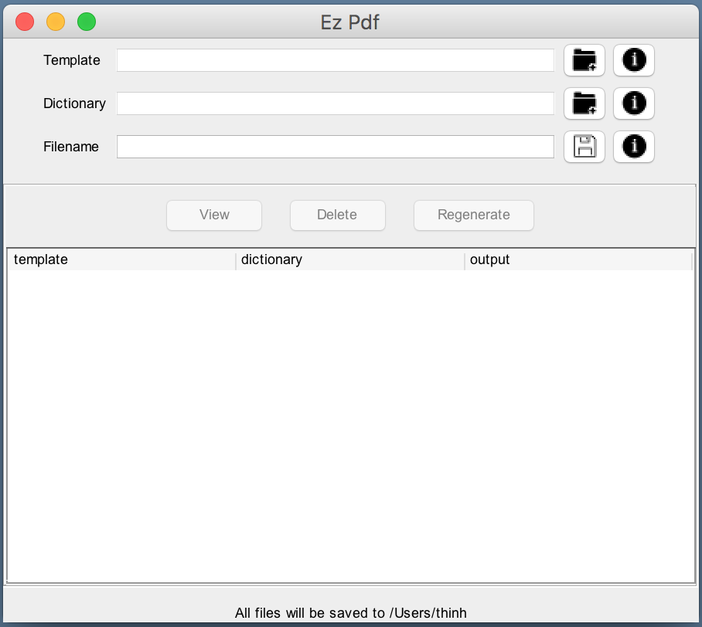

1. Click the folder  icon to select the appropriate files from Step #1 and #2, choosing an output file name

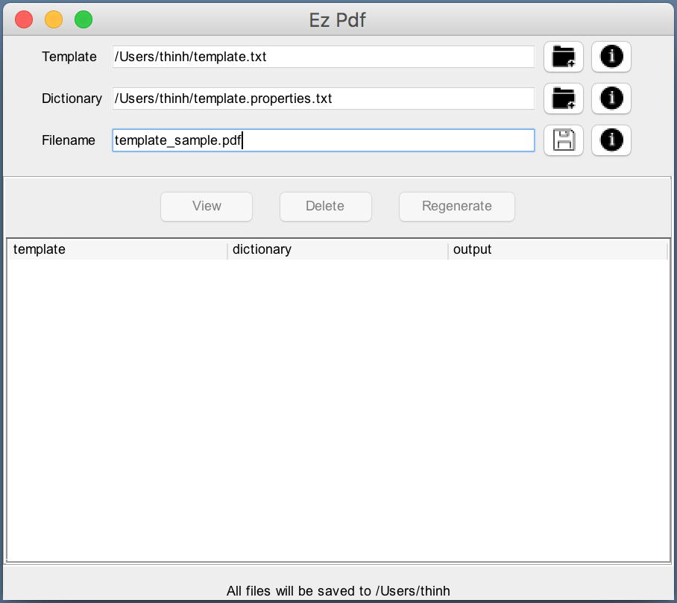

1. Click the save  icon to generate and save the pdf, and the document will be opened with the PDF viewer application installed on the Desktop

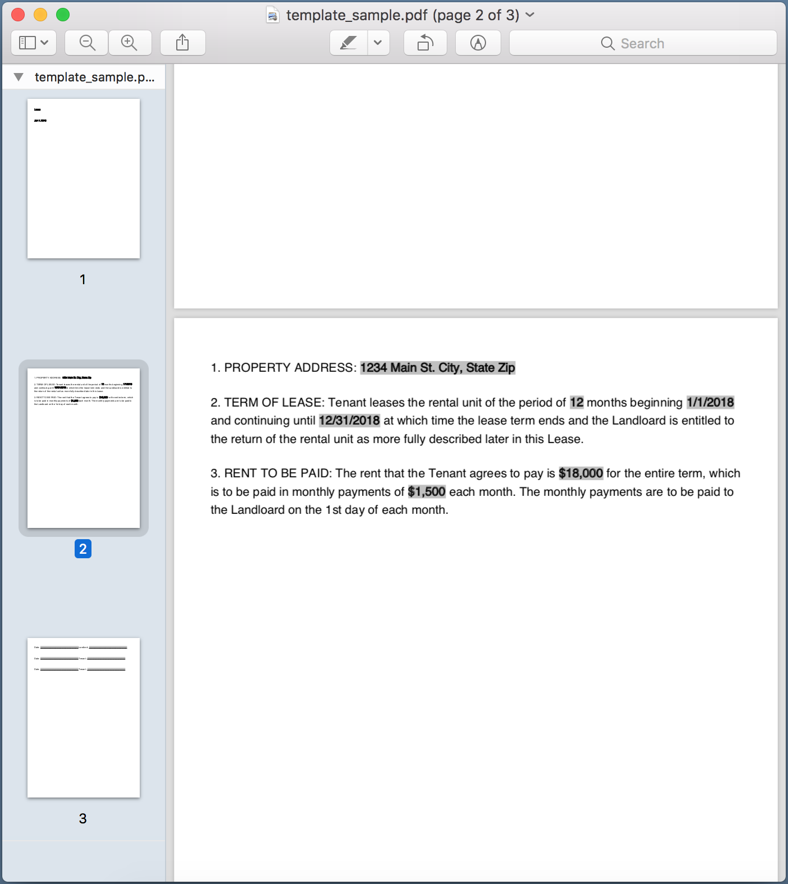

1. You may reopen the result document after you close the PDF view application by selecting a result and clicking the *View* button.
2. You may delete a result document by selecting it and clicking the *Delete* button.
3. If you've made modifications to either the template and/or the dictionary file, you may select a result document and click the *Regenerate* button to rebuild the document.