**INTRODUCTION**

Reservoir characterization is the act of finding specific characteristics of underground rocks that hold oil and gas. Some of the characteristics determined by the process of reservoir characterization include porosity (the amount of space available in the rock to store oil and gas), permeability (the ease of flow of oil and gas in the underground rocks) and water saturation (the amount of water stored in the underground rocks). Some major ways to determine the properties of these underground rocks includes well logging and core analysis. Well logging is the process of sending tools into the well (the hole created by drilling into the ground, it serves as the channel through which oil and gas flows to the surface). These tools measure specific characteristics of the underground rocks such as the speed of sound in those rocks, the density of the rocks, the amount of gamma ray radiation the rocks and rock fluids absorb, and the resistivity value of the rocks. These data are then used to build real time representation of these oil bearing rocks at various depths. The process itself is expensive because it is not effective to produce the oil and gas stored in the underground rocks using only one well, and therefore multiple wells have to be drilled. A well log has to be done for each individual well because the characteristics of the underground rocks change in all direction due to heterogeneity (different rock characteristics in all directions). To further make business decisions, a well core sample has to be collected for laboratory analysis. A core, is a physical representation of the underground rocks. It is taken from the well at various depths using special tools. These wells can either be onshore (on the land) or offshore (on the high sea), and the depths of the wells are usually greater than 3,000 feet.

The coring process and laboratory analysis are both quite expensive and time consuming, and research has been put into developing artificial intelligence models which can be trained on log data and core derived reservoir properties (porosity, saturation and permeability). These models would be able to find the patterns in data, and use those patterns to predict the reservoir properties in uncored zones. This method if proven successful and accurate, would save oil and gas companies time and money. Privacy has been a major limitation to the advancement of this field of research. This is because log data and core data are major trade secrets and these are not publicly available except requested for from oil and gas companies. Due to privacy concerns, the data isn’t given to start-ups, they are mainly given for academic research only.

This project entails building a model which would be able to predict the values of porosity for two wells. Encrypted deep learning as a service was used in this project for the second prediction. This was in order to show that one company (bob) can build a model on a large dataset, train it on their data and test it. This company (bob) can then encrypted its model and use additive secret sharing to secure its model, while the second company (Alice) can encrypt its data and test it with bob’s model. The results were positive, with the encrypted deep learning results of R squared values of over 0.85.

**METHODOLOGY**

The dataset used for this project had over 10,000 data points for well 1 and 498 data points for well 2. Reservoir log data and porosity data were collected for one well, and it was split into training, test and validation set. The porosity values at each depth was used as the target values, and the statistical accuracy of the model was calculated using the R squared value. The built model had four layers (two hidden layer, one output layer, and one input layer). All the layers were activated using a Relu function. The optimizer for gradient decent used was Adam, and a weight decay limit of 1e-4 was used to prevent the weights from taking large values. The loss function used was the root mean squared error loss.

The model was trained for 7,000 epochs, and at the end of the iterations the model was tested, and the R squared values were calculated using the regression package in sklearn. Encrypted deep learning as a service using secret additive sharing was used, assuming a real life scenario where a start-up has built a high accuracy model and they are offering their services to oil and gas companies. The model of the start-up (bob) was encrypted and the data of the oil and gas company (Alice) was also encrypted. The encrypted data was tested on the model and it gave an R squared value of above 0.85.

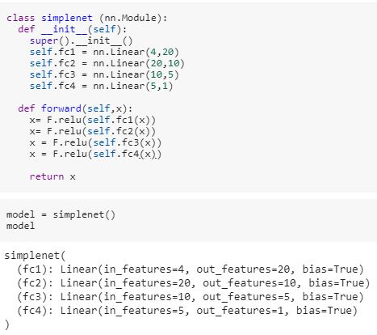

Figure 1.1: Deep learning model built to predict porosity values

**RESULTS**

The full code, with results would be uploaded to the SPAIC project showcase github repository. A few results would be displayed below:

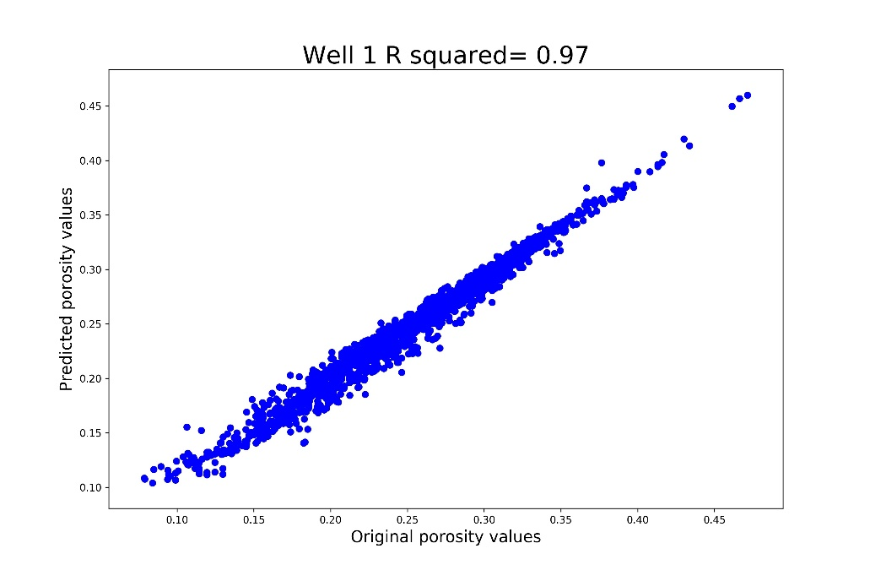

Figure 1.2: Trained Model Regression Values

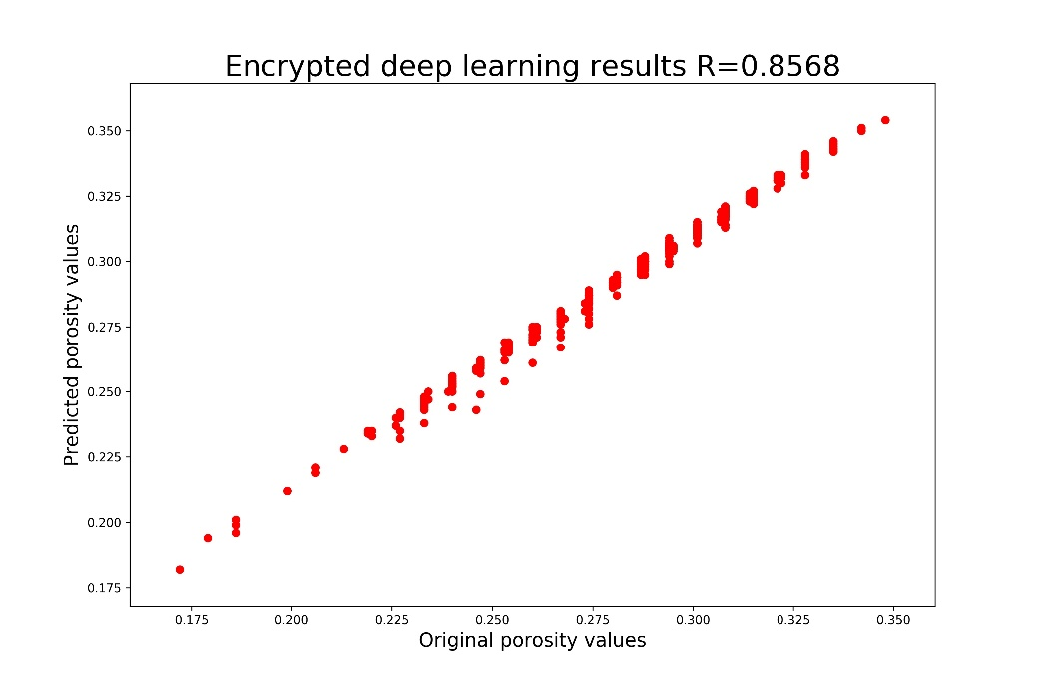

Figure 1.3: Encrypted Model Regression Values

**CONCLUSION/RELEVANCE**

The results of the project have shown the possibility of using transfer learning in the oil and gas field. Previously, it had not been proven that a model trained on Well 1 could be used to predict the characteristics of Well 2. This research opens a business opportunity for a young engineering start-up. This is because with enough data, start-ups can build models that accurately predict reservoir characteristics. These services can then be offered through a secure cloud network. The presence of differential privacy helps reduce most of the privacy concerns of major oil and gas corporations. With Encrypted deep learning, company data can be given to young start-ups and academic researchers to build more accurate models which can solve the problems faced by these corporations. This will in turn save the company time and money, and as well bring about further advancements of deep learning in the field of engineering.