User Stories

* As a developer, I need to players to be able to enter their name so that they can be identified in the game

Tests

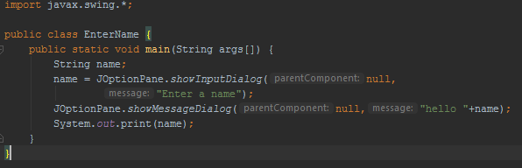

* As a player, I need to be able to move my character so that I’m able to play the game
* As a developer, I want to implement the bike leaving a trail behind so that the player has something to avoid
* As a developer, I want to have a re-sizeable grid so that more players are able to play the game
* As a developer, I want to implement a UDP server so that there can be multiple players
* As a developer, I want to implement leader boards so that payers can see how they rank

