The analyses completed up to this point were for a single variable with two outcomes. For example, for the Staring Case study, the individual doing the guessing was either correct or incorrect or for the AYP examples, the schools were either making AYP or not making AYP. In this handout, we allow for more than two categories.

Understanding Variation in Repeated Samples - Equal Proportions

This section to help us understand how much random variation is acceptable when investigating a single variable with several categories.

Example 6.1: The Minneapolis Police Department posts regular updates on crime statistics on their website. I have collected this data for the past two years ( identified as Fiscal Year = Current or Past) on all neighborhoods in Minneapolis. The data and prescient map are given here.

|  |  |
| --- | --- |
| Minneapolis Crime Statistics (see course website) | Precinct Map |

Source: <http://www.minneapolismn.gov/police/crime-statistics/>

The police chief for Precinct #2 has received a complaint from a permanent resident who lives in a neighborhood near the University of Minnesota. This resident has asked for additional patrol to take place in his neighborhood as he believes that crime rates vary over the course of the year.

Research Question: Is there evidence to suggest that crime patterns in the University of Minnesota neighborhood differ over the four seasons of the year?

Crime rates are reported by month, so use the following definitions for the Seasons:

* Fall: September, October, and November
* Winter: December, January, and February
* Spring: March, April, and May
* Summer: June, July, and August

The crimes of Murder, Rape, Robbery, Aggravated Assault, Burglary, Larceny, Auto Theft, and Arson are used in reporting the **Total**. The counts reflect the number of crimes reported and arrests made.

The Minneapolis Police Department reported that a total of 103 crimes for the University of Minnesota neighborhood last year.

|  |  |
| --- | --- |
| **Minneapolis Crime Case Study** | |
| Research Question | Is there evidence to suggest that crime patterns in the University of Minnesota neighborhood differ over the four seasons of the year? |
| Testable Hypothesis | Ho: Crimes are equally dispersed over the four seasons  HA: Crimes are not occurring equally over the four seasons |
| Parameters | The four parameters of interest are defined as follows:  = the probability of a crime occurring in the Fall  = the probability of a crime occurring in the Winter  = the probability of a crime occurring in the Spring  = the probability of a crime occurring in the Summer |
| Rewrite of Hypotheses |  |

The initial approach taken here to answer the research question will be similar to what we have done previously. We will conduct a simulation *assuming* the crime patterns are occurring equally across the four seasons. We will then check to see if our observed outcomes are outliers against the simulated outcomes. If the observed outcomes are outliers, then we have sufficient statistical evidence to say crimes rates vary of the four seasons.

|  |  |  |  |  |
| --- | --- | --- | --- | --- |
|  | Season | | | |
| Fall | Winter | Spring | Summer |
| U of MN | 25% | 25% | 25% | 25% |

Questions

1. What is the number of anticipated or expected outcomes for each season under the assumption that crimes are occurring equally over the four seasons? Carefully, explain how you obtained these values.

|  |  |  |  |  |  |
| --- | --- | --- | --- | --- | --- |
|  | Season | | | | Total |
| Fall | Winter | Spring | Summer |
| U of MN |  |  |  |  | 103 |

1. One of your annoying friends asks, “How would I compute the anticipated number if the percentages were not all equal?”. Consider the following percentages. Explain to your friend how to compute the anticipated number for this situation.

|  |  |  |  |  |
| --- | --- | --- | --- | --- |
|  | Season | | | |
| Fall | Winter | Spring | Summer |
| U of MN | 30% | 25% | 25% | 20% |

1. A statistician would argue that we must allow for some slight variations in the crime patterns over the four seasons because we should not expect the numbers to come out exactly at the expected number for each season. Do you agree? Explain.
2. On the following bar chart, provide an education guess for the amount of acceptable random variation for each of the four seasons.

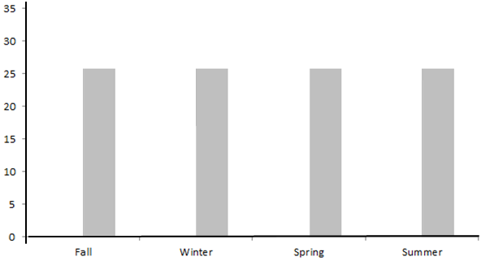

1. In the above plot, is the estimated amount of acceptable variation about the same for each season or different? Explain your rationale.

Simulation in JMP

In an effort to better understand an appropriate amount of random variation, you decide to run a simulation to understand the amount of inherent variation. Unfortunately, StatKey does not permit us to run this type of simulation.

|  |  |
| --- | --- |
| Add 103 Rows to the table | Add a column and specify the following formula. Select Random > Random Category. |

|  |  |  |  |
| --- | --- | --- | --- |
| Repeated Sample #1 | Repeated Sample #2 | … | Repeated Sample #100 |

For each trial, you and your friend record the number of crimes that occurred in fall, winter, spring, and summer. Plot the anticipated pattern for repeated trials on the number lines below.

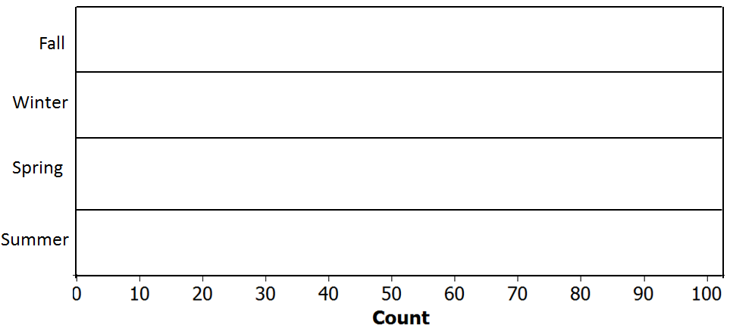

Questions

1. Why does each category have 25% for each season? Explain.
2. Why did we add 103 rows? Where did this number come from? Explain.
3. Did the outcomes from your trial (i.e. the number of crimes for fall, spring, summer, and winter) match mine? Should they match? Explain.
4. Your friend makes the following true statement, “It is reasonable to use the same lower and upper cutoff for each season.” Why is this statement true? Discuss.

Next, consider the actual crime statistics for the University of Minnesota neighborhood for the past year.

|  |  |  |  |  |  |
| --- | --- | --- | --- | --- | --- |
|  | Season | | | | Total |
| Fall | Winter | Spring | Summer |
| U of MN | 32 | 17 | 30 | 24 | 103 |

Research Question: Is there evidence to suggest that crime patterns in the University of Minnesota neighborhood differ over the four seasons of the year?

The outcomes from the 100 repeated trials are shown here.

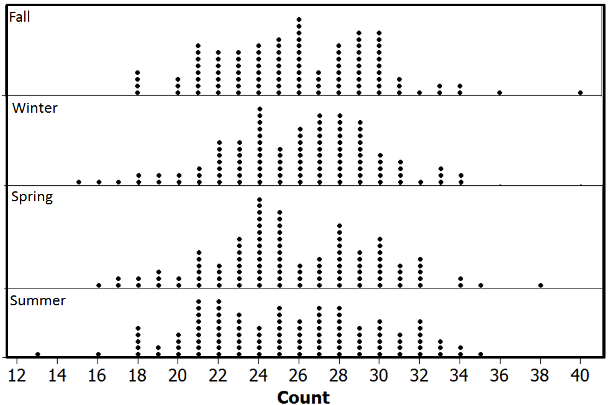

Recall, the research question for this case study, “Is there evidence to suggest that crime patterns in the University of Minnesota neighborhood differ over the four seasons of the year?” In order to answer this question, we need to identify whether or not the observed data would be considered an outlier. This needs to be done for each season.

|  |  |  |  |  |  |
| --- | --- | --- | --- | --- | --- |
|  | Season | | | | Total |
| Fall | Winter | Spring | Summer |
| U of MN | 32 | 17 | 30 | 24 | 103 |

Determine whether or not the outcomes for Winter and Spring would be considered outliers.

|  |  |  |  |
| --- | --- | --- | --- |
| Season | Outlier | | |
| Yes | No | Maybe |
| Fall |  |  | X |
| Winter |  |  |  |
| Spring |  |  |  |
| Summer |  | X |  |

To formalize the concept of an outlier, we will again consider the p-value approach. The definition of a p-value is given here as a reminder.

|  |
| --- |
| P-Value: the probability of observing an outcome as extreme or more extreme than the observed outcome that provides evidence for the research question |

Recall, the research question fro this analysis, “Is there evidence to suggest that crime patterns in the University of Minnesota neighborhood differ over the four seasons of the year?”

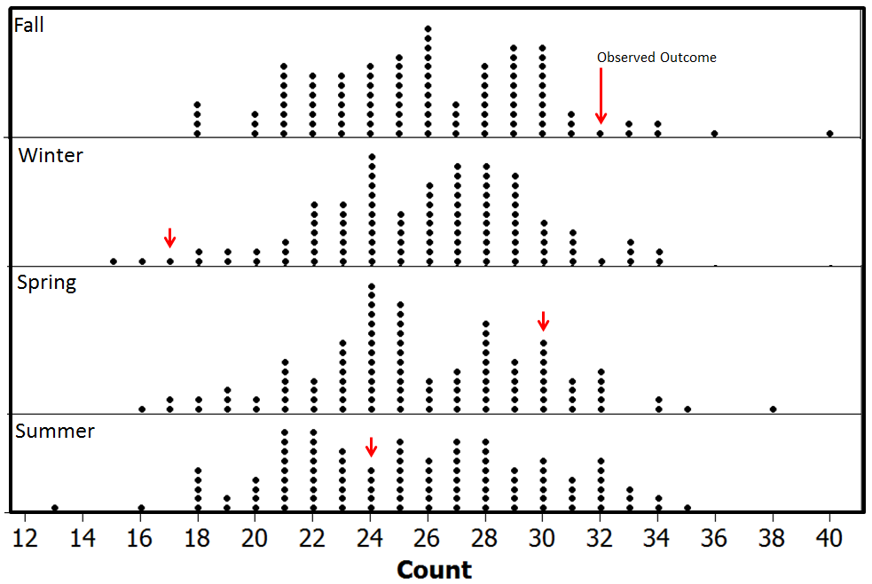

Compute the approximate *two-tailed* p-value for each season.

|  |  |  |  |  |  |
| --- | --- | --- | --- | --- | --- |
| Season | Computing p-value | # Dots  Upper-Side | # Dots  Lower-Side | Total  Dots | Estimated  P-Value |
| Fall | Number of dots more extreme than 32 |  |  |  |  |
| Winter | Number of dots more extreme than 17 |  |  |  |  |
| Spring | Number of dots more extrem than 30 |  |  |  |  |
| Summer | Number of dots more extreme than 24 |  |  |  |  |

Questions

1. Use the p-value computed above to determine whethor or not the data supprots the research question. What is your decision?

Formal Decision: If the p-value < 0.05, then data is said to support the research question.

* Data supports research question
* Data does not support research question

1. Discuss any difficulties when trying to answer this question when four categories are present. Specifically, why is it more difficult to determine whether or not our data supports the research question?

Comment: The issue of combining p-values (aka “multiplicity of tests” or simply “multiple comparisons”) to make a single decision has not been universally resolved. Statisticians continue to be required to deal with this issue in practice. The most significant concern when combining p-values is that the familywise (or experiment-wide) error rate is much greater than 0.05, our gold standard for making decisions.

|  |  |  |  |
| --- | --- | --- | --- |
| Season | Estimated  P-Value | Error  Rate | Statistically  Significant |
| Fall | 0.14 | 0.05 | No |
| Winter | 0.03 | 0.05 | Yes |
| Spring | 0.41 | 0.05 | No |
| Summer | 0.78 | 0.05 | No |
| Maximum Error Rate  (across all four comparisons) | | 0.20 |  |

The math for determining familywise and maximum error rates when multiple p-values are used to make a decision.

|  |  |
| --- | --- |
| * Familywise Error Rate     where *k* = # of tests being considered   * Maximum Error Rate (Boole’s Inequality) | Table Showing Possible Error Rates |

*Source*: Wiki page on Multiple Comparisons; <http://en.wikipedia.org/wiki/Multiple_comparisons>

Measuring Distance between Observed and Expected with Several Categories

As mentioned above, having multiple p-values is problematic when a single decision is to be made regarding a single research question. To overcome this problem, the distance from the Observed to the Expected Value is what is considerd in our formal statistical test. This is shown below.

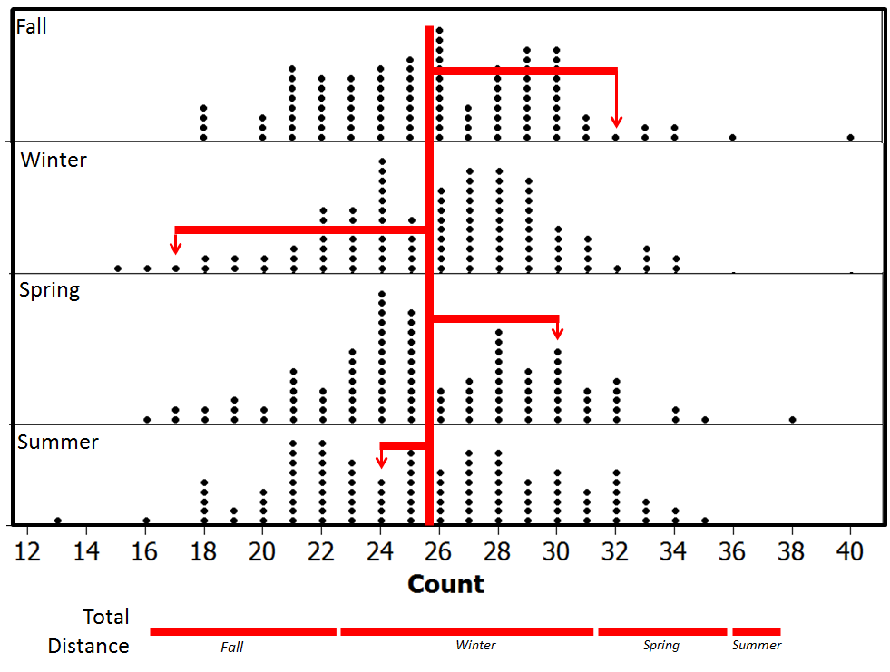

Compute the distance from the Observed to the Expected for the Spring and Summer seasons.

|  |  |  |  |  |  |
| --- | --- | --- | --- | --- | --- |
| U of MN | Season | | | | Total |
| Fall | Winter | Spring | Summer |
| Observed | 32 | 17 | 30 | 24 | 103 |
| Expected | 25.75 | 25.75 | 25.75 | 25.75 | 103 |
| Distance | 32 – 25.75 = 6.25 | 17 – 25.75 = -8.75 |  |  |  |

Questions

1. Add the Distance row in the table above. What is the total distance? Does this value make sense for total distance?
2. Why did we get a total distance of 0? How might we overcome this issue?

Taking the square of each distance is shown in the table below. This is done so that the negative distances do not cancel out the positive distances. The absolute values could have been used as well to get rid of the negatives; however, squaring each distance is used here.

|  |  |  |  |  |  |
| --- | --- | --- | --- | --- | --- |
| U of MN | Season | | | | Total |
| Fall | Winter | Spring | Summer |
| Observed | 32 | 17 | 30 | 24 | 103 |
| Expected | 25.75 | 25.75 | 25.75 | 25.75 | 103 |
| Distance | 6.25 | -8.75 | 4.25 | -1.75 | 0.00 |
| Distance2 | 39.06 | 76.56 | 18.06 | 3.06 | **136.74**  **≈ 137** |

The total squared distances summed up across all four seasons is about 137. We cannot determine whether or not 137 is an outlier using our previous graphs. The previous graphs considered each season individually. Our new measure is the squared distance between the Observed and Expected summed over four seasons. A new graph, a single graph, will need to be created to determine whether or not 137 is an outlier.

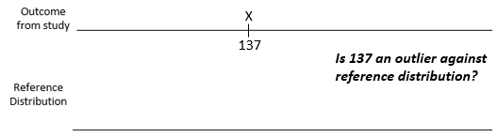

Questions

1. What would a value of 0 imply on the above number line? Explain why a value less than 0 is not possible when the distances are squared and summed across the categories.
2. What would a large value imply? Is this evidence for or against the original research question? Explain.
3. When squared distances are computed and summed across all categories, the appropriate test is one-tailed right. Explain why this is the case.

As previously stated, the simulation process cannot be done in StatKey. A brute force approach can be done with JMP. Consider again the outcomes from the Random Category provided above. The same approach used to obtain the value of 137 (the observed outcome from the study) must be mimicked in the simulation. Thus, the squared distance between the simulated outcome and the expected for each season must be computed. These squared distance values are then summed across the four seasons. The total squared distance for the 1st trial is 257. This process is repeated for many repeated trials.

|  |  |  |  |  |  |  |  |  |  |  |  |  |  |  |  |  |  |  |  |  |  |  |  |  |  |  |  |  |  |  |  |  |
| --- | --- | --- | --- | --- | --- | --- | --- | --- | --- | --- | --- | --- | --- | --- | --- | --- | --- | --- | --- | --- | --- | --- | --- | --- | --- | --- | --- | --- | --- | --- | --- | --- |
| Repeated Sample #1   |  |  |  | | --- | --- | --- | | Fall |  | = 138 | | Spring |  | = 10 | | Summer |  | = 3 | | Winter |  | = 105 | | Total | | 257 | | Repeated Sample #2   |  |  |  | | --- | --- | --- | | Fall |  | = | | Spring |  | = | | Summer |  | = | | Winter |  | = | | Total | | 77 | | …  …  … |

Plot the simulation outcomes on the number line below.

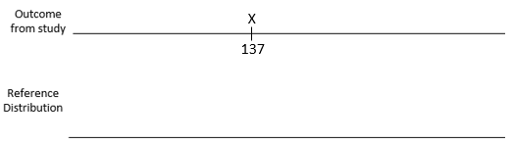

A graph of the total squared distances from 100 repeated trials is provided here. The p-value is determined using the proportion of dots greater than or equal to 137, the observed outcome from the study.

. 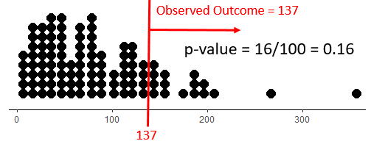

Questions

1. What is an approximate p-value from the above graph?
2. Why were values to the right used in computing the p-value?
3. Does this p-value provide enough evidence for the research qeustion?

Research Question: Is there evidence to suggest that crime patterns in the University of Minnesota neighborhood differ over the four seasons of the year?

Understanding Variation in Repeated Samples – Unequal Proportions

Example 6.2: The Minnesota Student Survey (MSS) is a survey administered every three years to 6th-, 9th- and 12th-grade students and also is offered to students in area learning centers and to youth in juvenile correctional facilities. The survey is an important vehicle for youth voice. School district leaders and educators, local public health agencies and state, community and social services agencies use the survey results in planning and evaluation for school and community initiatives and prevention programming.

Questions are asked related to both the home and school life of students; topics include family relationships, feelings about school, substance use, wellness activities, and more. Participation in the survey is voluntary, confidential and anonymous.

For the analysis here, we will consider Question # 105 from this survey. Data has been collected for Fillmore County which is in Southeastern Minnesota. The population of Fillmore County is 20,866 and consists of several small rural communities.

|  |  |
| --- | --- |
| Question #105 from MN Students Survey | Fillmore County is in  Southeastern Minnesota |

The following data was obtained from the Minnesota Department of Education website.

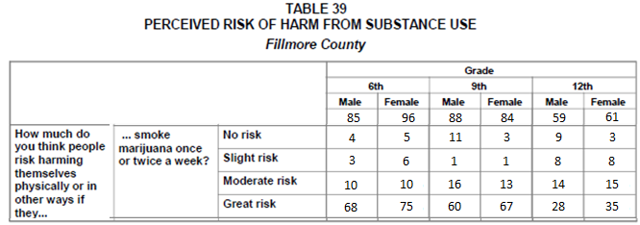

*Source*: Minnesota Department of Education; <http://education.state.mn.us/MDE/Learning_Support/Safe_and_Healthy_Learners/Minnesota_Student_Survey/index.html>

The survey is completed by students in Grade 6, 9, and 12. Information regarding the historical patterns for Grade 6 students from across the state of Minnesota is given here and will be used for comparisons.

Historical Patterns for Grade 6 Students Across the State of Minnesota

* + About 3 out of 4 students in Grade 6 respond to the third part of this question (i.e. “smoking marijuana once or twice a week” ) with “Great Risk”
  + A very small percentage, only about 1%, respond to the third part of this question with “No Risk”
  + The remaining students typically divide themselves between “Slight Risk” and “Moderate Risk” when responding to the third part of this question.

|  |  |
| --- | --- |
| **Fillmore County Marijuana Case Study** | |
| Research Question | Is there evidence to suggest that Grade 6 students from Fillmore County deviate from historical patterns of the marijuana portion of Question 105? |
| Testable Hypothesis | Ho: Fillmore County Grade 6 students do not deviate from historical patterns  HA: Fillmore County Grade 6 students deviate from historical patterns. |
| Parameters | The four parameters of interest are defined as follows:  = the probability of a Grade 6 student from Fillmore County will respond   to the marijuana portion of this question with No Risk  = the probability of a Grade 6 student from Fillmore County will   respond to the marijuana portion of this question with Slight Risk  = the probability of a Grade 6 student from Fillmore County will   respond to the marijuana portion of this question with   Moderate Risk  = the probability of a Grade 6 student from Fillmore County will   respond to the marijuana portion of this question with Great Risk |
| Rewrite of Hypotheses | Identify the appropriate proportions for each category |

Consider the following table. The first row of this table contains the Observed Outcomes for Grade 6 students from Fillmore County (Male and Female tallies were combined) and the second row contains the Expected Outcome (i.e. Anticipated Outcome under the null hypothesis) for each of the possible survey responses.

|  |  |  |  |  |  |
| --- | --- | --- | --- | --- | --- |
| Type of Outcome | Survey Responses for Fillmore County, 6th Grade | | | | Total |
| No Risk | Slight Risk | Moderate Risk | Great Risk |
| *Observed* | 9 | 9 | 20 | 143 | 181 |
| *Expected* | 1.81 | 21.72 | 21.72 | 135.75 | 181 |

Questions

1. The value in the first row and second column is 9 (i.e. *Observed* / Slight Risk). Explain where this number came from. What does this value represent?
2. What does the Total value for the Observed row represent?
3. The value for the second row and second column is 21.72 (i.e. *Expected* / Slight Risk). Explain where this number came from. How was it computed? What does this value represent?
4. Why is the Expected Value for Great Risk so much higher than the others? In the context of this problem, why would a county health nurse be excited to have such a high number in this category? Explain.
5. Your friend computes the following percentages: No Risk: 9/181 ≈ 5%; Slight Risk: 9/181 ≈ 5%; Moderate Risk: 20/181 ≈ 11%; and Great Risk: 143/181≈ 79%. Your friend then makes the following statement, “There is enough evidence for the research question because these percentages are different than the historical percentages (i.e. No Risk = 1%, Slight Risk = 12%, Moderate Risk = 12%, and Great Risk = 75%).” Why is this a statistically incorrect statement? Explain.

The conceptual framework for the simulation.

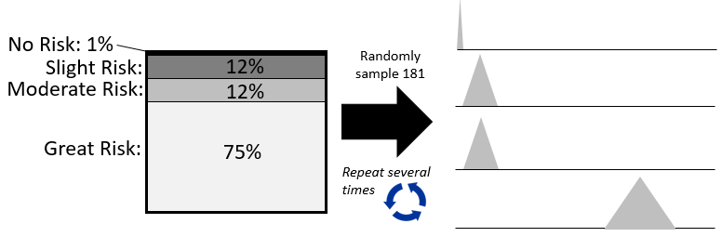

Simulation outcomes are provided here.

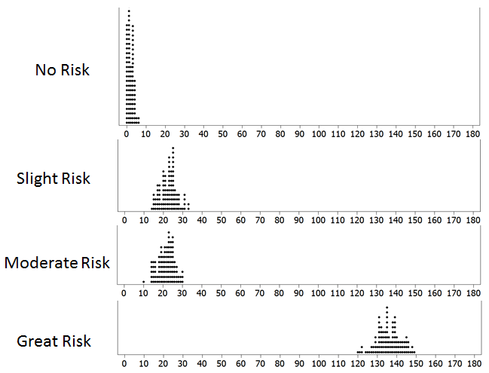

Determine whether or not the observed outcome for each category would be considered an outlier.

|  |  |  |  |
| --- | --- | --- | --- |
| Survey Outcome | Outlier? | | |
| Yes | No | Maybe |
| No Risk | X |  |  |
| Slight Risk |  |  |  |
| Moderate Risk |  |  |  |
| Great Risk |  | X |  |

Consider once again the distance between the Observed and the Expected outcome for each of the possible choices for this question.

|  |  |  |  |  |  |
| --- | --- | --- | --- | --- | --- |
|  | Survey Responses for Fillmore County, 6th Grade | | | | Total |
| No Risk | Slight Risk | Moderate Risk | Great Risk |
| *Observed (i.e.O)* | 9 | 9 | 20 | 143 | 181 |
| *Expected (i.e. E)* | 1.81 | 21.72 | 21.72 | 135.75 | 181 |
| Difference = (O - E) | 7.19 | -12.72 | -1.72 | 7.25 | 0 |

We discussed earlier the fact that we need to square the differences (i.e. distances) before summing because the positive and negative values cancel each other out. Upon careful inspection of these differences, there is another problem that is more substantial that needs to be addressed. In particular, notice that the Great Risk difference is 7.25 and the No Risk difference is slightly smaller at 7.19. However, when we identified the outliers above, we said 9 was an outlier for No Risk, but 143 was not an outlier for Great Risk. The discrepancy is a problem and can be summarized as follows -- when determining extremeness, we need to measure the distance or squared distance AND take the scale into consideration. Thus, for each category, the following is computed. These quantities are summed across all categories and the resulting value is called the **Test Statistic**.

Wiki Entry for Test Statistic for this test

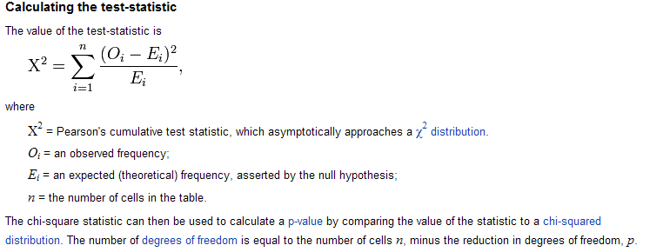

|  |  |  |  |  |  |
| --- | --- | --- | --- | --- | --- |
|  | Survey Responses for Fillmore County, 6th Grade | | | | Total |
| No Risk | Slight Risk | Moderate Risk | Great Risk |
| *Observed (i.e.O)* | 9 | 9 | 20 | 143 | 181 |
| *Expected (i.e. E)* | 1.81 | 21.72 | 21.72 | 135.75 |  |
| Difference = (O - E) | 7.19 | -12.72 | -1.72 | 7.25 |
|  | 51.7 | 161.8 | 2.96 | 52.56 |
|  | 28.56 | 7.45 | 0.14 | 0.39 | **36.54** |

The test statistics for this analysis would be

Test Statistic: __36.54__

Getting the Reference Distribution / P-Value in StatKey

The reference distribution for the following statistics is what is provided by StatKey.

The observed or sample data must be entered into StatKey first.

|  |  |
| --- | --- |
| Getting the data into StatKey | Setting up the parameters |

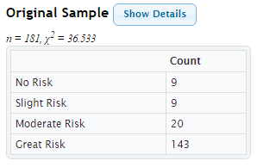

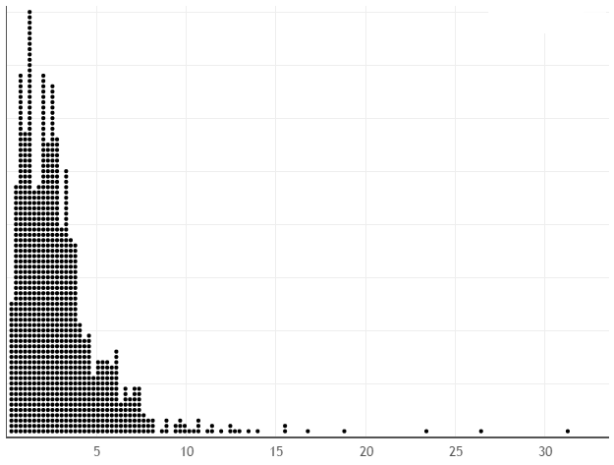

Getting the p-value in StatKey

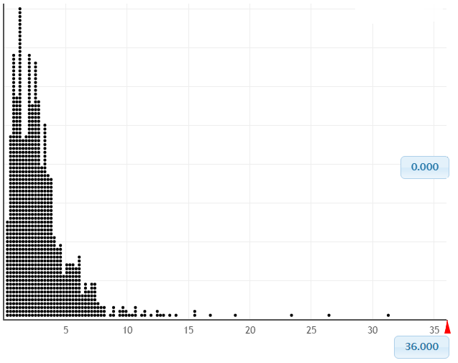

Getting the Analysis Done in JMP

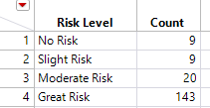

|  |  |
| --- | --- |
| Getting Risk Levels in the proper order | |
|  |  |

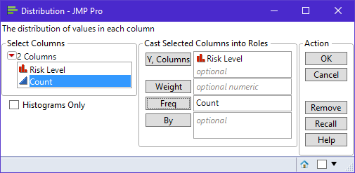

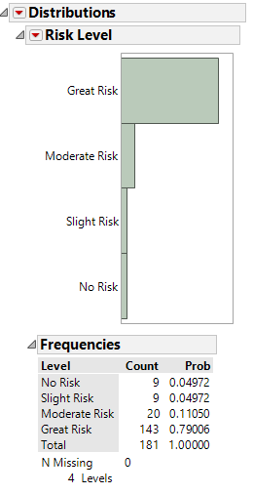

|  |  |
| --- | --- |
| Getting Risk Levels in the proper order | |
|  |  |

Output from JMP

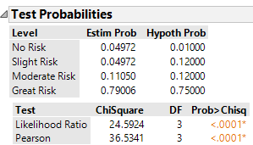

Working Through Some Examples

The name of the test completed above is called a **Goodness-of-Fit -- Chi Square Test**. This name is often shortened to Chi-Square test; however, there are a variety of test that use the Chi-Square distribution as it’s reference distribution; thus, statisticians refer to this particular type of Chi-Square Test as a Goodness-of-Fit test.

Example 6.3: Consider the following study done at Boston Medical Center. This study was centered around the scheduling of elective surgeries over a two year period. Scheduling surgeries is important to quality patient care and is an important health care management issue as well. In particular, consistency in the scheduling of the surgeries results in less cancellation and an appropriate level of staffing is more obtainable. This medical center made a significant change in their approach to scheduling surgeries between year 1 and year 2.

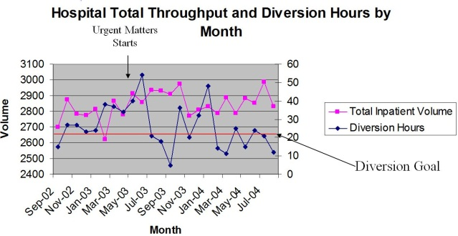

Consider the following data regarding number of surgeries over a two year period.

|  |  |
| --- | --- |
| Total inpatient volume in Year 1 | Total inpatient volume in Year 2 |

Consider the following research question. Define at least one of the parameter of interest in this case study.

|  |  |
| --- | --- |
| **Boston Medical Center Case Study** | |
| Research Question | Is there enough statistical evidence to suggest that total inpatient volume was inconsistent in Year 1? |
| Testable Hypothesis | Ho: Total inpatient volume at Boston Medical Center is consistent  HA: Total inpatient volume at Boston Medical Center is not consistent |
| Parameters | There are 12 parameters that need to be considered for this investigation --  , , , …,  Give a complete definition of one of the parameters, say .  = |
| Rewrite of Hypotheses | The null and alternative hypotheses are stated here. |

The observed outcomes in JMP.

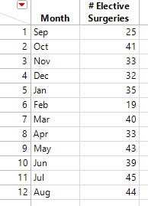

Getting the summaries in JMP. Select Analyze > Distribution.

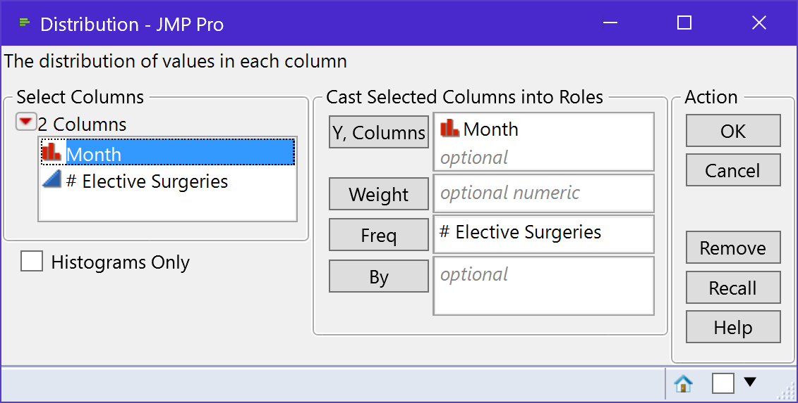

The output produced by JMP.

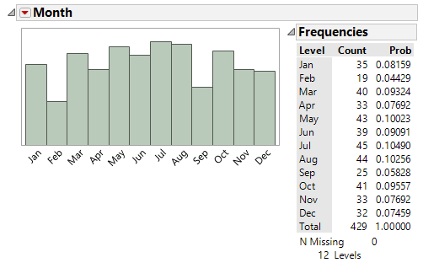

To specify a particular order in JMP, you must chance the Value Ordering of the variable. This is done in JMP under Column Properties, select Value Ordering. The outcomes for the variable can be ordered in the Value Ordering box.

|  |  |
| --- | --- |
|  | Specify the order in the Value Ordering box |

The output with the correct value ordering.

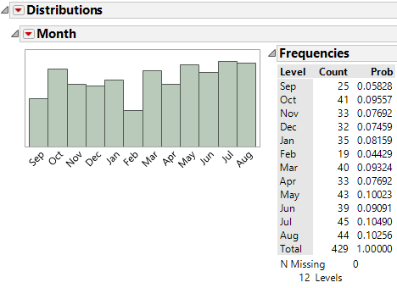

An alternative version of the graph – a simple line graph.

|  |  |
| --- | --- |
| Select Graph > Chart |  |

A reference line can be added to either axes in JMP. Right click on the axes and select Axis Settings…

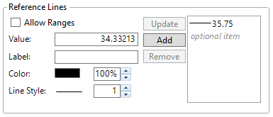

The final graph…

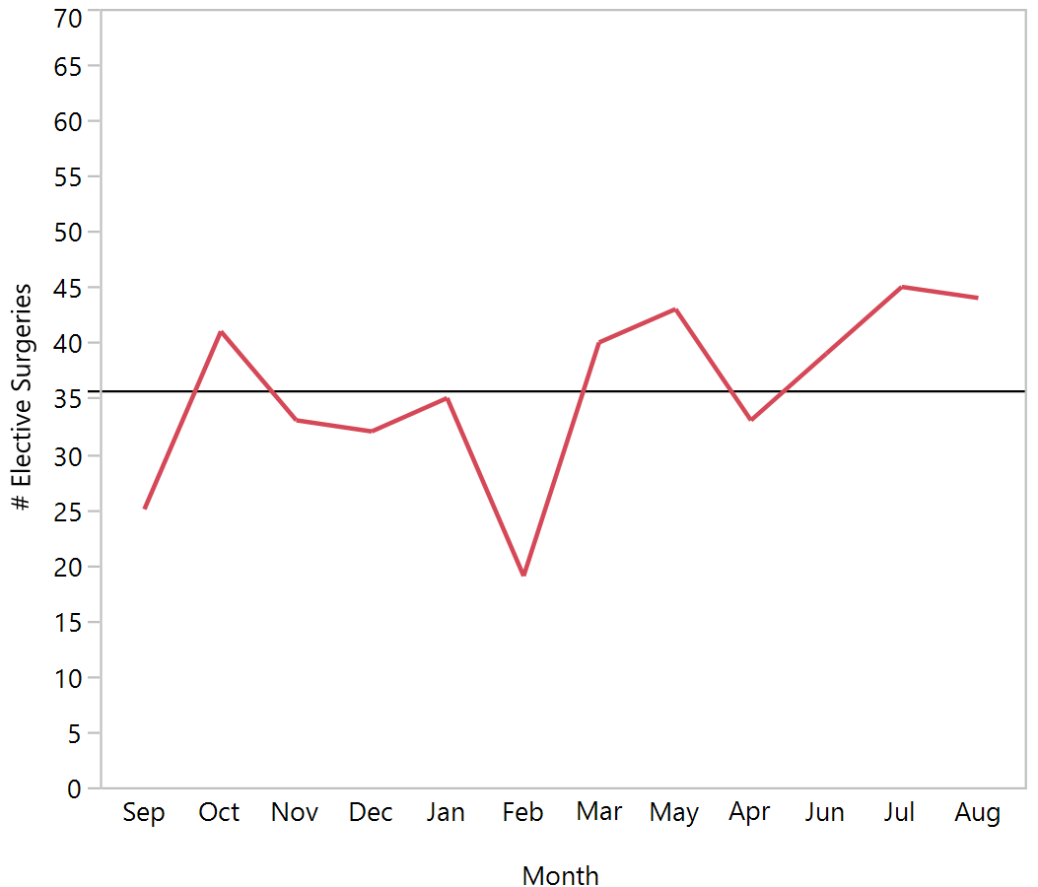

Questions:

1. How many surgeries occurred in Year 1? That is, what is the total number of surgeries in this investigation? Discuss.
2. What is the expected number of surgeries, for each month, if the surgeries are occuring equally throughout the year? Explain how you obtained this value. Sketch the expected value for each month on the above line graph.
3. Do you believe the variation seen in the observed data is within the boundaries of random variation (i.e. within the ‘margin-of-error’)? Explain.

Consider the following plot that shows the amount of random variation under the assumption that surgeries are occuring equally.

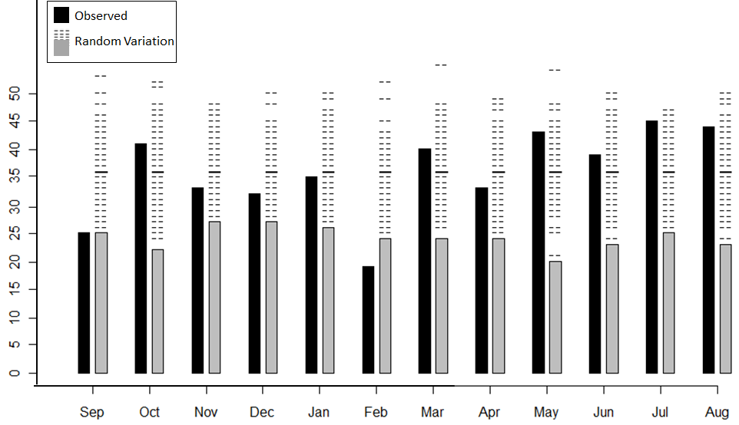

Questions:

1. For each month, the expected number (i.e. the bold line amonst the dashed lines) is the same. Why is this the case for this case study?
2. The amount of acceptable random variation is about the same for each month. Explain why this should be the case.
3. Using the above plot, which months would be considered outliers? How did you make this determination?
4. Your friend makes the following statement, “It’s rediculous to do repeated samples for each month . You can use the outcomes from one month, say Aug, for all the others to determine whether or not a month is an outlier. A statistician would agree with this. Why?

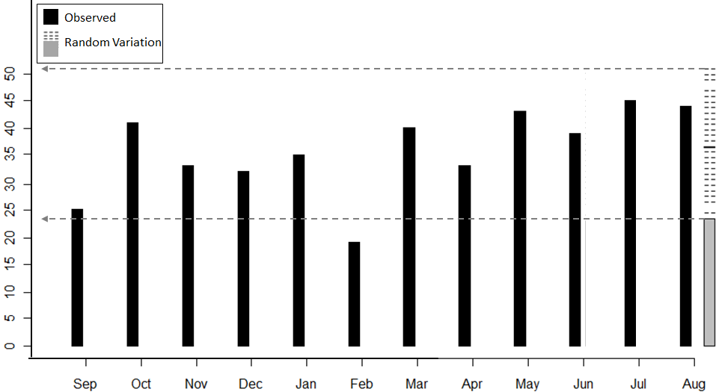

Getting our test done in JMP…

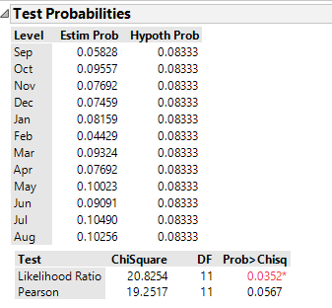

|  |  |
| --- | --- |
| **Boston Medical Center Case Study** | |
| Research Question | Is there enough statistical evidence to suggest that total inpatient volume was inconsistent in Year 1? |
| Testable Hypothesis | Ho: Total inpatient volume at Boston Medical Center is consistent  HA: Total inpatient volume at Boston Medical Center is not consistent |
| P-Value | P-Value = ___________________ |
| Decision | Decision: If the p-value < 0.05, then data is said to support the research question.   * Data supports research question * Data does not support research question |
| Conclusion | Write a final conclusion for the nurse in charge of staffing the inpatient surgery rooms at Boston Medical Center. |

Example 6.4: Reconsider the data from the Boston Medical Center. Rerun the analysis done on Year 1 using data from Year 2.

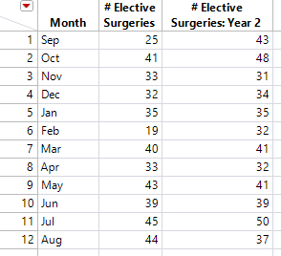

|  |  |
| --- | --- |
| **Boston Medical Center Case Study** | |
| Research Question | Is there enough statistical evidence to suggest that total inpatient volume was inconsistent in Year 2? |
| Testable Hypothesis | Ho: Total inpatient volume at Boston Medical Center is consistent  HA: Total inpatient volume at Boston Medical Center is not consistent |
| Rewrite of Hypotheses | The null and alternative hypothesis with the parameters. |
| P-Value | Use JMP to obtain the appropriate p-value.  P-Value = ___________________ |
| Decision | Decision: If the p-value < 0.05, then data is said to support the research question.   * Data supports research question * Data does not support research question |
| Conclusion | Write a final conclusion for the nurse in charge of staffing the inpatient surgery rooms at Boston Medical Center. |

Questions:

1. Consider the following graphic that show the amount of acceptable random varition for each month for the Year 2 investigation. Does this graph support or refute the conclusion reached above? Explain.

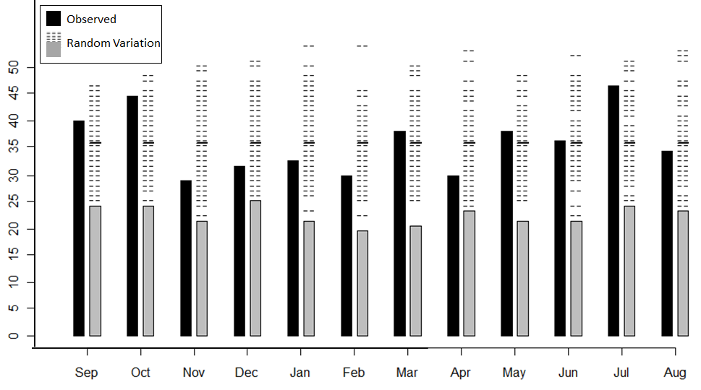

1. As mentioned in Example 3.4.1, the Boston Medical Center made a change in their scheduling of elective surgeries between Year 1 and Year 2. Did this change have the desired effect? That is, was total patient volume more consistent in Year 2 than in Year 1? Compare and contrast the p-value from Year 1 to that of Year 2 to support your answer.